**Introduction to Theoretical Ecology (EEB5096)**

**Midterm exam (2021/11/24)**

1. The dynamics of a population, *N*(*t*), with self-limitation can be described using the logistic growth equation: fraction numerator d N over denominator d t end fraction equals r N open parentheses 1 minus N over K close parentheses , where *r* and *K* are the species’ intrinsic rate of increase and carrying capacity, respectively. Use the technique of “separation of variables” to find the solution of this ordinary differential equation. In particular, show that the solution can be expressed as the following when the initial condition is *N0* at *t* = 0:



<!DOCTYPE html>
<html>
<head><meta charset="UTF-8"><title>Error 500</title></head>
<body>
<h1>Error 500</h1>

<!--

-->



</body>
</html>


Based on the above solution, explain why *K* is the stable final state of the dynamics. [15 pts]

***Solution***

*Step 1. Separate the variables:*

*Step 2. Integrate both sides:*

*Step 3. Take exponential of both sides:*

*Step 4. Plug in the initial values:*

*Step 5. Substitute C2 into the equation in step 3:*

*Step 6. Rearrange:*

As *t* approaches infinite, the denominator becomes 1 and thus the population size *N(t)* will reach *K*.

1. Levin’s metapopulation model describes a species’ occupancy on a landscape and models its dynamics as: fraction numerator d P over denominator d t end fraction equals c open parentheses P close parentheses open parentheses 1 minus P close parentheses minus e open parentheses P close parentheses P. Here, *P*(*t*) is the species’ occupancy, *c*(*P*) and *e*(*P*) represent the local colonization and extinction processes, both as a function of current occupancy. This general form of the model can incorporate both internal colonization and rescue effect. The model will then take the form as:

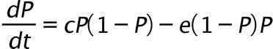

1. Find all equilibrium points of this model. [5 pts]
2. Use graphical analysis to determine the stability criteria for the equilibrium points. [5 pts]
3. Derive the stability criteria for the equilibrium points using local stability analysis. [5 pts]

***Solution***

1. The equilibrium points are *P\** = 0 and *P\** = 1.
2. Graphical analysis:

**c > e**

**dP/dt**

**P* = 1**

**P* = 0**

**c < e**

**dP/dt**

**P* = 0**

**P* = 1**

1. Local stability analysis:

* *P\** = 0: the derivative evaluated at *P\** = 0 is *c - e.* So this equilibrium will be stable if *c < e.*
* *P\** = 1: the derivative evaluated at *P\** = 1 is -(*c - e*)*.* So this equilibrium will be stable if *c > e.*

1. In the 1940s, some researchers have proposed the following modified Lotka-Volterra competition model to describe the dynamics of two species engaged in mutualism:

fraction numerator d N subscript 1 over denominator d t end fraction equals r subscript 1 N subscript 1 open parentheses fraction numerator K subscript 1 minus N subscript 1 plus alpha N subscript 2 over denominator K subscript 1 end fraction close parentheses

fraction numerator d N subscript 2 over denominator d t end fraction equals r subscript 2 N subscript 2 open parentheses fraction numerator K subscript 2 minus N subscript 2 plus beta N subscript 1 over denominator K subscript 2 end fraction close parentheses

Here, the two species densities are represented by *N1*(*t*) and *N2*(*t*), with intrinsic growth rates *r1* and *r2* as well as carrying capacity *K1* and *K2*, respectively. Heterospecific facilitation effect of *N2* on *N1* is captured by the parameter ** and that of *N1* on *N2* by ** (all parameters strictly positive).

1. Find all equilibrium points of this model. [5 pts]
2. Draw the ZNGI and movement arrows on the *s*tate space for *N1* and *N2* separately. [5 pts]
3. Combine the two ZNGIs and discuss the stability of the equilibrium points (and dynamics of the system) under different parameter scenarios using graphical analysis. [10 pts]

***Solution***

1. The equilibrium points (*N1*\*, *N2*\*) are (0, 0), (*K1*, 0), (0, *K2*), and .

*N1 ZNGI*

*N2 ZNGI*

*N1*

*Slope = β*

*K2*

*N2*

*Slope = 1/α*

*N2*

*N1*

*K1*

1. Graphical analysis:

**Scenario 2: αβ < 1**

*N2*

*N1*

**Scenario 1: αβ > 1**

*N2*

*N1*

*K2*

*0*

*0*

*K2*

*K1*

*K1*

*N1* and *N2* increase towards infinite over time

*N1* and *N2* stably coexist at

1. The life history diagram of *Mammillaria dixanthocentron* can be represented by the following diagram:

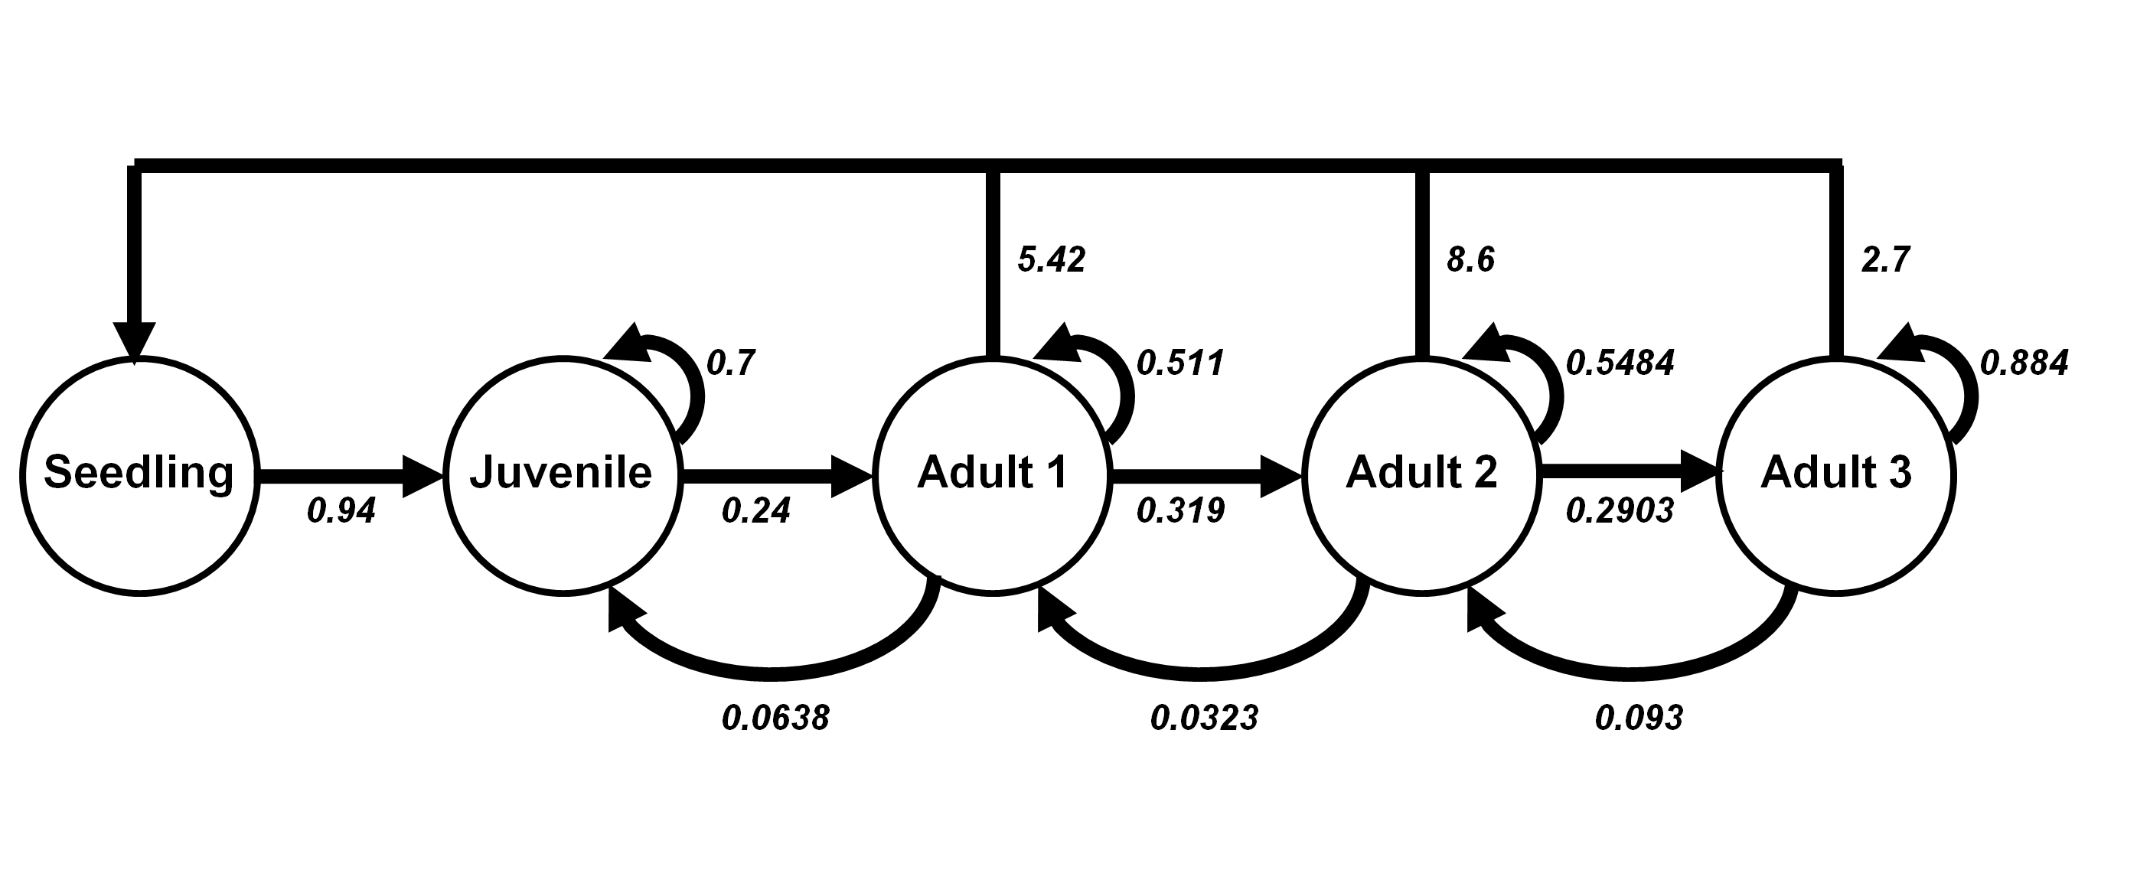

1. Based on the above diagram, write out its transition matrix. [5 pts]
2. Report its long-term finite rate of increase to the fourth decimal place. Would the population be growing or dying? [2.5 pts]
3. Report the steady stage distribution, rounded to the fourth decimal place. [2.5 pts]

***Solution***

1. Transition matrix:
2. The long-term finite rate of increase is 1.674. Since the growth rate is larger than one, the population will grow over time.
3. Steady stage distribution:

|  |  |  |  |  |
| --- | --- | --- | --- | --- |
| **Seedling** | **Juvenile** | **Adult 1** | **Adult 2** | **Adult 3** |
| 0.4418 | 0.4323 | 0.0899 | 0.0263 | 0.0097 |

**R code**

pop_mat <- matrix(data = c(0, 0, 5.42, 8.6, 2.7,

0.94, 0.7, 0.0638, 0, 0,

0, 0.24, 0.511, 0.0323, 0,

0, 0, 0.319, 0.5484, 0.093,

0, 0, 0, 0.2903, 0.884),

nrow = 5, byrow = T

)

Re(round(eigen(pop_mat)$values[1], 4))

round(Re(eigen(pop_mat)$vectors[, 1])/Re(sum(eigen(pop_mat)$vectors[, 1])), 4)

1. The spread of a disease within a population can be described by the classic SIR model, which stands for susceptible (*S*(*t*)), infected (*I*(*t*)), and recovered (*R*(*t*)) individuals within the population. The model assumes a constant arrival of new susceptible individuals (), a transmission process following the mass-action assumption with efficiency , recovery with rate , and decay of immunity with rate . Uninfected individuals have mortality rate  while infected individuals suffer a higher mortality rate . The model can be represented by the following diagram:

1. Based on the model diagram above, write down the set of ordinary differential equations for the system. [10 pts]
2. With initial population size *S*(0) = 100, *I*(0) = 2, and *R*(0) = 0, run the system to equilibrium using the following parameter values:  = 0.1,  = 0.01  = 0.05,  = 0.0,  = 0.01, and  = 0.02. Report the equilibrium population sizes (for all three state variables) rounded to the fourth decimal place. [5 pts]
3. Sketch the dynamics of the three state variables during the first 100 time steps. [5 pts]
4. Under certain parameters, the disease will not spread and the system will end up at the “disease-free equilibrium” with *I\** = *R\** = 0. With your model, derive the analytical form of *S\** at this disease-free equilibrium. [5 pts]
5. By changing only one parameter in (2) at a time, provide two different parameter sets that will cause the system to end up at the disease-free equilibrium. Explain the ecological meaning of your parameter alternation. [5 pts]
6. Consider a new population state, *V*(*t*), representing vaccinated individuals. Assume that the country’s vaccination rate is  = 0.005 (relatively low), write a new set of equations and simulate its long-term dynamics again with the parameters provided in (2). Report the new equilibrium population sizes for all four state variables rounded to the fourth decimal place. [10 pts]

***Solution***

1. System of differential equations:
2. The equilibrium population sizes:

|  |  |  |
| --- | --- | --- |
| **S** | **I** | **R** |
| 7.0000 | 0.4286 | 2.1429 |

**R code**

library(deSolve)

library(tidyverse)

SIR_model <- function(times, state, parms) {

with(as.list(c(state, parms)), {

dS_dt = theta + sigma*R - delta*S - beta*S*I

dI_dt = beta*S*I - gamma*I - rho*I

dR_dt = rho*I - delta*R - sigma*R

return(list(c(dS_dt, dI_dt, dR_dt)))

})

}

times <- seq(0, 10000, by = 1)

state <- c(S = 100, I = 2, R = 0)

parms <- c(theta = 0.1, beta = 0.01, rho = 0.05, sigma = 0, delta = 0.01, gamma = 0.02)

SIR_out <- ode(func = SIR_model, times = times, y = state, parms = parms)

1. The dynamics of S, I, and R during the first 100 time steps:

SIR.tiff

**R code**

times <- seq(0, 100, by = 0.1)

SIR_out_100 <- ode(func = SIR_model, times = times, y = state, parms = parms)

SIR_out_100 %>%

as.data.frame() %>%

pivot_longer(cols = -time, names_to = "state", values_to = "N") %>%

ggplot(aes(x = time, y = N, color = fct_reorder(state, N, last, .desc = T))) +

geom_line(size = 1.5) +

theme_classic(base_size = 12) +

labs(x = "Time", y = "N") +

scale_x_continuous(limits = c(0, 100.5), expand = c(0, 0)) +

scale_y_continuous(limits = c(0, 110), expand = c(0, 0)) +

scale_color_brewer(name = NULL, palette = "Set1")

1. When *I\** = *R\** = 0, the differential equation for *S* becomes:

Solving for the equation, we get the equilibrium *S* =*

1. Scenario 1: setting the mortality of infected individuals σ to 0.5

In this case, the infected individuals suffer from much higher mortality such that a high proportion of infected individuals would die before transmitting the disease to the susceptible individuals. As a result, the disease will not be able to maintain a positive growth rate in the population and thus will eventually disappear.

SIR.tiff

Scenario 2: setting the recovery rate  to 0.2

In this case, a high recovery rate (relative to the transmission rate) will remove the infected individuals in the population faster so that the spread of disease is reduced and eventually ceases.

2.tiff

1. System of differential equations with the vaccinated individuals:

The equilibrium population sizes:

|  |  |  |  |
| --- | --- | --- | --- |
| **S** | **I** | **R** | **V** |
| 6.6667 | 0.0000 | 0.0000 | 3.3333 |

3.tiff

**R code**

library(deSolve)

library(tidyverse)

SIR_model_V <- function(times, state, parms) {

with(as.list(c(state, parms)), {

dS_dt = theta + sigma*R - delta*S - beta*S*I - u*S

dI_dt = beta*S*I - gamma*I - rho*I - u*I

dR_dt = rho*I - delta*R - sigma*R - u*R

dV_dt = u*S + u*I + u*R - delta*V

return(list(c(dS_dt, dI_dt, dR_dt, dV_dt)))

})

}

times <- seq(0, 2000, by = 1)

state <- c(S = 100, I = 2, R = 0, V = 0)

parms <- c(theta = 0.1, beta = 0.01, rho = 0.05,

sigma = 0, delta = 0.01, gamma = 0.02,

u = 0.005)

SIR_out_v <- ode(func = SIR_model_V, times = times, y = state, parms = parms)

SIR_out_v %>%

as.data.frame() %>%

pivot_longer(cols = -time, names_to = "state", values_to = "N") %>%

ggplot(aes(x = time, y = N, color = fct_reorder(state, N, last, .desc = T))) +

geom_line(size = 1.5) +

theme_classic(base_size = 12) +

labs(x = "Time", y = "N") +

scale_x_continuous(limits = c(0, 10000.5), expand = c(0, 0)) +

scale_y_continuous(limits = c(0, 105), expand = c(0, 0)) +

scale_color_brewer(name = NULL, palette = "Set1")

ggsave("3.tiff", width = 6, height = 4, dpi = 600, device = "tiff")