**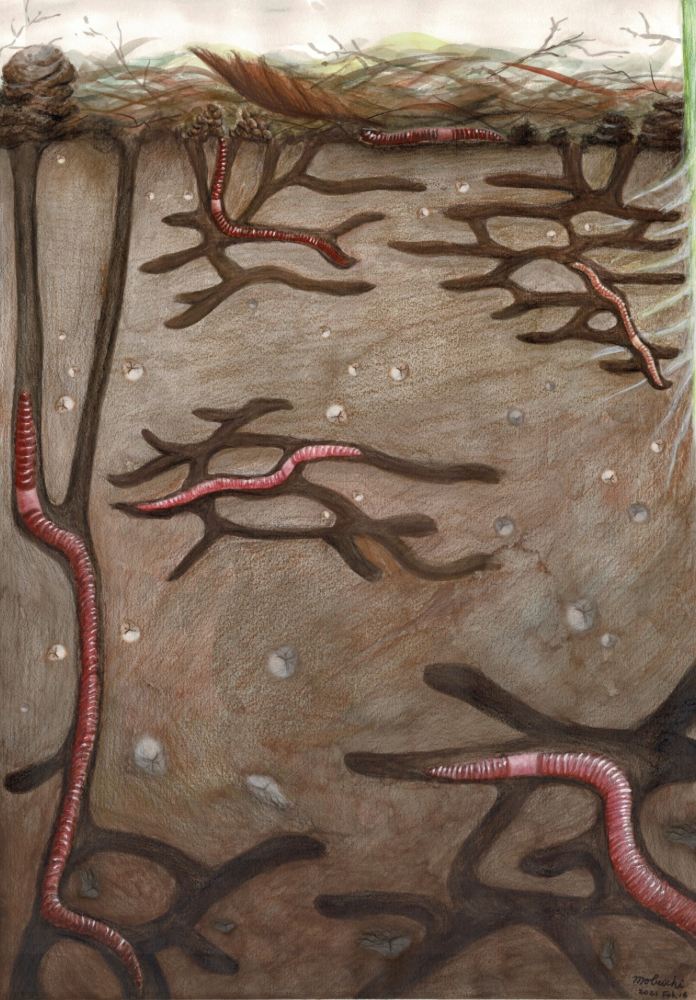**

**Figure 1** (This figure is a work in progress, not the final version.)

SEAb_biplot1.tiff

**Figure 2.** δ13C and δ15N biplot of earthworm species in each study site. Ovals are Bayesian standard ellipse area (SEAB) representing the core isotopic niche of each species. The isotope ratios of earthworm samples were standardized using background soil isotope signatures (see Methods for more details).

SEAb_biplot2.tiff

**Figure 3.** δ13C and δ15N biplot of earthworm species in each study site. Ovals are Bayesian standard ellipse area (SEAB) representing the core isotopic niche of each species. The isotope ratios of earthworm samples were standardized using background soil isotope signatures (see Methods for more details).

Overlap_grey.tiff

**Figure 4.** Percentage of overlapping SEAB between species pairs in the study sites BDTR1, BDTR2, and BARC. The percentage is calculated as the overlapping SEAB between “Species A” and “Species B” divided by the SEAB of “Species A”.

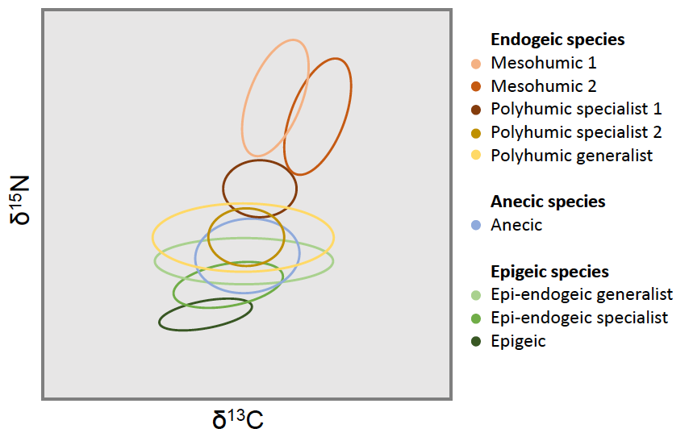

**Figure 5.** A revised concept of earthworm functional groups using the isotopic niches and their sizes based on 13C and 15N signatures. Note that the diagram includes only nine functional groups (as opposed to 10) because the oligohumic endogeic species was not included in our analysis. (This figure is a work in progress, not the final version.)