**Manuscript title**

An experimental framework for determining the degree of intraguild predation in a three-species omnivorous food web in the field

**Author names, institutions, and addresses**

Gen-Chang Hsu1

1Department of Life Science, National Taiwan University, Taipei, Taiwan

1No.1, Sec. 4, Roosevelt Rd., Taipei 10617, Taiwan (R.O.C.)

**Correspondence**

Gen-Chang Hsu

Department of Life Science, National Taiwan University, Taipei, Taiwan.

Email: genchanghsu@gmail.com

ORCID: https://orcid.org/0000-0002-6607-4382

**Acknowledgements**

I would like to thank Jia-Ang (William) Ou for the useful comments and editing work on this manuscript.

**Abstract**

Intraguild predation (IGP) is common in natural and human-managed systems and plays a critical role in food web dynamics. Although previous studies have documented the occurrence of IGP (e.g., through observations and molecular gut content analysis) across a wide range of predator taxa, few have qualitatively examined the degree of IGP. Here, I propose an experimental framework combining controlled feeding trials and stable isotope analysis of field samples to determine the degree of IGP in a three-species omnivorous food web (shared prey + mesopredator + top predator) in the field. The degree of IGP is defined herein as the proportion of mesopredator consumed in the total diet (shared prey + mesopredator) of top predator. The feeding trials are used to construct a standard curve for the degree of IGP in the focal system, and the stable isotope signatures of field samples will then be compared to the standards to estimate the degree of IGP in the field. Such a combined approach provides a useful tool for quantifying IGP in a more accurate (controlled feeding trials and standard IGP curves) and realistic (stable isotope analysis of field samples) fashion. If proven successful, the current framework can be extended to food webs involving more complex interactions (e.g., cannibalism and multiple shared prey) and further complemented with other approaches to capture a more complete picture of IGP dynamics in the field.

*Keywords: intraguild predation, stable isotope analysis, feeding experiment, omnivorous food web*

**Introduction**

Intraguild predation (IGP) is common in natural and human-managed ecosystems (Polis and Holt 1992, Müller and Brodeur 2002, Arim and Marquet 2004) and has been documented across a wide range of animal taxa (Polis et al. 1989). IGP could substantially affect the abundance and distribution of interacting species, which may have profound ecological and evolutionary consequences for food web dynamics (Polis et al. 1989).

Previous studies have used manipulative experiments (e.g., field cages) to assess the intensity of IGP by comparing the differences in the densities of prey or mesopredator in the presence vs. absence of top predator (Denno et al. 2004, Provost et al. 2005). This approach could reveal the mechanisms underlying predator-prey interactions, allowing for strong causal inferences about IGP. However, the confined settings in these experiments could potentially alter the encounter rates between organisms and thus lead to biased results.

Stable isotopes, particularly nitrogen isotope ratios (δ15N), have been used to estimate the trophic level of predators in the field and to make inferences about IGP (Halaj et al. 2005, Wise et al. 2006, Sanders and Platner 2007). It is suggested that IGP would increase the δ15N of predators (Ponsard and Arditi 2000), yet few studies have experimentally verified this proposal. Rickers et al. (2006) conducted feeding experiments on wolf spiders (*Alopecosa cuneata*) and revealed a higher δ15N of these top predators under IGP. However, the study did not quantify the degree of IGP as the IGP treatment was binary (absence vs. presence of mesopredator) with constant numbers of shared prey and mesopredator. Moreover, the trophic levels of top predators in previous studies were often calculated based on assumed trophic discrimination factors (TDFs) (e.g., Klarner et al. 2013, Svanbäck et al. 2015). Since TDFs are quite taxon-specific (Caut et al. 2009), these trophic level estimates could lead to incorrect inferences about IGP in the field.

Recently, researchers have applied molecular gut content analysis (MGCA) and immunological techniques to reliably detect the presence of certain food items in predators’ diet (Hagler 2006, Gagnon et al. 2011, Mansfield and Hagler 2016). These advances in technology have allowed researchers to compute the incidence rate of IGP (i.e., the percentage of top predator individuals with mesopredator detected in the gut contents). Nonetheless, the incidence rate may not necessarily reflect the degree of IGP in the system (Raso et al. 2014). For example, it is possible that a high percentage of top predator individuals feed on mesopredator yet each top predator individual consumes on average low proportion of mesopredator in the diet. In this case, a high incidence rate of IGP could be misleading and may result in false inference about the overall IGP dynamics in the field.

So far, there is still a lack of qualitative understanding regarding the intensity/degree of IGP in the field. To address this gap, I propose an experimental framework combining controlled feeding trials and stable isotope analysis of field samples to determine the degree of IGP in a three-species omnivorous food web (top predator + mesopredator + shared prey). The degree of IGP is defined herein as the proportion of mesopredator consumed in the total diet (mesopredator + shared prey) of top predator. The feeding trials will experimentally link different levels of mesopredator consumption by top predator individuals to the changes in their stable isotope values (δ15N) via a standard curve, to which the isotope signatures of field samples are compared to estimate the degree of IGP in the field.

**Experimental framework**

Here, I will illustrate the proposed framework using an example of a three-species omnivorous arthropod food web, in which a top predator and a mesopredator both feed on a shared prey, while the top predator also feeds on the mesopredator (Fig. 1a). Two sets of controlled feeding trials will be conducted. In the first feeding trial, the top predator and the mesopredator will be fed the shared prey for an appropriate period of time to allow for the incorporation of isotopes into the tissues (Fig. 1b). The purpose of the first trial is to ensure that both predators have reached an isotopic equilibrium state with the shared prey. In the second feeding trial (with the same duration as the first trial), the top predator will be fed mixed diets with different proportions of shared prey and mesopredator individuals from the first trial: (1) shared prey only, (2) 75% of shared prey + 25% of mesopredator, (3) 50% of shared prey + 50% of mesopredator, (4) 25% of shared prey + 75% of mesopredator, and (5) mesopredator only (Fig. 1c). The numbers of shared prey and mesopredator in the presented diet can be determined based on their field densities. The purpose of the second trial is to simulate a full range of potential encounter rates that the focal organisms might experience in the field.

At the end of the second feeding trial, the actual numbers of shared prey and mesopredator consumed by the top predator in each diet treatment are recorded, and the difference in nitrogen isotope signatures between the top predator individuals and the shared prey (baseline) are analyzed (δ15N*predator*─ δ15N*prey*; Δ15N). A standard curve can be constructed by plotting the Δ15N of top predator against the proportion of mesopredator consumed (Fig. 1d). Finally, field samples of shared prey and top predator individuals are collected, with their δ15N analyzed to obtain the empirical Δ15N. The degree of IGP in the field can then be determined by interpolating the field-derived Δ15N to the standard curve (Fig. 1e). A hypothetical example of data collection in the second feeding trial for standard curve construction is provided in Fig. 2.

**Applications**

The proposed experimental framework combines the strengths of previous approaches to studying IGP—the controlled feeding trials along with stable isotope analysis can yield accurate Δ15N to construct a standard curve, whereas the stable isotope analysis of field samples allows for trophic interactions under natural settings. Together, this framework provides a useful tool for determining the degree of IGP in the field in a more quantitative and realistic fashion.

Agricultural and aquatic ecosystems, in which IGP has been frequently documented (Polis et al. 1989, Rosenheim et al. 1995), are ideal for testing the proposed framework. The food web structures in these systems are relatively simple compared with other ecosystems. Therefore, the potential confounding effects of other species on the trophic interactions among focal organisms can be minimized (Vance-Chalcraft et al. 2007). The framework is useful for quantifying the effects of various abiotic and biotic factors on IGP under field settings. For instance, we can implement the framework along a gradient of habitat complexity to qualitatively examine how different levels of habitat complexity might affect the degree of IGP in the field. Moreover, the framework is robust to variations in background isotope signatures because the degree of IGP is determined based on the isotope difference between the focal organisms (Δ15N) rather than the original values (δ15N), thus allowing for comparisons across sites or systems with distinct background isotope signatures.

A better quantitative understanding of IGP can provide insights into the complex predator-predator-prey trophic interactions and may help predict the community structure and stability (Arim and Marquet 2004, Nakazawa and Yamamura 2006, Pahl et al. 2020). Furthermore, such an understanding can have useful implications for agricultural management, for example, evaluation of the effectiveness of biocontrol agents in pest control programs (Müller and Brodeur 2002). If proven successful, the current framework can be further extended to food webs involving more complex interactions (e.g., cannibalism and multiple shared prey) and complemented with other approaches (e.g., MGCA) to elucidate the IGP dynamics in the field.

**Acknowledgements**

I would like to thank Jia-Ang (William) Ou for the useful comments and editing work on this manuscript.

**Conflict of interest**

The author declares no potential conflict of interest.

Reference

Arim, M., and P. A. Marquet. 2004. Intraguild predation: a widespread interaction related to species biology. Ecology Letters **7**:557-564.

Caut, S., E. Angulo, and F. Courchamp. 2009. Variation in discrimination factors (Δ15N and Δ13C): the effect of diet isotopic values and applications for diet reconstruction. Journal of Applied Ecology **46**:443-453.

Denno, R. F., M. S. Mitter, G. A. Langellotto, C. Gratton, and D. L. Finke. 2004. Interactions between a hunting spider and a web‐builder: consequences of intraguild predation and cannibalism for prey suppression. Ecological entomology **29**:566-577.

Gagnon, A.-È., G. E. Heimpel, and J. Brodeur. 2011. The ubiquity of intraguild predation among predatory arthropods. PLoS One **6**:e28061.

Hagler, J. 2006. Development of an immunological technique for identifying multiple predator–prey interactions in a complex arthropod assemblage. Annals of Applied Biology **149**:153-165.

Halaj, J., R. W. Peck, and C. G. Niwa. 2005. Trophic structure of a macroarthropod litter food web in managed coniferous forest stands: a stable isotope analysis with δ15N and δ13C. Pedobiologia **49**:109-118.

Klarner, B., M. Maraun, and S. Scheu. 2013. Trophic diversity and niche partitioning in a species rich predator guild–Natural variations in stable isotope ratios (13C/12C, 15N/14N) of mesostigmatid mites (Acari, Mesostigmata) from Central European beech forests. Soil Biology and Biochemistry **57**:327-333.

Mansfield, S., and J. R. Hagler. 2016. Wanted dead or alive: scavenging versus predation by three insect predators. Food Webs **9**:12-17.

Müller, C. B., and J. Brodeur. 2002. Intraguild predation in biological control and conservation biology. Biological Control **25**:216-223.

Nakazawa, T., and N. Yamamura. 2006. Community structure and stability analysis for intraguild interactions among host, parasitoid, and predator. Population Ecology **48**:139-149.

Pahl, K. B., D. J. Yurkowski, K. J. Lees, and N. E. Hussey. 2020. Measuring the occurrence and strength of intraguild predation in modern food webs. Food Webs:e00165.

Polis, G. A., and R. D. Holt. 1992. Intraguild predation: the dynamics of complex trophic interactions. Trends in ecology & evolution **7**:151-154.

Polis, G. A., C. A. Myers, and R. D. Holt. 1989. The ecology and evolution of intraguild predation: potential competitors that eat each other. Annual review of ecology and systematics **20**:297-330.

Ponsard, S., and R. Arditi. 2000. What can stable isotopes (δ15N and δ13C) tell about the food web of soil macro‐invertebrates? Ecology **81**:852-864.

Provost, C., D. Coderre, E. Lucas, G. Chouinard, and N. J. Bostanian. 2005. Impact of intraguild predation and lambda‐cyhalothrin on predation efficacy of three acarophagous predators. Pest Management Science: formerly Pesticide Science **61**:532-538.

Raso, L., D. Sint, R. Mayer, S. Plangg, T. Recheis, S. Brunner, R. Kaufmann, and M. Traugott. 2014. Intraguild predation in pioneer predator communities of alpine glacier forelands. Molecular Ecology **23**:3744-3754.

Rickers, S., R. Langel, and S. Scheu. 2006. Stable isotope analyses document intraguild predation in wolf spiders (Araneae: Lycosidae) and underline beneficial effects of alternative prey and microhabitat structure on intraguild prey survival. Oikos **114**:471-478.

Rosenheim, J. A., H. K. Kaya, L. E. Ehler, J. J. Marois, and B. A. Jaffee. 1995. Intraguild predation among biological-control agents: theory and evidence. Biological Control **5**:303-335.

Sanders, D., and C. Platner. 2007. Intraguild interactions between spiders and ants and top-down control in a grassland food web. Oecologia **150**:611.

Svanbäck, R., M. Quevedo, J. Olsson, and P. Eklöv. 2015. Individuals in food webs: the relationships between trophic position, omnivory and among-individual diet variation. Oecologia **178**:103-114.

Vance-Chalcraft, H. D., J. A. Rosenheim, J. R. Vonesh, C. W. Osenberg, and A. Sih. 2007. The influence of intraguild predation on prey suppression and prey release: a meta‐analysis. Ecology **88**:2689-2696.

Wise, D. H., D. M. Moldenhauer, and J. Halaj. 2006. Using stable isotopes to reveal shifts in prey consumption by generalist predators. Ecological Applications **16**:865-876.

**Figure legends**

**Figure 1.** A schematic diagram of the proposed experimental framework for determining the degree of intraguild predation in a three-species omnivorous food web, in which a top predator and a mesopredator both feed on a shared prey, while the top predator also feeds on the mesopredator (a). In the first feeding trial (b), the top predator and the mesopredator are fed the shared prey for an appropriate period of time to ensure that both predators have reached an isotopic equilibrium state with the shared prey. In the second feeding trial (c), the top predator is fed mixed diets with different proportions of shared prey and mesopredator individuals to simulate a full range of potential encounter rates that the focal organisms might experience in the field. (d) A standard curve can be constructed by plotting the difference in nitrogen isotope signatures between the top predator individuals and the shared prey (baseline) (δ15N*predator*─ δ15N*prey*; Δ15N) against the proportion of mesopredator consumed. (Note that the curve may not necessarily be linear due to the differences in the biomass of shared prey and mesopredator individuals.) (e) The δ15N of field-sampled shared prey and top predator individuals are analyzed to obtain the empirical Δ15N, which is then interpolated to the standard curve to determine the degree of IGP in the field.

**Figure 2.** A hypothetical example of data collection in the second feeding trial for standard curve construction. Each diet treatment consists of five replicates (i.e., five different top predator individuals). *N*: number of prey supplied in the mixed diet (shared prey/mesopredator); *C*: number of prey consumed by the top predator (shared prey/mesopredator); *P*: proportion of mesopredator consumed (%). Each point in the standard curve represents a top predator individual.

**Figure 1**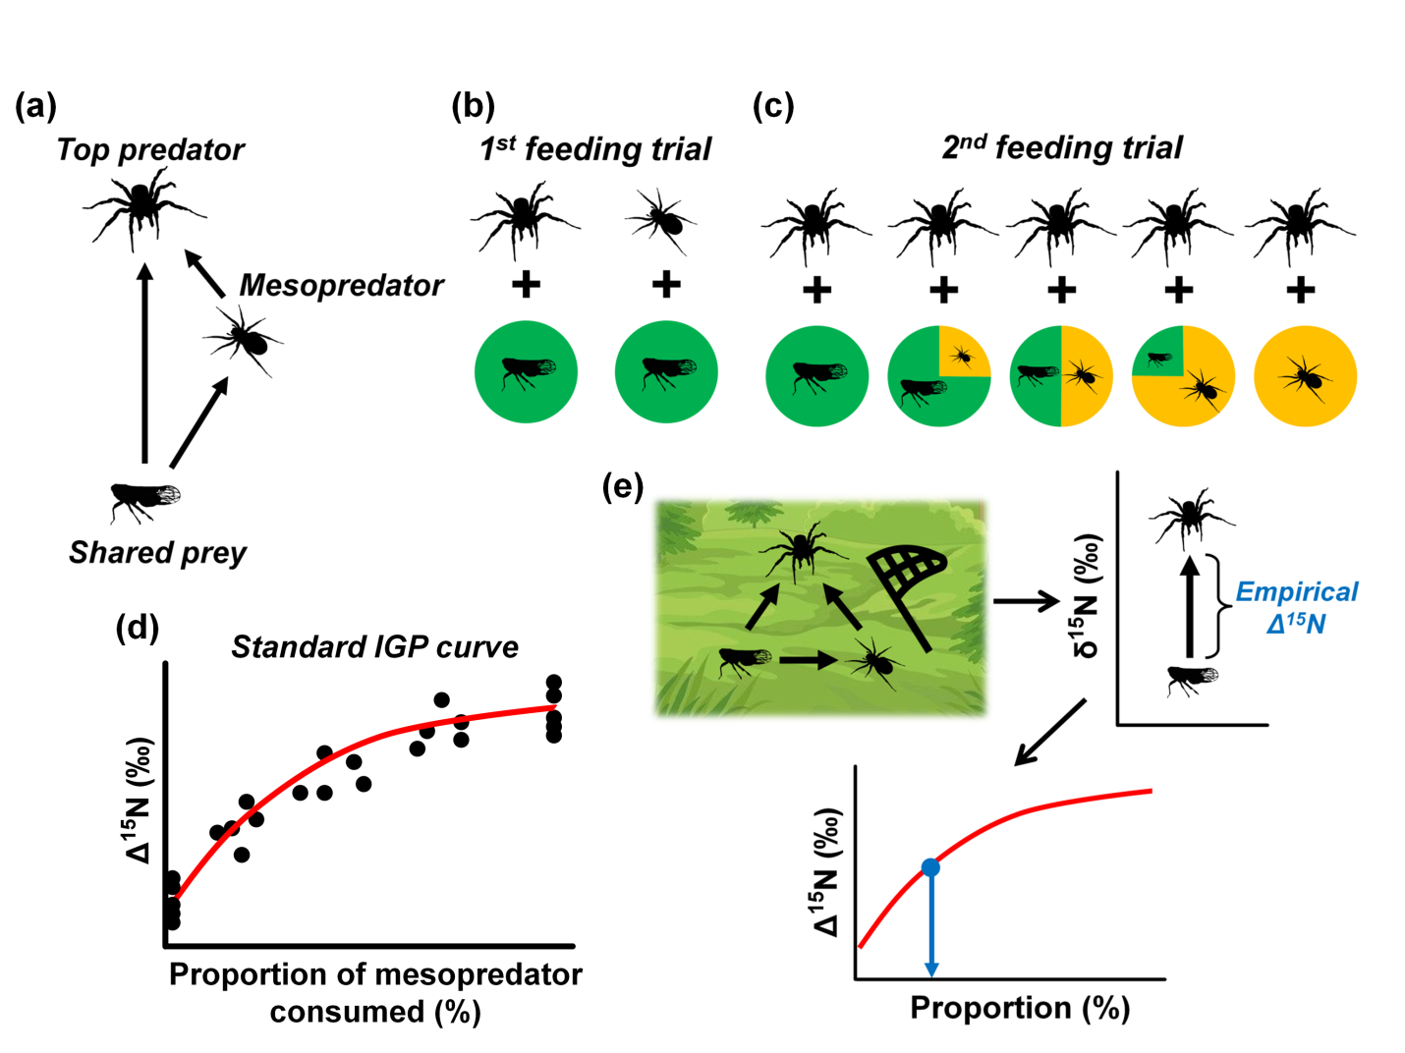

**Figure 2**