**Figure**

Figure 1.

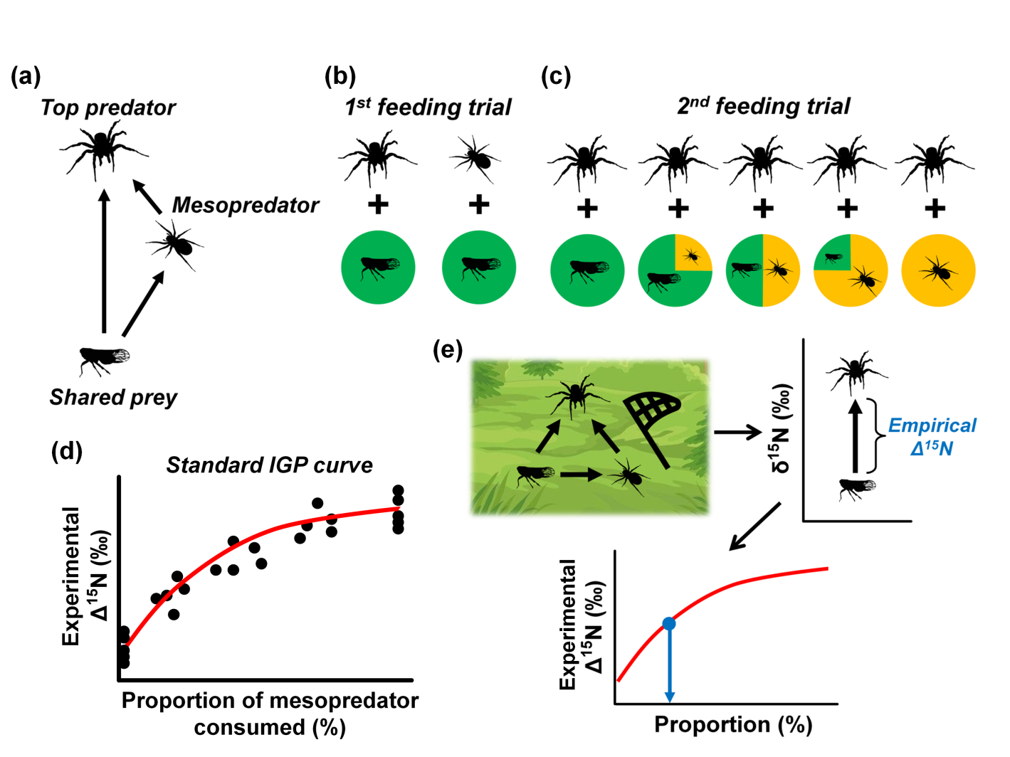

Figure 2.

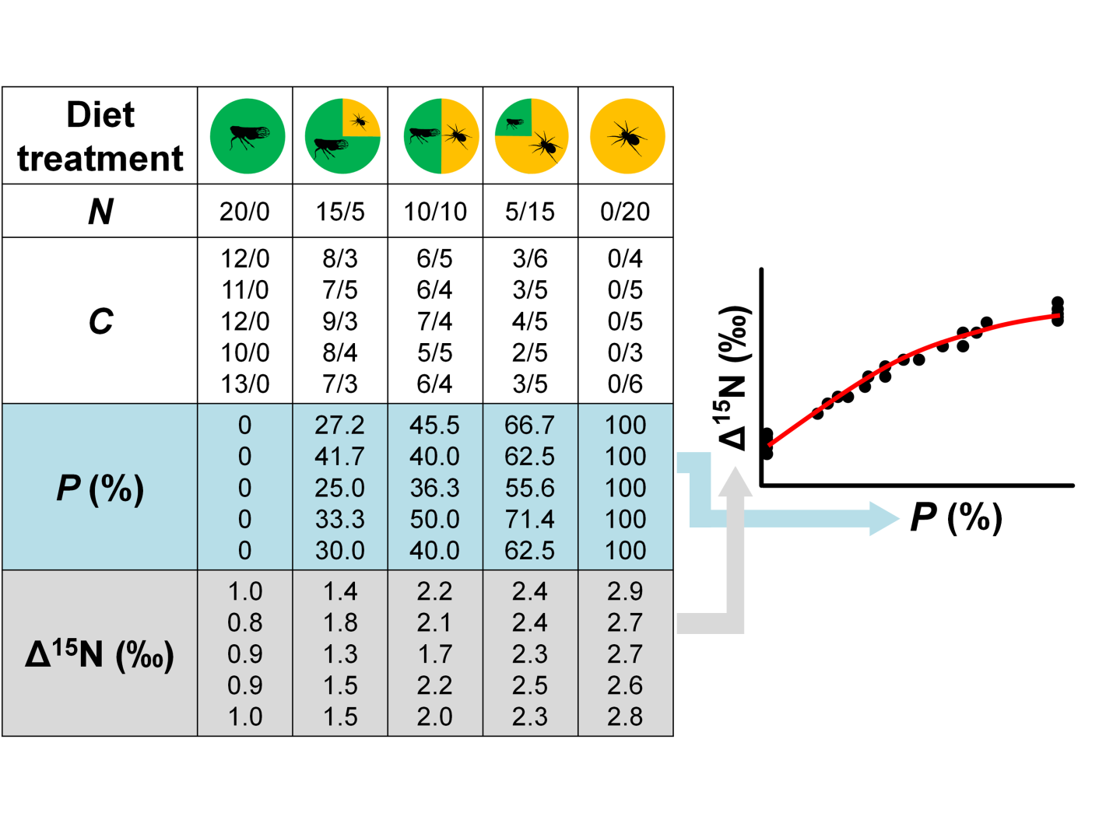

**Figure captions**

Figure 1.A schematic diagram of the proposed experimental framework for determining the degree of intraguild predation in a three-species omnivorous food web, in which a top predator and a mesopredator both feed on a shared prey, while the top predator also feeds on the mesopredator (a). In the first feeding trial (b), the top predator and the mesopredator are fed the shared prey for an appropriate period of time to ensure that both predators have reached an isotopic equilibrium state with the shared prey. In the second feeding trial (c), the top predators are fed mixed diets with different proportions of shared prey and mesopredator individuals to simulate a full range of potential encounter rates that the focal organisms might experience in the field. (d) A standard curve can be constructed by plotting the difference in nitrogen isotope signatures between the top predator individuals and the shared prey (baseline) (δ15N*predator*─ δ15N*prey*; experimental Δ15N) against the proportion of mesopredator consumed. (Note that the curve may not necessarily be linear due to the differences in the biomass of shared prey and mesopredator individuals.) (e) The δ15N of field-sampled shared prey and top predator individuals are analyzed to obtain the empirical Δ15N, which is then interpolated to the standard curve to estimate the degree of IGP in the field.

Figure 2. A hypothetical example of data collection in the second feeding trial for standard curve construction. Each diet treatment consists of five replicates (i.e., five different top predator individuals). *N*: number of shared prey/mesopredator supplied in the mixed diet; *C*: number of shared prey/mesopredator consumed by the top predators; *P*: proportion of mesopredator consumed (%). Each point in the standard curve represents a top predator individual.