**Title**

An experimental framework for determining the degree of intraguild predation in a three-species omnivorous food web in the field

**Author names and affiliations**

Gen-Chang Hsua

aDepartment of Life Science, National Taiwan University, Taipei, Taiwan

aNo.1, Sec. 4, Roosevelt Rd., Taipei 10617, Taiwan (R.O.C.)

**Corresponding author**

Gen-Chang Hsu

Department of Life Science, National Taiwan University, Taipei, Taiwan.

Email: genchanghsu@gmail.com

ORCID: https://orcid.org/0000-0002-6607-4382

**Present address**

Department of Life Science, National Taiwan University, Taipei, Taiwan

No.1, Sec. 4, Roosevelt Rd., Taipei 10617, Taiwan (R.O.C.)

**Abstract**

Intraguild predation (IGP) is common in natural and human-managed systems and plays a critical role in food web dynamics. Previous studies have documented the occurrence of IGP across a wide range of predator taxa, yet there is still a lack of quantitative understanding regarding the degree/intensity of IGP in these systems. Here, I propose an experimental framework combining controlled feeding trials and stable isotope analysis to determine the degree of IGP in a three-species omnivorous food web (shared prey + mesopredator + top predator) in the field. The degree of IGP is defined herein as the proportion (in number) of mesopredator consumed in the total diet (shared prey + mesopredator) of top predator. The feeding trials are used to construct a standard curve for the degree of IGP in the focal system, to which the stable isotope signatures of field samples are compared to estimate the degree of IGP in the field. The proposed framework leverages the strengths of different experimental approaches to studying trophic interactions, providing a useful tool for quantifying IGP in a more accurate (controlled feeding trials and standard IGP curve) and realistic (stable isotope analysis of field samples) fashion. If proven successful, the current framework can be extended to food webs involving more complex interactions (e.g., cannibalism and multiple shared prey) and further complemented with other approaches (e.g., molecular gut content analysis) to capture a more complete picture of IGP dynamics in the field.

**Keywords**

food webs, intraguild predation, omnivory, stable isotope analysis, trophic interactions

**Introduction**

Intraguild predation (IGP) is common in natural and human-managed ecosystems (Polis and Holt 1992; Müller and Brodeur 2002; Arim and Marquet 2004) and has been documented across a wide range of animal taxa (Polis et al. 1989; Fonseca et al. 2017). IGP could substantially affect the abundance and distribution of interacting species, which may have profound ecological and evolutionary consequences for food web dynamics (Polis et al. 1989).

Previous studies have used manipulative experiments (e.g., field cages) to assess the intensity of IGP by comparing the differences in the densities of prey or mesopredator in the presence vs. absence of top predator (Denno et al. 2004; Provost et al. 2005). This approach could reveal the mechanisms underlying predator-prey interactions, allowing for strong causal inferences about IGP. However, the confined settings in these experiments could potentially alter the encounter rates between organisms and thus lead to biased results.

Stable isotopes, particularly nitrogen isotope signatures (δ15N), have been used to estimate the trophic level of predators in the field for inferences about IGP (Halaj et al. 2005; Wise et al. 2006; Sanders and Platner 2007). It is suggested that IGP would increase the δ15N of predators (Ponsard and Arditi 2000). Rickers et al. (2006) conducted feeding experiments on wolf spiders (*Alopecosa cuneata*) and revealed a higher δ15N of these top predators in IGP treatment. However, the study did not quantify the degree of IGP as the IGP treatment was binary (absence vs. presence of mesopredator) with constant numbers of shared prey and mesopredator. Moreover, the trophic levels of top predators in previous studies were often calculated based on assumed trophic discrimination factors (TDFs) (e.g., Klarner et al. 2013; Svanbäck et al. 2015). Since TDFs are quite taxon-specific (Caut et al. 2009), these trophic level estimates could lead to incorrect inferences about IGP in the field.

Recently, researchers have applied molecular gut content analysis (MGCA) and immunological techniques to reliably detect the presence of certain food items in predators’ diet (Hagler 2006; Gagnon et al. 2011; Mansfield and Hagler 2016). These advances in technology have allowed researchers to compute the incidence rate of IGP (i.e., the percentage of top predator individuals with mesopredator detected in the gut contents). Nonetheless, the incidence rate may not necessarily reflect the degree of IGP in the system (Raso et al. 2014). For example, it is possible that a high percentage of top predator individuals feed on mesopredator yet each top predator individual consumes on average low proportion of mesopredator in the diet. In this case, a high incidence rate of IGP could be misleading and may fail to capture the overall IGP dynamics in the field.

So far, there is still a lack of quantitative information regarding the intensity/degree of IGP in the field, and such information is the first step towards a deeper understanding of food web dynamics. To address this gap, I propose an experimental framework combining controlled feeding trials and stable isotope analysis of field samples to determine the degree of IGP in a three-species omnivorous food web (top predator + mesopredator + shared prey) in the systems of interest. The degree of IGP is defined herein as the proportion (in number) of mesopredator consumed in the total diet (mesopredator + shared prey) of top predator. The feeding trials will experimentally link different levels of mesopredator consumption by top predators to the changes in their nitrogen isotope signatures (δ15N) via a standard curve, to which the isotope signatures of field samples are compared to estimate the degree of IGP in the field.

**Material and methods**

Here, I illustrate the proposed framework using an example of a three-species omnivorous arthropod food web, in which a top predator and a mesopredator both feed on a shared prey, while the top predator also feeds on the mesopredator (Fig. 1a). Two sets of controlled feeding trials will be conducted. In the first feeding trial, the top predator and the mesopredator are fed the shared prey for an appropriate period of time to allow for the incorporation of isotopes into the tissues (Fig. 1b). The purpose of the first trial is to ensure that both predators have reached an isotopic equilibrium state with the shared prey. In the second feeding trial (with the same duration as the first trial), the top predator are fed mixed diets with different proportions of shared prey and mesopredator individuals from the first trial: (1) shared prey only, (2) 75% of shared prey + 25% of mesopredator, (3) 50% of shared prey + 50% of mesopredator, (4) 25% of shared prey + 75% of mesopredator, and (5) mesopredator only (Fig. 1c). The numbers of shared prey and mesopredator in the presented diet can be determined based on their field densities. The purpose of the second trial is to simulate a full range of potential encounter rates that the focal organisms might experience in the field.

At the end of the second feeding trial, the actual numbers of shared prey and mesopredator consumed by the top predator in each diet treatment are recorded, and the difference in nitrogen isotope signatures between the top predator individuals and the shared prey (baseline) are analyzed (δ15N*predator*─ δ15N*prey*; Δ15N). A standard curve can be constructed by plotting the experimental Δ15N of top predator against the proportion of mesopredator consumed (Fig. 1d). Finally, field samples of shared prey and top predator individuals are collected, with their δ15N analyzed to obtain the empirical Δ15N. The degree of IGP in the field can thus be estimated by interpolating the empirical Δ15N to the standard curve (Fig. 1e). A hypothetical example of data collection in the second feeding trial for standard curve construction is provided in Fig. 2.

**Results and discussion**

The proposed experimental framework leverages the strengths of previous approaches to studying IGP—the controlled feeding trials combined with stable isotope analysis can yield accurate experimental Δ15N to construct a standard curve, whereas the empirical Δ15N derived from stable isotope analysis of field samples reflects the trophic interactions under natural settings. Together, this framework provides a useful tool for determining the degree of IGP in the field in a more quantitative and realistic fashion.

Agricultural and aquatic ecosystems, in which IGP has been frequently documented (Polis et al. 1989; Rosenheim et al. 1995), are ideal for testing the proposed framework. The food web structures in these systems are relatively simple compared with other ecosystems. Therefore, the potential confounding effects of non-focal species on the trophic interactions among focal organisms can be minimized (Vance-Chalcraft et al. 2007). Moreover, this framework is useful for quantifying the effects of various abiotic and biotic factors on IGP under field settings. For instance, the framework can be implemented along a gradient of habitat complexity to examine how different levels of habitat complexity might affect the degree of IGP in the field. Finally, the framework is robust to variations in background isotope signatures because the degree of IGP is determined based on the difference between nitrogen isotope signatures of the focal organisms (Δ15N) rather than their original values (δ15N), thus allowing for comparisons across sites or systems with distinct background isotope signatures.

A better quantitative understanding of IGP can provide critical insights into the complex predator-predator-prey trophic interactions and could help predict the community structure and stability (Arim and Marquet 2004; Nakazawa and Yamamura 2006; Pahl et al. 2020). Furthermore, such an understanding can have useful implications for practical issues, for example, evaluation of the effectiveness of biocontrol agents in pest control programs (Müller and Brodeur 2002). If proven successful, the current framework can be further extended to food webs involving more complex interactions (e.g., cannibalism and multiple shared prey) and complemented with other approaches (e.g., MGCA) to elucidate the IGP dynamics in the field.

**Acknowledgements**

I would like to thank Jia-Ang (William) Ou for the useful comments and editing work on this manuscript.

**Funding sources**

This research did not receive any specific grant from funding agencies in the public, commercial, or not-for-profit sectors.

**Declarations of interest**

None

Reference

Arim M, Marquet PA (2004) Intraguild predation: a widespread interaction related to species biology. Ecol. Lett. 7:557-564 doi: <https://doi.org/10.1111/j.1461-0248.2004.00613.x>

Caut S, Angulo E, Courchamp F (2009) Variation in discrimination factors (Δ15N and Δ13C): the effect of diet isotopic values and applications for diet reconstruction. J. Appl. Ecol. 46:443-453

Denno RF, Mitter MS, Langellotto GA, Gratton C, Finke DL (2004) Interactions between a hunting spider and a web‐builder: consequences of intraguild predation and cannibalism for prey suppression. Ecol. Entomol. 29:566-577 doi: <https://doi.org/10.1111/j.0307-6946.2004.00628.x>

Fonseca MM, Montserrat M, Guzmán C, Torres-Campos I, Pallini A, Janssen A (2017) How to evaluate the potential occurrence of intraguild predation. Exp. Appl. Acarol. 72:103-114 doi: <https://doi.org/10.1007/s10493-017-0142-x>

Gagnon A-È, Heimpel GE, Brodeur J (2011) The ubiquity of intraguild predation among predatory arthropods. PLoS One 6:e28061

Hagler J (2006) Development of an immunological technique for identifying multiple predator–prey interactions in a complex arthropod assemblage. Ann. Appl. Biol. 149:153-165 doi: <https://doi.org/10.1111/j.1744-7348.2006.00076.x>

Halaj J, Peck RW, Niwa CG (2005) Trophic structure of a macroarthropod litter food web in managed coniferous forest stands: a stable isotope analysis with δ15N and δ13C. Pedobiologia 49:109-118 doi: <https://doi.org/10.1016/j.pedobi.2004.09.002>

Klarner B, Maraun M, Scheu S (2013) Trophic diversity and niche partitioning in a species rich predator guild–Natural variations in stable isotope ratios (13C/12C, 15N/14N) of mesostigmatid mites (Acari, Mesostigmata) from Central European beech forests. Soil Biol. Biochem. 57:327-333 doi: <https://doi.org/10.1016/j.soilbio.2012.08.013>

Mansfield S, Hagler JR (2016) Wanted dead or alive: scavenging versus predation by three insect predators. Food Webs 9:12-17 doi: <https://doi.org/10.1016/j.fooweb.2016.03.003>

Müller CB, Brodeur J (2002) Intraguild predation in biological control and conservation biology. Biological Control 25:216-223

Nakazawa T, Yamamura N (2006) Community structure and stability analysis for intraguild interactions among host, parasitoid, and predator. Popul. Ecol. 48:139-149 doi: <https://doi.org/10.1007/s10144-005-0249-5>

Pahl KB, Yurkowski DJ, Lees KJ, Hussey NE (2020) Measuring the occurrence and strength of intraguild predation in modern food webs. Food Webs:e00165 doi: <https://doi.org/10.1016/j.fooweb.2020.e00165>

Polis GA, Holt RD (1992) Intraguild predation: the dynamics of complex trophic interactions. Trends Ecol. Evol. 7:151-154 doi: <https://doi.org/10.1016/0169-5347(92)90208-S>

Polis GA, Myers CA, Holt RD (1989) The ecology and evolution of intraguild predation: potential competitors that eat each other. Annu. Rev. Ecol. Syst. 20:297-330 doi: <https://doi.org/10.1146/annurev.es.20.110189.001501>

Ponsard S, Arditi R (2000) What can stable isotopes (δ15N and δ13C) tell about the food web of soil macro‐invertebrates? Ecology 81:852-864 doi: [https://doi.org/10.1890/0012-9658(2000)081[0852:WCSINA]2.0.CO;2](https://doi.org/10.1890/0012-9658(2000)081%5b0852:WCSINA%5d2.0.CO;2)

Provost C, Coderre D, Lucas E, Chouinard G, Bostanian NJ (2005) Impact of intraguild predation and lambda‐cyhalothrin on predation efficacy of three acarophagous predators. Pest Management Science: formerly Pesticide Science 61:532-538 doi: <https://doi.org/10.1002/ps.1027>

Raso L et al. (2014) Intraguild predation in pioneer predator communities of alpine glacier forelands. Mol. Ecol. 23:3744-3754 doi: <https://doi.org/10.1111/mec.12649>

Rickers S, Langel R, Scheu S (2006) Stable isotope analyses document intraguild predation in wolf spiders (Araneae: Lycosidae) and underline beneficial effects of alternative prey and microhabitat structure on intraguild prey survival. Oikos 114:471-478 doi: <https://doi.org/10.1111/j.2006.0030-1299.14421.x>

Rosenheim JA, Kaya HK, Ehler LE, Marois JJ, Jaffee BA (1995) Intraguild predation among biological-control agents: theory and evidence. Biol. Control 5:303-335 doi: <https://doi.org/10.1006/bcon.1995.1038>

Sanders D, Platner C (2007) Intraguild interactions between spiders and ants and top-down control in a grassland food web. Oecologia 150:611 doi: <https://doi.org/10.1007/s00442-006-0538-5>

Svanbäck R, Quevedo M, Olsson J, Eklöv P (2015) Individuals in food webs: the relationships between trophic position, omnivory and among-individual diet variation. Oecologia 178:103-114 doi: <https://doi.org/10.1007/s00442-014-3203-4>

Vance-Chalcraft HD, Rosenheim JA, Vonesh JR, Osenberg CW, Sih A (2007) The influence of intraguild predation on prey suppression and prey release: a meta‐analysis. Ecology 88:2689-2696

Wise DH, Moldenhauer DM, Halaj J (2006) Using stable isotopes to reveal shifts in prey consumption by generalist predators. Ecol. Appl. 16:865-876 doi: [https://doi.org/10.1890/1051-0761(2006)016[0865:USITRS]2.0.CO;2](https://doi.org/10.1890/1051-0761(2006)016%5b0865:USITRS%5d2.0.CO;2)

**Figure**

Figure 1.

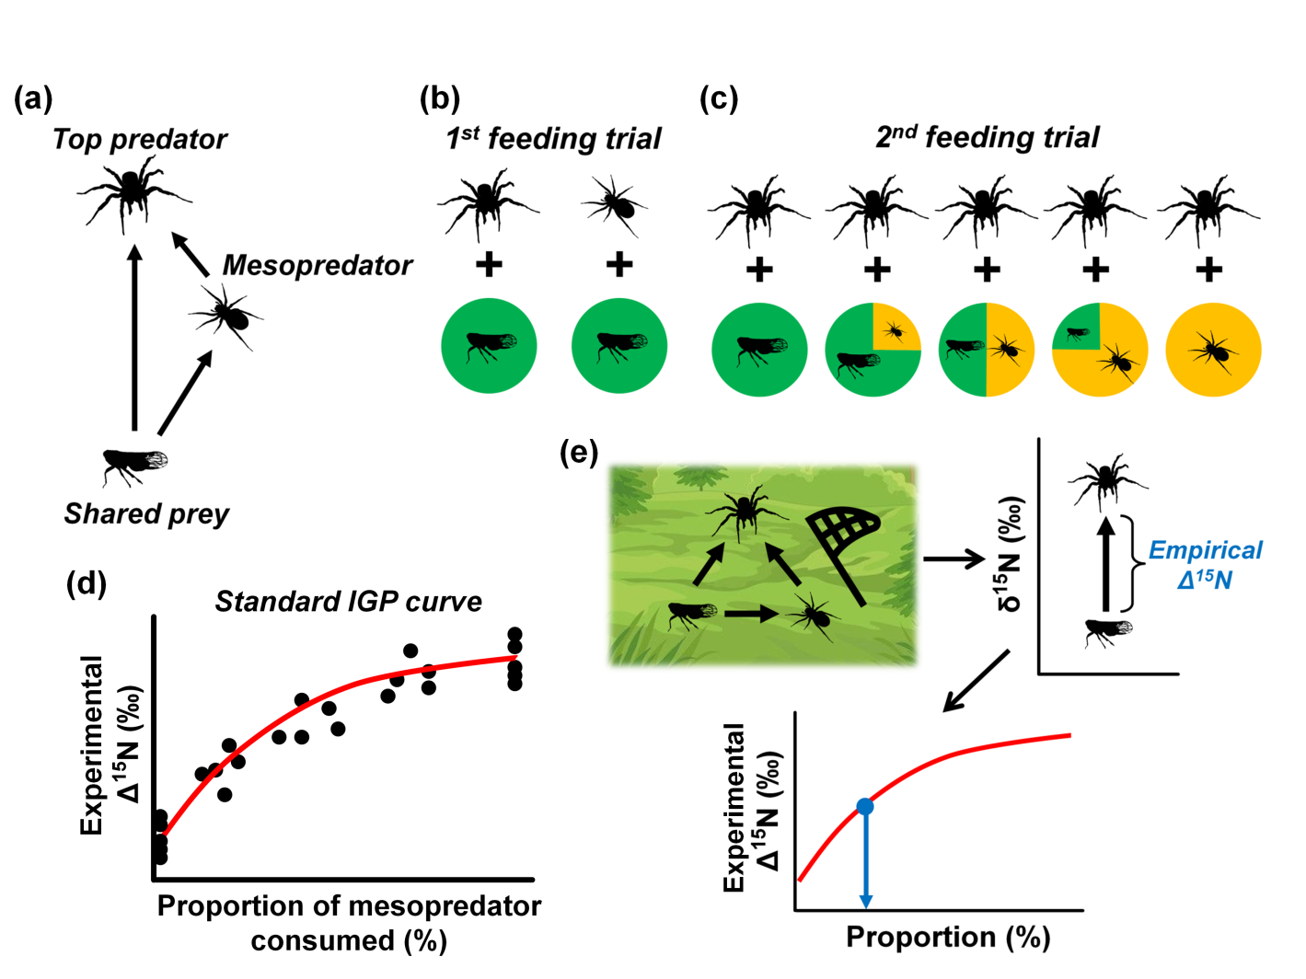

Figure 2.

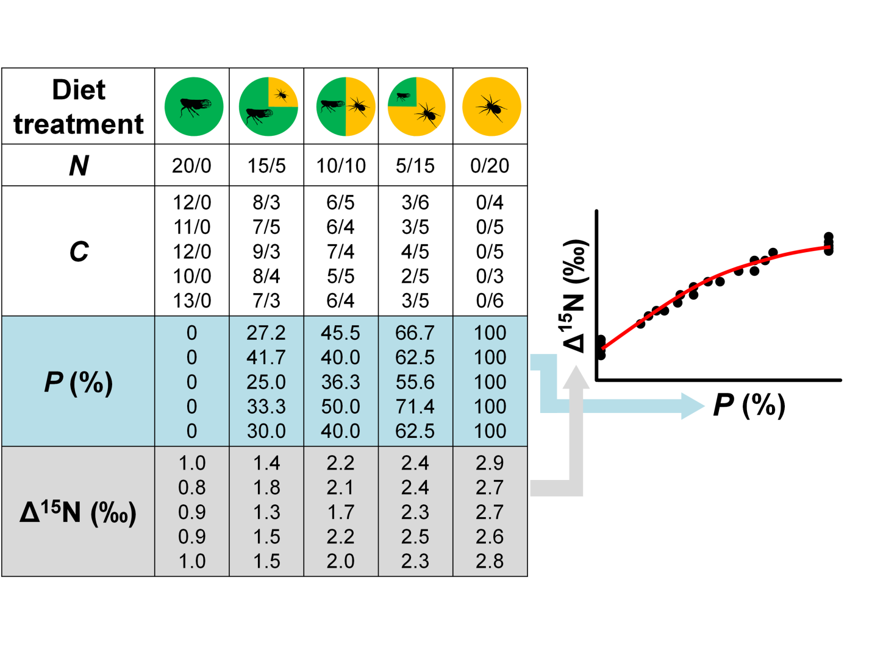

**Figure captions**

Figure 1.A schematic diagram of the proposed experimental framework for determining the degree of intraguild predation in a three-species omnivorous food web, in which a top predator and a mesopredator both feed on a shared prey, while the top predator also feeds on the mesopredator (a). In the first feeding trial (b), the top predator and the mesopredator are fed the shared prey for an appropriate period of time to ensure that both predators have reached an isotopic equilibrium state with the shared prey. In the second feeding trial (c), the top predators are fed mixed diets with different proportions of shared prey and mesopredator individuals to simulate a full range of potential encounter rates that the focal organisms might experience in the field. (d) A standard curve can be constructed by plotting the difference in nitrogen isotope signatures between the top predator individuals and the shared prey (baseline) (δ15N*predator*─ δ15N*prey*; experimental Δ15N) against the proportion of mesopredator consumed. (Note that the curve may not necessarily be linear due to the differences in the biomass of shared prey and mesopredator individuals.) (e) The δ15N of field-sampled shared prey and top predator individuals are analyzed to obtain the empirical Δ15N, which is then interpolated to the standard curve to estimate the degree of IGP in the field.

Figure 2. A hypothetical example of data collection in the second feeding trial for standard curve construction. Each diet treatment consists of five replicates (i.e., five different top predator individuals). *N*: number of shared prey/mesopredator supplied in the mixed diet; *C*: number of shared prey/mesopredator consumed by the top predators; *P*: proportion of mesopredator consumed (%). Each point in the standard curve represents a top predator individual.