ADMLT代码使用文档

输入：两张图像

输入：拼接完成之后的图像

1 代码所需要的外部依赖

1.1 opencv3.3.0

1.2 Eigen3

1.3 vlfeat-0.9.20-bin

1.4 TinyVLib

以上这些库均已经编译好，跟源代码放在一起

2 代码的编译需要完成三步（以Release版本为例，头文件、静态库、动态库）

2.1、头文件的配置

属性—>VC++目录—>包含目录

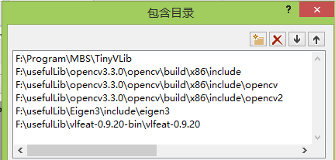

2.2、静态库的配置

属性—>VC++目录—>库目录

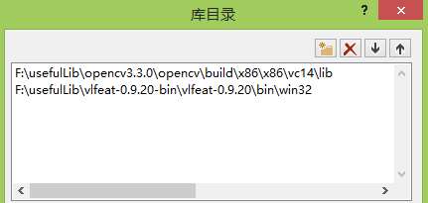

属性—>链接器—>输入—>附加依赖项

opencv_aruco330.lib

opencv_bgsegm330.lib

opencv_bioinspired330.lib

opencv_calib3d330.lib

opencv_ccalib330.lib

opencv_core330.lib

opencv_datasets330.lib

opencv_dnn330.lib

opencv_dpm330.lib

opencv_face330.lib

opencv_features2d330.lib

opencv_flann330.lib

opencv_fuzzy330.lib

opencv_highgui330.lib

opencv_imgcodecs330.lib

opencv_imgproc330.lib

opencv_img_hash330.lib

opencv_line_descriptor330.lib

opencv_ml330.lib

opencv_objdetect330.lib

opencv_optflow330.lib

opencv_phase_unwrapping330.lib

opencv_photo330.lib

opencv_plot330.lib

opencv_reg330.lib

opencv_rgbd330.lib

opencv_saliency330.lib

opencv_shape330.lib

opencv_stereo330.lib

opencv_stitching330.lib

opencv_structured_light330.lib

opencv_superres330.lib

opencv_surface_matching330.lib

opencv_text330.lib

opencv_tracking330.lib

opencv_video330.lib

opencv_videoio330.lib

opencv_videostab330.lib

opencv_xfeatures2d330.lib

opencv_ximgproc330.lib

opencv_xobjdetect330.lib

opencv_xphoto330.lib

vl.lib

2.3、动态库配置

将所需要的动态库文件放置在生成的Release文件夹下

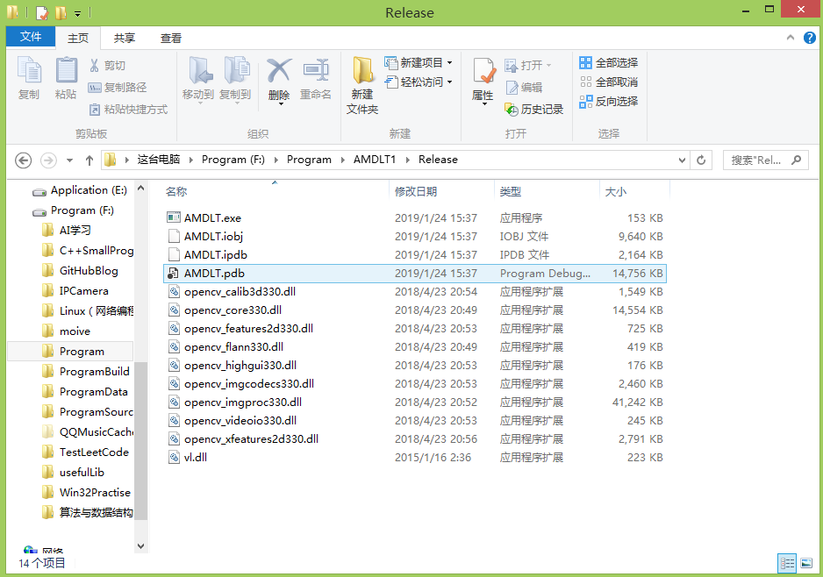

3 运行

将图像放在在一个文件夹下面，输入就是需要拼接的图像，输出就是拼接的结果图。