JUNGLE 2D

A game framework for iPhone and iPad

Genaro Codina Reverter

Table of Contents
Overview 3
Software development 4
Performance analysis 7
Final remarks 8

Overview
This is a simple 2D game where a character (whose name is Tom) has to guide the emu chicks to their mother. Futhermore, Tom has to collect all the “starts” placed in the map.
The player has to touch the iPhone/iPad screen with his finger and then Tom will walk to that specific point. In addition, Tom will be able to jump over the logs placed on the river; in order to perform this acction, the player will have to place Tom in front of the logs (and close to the river) and then tap over Tom position. The following image shows part of the game for iPad.

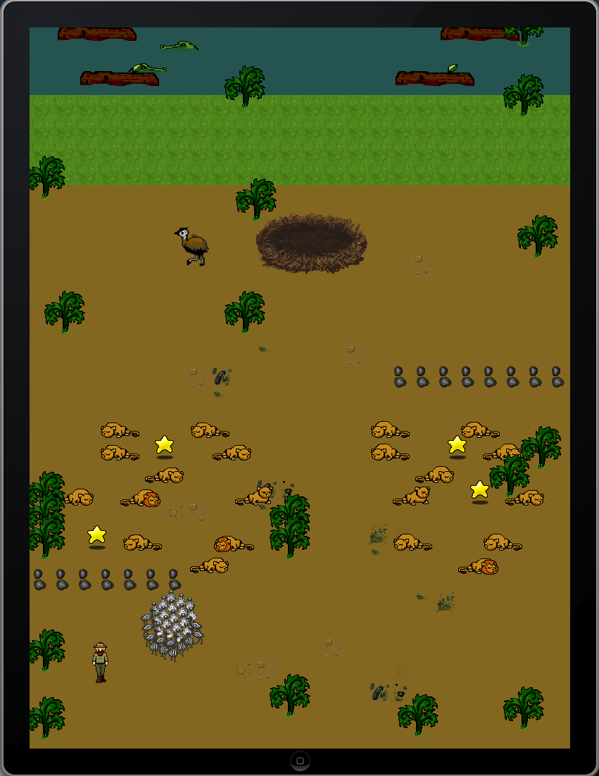

Software development
The main classes involved in the development are:
- “GameStateManager” class: It provides the “changeState” function (which will be inherited and overridden). The main purpose of this function is to allow the creation of several game levels (states) from the main menu and then to render the suitable level on the screen. This game has only one level but its design offer the possibility to add more levels in an object oriented way.
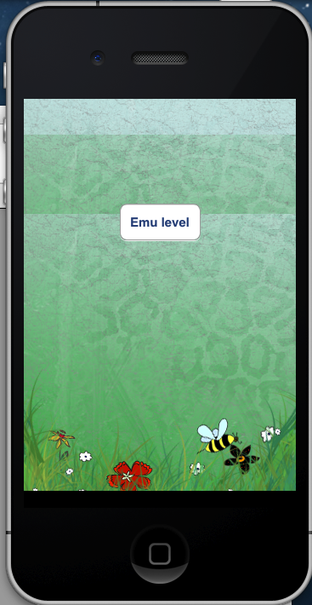
When the button “Emu level” is pressed, then the “changeState” takes as argument the “EmuLevel” class and the game is initialized and rendered on the screen.
- “GameState” and “GLESGameState” classes: “GameState” inherits from “UIView” and offers the basic functionality to create a view; however, we need to create a special view in order to render images from OpenGL; this is the reason why we have created the class “GLESGameState” (which inherits from “GameState”). Consequently, all the levels from our game will have to inherit from “GLESGameState”. Due to our game has only only level, the “Emu level”, this means that the class “EmuLevel” inherits from “GLESGameState”.
- “GSMainMenu” class shows the initial screen with all the possible game levels (only the “Emu level”, in our game).
- “AppDelegate” class inherits from “GameStateManager” and overrides function “changeState” in the following way:

- (void) changeState:(Class)state
{
[UIView beginAnimations:nil context:NULL];
[UIView setAnimationDuration:0.5];
[UIView setAnimationTransition:UIViewAnimationTransitionFlipFromLeft forView:self.window cache:YES];

if (self.viewController.view != nil)
{
[self.viewController.view removeFromSuperview]; //remove view from window's subviews.
}
CGRect screenSize = [[UIScreen mainScreen] bounds];
self.viewController.view = [[state alloc] initWithFrame:CGRectMake(0, 0, screenSize.size.width, screenSize.size.height) andManager:self];

//now set our view as visible
[self.window addSubview:self.viewController.view];
[self.window makeKeyAndVisible];

[UIView commitAnimations];
}

That is, it accepts as a parameter a “Class” (it could be a “GameState” class in C++) and then, in hte code:
self.viewController.view = [[state alloc] initWithFrame:CGRectMake(0, 0, screenSize.size.width, screenSize.size.height) andManager:self];

it creates a suitable view using the suitable class. For example, when the application starts, it is called the function “changeState” passing as an argument an instance of the class “GSMainMenu”, the result is that the main menu is shown (it contains only one button whose text is “Emu level”), then, when the “Emu level” button is pressed, the “changeState” function is called again but this time the argument is an instance of the “EmuLevel” class; consequently the this level rendered on the screen and the game begins.
Every class inherited from “GameLevel” overrides the following two functions: “update” and “render”. This is the case of the “EmuLevel” class. The main reason of doing so is to allows the “AppDelegate” class to control the “game loop” of the game using the function “gameLoop”
- (void) gameLoop:(id) sender
{
double currTime = [[NSDate date] timeIntervalSince1970];
_fpsFramesThisSecond++;
float timeThisSecond = currTime - _fpsLastSecondStart;
if( timeThisSecond > 1.0f )
{
_fps = _fpsFramesThisSecond;
_fpsFramesThisSecond = 0;
_fpsLastSecondStart = currTime;
}

[((GameState *)self.viewController.view) update];
[((GameState *)self.viewController.view) render];
[NSTimer scheduledTimerWithTimeInterval:0.02f target:self selector:@selector(gameLoop:) userInfo:nil repeats:NO];
}

So, every 0.02 seconds this function is called and then the corresponding game state (EmuLevel, for example) is updated and rendered.
The movement of the characters in the game is based on time based logic, so, by keeping track since the last update, it is possible to apply a portion of the movement speed. In our game we specify a speed based on units per second; for example, the speed of the “crocodiles” is:
float speed = time * 200; //in pixels per second.
- “TileWorld”: This class is responsible of reading the configuration files “level_1_idx_iPad.txt” or “level_1_idx_iPhone.txt” and draw a tile map using the “level_1_tiles.png” images.
In addition, the information in such .txt files not only contains the images but also information about if a specific tile is “walkable” or not (i.e. a wall, water, etc.).
- “Sprite”, “Animation” and “AnimationSequence” classes; which are responsible for drawing and animating the sprites related to the characters of the game. This classes work wich the configuration file “Amination.plist”, which contents information about the duration of every one of the sequences of every sprite.
- “Entity”: Every character in the game inherits from this class. It contents “Sprite” (for animation) and “TileWorld” instances (to detect collisons with the tile map).
- Entities classes: Inherited from “Entity” this classes are: “Tom”, “Emu”, “EmuMother”, Rideable”, “Lion” and “Crocodile”.
The following features related to collison between “entity-entity” have been taken into account:
8.1) emu chicks go away from Tom when it is close to the group
8.2) emu chichs go to their emu mum when they are close to her
8.3) when Tom is very close to the lion claws, he dies
8.4) when Tom is very close to crocodiles, he dies
8.5) Tom cannot walk on the river, he only can jump to the logs placed on it.

Performance analysis
- iPad: The application for the iPad is different from the iPhone in the sense that the number of entities is much higher than for iPhone; for example, the number of chicks in the iPad application is 30; however, the number of chicks in the iPhone app is 10, in the same way the number of lions, crocodiles and plants is much bigger in the iPad app than in the iPhone one; consequently, the performance analysis in the iPad is:
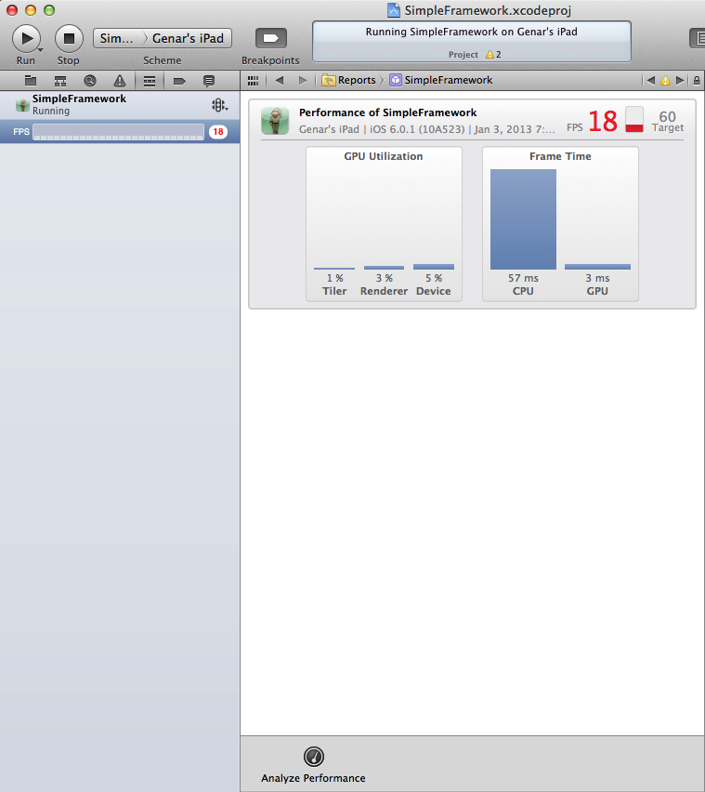

- iPhone: The performance for FPS looks better.
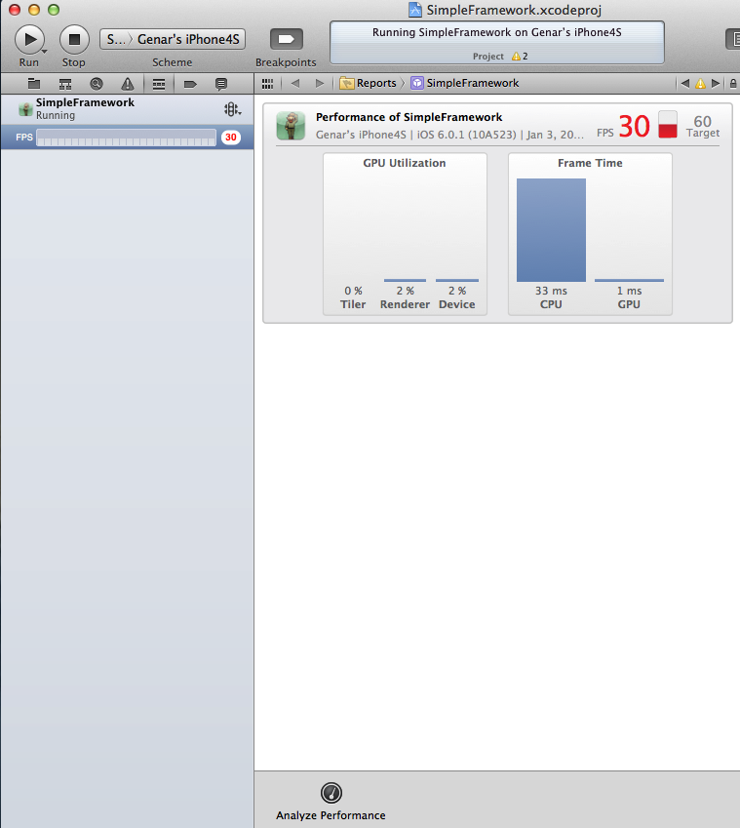
The conclusion about this report is that it coould be advisable to reduce the number of characters in the iPad app in order to increase the FPS.

Final remarks
In this game it has been used OpenGL ES 1.1, which uses a fixed pipeline (programs using OpenGL ES 1.1 can work in old devices like iPhone 3G). In next games it could be advisable to use OpenGL ES 2.0 in order to use “vertex shaders” and “fragment shaders”, which is the recomended way to develop OpenGL programs running in current devices according to the “Kronos group”.
In this game it has not been used the GLKit class. The GLKit framework appear for iOS5. The idea of the GLKit class is to provide the same functionality as the “GLESGameState” developed in our game. In addition, the GLKit class provides additional functionality to draw textures in an easier way; in our game, we have used a "GLTexture” class (from Apple, year 2008) in order to render textures. Apple recomends to use GLKit class for the development of games for iPhone/iPad.
Part of the code and the images have been taken from the book “iPhone Game Development” (O'Reilly, 2009) by Paul Zirkle and Joe Hogue.

