whatData leakage caused high accuracy
Confusion Matrix:
[[29137 2805]
[ 3520 28550]]
Classification Report:
precision recall f1-score support

0 0.89 0.91 0.90 31942
1 0.91 0.89 0.90 32070

accuracy 0.90 64012
macro avg 0.90 0.90 0.90 64012
weighted avg 0.90 0.90 0.90 64012

ROC-AUC Score: 0.9655
Feature Importance
2 avg_scaled_fiveg_usage_percentage 0.176956
1 avg_scaled_5g_uptime 0.169486
12 avg_scaled_percentageReceived 0.114245

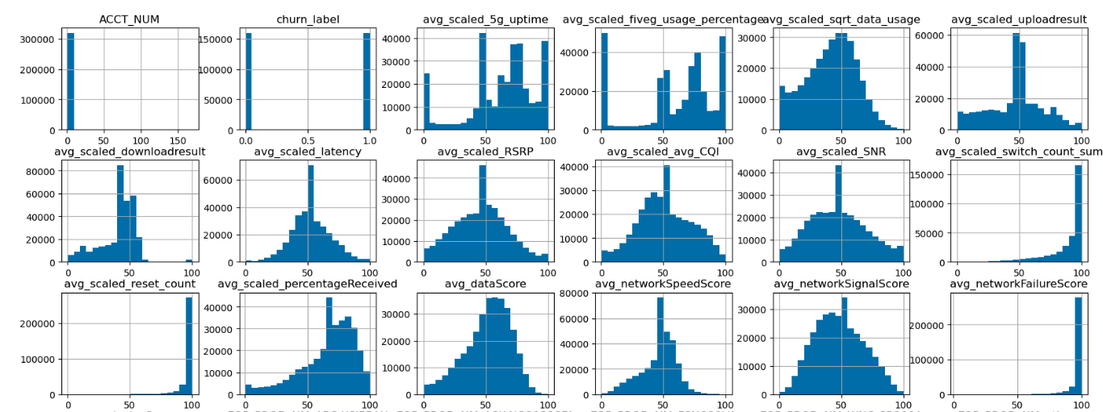

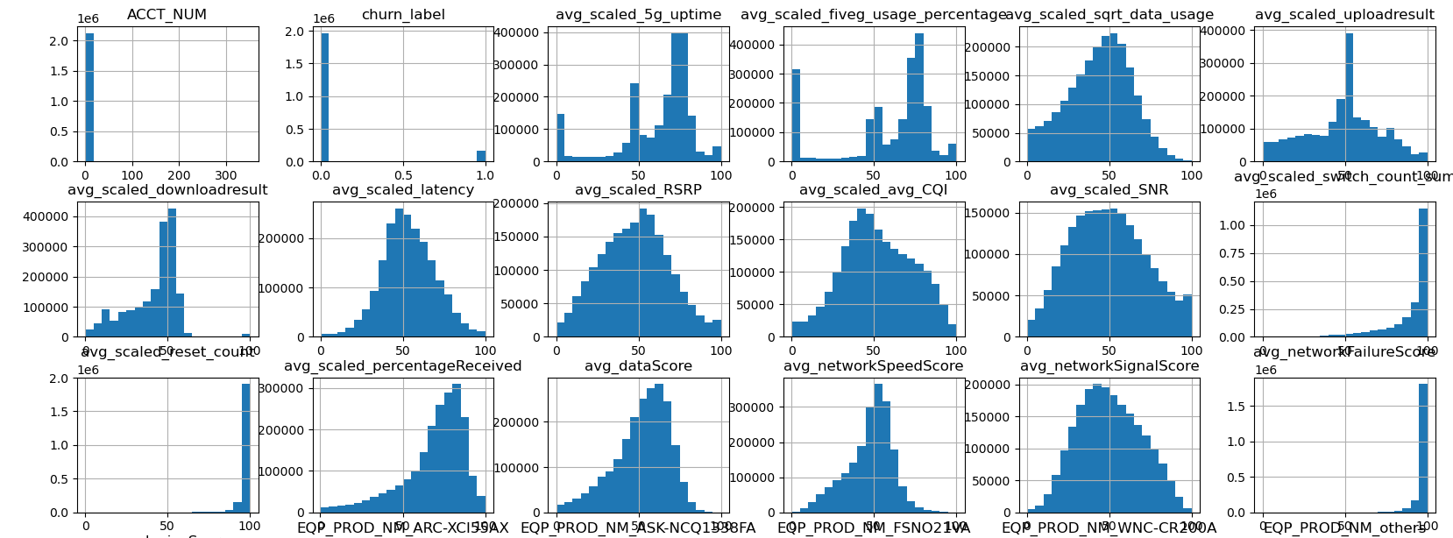

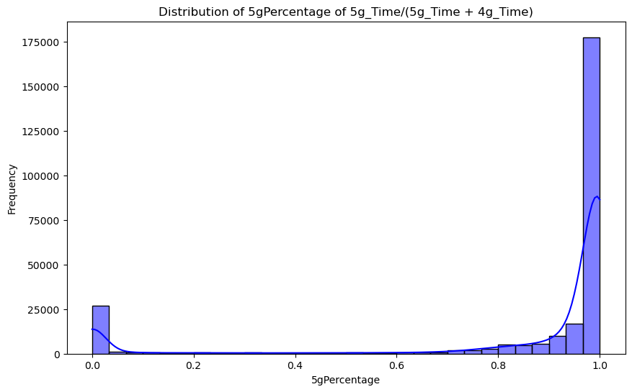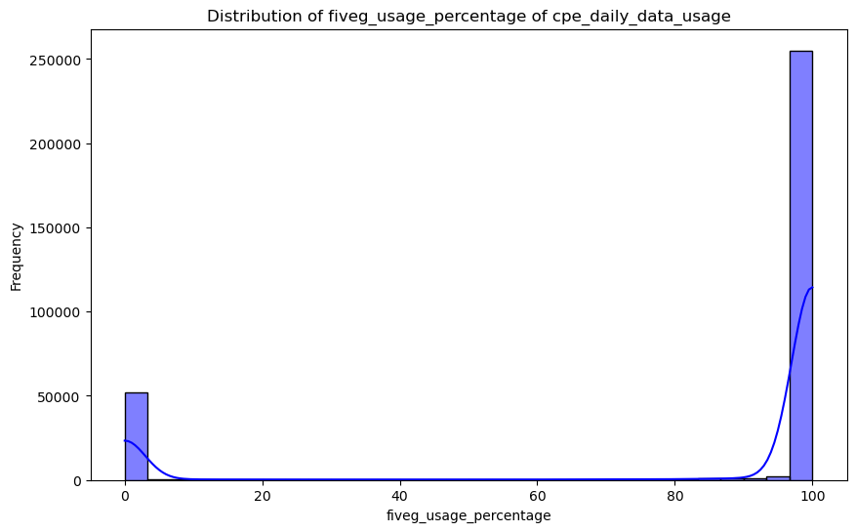

Training Accuracy: 0.7899
Training Confusion Matrix:
[[72294 15219]
[21524 65877]]
Training Classification Report:
precision recall f1-score support

0 0.77 0.83 0.80 87513
1 0.81 0.75 0.78 87401

accuracy 0.79 174914
macro avg 0.79 0.79 0.79 174914
weighted avg 0.79 0.79 0.79 174914

Test Accuracy: 0.7794
Test Confusion Matrix:
[[30417 7009]
[ 9531 28007]]
Test Classification Report:
precision recall f1-score support

0 0.76 0.81 0.79 37426
1 0.80 0.75 0.77 37538

accuracy 0.78 74964
macro avg 0.78 0.78 0.78 74964
weighted avg 0.78 0.78 0.78 74964

ROC-AUC Score: 0.8636

Feature Importance
11 scaled_percentageReceived 0.307799
9 scaled_reset_count 0.304561
10 scaled_avg_MemoryPercentFree 0.083887
6 scaled_avg_CQI 0.046483
0 5g_uptime 0.044500
1 scaled_sqrt_data_usage 0.044454
2 scaled_uploadresult 0.043507
7 scaled_SNR 0.034537
8 scaled_switch_count_sum 0.027290
3 scaled_downloadresult 0.022282
5 scaled_RSRP 0.021840
4 scaled_latency 0.017661
12 ACCT_NUM 0.001199

No demographic feature->overfitting

Most of feature goes down when close to churn

Percentage Received vs time
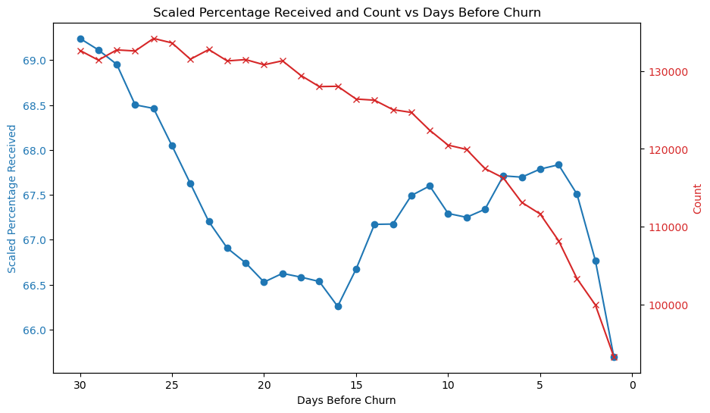
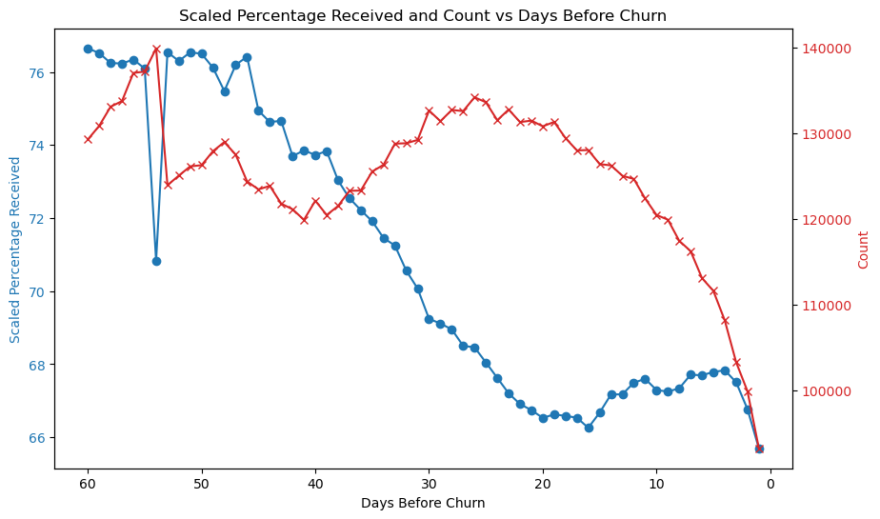
- Keep going down, the only bounce back comes from less people using it.
  - We can capture churn by looking when service going down
- A lot of people stop using the service days before they actually churn
  - Hard to define universally the important timing.
  - Generally, there should be an important

Churn vs Active, feature vs. time
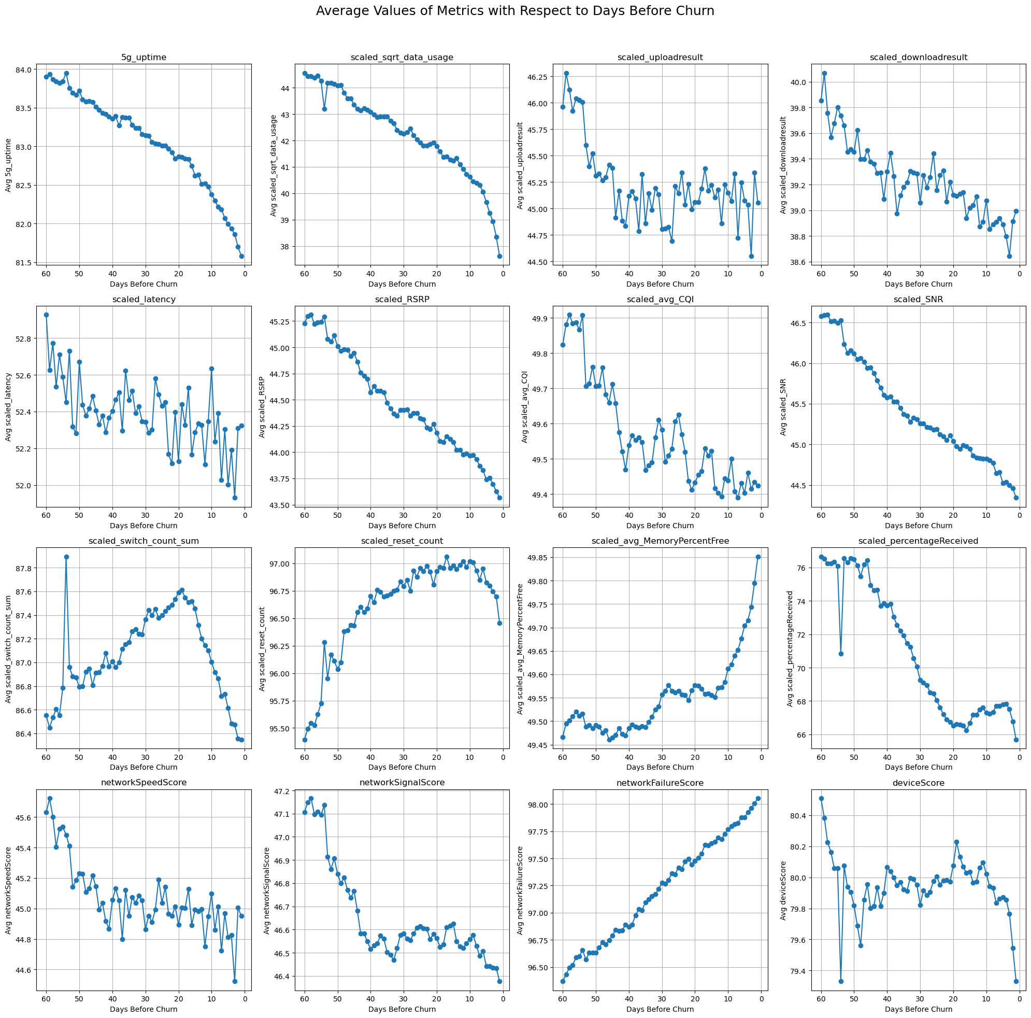

Early signs of churn can be detected by temporal changes in customer 5G experience(cpe Score).

Time prediction: 2 month, 3 month, or 4 month

Active customer. Focus on active at least n month.

Balance between early recognition and accuracy

Churn pattern

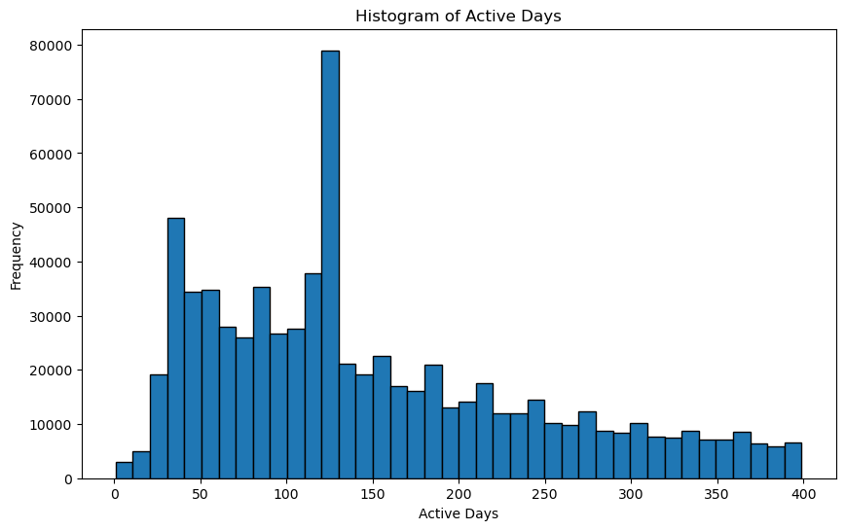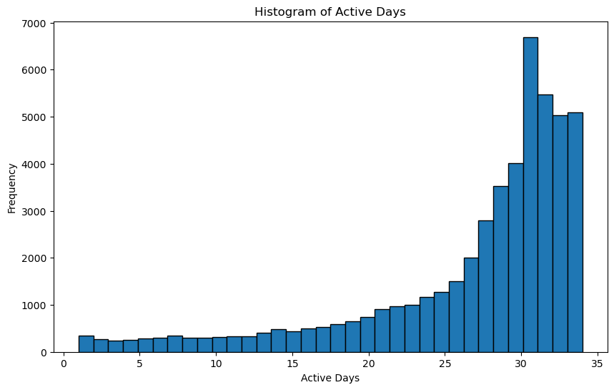
Periodical trends

