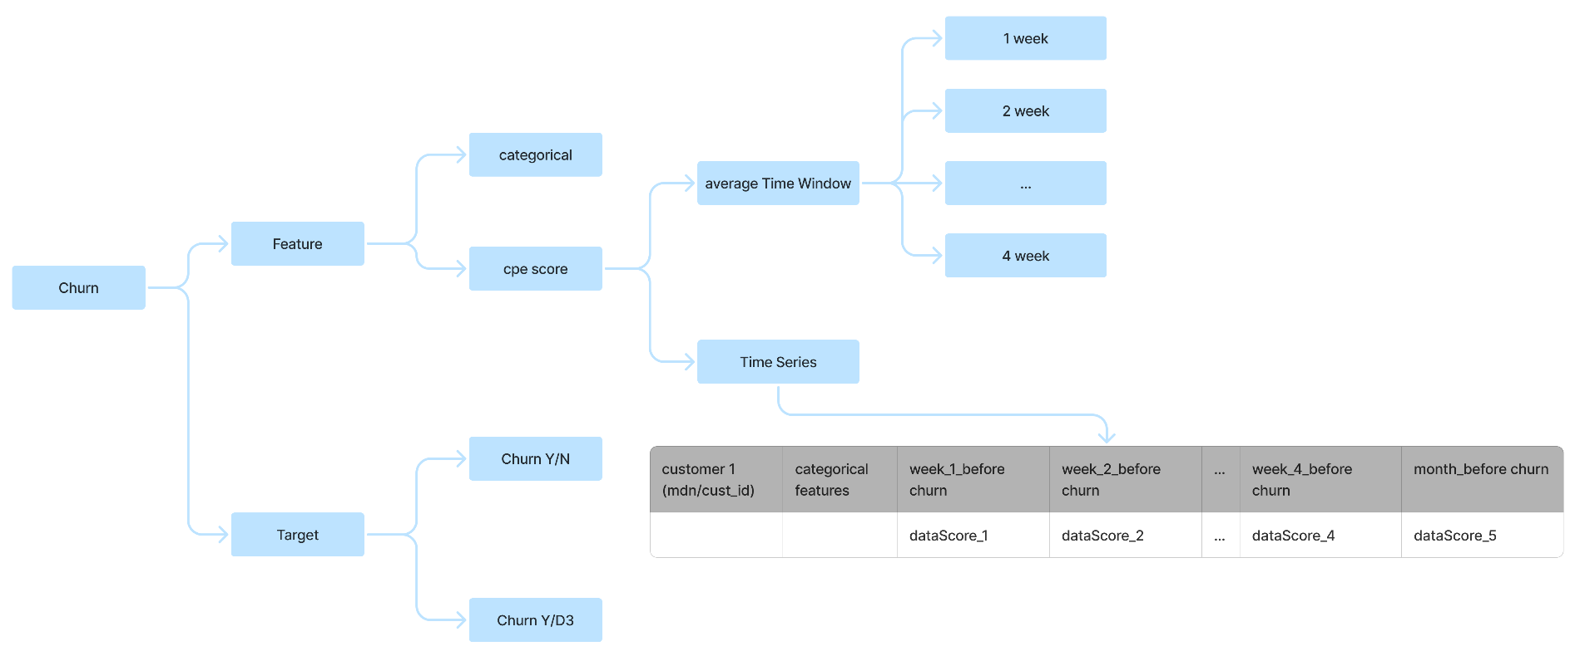

D3_DE difference

+--------+------+
|deact_cd| count|
+--------+------+
| D3 | 90795|
| DE |159971|
+--------+------+

Difference wrt Average value

ACTIVITY_CD | AC | D3 | DE
avg_scaled_5g_uptime | 61.51 | 59.98 | 61.84
avg_scaled_fiveg_usage_percentage | 57.87 | 59.24 | 59.1
avg_scaled_sqrt_data_usage | 45.62 | 33.16 | 41.05
avg_scaled_uploadresult | 49.17 | 42.93 | 45.12
avg_scaled_downloadresult | 41.51 | 39.1 | 39.17
avg_scaled_latency | 53.71 | 52.23 | 52.39
avg_scaled_RSRP | 47.43 | 43.72 | 43.93
avg_scaled_avg_CQI | 53.13 | 49.77 | 49.42
avg_scaled_SNR | 49.23 | 44.08 | 44.75
avg_dataScore | 52.92 | 46.82 | 51.07
avg_networkSpeedScore | 47.66 | 45.21 | 45.09
avg_networkSignalScore | 50.95 | 46.33 | 46.68
avg_networkFailureScore | 98.01 | 98.66 | 97.96
avg_deviceScore | 82.05 | 78.6 | 80.36

Difference wrt Null percentage

