Module 13 | drill

1.

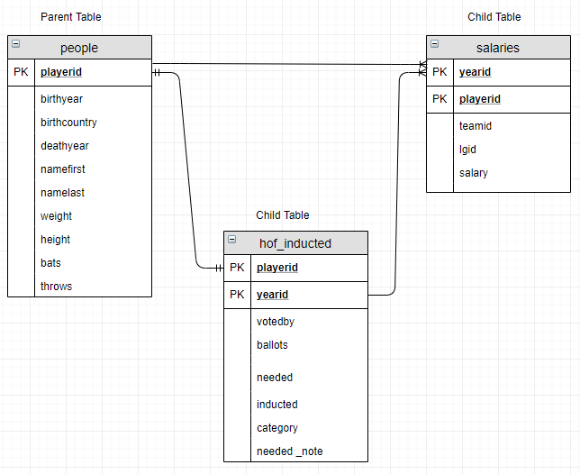

2.

SELECT namefirst,namelast,inducted

FROM people LEFT OUTER JOIN hof_inducted

ON people.playerid = hof_inducted.playerid;

3.

SELECT yearid, votedby

FROM hof_inducted

WHERE yearid = 2006 AND votedby = 'Negro League';

4.

SELECT salaries.yearid, salaries.playerid, salaries.teamid, salaries.salary, hof_inducted.category

FROM salaries INNER JOIN hof_inducted

ON salaries.playerid = hof_inducted.playerid;

5.

SELECT salaries.playerid, salaries.yearid, salaries.teamid,salaries.lgid, hof_inducted.inducted

FROM salaries FULL OUTER JOIN hof_inducted

ON salaries.playerid = hof_inducted.playerid;

6.1

SELECT

FROM hof_inducted

UNION ALL

SELECT

FROM hof_not_inducted;

6.2

SELECT playerid FROM hof_inducted

UNION

SELECT playerid FROM hof_not_inducted;

7. SELECT namalast, namefirst, SUM(salary)

FROM salaries LEFT OUTER JOIN people

ON Salaries.player.id = people.player.id

GROUP BY namelast, namafirst

ORDER BY namelast, namafirst

8.

|  |
| --- |
| SELECT hof_inducted.playerid, yearid, namefirst, namelast |
|  | FROM hof_inducted LEFT OUTER JOIN people |
|  | ON hof_inducted.playerid = people.playerid |
|  |  |
|  | UNION ALL |
|  |  |
|  | SELECT hof_not_inducted.playerid, yearid, namefirst, namelast |
|  | FROM hof_not_inducted LEFT OUTER JOIN people |
|  | ON hof_not_inducted.playerid = people.playerid; |
|  |  |
|  |  |
|  | --9. Like 8. but Filtered since 1980 and |
|  | --sorted by year and a field "lastname, firstname" |
|  |  |
|  |  |
|  | SELECT concat(namelast,', ', namefirst) AS namefull, yearid, inducted |
|  | FROM hof_inducted LEFT OUTER JOIN people |
|  | ON hof_inducted.playerid = people.playerid |
|  | WHERE yearid >= 1980 |
|  |  |
|  | UNION ALL |
|  |  |
|  | SELECT concat(namelast,', ', namefirst) AS namefull, yearid, inducted |
|  | FROM hof_not_inducted LEFT OUTER JOIN people |
|  | ON hof_not_inducted.playerid = people.playerid |
|  | WHERE yearid >= 1980 |
|  |  |
|  | ORDER BY yearid, inducted DESC, namefull; |
|  |  |
|  | --10. Return a table containing the highest annual salary |
|  | -- for each teamid, ranked high to low along with the |
|  | -- matching playerid. |
|  | -- BONUS! In addition to playerid, return namelast |
|  | -- and namefirst in this table (These are in the people table.). |
|  |  |
|  |  |
|  | SELECT yearid, teamid, playerid, salary |
|  | FROM salaries |
|  | WHERE salary IN |
|  | (SELECT MAX(salary) |
|  | FROM salaries |
|  | GROUP BY yearid, teamid) |
|  | ORDER BY salary DESC; |
|  |  |
|  | --10. Bonus! |
|  |  |
|  | SELECT yearid, teamid, salaries.playerid, namelast, namefirst, salary |
|  | FROM salaries LEFT OUTER JOIN people |
|  | ON salaries.playerid = people.playerid |
|  | WHERE salary IN |
|  | (SELECT MAX(salary) |
|  | FROM salaries |
|  | GROUP BY yearid, teamid) |
|  | ORDER BY salary DESC; |
|  |  |
|  |  |
|  |  |
|  | --11. Select birthyear, deathyear, namefirst, namelast |
|  | -- of all players born since birthyear of |
|  | -- Babe Ruth (ID = ruthba01). Sort low to high. |
|  |  |
|  | SELECT birthyear, deathyear, namefirst, namelast |
|  | FROM people |
|  | WHERE birthyear > ANY |
|  | (SELECT birthyear |
|  | FROM people |
|  | WHERE playerid = 'ruthba01') |
|  | ORDER BY birthyear; |
|  |  |
|  | -- 12. Using the people table, |
|  | -- create a table containing |
|  | -- namefirst, namelast, and a |
|  | -- field called usaborn where |
|  | -- if the player's birthcountry is USA |
|  | -- then 'USA', else 'non-USA'. |
|  | -- order by 'non-USA' records first. |
|  |  |
|  | SELECT namefirst, namelast, |
|  | CASE |
|  | WHEN birthcountry = 'USA' THEN 'USA' |
|  | ELSE 'non-USA' |
|  | END AS usaborn |
|  | FROM people |
|  | ORDER BY 3; |
|  |  |
|  | -- 13. Calculate the average height |
|  | -- for players throwing with their |
|  | -- right versus left hand. |
|  | -- Name these fields right_height |
|  | -- and left_height |
|  |  |
|  |  |
|  | SELECT |
|  | AVG(CASE WHEN throws = 'R' THEN height END) AS right_height, |
|  | AVG(CASE WHEN throws = 'L' THEN height END) AS left_height |
|  | FROM people; |
|  |  |
|  | -- 14. Get average of team |
|  | -- maximum salaries since 2010. |
|  | -- (Hint: WHERE goes in your CTE!) |
|  |  |
|  | WITH max_team_sal AS |
|  | ( |
|  | SELECT teamid, MAX(salary) as max_sal |
|  | FROM salaries |
|  | WHERE yearid > 2010 |
|  | GROUP BY teamid |
|  | ) |
|  | SELECT AVG(max_sal) AS avg_max_sal |
|  | FROM max_team_sal; |