INFO 5602 Team 3 Final Project Write up

**Chih-Wei Lin Yijun Zhang Yuhan Lin**

[Chih.W.Lin@colorado.edu](mailto:Chih.W.Lin@colorado.edu) [yijun.zhang@colorado.edu](mailto:yijun.zhang@colorado.edu) [yuhan.lin@colorado.edu](mailto:yuhan.lin@colorado.edu)

*University of Colorado Boulder University of Colorado Boulder University of Colorado Boulder*

Abstract

While there are kinds of public transportation around the world, evidence shows that bus service is the most common and widespread. Buses play an important role in commuting; as the result, save a lot of traffic problems. However, finding and waiting for buses is another issue for not only visitors but also locals. In this project, we dived into RTD Bus System which is a regional transportation system that provides convenient bus service to the Denver Area. We visualized real-time bus position and overall bus stations in Denver Area to provide people a brand new way regarding to bus information.

# Introduction

Public transit is a very important part to many people in the Colorado area, especially for college students who live in Denver and Boulder area and don’t own a personal vehicle. But sometimes checking these routes of public transit could be a problem. Viewing the static route map (electronic version or paper version, for example, Figure 1) is definitely old-school style and inefficient.

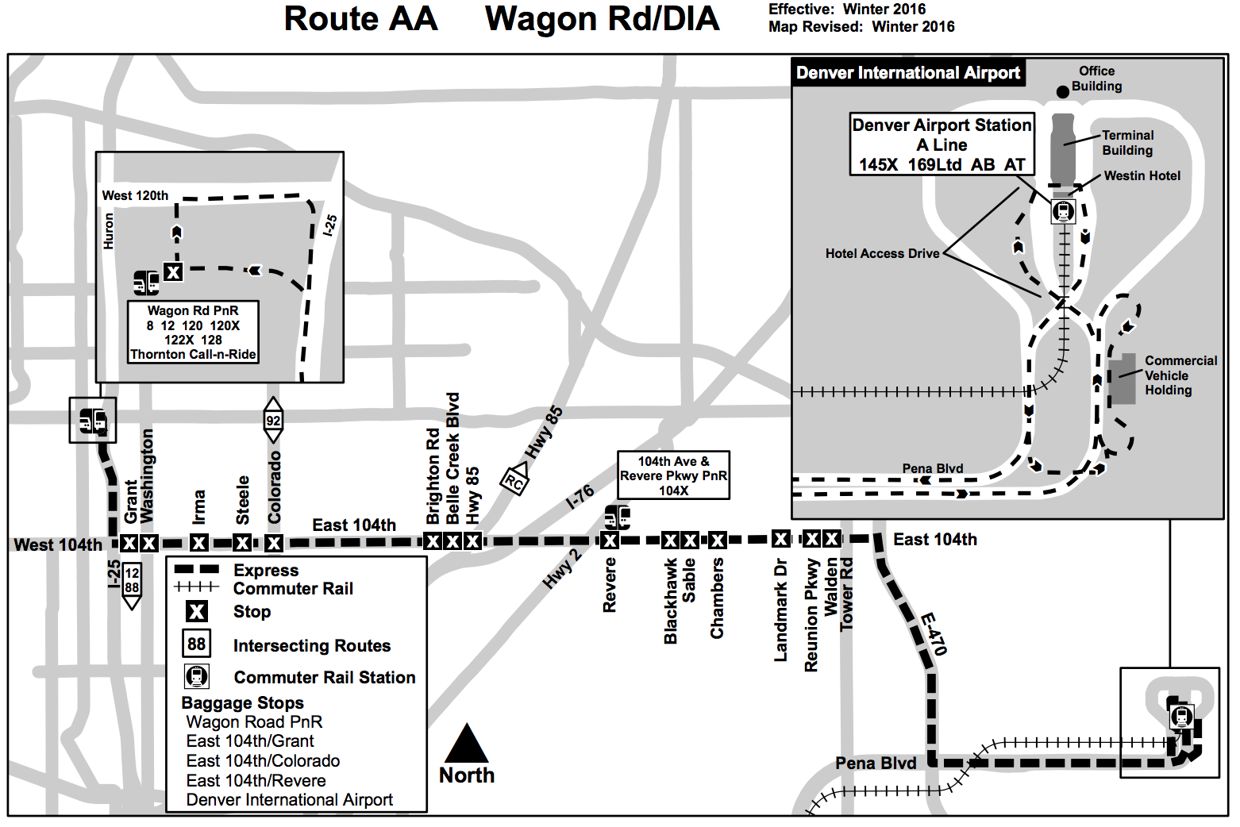

1. AA Bus Route Map by RTD

Google Maps does provide a convenient way to give you a perfect public transit route if you already where exactly you are going from and going to. But this doesn’t always work. For example, I’m renting a new apartment and want to see which places have more buses pass by. Or I’m just taking a bus to see the beautiful view of Colorado on a nice weather, so I want to pick a bus route pass through as many places I want to see as possible. Therefore, it could be very useful to have such a interactive, informative and user-friendly tool.

COPYRIGHT@2018

# Related Work

## Google Maps Platform[2]

Google Maps Platform provides free/paid products for users to make use of the big data collected by Google and APIs to visualize the data easily and elegantly. There are three kinds of product including Maps (build customized static/dynamic maps, Street View imagery and 360 degree views), Routes (find the best way to get from A to B with comprehensive data and real-time traffic information) and Places (find over 100 million specific places with phone numbers, addresses, real-time signal and other location data). In our project, we mainly used Maps JavaScript API to render the map and heatmap, visualize geographic positions defined by latitude and longitude, and draw routes with Directions Service provided by the API.

## General Transit Feed Specification(GTFS)[3]

GTFS defines a common format for public transportation schedules and associated geographic information. A GTFS feed is composed of a series of text files collected in a ZIP file. Each file models a particular aspect of transit information: stops, routes, trips, and other schedule data. Other than the GTFS-Realtime, the data in GTFS are non-real-time and won’t be changed frequently. RTD provides their GTFS schedule dataset and can be viewed in details and downloaded at <http://www.rtd-denver.com/GoogleFeeder/> .  The dataset is used to visualize the routes on the map and generate the stops heat map.

## GTFS-Realtime[4]

GTFS Realtime is a feed specification that allows public transportation agencies to provide real-time updates about their fleet to application developers. It is an extension to GTFS (General Transit Feed Specification), an open data format for public transportation schedules and associated geographic information.  RTD also provides their GTFS-Realtime data feeds, it can be fetched by applying access to RTD. Specifically, the RTD GTFS-Realtime data feeds consist two parts, vehicle position and trip update. We only use the vehicle position part to get the real-time vehicle position, visualize them on the map and generate the bus map. But it has to work with the GTFS dataset stated above to provide meaningful information.

## Protocol Buffer[5]

Protocol buffers are Google's language-neutral, platform-neutral, extensible mechanism for serializing structured data. The GTFS-Realtime data is in protocol buffer format. Protocol buffer is similar to XML or JSON, but unlike neither of them, it’s in binary format. Which means you are not able to know what’s in the protocol buffer unless you have the right way to parse and read it. And it seems Google doesn’t provide a very useful JavaScript protocol buffer, so we use a third-party parser called protobuf.js provided by dcodeIO[6]. A gtfs-realtime.proto[7] is also needed to compile the GTFS-Realtime data.

## Google Maps Transit[8][9]

Google Maps Transit (You can either directly visit the Google Maps Transit website or use in the Google Maps or download the Transit app) is a example usage of the GTFS dataset and GTFS-Realtime data feeds. After inputting two places, to and from, Google Maps Transit will generate a route to get to your destination by taking the public transit only. It will also show the estimated arrival time of the vehicles.

## When (ish) is my bus? User-centered visualizations of uncertainty in everyday, mobile predictive systems.[10]

This related work is a paper proposed by Matthew Kay et al. on 2016. It present a mobile interface design and visualization of uncertainty for transit predictions. Compared with our project, the proposed mobile predictive system focuses on predicting the arrival/departure time and visualizing the uncertainty of the prediction, while our project focuses on visualizing the information about geographic position.

## CU Bus Tracker[11]

CU Bus Tracker is an mobile app developed by University of Colorado Boulder and is open for the public to download and use. Users can use this app to check the visualized locations of bus stops and routes, and track the real-time bus locations of specific routes on the embedded Google Maps. Compared with our project, CU Bus Tracker tracks only 5 bus routes near the campus, while it provides estimation of arrival time, which could be a future work of our project.

## Colorado Population by County[12]

In order to see the relationship of the number of stops RTD set up in different area in Colorado and the population in that area, we went to see the population in different county in Colorado. According to the data and the visualization, most population in Colorado are living in near to the Denver County(The lower small deep red area in Figure 2).

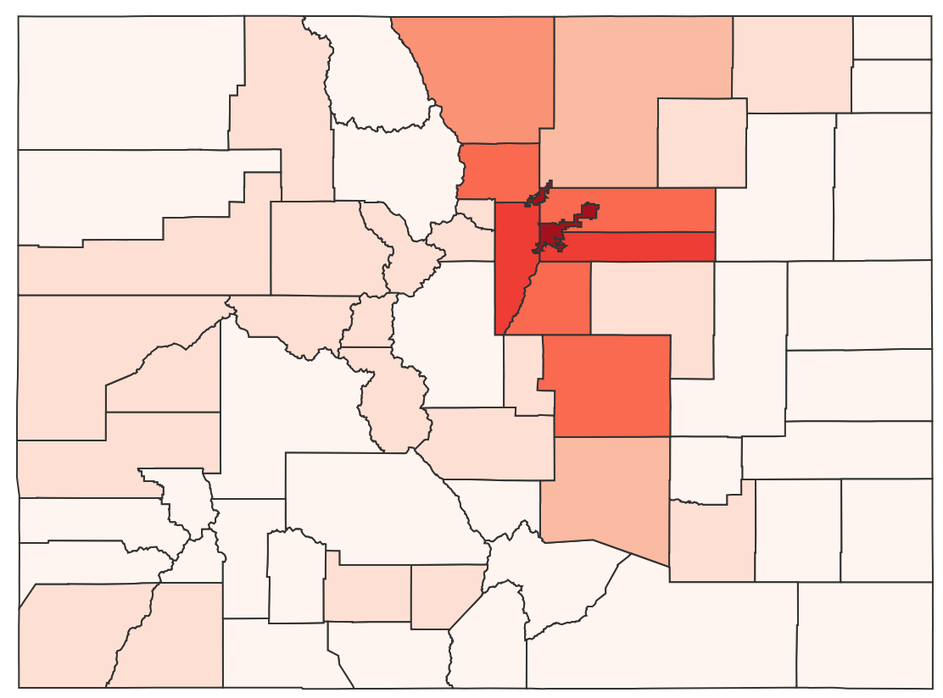

1. Colorado Population by County

# Project Description

This project is based on RTD open source data which provides real-time bus location and all RTD trips information. We chose to use google map API for visualizing geographic data to provide interactive map.

## Real Time Bus Location by Routes

In this part, we visualized the bus routes and real-time bus position by querying the bus line from the list on the right.

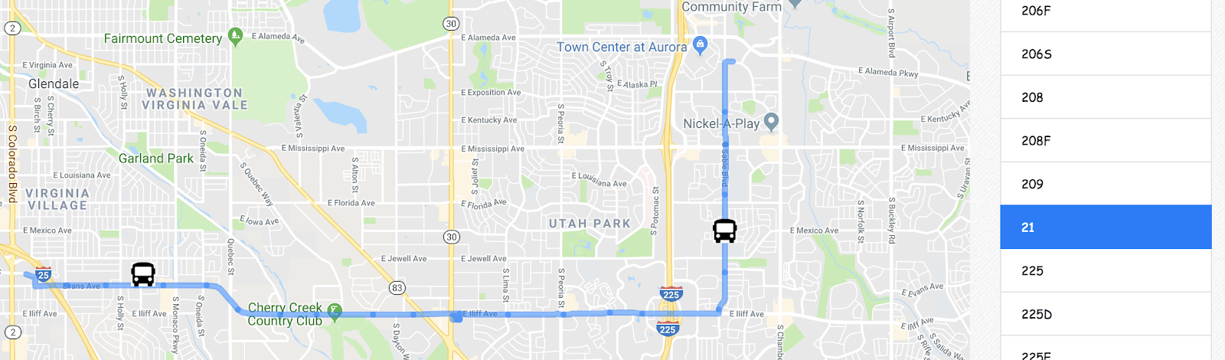

1. Visualization of Route 21 on Fri May 04 2018 21:12:08 GMT-0600 (MDT)

The real-time bus locations of a specific routes will be displayed as a marker on the map. For example, figure 4 shows the bus locations of Route 15L on May 04 2018 21:12:32 (MDT) and figure 5 show the bus locations of the same route on 23:00:15.

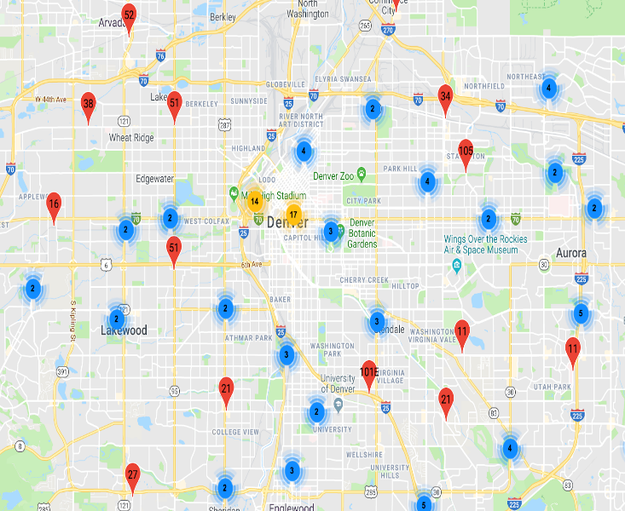

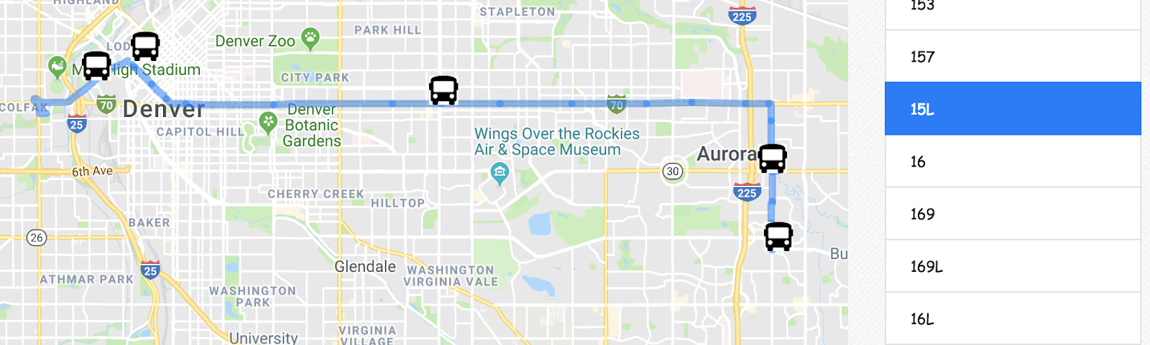

1. Visualization of Route 15L on Fri May 04 2018 21:12:32 GMT-0600 (MDT)

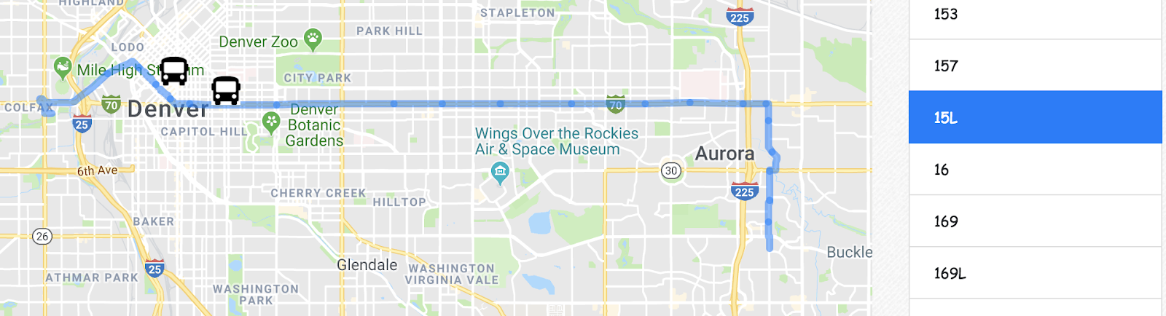

1. Visualization of Route 15L on Fri May 04 2018 23:00:15 GMT-0600 (MDT)

## Real Time Bus Location in Denver Area

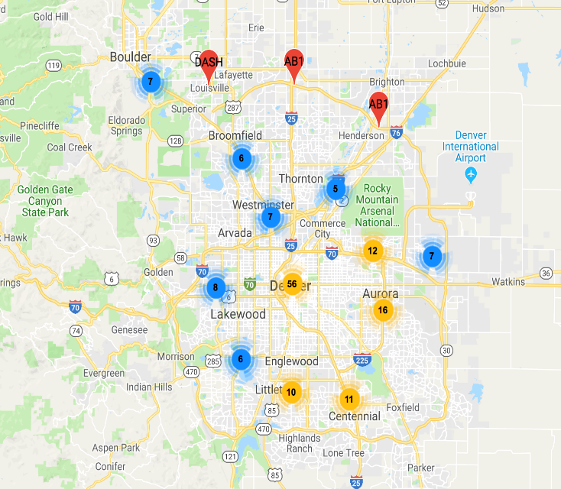In order to know how many buses are running at a certain time, we created two visualizations for the overview. The first visualization is clustering markers. The nearby bus locations were clustered into groups, and the number indicates the size of the cluster. (Figure 6) As users click on one cluster, the map zooms into that area, showing the data points in detail (Figure 7). After a few times of zooming, you are able to see the exactly bus position marker with the routes name on it.

1. Bus clusters in high-level hierarchy
2. Bus clusters in lower-level hierarchy

The second visualization uses accumulating circles to show the distribution of moving buses. We modify the circles to have transparency so that we can tell the difference bus volume between areas. The more active buses are, the darker the area is. The saturation perfectly maps to the density which we can easily tell the main idea of the visualization.

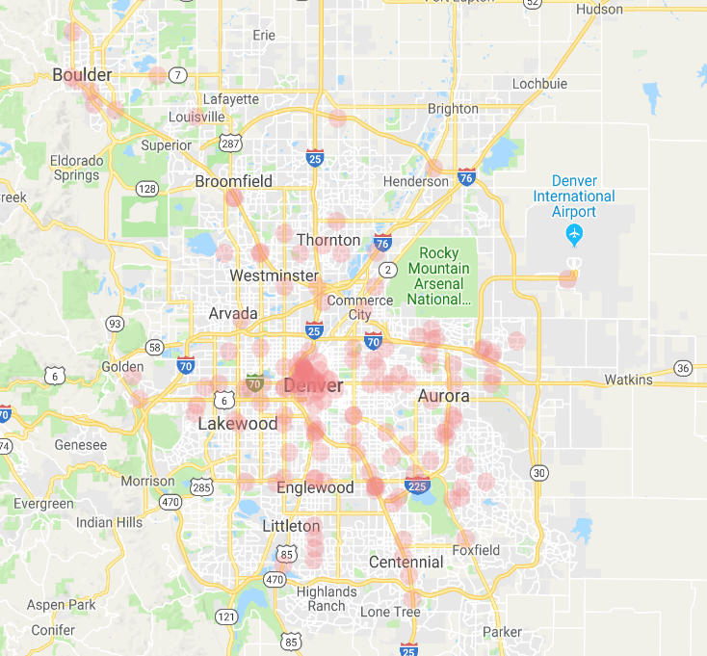

1. Distribution of active buses showed by circles

## Bus Stops Heatmap

Besides the real-time bus location map, we also created a static heatmap to visualize the locations of all the RTD stops to explore where buses pass most frequently.

1. 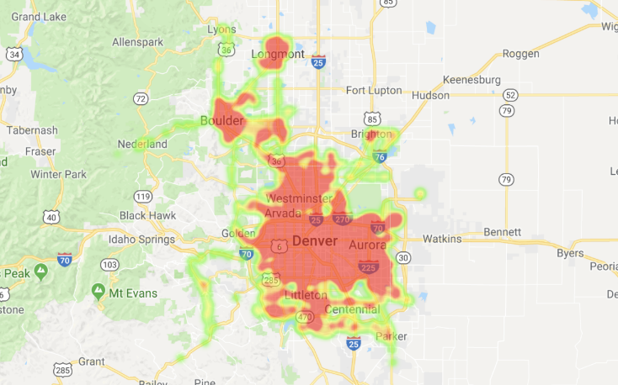Bus Stops Heat Map

# Discussion

Looking into the real-time bus positions, we have the idea that Denver has the highest bus density around the area. With the aggregate number, we also know that the number of buses in Denver is eight times more than that in Boulder.

From the heatmap, we found that most bus stops located in Longmont, Boulder and the Great Denver Area. We may imply from the visualization that most people in Colorado inhabit and perform their daily activities in these three regions. After exploring the Colorado Population introduced in the related work, most people live in counties located in these three regions, which may prove that RTD bus routes have been well planned to fulfill most people’s daily need.

References

1. <http://www.rtd-denver.com/Developer.shtml>
2. <https://cloud.google.com/maps-platform/>
3. <https://developers.google.com/transit/gtfs/>
4. <https://developers.google.com/transit/gtfs-realtime/>
5. <https://developers.google.com/protocol-buffers/>
6. <https://github.com/dcodeIO/ProtoBuf.js/>
7. <https://developers.google.com/transit/gtfs-realtime/gtfs-realtime-proto/>
8. <https://maps.google.com/landing/transit/index.html>
9. <https://play.google.com/store/apps/details?id=com.thetransitapp.droid&hl=en_US>
10. Kay, Matthew, et al. "When (ish) is my bus?: User-centered visualizations of uncertainty in everyday, mobile predictive systems." *Proceedings of the 2016 CHI Conference on Human Factors in Computing Systems*. ACM, 2016.
11. <https://itunes.apple.com/us/app/cu-bus-tracker/id1031736878?mt=8>
12. <http://worldpopulationreview.com/states/colorado-population/>
13. Ceder, Avishai. *Public transit planning and operation: Modeling, practice and behavior*. CRC press, 2007.
14. Antrim, Aaron, and Sean J. Barbeau. "The many uses of GTFS data–opening the door to transit and multimodal applications." *Location-Aware Information Systems Laboratory at the University of South Florida* 4 (2013).