3. TECHNICAL DESIGN

3.1 Rover Concept and Component Overview

Parameter | Design target or calculation
Net Dimension | 655 × 630 × 421 mm = 25.79 × 24.80 × 16.57 in (L × W × H)  N.B: Height is measured from ground level to the top of the camera housing, excluding the antenna
Top speed | At 190 RPM:  π × 0.215 × 190 × 60 = 7,700 m/h (Roughly) = 7.70 km/h (Roughly) = 4.78 mph  N.B: We will use 200 RPM motor. Under load, the RPM may reduce to ±190 RPM. We will also calibrate transmitter/ESC settings in order to keep the rover’s net speed under 8 km/h.
Wheel size | 4 wheels, each diameter x width = 215 × 90 mm = 8.46 × 3.54 in, Wheel rim outer diameter = 188 mm (7.40 in), Tyre radial thickness = 13.5 mm (0.53 in) including tread. PETG rim and TPU tyre.
Suspension | We will use independent suspension at all four wheels, with pivoting arms and two coil springs per wheel: one incorporating a damper and one separate spring. Our complete system includes eight coil springs and four dampers, designed to absorb shocks and control bouncing over uneven terrain.
Power source | Separate 3S LiPo packs: 11.1 V, 5,000 mAh drive purpose + 2,200 mAh for tasks.  55.50 + 24.42 = 79.92 Wh nominal.
Main protection | We protect each electrical system separately:  - Drive system: 20 A main fuse and a dedicated master power switch.  - Task electronics: 7.5 A main fuse and a separate master power switch.  - Individual circuits: Four additional fuses in each system protect its separate power branches.
Mass  (Click to view the detailed calculation) | 10.919 kg, or roughly 10.92 kg  In pounds: 10.919 divided by 0.45359237 gives roughly 24.07 lb.  N.B:  - 20 lb = 9.0718474 kg; nominal excess = 10.919 minus 9.0718474 = 1.8471526 kg, or roughly 1.847 kg (4.07 lb).  - Handbook Rule 6.4.5 states that 60 lb is maximum. Rule 8.2 awards 5 mass points at 20 lb or less. Our design objective is below 20 lb.  - Our theoretical calculation currently exceeds 20 lb. During practical fabrication, we will measure each assembly and try to reduce the mass below 20 lb by refining the chassis, covers, rims and tyre construction while validating their strength. We treat this as our objective, not achieved compliance.
Excursion time | 12-minute mission target.

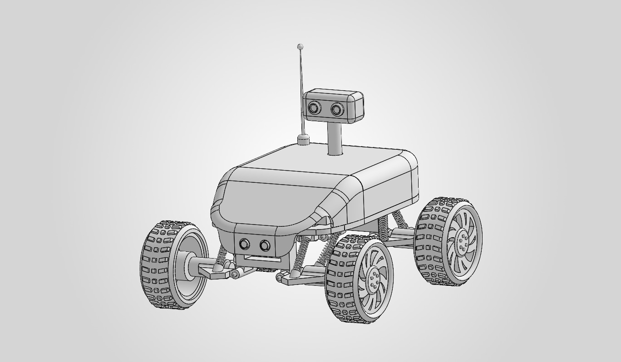
Fig 1.0: Rover Assembly in Three-Quarter View
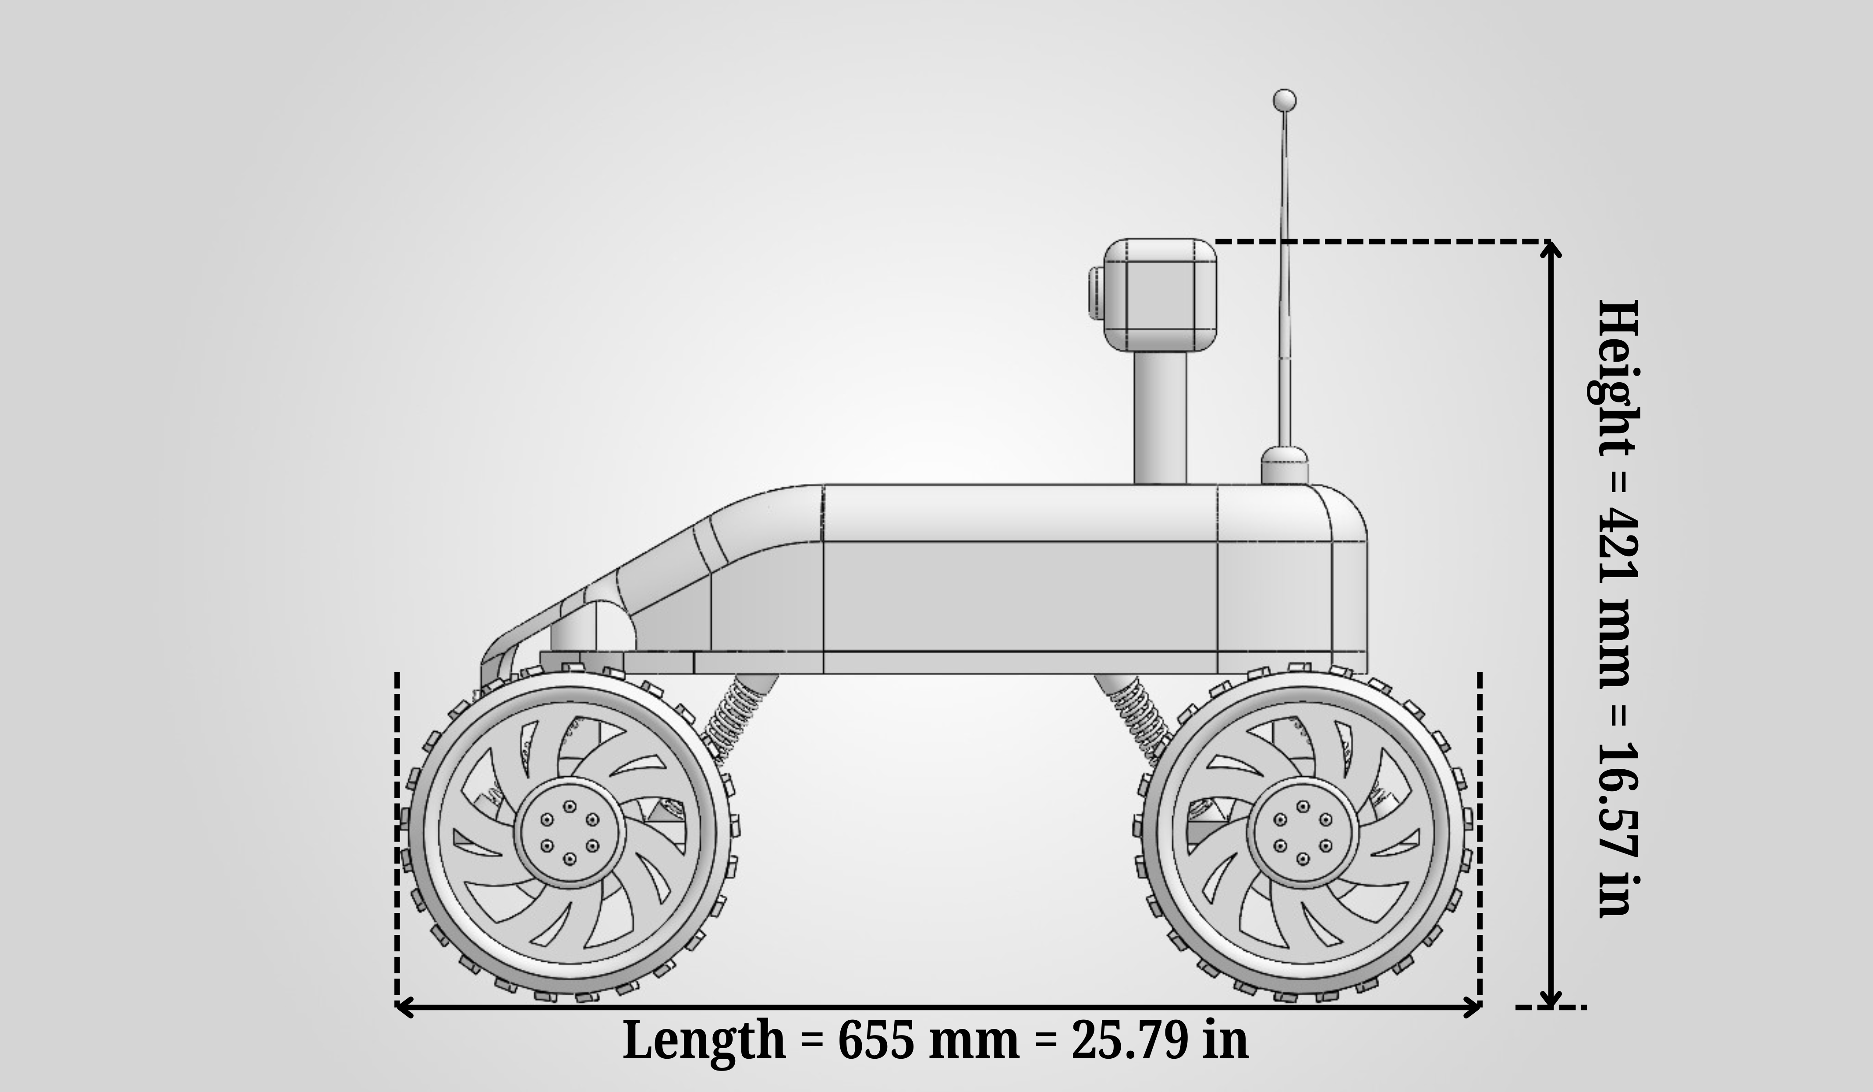
Fig 1.1: Rover Side View: Overall Length and Height to the Camera, Excluding Antenna

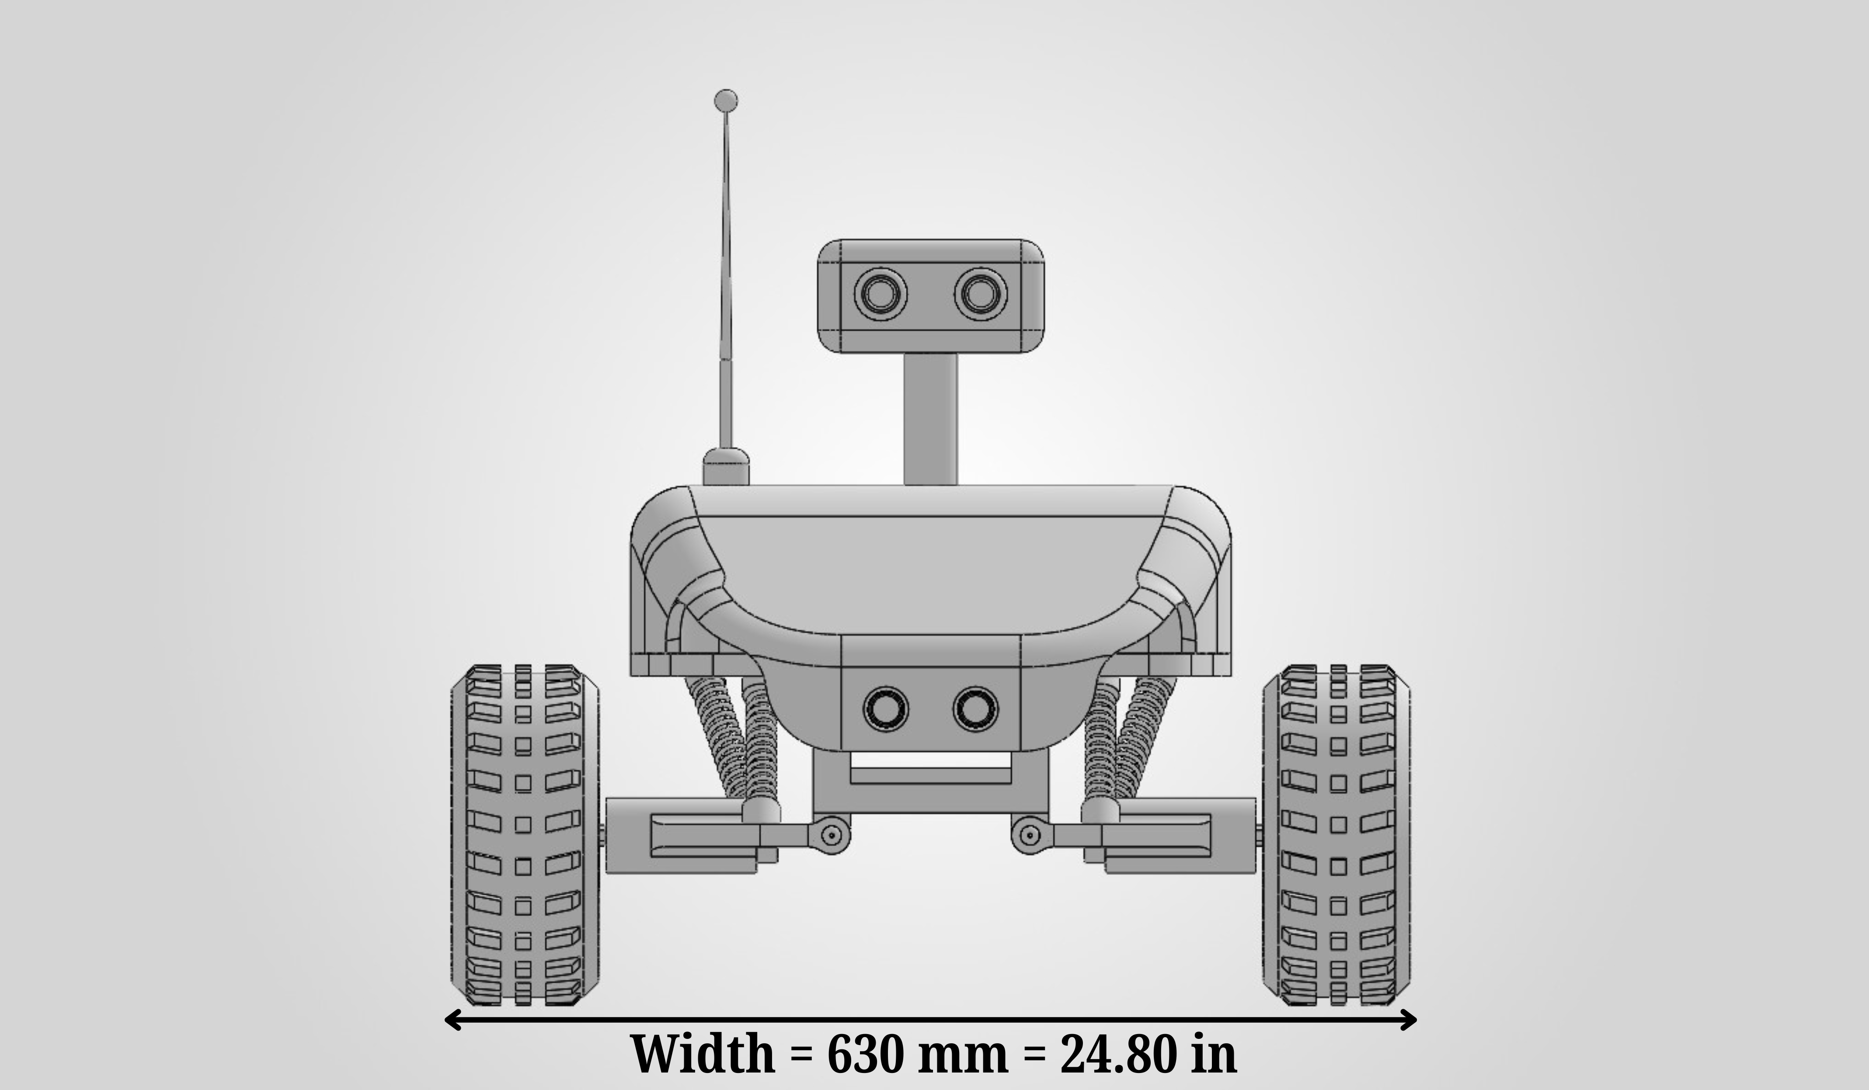
Fig 1.2: Rover Front View: Overall Width

3.2 Wheel Design Ideas and Fabrication Plans

We will make four identical wheels, each with a PETG rim and a TPU tyre. The dimensions are:
- Overall wheel diameter: 215 mm (8.46 in), including tread.
- Overall wheel width: 90 mm (3.54 in).
- Rim outer diameter: 188 mm (7.40 in), measured across the outer lip.
- Tyre radial thickness: 13.5 mm (0.53 in), measured from the rim lip to the tread peak.
The wheel will consist of two main printed parts:
- PETG rim: Curved spokes will connect the reinforced central hub to the outer ring, supporting the tyre and transferring drive from the motor.
- TPU tyre: The flexible tyre will have raised tread blocks, with gaps intended to release loose sand and gravel.
We will 3D-print the rim and tyre separately, check their fit, and assemble the wheel with a 6 mm hex motor coupler. We will first test one complete wheel under load for deformation, hub security and traction before making the remaining three.

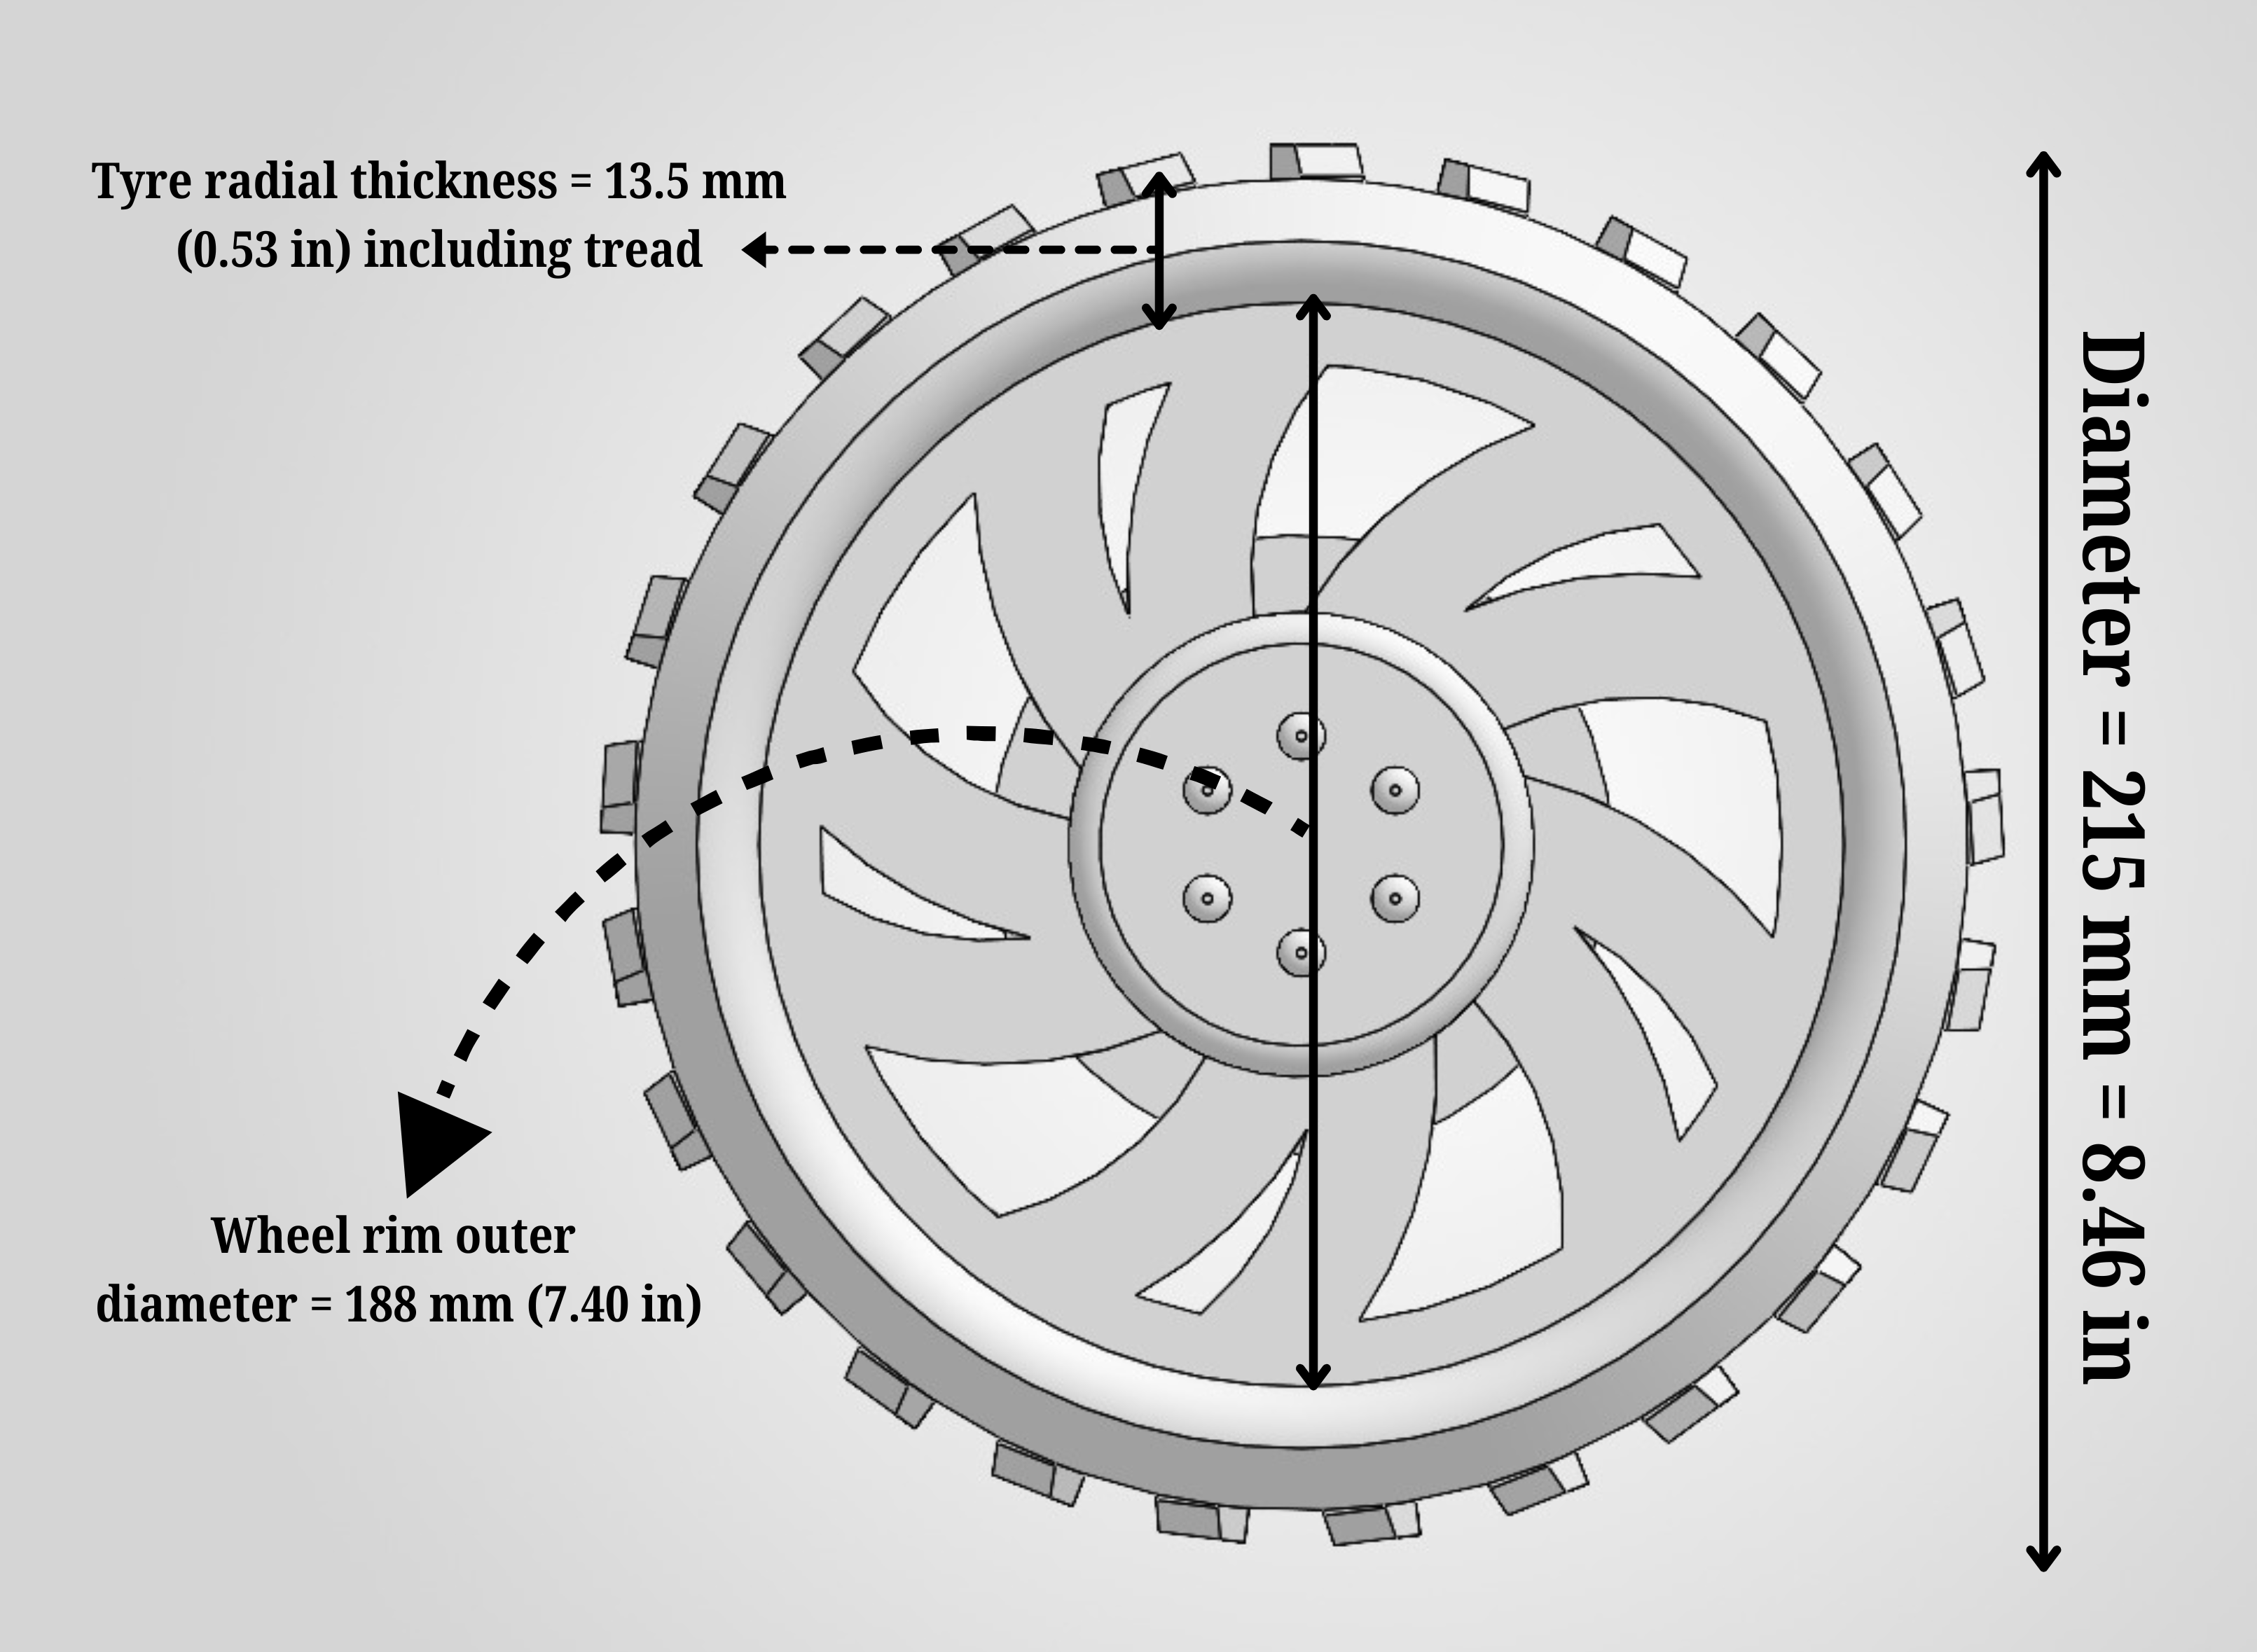
Fig 2.0: Wheel Geometry: Overall Diameter, Rim Diameter and Tyre Thickness
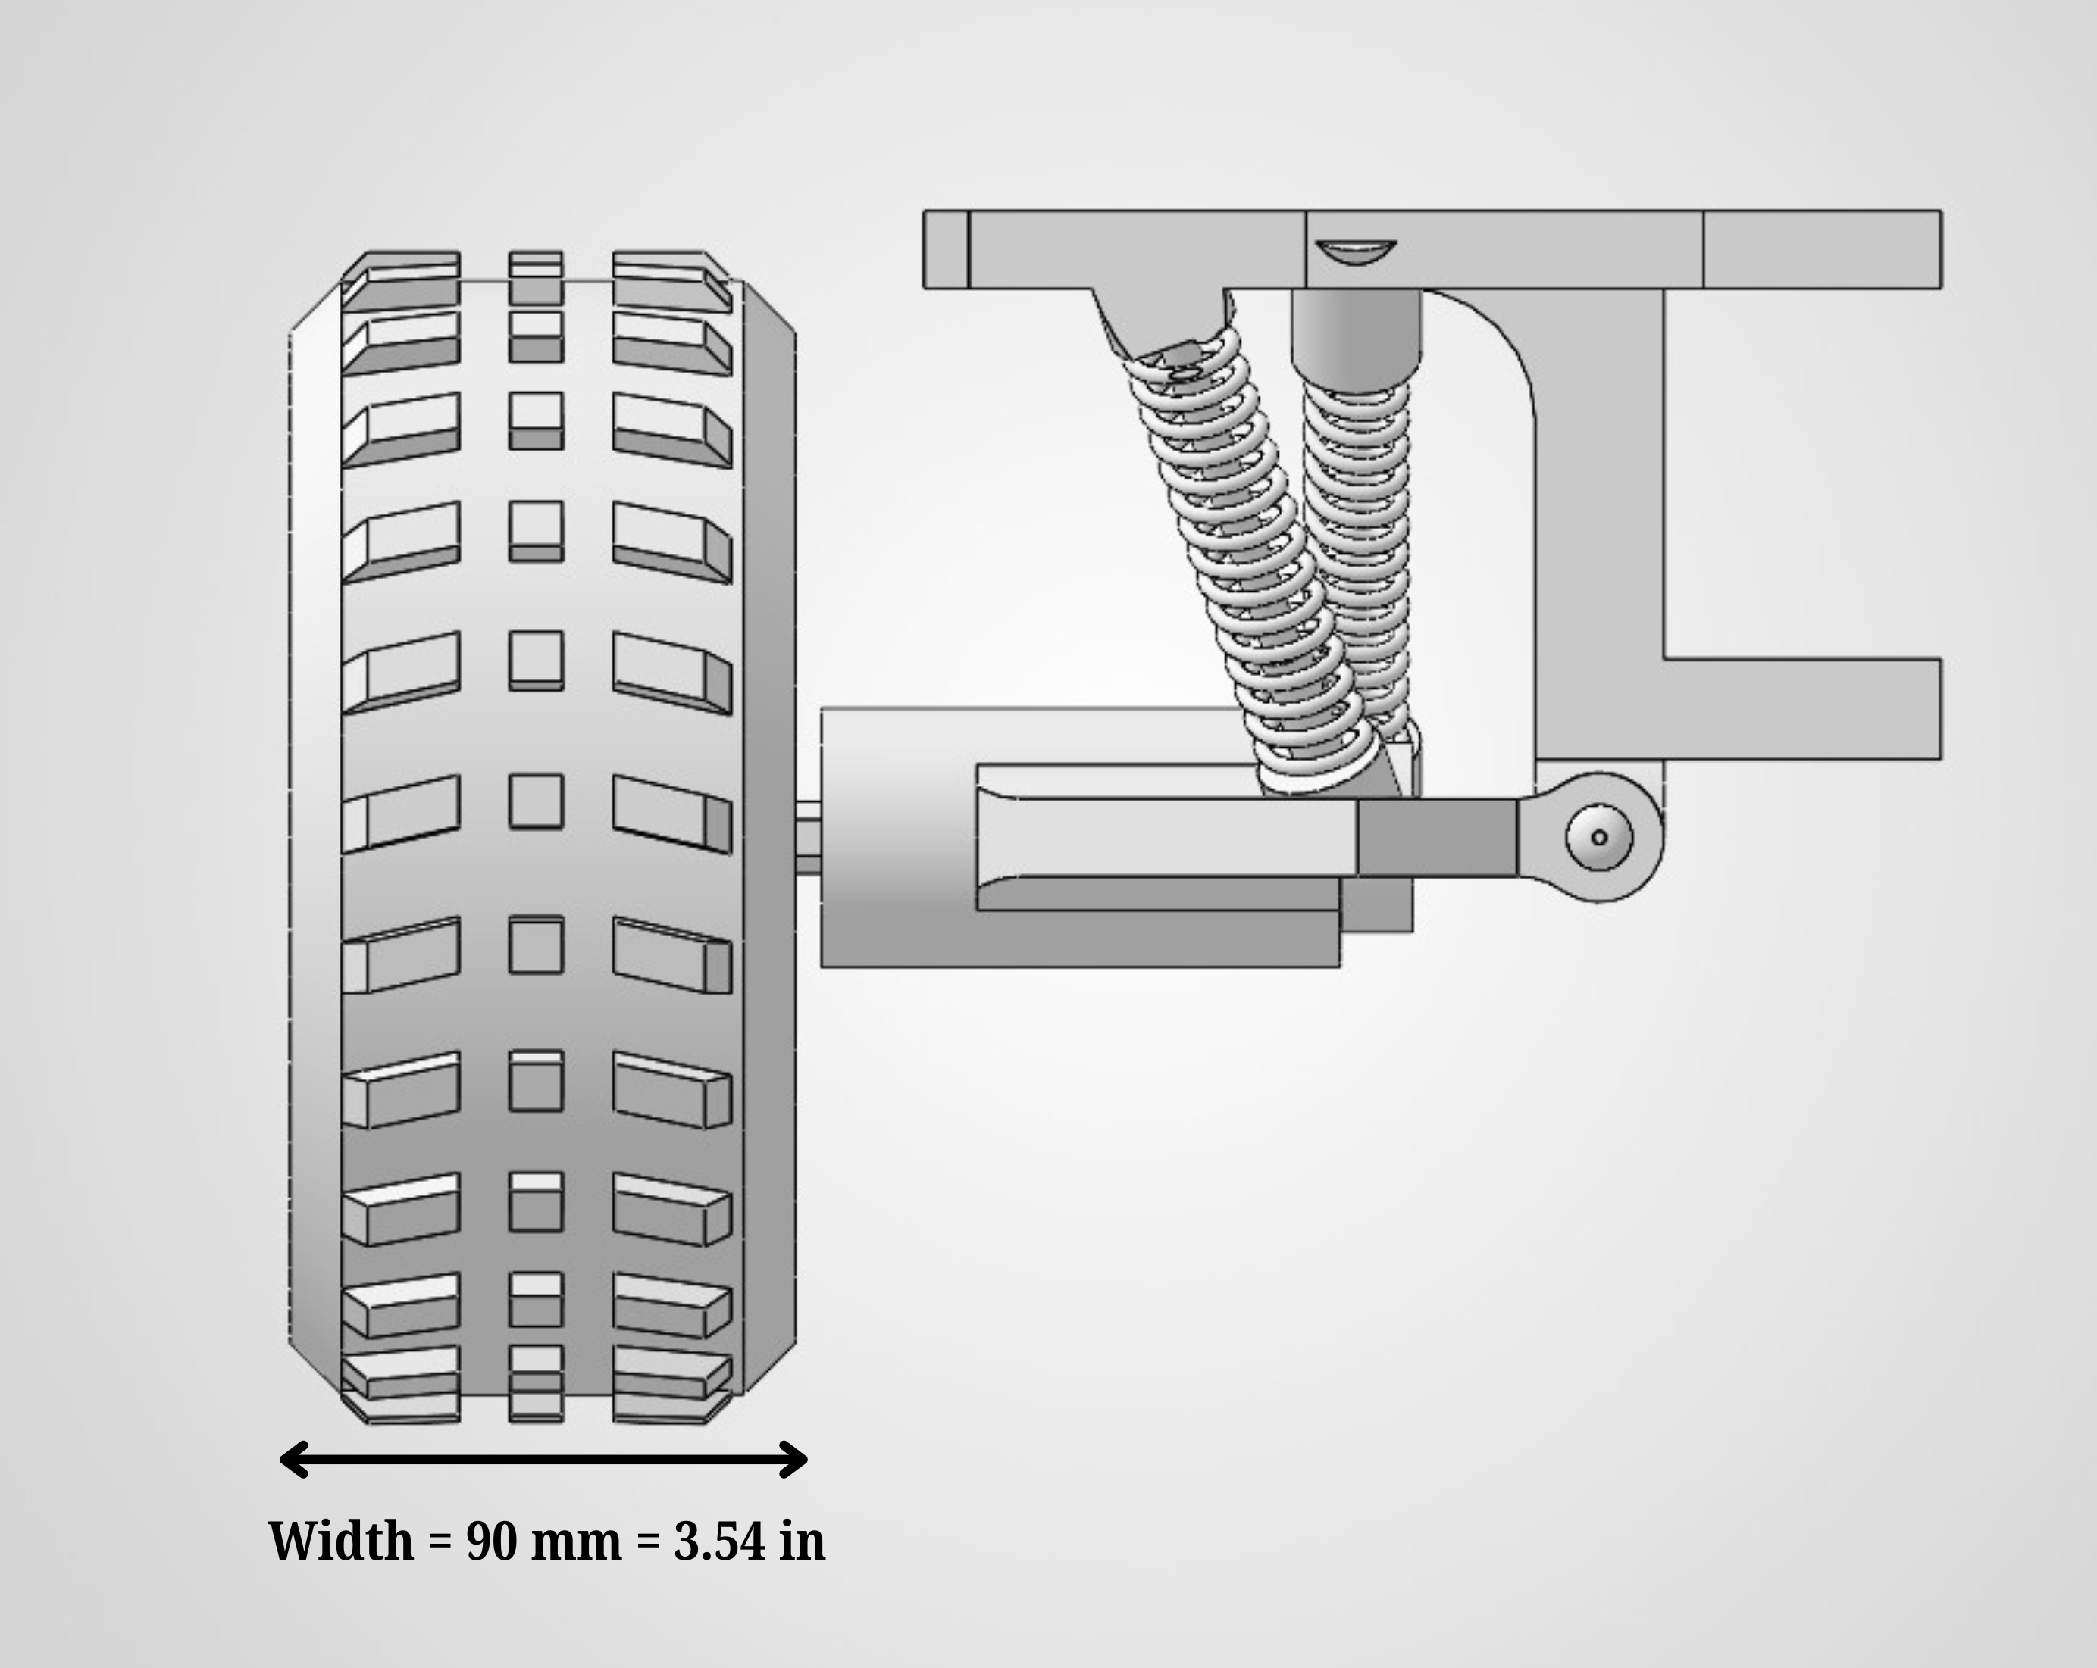
Fig 2.1: Wheel Width and Paired-Spring Suspension Assembly

3.3 Drivetrain Concept and Design with Fabrication Plans

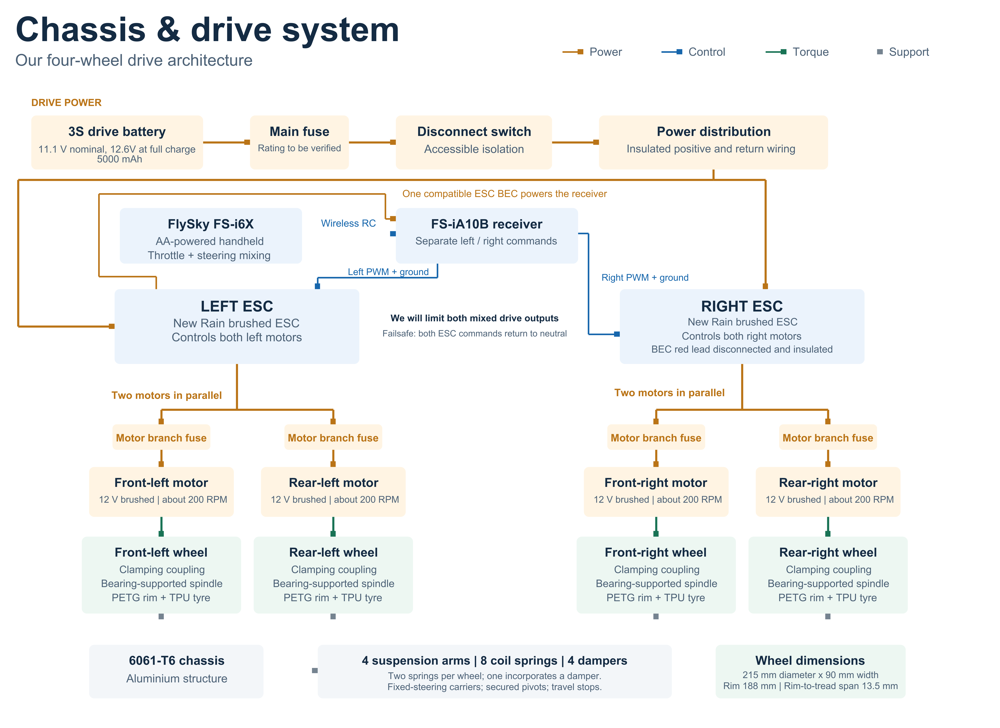
Fig 3.0: Integrated hardware system architecture of the Chassis & Drive System

We will drive all four wheels using one 12 V brushed gearmotor per wheel and steer by varying the commands to the left and right sides. This arrangement keeps the wheel carriers fixed in the steering direction and avoids a separate steering linkage. We have selected geared motors in the approximately 200 RPM class to provide wheel torque at a useful rover speed. Before accepting the motors, we will check their continuous torque, current and gearbox limits against the fully loaded rover’s climbing and turning requirements.

We will fabricate the chassis from 6061-T6 aluminium tube and sheet and fit four independent suspension arms with secured pivots and travel stops. Each wheel will have one spring-and-damper assembly and one separate coil spring, giving eight springs and four dampers. We will select the combined spring rates, preload and travel from the loaded corner weights and suspension geometry. Our PETG rims and TPU 95A tyres will form wheels measuring 215 mm in overall diameter and 90 mm in width. The rim outer diameter will be 188 mm, leaving a radial distance of 13.5 mm from the rim lip to the tread peak.
We will support each wheel spindle on two spaced bearings and retain the wheel through its mounting flange. A clamping coupling will connect the gearbox output to the spindle, with a 6 mm motor-side bore and a spindle-side bore matched to the selected shaft. We will mount the motor and spindle-bearing supports on the same moving carrier to maintain their alignment throughout suspension travel. This gives wheel impact and sideways loads a path through the spindle bearings and carrier into the suspension.

We will purchase the gearmotors, ESCs, radio equipment, batteries, bearings, couplings, springs, dampers and standard fasteners. We will make the chassis, suspension structures, wheel carriers, rims and tyres from our drawings. This division follows the high-school RC provision for purchased drive and suspension components while keeping the chassis, wheels and tyres team-designed and manufactured. HERC Handbook, Rule 6.4.2.1

We will carry out fabrication at Robo Tech Valley using the equipment listed in Section 1.1.3. We will cut aluminium stock with the bandsaw or cut-off saw, deburr the edges, and use the mills and drill press to prepare brackets, mounting faces and

attachment holes. The lathe will support spindle, flange and spacer work. We will check bearing fits, shaft alignment and frame dimensions before final assembly. We will use the FDM printer to make the PETG rims and TPU tyres separately, first completing one wheel-and-suspension module to check fit, retention and movement. Staff-operated machining will follow the supervision arrangements in Section 1.1.3, with our team preparing the drawings and checking the finished parts.

We will install one 3S, 5000 mAh LiPo drive battery, rated at 11.1 V nominal and 12.6 V fully charged, in its own insulated enclosure. A main fuse close to battery positive, an accessible DC disconnect and insulated distribution wiring will supply both New Rain ESCs. Each ESC will power the two motors on its side in parallel, with one fuse in an individual lead of each motor branch. Both motor terminals will connect to the ESC’s reversible output pair. We will finalise the proposed 20 A main fuse and 5 A time-delay branch fuses using measured currents, fuse characteristics and wiring ratings.

We will use the four-AA-powered FlySky FS-i6X to mix two spring-centred stick inputs into left- and right-side commands, delivered through the FS-iA10B receiver’s PWM outputs. We will power the receiver from one compatible ESC BEC and disconnect and insulate the other BEC’s positive lead, retaining both ESC signal and ground connections. Equal commands will drive approximately straight; unequal commands will steer. Opposite commands will permit a pivot turn where traction and available torque allow. We will set both drive-channel failsafes to calibrated neutral and test stopping after loss of the radio link.

With 215 mm wheels turning at exactly 200 RPM, the calculated speed before slip is 8.11 km/h, or 5.04 mph. We will therefore configure maximum outputs for both drive channels and verify that the complete system stays below 8 km/h, as required by Rule 6.4.4. We will test at full battery charge in forward, reverse and combined steering, repeating the checks after ESC startup calibration and power cycling. We will also check downhill speed and stopping. We will accept the limiting arrangement only after these tests demonstrate that it remains effective. HERC Handbook, Rule 6.4.4

Before installation, we will confirm that the supplied ESCs support 12.6 V, direct proportional forward/reverse operation, suitable LiPo protection and the combined current of two motors. We will use the electronics bench to check wiring, receiver supply and control signals, fit a 100 nF ceramic capacitor across each motor’s terminals, and secure the wiring clear of moving parts. Full-rover tests will cover loaded climbing, turning current, motor and ESC temperatures, stopping and runtime. We will record the completed rover’s mass and measure its excursion-ready dimensions, including the antenna.

3.4 Preliminary Task Hardware and Software Design
Fig 4.0: ask System Architecture: Power Distribution and Hardware Interfaces
Fig 4.1: Autonomous Task Execution: Command Processing, Measurement and Results Reporting
We will use an onboard camera and LiDAR system to photograph targets and measure their distances in response to NASA’s live radio commands. Our pilots will position and align the rover before the sequence begins. Once aligned, we will leave task execution to the onboard controller, with no manual aiming, filter selection, image triggering or distance entry.

We will design and test the system around the handbook’s target arrangement: 4 ft by 4 ft white boards carrying a filled red circle of 12 in diameter, a filled blue square with 12 in sides, or a filled green equilateral triangle of 12 in height. We will place the test shapes at least 1 ft above ground, with the boards facing the starting point and positioned within 50 ft of it.

We will power the task system from its own enclosed 3S, 2200 mAh LiPo battery, rated at 11.1 V nominal and 12.6 V when fully charged. Battery positive will pass through the main fuse and master switch before reaching four individually fused supply branches:
- Pi and connected peripherals: We will use the 52Pi EP-0225’s DC input and USB-C output, verifying successful 5.15 V, 5 A Power Delivery negotiation with the Raspberry Pi 5.
- Pan mechanism: We will set the Hobbywing UBEC to 5 V for the MG996R servo and SN74AHCT125 signal buffer.
- LiDAR: We will use one DFR0379 converter set to 5.2 V.
- Tilt mechanism: We will use a second DFR0379 converter set to 5.2 V for the positional FS90 servo.
We will use only one input on the EP-0225 and keep the four regulated positive supplies separate, including at the servo-driver connections. Our proposed fuse ratings are 7.5 A at the battery and 5 A, 3 A, 1 A and 1 A for the four branches respectively. We will confirm these against measured startup currents, operating loads, fuse characteristics and wiring capacity.

We will install the Kemo M148A in the common negative return. All task-electronics grounds will connect to its protected LOAD− terminal, and its BATTERY− terminal will connect to the task battery’s negative terminal. We will connect its positive reference to the switched positive supply according to the manufacturer’s instructions. This allows the guard to disconnect all four branches together. We will prevent any ground connection that bypasses it through raw battery negative, the drive system, chassis or external equipment.

We will treat the Kemo guard as backup protection against excessive pack discharge. A separate per-cell alarm on the battery’s balance connector will provide an earlier warning. We will establish enough battery reserve to complete the task and present the results, then shut down the Pi through software before switching off its supply. Neither the guard nor the audible alarm provides an automatic, orderly Pi shutdown.

We will receive NASA’s assigned channel within 144–148 MHz through a VHF antenna and receive-only RTL-SDR. On the Pi, rtl_fm will demodulate the signal and Dire Wolf will decode the live 1200-baud AX.25/APRS packets. Our Python parser will extract valid task commands and place them in an ordered queue. We will keep reception running while the rover moves the platform, captures photographs or saves results.

We will organise the controller around three main states: waiting for AAA, executing received commands and finalising the record after ZZZ. During execution, we will track the commanded viewing direction, active filter and outcome of each operation. Our command handlers will perform the following actions:
- AAA: Begin the sequence and open its run record.
- B / C: Turn the commanded view 30 degrees right or left.
- E / F / G: Select a red, blue or no-filter image, replacing the previous selection.
- D: Capture and save a new photograph.
- H: Measure the distance to the intended target.
- ZZZ: End the sequence and retain the completed results.

We will write the command handlers and calibration routines in advance, but the order of task operations will come from NASA’s live broadcast. We will configure packet parsing and repeated-transmission handling to NASA’s supplied format. Unknown or malformed commands will be logged without triggering unintended movement.

We will rotate the camera and LiDAR together on a bearing-supported platform driven by the MG996R. The FS90 will adjust LiDAR elevation. We will control both through the PCA9685, using 3.3 V I²C logic and pull-ups. The SN74AHCT125 will translate the pan-servo signal to 5 V; the FS90 will receive 3.3 V PWM. We will calibrate the actual viewing angles, sensor alignment, usable travel and cable clearance. We will confirm that the proposed pan servo can accommodate the required command range before accepting it for the completed rover.

For D, we will use Camera Module 3 with Picamera2, waiting for movement and autofocus to settle before acquiring a fresh frame. We will apply the selected red or blue filter electronically on the Pi; G will retain normal colour. We will save each image with its capture date and time, using the checked Pi clock supported by the RTC battery. We will ensure that an older queued frame cannot be returned as the new photograph.

For H, we will use the unfiltered camera view and OpenCV to identify the intended board in the commanded direction. We will align the LiDAR beam using the calibrated relationship between the sensors, accounting for their physical separation. The TF03-100 UART/CAN version will communicate through a verified 3.3 V-logic CP2102 adapter at 115200 baud. We will cross the transmit and receive connections, share the protected task ground and leave the adapter’s power output disconnected because the dedicated converter supplies the LiDAR.

After aiming settles, we will discard earlier readings and validate fresh TF03 frames, including their checksum and measurement status. We will confirm NASA’s RC distance reference before configuring any correction for sensor position and aiming geometry. We will apply the required correction, then divide the corrected distance in centimetres by 30.48 to report feet.
If target identification or ranging fails, we will automatically reacquire the same commanded target and collect new samples within a defined retry and time limit. If no valid measurement is obtained, we will record “distance unavailable.” We will preserve the selected image filter throughout this operation and restore the commanded view after either success or failure.

We will save photographs, distances, target associations and command outcomes to the microSD card as the sequence progresses. After ZZZ, our onboard HDMI touchscreen will present the completed record, including readable capture timestamps

and distances in feet. Our pilots will show these results at the post-excursion review without returning to the pit or processing the results afterwards.

Before competition, we will run unfamiliar command sequences at the handbook’s 30-second intervals. We will check repeated turns and filter changes, target acquisition, fresh image capture, ranging accuracy, failure recovery and timestamp consistency. We will also test radio reception with the drive electronics operating, supply stability during servo movement, combined USB and cooling-fan consumption, and battery endurance through results review. We will record the measured results and resolve failures before accepting the system for competition.

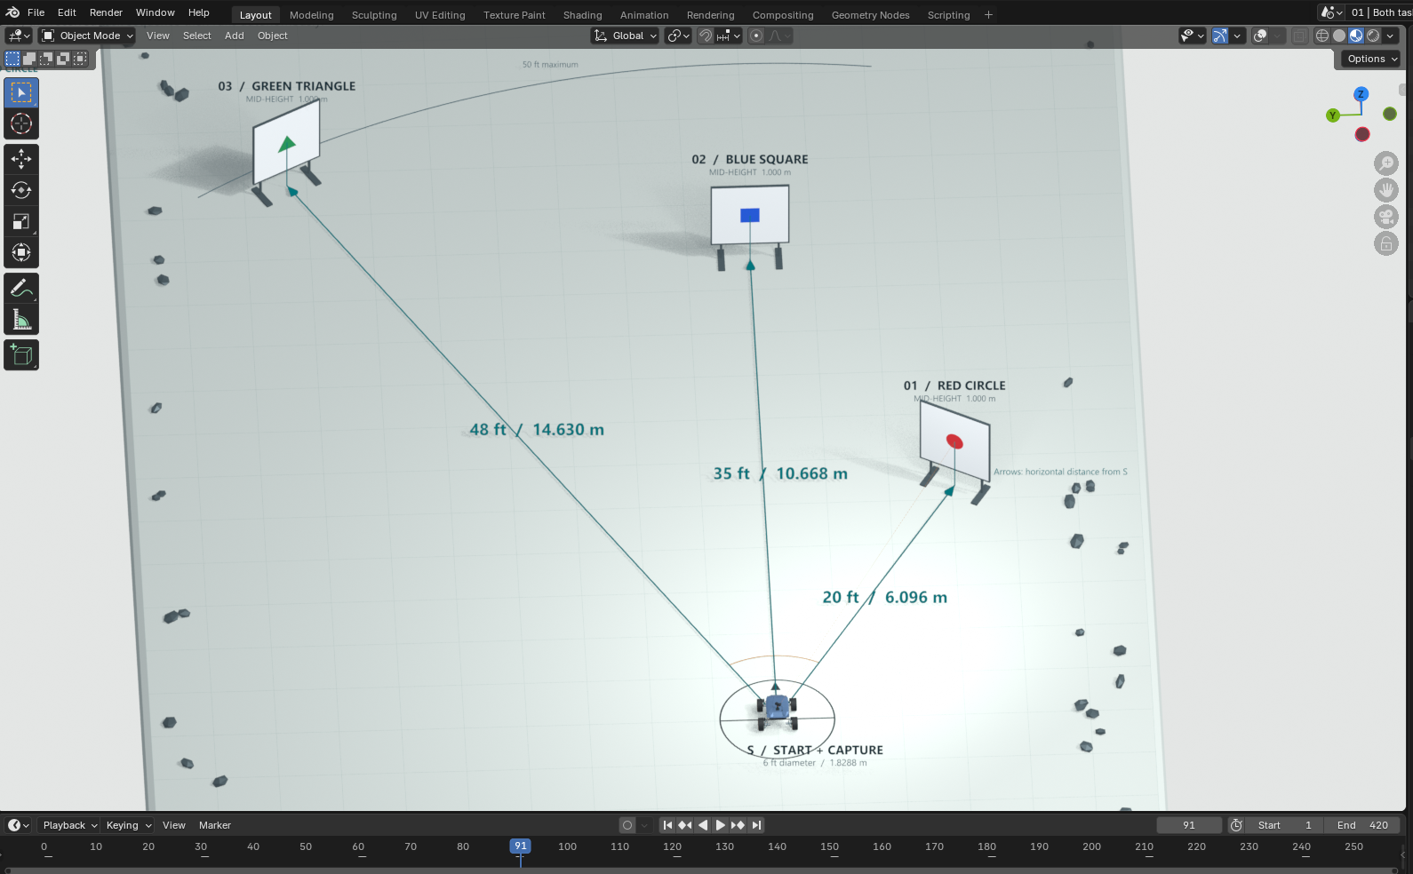
Fig 4.2: Three-Dimensional Task-Site Layout with Illustrative Target Distances; Created in Blender Animation

3.5 Major Technical Challenges and Possible Solutions
Challenge | Why it is hard for our team | Possible solution or approach | Decision point
Wheel and suspension strength | Our printed rims and tyres face impacts and side loads. | We will load-test one wheel assembly on gaps and rocks before printing all four. | 14 Nov 2026  Drawing release
Low mass with enough stiffness | Our estimate exceeds the 20 lb scoring target. | We will weigh assemblies and remove material only where strength tests allow. | 30 Jan 2027  Integration
Drive torque and speed | Motor torque, ESC ratings and full-charge speed need confirmation. | We will check loaded turning, current and stopping, then verify the speed limiter. | 30 Jan 2027  Rover tests
Live commands and radio reception | We must decode new commands while other hardware runs. | We will test unfamiliar APRS sequences with motors running and adjust antenna routing. | 30 Jan 2027  Integration
Accurate target ranging | Our camera and LiDAR may aim at different surfaces. | We will calibrate aiming and distance, retry failed readings, and flag unresolved results. | 30 Jan 2027  Calibration
Stable task power | Servo peaks and USB loads may cause Pi restarts. | We will check voltages with all loads running and test battery reserve through results review. | 30 Jan 2027  Integration
Imported component availability | Late parts could delay our planned 6 Nov bench checks. | We will confirm stock before ordering and check compatible alternatives if delivery slips. | 16 Oct 2026  Place orders
THE END

