

**Door System**

Documentation

**Implemented by:**

-**Ahmed Mohamed Genidi**

**-hammam mazen**

**-Mina Yousry**

**-Nouran Mamdouh**

**-Mohamed Anwar**

**Document Status**

|  |  |  |  |
| --- | --- | --- | --- |
| **Version** | **Status** | **Author** | **Date** |
| V 1.0 | Draft | Mina Yousry | 27/2/2020 |

**Document History**

|  |  |  |  |
| --- | --- | --- | --- |
| **Version** | **Author** | **Date** | **Change** |
| V 1.0 | Mina Yousry | 27/2/2020 | Initial creation |

## **Table of contents**

1. **Document status**
2. **Document History**
3. **layered Architecture**
4. **System APIs**

**Project Description:**

**layered Architecture:**

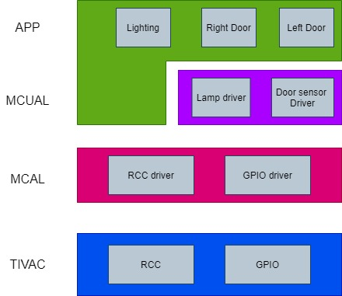

### **System APIs:**

**APP:**

**Left door**

|  |  |  |  |
| --- | --- | --- | --- |
| **API** | Error_Status LeftDoor_init(void) | | |
| **Description** |  | | |
| **Inputs** | Door Sensor | outputs | Lamp |

|  |  |  |  |
| --- | --- | --- | --- |
| **API** | Error_Status LeftDoor_GetStatus(uint8_t *DoorStatus) | | |
| **Description** |  | | |
| **Inputs** | Door Sensor | outputs | Lamp |

**Lighting:**

|  |  |  |  |
| --- | --- | --- | --- |
| **API** | Error_Status Lighting_init(void); | | |
| **Description** |  | | |
| **Inputs** | Door Sensor | outputs | Lamp |

|  |  |  |  |
| --- | --- | --- | --- |
| **API** | Error_Status Lighting_Control(uint8_t LampState); | | |
| **Description** |  | | |
| **Inputs** | Door Sensor | outputs | Lamp |

**Right door:**

|  |  |  |  |
| --- | --- | --- | --- |
| **API** | Error_Status RightDoor_init(void); | | |
| **Description** |  | | |
| **Inputs** | Door Sensor | outputs | Lamp |

|  |  |  |  |
| --- | --- | --- | --- |
| **API** | Error_Status RighttDoor_GetStatus(uint8_t *DoorStatus); | | |
| **Description** |  | | |
| **Inputs** | Door Sensor | outputs | Lamp |

**ECUAL:**

**Door Sensor**

|  |  |  |  |
| --- | --- | --- | --- |
| **API** | Error_Status DoorSensor_Init(void); | | |
| **Description** |  | | |
| **Inputs** | Door Sensor | outputs | Lamp |

|  |  |  |  |
| --- | --- | --- | --- |
| **API** | Error_Status DoorSensor_ReadStatus(uint8_t Sensor_Ch, uint8_t*state); | | |
| **Description** |  | | |
| **Inputs** | Door Sensor | outputs | Lamp |

**Lamp**

|  |  |  |  |
| --- | --- | --- | --- |
| **API** | Error_Status Lamp_Init(void); | | |
| **Description** |  | | |
| **Inputs** | Door Sensor | outputs | Lamp |

|  |  |  |  |
| --- | --- | --- | --- |
| **API** | Error_Status Lamp_Update(uint8_t Lamp_Ch, uint8_t State); | | |
| **Description** |  | | |
| **Inputs** | Door Sensor | outputs | Lamp |

**MCAL:**

**RCC:**

|  |  |  |  |
| --- | --- | --- | --- |
| **API** | Error_Status RRC_EnablePreph(preph_t Preph); | | |
| **Description** |  | | |
| **Inputs** | Door Sensor | outputs | Lamp |

**GPIO:**

|  |  |  |  |
| --- | --- | --- | --- |
| **API** | Error_Status GPIO_Init(uint8_t Port, uint8_t Pin, uint8_t Mode); | | |
| **Description** |  | | |
| **Inputs** | Door Sensor | outputs | Lamp |

|  |  |  |  |
| --- | --- | --- | --- |
| **API** | Error_Status GPIO_ReadPin(uint8_t Port, uint8_t Pin, uint8_t * Value); | | |
| **Description** |  | | |
| **Inputs** | Door Sensor | outputs | Lamp |

|  |  |  |  |
| --- | --- | --- | --- |
| **API** | Error_Status GPIO_WritePin(uint8_t Port, uint8_t Pin, uint8_t Value); | | |
| **Description** |  | | |
| **Inputs** | Door Sensor | outputs | Lamp |