Screenshot of installed java 8

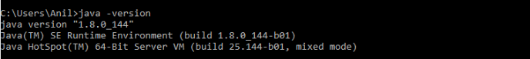

Screenshot of installed java 11

Screenshot of installed Java 13

3.5.1

3.5.2

