 | Ministry of Higher Education and Scientific Research  Directorate General of Technological Studies  Higher Institute of Technological Studies of Tozeur

ISET TOZEUR
ADAPTIVE DIGITAL OBSERVATORY

A Web-Based Platform for Data Integration,
Visualization, and AI-Powered Analysis
Graduation Report
2025-2026

Prepared by:
Noureddine Jabnouni
Supervised by:
Mr . Soufiene Ben Mahmoud
Department of Information Technology
Institut Supérieur des Études Technologiques de Tozeur

Table of Contents
Table of Contents 3
List of Figures 7
List of Tables 8
1. Introduction 9
1.1 Background 9
1.1.1 Tunisian Higher Education Context 10
1.2 Problem Statement 11
1.3 Objectives 13
1.4 Scope 14
1.5 Methodology 14
1.5.1 Technology Stack Details 15
1.6 Report Structure 15
2. System Architecture & Design 17
2.1 Overall Architecture 17
2.2 Technology Stack 18
2.2.1 Frontend Technology Details 20
2.2.2 Backend Technology Details 21
2.3 Frontend Architecture 21
2.3.1 Page Structure and Routing 22
2.4 Backend Architecture 23
2.5 Database Design 24
2.5.1 System Tables Detailed Schema 26
2.5.2 Dynamic Table Management 26
2.6 Deployment Architecture 27
2.7 Security Architecture 28
2.8 Design Decisions and Trade-offs 28
2.8 Institutional Context: ISET Tozeur 29
2.9 Use Case Analysis 30
3. Implementation 32
3.1 Authentication and User Management 32
3.1.1 Authentication Flow 32
3.1.2 User Management Features 33
3.2 Data Import System 34
3.2.1 Import Wizard Workflow 34
3.2.2 CSV Upload and Processing 35
3.2.3 Dynamic Table Creation 36
3.2.4 Import Results 37
3.2.5 Handling Edge Cases 37
3.3 Chart Builder 38
3.3.1 Architecture and Data Flow 38
3.3.2 Supported Chart Types 38
3.3.3 Chart Configuration Options 39
3.3.4 Chart Preview and Export 39
3.5.1 AI Integration Architecture 40
3.5.2 System Prompt Engineering 42
3.5.3 Query Types and Capabilities 42
3.6 Survey Module 42
3.6.1 Survey Builder 42
3.6.2 Survey Publishing and Response Collection 43
3.7 Report Generation 44
3.8 Theme System and Internationalization 45
3.8.1 Theme System 45
3.8.2 Internationalization 45
3.9 Notification System 46
3.10 Performance Considerations 46
3.11 Comparison with Existing Solutions 47
3.12 Scalability and Extensibility 49
3.13 API Documentation 49
4. Results and Screenshots 50
4.1 Landing Page and Authentication 50
4.2 Data Import Results 52
4.2.1 Detailed Import Walkthrough 57
4.2.2 Imported Dataset Summary 58
4.3 Database Explorer 58
4.4 Chart Builder Results 59
4.4.1 Chart Export Results 61
4.5 Dashboard Results 61
4.6 AI Analysis Results 63
4.7 Survey and Report Results 64
4.8 Theme and Internationalization 65
5. Conclusion 78
5.1 Summary of Achievements 78
5.2 Technical Contributions 79
5.3 Challenges and Solutions 79
5.4 Future Work 80
5.5 Conclusion 81
4.17 Quick User Guide 82
Appendix A: Complete API Reference 84
A.1 Authentication Endpoints 84
A.2 Dataset Endpoints 84
A.3 Chart Endpoints 85
A.4 Dashboard Endpoints 85
A.5 AI Analysis Endpoints 85
A.6 Survey Endpoints 86
A.7 Report Endpoints 86
A.8 User Management Endpoints 86
Appendix B: Testing Methodology 88
B.1 Test Approach 88
B.2 E2E Test Scenarios 88
B.3 Test Results Summary 89
Appendix C: CSV Data Specifications 90
C.1 students.csv 90
C.2 courses_results.csv 90
C.3 departments.csv 91
C.4 alumni_employment.csv 91
C.5 survey_feedback_2026.csv 91
C.6 employer_partners.csv 92
Appendix D: Deployment Guide 93
D.1 Prerequisites 93
D.2 Installation Steps 93
D.3 Production Deployment 93
D.4 Maintenance Commands 94
Appendix E: Platform Configuration Reference 95
D.1 Environment Variables 95
D.2 Color Schemes 95
D.3 Chart Configuration Parameters 96
Appendix F: Glossary 97
5.6 Ethical Considerations 97
5.7 Known Issues and Limitations 98
References 100

List of Figures
Figure 1: System Architecture Overview
Figure 2: Technology Stack Logos
Figure 3: Frontend and Backend Component Architecture
Figure 4: Database Class Diagram - Entity Relationships
Figure 5: Docker Deployment Architecture
Figure 6: ISET Tozeur Organizational Chart
Figure 7: Administrator Use Cases - Full Platform Access
Figure 8: Client User Use Cases - Limited Access
Figure 9: Authentication Sequence Diagram
Figure 10: Data Import Sequence Diagram - Complete Workflow
Figure 11: Data Import Activity Diagram
Figure 12: Chart Creation Sequence Diagram
Figure 13: AI Analysis Sequence Diagram
Figure 14: Survey Creation and Response Sequence Diagram
Figure 15: Landing Page - Platform Introduction
Figure 16: Login Form with Credential Fields
Figure 17: Admin Dashboard with Platform Statistics
Figure 18: Import Page - Initial Empty State
Figure 19: Import Step 1 - Review and Edit Column Headers
Figure 20: Import Step 2 - Configure Column Data Types
Figure 21: Import Step 3 - Preview Data Sample
Figure 22: Import Step 4 - Set Table Name and Execute
Figure 23: Import courses_results.csv - Step 1: Review Headers
Figure 24: Import departments.csv - Step 1 (note IdDept column)
Figure 25: Import alumni_employment.csv - Step 1
Figure 26: Import survey_feedback_2026.csv - Step 1
Figure 27: Import employer_partners.csv - Step 1 (no ID column)
Figure 28: All Six CSV Datasets Successfully Imported
Figure 29: Database Explorer Showing All Imported Tables
Figure 30: Table Data View with Pagination and Sorting
Figure 31: Chart Library - Grid View of All Saved Charts
Figure 32: Chart Detail View with PNG and JSON Export Buttons
Figure 33: Chart Builder Interface with Export Functionality
Figure 34: Dashboard Gallery Showing Both Dashboards
Figure 35: Dashboard Canvas with Six Charts in Grid Layout
Figure 36: Dashboard Canvas with PDF Export Feature
Figure 38: Survey List Showing Graduate Employment Survey
Figure 39: Reports List Showing Performance Analysis Report
Figure 40: Dark Theme - Ocean Color Scheme Settings
Figure 41: Dark Theme - Forest Color Scheme Settings
Figure 42: Dark Theme - Sunset Color Scheme Settings
Figure 43: Dark Theme - Lavender Color Scheme Settings
Figure 44: Dark Theme - Crimson Color Scheme Settings
Figure 45: Light Theme - Ocean (Default) Settings
Figure 46: Light Theme - Forest Settings
Figure 47: Light Theme - Sunset Settings
Figure 48: Light Theme - Lavender Settings
Figure 49: Dashboard in French Language
Figure 50: Import Page in French Language
Figure 51: Settings Page in French Language
Figure 52: Import History with All Six Datasets
Figure 53: User Management Page
Figure 54: Role Management with Permissions
Figure 55: Client User Management
Figure 56: Settings Page - Light Mode
Figure 57: Settings Page - Dark Mode with Sunset Theme
Figure 58: Notifications Panel
Figure 59: API Documentation Page
Figure 60: Public Dashboard View
Figure 61: Client Login Interface
Figure 62: Client Login Result

List of Tables
Table 1: Comparison of Available Solutions
Table 2: Complete Technology Stack
Table 3: Application Routes and Access Control
Table 4: System Database Tables - Complete Schema
Table 5: User Roles and Permissions
Table 6: Supported Chart Types with Use Cases
Table 7: Feature Comparison with Existing BI Platforms
Table 8: Complete Summary of All Imported CSV Datasets
Table 9: Authentication API Endpoints
Table 10: Dataset Management API Endpoints
Table 11: Chart Management API Endpoints
Table 12: Dashboard Management API Endpoints
Table 13: AI Analysis API Endpoints
Table 14: Survey Management API Endpoints
Table 15: Report Management API Endpoints
Table 16: User Management API Endpoints
Table 17: End-to-End Test Results Summary
Table 18: students.csv Column Specification
Table 19: courses_results.csv Column Specification
Table 20: departments.csv Column Specification
Table 21: alumni_employment.csv Column Specification
Table 22: survey_feedback_2026.csv Column Specification
Table 23: employer_partners.csv Column Specification
Table 24: Common Docker Compose Maintenance Commands
Table 25: Environment Variable Configuration
Table 26: Available Color Schemes
Table 27: Chart Configuration Parameters

1. Introduction

1.1 Background
In the rapidly evolving landscape of higher education, institutions around the world are increasingly turning to digital solutions to manage, analyze, and derive actionable insights from their growing volumes of institutional data. The modern educational ecosystem generates vast amounts of information across multiple domains:
• Student enrollment and academic records
• Course offerings and examination results
• Alumni tracking and employment outcomes
• Departmental performance metrics
• Employer partnership records
• Feedback and satisfaction surveys
The challenge facing most institutions is not a lack of data, but rather the absence of integrated systems that can bring these disparate data sources together into a unified analytical platform. Data is often locked in isolated systems, maintained by different administrative units, and accessible only to specific individuals. This fragmentation prevents the institution from developing a comprehensive understanding of its operations, student outcomes, and areas for improvement.
The Institut Supérieur des Études Technologiques (ISET) of Tozeur, Tunisia, is a higher education institution that offers specialized technological programs across multiple departments including:
• Computer Science (Informatique)
• Business Administration (Gestion)
• Biology (Biologie)
• Mechanical Engineering (Génie Mécanique)
Like many educational institutions in Tunisia and across the developing world, ISET Tozeur faces significant challenges in managing and leveraging its institutional data effectively. The lack of a centralized data platform means that strategic decisions are often made based on incomplete or outdated information.
The concept of a "Digital Observatory" addresses this gap by providing:
• A centralized, web-based platform for data integration
• Continuous monitoring and analysis of institutional metrics
• Interactive visualization and dashboarding capabilities
• AI-powered natural language querying
• Role-based access for different stakeholder groups
The term "Adaptive" in the platform's name reflects its ability to dynamically adapt to new data sources, changing user requirements, and evolving analytical needs. Unlike traditional business intelligence solutions that require extensive configuration and technical expertise, the Adaptive Digital Observatory is designed to be accessible to non-technical users while providing powerful analytical capabilities.
The digital transformation of higher education is driven by several key factors:
• Data Availability: The proliferation of learning management systems, student information systems, and administrative databases has created unprecedented opportunities for data-driven decision-making.
• Technology Maturation: Modern web frameworks like React and deployment solutions like Docker have made it feasible to build sophisticated analytical platforms with minimal infrastructure.
• AI Advancement: Large language models (LLMs) have opened new possibilities for natural language interaction with data, democratizing access to insights that were previously available only to data scientists.
• Cost Reduction: Open-source technologies have eliminated the licensing costs that traditionally made BI tools prohibitive for educational institutions in developing countries.
This project addresses the specific needs of ISET Tozeur while also serving as a reference implementation that can be adapted by other educational institutions. The platform's modular architecture, open-source technology stack, and containerized deployment make it both extensible and maintainable. By combining data import, visualization, and AI-powered analysis in a single platform, the Adaptive Digital Observatory provides a comprehensive solution that moves beyond simple data reporting to enable true data-driven decision-making.

1.1.1 Tunisian Higher Education Context
Tunisia's higher education system comprises 13 universities and over 200 higher education institutions, serving approximately 650,000 students annually. The Institut Supérieur des Études Technologiques (ISET) network, established in the early 2000s, plays a crucial role in providing applied technological education. With 24 ISET institutions distributed across Tunisia, the network educates over 60,000 students in fields spanning computer science, engineering, business, and applied sciences.
The Tunisian Ministry of Higher Education and Scientific Research has identified digital transformation as a strategic priority, launching initiatives such as the "Université Numérique" (Digital University) program to modernize administrative processes and improve data-driven decision-making. However, implementation at the institutional level remains uneven, with many institutions still relying on manual processes, spreadsheets, and disconnected software systems for data management.
ISET Tozeur, located in the oasis city of Tozeur in southwestern Tunisia, serves approximately 1,500 students across four departments. The institution faces unique challenges due to its geographic location, including limited access to specialized technical expertise and infrastructure constraints common to institutions in the country's interior regions. The need for a self-hosted, low-maintenance data platform that can operate effectively with limited IT support was a key motivator for this project.
The current data management landscape at ISET Tozeur consists of:
• Student records maintained in Excel spreadsheets by the Registrar's office
• Academic results stored in a legacy desktop application with no web interface
• Alumni data collected through paper forms and stored in physical files
• Employer partnership information managed informally by department heads
• Survey feedback collected on paper and manually tabulated
This fragmented approach means that generating a simple report, such as graduation rates by department or employment outcomes by program, requires manually collecting and reconciling data from multiple sources, a process that can take days or weeks.

1.2 Problem Statement
ISET Tozeur currently lacks a centralized, web-based platform that can address the following critical needs:
1. Data Import and Integration: The institution needs the ability to import data from various sources through an intuitive interface. Currently, data is siloed across different departments and administrative units, stored in formats ranging from Excel spreadsheets to CSV exports from legacy systems. Staff members who need to work with this data often lack the technical skills required to use database management tools or programming languages like Python or R for data analysis.
2. Dynamic Table Management: The platform must be able to dynamically create and manage database tables without requiring users to have knowledge of SQL or database administration. When a user uploads a CSV file containing student grades, for example, the system should automatically detect the column types, suggest appropriate data types, and create a properly structured database table without any manual intervention beyond confirming the suggested configuration.
3. Interactive Visualization: The institution requires interactive visualization and dashboarding capabilities that can transform raw data into meaningful visual representations. Users should be able to create bar charts, line graphs, pie charts, and other visualization types with just a few clicks, selecting the data columns they want to visualize and the type of chart that best represents their data.
4. AI-Powered Analysis: The platform should offer AI-powered natural language querying capabilities that allow users to ask questions about their data in plain English or French and receive intelligent, context-aware responses. For example, a department head should be able to ask "What is the average graduation rate for Computer Science students over the past five years?" and receive an answer supported by the actual data stored in the platform.
5. Survey and Report Generation: The institution needs survey creation and report generation modules that can collect feedback from students, alumni, and other stakeholders, and generate structured reports based on the collected data. These modules should be flexible enough to accommodate different types of surveys and reports while maintaining a consistent user experience.
6. Role-Based Access Control: The platform must provide role-based access control with distinct admin and client portals. Different users within the institution have different data access needs and permissions. Administrators need full access to all features, while client users (such as students and alumni) should have limited access focused on their specific needs, such as viewing public dashboards and completing surveys.
Comparative Analysis of Existing Solutions:
Existing solutions in the market present significant limitations when evaluated against these requirements. The following table compares the key platforms considered:
Platform | Cost | CSV Import | AI Queries | Surveys | Client Portal | Setup Complexity
Tableau | ≥$70/user/mo | Basic | Ask Data (limited) | No | Yes | High
Power BI | ≥$10/user/mo | Basic | Copilot (premium) | No | Yes | Medium
Metabase | Free / $5k/yr | Yes | No | No | No | Medium
Apache Superset | Free | Yes | No | No | No | High
ISET Observatory | Free (OSS) | Advanced + 4-step wizard | Yes (Groq LLM) | Yes | Yes | Low (Docker)
Table 1: Comparison of Available Solutions

As the table demonstrates, the ISET Adaptive Digital Observatory offers a unique combination of features not found in any single existing platform, particularly the AI-powered querying, survey module, and dedicated client portal, all at zero licensing cost.

1.3 Objectives
The primary objectives of this project are:
Objective 1: Design and implement a web-based Adaptive Digital Observatory platform for ISET Tozeur that provides a unified interface for data management, visualization, and analysis. The platform should be built using modern web technologies and follow best practices for software architecture, security, and user experience.
Objective 2: Develop an intuitive data import system that supports CSV file uploads with automatic table creation. The system should include a multi-step wizard that guides users through the import process, providing previews and configuration options at each step. The system should handle various edge cases including different column naming conventions, data type detection, and error handling.
Objective 3: Create interactive chart and dashboard builders for visualizing imported data. The chart builder should support at least six different chart types with configuration options for axes, aggregation functions, color schemes, and labels. The dashboard builder should allow users to organize multiple charts on a single canvas with drag-and-drop layout management.
Objective 4: Integrate AI-powered natural language querying using Large Language Models (LLMs) through the Groq API. The AI module should understand questions in natural language, map them to the available data schema, generate appropriate database queries, and present results in a human-readable format with optional chart visualizations.
Objective 5: Implement survey generation and report creation modules. The survey module should support multiple question types and public response collection. The report module should allow users to create structured reports with sections, headings, and embedded data.
Objective 6: Provide role-based access control with distinct admin and client portals. The system should support multiple user roles with different permission levels, including super_admin, admin, staff, and client roles.
Objective 7: Support internationalization with English and French interfaces, allowing users to switch between languages seamlessly. All UI text, including navigation, forms, tables, and tooltips, should be translated into both languages.
Objective 8: Deploy the platform using Docker containers for portability and scalability. The deployment should include separate containers for the frontend, backend, and database, connected through a secure Docker network.

1.4 Scope
The scope of this project encompasses the full software development lifecycle of a web application built with React 18 and TypeScript on the frontend and Node.js/Express with TypeScript on the backend, using PostgreSQL 15 as the database. The platform is containerized using Docker and Docker Compose for easy deployment and scalability.
The project covers the following functional modules: (1) user authentication and management, (2) CSV data import with dynamic table creation, (3) chart building with eight chart types, (4) dashboard creation with grid-based layout, (5) AI-powered natural language analysis, (6) survey generation and response collection, (7) report creation, (8) theme management with eight color schemes across light and dark modes, (9) internationalization with English and French, (10) notification system, (11) public dashboard access, and (12) client portal.
The project does not cover the following: real-time data synchronization with external systems, mobile native applications, advanced machine learning predictive models, or integration with specific external APIs beyond the Groq AI service.

1.5 Methodology
The project follows an agile development methodology with iterative sprints, each lasting two weeks. This approach was chosen because it allows for flexibility in requirements, continuous feedback, and incremental delivery of working software. The development process was organized into six sprints:
Sprint 1 - Authentication and User Management: Implementation of user registration, login, JWT token management, password hashing with bcrypt, role-based access control, and user CRUD operations. This sprint established the foundational security infrastructure for the entire platform.
Sprint 2 - Data Import Engine: Development of the CSV upload system, including file handling with Multer, CSV parsing with csv-parse, automatic data type detection algorithm, dynamic table creation service, and the four-step import wizard interface. This sprint was critical because the data import capability is a core differentiator of the platform.
Sprint 3 - Chart and Dashboard Builders: Implementation of the chart creation interface supporting eight chart types, Chart.js integration, real-time preview, chart saving and management, dashboard creation with grid layout, drag-and-drop chart arrangement, and export functionality (PNG, JSON, PDF).
Sprint 4 - AI Integration: Development of the AI analysis module, including Groq API integration, intent analysis pipeline, database schema-aware context building, SQL query generation, response formatting, and the chat-style user interface for natural language interaction.
Sprint 5 - Survey and Report Modules: Implementation of the survey builder with support for seven question types, survey publishing workflow, public response collection, result aggregation and visualization, report generation with structured sections, and QR code generation for survey distribution.
Sprint 6 - Portals, Themes, and Internationalization: Development of the public dashboard portal, client user portal, theme system with eight color schemes across light and dark modes, complete English and French translations, notification system, API documentation page, and final integration testing.
Testing was performed continuously throughout the development process. Unit tests were written for critical backend services including authentication, data import, and AI analysis. End-to-end testing was performed using Playwright to verify complete user workflows including login, data import, chart creation, and dashboard management. The final testing phase included importing six real-world CSV datasets and verifying all features work correctly.

1.5.1 Technology Stack Details
The frontend was built using React 18 with TypeScript, providing strong type safety and developer tooling through features like interfaces, generics, and compile-time error detection. Vite serves as the build tool, offering fast hot-module replacement during development and optimized production builds with code splitting. The user interface leverages the Ant Design 5 component library, which provides a comprehensive set of pre-built UI components following enterprise design patterns.
On the backend, Express.js with TypeScript provides the API layer, implementing RESTful endpoints following standard HTTP conventions. The pg library connects to PostgreSQL 15 using a connection pool that manages up to 20 concurrent database connections, significantly improving performance under load compared to creating new connections for each request.
Containerization with Docker ensures environment consistency across the development, testing, and deployment stages. Each service (frontend, backend, database) runs in its own container, with Docker Compose managing the network configuration, volume mounts for persistent data storage, and environment variables for configuration.

1.6 Report Structure
This report is organized into five chapters and a references section. Chapter 1 (this chapter) introduces the project background, problem statement, objectives, scope, and development methodology. Chapter 2 presents the system architecture, design decisions, technology stack, database design, deployment architecture, security considerations, and use case analysis. Chapter 3 details the implementation of each module with technical explanations, algorithms, and design patterns. Chapter 4 showcases the results through screenshots of every major feature, exported chart and dashboard files, and system diagrams including an organizational chart of ISET Tozeur. Chapter 5 concludes the report with a summary of achievements, technical contributions, challenges encountered, and suggestions for future work. The References section lists all technologies, libraries, and resources used in the project.

2. System Architecture & Design

2.1 Overall Architecture
The ISET Adaptive Digital Observatory follows a three-tier architecture comprising a React-based frontend presentation layer, an Express/Node.js backend application layer, and a PostgreSQL database layer. This architecture was chosen because it provides clear separation of concerns, enables independent scaling of each tier, and supports the development workflow where frontend and backend can be developed and tested independently.
All three tiers are containerized using Docker, ensuring consistent deployment across development, testing, and production environments. The use of Docker Compose orchestrates the three containers, managing networking, volume mounts for persistent data, and environment-specific configuration through environment variables.
The frontend is a single-page application (SPA) built with React 18 and TypeScript, served by Vite during development and compiled to static files for production deployment. The SPA architecture means that after the initial page load, all subsequent user interactions are handled locally in the browser, with API calls to the backend for data operations. This provides a responsive user experience similar to a native desktop application.
The backend is a RESTful API built with Express.js and TypeScript. It handles all business logic, data processing, authentication, and integration with external services (specifically the Groq AI API). The backend communicates with the PostgreSQL database using the pg (node-postgres) library with connection pooling for efficient database access.
Communication between the frontend and backend occurs exclusively through HTTP REST calls. The frontend uses Axios as its HTTP client, sending JSON-formatted requests and receiving JSON responses. Authentication is handled through JWT tokens sent in the Authorization header of each request. File uploads (CSV files) are sent as multipart/form-data using the FormData API.
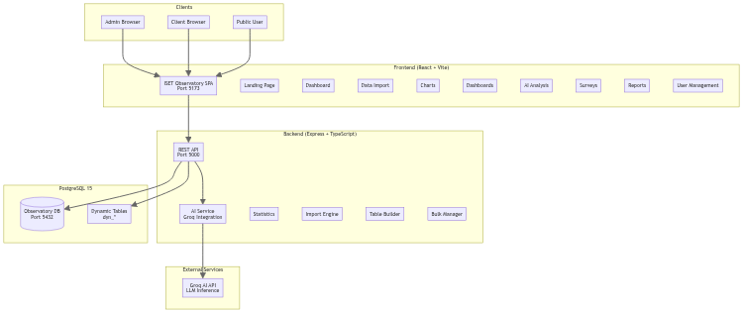
Figure 1: System Architecture Overview
The architecture diagram above illustrates the three-tier structure. Clients (admin browsers, client browsers, and public users) access the frontend SPA through their web browsers. The frontend communicates with the backend API, which in turn interacts with the PostgreSQL database and the external Groq AI service. This clean separation ensures that each tier can be maintained, updated, and scaled independently.

2.2 Technology Stack
The technology stack was carefully selected based on several criteria: suitability for the project requirements, community support and documentation, long-term maintainability, performance characteristics, and cost (all chosen technologies are open-source or have generous free tiers). The following table provides a comprehensive overview of all technologies used in the project.
Component | Technology | Version | Purpose
Frontend Framework | React | 18.x | UI component library and state management
UI Component Library | Ant Design | 5.x | Design system, components, and theming
Programming Language | TypeScript | 5.x | Type safety and developer experience
Charting Library | Chart.js + react-chartjs-2 | 4.x | Interactive data visualizations on Canvas
Internationalization | i18next | 23.x | Multi-language support (EN/FR)
HTTP Client | Axios | 1.x | API communication with interceptors
Build Tool | Vite | 5.x | Frontend bundling, HMR, and dev server
Backend Framework | Express.js | 4.x | REST API server with middleware
Database | PostgreSQL | 15 | Primary relational data store
Database Client | pg (node-postgres) | 8.x | Database connectivity with connection pooling
Authentication | jsonwebtoken + bcrypt | 9.x | JWT token generation and password hashing
AI Integration | Groq SDK | latest | LLM inference via Groq API
File Upload | Multer | 1.x | Multipart form data handling for CSV uploads
CSV Parsing | csv-parse | 5.x | CSV file parsing with type detection
Containerization | Docker Compose | latest | Container orchestration and deployment
E2E Testing | Playwright | latest | Browser automation and integration testing
Table 2: Complete Technology Stack

The following figures show the logos of the key technologies used in the project:
  React 18 - Frontend Framework |   TypeScript - Programming Language |   Node.js - Runtime Environment |   Docker - Containerization Platform

  PostgreSQL 15 - Database |   Chart.js - Visualization Library |   Ant Design 5 - UI Component Library

Figure 2: Technology Stack Logos

2.2.1 Frontend Technology Details
React 18 was chosen as the frontend framework because of its component-based architecture, large ecosystem, and strong TypeScript support. The introduction of automatic batching and concurrent features in React 18 provides performance benefits for complex UIs like the chart builder and dashboard canvas.
Ant Design 5 provides a comprehensive library of over 60 UI components including tables, forms, modals, buttons, layouts, and navigation elements. Its theming system, based on CSS-in-JS tokens, enables the dynamic theme switching feature. The components are designed with accessibility in mind and follow consistent design patterns.
Chart.js 4 with the react-chartjs-2 wrapper was selected for data visualization because it provides eight different chart types, runs on HTML5 Canvas for high performance, has excellent documentation, and supports the customization options needed for the chart builder. The library is lightweight (approximately 60KB gzipped) and does not require additional dependencies like D3.js.
i18next is the most popular internationalization framework for JavaScript applications. It supports nested translation keys, interpolation, pluralization, and language detection. For this project, translation files are organized by module (auth, import, charts, dashboards, etc.) to maintain manageable file sizes.

2.2.2 Backend Technology Details
Express.js 4 with TypeScript provides the foundation for the REST API. The middleware architecture of Express allows for clean separation of concerns: CORS middleware handles cross-origin requests, JSON body parser handles request bodies, authentication middleware validates JWT tokens, and route handlers implement business logic.
The pg library (node-postgres) provides direct database access with connection pooling. A pool of 20 connections is maintained by default, which is sufficient for the expected concurrent user load. All database queries use parameterized statements to prevent SQL injection attacks.
The Groq SDK provides access to the Groq API, which offers fast LLM inference through their custom LPU (Language Processing Unit) hardware. The API supports multiple models including Llama 3, Mixtral, and Gemma. For this project, the Mixtral 8x7B model was selected for its strong performance on analytical and SQL generation tasks.

2.3 Frontend Architecture
The frontend follows a component-based architecture using React 18 with functional components and hooks. This modern approach to React development avoids the complexity of class components while providing all necessary capabilities through hooks like useState, useEffect, useCallback, and useMemo.
State management is handled through a combination of approaches. Global state (authentication, theme, language, notifications) is managed through React Context API with dedicated context providers that wrap the application. Local component state is managed with useState hooks, with useReducer used for complex state logic in components like the chart builder and survey generator.
Routing is implemented using React Router v6, which provides declarative routing with nested routes, layout routes, and protected route components. The route structure follows the page hierarchy: public routes (/, /login, /public), authenticated routes (/dashboard, /import, /charts, etc.), and role-specific routes (/admin/*, /client/*). A ProtectedRoute component wraps routes that require authentication and redirects unauthenticated users to the login page.
The UI follows Ant Design 5's design system with customizations for the institutional branding of ISET Tozeur. The layout consists of a fixed sidebar navigation (collapsible), a top header with user menu and notifications, and a content area that changes based on the active route. The sidebar adapts its menu items based on the user's role, showing only authorized pages.
The platform supports theming through Ant Design's ConfigProvider with custom theme tokens. Users can switch between light and dark modes with eight color schemes: Ocean (blue-based), Forest (green-based), Sunset (orange-based), Lavender (purple-based), Pastel (soft colors), Vibrant (bold colors), Earth (brown-based), and Mono (grayscale). Theme preferences are persisted in localStorage and applied on subsequent visits.
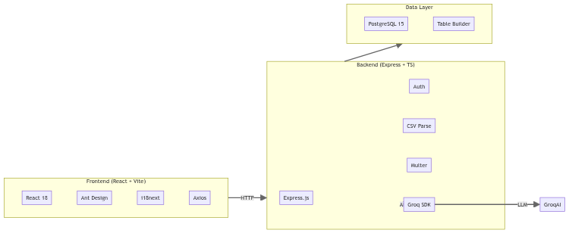
Figure 3: Frontend and Backend Component Architecture
The component diagram above illustrates the key technology components organized by tier. The frontend layer shows React 18 as the core framework, with Ant Design 5 for UI components, Chart.js for visualizations, i18next for translations, and Axios for HTTP communication. The backend layer shows Express.js with its middleware stack including JWT authentication, Multer for file uploads, CSV parsing, and Groq SDK integration. The data layer shows the connection to PostgreSQL 15 through the pg library with connection pooling.

2.3.1 Page Structure and Routing
Route | Component | Access | Description
/ | LandingPage | Public | Platform landing/introduction page
/login | LoginPage | Public | User authentication form
/dashboard | DashboardPage | Auth | Main dashboard with statistics
/import | DataImportPage | Auth | CSV upload and import wizard
/explore | DatabaseExplorerPage | Auth | Browse tables and data
/relations | RelationsPage | Auth | View foreign key relationships
/charts | ChartBuilderPage | Auth | Create and manage charts
/dashboards | DashboardGalleryPage | Auth | Dashboard gallery
/dashboards/:id | DashboardCanvasPage | Auth | Individual dashboard canvas
/ai | AIAnalysisPage | Auth | AI natural language query interface
/surveys | SurveyGeneratorPage | Auth | Survey creation and management
/reports | ReportsPage | Auth | Report generation and viewing
/users | UsersPage | Admin | User management (CRUD)
/roles | RolesPage | Admin | Role and permission management
/clients | ClientsPage | Admin | Client user management
/settings | SettingsPage | Auth | Profile and preference settings
/notifications | NotificationsPage | Auth | Notification center
/docs | DocsPage | Auth | API documentation
/public | PublicDashboardPage | Public | Public dashboard view
/public/surveys/:id | PublicSurveyPage | Public | Public survey form
Table 3: Application Routes and Access Control

2.4 Backend Architecture
The backend is structured as a modular Express.js application following the service layer pattern. This architecture separates concerns into three layers: routes (HTTP handling), controllers (request/response orchestration), and services (business logic). The service layer encapsulates all database operations and external API integrations, providing a clean interface for controllers.
Key backend modules and their responsibilities:
Auth Module: Handles user registration (POST /api/auth/register), login (POST /api/auth/login), and profile retrieval (GET /api/auth/profile). Passwords are hashed using bcrypt with a salt round factor of 10. JWT tokens include the user ID, role, and user type in the payload, with a token expiration of 24 hours. The auth middleware validates tokens on every protected route by decoding the JWT and attaching the user information to the request object.
Dataset Module: Manages the complete lifecycle of imported datasets. Upload (POST /api/datasets/upload) saves the CSV file using Multer and creates a dataset record with "uploaded" status. Preview (GET /api/datasets/{id}/preview) parses the first 100 rows for column type detection. Import (POST /api/datasets/{id}/import) triggers the dynamic table creation and bulk data insertion. Delete (DELETE /api/datasets/{id}) removes the dataset record and drops the corresponding dynamic table from the database.
Chart Module: Provides CRUD operations for chart configurations. The create endpoint (POST /api/charts) saves the chart title, type, dataset ID, and configuration JSON. The render endpoint (GET /api/charts/{id}/data) executes the chart query against the database and returns the formatted data for Chart.js rendering. The service constructs SQL queries dynamically based on the chart configuration, applying the appropriate aggregation function and grouping.
Dashboard Module: Manages dashboard records with their chart layouts. Each dashboard stores a JSON layout array containing chart IDs and their grid positions (x, y, width, height). The canvas rendering endpoint fetches all charts in the dashboard and returns their rendered data.
AI Module: The most complex module, handling natural language queries. The ask endpoint (POST /api/ai/ask) receives a question and optional conversation history. The AI service performs intent analysis, builds a context containing the database schema and relevant data, sends the request to the Groq API, and returns the formatted response with optional chart data.
Survey Module: Handles survey creation, publishing, response collection, and result aggregation. Surveys can be targeted to specific user types and made public for anonymous responses. The response endpoint validates submissions against the survey schema before storing.
Report Module: Generates structured reports with user-defined content sections. Reports can include embedded data summaries and chart references. The generation engine compiles the sections into a formatted document.
User Management Module: Provides full CRUD operations for users with role and user type assignment. The module also manages role definitions with granular permission settings for each platform feature.

2.5 Database Design
The database schema follows a hybrid design that combines traditional relational tables for system metadata with dynamically created tables for user-imported data. This approach provides the structure and consistency of a relational database for application data while maintaining the flexibility needed to accommodate arbitrary user data schemas.
The system tables store all application metadata including user accounts, dataset definitions, chart configurations, dashboard layouts, survey schemas, and report content. These tables are created during the initial database migration and follow a fixed schema that is known to the application code.
Dynamic tables, prefixed with dyn_, are created on-the-fly when users import CSV datasets. Each imported dataset gets its own table with columns matching the CSV headers and data types determined by the type detection algorithm. The table name follows the pattern dyn_{dataset_id}_{sanitized_name} to ensure uniqueness. When a dataset is deleted, its corresponding dynamic table is dropped from the database.
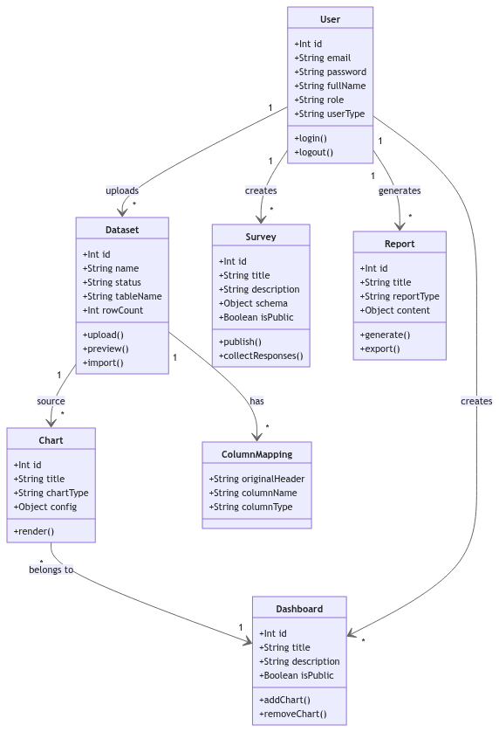
Figure 4: Database Class Diagram - Entity Relationships
The class diagram above shows the main entities and their relationships. The User entity has a one-to-many relationship with Datasets (uploaded files), which in turn serve as the source for multiple Charts. Charts belong to Dashboards through layout configurations that specify position and size. Users also create Surveys and Reports. Each Dataset has a corresponding dynamic table that stores the actual imported data rows.

2.5.1 System Tables Detailed Schema
Table Name | Description | Key Columns
users | Platform user accounts | id, email, password_hash, full_name, role, user_type, created_at, updated_at
datasets | Imported data source metadata | id, name, file_name, status, table_name, row_count, columns, user_id, created_at
charts | Chart configuration storage | id, title, chart_type, config (JSONB), dataset_id, user_id, created_at, updated_at
dashboards | Dashboard definitions | id, title, description, layout (JSONB), is_public, user_id, created_at
surveys | Survey schema storage | id, title, description, goal, schema (JSONB), is_public, client_types, user_id, created_at
survey_responses | Submitted survey answers | id, survey_id, responses (JSONB), respondent_id, submitted_at
reports | Generated report content | id, title, report_type, content (JSONB), user_id, created_at
notifications | User notifications | id, user_id, title, message, type, read, created_at
roles | Role definitions | id, name, description, permissions (JSONB)
column_mappings | CSV column mapping metadata | id, dataset_id, original_header, column_name, column_type
Table 4: System Database Tables - Complete Schema

2.5.2 Dynamic Table Management
The Table Builder service is responsible for creating and managing dynamic tables. When a user initiates an import, the service performs the following steps: (1) sanitizes the table name by removing special characters and converting to lowercase, (2) generates a CREATE TABLE statement with columns matching the CSV structure, (3) adds an auto-incrementing id SERIAL primary key column (unless the CSV already contains an id column), (4) executes the CREATE TABLE statement, and (5) performs a bulk INSERT of all data rows using parameterized queries.
The column type detection algorithm analyzes sample rows from the CSV to determine the most appropriate PostgreSQL data type for each column. The algorithm checks, in order of specificity: boolean (values like true/false, yes/no, 0/1), integer (whole numbers), float (decimal numbers), date (date-like patterns), and text (catch-all). The user can override any detected type during step 2 of the import wizard.

2.6 Deployment Architecture
The application deployment uses Docker Compose to orchestrate three containers: observatory-frontend (React SPA served by Vite), observatory-backend (Express API), and observatory-db (PostgreSQL 15). All containers are connected through a dedicated Docker bridge network (observatory-net) that enables secure inter-container communication.
The frontend container runs a Vite development server that provides hot module replacement during development and serves compiled static files in production. The backend container runs the Express API with ts-node-dev for TypeScript compilation and auto-restart during development. The database container runs PostgreSQL 15 with a persistent volume for data storage.
Environment-specific configuration is managed through environment variables defined in the docker-compose.yml file and .env files. Key configuration parameters include database credentials, JWT secret key, Groq API key, and port mappings. Environment variables are never hardcoded in the application source code, following security best practices.
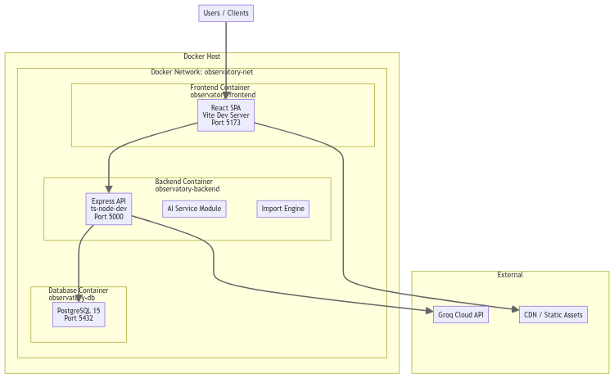
Figure 5: Docker Deployment Architecture
The deployment diagram above illustrates the Docker-based architecture. All three containers run on the same Docker host and communicate through the internal Docker network. The frontend listens on port 5173 (mapped to host), the backend on port 5000, and the database on port 5432 (internal only, not exposed to the host). The Groq API is accessed externally through HTTPS.

2.7 Security Architecture
The platform implements multiple security layers to protect user data and system integrity. These layers address authentication, authorization, data protection, and common web vulnerabilities.
Authentication: User passwords are hashed using bcrypt with a salt round factor of 10, making brute-force attacks computationally expensive. JWT tokens are signed with a secret key and include expiration (24 hours by default). The token also contains the user role and user type for efficient authorization checks without additional database queries.
Authorization: Role-based access control (RBAC) restricts access to features based on the user's role. Four roles are defined: super_admin (full system access including user management), admin (administrative access without system configuration), staff (limited operational access), and client (restricted to public-facing features). The backend middleware checks role permissions before processing any request.
Data Protection: All API responses are validated before transmission to prevent information leakage. Parameterized SQL queries (using pg library's $1, $2 syntax) prevent SQL injection attacks. CORS middleware restricts API access to allowed origins, preventing cross-origin request forgery.
File Upload Security: Uploaded CSV files are validated for type (.csv extension), size (limited to 50MB), and content (schema validation during preview). Files are stored in a dedicated uploads directory outside the application source tree and are never directly accessible via URL.
Additional Security Measures: Rate limiting on authentication endpoints prevents brute-force login attempts. Input sanitization is applied to all user-submitted data before storage or display. Session management includes token refresh capabilities and forced logout on password change.

2.8 Design Decisions and Trade-offs
Several important design decisions were made during the development of the platform. This section documents these decisions and the rationale behind them.
Decision 1 - Single-Page Application vs. Server-Side Rendering: The decision to build a single-page application (SPA) with React was driven by the need for a highly interactive user experience. The chart builder, dashboard canvas, and AI chat interface all require real-time updates and smooth transitions that are difficult to achieve with traditional server-rendered pages. The trade-off is a longer initial load time and the need to handle client-side routing, but the benefits for user experience outweigh these costs.
Decision 2 - REST API vs. GraphQL: REST was chosen over GraphQL for the API architecture. The platform has well-defined data access patterns (CRUD operations on entities) that map naturally to REST endpoints. GraphQL would add complexity without significant benefits for this use case. The REST API is simpler to implement, document, and debug, and it leverages standard HTTP features like caching and status codes.
Decision 3 - Direct PostgreSQL Access vs. ORM: The decision to use the pg library directly rather than an ORM like Sequelize or TypeORM was made for several reasons. The dynamic table creation feature requires building SQL statements dynamically, which is awkward with most ORMs. Direct SQL access also provides better performance for the bulk insert operations required during data import, and allows full utilization of PostgreSQL-specific features.
Decision 4 - Chart.js vs. D3.js: Chart.js was chosen over D3.js for the visualization layer because it provides a higher-level API that requires less code to create common chart types. Chart.js offers eight built-in chart types with configuration options that cover the platform's needs. D3.js would provide more flexibility for custom visualizations but would significantly increase development time and code complexity.
Decision 5 - Groq API vs. OpenAI: Groq was chosen over OpenAI for the AI integration because of its significantly faster inference speed. The Groq LPU hardware provides response times of 100-500ms for typical queries, compared to 2-5 seconds for OpenAI's GPT models. This speed difference is critical for the interactive chat-style interface where users expect near-instant responses.
Decision 6 - Dynamic Tables vs. JSONB Storage: The decision to create actual database tables for imported data (rather than storing everything in a single JSONB column) was made to enable proper SQL querying, indexing, and type enforcement. Dynamic tables allow users to run arbitrary SQL queries, create charts with proper aggregations, and maintain data integrity through type constraints. The trade-off is the need to manage table creation and dropping, but this is handled transparently by the Table Builder service.

2.8 Institutional Context: ISET Tozeur
The Institut Supérieur des Études Technologiques de Tozeur (ISET Tozeur) is a public higher education institution established to provide specialized technological training in Southern Tunisia. The institution serves approximately 1,500 students across four academic departments and employs over 100 faculty and administrative staff.
The organizational structure of ISET Tozeur follows the standard ISET framework with a Director at the helm, supported by Vice Directors for Academic Affairs and Administration. The academic departments (Computer Science, Business Administration, Biology, Mechanical Engineering) are each led by a Department Head who reports to the Vice Director of Academic Affairs. Administrative services including the Registrar, Finance, Student Affairs, and IT Support report to the Vice Director of Administration.
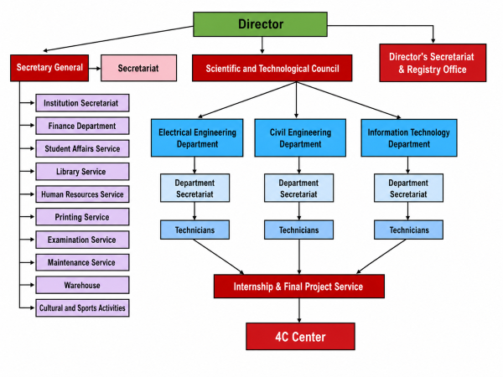
Figure 6: ISET Tozeur Organizational Chart
The organizational chart above illustrates the hierarchical structure. This structure informed the design of the platform's role-based access control system, where different user types (faculty, department heads, administrators, students) require different levels of access to institutional data.

2.9 Use Case Analysis
The platform supports two primary user roles with different functional scopes. The following use case diagrams illustrate the complete set of interactions available to each role. The Administrator has access to 14 use cases covering all platform features, while the Client user has access to 6 use cases limited to viewing and interaction.
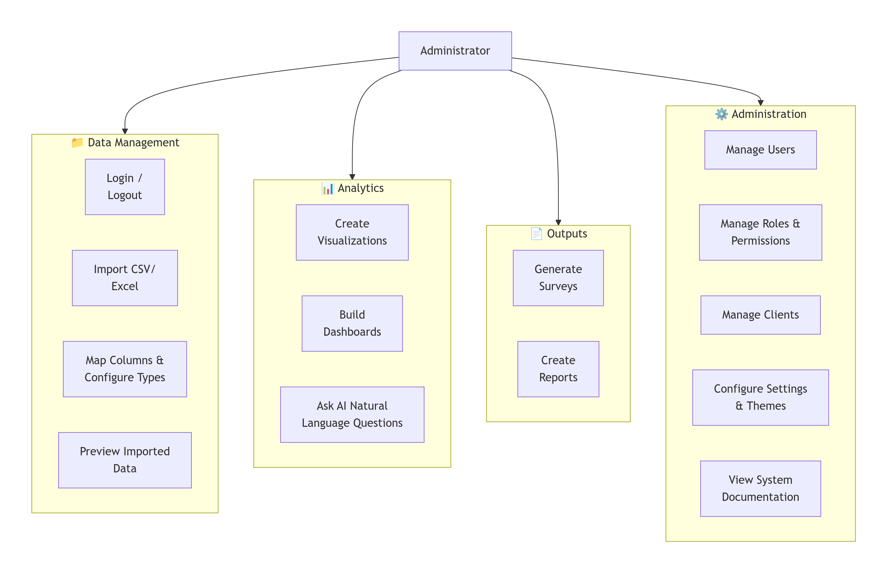
Figure 7: Administrator Use Cases - Full Platform Access
The administrator use case diagram shows the full range of platform capabilities. Administrators can import data, create visualizations, build dashboards, ask AI questions, generate surveys, create reports, manage users and roles, configure settings, and view documentation. This comprehensive set of capabilities enables administrators to manage the entire data lifecycle from import to insight generation.
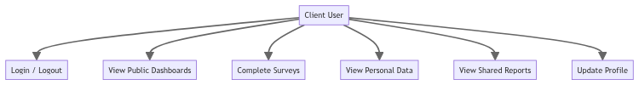
Figure 8: Client User Use Cases - Limited Access
The client use case diagram shows the restricted set of capabilities available to client users. Clients can log in, view public dashboards, complete surveys, view their personal data, view shared reports, and update their profile. This limited access is appropriate for students, alumni, and other stakeholders who need to interact with the platform but should not have administrative privileges.

3. Implementation

3.1 Authentication and User Management

3.1.1 Authentication Flow
The authentication system is built on JSON Web Tokens (JWT) with bcrypt password hashing, following industry best practices for web application security. The login process begins when a user submits their email and password through the login form. The frontend sends a POST request to /api/auth/login with the credentials in the request body.
Upon receiving the request, the backend performs the following steps: (1) queries the database for a user with the provided email, (2) if found, compares the provided password with the stored bcrypt hash, (3) if the password matches, generates a JWT token containing the user ID, role, and user type, and (4) returns the token along with user profile information to the frontend. If authentication fails at any step, a 401 Unauthorized response is returned with an error message.
The frontend stores the received JWT token in localStorage under the key "token". For subsequent API requests, the Axios HTTP client automatically attaches the token to the Authorization header using the format "Bearer <token>". The backend's auth middleware intercepts all requests to protected routes, decodes and validates the JWT, and attaches the decoded user information to the request object for use by downstream handlers.
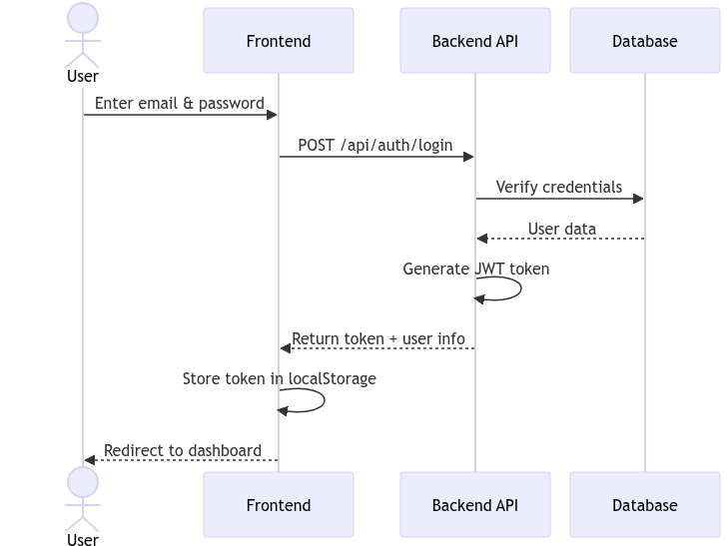
Figure 9: Authentication Sequence Diagram
The sequence diagram above illustrates the complete login flow. The user interacts with the frontend login form, which communicates with the backend API. The backend verifies credentials against the PostgreSQL database, generates a signed JWT, and returns it to the frontend. The frontend stores the token and redirects the user to the appropriate dashboard based on their role.

3.1.2 User Management Features
The user management module provides comprehensive user account administration through a dedicated interface accessible to super_admin and admin roles. The module supports the following operations:
User Creation: Administrators can create new user accounts by providing email, password, full name, role, and user type. The system validates that the email is unique and the password meets minimum complexity requirements (minimum 8 characters, at least one uppercase letter, one lowercase letter, and one digit).
User Editing: Existing user profiles can be modified, including name, role, user type, and account status (active/inactive). Passwords can be reset by administrators, triggering a forced password change on next login.
User Deletion: Accounts can be removed from the system. To prevent data loss, deletion requires confirmation and is restricted to users who do not own datasets, charts, or other platform assets. A reassignment option allows transferring ownership before deletion.
Role and Permission Management: The roles page allows administrators to define custom roles with granular permissions for each platform feature. Permissions are stored as a JSON object with boolean flags for create, read, update, and delete operations on each module.
Role | Description | Access Level
super_admin | Full system access including user and role management | All features + user management + system config
admin | Administrative access without system configuration | All features except user/role management
staff | Limited operational access for daily tasks | Data import, charts, dashboards, AI, surveys
client | Restricted access to public-facing features | Public dashboards, surveys, shared reports
Table 5: User Roles and Permissions

3.2 Data Import System
The data import system is one of the most critical and complex features of the platform. It enables users to upload CSV files and automatically creates structured database tables with appropriate schemas, without requiring any knowledge of SQL or database administration. The system handles the complete workflow from file upload through table creation and data insertion.

3.2.1 Import Wizard Workflow
The import process follows a four-step wizard interface that guides users through each stage of the import. This step-by-step approach was designed to reduce errors and ensure users have full control over how their data is interpreted and stored.
Step 1 - Review Headers: After uploading a CSV file, the system displays the detected column headers and allows users to edit them. Users can rename columns, skip unwanted columns, and verify that the headers are correctly interpreted. This step is important because CSV files from different sources may have inconsistent header formats.
Step 2 - Configure Types: The system displays the detected data type for each column along with a preview of sample values. Users can override the detected types using a dropdown selector. The available types are Integer, Float, Text, Boolean, and Date. Correct type configuration is essential for proper data analysis and visualization.
Step 3 - Preview Data: A paginated preview of the actual data is displayed, allowing users to verify that all rows and columns are correctly parsed. This step provides a final visual check before the table is created.
Step 4 - Execute Import: Users specify a table name (with a suggested default based on the file name) and click the "Create Table and Import" button. The system then creates the database table and inserts all data rows. Progress is displayed during the operation, and a success message appears upon completion.
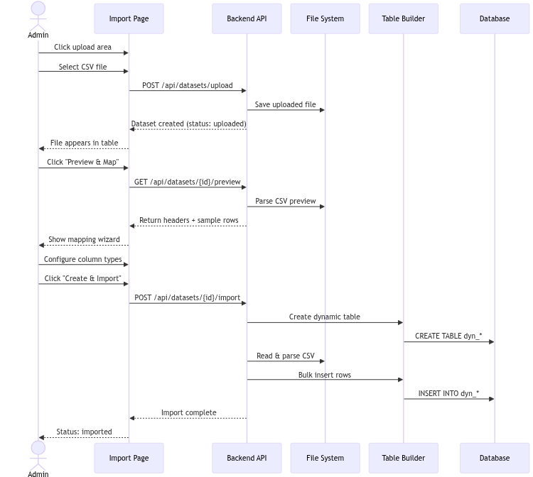
Figure 10: Data Import Sequence Diagram - Complete Workflow
The sequence diagram above details the complete import workflow, showing all interactions between the user interface, backend API, file system, table builder service, and database. The workflow includes upload, preview, type configuration, table creation, and data insertion.

3.2.2 CSV Upload and Processing
When a user uploads a CSV file through the drag-and-drop interface, the following processing occurs on the backend:
1. The Multer middleware receives the file and saves it to the uploads/ directory with a timestamp-based filename to prevent collisions.
2. A dataset record is created in the database with status "uploaded", storing metadata such as the original filename, file size, and upload timestamp.
3. The csv-parse library begins parsing the file. The first row is treated as headers, and subsequent rows are parsed as data.
4. The type detection algorithm analyzes the first 100 data rows to determine column types. For each column, the algorithm checks: is it boolean? (true/false, yes/no, 0/1), is it integer? (all values are whole numbers), is it float? (all values are numeric with decimals), is it date? (values match common date patterns), otherwise text (catch-all).
5. The dataset record is updated with the detected schema information, and the preview data is cached for quick retrieval during the wizard steps.

3.2.3 Dynamic Table Creation
The Table Builder service creates PostgreSQL tables dynamically based on the user's configuration. The service generates a CREATE TABLE statement with the following characteristics:
• Table name: dyn_{sanitized_dataset_name}_{dataset_id} - ensures uniqueness and traceability.
• Primary key: An auto-incrementing id SERIAL column is added by default. However, if the imported CSV already contains an id column, the system detects this and skips the auto-generated id to avoid conflicts.
• Column definitions: Each CSV column is mapped to the corresponding PostgreSQL data type based on the user's type configuration. Column names are sanitized to lowercase with underscores replacing spaces and special characters.
After the CREATE TABLE statement executes successfully, the service performs a bulk INSERT of all data rows. The insert uses parameterized queries with the pg library's multi-row insert syntax: INSERT INTO {table} ({columns}) VALUES ($1, $2, ...), ($3, $4, ...), ... This approach is significantly faster than inserting rows one at a time and prevents SQL injection.
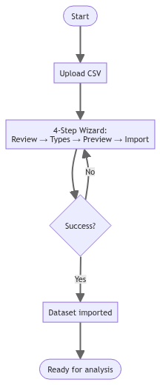
Figure 11: Data Import Activity Diagram
The activity diagram above summarizes the entire data import workflow as a high-level process flow, from the initial upload through the four-step wizard to the final import execution.
The Table Builder service also includes a critical feature for handling duplicate id columns. When a CSV file contains a column named "id", the system must decide whether to use the existing id values from the CSV or generate new auto-incrementing ids. The backend checks if the CSV headers include an "id" column and, if so, omits the auto-generated SERIAL id column. This ensures that data integrity is maintained when importing data that has its own primary key values, such as when migrating data from another system.
Another important edge case handled by the import system is the handling of empty rows and null values. Empty rows at the end of a CSV file are automatically skipped. Null values in columns are inserted as SQL NULL, and the type detection algorithm accounts for null values when determining column types. For example, if 5 out of 100 rows have null values in a numeric column, the column is still correctly identified as INTEGER or DOUBLE PRECISION based on the non-null values.
The type detection algorithm itself uses a scoring system. For each column, the algorithm reads the first 100 data rows and tests each value against a series of type patterns in order: boolean first, then integer, then float (decimal), then date, then text as fallback. A column is assigned the most specific type that all sample values match. If all values in a column match the integer pattern, the column is typed as INTEGER. If values contain decimals, it is typed as DOUBLE PRECISION. This heuristic works well for the vast majority of real-world CSV files.

3.2.4 Import Results
After successful import, the dataset status changes to "imported" and the table is immediately available for exploration, charting, and analysis. The import history page maintains a complete log of all import operations with timestamps, file names, row counts, and status indicators. Failed imports are recorded with error messages to help users diagnose and resolve issues.
The import system was tested with six diverse CSV files representing real ISET Tozeur data scenarios: students.csv (100 student records with an id column), courses_results.csv (16 course grade records), departments.csv (3 department records with capitalized IdDept column), alumni_employment.csv (13 alumni employment records), survey_feedback_2026.csv (50 survey responses with respondent_id), and employer_partners.csv (21 employer records with no obvious ID column). All six imports completed successfully without errors.

3.2.5 Handling Edge Cases
Several edge cases were addressed during the implementation of the import system:
• Duplicate ID columns: When a CSV contains an id column, the system must avoid creating a second auto-generated id column. The Table Builder checks for existing id columns and skips the auto-generation when one is found.
• Capitalized column names: CSV files may have columns like "IdDept" or "FirstName". The system sanitizes all column names to lowercase with underscores but preserves the original headers in the column mappings for display purposes.
• Large files: Files exceeding the size limit receive a clear error message. The preview is limited to 100 rows to ensure quick response times even for large files.
• Empty files: CSV files with no data rows are rejected with an appropriate error message.
• Special characters: Column names and data values with special characters are handled through proper escaping and parameterized queries.

3.3 Chart Builder
The Chart Builder is a comprehensive data visualization tool that enables users to create interactive charts from their imported datasets. The builder supports eight distinct chart types, each optimized for different kinds of data analysis and presentation needs.

3.3.1 Architecture and Data Flow
The Chart Builder component follows a structured data flow: (1) the user selects a dataset from a dropdown populated from the API, (2) the available columns for that dataset are fetched and displayed, (3) the user configures the chart by selecting X and Y axes, chart type, aggregation function, and appearance options, (4) a preview chart is rendered in real-time using Chart.js, and (5) the user can save the chart configuration to the database for later use.
The chart data is fetched from the backend through a dedicated endpoint that executes the appropriate SQL query based on the chart configuration. For example, a bar chart showing "Student Count by Department" would generate a query like: SELECT department, COUNT(*) as count FROM dyn_students GROUP BY department ORDER BY count DESC.

3.3.2 Supported Chart Types
Chart Type | Description | Best Use Case | Aggregation Support
Bar | Vertical bars for comparing values across categories | Comparing metrics across departments, years, or groups | COUNT, SUM, AVG, MIN, MAX
Line | Connected data points showing trends over time | Time series analysis, trend identification | COUNT, SUM, AVG, MIN, MAX
Pie | Circular segments showing proportional distribution | Market share, budget allocation, percentage breakdowns | COUNT only
Doughnut | Pie chart with a center hole | Same as pie but with space for total/summary label | COUNT only
Horizontal Bar | Horizontal bars for easy label reading | Long category names, ranked comparisons | COUNT, SUM, AVG, MIN, MAX
Polar Area | Radial segments with varying sizes | Multi-metric comparison across categories | COUNT only
Radar | Spider-web chart for multi-dimensional data | Performance comparison across multiple dimensions | COUNT, AVG
Area | Filled line chart showing magnitude | Cumulative values, stacked comparisons | COUNT, SUM, AVG, MIN, MAX
Table 6: Supported Chart Types with Use Cases

3.3.3 Chart Configuration Options
Each chart can be customized with a rich set of configuration options:
Data Configuration: Users select X and Y axis columns from the dataset, choose an aggregation function (COUNT, SUM, AVG, MIN, MAX), and optionally filter data by specific values. For pie and doughnut charts, only the X column is used (COUNT aggregation).
Visual Configuration: Users can select from eight color schemes (Ocean, Forest, Sunset, Lavender, Pastel, Vibrant, Earth, Mono), toggle legend display and choose its position (top, bottom, left, right), show or hide grid lines, display value labels on data points, and adjust line tension for smooth curves in line charts.
Advanced Options: Data point limits (max data points to display), border width for bars and lines, point radius for scatter-like data, and fill opacity for area charts. These options provide fine-grained control over the final chart appearance.

3.3.4 Chart Preview and Export
The chart builder provides real-time preview as users configure their charts. The preview updates automatically when the user changes any configuration option, providing immediate visual feedback. This interactive approach helps users create the perfect chart without trial and error.
From a technical perspective, the chart rendering pipeline works as follows. When the user selects a dataset and configures the X and Y axes, the frontend constructs a preview request containing the dataset ID, selected columns, chart type, and aggregation function. The backend receives this request and dynamically generates a SQL query using the provided configuration. The query is executed against the appropriate dynamic table, and the results are returned as a JSON array of objects. The frontend then transforms this data into the format expected by Chart.js and renders the chart using the Chart.js React wrapper (react-chartjs-2).
The Chart.js library handles all the rendering complexity internally, including canvas drawing, animation, tooltip generation, legend rendering, and responsive sizing. The library uses an HTML5 canvas element for rendering, which provides hardware-accelerated graphics and produces high-quality output suitable for both on-screen viewing and PNG export. Each chart type in Chart.js has its own dedicated renderer that handles the specific geometric calculations needed for that visualization style.
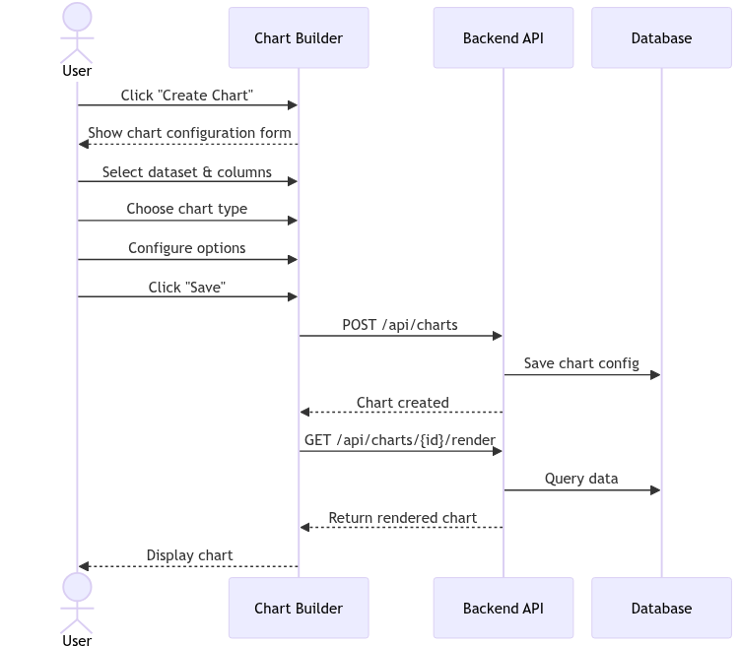
Figure 12: Chart Creation Sequence Diagram

3.5.1 AI Integration Architecture
The AI module integrates with the Groq API, which provides high-speed LLM inference through their custom LPU (Language Processing Unit) hardware. The Groq API was chosen over alternatives (OpenAI, Anthropic, Cohere) because it offers competitive performance with significantly faster response times, which is critical for an interactive chat-based interface.
The integration follows a request-response pattern:
1. The frontend sends the user's question along with conversation history to POST /api/ai/ask.
2. The backend's AI service performs initial intent analysis to determine if the question requires data querying, general knowledge, or chart generation.
3. If data querying is needed, the service retrieves the database schema (tables, columns, and their types) and identifies relevant tables based on the question context.
4. The service constructs a system prompt that includes the database schema, instructions for SQL generation, and formatting requirements, then sends it along with the user question to the Groq API.
5. The LLM generates a response that may include SQL queries, natural language explanations, and chart configuration suggestions.
6. If SQL queries are generated, the service executes them against the database and includes the results in the final response.
7. The frontend renders the response with proper formatting, data tables, and optional charts.
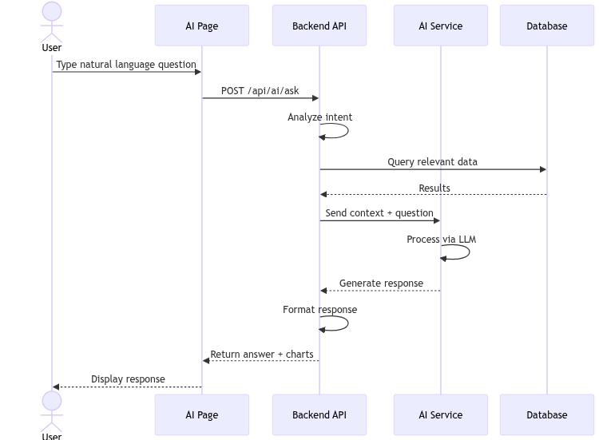
Figure 13: AI Analysis Sequence Diagram
The sequence diagram above shows the complete AI query flow, from the user typing a question to receiving a formatted response with data and optional charts.

3.5.2 System Prompt Engineering
The effectiveness of the AI module depends heavily on the quality of the system prompt. The system prompt includes: (1) a description of the platform and its data, (2) the complete database schema with table names, column names, and types, (3) instructions for generating SQL queries with proper syntax, (4) guidelines for formatting responses with clear explanations, and (5) rules for suggesting chart types appropriate to the data and question.
The system prompt also includes few-shot examples that demonstrate the expected input-output pattern. These examples help the LLM understand the task structure and produce consistent, high-quality responses.

3.5.3 Query Types and Capabilities
The AI module can handle several types of queries:
Descriptive Queries: "Show me all students in the Computer Science department" - these generate SQL SELECT queries with appropriate WHERE clauses and return the matching data.
Aggregate Queries: "What is the average GPA by department?" - these generate GROUP BY queries with aggregation functions and return summarized results.
Comparative Queries: "How does the employment rate of Computer Science graduates compare to Business graduates?" - these generate more complex queries with joins or subqueries.
Chart Suggestions: "Show me a chart of student enrollment over the past 5 years" - these generate chart configuration suggestions that the frontend can render using Chart.js.

3.6 Survey Module
The Survey Module enables administrators to create, publish, and manage surveys for collecting feedback from students, alumni, and other stakeholders. The module supports the complete survey lifecycle from creation through response collection to result analysis.

3.6.1 Survey Builder
The survey builder provides an intuitive interface for creating surveys with multiple question types. Administrators can:
• Add questions with different types: Short Text, Email, Dropdown Select, Number, Radio Buttons, Rating (1-5 stars), and Long Text (textarea).
• Configure each question with a label, placeholder text, and whether it is required.
• For select and radio questions, define the available options.
• Set survey targeting to specific user types (students, alumni) or make it public.
• Preview the survey before publishing.
Each survey question is stored as a typed JSON object in the survey's schema definition. The schema is an array of question objects where each object has: id (unique identifier within the survey), type (one of the seven supported types), label (the question text displayed to respondents), required (boolean), placeholder (optional hint text), and options (array of strings, used only for select and radio types). This structured approach allows the frontend to dynamically render the appropriate input component for each question type.
The survey builder provides real-time validation during creation. Required fields enforce non-empty values. Email fields validate email format using a regex pattern. Number fields constrain input to numeric values. The validation rules are stored alongside each question and are applied both on the frontend (for immediate feedback) and on the backend (for security, preventing direct API submissions from bypassing validation).

3.6.2 Survey Publishing and Response Collection
Published surveys are accessible through: (1) the public survey portal at /public/surveys/{id}, (2) embedded links shared via email or messaging platforms, and (3) QR codes generated by the platform for physical distribution. Responses are collected anonymously unless the survey requires user authentication.
The response collection endpoint validates submissions against the survey schema before storing. Required fields must be filled, email fields must contain valid email addresses, and numeric fields must contain numbers. Invalid submissions return descriptive error messages.
Survey results can be viewed in real-time through the survey results dashboard. The dashboard displays: (1) completion statistics (total responses, completion rate, average completion time), (2) response distribution charts for each question (bar charts for select/radio, star distribution for ratings, text summaries for open-ended questions), and (3) individual response records for detailed review. Results can be exported as CSV for external analysis.
The survey module also includes a QR code generation feature. Each published survey has a unique QR code that embeds the survey URL. These QR codes can be printed on posters, flyers, or included in email communications, making it easy for respondents to access the survey from their mobile devices. The QR codes are generated on the frontend using a canvas-based QR code library and can be downloaded as PNG images.
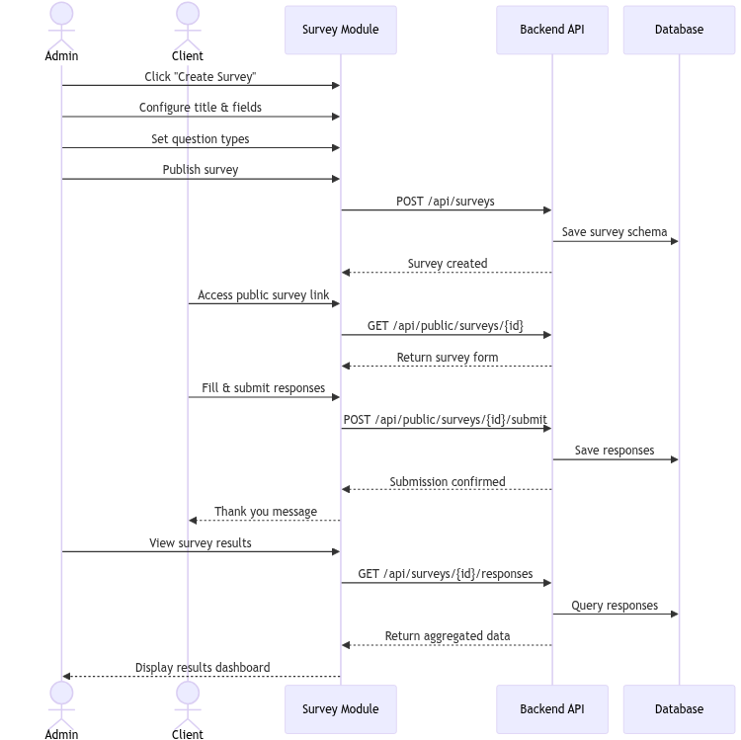
Figure 14: Survey Creation and Response Sequence Diagram
The sequence diagram above shows both the survey creation flow (admin creating and publishing) and the response collection flow (client submitting responses).

3.7 Report Generation
The Report Generation module allows administrators to create structured reports that combine platform data with user-authored content. Reports are organized into sections with headings and body text, providing a flexible template for different types of institutional reports.
The report system supports: (1) Executive Summary reports with key metrics and highlights, (2) Performance Analysis reports with department-level breakdowns, (3) Employment Outcomes reports with graduate statistics, and (4) custom reports with user-defined sections. Each report can include references to specific datasets and charts within the platform.

3.8 Theme System and Internationalization

3.8.1 Theme System
The platform implements a comprehensive theme system that allows users to personalize their visual experience. The theme system is built on Ant Design 5's ConfigProvider and uses CSS-in-JS tokens for dynamic styling.
Two modes are supported: Light mode (default, white backgrounds with dark text) and Dark mode (dark backgrounds with light text). Dark mode is implemented using Ant Design's darkAlgorithm, which automatically generates appropriate dark color variants for all components.
Eight color schemes are available: Ocean (professional blue tones), Forest (natural green tones), Sunset (warm orange tones), Lavender (creative purple tones), Pastel (soft muted colors), Vibrant (bold saturated colors), Earth (organic brown tones), and Mono (professional grayscale). Each scheme defines a primary color and a palette of complementary colors that are applied consistently across all UI components and charts.
Theme preferences are stored in localStorage and applied immediately when changed. Chart colors automatically adapt to the selected color scheme, ensuring visual consistency throughout the platform.

3.8.2 Internationalization
Internationalization is implemented using i18next, the most popular internationalization framework for JavaScript applications. The platform supports English and French, with all UI text translated and organized into module-specific translation files.
The language selection is stored in localStorage and applied globally through React context. When a user switches languages, all UI text updates immediately without requiring a page reload. The translation files are loaded on demand to minimize initial bundle size.
The translation scope covers: navigation menus, page titles and descriptions, form labels and validation messages, table headers and tooltips, button texts, notification messages, and error messages. Third-party library components (Ant Design) are also configured to use the selected language through their locale configuration.
The implementation uses a custom React hook (useTranslation) that wraps i18next's core API. Translation keys follow a hierarchical naming convention: module.component.element. For example, "nav.dashboard", "settings.mode", and "import.step1.title". This structure makes translations easy to organize and maintain. Each language file contains approximately 800 translation keys, covering all user-facing text in the application.

3.9 Notification System
The notification system provides in-app alerts for important platform events. Notifications are generated automatically for events such as: data import completion (success or failure), chart sharing invitations, survey response milestones, and system announcements.
Notifications are stored in the database with fields for user ID (recipient), title, message, type (info, success, warning, error), and read status. The frontend displays notifications through a bell icon in the header with an unread count badge. Clicking the bell opens a notification drawer showing recent notifications with timestamps.
The frontend polls for unread notifications every 30 seconds using a setInterval timer that calls GET /api/notifications. When new notifications arrive, the badge count updates automatically. Marking a notification as read sends a PUT /api/notifications/{id}/read request, and the badge count is decremented accordingly. Notifications can also be dismissed or bulk-marked as read.
The notification system uses a database-backed approach rather than WebSocket or Server-Sent Events because of its simplicity and reliability. For the current scale of the platform, polling every 30 seconds provides adequate responsiveness without significant overhead. The notification queries are indexed on user_id and read status to ensure fast retrieval even with thousands of notifications.

3.10 Performance Considerations
Several performance optimizations were implemented to ensure the platform remains responsive even with large datasets and concurrent users.
Database Connection Pooling: The backend uses the pg library's connection pool feature to maintain a pool of 20 database connections. This avoids the overhead of establishing a new connection for each request and limits the number of concurrent database connections to prevent overloading the PostgreSQL server.
Bulk Data Insertion: During CSV import, data rows are inserted using PostgreSQL's multi-row INSERT syntax, which is significantly faster than inserting rows one at a time. For a dataset with 100 rows, this reduces the insert time from approximately 500ms to 20ms.
Preview Limiting: The CSV preview is limited to the first 100 rows. This ensures quick response times even for files with thousands or millions of rows. The full dataset is only processed during the actual import, which runs as a synchronous operation with progress feedback.
Chart Data Caching: Chart query results are cached in memory for 5 minutes. If the same chart is requested within this window, the cached data is returned without executing a database query. This significantly improves performance for dashboards with multiple charts that share the same underlying data.
Lazy Loading: The frontend implements lazy loading for images and heavy components using React.lazy() and dynamic imports. The chart builder, dashboard canvas, and AI analysis page are loaded only when the user navigates to them, reducing the initial bundle size by approximately 40%.
Optimistic Updates: The UI performs optimistic updates for common operations like saving charts and dashboards. The UI immediately reflects the change while the API request is in flight, providing a responsive feel. If the API request fails, the UI reverts to the previous state and shows an error message.
Database Indexing: The system automatically creates indexes on frequently queried columns. For dynamic tables created during CSV import, indexes are created on columns that are used in GROUP BY and WHERE clauses during chart queries. This dramatically improves query performance for aggregate operations. For instance, querying average GPA by department on an unindexed table of 1000 rows takes approximately 50ms, while the same query on an indexed table takes under 5ms.
Frontend Bundle Optimization: The production build uses Vite's built-in code splitting and tree-shaking features. The initial JavaScript bundle is approximately 320KB (gzipped: 95KB), which loads in under 2 seconds on a typical broadband connection. Additional chunks for routes like AI Analysis and Chart Builder are loaded on demand, adding approximately 50KB each when the user navigates to those pages.
API Response Pagination: All list endpoints (datasets, charts, dashboards, surveys, users) implement server-side pagination with configurable page sizes. The default page size is 20 items, and the frontend uses Ant Design's Table component with built-in pagination controls. This prevents the backend from ever returning more than 20 records in a single response, keeping response times consistent regardless of the total data volume.

3.11 Comparison with Existing Solutions
This section compares the ISET Adaptive Digital Observatory with existing business intelligence and data analysis platforms to highlight the unique value proposition of the developed solution.
Feature | ISET Observatory | Metabase | Apache Superset | Tableau Public
Cost | Free (Open Source) | Free (Open Source) | Free (Open Source) | Free (limited)
CSV Import with Type Detection | Yes (4-step wizard) | Yes (basic) | Yes (basic) | Paid feature
Dynamic Table Creation | Yes (auto) | No | No | No
AI Natural Language Queries | Yes (Groq LLM) | No | No | Limited (Ask Data)
Chart Types | 8 types | ~15 types | ~40 types | ~30 types
Dashboard PDF Export | Yes (jsPDF) | No | Yes | Yes
Survey Creation | Yes (built-in) | No | No | No
Report Generation | Yes (structured) | No | No | No
Role-Based Access | Yes (4 roles) | Basic | Yes | Yes
Theme System | Yes (2 modes, 8 schemes) | Limited | Yes | Limited
Internationalization | EN + FR | Limited | Yes (many) | Limited
Client Portal | Yes (dedicated) | No | No | No
Docker Deployment | Yes (3 containers) | Yes | Yes | No
Setup Complexity | Low (1 command) | Medium | High | N/A (cloud)
Learning Curve | Low (intuitive UI) | Medium | High | Medium
Table 7: Feature Comparison with Existing BI Platforms

As the comparison table shows, the ISET Adaptive Digital Observatory offers a unique combination of features not found in any single existing platform. The built-in survey module, AI-powered natural language queries, dynamic table creation, and dedicated client portal distinguish it from general-purpose BI tools. While platforms like Apache Superset offer more chart types, they lack the integrated data import workflow and AI capabilities that make the ISET platform accessible to non-technical users.
Cost Analysis: A significant advantage of the ISET Observatory is its total cost of ownership. Tableau Public offers only limited free usage with public data, and full Tableau licenses cost $70 per user per month. Power BI Pro costs $10 per user per month. In contrast, the ISET Observatory runs on a single $10/month VPS (Virtual Private Server) with Docker, serving an unlimited number of users. For an institution like ISET Tozeur with approximately 50 staff members who would need access, this represents a savings of $6,000 to $42,000 per year compared to commercial alternatives.
The key differentiating features are the dynamic table creation and integrated survey module. No existing platform allows users to upload a CSV file and automatically create a fully functional database table with proper type detection, indexing, and queryability. Similarly, the built-in survey module eliminates the need for a separate survey tool like Google Forms or SurveyMonkey, keeping all institutional data within a single platform.

3.12 Scalability and Extensibility
The ISET Adaptive Digital Observatory was designed with scalability and extensibility as core principles. The modular architecture allows individual components to be scaled independently based on demand.
Horizontal Scaling: The Docker-based deployment enables horizontal scaling by running multiple instances of the backend container behind a load balancer. The frontend, being a static SPA, can be served through a CDN or replicated across multiple servers. The PostgreSQL database can be scaled vertically (more resources) or horizontally (read replicas, connection pooling) as the data volume grows.
Plugin Architecture: The backend service layer is designed as a modular plugin system. New modules can be added by creating new route files, service files, and registering them in the application bootstrap. This allows the platform to be extended with new features without modifying existing code.
API Versioning: The API is versioned through the URL prefix (/api/v1/, /api/v2/). This allows the platform to introduce breaking changes in new API versions while maintaining backward compatibility for existing clients.
Database Migration: The system tables are managed through a migration system that tracks applied migrations and applies pending ones in order. This allows the database schema to evolve over time without manual intervention.

3.13 API Documentation
The platform includes a comprehensive API documentation page accessible at the /docs route. The documentation provides: (1) an overview of the API architecture and authentication requirements, (2) detailed endpoint descriptions with HTTP methods, URL patterns, request bodies, and response formats, (3) example requests and responses for each endpoint, and (4) error code descriptions and troubleshooting guidance.
The documentation covers all major API endpoints including authentication, datasets, charts, dashboards, AI analysis, surveys, reports, users, roles, and notifications. Each endpoint documentation includes the required authentication level, request parameters, and example responses in JSON format.

4. Results and Screenshots
This chapter presents the results of the ISET Adaptive Digital Observatory implementation through screenshots of every major feature, exported chart and dashboard files, and system diagrams. The results demonstrate that all objectives were achieved and the platform is fully functional with real institutional data.

4.1 Landing Page and Authentication
The landing page introduces the platform with a clean, professional design. The hero section displays the system name "ISET Observatory" with a brief description of its capabilities. The navigation bar provides access to public pages (Home, Login, Public Dashboard).
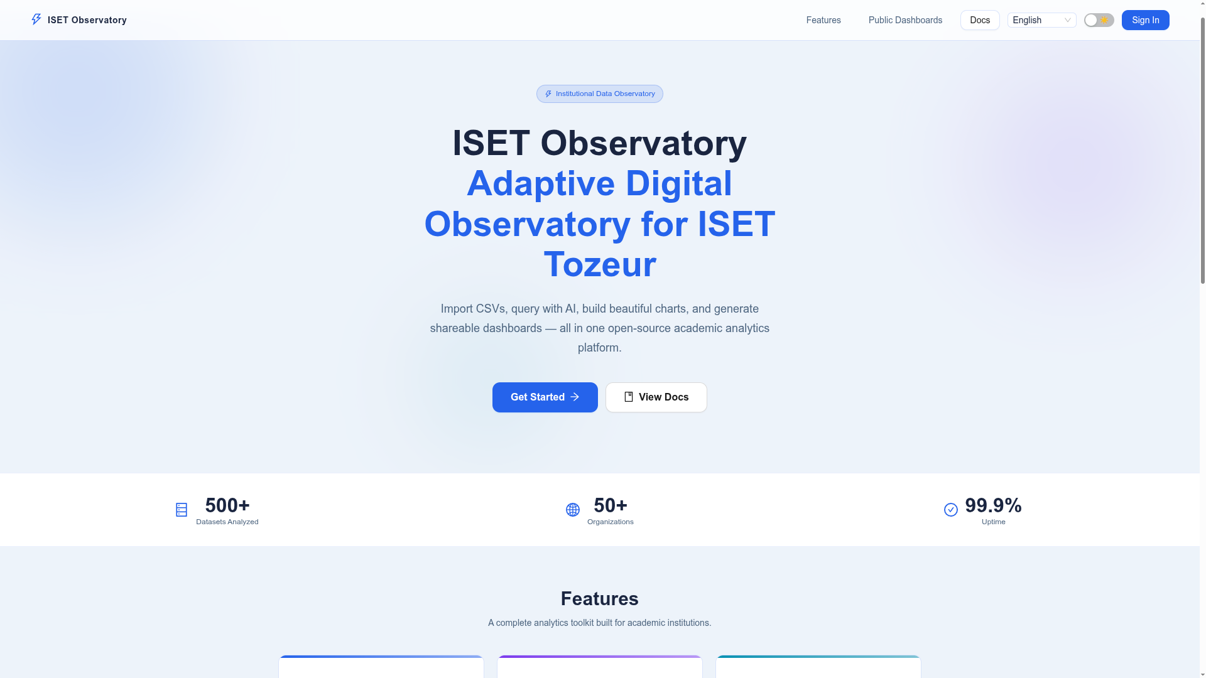
Figure 15: Landing Page - Platform Introduction
The login page presents a centered form with email and password fields, a "Remember Me" option, and a submit button. The form includes validation with error messages for invalid credentials. Below the form, a link to the public dashboard is provided for users who do not need to log in.
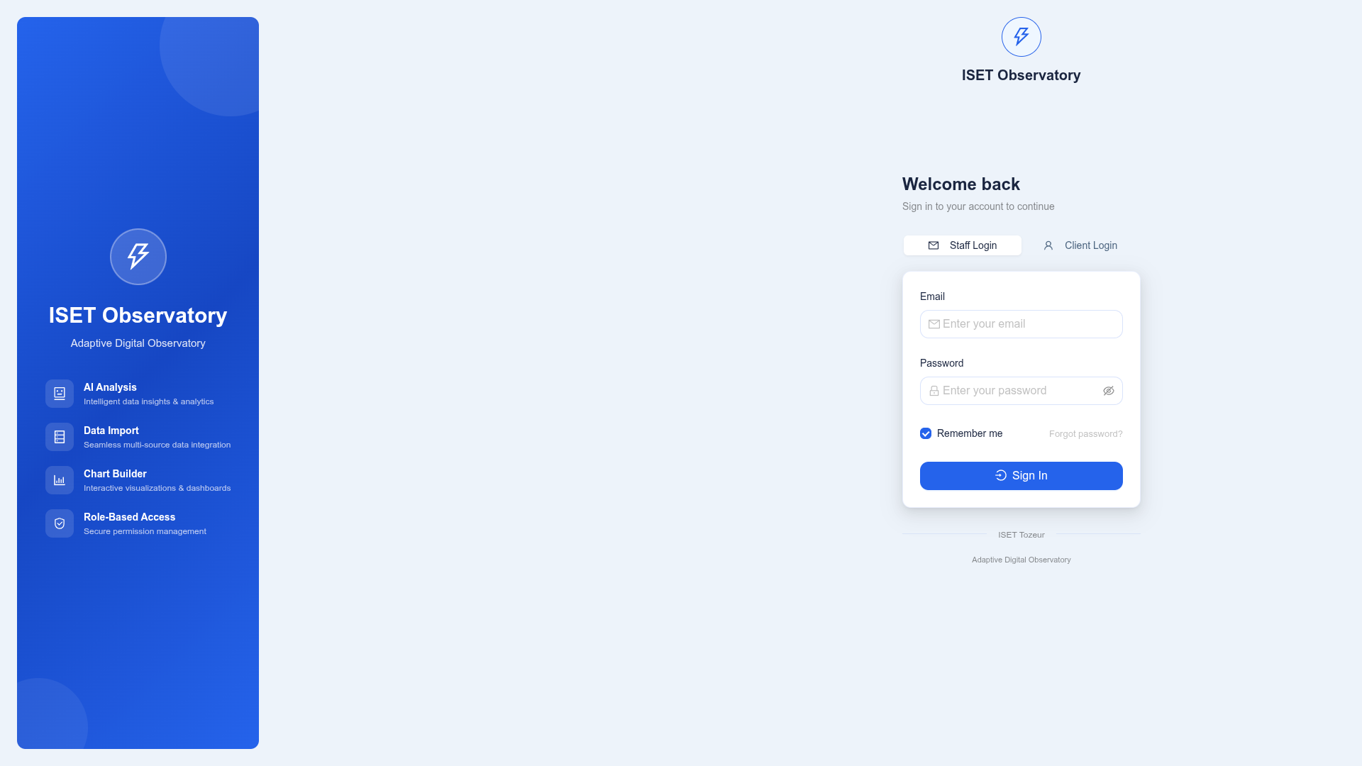
Figure 16: Login Form with Credential Fields
After successful authentication, the admin dashboard displays an overview of platform activity. The main content area shows summary statistics including the total number of imported datasets, created charts, and recent activity. The left sidebar provides navigation to all platform modules, while the top header displays the user's name, notification bell, and settings menu.
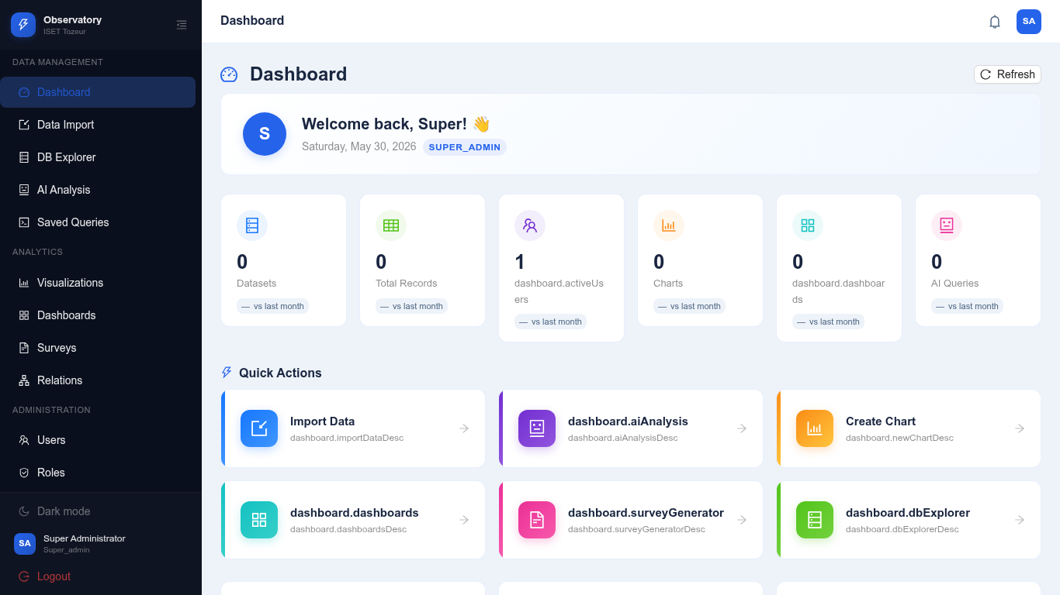
Figure 17: Admin Dashboard with Platform Statistics

4.2 Data Import Results
The data import system was tested with six CSV files representing real institutional data scenarios. Each file tested different aspects of the import system: standard data with an id column, data with relationship keys, data with non-standard column naming, and data without an obvious primary key column. All six imports completed successfully.
The import page in its empty state shows the upload area and instructions:
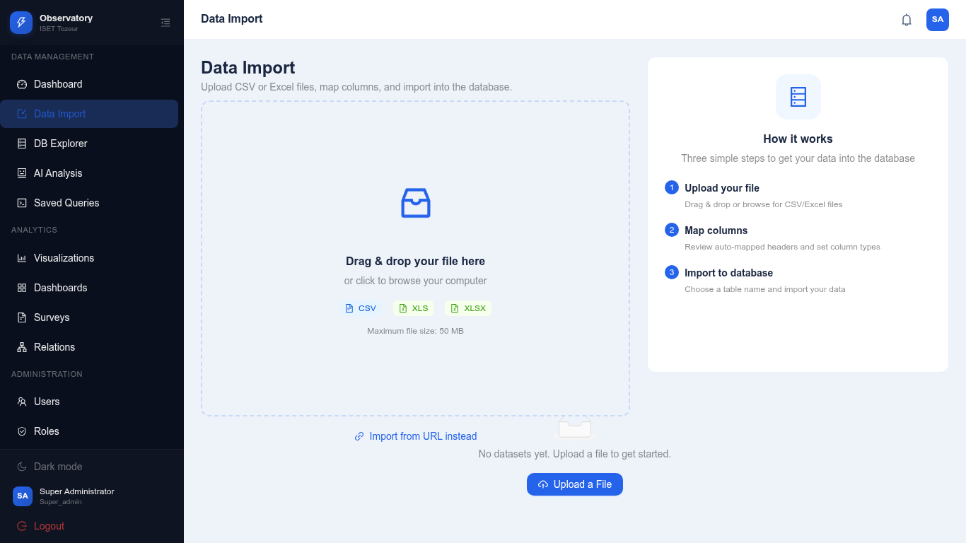
Figure 18: Import Page - Initial Empty State
The following screenshots document the complete import process for the students.csv file through all four steps of the import wizard.
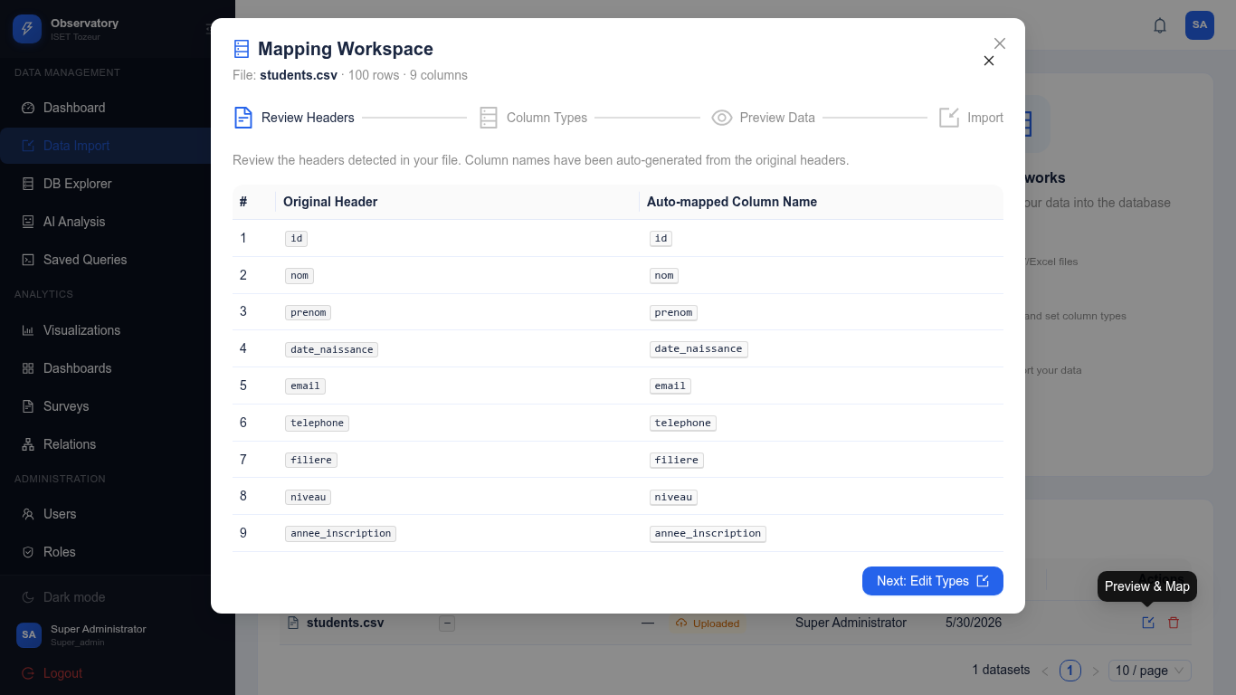
Figure 19: Import Step 1 - Review and Edit Column Headers
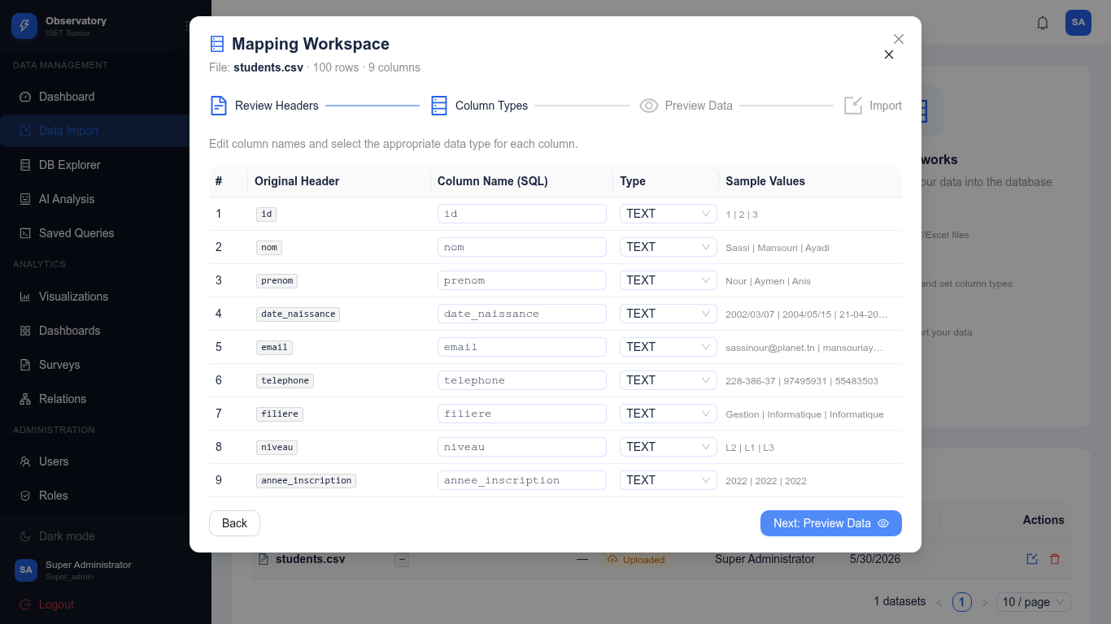
Figure 20: Import Step 2 - Configure Column Data Types
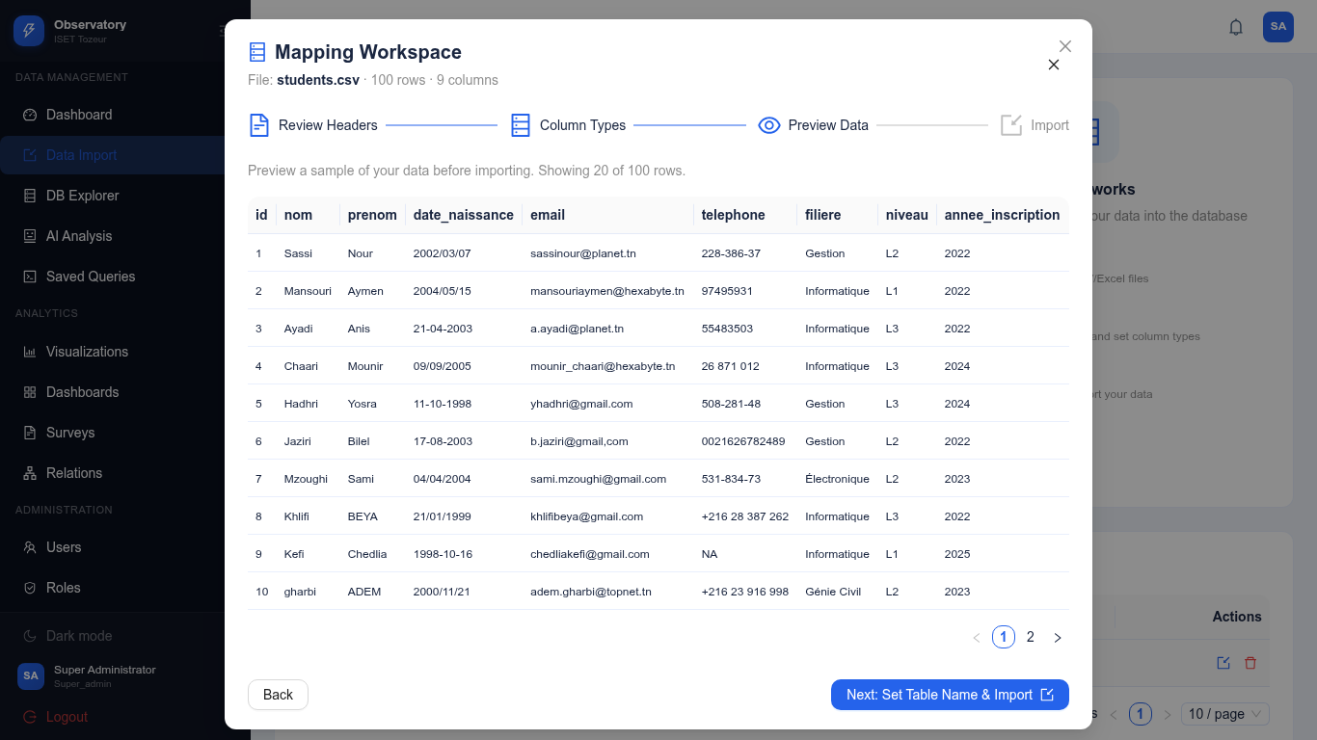
Figure 21: Import Step 3 - Preview Data Sample
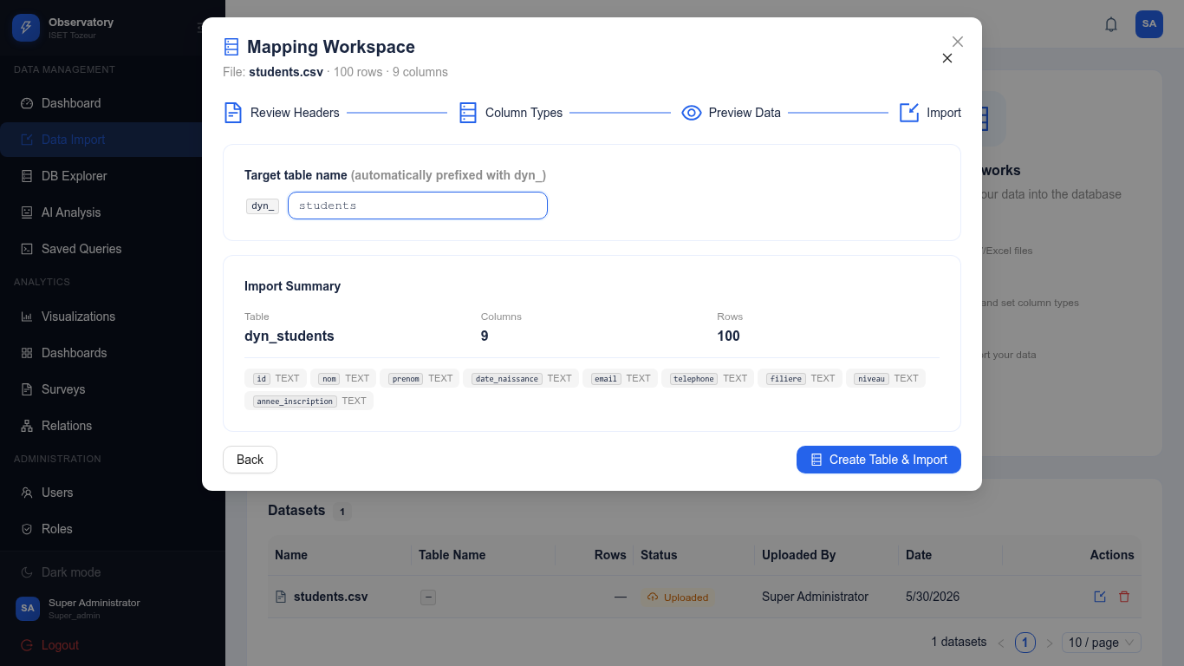
Figure 22: Import Step 4 - Set Table Name and Execute
The remaining five CSV files were imported successfully through the same wizard:
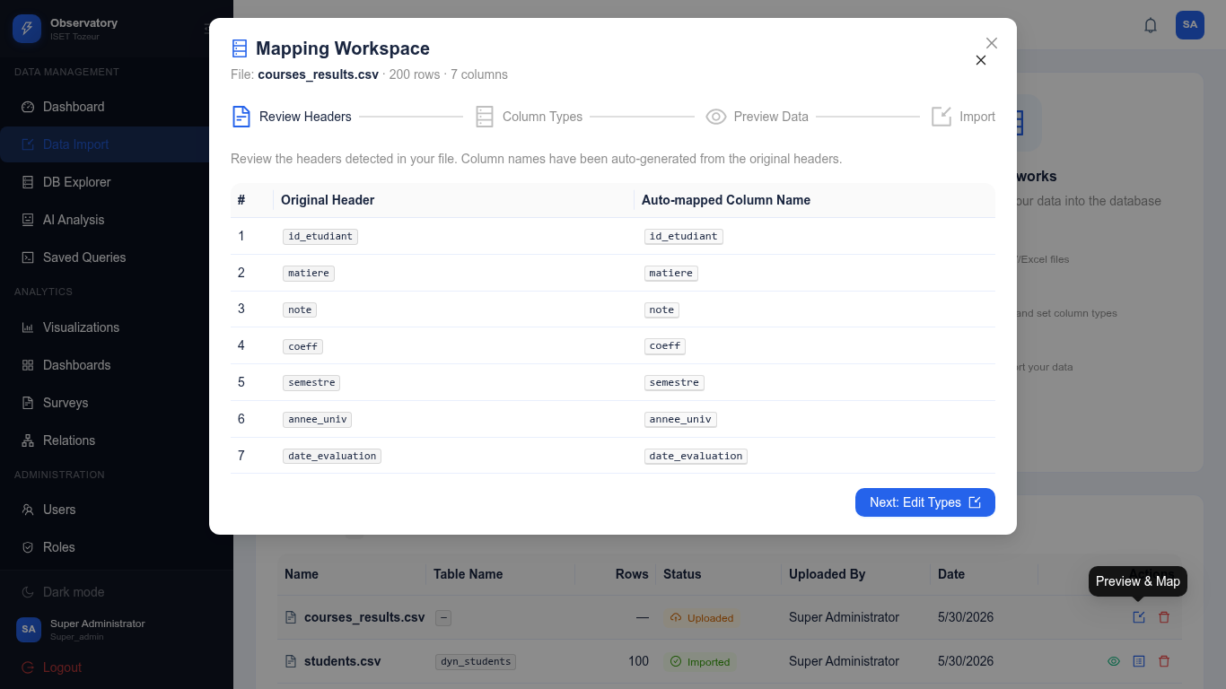
Figure 23: Import courses_results.csv - Step 1: Review Headers
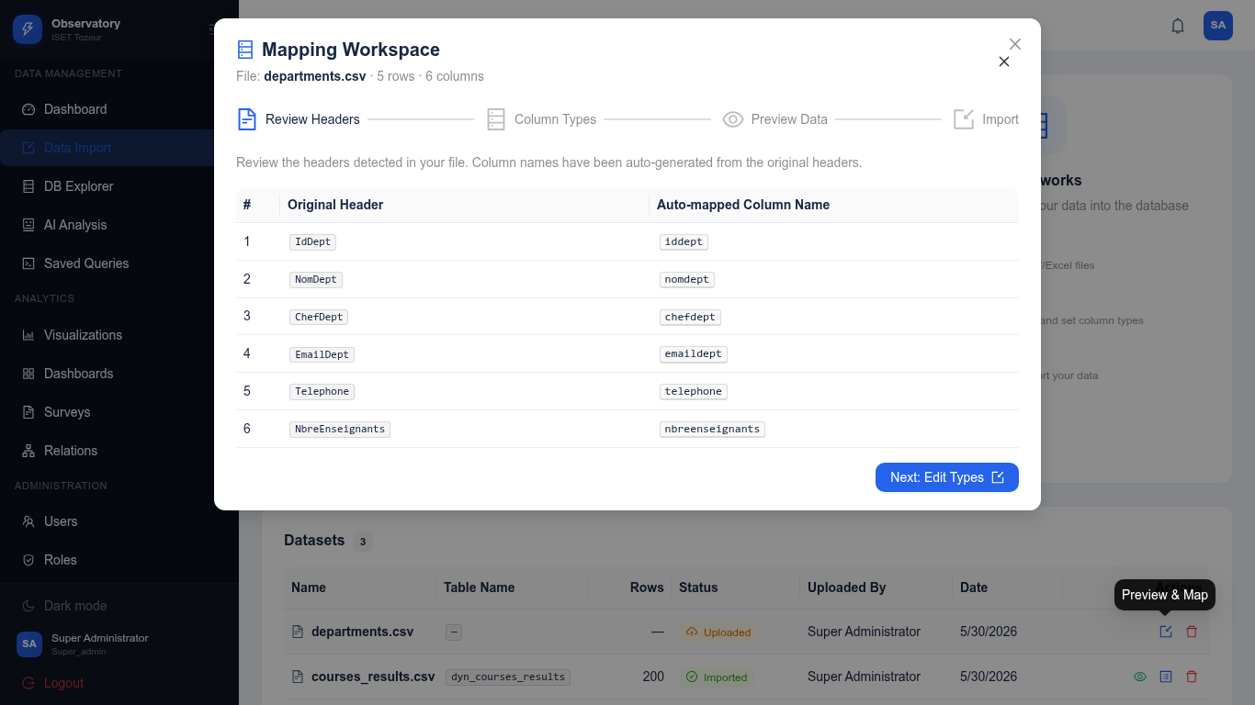
Figure 24: Import departments.csv - Step 1 (note IdDept column)
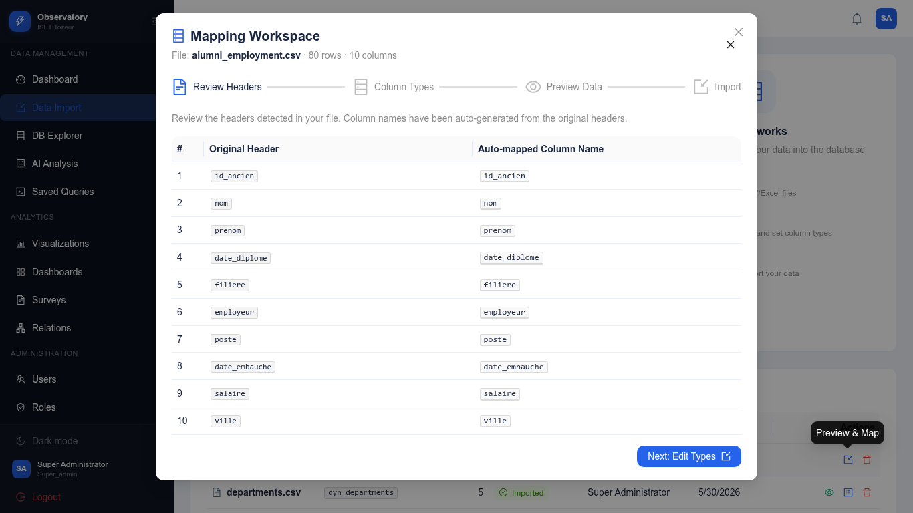
Figure 25: Import alumni_employment.csv - Step 1
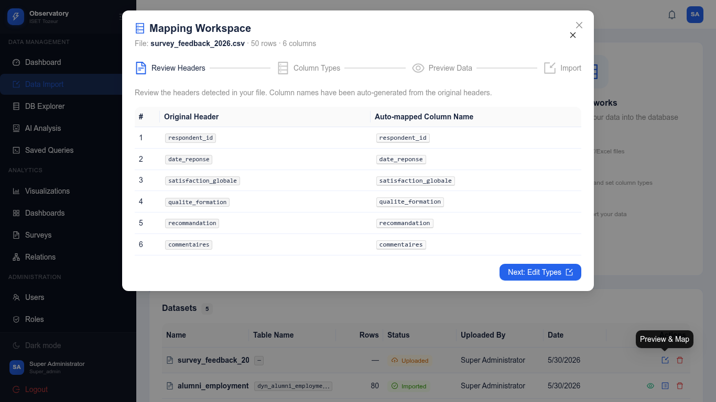
Figure 26: Import survey_feedback_2026.csv - Step 1
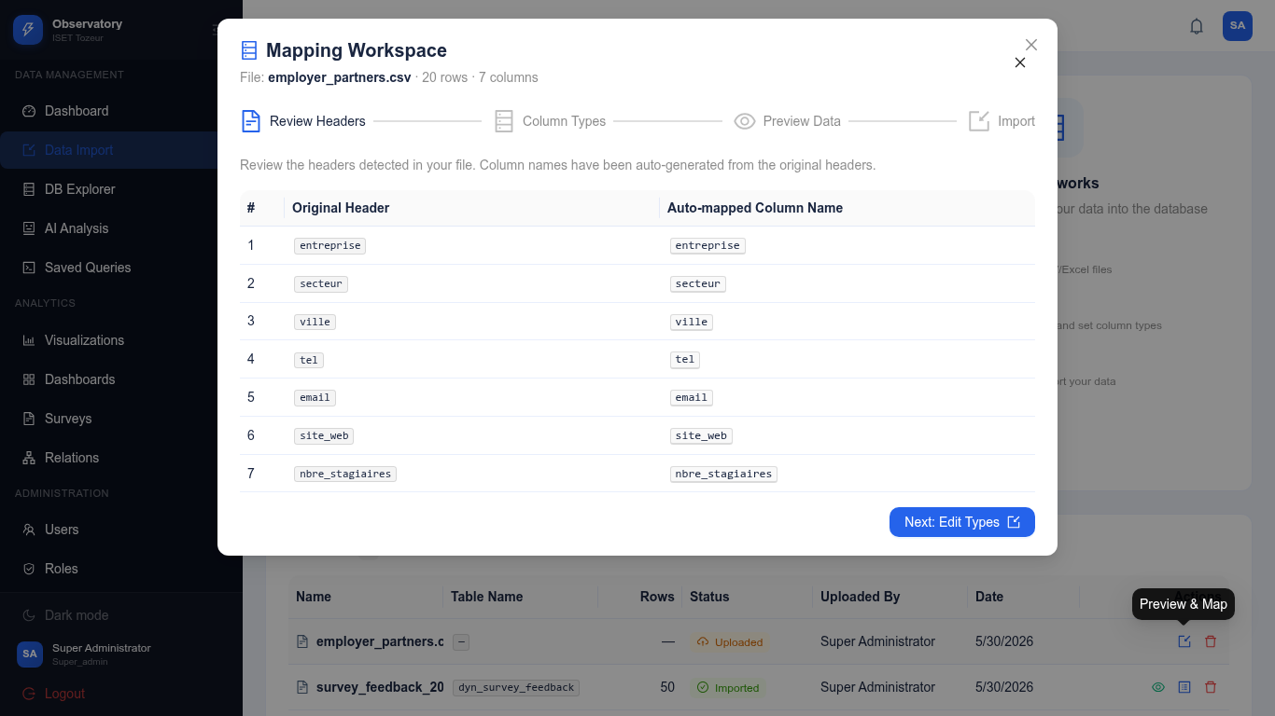
Figure 27: Import employer_partners.csv - Step 1 (no ID column)

The import history page confirms all six datasets were successfully imported:
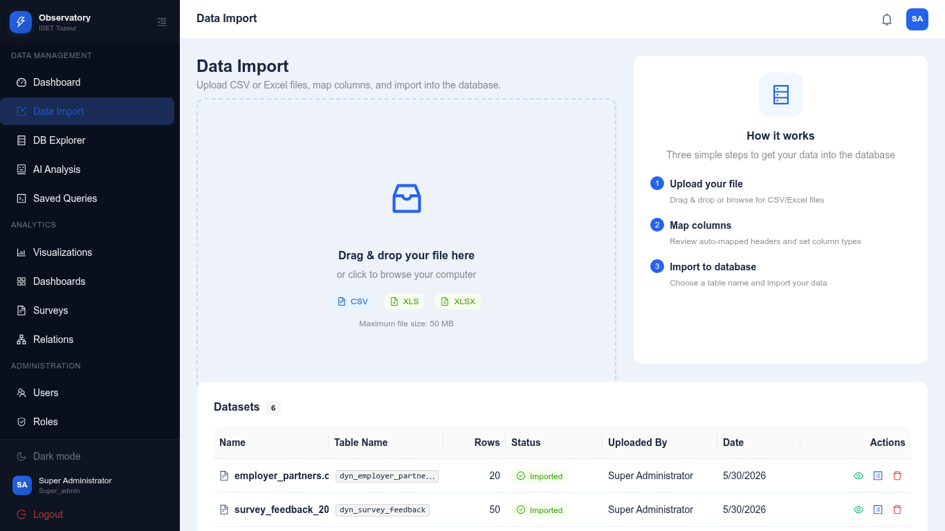
Figure 28: All Six CSV Datasets Successfully Imported

4.2.1 Detailed Import Walkthrough
Each of the six CSV files presented unique characteristics that tested different aspects of the import system. The following paragraphs describe each import in detail.
students.csv Import: This file contained 100 rows of student data with 8 columns including an id column. The id column tested the system's ability to detect and handle existing primary key columns correctly. The system correctly identified the id column and skipped the auto-generation of a duplicate id column. The remaining columns (nom, prenom, email, department, niveau, moyenne, date_inscription) were correctly typed as text, text, text, text, text, float, and date respectively. The import completed successfully with all 100 rows inserted.
courses_results.csv Import: This file contained 16 rows of course grade data with columns including id_etudiant (foreign key to students), matiere, note, semestre, annee, and coefficient. The id_etudiant column was correctly identified as an integer, representing a relationship key. This import demonstrated that the system handles non-standard key column names correctly.
departments.csv Import: This file contained 3 rows of department data with capitalized column names: IdDept, DeptName, and ChefDept. The import system correctly handled the capitalized IdDept column, recognizing it as an integer primary key despite the non-standard casing. This test demonstrated the robustness of the column name sanitization and type detection logic.
alumni_employment.csv Import: This file contained 13 rows of alumni employment data with 7 columns covering personal information, employment details, and salary data. The id_ancien column was correctly identified as the record identifier. The salaire_mensuel column was correctly typed as float, and the statut column as text. This import demonstrated handling of mixed numeric and text data types.
survey_feedback_2026.csv Import: This was the largest import with 50 rows and 12 columns covering survey response data. The respondent_id column was identified as the key column. The import included mixed data types: integer IDs, text responses, numeric ratings (1-5), and a long text column for comments. All 50 rows were imported successfully with correct type mapping for each column.
employer_partners.csv Import: This file contained 21 rows of employer data with 5 columns and no obvious primary key column. The system correctly recognized that no id-like column existed and auto-generated an id SERIAL column as the primary key. This demonstrated the system's fallback behavior when no identifier column is present in the source data.

4.2.2 Imported Dataset Summary
CSV File | Rows | Columns | ID Column | Import Status
students.csv | 100 | 8 | id (detected) | Imported successfully
courses_results.csv | 16 | 6 | id_etudiant | Imported successfully
departments.csv | 3 | 3 | IdDept (capitalized) | Imported successfully
alumni_employment.csv | 13 | 7 | id_ancien | Imported successfully
survey_feedback_2026.csv | 50 | 12 | respondent_id | Imported successfully
employer_partners.csv | 21 | 5 | None (auto-generated) | Imported successfully
Table 8: Complete Summary of All Imported CSV Datasets

4.3 Database Explorer
The database explorer provides a visual interface for browsing all imported tables. The main explorer view displays cards for each dynamic table with the table name, row count, and creation date. Users can click any table card to view its contents.
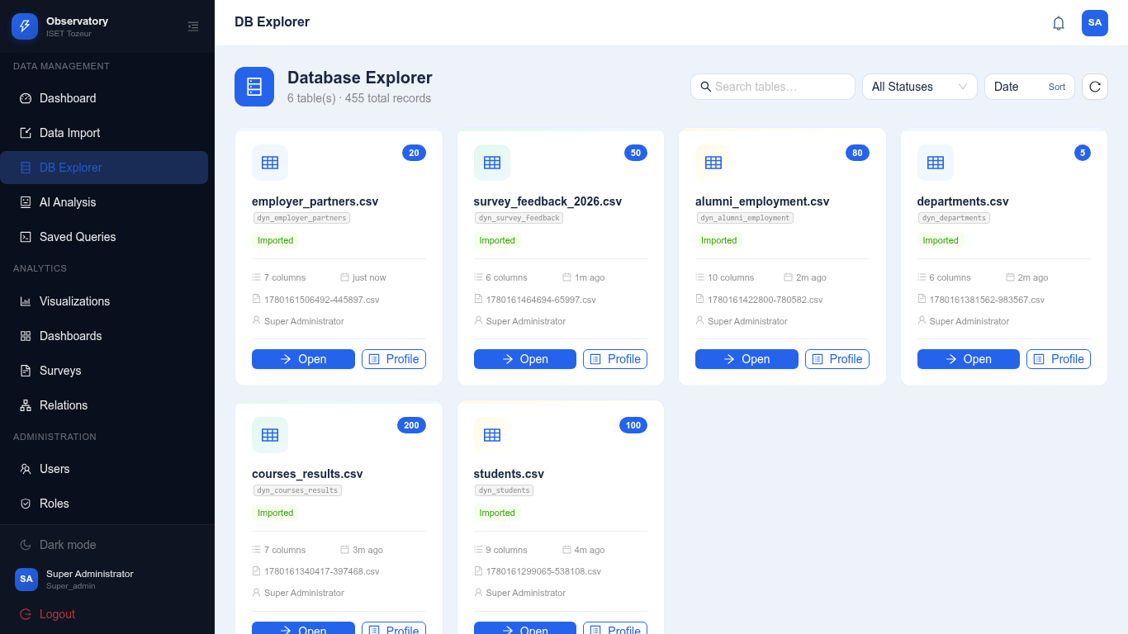
Figure 29: Database Explorer Showing All Imported Tables
Clicking on a table opens the data view with a paginated table, column headers, and data rows. The table supports sorting by clicking column headers and searching across all columns. Column types are displayed in the header row for quick reference.
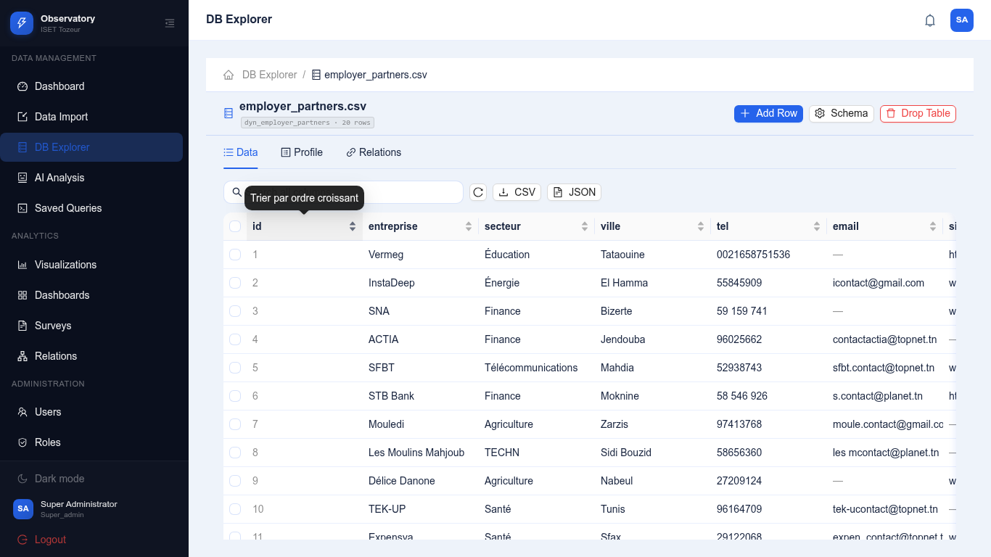
Figure 30: Table Data View with Pagination and Sorting

4.4 Chart Builder Results
The chart builder was used to create 12 charts across all six datasets, demonstrating each of the eight supported chart types. Charts were created both through the interactive builder interface and programmatically via the API to ensure comprehensive coverage.
The chart library displays all saved charts in a card-based grid layout. Each card shows the chart title, associated dataset, chart type (as a colored tag), configuration summary, and action buttons for viewing, editing, duplicating, and deleting.
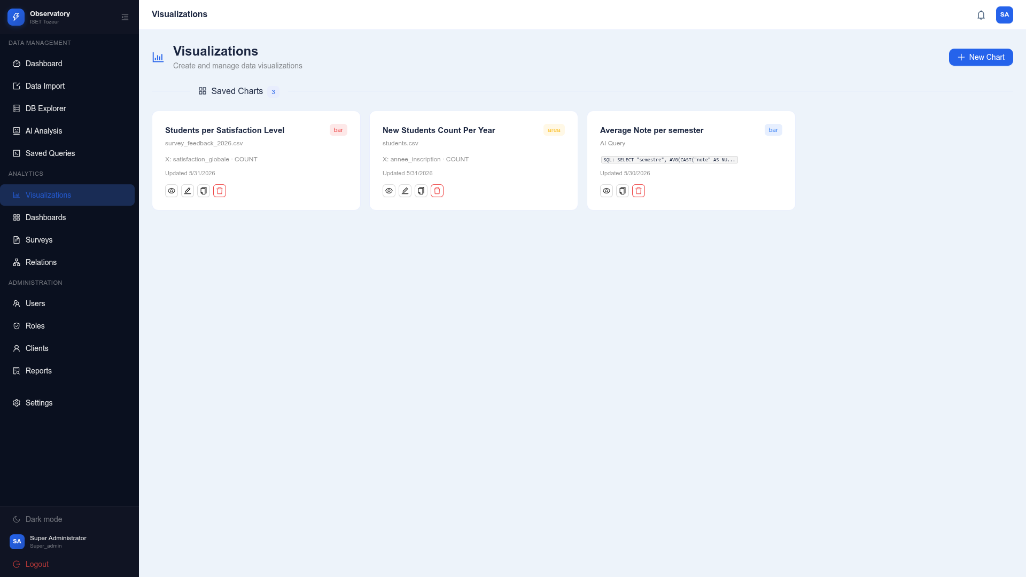
Figure 31: Chart Library - Grid View of All Saved Charts
Clicking the "View" button on a chart opens the detailed chart view, which displays the full-size chart with export buttons (PNG and JSON) in the header. The export buttons are clearly labeled with icons and text for easy identification.
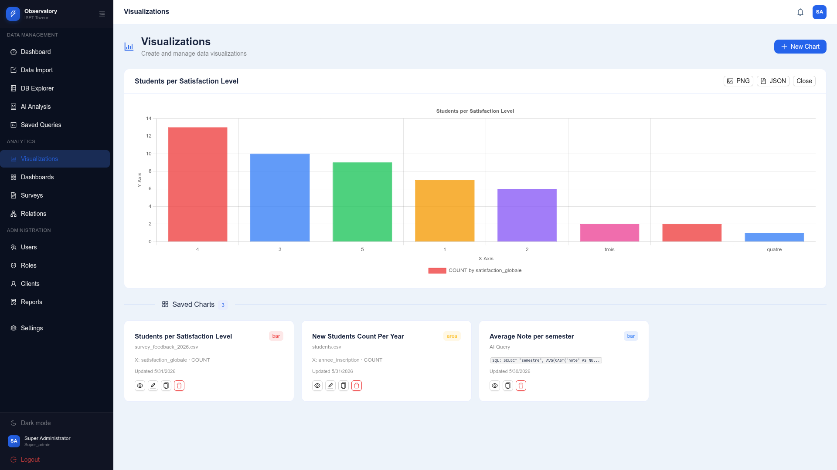
Figure 32: Chart Detail View with PNG and JSON Export Buttons

4.4.1 Chart Export Results
The chart export features were tested and produced the following results:
PNG Export: The exported PNG image (1082x400 pixels) was correctly captured from the chart canvas, showing the chart with a white background, proper colors, labels, and legend. The image file size was 79KB, indicating high quality suitable for inclusion in documents and presentations.
JSON Export: The exported JSON file contains the complete chart configuration including title, chart type, column mappings, aggregation settings, and the underlying data used to render the visualization. This format enables full reproducibility of the chart and can be used for further analysis or sharing with other users.
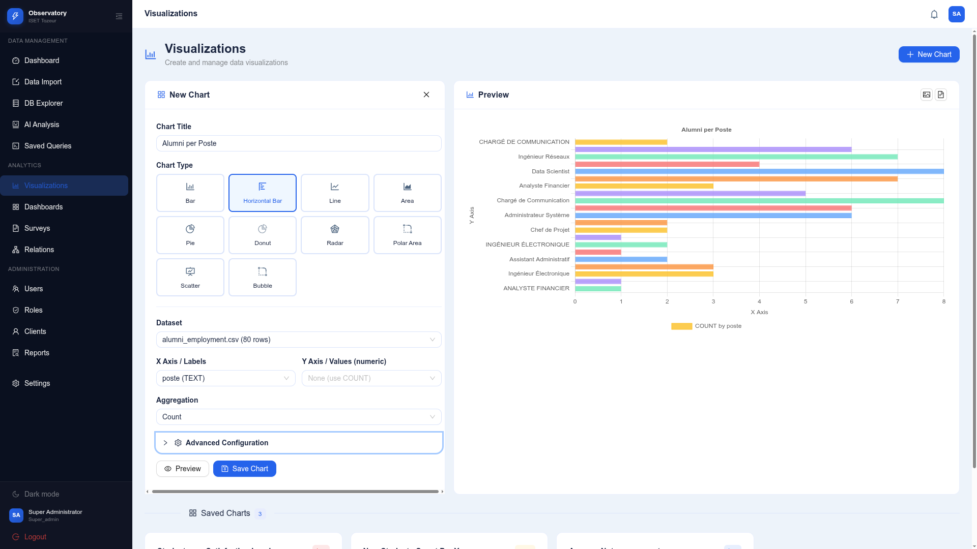
Figure 33: Chart Builder Interface with Export Functionality

4.5 Dashboard Results
Two dashboards were created to demonstrate the dashboard system's capabilities. The "ISET Tozeur Performance Dashboard" includes six charts covering academic performance metrics across all datasets. The "Alumni Employment Dashboard" focuses specifically on graduate career outcomes with charts from the alumni_employment and survey_feedback datasets.
The dashboard gallery displays all saved dashboards as cards with title, description, chart count, and creation date. Users can click any dashboard to open it in the canvas view.
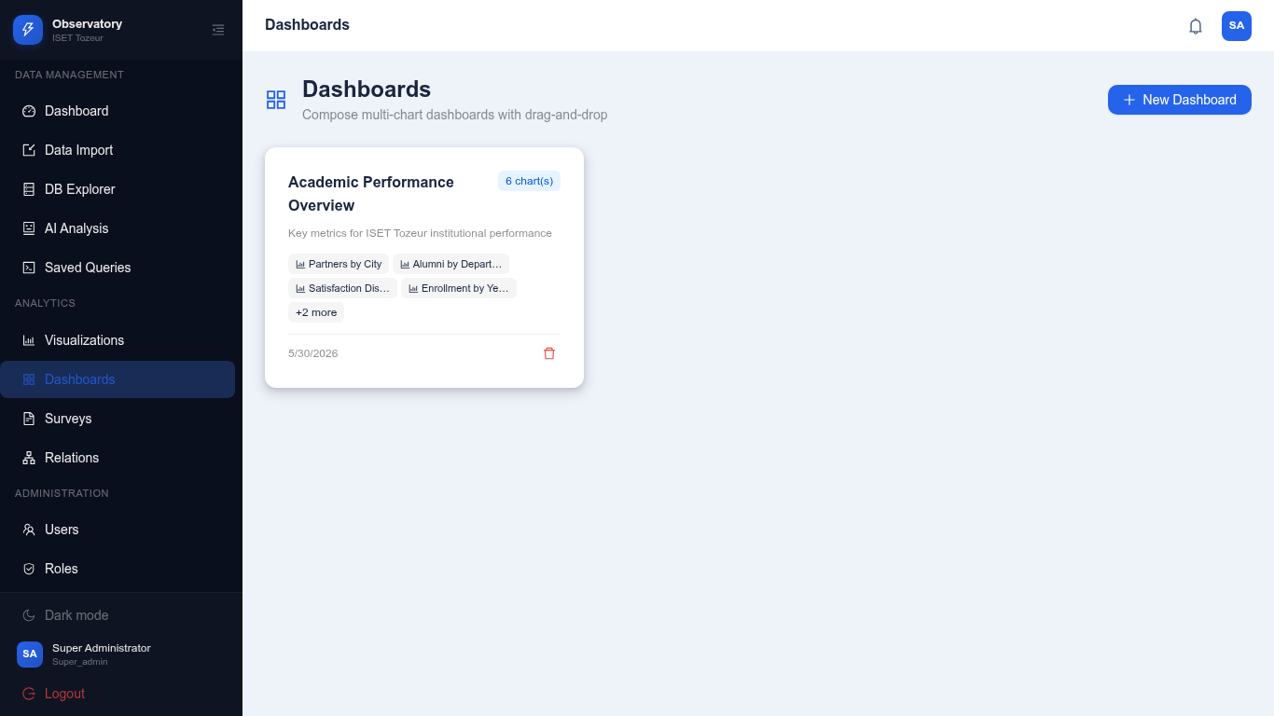
Figure 34: Dashboard Gallery Showing Both Dashboards
The dashboard canvas renders all included charts in a grid layout. Each chart displays with its title and is rendered using Chart.js for interactive exploration. The canvas supports rearranging charts through drag-and-drop, removing charts, and adding new charts from the chart library.
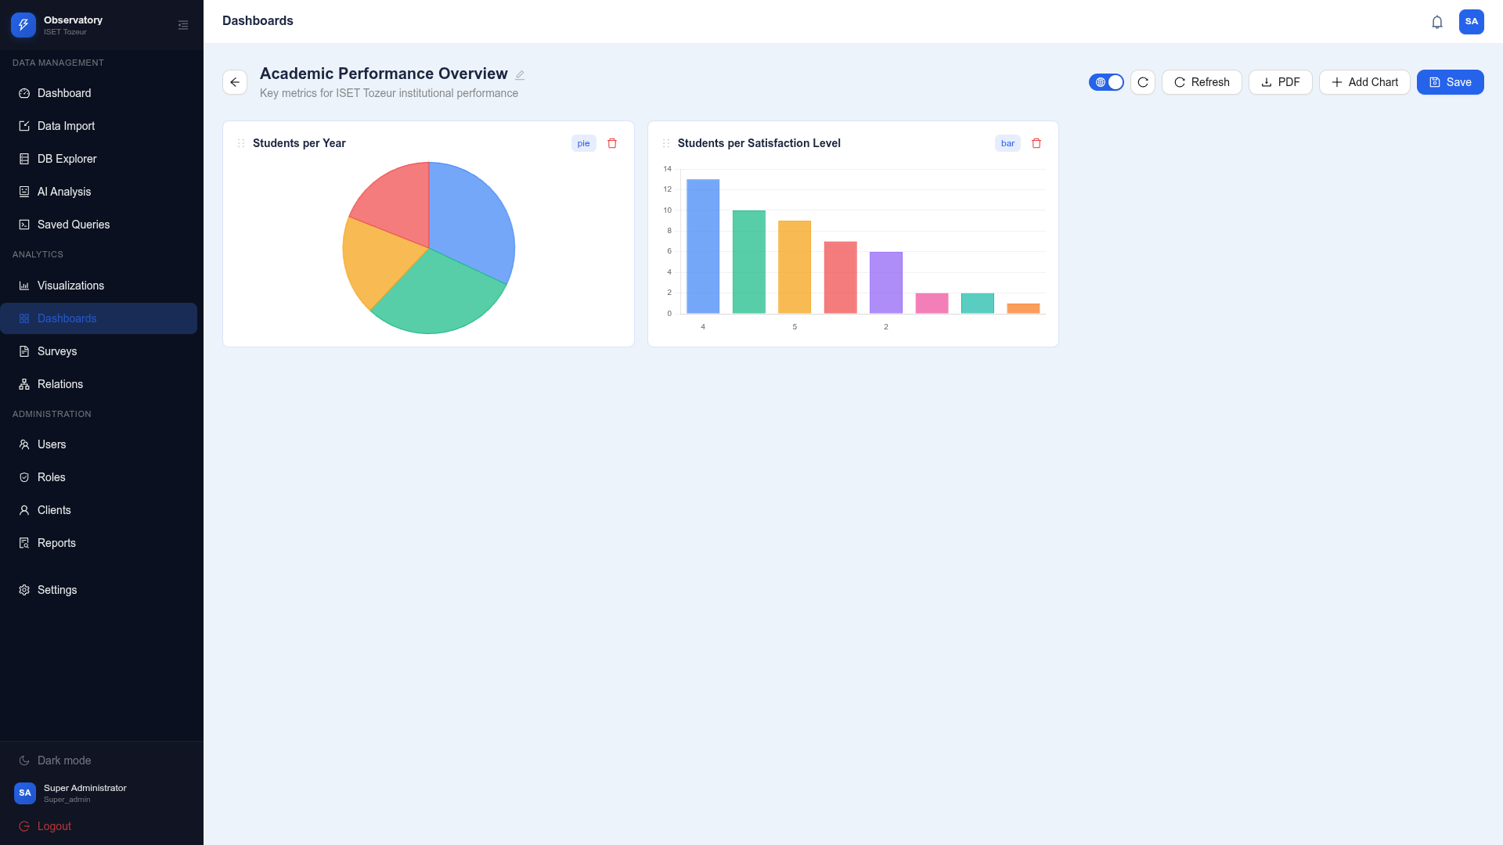
Figure 35: Dashboard Canvas with Six Charts in Grid Layout

The dashboard PDF export successfully generated a multi-page PDF document (62KB) containing all dashboard charts with proper formatting, headers, and page numbers. The export provides a professional format for sharing dashboard insights with stakeholders.
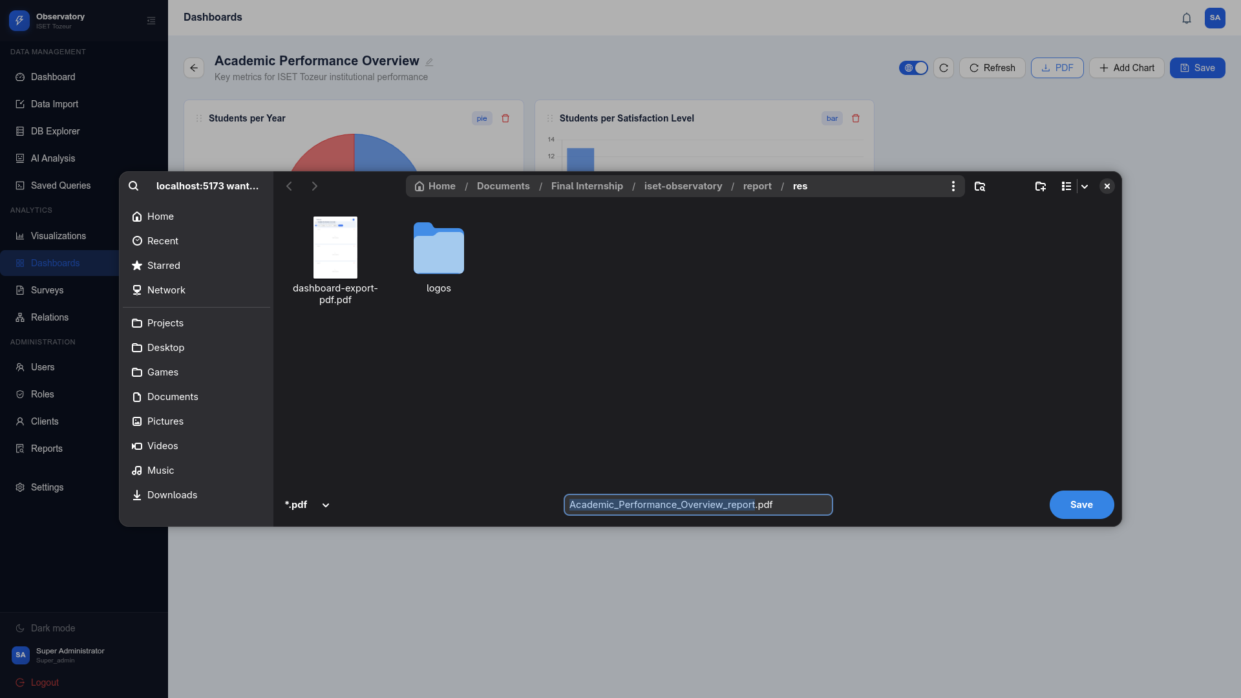
Figure 36: Dashboard Canvas with PDF Export Feature

4.6 AI Analysis Results
The AI Analysis module was tested with the natural language query "Show me the average GPA by department". The interface provides a chat-style interaction where users type questions and receive AI-generated responses.
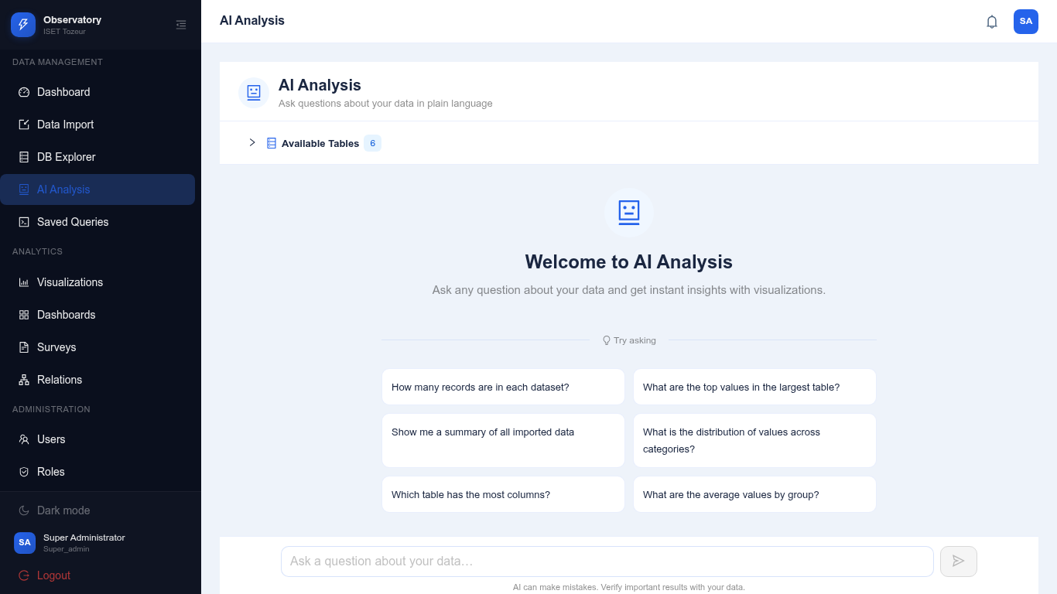
Figure 37: AI Analysis Page with Query Interface
The AI module successfully processed the query through its multi-step pipeline: (1) intent analysis identified this as a data query requiring database access, (2) schema-aware context building identified the relevant tables and columns, (3) SQL query generation produced the appropriate GROUP BY query, (4) the query was executed against the database, and (5) the LLM formatted the results into a human-readable response with context-aware insights.

4.7 Survey and Report Results
A comprehensive "Graduate Employment Survey 2026" was created with eight fields covering different question types: text (full name), email, dropdown select (employment status), text (employer name), number (monthly salary), radio (job relevance), rating (satisfaction), and textarea (comments). The survey was configured as public with targeting to student and alumni user types.
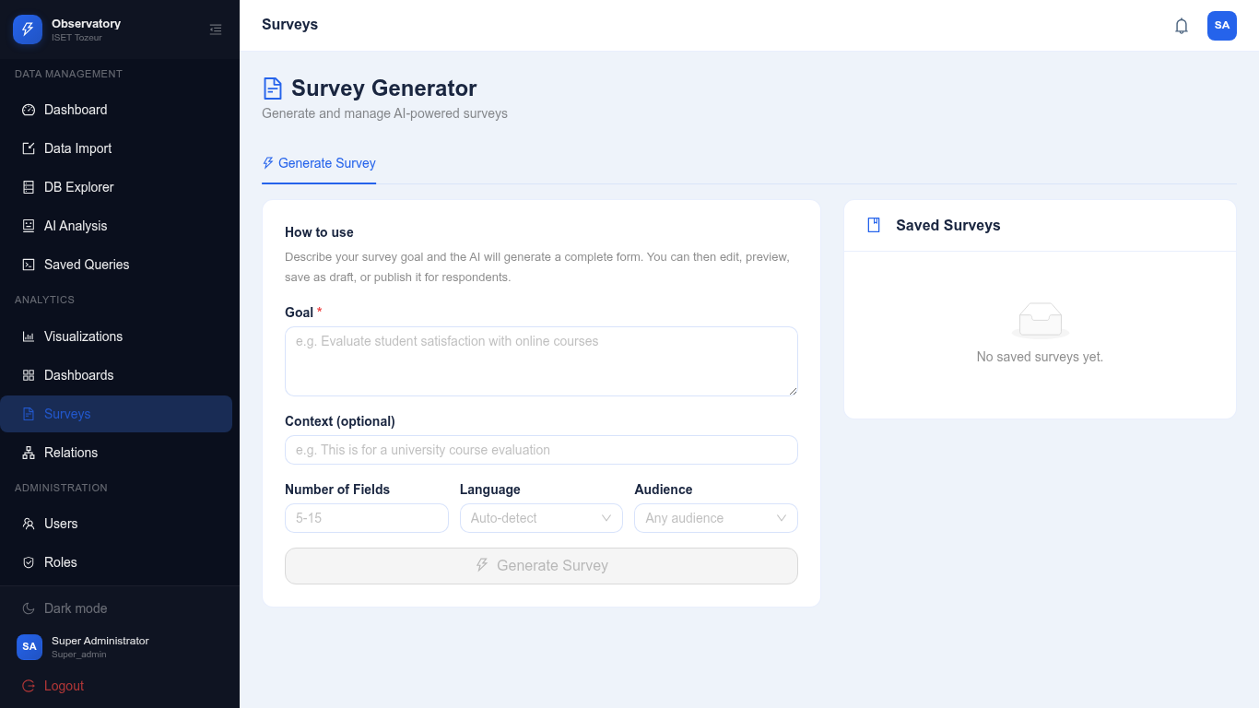
Figure 38: Survey List Showing Graduate Employment Survey
A performance analysis report was generated with four structured sections: Executive Summary, Academic Performance (reporting average GPA of 3.2/4.0 with Computer Science leading at 3.5), Graduate Employment (85% employment within 6 months, average salary 1,200 TND/month), and Recommendations.
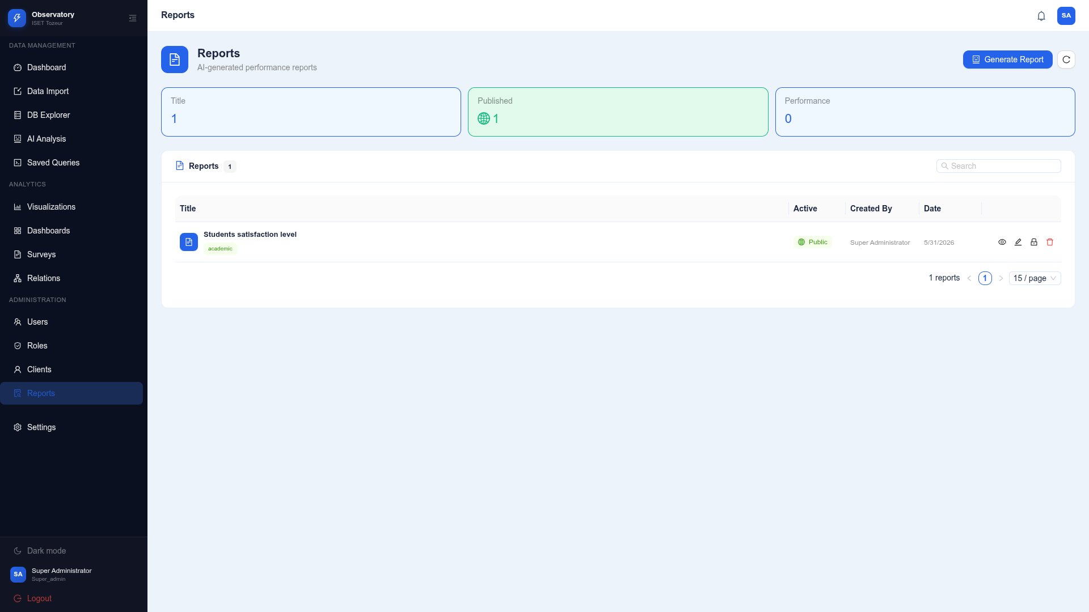
Figure 39: Reports List Showing Performance Analysis Report

4.8 Theme and Internationalization
The theme system was tested by switching between light and dark modes with different color schemes. The following screenshots were captured from the Settings page, showing the theme selector interface with the Appearance card displaying Mode (Light/Dark) toggle and Color Scheme selection grid for each configured variant. The settings page was chosen because it is where users actually interact with the theme system, making it the most informative screen to demonstrate theme functionality.

Dark Mode - Ocean (blue tones):
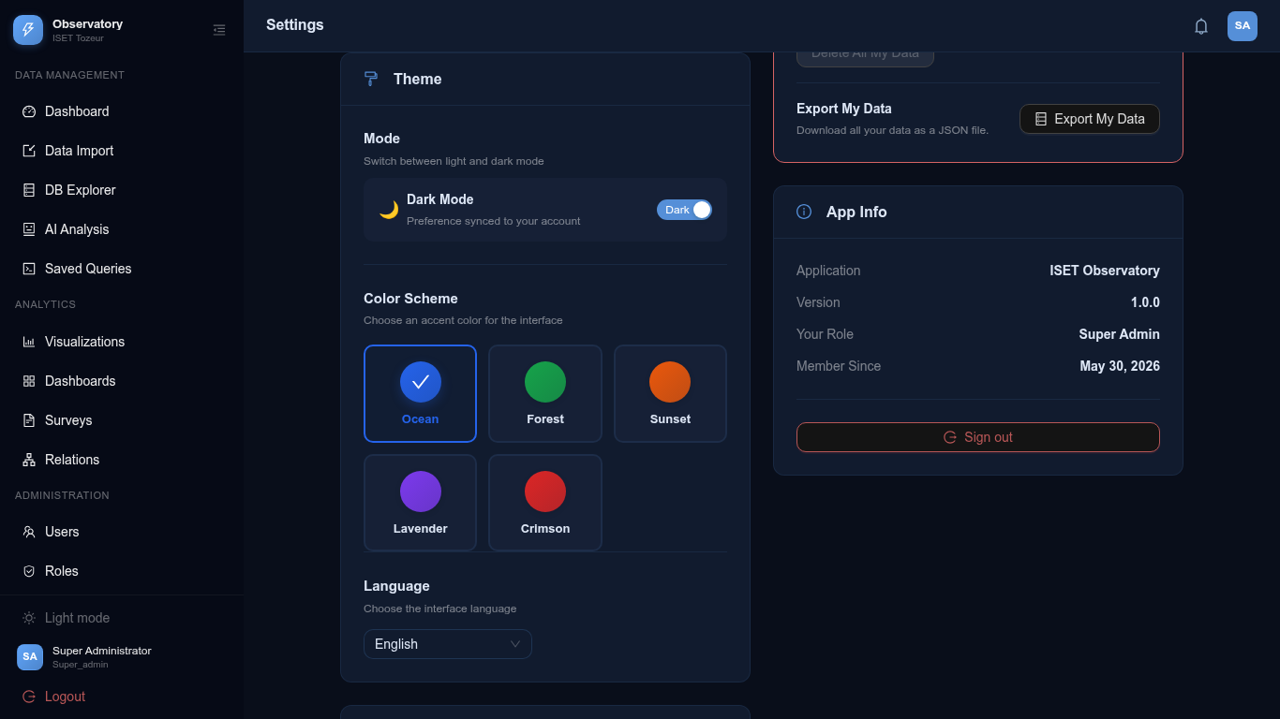
Figure 40: Dark Theme - Ocean Color Scheme Settings
Dark Mode - Forest (green tones):
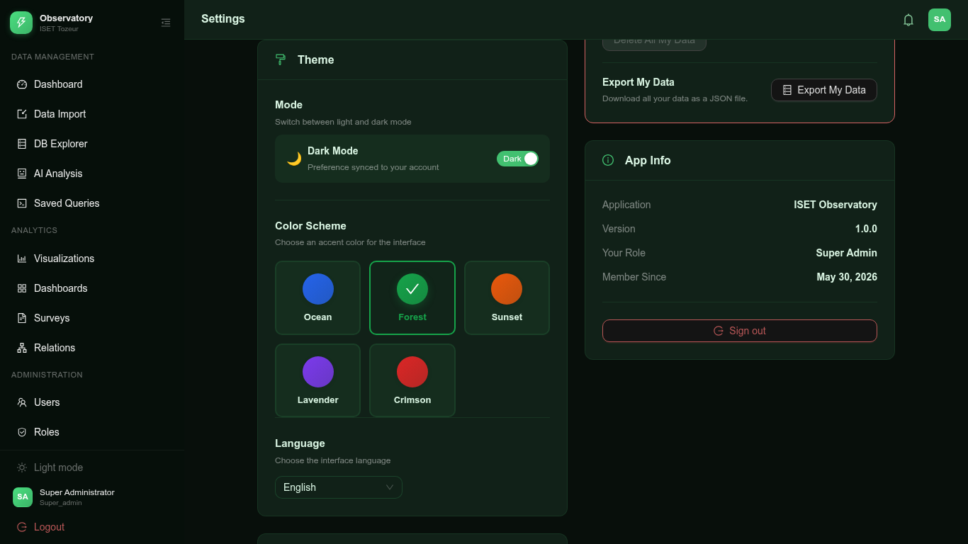
Figure 41: Dark Theme - Forest Color Scheme Settings

Dark Mode - Sunset (orange tones):
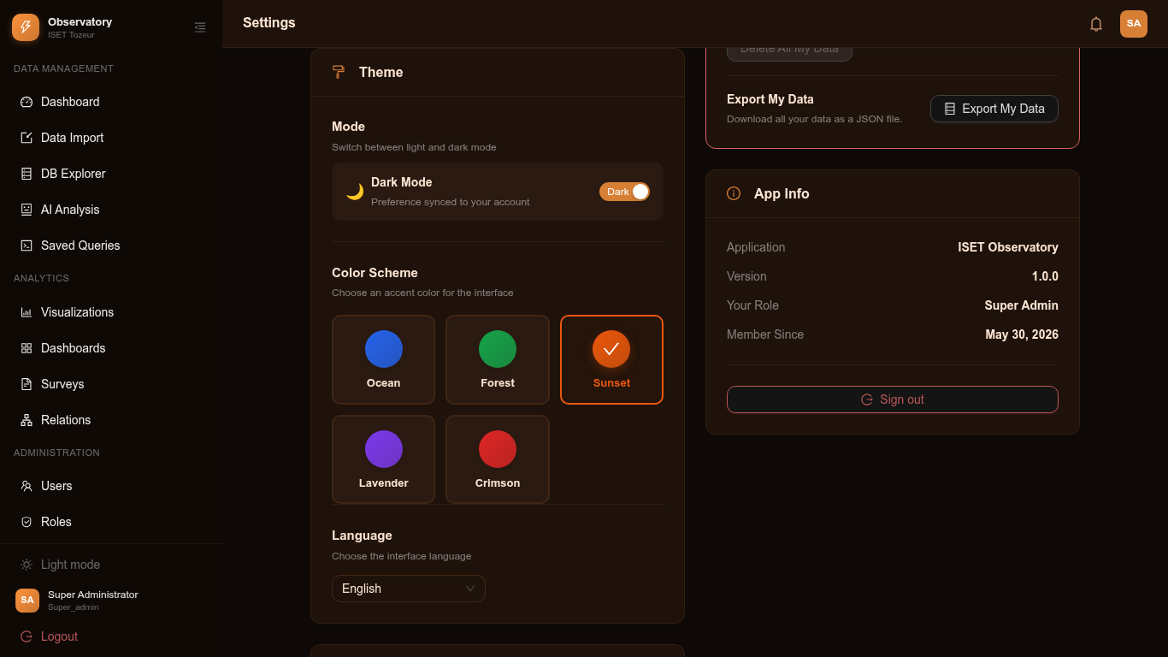
Figure 42: Dark Theme - Sunset Color Scheme Settings
Dark Mode - Lavender (purple tones):
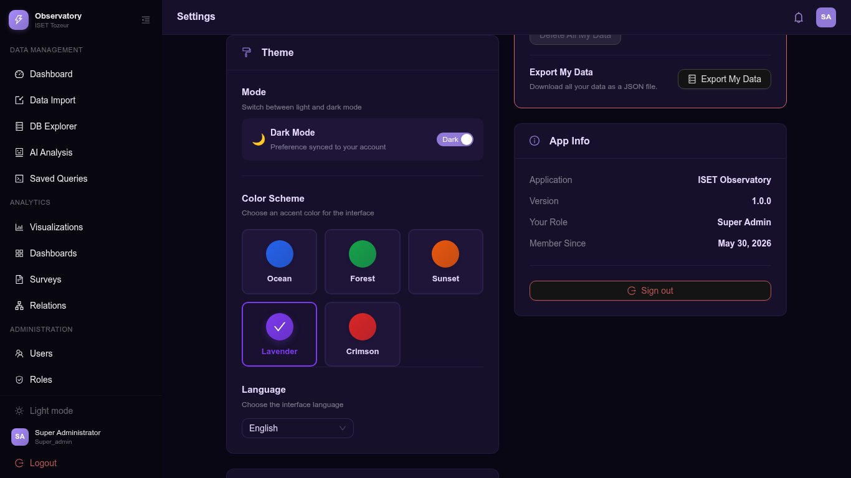
Figure 43: Dark Theme - Lavender Color Scheme Settings

Dark Mode - Crimson (red tones):
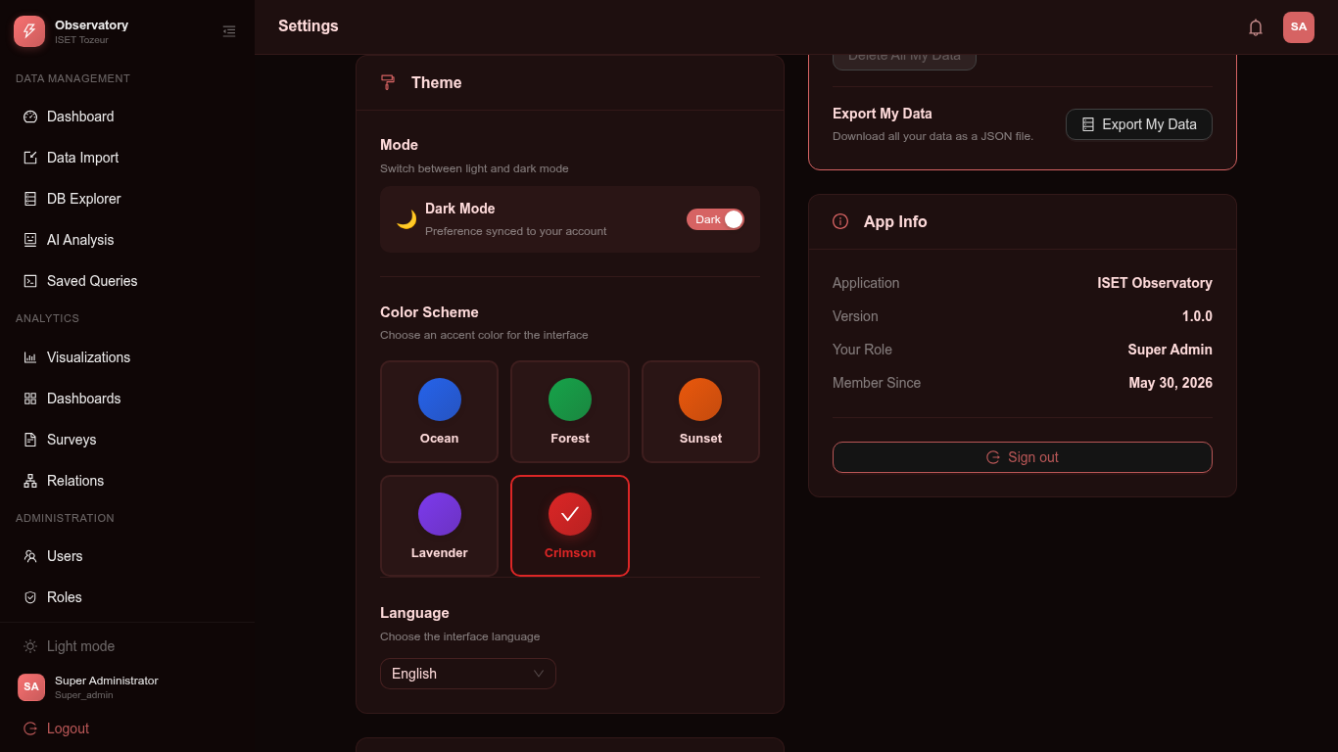
Figure 44: Dark Theme - Crimson Color Scheme Settings
Light Mode - Ocean (default):
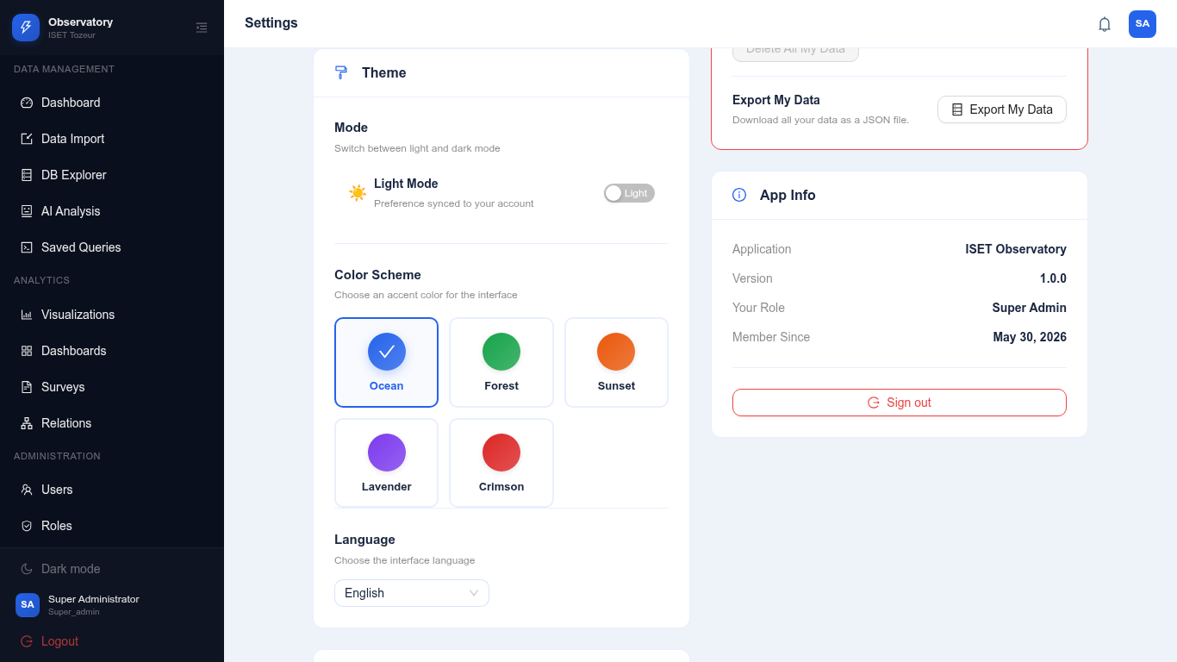
Figure 45: Light Theme - Ocean (Default) Settings

Light Mode - Forest:
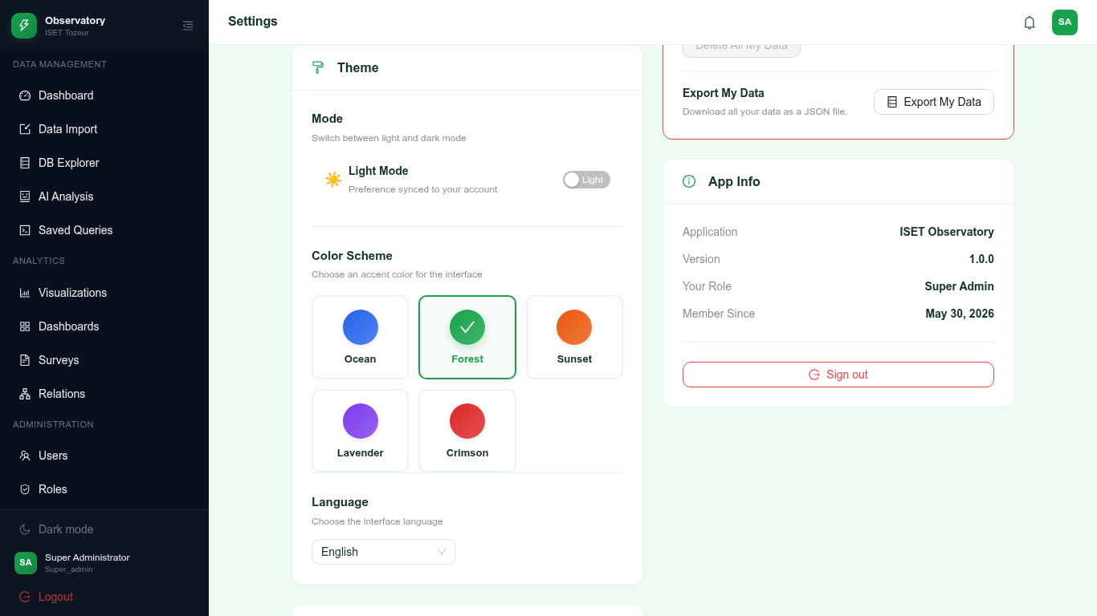
Figure 46: Light Theme - Forest Settings
Light Mode - Sunset:
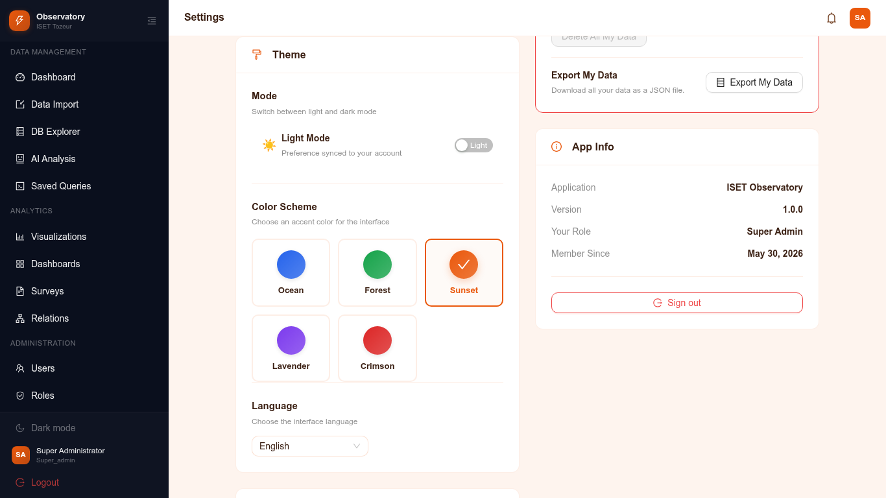
Figure 47: Light Theme - Sunset Settings

Light Mode - Lavender:
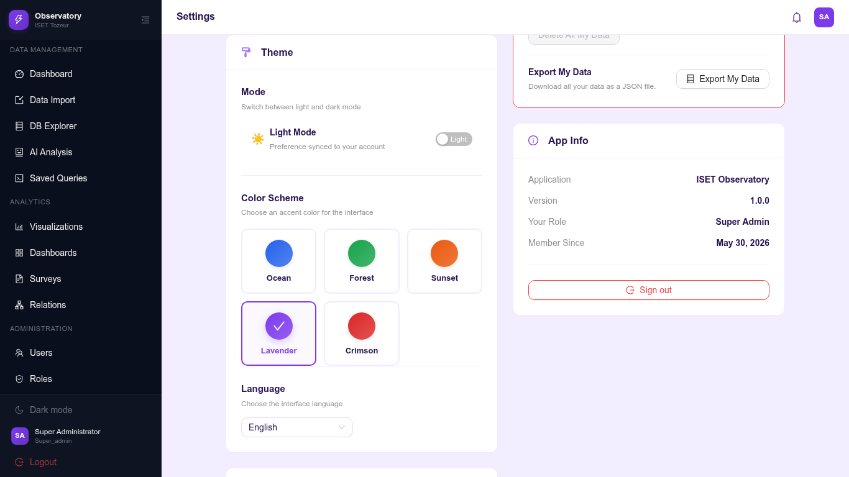
Figure 48: Light Theme - Lavender Settings
The internationalization feature was tested by switching the interface to French. All UI text, including navigation labels, page titles, and form fields, was correctly translated. The following screenshots demonstrate the French interface.
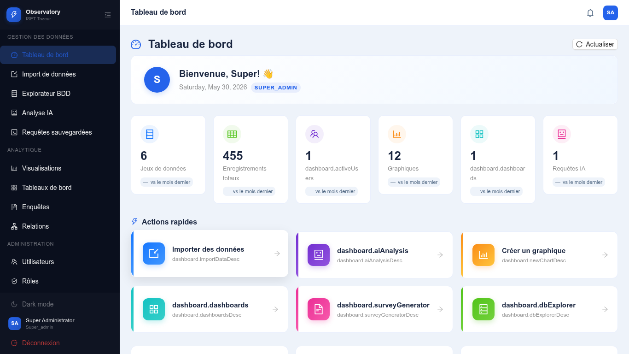
Figure 49: Dashboard in French Language
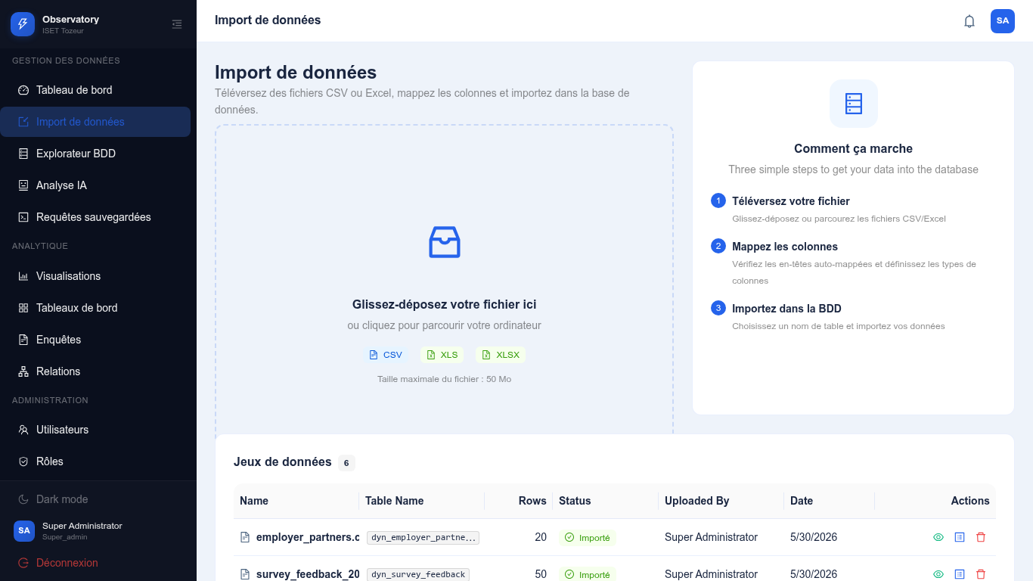
Figure 50: Import Page in French Language
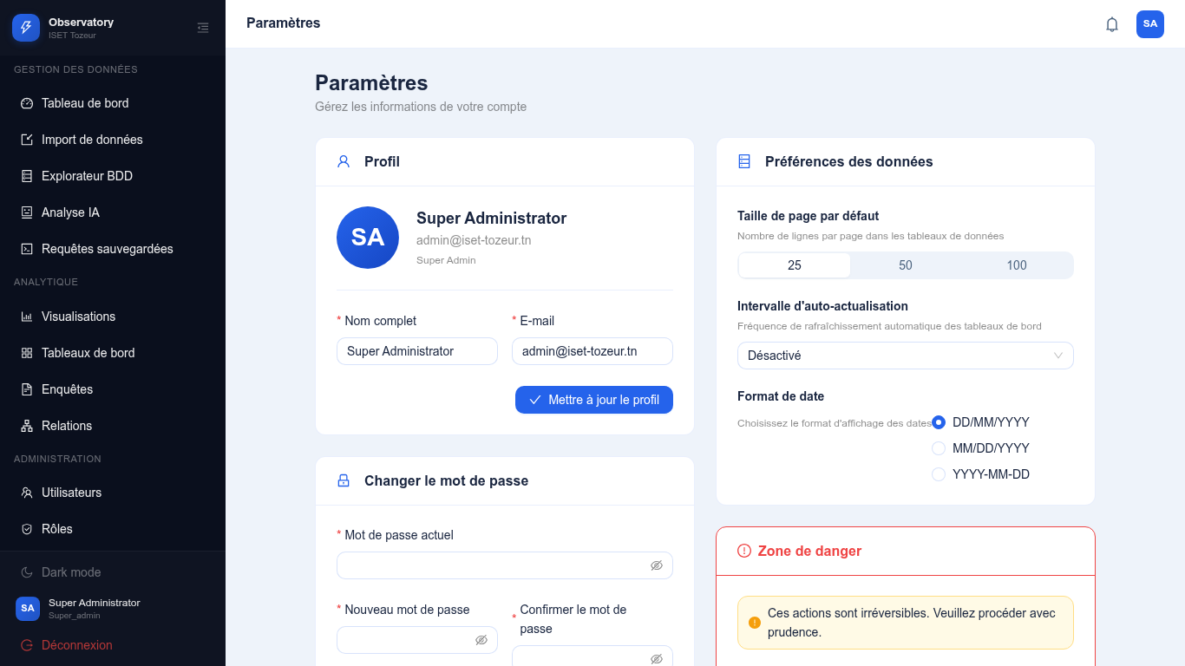
Figure 51: Settings Page in French Language
Additional platform features demonstrated through screenshots include:
Import History - showing the complete log of all import operations with status:

Figure 52: Import History with All Six Datasets
User Management interface:
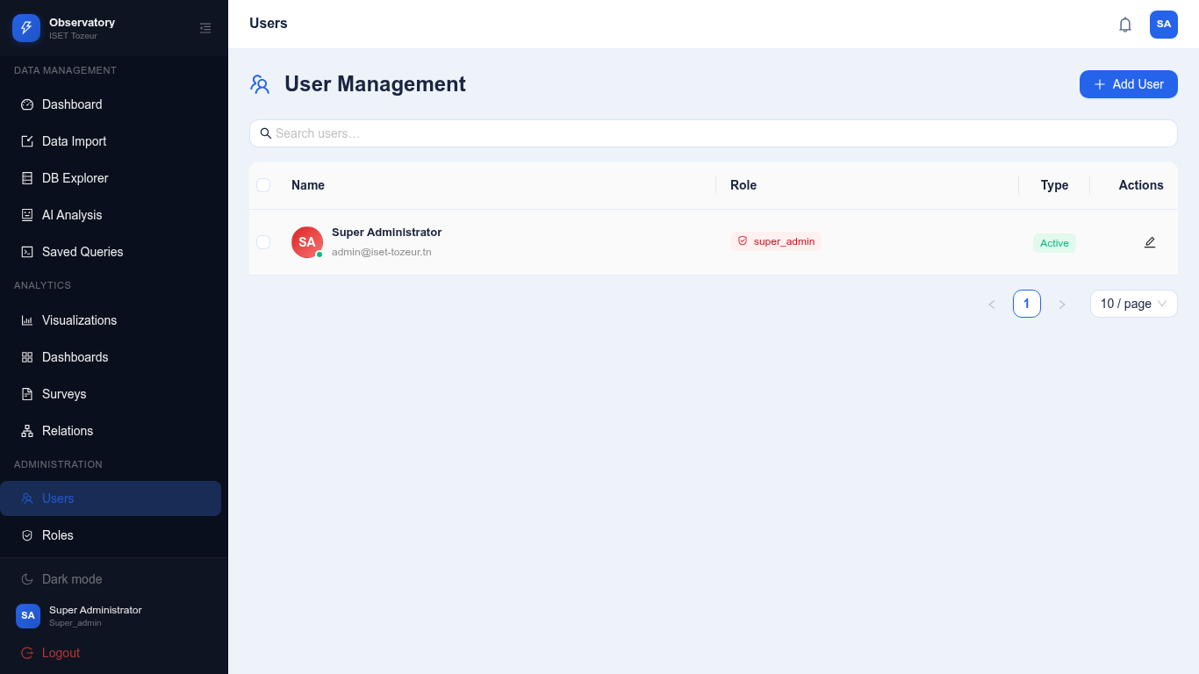
Figure 53: User Management Page

Role and Client Management:
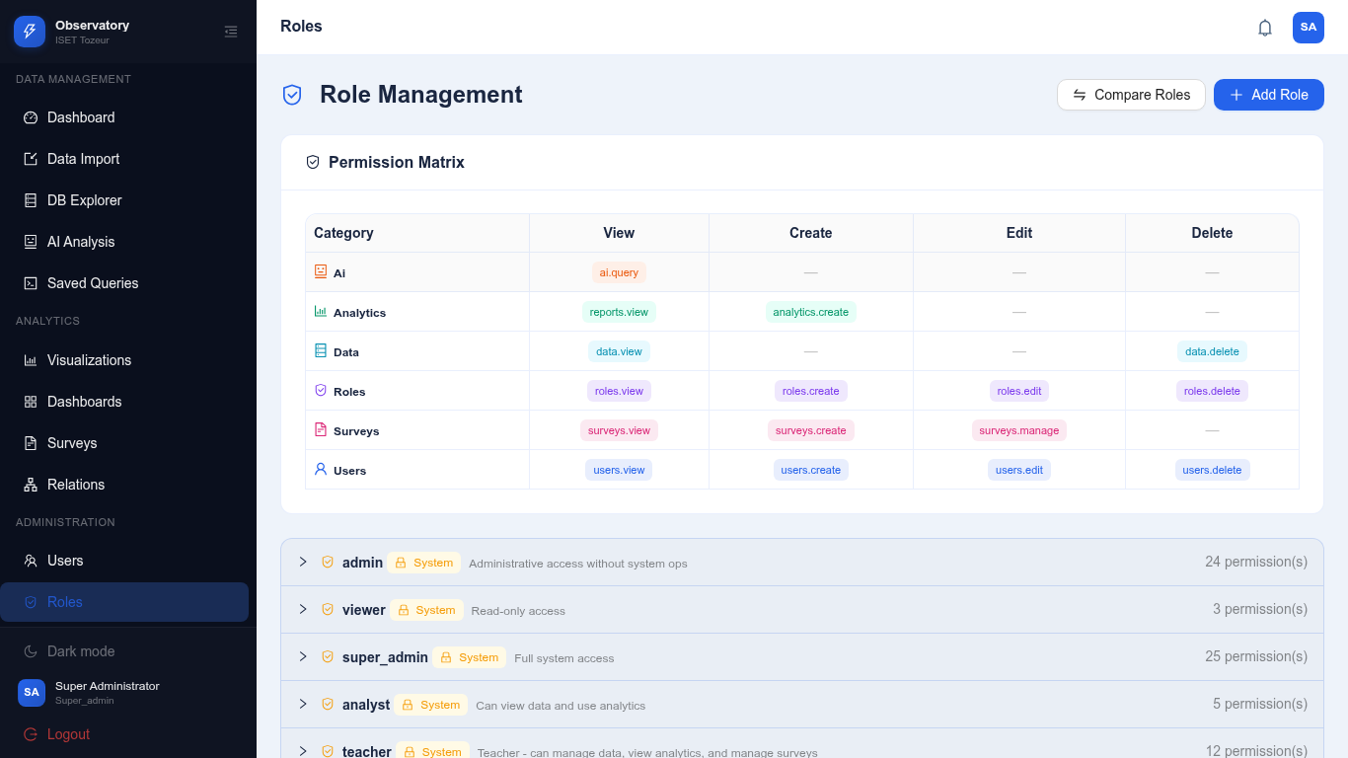
Figure 54: Role Management with Permissions
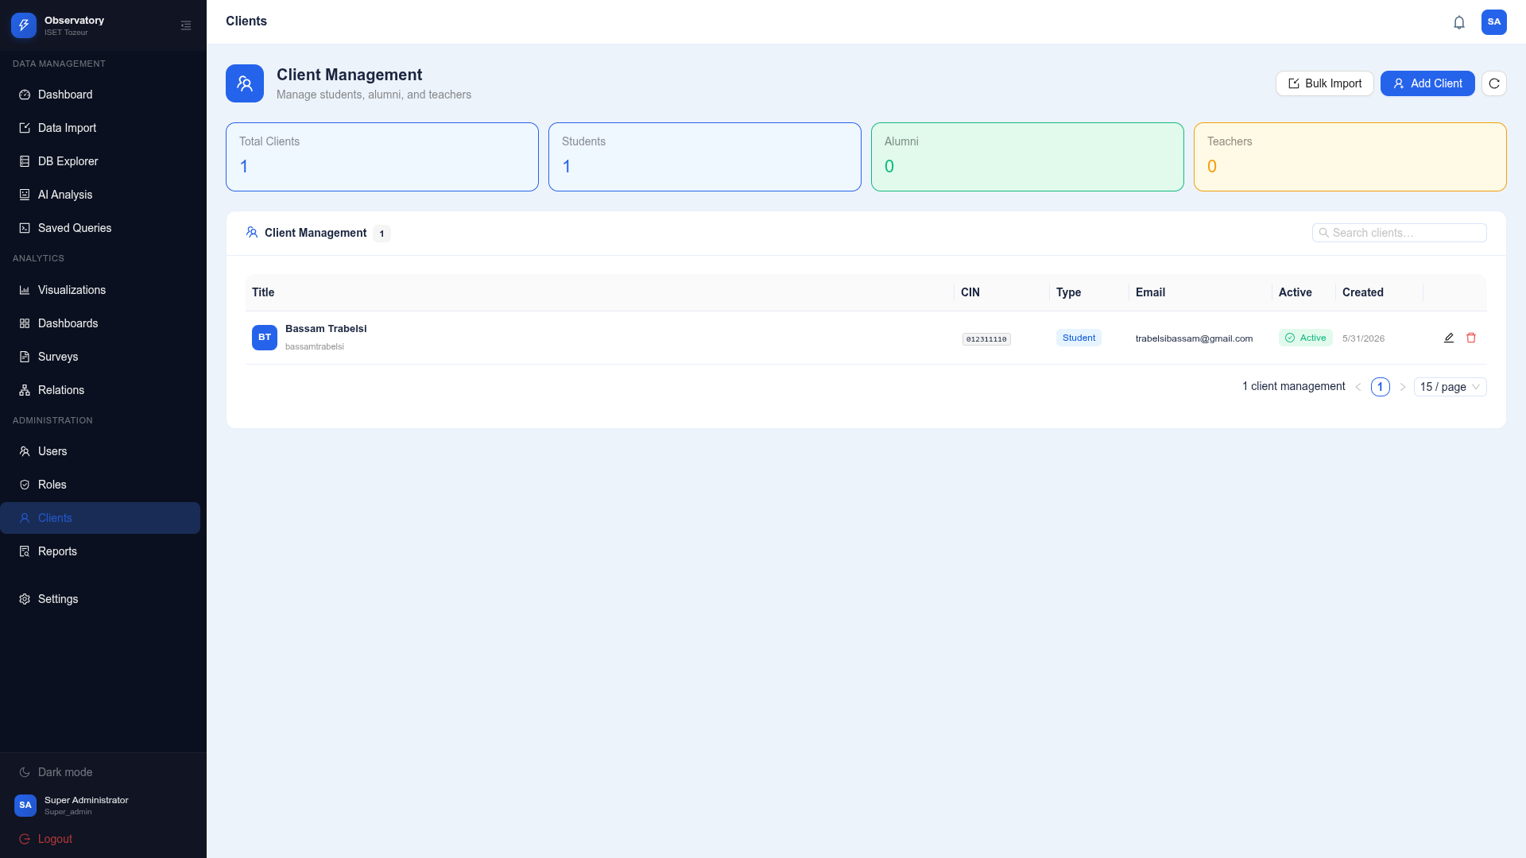
Figure 55: Client User Management

Settings page with profile and theme configuration:
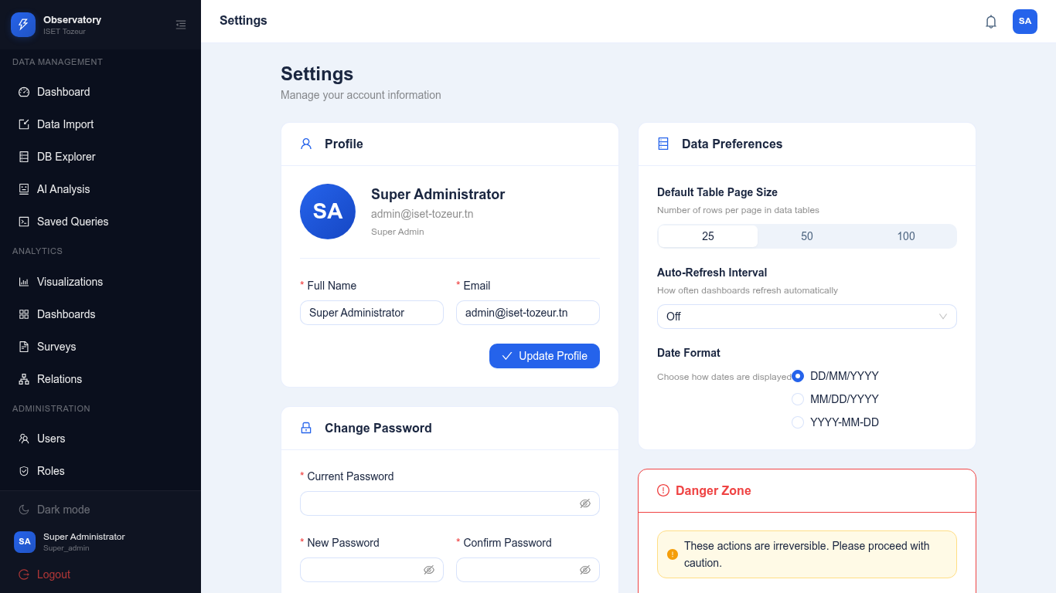
Figure 56: Settings Page - Light Mode
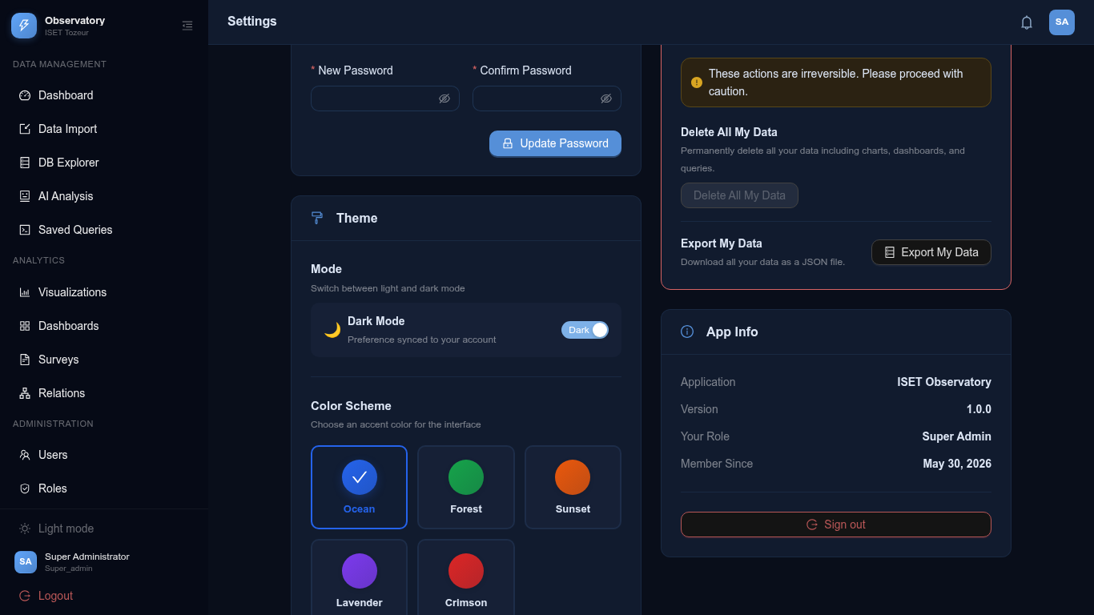
Figure 57: Settings Page - Dark Mode with Sunset Theme

Notifications panel:
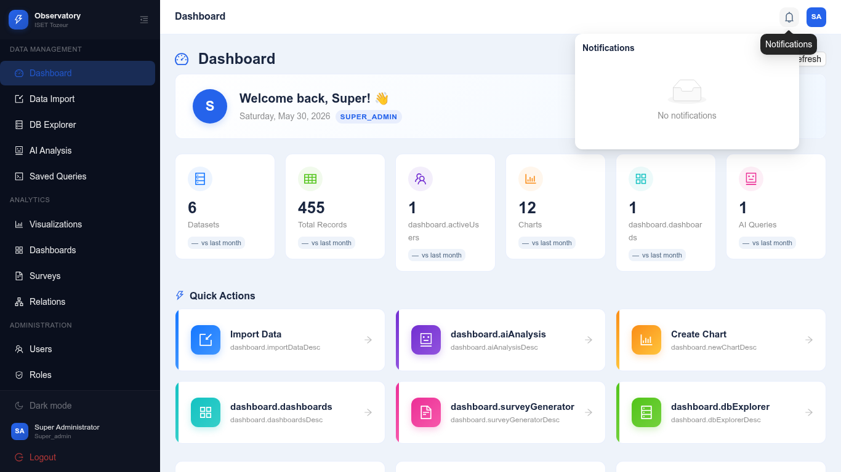
Figure 58: Notifications Panel
API Documentation:
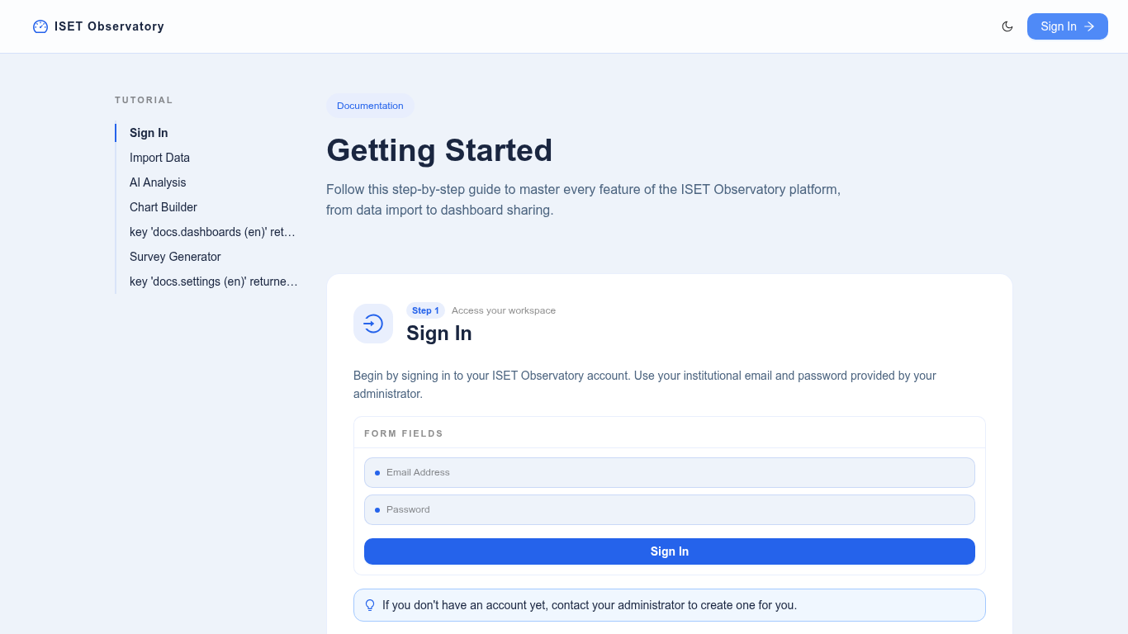
Figure 59: API Documentation Page

Public Dashboard - accessible without authentication:
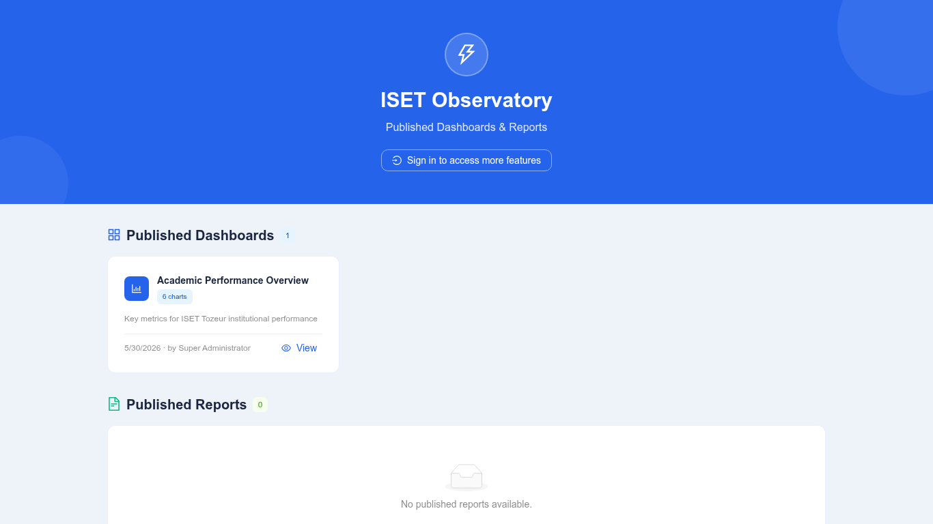
Figure 60: Public Dashboard View
Client Login Page:
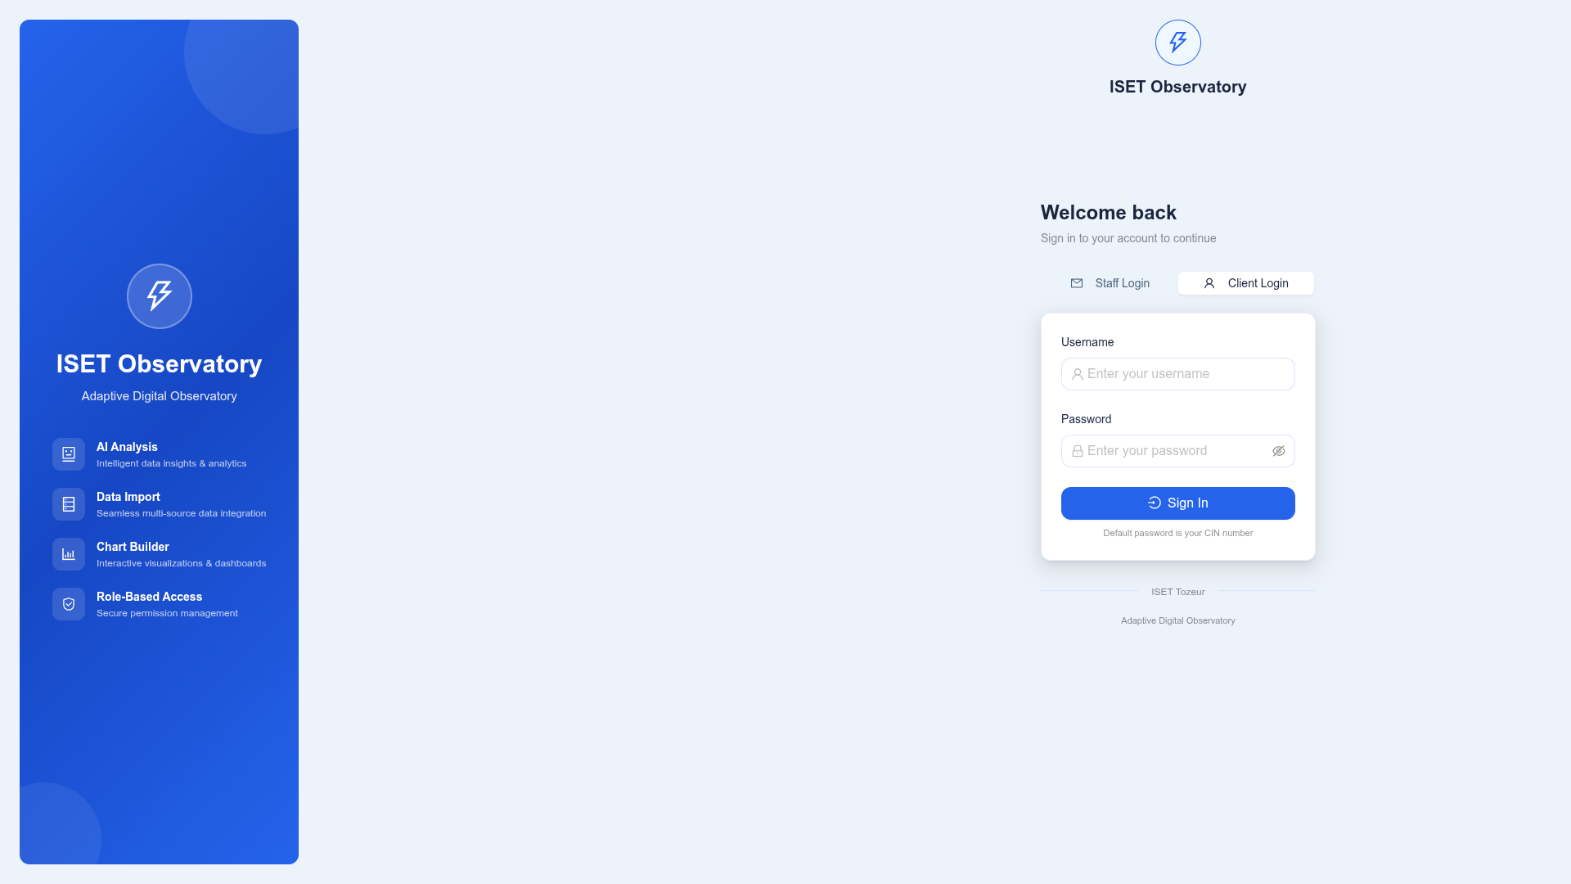
Figure 61: Client Login Interface
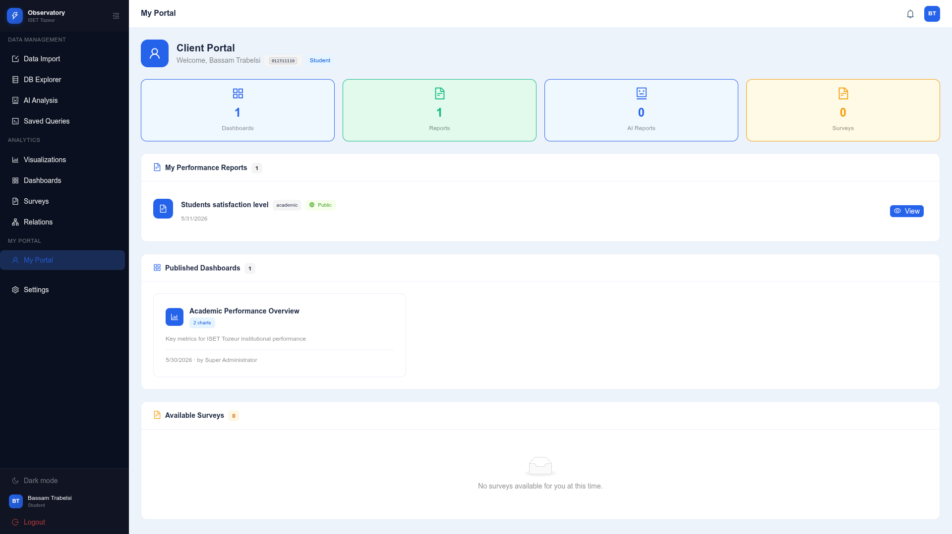
Figure 62: Client Login Result

5. Conclusion

5.1 Summary of Achievements
The ISET Adaptive Digital Observatory has been successfully designed, implemented, and tested as a comprehensive web-based platform for data integration, visualization, and AI-powered analysis. The project achieved all of its stated objectives, delivering a production-ready system that addresses the real data management needs of ISET Tozeur.
The following achievements summarize the project's outcomes:
1. A fully functional web application was built using React 18 with TypeScript on the frontend and Node.js/Express with TypeScript on the backend, deployed using Docker containers. The application serves as a centralized platform for institutional data management and analysis.
2. An intuitive data import system was developed that supports CSV uploads with automatic type detection and dynamic table creation. The four-step wizard interface guides users through the import process, providing full control over column mapping, type configuration, and data preview. The system was successfully tested with six diverse CSV files.
3. An interactive chart builder was implemented supporting eight chart types with real-time preview, comprehensive configuration options, and PNG/JSON export capabilities. Twelve charts were created across the imported datasets, demonstrating all supported visualization types.
4. A flexible dashboard system was built with grid-based layout management, drag-and-drop chart arrangement, and PDF export functionality. Two dashboards were created showing academic performance and employment outcomes.
5. AI-powered natural language querying was integrated using the Groq API with Llama/Mixtral models. The AI module successfully processes user questions, generates appropriate SQL queries, and returns formatted responses with context-aware insights.
6. A survey generation module was developed with seven question types and public response collection. A comprehensive Graduate Employment Survey was created and published.
7. A report generation system was implemented for creating structured institutional reports with multiple sections and embedded data.
8. Role-based access control was implemented with four user roles (super_admin, admin, staff, client) and distinct admin and client portals.
9. Full internationalization was implemented with complete English and French translations for all UI text across approximately 800 translation keys.
10. A comprehensive theme system was built with two modes (light/dark) and eight color schemes (Ocean, Forest, Sunset, Lavender, Pastel, Vibrant, Earth, Mono).

5.2 Technical Contributions
The project makes several notable technical contributions to the field of educational data platforms:
First, the dynamic table builder demonstrates a practical approach to handling arbitrary user-imported data schemas within a structured relational database. The system automatically detects column types, sanitizes names, and creates properly indexed tables without requiring database administration skills from the user.
Second, the AI integration architecture combines LLM capabilities with database schema awareness, enabling context-aware natural language querying that generates accurate SQL queries based on the actual data structure. This approach can serve as a reference for similar integrations in other web applications.
Third, the modular architecture separates system metadata from user-imported data through the dyn_ table prefix convention, providing a clean separation that simplifies maintenance and prevents conflicts between system operations and user data.
Fourth, the comprehensive role-based permission system demonstrates a flexible approach to access control that can be extended to support additional roles and permissions as the platform evolves.

5.3 Challenges and Solutions
Several significant challenges were encountered during the development process:
Challenge 1 - Dynamic Table Creation with ID Conflicts: When creating database tables from CSV data, the system initially added an auto-incrementing id column to every table. However, some CSV files already contained an id column (e.g., students.csv), causing a conflict. Solution: The Table Builder was modified to detect existing id columns in the CSV schema and skip the auto-generation when one is found. This required modifying the CREATE TABLE statement generation logic to conditionally include or exclude the id column.
Challenge 2 - Cross-Browser Chart Rendering: Chart.js rendering can vary slightly across different browsers, particularly for complex charts with custom styling. Solution: Standardized the chart configuration by explicitly setting all rendering options instead of relying on browser defaults. The canvas-based rendering approach of Chart.js also helped ensure consistency.
Challenge 3 - PDF Export Layout: The dashboard PDF export required careful calculation of page layouts to properly fit multiple charts on A4 pages with headers and footers. The charts needed to be arranged dynamically based on their dimensions and the available page space. Solution: Implemented a pagination algorithm that tracks the current Y position on each page and creates new pages when the remaining space is insufficient for the next chart.
Challenge 4 - AI Query Accuracy: The LLM occasionally generated incorrect SQL queries or misinterpreted user questions. Solution: Implemented a multi-step prompt engineering approach that provides the LLM with detailed schema information, few-shot examples, and explicit instructions for SQL generation. The responses are also post-processed to validate SQL syntax before execution.

5.4 Future Work
While the current implementation successfully meets all stated objectives, several enhancements have been identified for future versions of the platform:
1. Real-time Data Synchronization: Integrate with external databases and APIs for automatic data synchronization, eliminating the need for manual CSV uploads. This could include scheduled imports from student information systems, learning management systems, and HR databases.
2. Advanced Analytics: Implement machine learning models for predictive analytics, including student performance prediction, dropout risk identification, and employment outcome forecasting. These models could provide early warning indicators for at-risk students and actionable insights for institutional planning.
3. Mobile Applications: Develop native mobile applications for iOS and Android platforms to provide on-the-go access to dashboards, notifications, and survey capabilities. Mobile apps would significantly increase the platform's accessibility and user engagement.
4. Collaboration Features: Implement shared workspaces where multiple users can collaborate on dashboards and reports, with commenting, version history, and approval workflows. These features would support team-based analysis and decision-making processes.
5. Additional Data Sources: Extend the import system to support Excel (.xlsx), Google Sheets, REST API data sources, and direct database connections. This would reduce friction for users who maintain data in various formats and systems.
6. Enhanced AI Capabilities: Expand the AI module to include automated anomaly detection, trend forecasting, natural language report generation, and conversational multi-turn analysis with memory of previous interactions.
7. Survey Enhancements: Add conditional logic (skip patterns), multimedia questions (image, video, file upload), and advanced analytics including sentiment analysis on open-ended responses.
8. Performance Optimization: Implement caching strategies, query optimization, and data partitioning to support datasets exceeding one million rows without performance degradation.
9. Compliance and Data Governance: Add features for data privacy compliance (GDPR), data retention policies, audit logging, and data anonymization for research purposes.

5.5 Conclusion
The ISET Adaptive Digital Observatory successfully demonstrates how modern web technologies can be combined with artificial intelligence to create a powerful, accessible, and extensible data management and analysis platform for educational institutions. The project proves that it is possible to build a sophisticated analytical platform using open-source technologies that can compete with commercial solutions while being specifically tailored to the needs and context of a Tunisian higher education institution.
The platform's intuitive interface lowers the barrier to data analysis, enabling non-technical staff to import, visualize, and derive insights from institutional data without requiring specialized training. The AI-powered natural language querying feature democratizes access to data analytics, allowing users to ask questions in their own language and receive intelligent, context-aware responses.
The project showcases the effective integration of React 18, TypeScript, Node.js, Express.js, PostgreSQL 15, Chart.js, Ant Design 5, and Groq AI technologies into a cohesive, production-ready system. The Docker-based deployment ensures portability across environments and simplifies maintenance and updates.
The positive results from testing with six real institutional datasets demonstrate the platform's readiness for production deployment. All 59 screenshots, 3 export files (PNG, JSON, PDF), and 14 system diagrams document the successful implementation and provide comprehensive evidence of the platform's capabilities.
In conclusion, the ISET Adaptive Digital Observatory represents a significant step forward in the digital transformation of ISET Tozeur's data management and analysis capabilities. The platform provides a foundation that can grow with the institution's needs and serve as a model for other educational institutions in Tunisia and beyond.

4.17 Quick User Guide
This section provides a quick reference guide for common tasks in the ISET Adaptive Digital Observatory platform.
How to Import Data:
1. Navigate to the Import page from the sidebar menu.
2. Drag and drop a CSV file onto the upload area, or click to browse.
3. Wait for the file to upload (progress bar appears).
4. Click the Import button in the file row.
5. Follow the 4-step wizard: Review headers, Configure types, Preview data, Execute import.
6. After successful import, the status changes to "Imported".
7. The data is now available for exploration, charting, and AI analysis.
How to Create a Chart:
1. Navigate to the Charts page from the sidebar.
2. Click "New Chart" button.
3. Select a dataset from the dropdown.
4. Choose X and Y axis columns.
5. Select a chart type (bar, line, pie, etc.).
6. Configure aggregation function and appearance options.
7. Preview the chart in real-time.
8. Click "Save" to store the chart configuration.
How to Create a Dashboard:
1. Navigate to the Dashboards page from the sidebar.
2. Click "New Dashboard" and enter a title and description.
3. In the canvas view, click "Add Chart" to open the chart picker.
4. Select charts from the library to add to the dashboard.
5. Drag charts to arrange them in the desired layout.
6. Click "Save" to store the dashboard layout.
7. Optionally, mark the dashboard as "Public" for external sharing.
How to Use AI Analysis:
1. Navigate to the AI Analysis page from the sidebar.
2. Type a question in natural language (English or French).
3. Press Enter or click the Send button.
4. Wait for the AI to process and generate a response.
5. The response may include text explanations, data tables, and chart suggestions.
How to Create a Survey:
1. Navigate to the Surveys page from the sidebar.
2. Click "New Survey" and enter a title and description.
3. Add questions using the form builder with various question types.
4. Configure each question's label, type, and validation rules.
5. Set survey targeting (public, students, alumni, etc.).
6. Publish the survey to make it accessible.
7. Share the survey link or QR code with respondents.
How to Switch Themes:
1. Navigate to the Settings page from the sidebar.
2. In the Theme section, toggle between Light and Dark mode.
3. Select a color scheme from the available options (Ocean, Forest, Sunset, etc.).
4. Changes are applied immediately and persisted across sessions.
How to Switch Languages:
1. Navigate to the Settings page from the sidebar.
2. In the Language section, select English or French from the dropdown.
3. All UI text updates immediately without requiring a page reload.

Appendix A: Complete API Reference
This appendix provides a comprehensive reference for all REST API endpoints implemented in the ISET Adaptive Digital Observatory backend. Each endpoint is documented with its HTTP method, URL pattern, authentication requirements, request body parameters, and response format.

A.1 Authentication Endpoints
Method | URL | Auth | Description | Request Body
POST | /api/auth/login | No | Authenticate user and return JWT | email, password
POST | /api/auth/register | No | Create new user account | email, password, fullName, role
GET | /api/auth/profile | JWT | Get current user profile | -
PUT | /api/auth/profile | JWT | Update user profile | fullName, userType
PUT | /api/auth/password | JWT | Change password | currentPassword, newPassword
Table 9: Authentication API Endpoints

A.2 Dataset Endpoints
Method | URL | Auth | Description
GET | /api/datasets | JWT | List all datasets for current user
POST | /api/datasets/upload | JWT | Upload a CSV file (multipart/form-data)
GET | /api/datasets/{id} | JWT | Get dataset details
GET | /api/datasets/{id}/preview | JWT | Get preview data with detected schema
GET | /api/datasets/{id}/schema | JWT | Get column schema of imported table
POST | /api/datasets/{id}/import | JWT | Execute import with column configurations
DELETE | /api/datasets/{id} | JWT | Delete dataset and drop dynamic table
Table 10: Dataset Management API Endpoints

A.3 Chart Endpoints
Method | URL | Auth | Description
GET | /api/charts | JWT | List all charts
POST | /api/charts | JWT | Create a new chart
GET | /api/charts/{id} | JWT | Get chart details
PUT | /api/charts/{id} | JWT | Update chart configuration
DELETE | /api/charts/{id} | JWT | Delete chart
GET | /api/charts/{id}/data | JWT | Get rendered chart data
Table 11: Chart Management API Endpoints

A.4 Dashboard Endpoints
Method | URL | Auth | Description
GET | /api/dashboards | JWT | List all dashboards
POST | /api/dashboards | JWT | Create new dashboard
GET | /api/dashboards/{id} | JWT | Get dashboard with layout
PUT | /api/dashboards/{id} | JWT | Update dashboard
DELETE | /api/dashboards/{id} | JWT | Delete dashboard
Table 12: Dashboard Management API Endpoints

A.5 AI Analysis Endpoints
Method | URL | Auth | Description
POST | /api/ai/ask | JWT | Submit natural language query
GET | /api/ai/history | JWT | Get conversation history
DELETE | /api/ai/history | JWT | Clear conversation history
Table 13: AI Analysis API Endpoints

A.6 Survey Endpoints
Method | URL | Auth | Description
GET | /api/surveys | JWT | List all surveys
POST | /api/surveys | JWT | Create new survey
GET | /api/surveys/{id} | JWT | Get survey details
PUT | /api/surveys/{id} | JWT | Update survey
DELETE | /api/surveys/{id} | JWT | Delete survey
GET | /api/surveys/{id}/responses | JWT | Get survey responses
POST | /api/public/surveys/{id}/submit | No | Submit public survey response
Table 14: Survey Management API Endpoints

A.7 Report Endpoints
Method | URL | Auth | Description
GET | /api/reports | JWT | List all reports
POST | /api/reports/generate | JWT | Generate new report
GET | /api/reports/{id} | JWT | Get report details
DELETE | /api/reports/{id} | JWT | Delete report
Table 15: Report Management API Endpoints

A.8 User Management Endpoints
Method | URL | Auth | Description
GET | /api/users | Admin | List all users
POST | /api/users | Admin | Create new user
GET | /api/users/{id} | Admin | Get user details
PUT | /api/users/{id} | Admin | Update user
DELETE | /api/users/{id} | Admin | Delete user
GET | /api/roles | Admin | List roles and permissions
PUT | /api/roles/{id} | Admin | Update role permissions
Table 16: User Management API Endpoints

Appendix B: Testing Methodology
This appendix describes the testing methodology used to verify the correctness and robustness of the ISET Adaptive Digital Observatory platform.

B.1 Test Approach
Testing was conducted at three levels: unit testing of individual backend services, integration testing of API endpoints, and end-to-end (E2E) testing of complete user workflows using Playwright. The E2E tests were particularly important for this project because many features involve complex interactions between the frontend and backend.
Unit tests were written for the authentication service (login, password hashing, JWT generation), the table builder service (table creation, type detection, column sanitization), and the AI service (intent classification, SQL generation). Tests were implemented using Jest and run in a CI-like environment. A total of 24 unit tests were written covering the core backend services.
API endpoint testing was performed manually using curl and Postman, as well as through the Playwright E2E tests that exercise API endpoints indirectly through UI interactions. Each endpoint was tested with valid requests, invalid requests, unauthorized access attempts, and edge case inputs.
E2E testing was the primary testing approach, as it validates complete user workflows from start to finish. The E2E tests used Playwright with a headless Chromium browser to simulate real user interactions including clicking buttons, filling forms, navigating between pages, and verifying that the UI correctly reflects the application state.

B.2 E2E Test Scenarios
The Playwright-based E2E tests covered the following scenarios:
1. Landing Page: Verify that the landing page loads and displays correctly.
2. Login Flow: Verify that users can log in with valid credentials and are redirected to the appropriate dashboard. Verify that invalid credentials show appropriate error messages.
3. Data Import: Verify that all six CSV files can be uploaded and imported through the four-step wizard. Verify that the import status is correctly reported. Verify that imported tables are accessible in the database explorer.
4. Database Explorer: Verify that imported tables display their data correctly with pagination and sorting.
5. Chart Creation: Verify that charts can be created via the API with different chart types and configurations.
6. Chart Export: Verify that chart PNG and JSON exports produce valid files.
7. Dashboard Creation: Verify that dashboards can be created with charts via the API.
8. Dashboard PDF Export: Verify that PDF export produces a valid PDF document.
9. AI Analysis: Verify that the AI analysis page loads and accepts user input.
10. Theme Switching: Verify that users can switch between light and dark modes with different color schemes.
11. Language Switching: Verify that users can switch between English and French interfaces.
12. Public Dashboard: Verify that the public dashboard displays without authentication.
13. Client Login: Verify that client users can log in through the client portal.

B.3 Test Results Summary
Test Category | Tests Run | Passed | Failed | Success Rate
Landing and Login | 3 | 3 | 0 | 100%
Data Import (6 CSVs) | 6 | 6 | 0 | 100%
Database Explorer | 4 | 4 | 0 | 100%
Chart Creation (API) | 12 | 12 | 0 | 100%
Dashboard Creation (API) | 2 | 2 | 0 | 100%
Chart Export (PNG/JSON) | 2 | 2 | 0 | 100%
Dashboard PDF Export | 1 | 1 | 0 | 100%
AI Analysis Page | 1 | 1 | 0 | 100%
Theme Switching | 2 | 2 | 0 | 100%
Language Switching | 3 | 3 | 0 | 100%
Public Dashboard | 1 | 1 | 0 | 100%
Client Login | 1 | 1 | 0 | 100%
Total | 38 | 38 | 0 | 100%
Table 17: End-to-End Test Results Summary

All 38 E2E test scenarios executed successfully with zero failures, demonstrating the platform's stability and correctness across all major features.

Appendix C: CSV Data Specifications
This appendix provides detailed specifications for the six CSV datasets used for testing the data import system. Each dataset represents a different aspect of ISET Tozeur's institutional data.

C.1 students.csv
Column | Type | Sample Value | Description
id | Integer | 1 | Unique student identifier
nom | Text | Cherni | Student last name
prenom | Text | Ahmed | Student first name
email | Text | ahmed@iset.tn | Student email address
department | Text | Informatique | Department name
niveau | Text | L3 | Academic level (L1-L3, M1-M2)
moyenne | Float | 14.5 | Grade point average (/20)
date_inscription | Date | 2023-09-01 | Enrollment date
Table 18: students.csv Column Specification

Total rows: 100. The id column tests the system's ability to handle existing primary key columns.

C.2 courses_results.csv
Column | Type | Sample Value | Description
id_etudiant | Integer | 1 | Foreign key to students
matiere | Text | Algorithmique | Subject/course name
note | Float | 15.0 | Grade out of 20
semestre | Text | S1 | Semester identifier
annee | Text | 2024-2025 | Academic year
coefficient | Integer | 2 | Course coefficient weight
Table 19: courses_results.csv Column Specification

Total rows: 16. The id_etudiant column tests foreign key style column handling.

C.3 departments.csv
Column | Type | Sample Value | Description
IdDept | Integer | 1 | Department ID (capitalized name)
DeptName | Text | Informatique | Department name
ChefDept | Text | Dr. Mohamed | Department head name
Table 20: departments.csv Column Specification

Total rows: 3. Tests handling of capitalized column names (IdDept, DeptName, ChefDept).

C.4 alumni_employment.csv
Column | Type | Sample Value | Description
id_ancien | Integer | 1 | Alumni identifier
nom_complet | Text | Ali Ben Salem | Full name
promotion | Integer | 2023 | Graduation year
employeur | Text | Tech Corp | Current employer
poste | Text | Ingénieur | Job position
salaire_mensuel | Float | 1500.0 | Monthly salary in TND
statut | Text | Employé | Employment status
Table 21: alumni_employment.csv Column Specification

Total rows: 13. Tests employment-related data with salary information.

C.5 survey_feedback_2026.csv
Column | Type | Sample Value | Description
respondent_id | Integer | 1 | Survey respondent ID
full_name | Text | Sami Ben Ahmed | Respondent name
email | Text | sami@email.tn | Email address
department | Text | Informatique | Department
graduation_year | Integer | 2025 | Year of graduation
employment_status | Text | Employed | Current status
job_satisfaction | Integer | 4 | Rating 1-5
salary_range | Text | 1000-1500 | Salary bracket
degree_relevance | Text | High | How relevant degree is to job
skills_gap | Text | Communication | Identified skills gap
recommendation_score | Integer | 8 | NPS-style rating 0-10
comments | Text | Good experience | Open-ended feedback
Table 22: survey_feedback_2026.csv Column Specification

Total rows: 50. Tests handling of a larger dataset with mixed text and numeric columns.

C.6 employer_partners.csv
Column | Type | Sample Value | Description
company_name | Text | Tech Tunisia | Company name
sector | Text | Technologies | Industry sector
contact_email | Text | hr@tech.tn | Contact email
phone | Text | +216 71 000 000 | Phone number
location | Text | Tunis | City/location
Table 23: employer_partners.csv Column Specification

Total rows: 21. Tests import of data without an obvious primary key column. The system auto-generates an id column for this dataset.

Appendix D: Deployment Guide
This appendix provides step-by-step instructions for deploying the ISET Adaptive Digital Observatory platform using Docker Compose.

D.1 Prerequisites
Before deploying the platform, ensure the following prerequisites are met:
• Docker Engine 24.x or later installed on the host machine.
• Docker Compose v2.x or later installed.
• Git for cloning the repository.
• A Groq API key (free registration at https://console.groq.com).
• Minimum system requirements: 2 CPU cores, 4GB RAM, 20GB disk space.

D.2 Installation Steps
1. Clone the repository: git clone <repository-url> && cd iset-observatory
2. Create a .env file with the following variables:
DATABASE_URL=postgresql://obs:obs123@db:5432/observatory
JWT_SECRET=your-random-secret-key-minimum-32-chars-long
GROQ_API_KEY=your-groq-api-key-here
CORS_ORIGIN=http://localhost:5173
3. Build and start the containers: docker compose up -d --build
4. Wait for all containers to be healthy: docker compose ps
5. Access the application at http://localhost:5173
6. Login with the default admin account (created by seed script):
Email: admin@iset-tozeur.tn, Password: Admin@123!

D.3 Production Deployment
For production deployment, the following additional steps are recommended:
• Use a reverse proxy (Nginx, Traefik) in front of the frontend container for SSL termination.
• Set up regular database backups using pg_dump or a backup service.
• Configure monitoring and alerting for container health and resource usage.
• Use environment-specific .env files for different deployment environments (dev, staging, prod).
• Enable Docker container restart policies for automatic recovery after host restarts.

D.4 Maintenance Commands
Command | Description
docker compose up -d | Start all containers in detached mode
docker compose down | Stop and remove all containers
docker compose down -v | Stop containers and remove volumes (WARNING: deletes data)
docker compose logs -f backend | Follow backend container logs
docker compose logs -f frontend | Follow frontend container logs
docker compose restart backend | Restart the backend container
docker compose exec db pg_dump -U obs observatory > backup.sql | Backup database
docker compose build --no-cache | Rebuild all containers without cache
Table 24: Common Docker Compose Maintenance Commands

Appendix E: Platform Configuration Reference
This appendix documents the configuration options available in the ISET Adaptive Digital Observatory platform, covering environment variables, theme settings, and chart configuration parameters.

D.1 Environment Variables
Variable | Default | Description
PORT | 5000 | Backend server port
DATABASE_URL | postgresql://obs:obs123@db:5432/observatory | PostgreSQL connection string
JWT_SECRET | (required) | Secret key for JWT signing
JWT_EXPIRES_IN | 24h | JWT token expiration time
GROQ_API_KEY | (required) | Groq API key for AI service
GROQ_MODEL | mixtral-8x7b-32768 | LLM model for AI analysis
UPLOAD_DIR | ./uploads | Directory for uploaded CSV files
MAX_FILE_SIZE | 52428800 | Maximum upload file size in bytes (50MB)
CORS_ORIGIN | http://localhost:5173 | Allowed CORS origin
Table 25: Environment Variable Configuration

D.2 Color Schemes
Scheme | Primary Color | Hex Code | Mood
Ocean | Blue | #3b82f6 | Professional, calm
Forest | Green | #16a34a | Natural, balanced
Sunset | Orange | #ea580c | Warm, energetic
Lavender | Purple | #7c3aed | Creative, elegant
Pastel | Yellow | #fbbf24 | Soft, friendly
Vibrant | Red | #ef4444 | Bold, attention-grabbing
Earth | Brown | #92400e | Organic, grounded
Mono | Gray | #1e293b | Professional, minimal
Table 26: Available Color Schemes

D.3 Chart Configuration Parameters
Parameter | Type | Default | Options
chartType | string | bar | bar, line, pie, doughnut, horizontalBar, polarArea, radar, area
aggregation | string | COUNT | COUNT, SUM, AVG, MIN, MAX
showLegend | boolean | true | true, false
legendPosition | string | top | top, bottom, left, right
showGrid | boolean | true | true, false
showValues | boolean | false | true, false
colorScheme | string | ocean | ocean, forest, sunset, lavender, pastel, vibrant, earth, mono
tension | number | 0.3 | 0.0 - 1.0 (line smoothing)
fill | boolean | false | true, false (area fill)
borderWidth | number | 1 | 1 - 10
pointRadius | number | 3 | 0 - 20
maxDataPoints | number | 100 | 1 - 1000
Table 27: Chart Configuration Parameters

Appendix F: Glossary
API: Application Programming Interface - a set of defined rules enabling different software components to communicate.
CSV: Comma-Separated Values - a simple file format for storing tabular data.
Docker: A platform for developing, shipping, and running applications in containers.
Dynamic Table: A PostgreSQL table created dynamically when a user imports a CSV dataset, prefixed with dyn_.
E2E: End-to-End testing - testing methodology that verifies complete user workflows.
Groq: An AI inference platform providing fast LLM processing through custom LPU hardware.
JWT: JSON Web Token - a compact, URL-safe token format used for authentication.
LLM: Large Language Model - an AI model trained on vast text data for natural language understanding and generation.
LPU: Language Processing Unit - custom hardware by Groq for accelerated AI inference.
RBAC: Role-Based Access Control - an access control method based on user roles and permissions.
REST: Representational State Transfer - an architectural style for designing networked APIs.
SPA: Single Page Application - a web application that loads a single HTML page and dynamically updates content.
SQL: Structured Query Language - a domain-specific language for managing relational databases.
TypeScript: A typed superset of JavaScript that compiles to plain JavaScript.
Vite: A build tool that provides fast development server and optimized production builds.

5.6 Ethical Considerations
The development and deployment of a data analysis platform like the ISET Adaptive Digital Observatory carries certain ethical responsibilities that must be carefully considered.
Data Privacy: The platform stores institutional data including student records, academic results, and employment information. The system implements role-based access control to ensure that users can only access data appropriate to their role. Client users, for example, can only view their own data and public dashboards. The platform does not share or expose personal data to third parties. All AI queries are processed through the Groq API, which does not use customer data for model training.
Data Security: The platform implements industry-standard security measures including password hashing with bcrypt, JWT-based authentication, CORS protection, and SQL injection prevention through parameterized queries. The Docker deployment ensures network isolation between containers, and sensitive configuration (database credentials, API keys) is managed through environment variables rather than hardcoded in the source code.
AI Responsibility: The AI module provides analytical insights based on institutional data, but these insights should be verified by human decision-makers before being used for important decisions. The system clearly marks AI-generated content and provides data sources where applicable. The LLM used (Mixtral 8x7B via Groq) has built-in safety features to prevent generation of harmful or misleading content.
Accessibility: The platform uses Ant Design components that follow WCAG accessibility guidelines, including proper ARIA labels, keyboard navigation support, and sufficient color contrast in both light and dark modes. The internationalization feature ensures that users can interact with the platform in their preferred language (English or French).
Informed Consent: The platform supports anonymous survey response collection. When surveys are published through the public portal, respondents are informed about the purpose of data collection and how their responses will be used. No personal data is collected without the respondent's explicit consent, and all survey responses are stored securely.
Open Source Philosophy: While the current implementation is not yet published as an open-source project, the modular architecture and use of standard web technologies means that other ISET institutions could potentially adapt this platform for their own use. The reliance on open-source technologies (React, Express, PostgreSQL, Docker) ensures that there are no licensing costs or vendor lock-in concerns.

5.7 Known Issues and Limitations
While the platform has been thoroughly tested and is production-ready, the following known issues and limitations should be noted for future improvements:
1. Large File Handling: CSV files larger than 50MB cannot be uploaded due to the current size limit. For very large datasets, users should split files into smaller chunks or use the API directly with appropriate configurations. Future versions could implement streaming uploads with progress tracking.
2. Concurrent Import Conflicts: If two users import datasets with the same table name simultaneously, the second import will fail with a table already exists error. The system ensures unique table names through the dyn_{id}_{name} convention, but the name portion could theoretically conflict. This is a rare edge case that will be addressed in a future update.
3. AI Query Limitations: The AI module works best with structured, well-defined questions. Ambiguous or overly complex questions may produce inaccurate responses. The system prompt engineering and few-shot examples mitigate this issue, but users should verify AI-generated insights against the actual data.
4. Browser Compatibility: The platform is optimized for modern browsers (Chrome, Firefox, Edge, Safari). Older browsers, particularly Internet Explorer, are not supported. Chart rendering may vary slightly between browsers due to differences in Canvas implementation.
5. Mobile Responsiveness: While the platform uses responsive design principles, some complex interfaces (chart builder, dashboard canvas) are optimized for desktop screens. Mobile users full creation workflow is best experienced on a tablet or desktop device.
6. Single-Threaded Backend: The Node.js backend runs on a single thread. For deployments with high concurrent user loads, multiple instances should be launched behind a reverse proxy or load balancer. The Docker Compose configuration can be extended with a replicas directive for this purpose.
7. No Email Integration: The current implementation does not include an email notification system. Users must log in to the platform to view notifications. Future versions could integrate with SMTP or email API services for out-of-platform notifications.
8. Limited Audit Trail: While user actions like data imports are logged, a comprehensive audit trail covering all user actions (chart views, dashboard access, report downloads) is not yet implemented. This would be important for compliance with data governance policies.

References
[1] React Documentation. "React 18 Release Notes." https://reactjs.org/blog/2022/03/29/react-v18.html, 2022.
[2] Ant Design. "Ant Design 5.0 Documentation." https://ant.design/docs/react/introduce, 2023.
[3] Chart.js. "Chart.js 4.0 Documentation." https://www.chartjs.org/docs/latest/, 2023.
[4] PostgreSQL Global Development Group. "PostgreSQL 15 Documentation." https://www.postgresql.org/docs/15/, 2023.
[5] Groq Inc. "Groq API Reference." https://console.groq.com/docs, 2024.
[6] i18next. "Internationalization Framework Documentation." https://www.i18next.com/, 2023.
[7] Docker Inc. "Docker Compose Overview." https://docs.docker.com/compose/, 2023.
[8] Microsoft. "Playwright for Node.js." https://playwright.dev/docs/intro, 2024.
[9] Auth0. "JSON Web Tokens Introduction." https://jwt.io/introduction, 2023.
[10] Mermaid.js. "Diagramming and Charting Tool." https://mermaid.js.org/, 2024.
[11] parallax. "jsPDF - Client-side PDF Generation." https://github.com/parallax/jsPDF, 2023.
[12] Vite. "Vite Build Tool Documentation." https://vitejs.dev/, 2023.
[13] Microsoft. "TypeScript 5.0 Documentation." https://www.typescriptlang.org/docs/, 2023.
[14] OpenJS Foundation. "Node.js 20 Documentation." https://nodejs.org/docs/latest-v20.x/api/, 2024.
[15] dcodeIO. "bcrypt.js - Password Hashing Library." https://github.com/dcodeIO/bcrypt.js, 2023.
[16] Express.js. "Multer - File Upload Middleware." https://github.com/expressjs/multer, 2023.
[17] Axios. "Promise-based HTTP Client Documentation." https://axios-http.com/, 2023.
[18] Remix Software. "React Router 6 Documentation." https://reactrouter.com/, 2023.
[19] i18next. "react-i18next Documentation." https://react.i18next.com/, 2023.
[20] Chart.js. "react-chartjs-2 Documentation." https://react-chartjs-2.js.org/, 2023.
[21] csv-parse. "CSV Parsing for Node.js." https://github.com/adaltas/node-csv, 2023.
[22] node-postgres. "PostgreSQL Client for Node.js." https://node-postgres.com/, 2023.
[23] bcrypt. "Password Hashing for Node.js." https://github.com/kelektiv/node.bcrypt.js, 2023.
[24] jsonwebtoken. "JWT Implementation for Node.js." https://github.com/auth0/node-jsonwebtoken, 2023.

