Hypothesis:

If dry mass carbohydrates from Oxyhydrogen (Solar Foods) or Hydrogentroph (Air Protein) organisms, can be feed directly to a jet micro turbine generators, a helical bioreactor design is most optimal for microbial growth/farming, most family nutritional needs and basic survival energy needs could be met in the Republic of Burundi.

Based on rough calculations from internet research, approximately out of the 21 million reactors are needed for energy and nutrition, while only 3,000,000 spiral (aka helical/Christmas tree) bioreactors are needed at 40L each to yield enough carbs and proteins and fats for 80% of Burundi people which are at poverty line or less
@ ~ $1.90 USD/day. Burundi has a current population of around 12.8 million people.

Electricity is provided by micro turbine jet generators that if fed pure carbohydrates separated from the microbial mass there should be enough energy to charge all phones 1-2 twice a day and have enough food to cook 3 meals on ECOCA stoves for a average family size of 6 members.

The claim above is based on a few things:

0. Dry mass microbes/carbohydrates/algae can be feed into a jet turbine engine and that Chlorella Pyrenoidosa has an average carbohydrate dry mass content no more than the maximum possible value in algae.

1. The following patent that uses Chlorella Pyrenoidosa algae, is accurate:
“Internal combustion utilizing algae as fuel and improved fuel induction system.”
International Publication Number: WO 95/24548
International Patent Classification # F02B 45/08

“At full load the 150kw [modified diesel] engine uses approximately 56 kg of algae per hour, which constitutes 90% of the fuel used, the remaining 10% being diesel oil.”

2. Micro turbines can be scaled in production in China and have around double or more the efficiency of a standard diesel engine.

3. ECOCA stoves can cook around 3 meals a day based on the given 400 watt solar panel and average 5 Sun hours a day per year in Burundi (figures are from lowest Sun hours per day which is seen in November).

4. Average phone energy capacity of 4 amp hours and at least a C/Charge rate of 2-4 (think Tesla's newest cells that could be donated as very small Tesla Power Walls)

5. Air Protein's research is accurate on geometries and optimal reactor design:

“Certain embodiments of the present invention minimize material costs by using chemosynthetic vessel geometries having a low surface area to volume ratio, such as but not limited to cubic, cylindrical shapes with medium aspect ratio, ellipsoidal or “egg-shaped”, hemispherical, or spherical shapes, unless material costs are superseded by other design considerations (e.g. land footprint size). “

Thus, the technology in the following patent must be accessible:

United States Patent No. 8,586,344, entitled, Tubular Photobioreactor, credited to Mueller-Rees et al., seems to be owned by Wacker Chemie AG, Munich (DE), now GICON®-Großmann Ingenieur
Consult GmbH.

https://patents.google.com/patent/USzzzzzzzzz8586344B2/en?oq=8586344+
https://www.gicon-consult.de/company
https://www.linkedin.com/company/gicon-gruppe/

(***Not Shown – extensive research data, conversions, and calculations***)

Other Considerations...

- The nearest sea port to enable Chinese logistics would be Port of Tanga, Tanzania, at around 1400 Km road distance to the east.

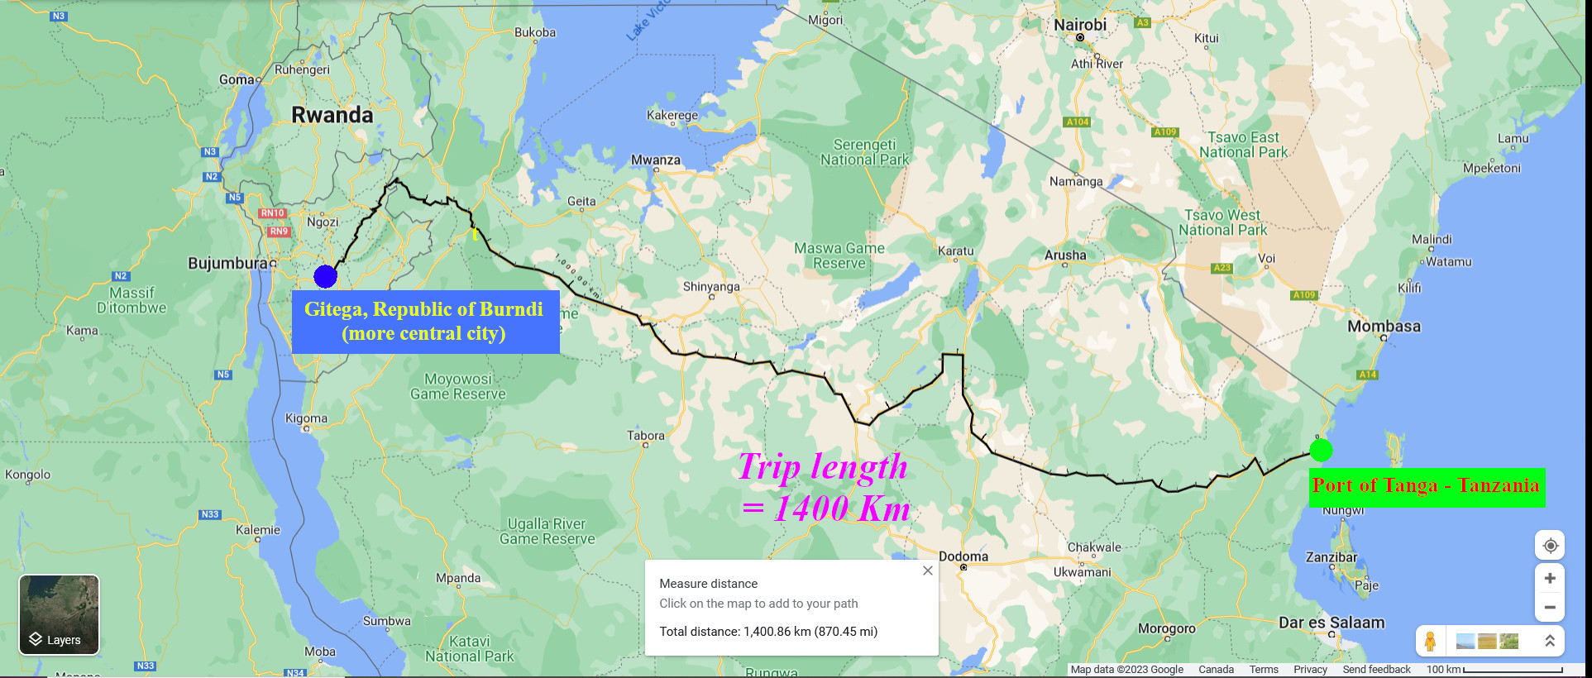

-Trucks will be needed that are CLEAN and SAFE for nutrient and other transport as well carry sustainable and reusable and recyclable "containers”

- Local larger communities should have a large stock of edible powder, with “large community containers”

-Tzhese containers could have a IoT powered weight scale and other measurement taking that could also provide Internet access locally (worst case scenario, StarLink satellite connections are purchased)

- Community delivery will be done with human operated heavy commercial vehicles from the first then closest factory if devices are not decentralized and installed in all participating homes. The trucks must quickly, cleanly and safely deliver the powder. The large community containers may be above, semi-above, and below ground. Filling containers could be achieved the same way grains are delivered that is with gravity

-Far away secluded residential areas/homes, and seniors must have local delivery network or micro turbine powered drones could do delivery

-Home delivery could also be a scaled down version of the Community delivery truck

More Designs...

Hydrogen leak mitigation and Hydrogen Manifolds for Spiral/Helical bioreactors

With a tube in tube concentric design, the space in between can be filled with metal organic frameworks (MOFs) so that hydrogen leaks could slowly be removed, as well non reactive noble gasses could be pumped in to perhaps prevent hydrogen gas accidents.

As well, through the MOFs, perhaps channel could be laid to supply the input gasses into manifolds along the shaft/tube.
Alternatively very small tubes could be used.

Tube robots, the style used to clean and inspect pipe lines or used in disaster recovery could be used to lay membrane used to seed growth of the microbes. As well this tube robot could be used to clean the tubes semi-automatically.

Spiral/Helical photobioreactors could also be used to grow algae as a burned carbon source.
Proposed Network Contact List:
Republic of Burundi www.minisante.bi - info@minisante.bi

Air Protein - www.airprotein.com information@airprotein.com

Solar Foods - www.solarfoods.fi info@solarfoods.com

Chinese Ambassador Liu Yuxi www.twitter.com/Ambassador_Liu

American 8kw Turbines/Generators www.FusionFlight.com info@fusionflight.com

Australian Worlds Tiniest Turbines www.ecojetengineering.com.au jameskim@ecojetengineering.com.au

ECOCA stove -www.pesitho.com info@pesitho.com

Helical/Spiral Photobioreactor
patent owner
www.gicon-consult.de
info@gicon.de

