Instructions:
Create a team of up to 5 people for solving this seminar. (You can also do it alone)
Tasks:
1. The following table was created using the data, where standard errors are in parentheses below the coefficients:
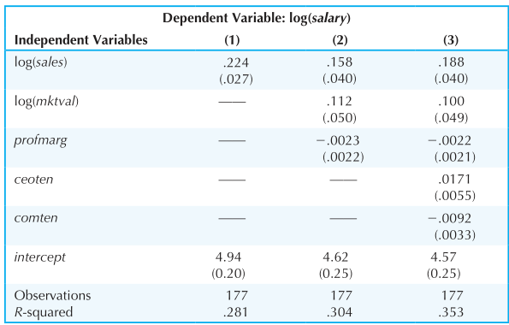
The variable salary is a CEO salary in $ thousand, mktval is market value of the firm, profmarg is profit as a percentage of sales, ceoten is years as CEO with the current company, and comten is total years with the company.
a. Comment on the effect of profmarg on CEO salary.
b. Does market value have a significant effect? Explain.
c. Interpret the coefficients on ceoten and comten. Are these explanatory variables statistically significant?
d. What do you make of the fact that longer tenure with the company, holding the other factors fixed, is associated with a lower salary?
2. Now, you would need EViews. Load the data set “WAGE1”.
a. Run a regression of wage on ‘educ’, ‘exper’ and ‘female’ (include intercept). Report and explain coefficients for each independent variable.
b. What is predicted wage for respondent #47? What is actual wage for respondent #47? Are they equal? Explain why they might not be equal.
c. How predicted wage will change if ‘educ’ increases by 3 years? How predicted wage will change if ‘exper’ decreases by 3 years?
d. Consider John and Julia who have 12 years of education. How does predicted hourly wage differ between them?
e. What is R-squared in this model? How would you interpret it?
f. Run a regression from part (a) with log(wage) as a dependent variable. How do the coefficients change? How predicted wage will change if ‘educ’ increases by 3 years? How predicted wage will change if ‘exper’ decreases by 3 years? Compare with part (c).
g. Test whether the explanatory variables are individually and jointly significant at the 5% level.
3. The following model can be used to study whether campaign expenditures affect election outcomes:
where voteA is the percentage of the vote received by Candidate A, expendA and expendB are campaign expenditures by Candidates A and B, and prtystrA is a measure of party strength for Candidate A (the percentage of the most recent presidential vote that went to A’s party).
a. What is the interpretation of $β_{1}$?
b. In terms of the parameters, state the null hypothesis that a 1% increase in A’s expenditures is offset by a 1% increase in b’s expenditures.
c. Estimate the given model using the data in “VOTE1”. Do A’s expenditures affect the outcome? What about b’s expenditures?
d. Test the hypothesis in part (b).
(extra) e. Estimate a model that directly gives the t-statistic for testing the hypothesis in part (b). What do you conclude?
4. Use the data in “MLB1” for this exercise. Consider the following model:
$$\log\left(salary\right)=β_{0}+β_{1}years+β_{2}gamesyr+β_{3}bavg+β_{4}hrunsyr+β_{5}rbisyr+u$$

where salary is the 1993 total salary, years is years in the league, gamesyr is average games played per year, bavg is career batting average (for example, bavg =250), hrunsyr is home runs per year, and rbisyr is runs batted in per year.
a. Estimate the given model. Construct and report 95% confidence intervals for the independent variables. Determine the significance of the coefficients based on confidence intervals.
b. Use the model estimated in part (a) and drop the variable rbisyr. What happens to the statistical significance of hrunsyr? What about the size of the coefficient on hrunsyr?
c. Add the variables runsyr (runs per year), fldperc (fielding percentage), and sbasesyr (stolen bases per year) to the model from part (b). Which of these factors are individually significant?
d. In the model from part (c), test the joint significance of bavg, fldperc, and sbasesyr.

