Tasks:
- Practice variable scaling:
  - You get the regression of GDPpc with relation to Democracy Index and Oil reserves in the country. You get the following regression:
$GDP=5.61+0.75*DI+0.68*OR$, where GDPpc is measured in thousand USD, Democracy Index is measured on a scale from 0 to 10 and Oil Reserves are measured in billion barrels. Politician who requested the study doesn’t understand these scales and asks to transfer Democracy Index to 0 to 100 scale, and Oil Reserves to millions cubic meters. One barrel is 0,16 m³. What are the regression coefficients now? Politician also wants to transfer GPDpc from USD to EUR. 1EUR=1.16USD. What are the regression coefficients now?
  - For some other countries, which are primarily agricultural, temperature and rainfall are particularly important for GDP. Estimated regression is the following:
$GDPpc=7.31+0.56*T-0.043*T^{2}+0.67*R-0.07*R^{2}$, where GDPpc is measured in thousand USD, temperature is measured in Celsius, and rainfall in average rainfall per month in mm. Demanding politician again wants you to adjust variables to something they are more used to: temperature in Fahrenheit, and rainfall to total per year and in cm. What are the coefficients now?
  - What happens to standard errors, statistical significance, and R2 in the first regression after transformation? In the second?
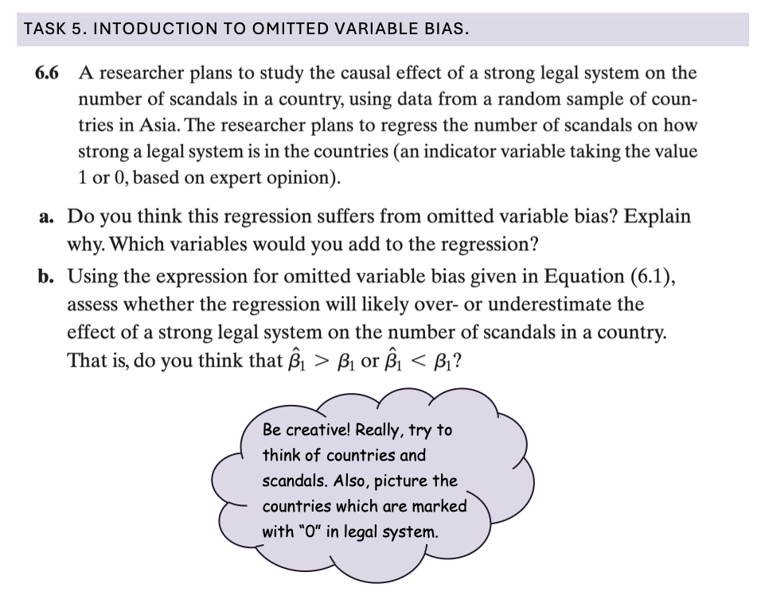
- OVB:


