**20-09-2005**

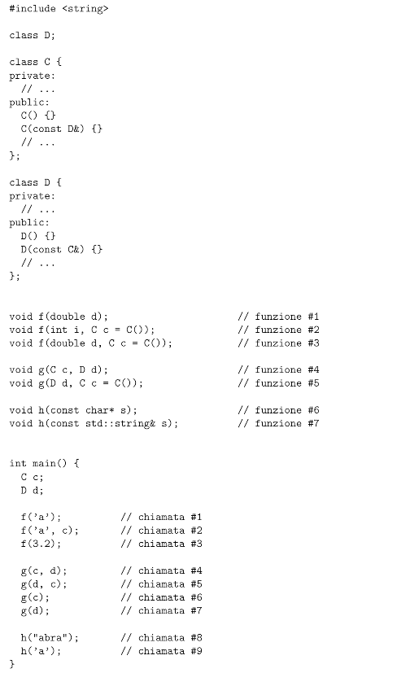

|  |  |  |  |
| --- | --- | --- | --- |
| **Chiamata** | **Candidate** | **Utilizzabili** | **tMigliore** |
| 1 | 1 2 3 | 2 | 2 |
| 2 | 2 3 | 2 | 2 |
| 3 | 1 2 3 | 1 3 | 1 |
| 4 | 4 5 | 4 | 4 |
| 5 | 4 5 | 5 | 5 |
| 6 | X | X | X |
| 7 | 5 | 5 | 5 |
| 8 | 6 7 | 6 7 | 6 |
| 9 | 6 7 | X | X |

**06-02-2006**

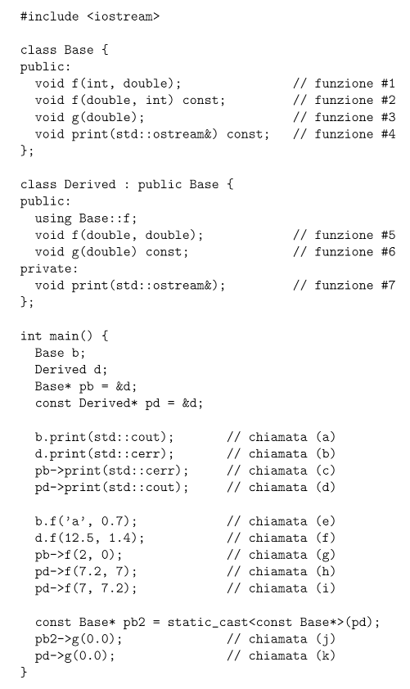

|  |  |  |  |
| --- | --- | --- | --- |
| **Chiamata** | **Candidate** | **Utilizzabili** | **Migliore** |
| a | 4 | 4 | 4 |
| b | 4 7 | X | X |
| c | 4 | 4 | 4 |
| d | 4 7 | 4 | 4 |
| e | 1 2 | 1 | 1 |
| f | 1 2 5 | 1 2 5 | 5 |
| g | 1 2 | 1 2 | ambiguo |
| h | 1 2 5 | 2 | 2 |
| i | 1 2 5 | 2 | 2 |
| j | 3 | 3 | 3 |
| k | 3 6 | 6 | 6 |