**Birla Institute of Technology and Science, Pilani**



**COMPUTER NETWORKS**

**Assignment**

|  |  |
| --- | --- |
| **Submitted By-** | **Submitted To-** |
| **Name: Nitin Kumar** | **Lohith J J** |
| **Roll No: 2020HS70003** |  |

Table of Contents

Question 1 3

Answer 3

Question 2 6

Answer 6

Question 3 6

Answer 7

Question 4 7

Answer 7

# Question 1

Execute TCP/IP socket program to establish client server communication and send your BITS ID from client side and display it on the server side. Attach output screenshot and program

## Answer

Server.c

#include <stdio.h>

#include <netdb.h>

#include <netinet/in.h>

#include <stdlib.h>

#include <string.h>

#include <sys/socket.h>

#include <sys/types.h>

#include <unistd.h>

#define MAX 80

#define PORT 8080

#define SA struct sockaddr

void func(int connfd)

{

char buffer[MAX];

int n;

for (;;) {

bzero(buffer, MAX);

read(connfd, buffer, sizeof(buffer));

printf("Message from client: %s\t To client: ", buffer);

bzero(buffer, MAX);

n = 0;

while ((buffer[n++] = getchar()) != '\n');

write(connfd, buffer, sizeof(buffer));

if (strncmp("exit", buffer, 4) == 0) {

printf("Server Exit...\n");

break;

}

}

}

// Driver function

int main()

{

int sockfd, connfd, len;

struct sockaddr_in servaddr, cli;

sockfd = socket(AF_INET, SOCK_STREAM, 0);

if (sockfd == -1) {

printf("socket creation failed...\n");

exit(0);

}

else

printf("Socket successfully created..\n");

bzero(&servaddr, sizeof(servaddr));

servaddr.sin_family = AF_INET;

servaddr.sin_addr.s_addr = htonl(INADDR_ANY);

servaddr.sin_port = htons(PORT);

if ((bind(sockfd, (SA*)&servaddr, sizeof(servaddr))) != 0) {

printf("socket bind failed...\n");

exit(0);

}

else

printf("Socket successfully binded..\n");

if ((listen(sockfd, 5)) != 0) {

printf("Listen failed...\n");

exit(0);

}

else

printf("Server listening..\n");

len = sizeof(cli);

connfd = accept(sockfd, (SA*)&cli, &len);

if (connfd < 0) {

printf("server accept failed...\n");

exit(0);

}

else

printf("server accepted the client...\n");

func(connfd);

close(sockfd);

}

Client.c

#include <netdb.h>

#include <stdio.h>

#include <stdlib.h>

#include <string.h>

#include <sys/socket.h>

#include <unistd.h>

#include <sys/socket.h>

#include <arpa/inet.h>

#define MAX 80

#define PORT 8080

#define SA struct sockaddr

void func(int sockfd)

{

char buffer[MAX];

int n;

for (;;) {

bzero(buffer, sizeof(buffer));

printf("Enter a message : ");

n = 0;

while ((buffer[n++] = getchar()) != '\n')

;

write(sockfd, buffer, sizeof(buffer));

bzero(buffer, sizeof(buffer));

read(sockfd, buffer, sizeof(buffer));

printf("Message from server : %s", buffer);

if ((strncmp(buffer, "exit", 4)) == 0) {

printf("Client Exit...\n");

break;

}

}

}

int main()

{

int sockfd, connfd;

struct sockaddr_in servaddr, cli;

sockfd = socket(AF_INET, SOCK_STREAM, 0);

if (sockfd == -1) {

printf("socket creation failed...\n");

exit(0);

}

else

printf("Socket successfully created..\n");

bzero(&servaddr, sizeof(servaddr));

servaddr.sin_family = AF_INET;

servaddr.sin_addr.s_addr = inet_addr("127.0.0.1");

servaddr.sin_port = htons(PORT);

if (connect(sockfd, (SA*)&servaddr, sizeof(servaddr)) != 0) {

printf("connection with the server failed...\n");

exit(0);

}

else

printf("connected to the server..\n");

func(sockfd);

close(sockfd);

}

Screenshots:

Client Program:

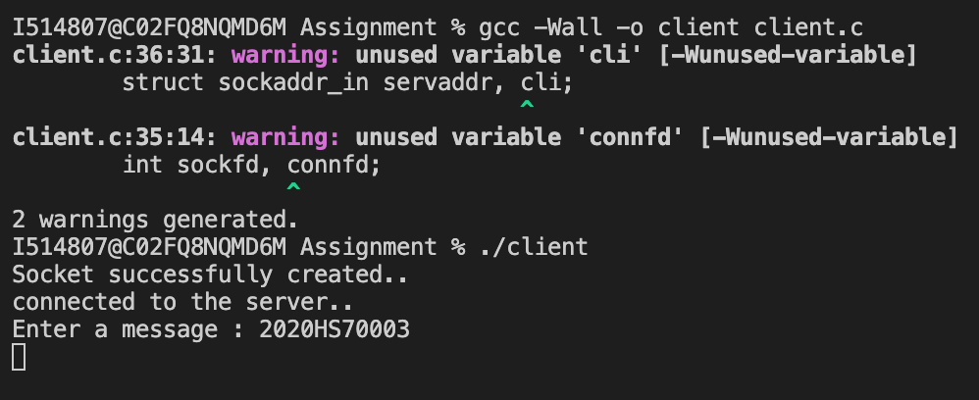

Server Program:

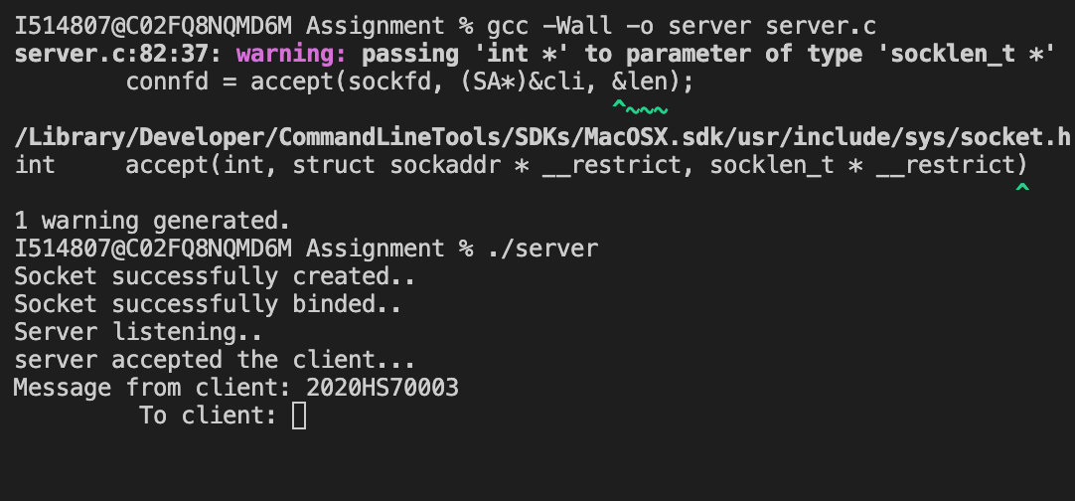

# Question 2

Suppose a packet arrives at a router and it needs to be forwarded to an network having MTU of 576 bytes. The packet has an header of 20 bytes and a data part of (1000+your last 3 digits in BITS ID…for ex your BITS ID is 2019WB86477, then data part will be 1000+477). Perform fragmentation, and specify all the fields and values.

## Answer

Server.c

# Question 3

Consider an IP Address of 150. 100. 12. - - -. ( fill last part with your last 3 digits of BITS ID. For ex. If your last 3 digits is below 255, use same number, 150. 100 . 12. 255. If your last 3 digits are above 255, then divide it by 8 , then use the resultant decimal part. For ex if your id number is 257/8 = 32.125, so use 32. 150. 100. 12. 32). Calculate the subnet number of the IP address

## Answer

Server.c

# Question 4

Consider writing a letter to your friend. Explain the process of sending letter from sender side to receiving letter at receiver side using TCP/IP structure.

## Answer

Server.c