Rowan Westenberg

[Company name]  [Company address]

Appendix   
AfasApi & Clarify intergration

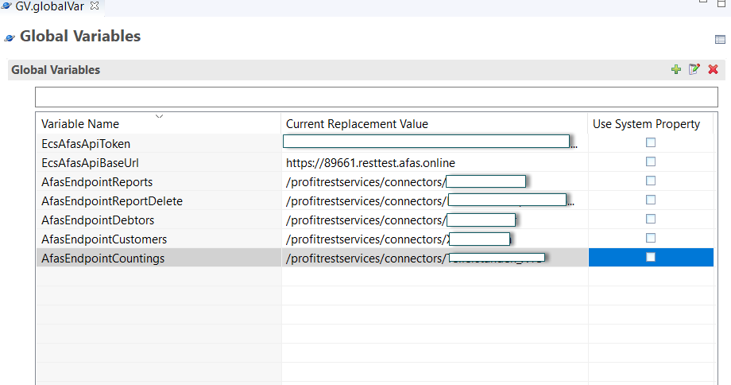

Figure 1 Global variables

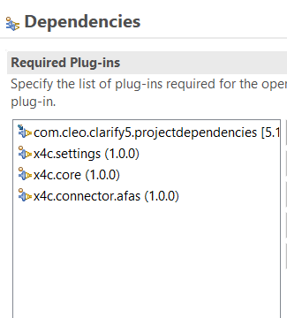

Figure 2 Dependencies

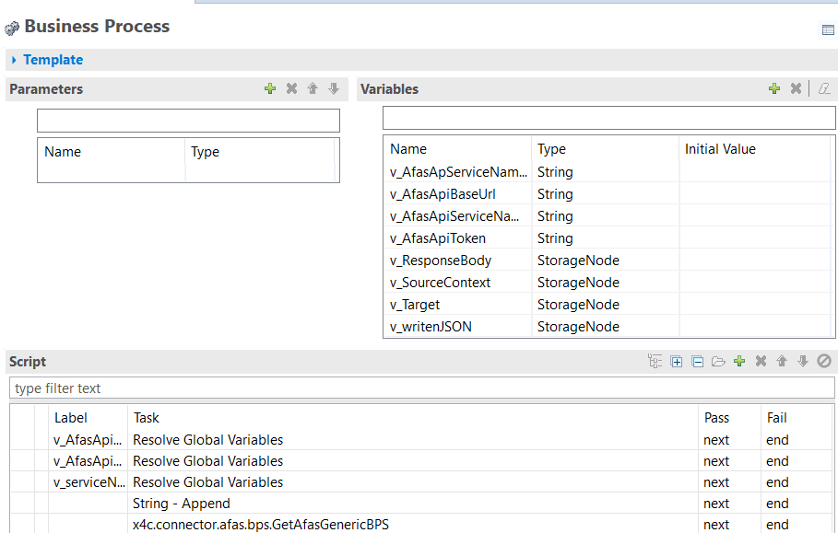

Figure 3 Business process

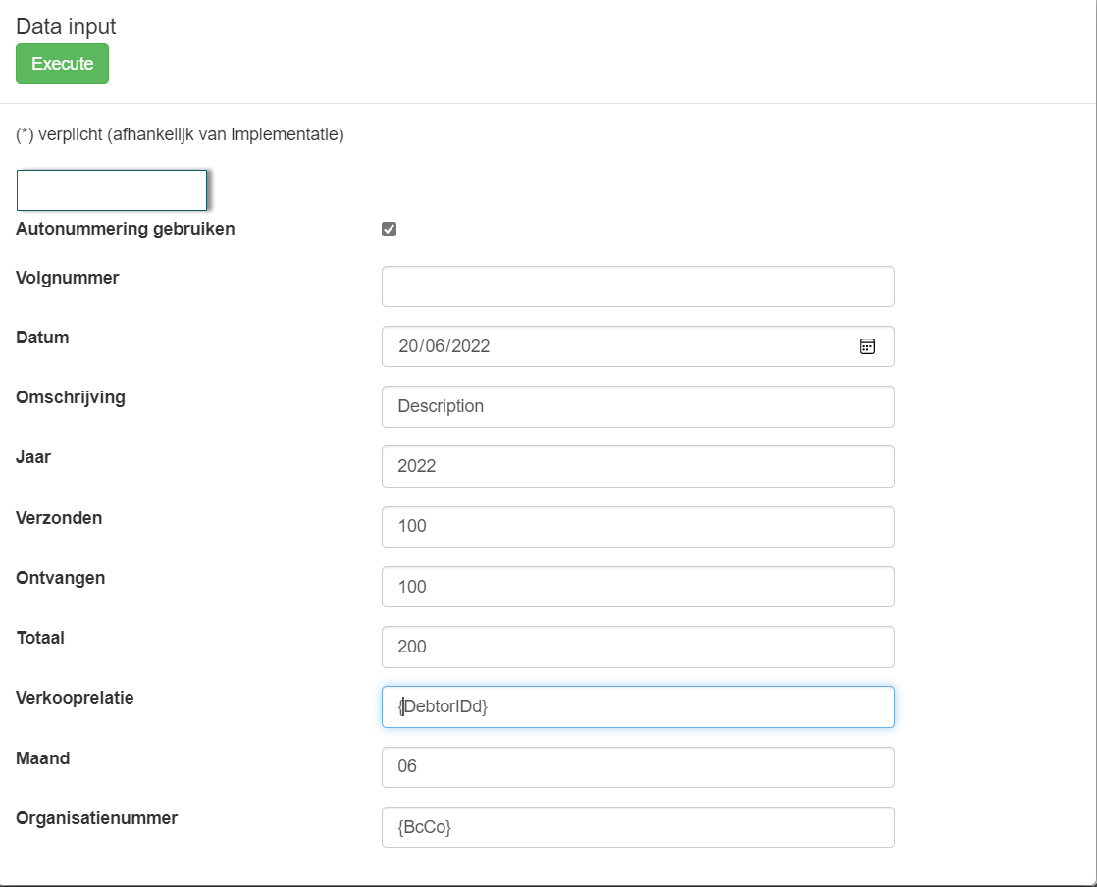

Figure 4 Post Endpoint Fields

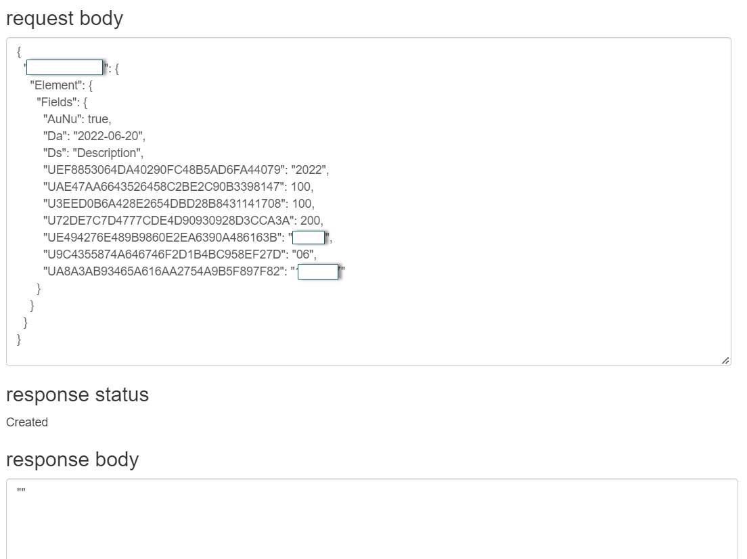

Figure 5 Post Successful JSON

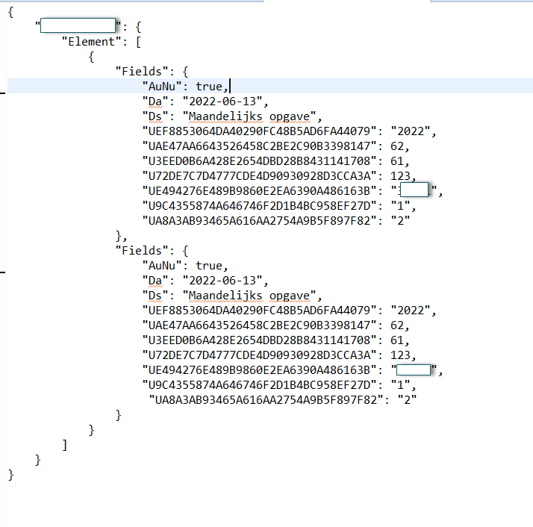

Figure 6 Sending Multiple