**Visvesvaraya Technological University**

**Jnana Sangama, Belagavi – 590018, Karnataka**



**A Mini Project Report**

**on**

**“**Department Library Management**”**

**Submitted in partial fulfillment of the requirement for the DBMS Laboratory with mini project (18CSL58) of V semester**

**Bachelor of Engineering**

**In**

**Computer Science and Engineering**

**Submitted By**

|  |  |
| --- | --- |
| DIVYA BHAT N | (1GA18CS055) |
| SHARAN S | (1GA18CS148) |
|  |  |

**Under the Guidance of**

**Mrs.Vanishree M L**

**Assistant Professor,**

**Dept. of CSE**

**Mrs. Reshma S**

**Assistant Professor,**

**Dept. of CSE**

**Mrs.Jyothi.R** 

**GLOBAL ACADEMY OF TECHNOLOGY**

**Department of Computer Science and Engineering**

**(Accredited by NBA 2019-2022)**

**Raja Rajeshwari Nagar, Bengaluru – 560 098**

**2020-2021**

**GLOBAL ACADEMY OF TECHNOLOGY**

**Department of Computer Science and Engineering**

**(Accredited by NBA 2019-2022)**

**Raja Rajeshwari Nagar, Bengaluru – 560 098**

Certificate

This is to certify that V Semester Mini project entitled **“DEPARTMENT LIBRARY MANAGEMENT”** is a bonafide work carried out by **DIVYA BHAT N (1GA18CS055), SHARAN S (1GA18CS148)** as a partial fulfillment for the award of Bachelor’s Degree in Computer Science and Engineering for DBMS Laboratory with Mini Project [18CSL58] as prescribed by **Visvesvaraya Technological University**, **Belagavi** during the year 2020-2021.

--------------------- --------------------- ---------------------

Dr. Srikanta Murthy K

Professor & Head,

Dept of CSE,

GAT, Bengaluru.

Mrs. Vanishree M L

Assistant Professor,

Dept of CSE,

GAT, Bengaluru.

Mrs. Reshma S

Assistant Professor,

Dept of CSE,

GAT, Bengaluru.

**External Exam**

Name of the Examiner Signature with date

1**.**_______________________ _______________________

2**.**_______________________ _______________________

**ABSTRACT**

A Library plays the most vital part in an Educational Institution. A library is a main element that thrives students to learn more about a particular subject. Digitalization is the next sensation. To encourage/improve digitalization, this project stands as an initiation. Bidding adieu to the process of data storing of library history in registers, it is time to implement a digitalized version of the same.

The website to be produced is the Digitalized Department Library Management. Here, there are 3 users. They are The Admin, The Teachers and The Students. The Admin has access to all the data and can make necessary changes or add in entries of new book arrivals, register students and also teachers along with the removal of the same. The Teachers and Students can also create their own personal accounts and view available books online and then borrow it later from the Department. The Student Information stored includes their Name, USN, Email ID, Date of Birth and a track of all the recently borrowed books. The Teacher Information stored includes their Name, Employee Code, Email ID, Date of Birth and a track of all the recently borrowed books. All the data and history of the person is stored using their unique member ID such as the USN or Employee Code. Finally, if the person wishes to quit, they can De-register by simply deactivating their account.

**ACKNOWLEDGEMENT**

The satisfaction and euphoria that accompany the successful completion of any task would be incomplete without the mention of the people who made it possible and whose constant encouragement and guidance crowned our efforts with success.

We consider ourselves proud, to be part of **Global Academy of Technology** family, the institution which stood by our way in endeavors.

We express our deep and sincere thanks to our Principal **Dr. N. Rana Pratap Reddy** for his support.

We are grateful to **Dr. Srikanta Murthy K,** Professor and Head, Dept. of Computer Science & Engineering who is source of inspiration and of invaluable help in channelizing my efforts in right direction.

We wish to thank our internal guide **Mrs. Reshma S** and **Mrs. Vanishree M L**, Assistant Professor, Dept of CSE for guiding and correcting various documents with attention and care. She has taken lot of pain to go through the document and make necessary corrections as and when needed.

We would like to thank the faculty members and supporting staff of the Department of CSE, GAT for providing all the support for completing the Project work.

Finally, we are grateful to our parents and friends for their unconditional support and help during our Project work.

**DIVYA BHAT N (1GA18CS055)**

**SHARAN S (1GA18CS148)**

**TABLE OF CONTENTS**

|  |  |  |  |
| --- | --- | --- | --- |
|  |  | **ABSTRACT** | **i** |
| **1.** |  | **INTRODUCTION** |  |
|  | 1.1 | INTRODUCTION TO SQL | 1 |
|  | 1.2 | INTRODUCTION TO FRONTEND SOFTWARE | 2 |
|  | 1.3 | ABOUT PROJECT | 3 |
| **2.** |  | **REQUIREMENT SPECIFICATION** |  |
|  | 2.1 | SOFTWARE REQUIREMENTS | 4 |
|  | 2.2 | HARDWARE REQUIREMENTS | 4 |
| **3.** |  | **IMPLEMENTATION** |  |
|  | 3.1 | ER DIAGRAM | 5 |
|  | 3.2 | RELATIONAL SCHEMA DIAGRAM | 6 |
|  | 3.3 | CREATION OF TABLES | 7 |
|  | 3.4 | INSERTION OF TUPLES | 9 |
|  | 3.5 | CREATION OF TRIGGERS | 10 |
|  | 3.6 | CREATION OF STORED PROCEDURES | 10 |
| **4.** |  | **RESULTS** |  |
|  | 4.1 | SNAPSHOTS | 11 |
| **5.** |  | **CONCLUSION** | 13 |
| **6.** |  | **REFERENCES** | 14 |

**CHAPTER 1**

**INTRODUCTION**

* 1. **Introduction to SQL**

SQL is a language to operate databases; it includes database creation, deletion, fetching rows, modifying rows, etc. SQL is an **ANSI** (American National Standards Institute) standard language, but there are many different versions of the SQL language.

SQL is Structured Query Language, which is a computer language for storing, manipulating and retrieving data stored in a relational database.

SQL is the standard language for Relational Database System. All the Relational Database Management Systems (RDMS) like MySQL, MS Access, Oracle, Sybase, Informix, Postgres and SQL Server use SQL as their standard database language.

Also, they are using different dialects, such as:

* MS SQL Server using T-SQL
* Oracle using PS/SQL

SQL is widely popular because it offers the following advantages:

1. Allows users to access data in the relational database management systems.
2. Allows users to describe the data.
3. Allows users to define the data in a database and manipulate that data.
4. Allows to embed within other languages using SQL modules, libraries & pre-compilers.
5. Allows users to create and drop databases and tables.
6. Allows users to create view, stored procedure, functions in a database.
7. Allows users to set permissions on tables, procedures and views.
   1. **Introduction to Frontend**

Front-end web development, also known as client-side development is the practice of producing HTML, CSS and JavaScript for a website or Web Application so that a user can see and interact with them directly. The challenge associated with front end development is that the tools and techniques used to create the front end of a website change constantly and so the developer needs to constantly be aware of how the field is developing.

The objective of designing a site is to ensure that when the users open up the site they see the information in a format that is easy to read and relevant. This is further complicated by the fact that users now use a large variety of devices with varying screen sizes and resolutions thus forcing the designer to take into consideration these aspects when designing the site. They need to ensure that their site comes up correctly in different browsers (cross-browser), different operating systems (cross-platform) and different devices (cross-device), which requires careful planning on the side of the developer.

A front-end developer architects and develops websites and applications using web technologies (i.e., [HTML](https://developer.mozilla.org/en-US/docs/Web/HTML), [CSS](https://developer.mozilla.org/en-US/docs/Web/CSS), [DOM](https://developer.mozilla.org/en-US/docs/Web/API/Document_Object_Model), and [JavaScript](https://developer.mozilla.org/en-US/docs/Web/JavaScript)), which run on the [Open Web Platform](https://en.wikipedia.org/wiki/Open_Web_Platform) or act as compilation input for non-web platform environments. A web browser is software used to retrieve, present, and traverse information on the [WWW](https://en.wikipedia.org/wiki/World_Wide_Web). Typically, browsers run on a desktop or laptop computer, tablet, or phone, but as of late a browser can be found on just about anything.

* 1. **About Project**

The Project demonstrates working of a digitalized management of the department library. The project has been completed with the complete implementation of the frontend and backend along with the connection of the front and back ends. HTML, CSS, Bootstrap and JavaScript have been implemented for the designing of the webpages. The database has been implemented using MySQL. The linking of the front and back ends is established using “Flask” a Python framework for Web Development.

In the project, The Admin has access to all details of all the users. Separate templates have been implemented for teacher and student users. The database comprises of 4 tables. One exclusively for storing student user information, one for storing teacher user information, one for storing details of books and one for storing the book borrowing information. The Teacher and Student Users can register online and create an account for themselves with functionalities such as viewing their details, updating their details, viewing available books, and viewing their book borrowing history. The Admin, has functionalities to add and remove student users, teacher users and also new book arrivals. The Admin also has access to the consolidated history of book borrowing. The history can be viewed in 3 formats, one exclusively providing borrowing info of all students, one providing borrowing info of all teachers and one complete view of book borrowing history without any constraints.

The project is mainly based on Web Development which is an all time in the corporate world, especially with the nation moving towards digitalization. The project was initiated to overcome the tedious tasks of maintain records through huge and heavy registers. The project has currently been implemented using only basic necessity to reduce human effort which in further time will be upgraded to give out much sophisticated versions.

**CHAPTER 2**

**SYSTEM REQUIREMENTS**

**2.1 Software Requirements**

1. Operating System (Windows-XP or Higher)
2. Efficient Search Engine
3. SQL Server Edition

**2.2 Hardware Requirements**

1. Pentium III or better processor
2. 256 MB RAM
3. 10GB hard disk
4. 10 – 50 Mbps of Stable Network

**CHAPTER 3**

**IMPLEMENTATION**

* 1. 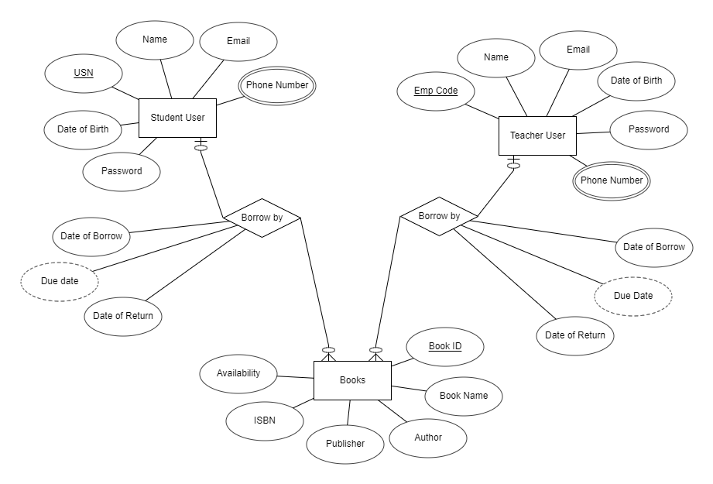**ER DIAGRAM**
  2. **RELATIONAL SCHEMA DIAGRAM**

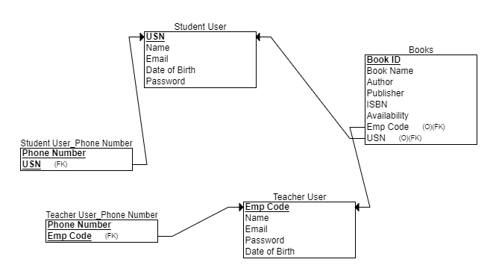

* 1. **TABLE CREATION**

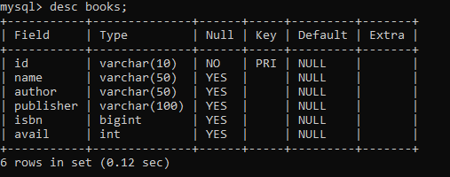

**3.3.1: Table Creation for books**

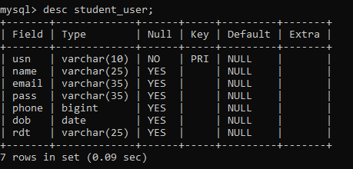

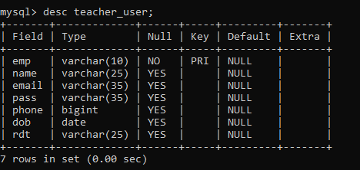**3.3.2: Table Creation for student_user**

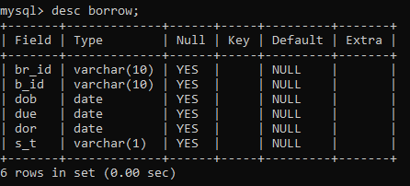**3.3.3: Table Creation for teacher_user**

**3.3.4: Table Creation for borrow**

* 1. **INSERTION OF TUPLES**

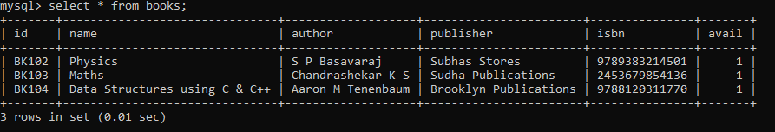

**3.4.1: Records in books Table**

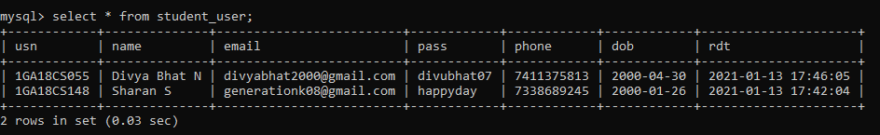

**3.4.2: Records in student_user Table**

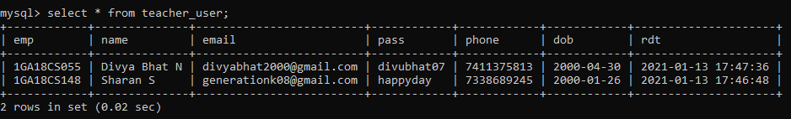

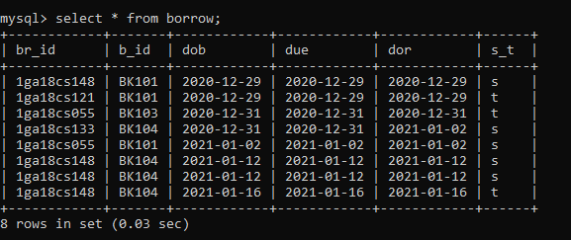**3.4.3: Records in teacher_user Table**

**3.4.4: Records in borrow Table**

* 1. **CREATION OF TRIGGERS**

The triggers are implemented on student_user and teacher_user on rdt columns of both tables which stores the date and time of the user at the time of registration to the online portal.

**CODE:**

CREATE DEFINER=`root`@`localhost` TRIGGER `student_user_BEFORE_INSERT` BEFORE INSERT ON `student_user` FOR EACH ROW BEGIN

SET NEW.rdt=NOW();

END

2)

CREATE DEFINER=`root`@`localhost` TRIGGER `teacher_user_BEFORE_INSERT` BEFORE INSERT ON `teacher_user` FOR EACH ROW BEGIN

SET NEW.rdt=NOW();

END

* 1. **CREATION OF STORED PROCEDURES**

The stored procedure is implemented to view all the records in the borrow table.

**CODE:**

CREATE DEFINER=`root`@`localhost` PROCEDURE `new_procedure`()

BEGIN

select * from borrow ;

END

**CHAPTER 4**

**RESULTS**

* 1. **SNAPSHOTS**

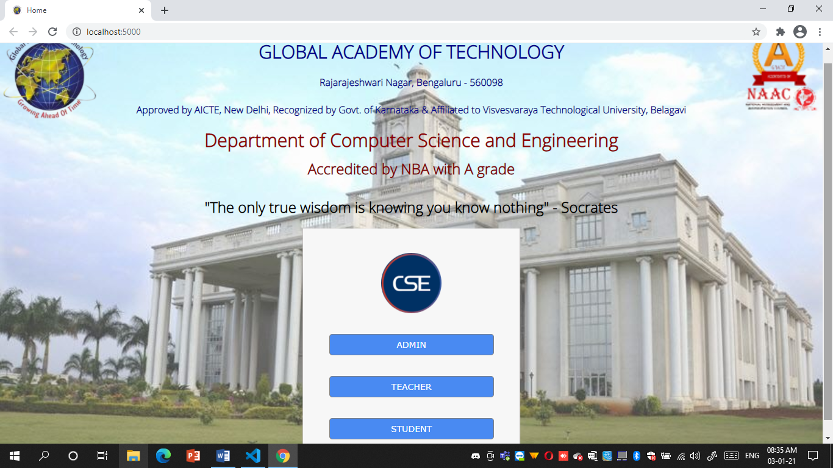

**Snapshot 3.3.1 : Home page**

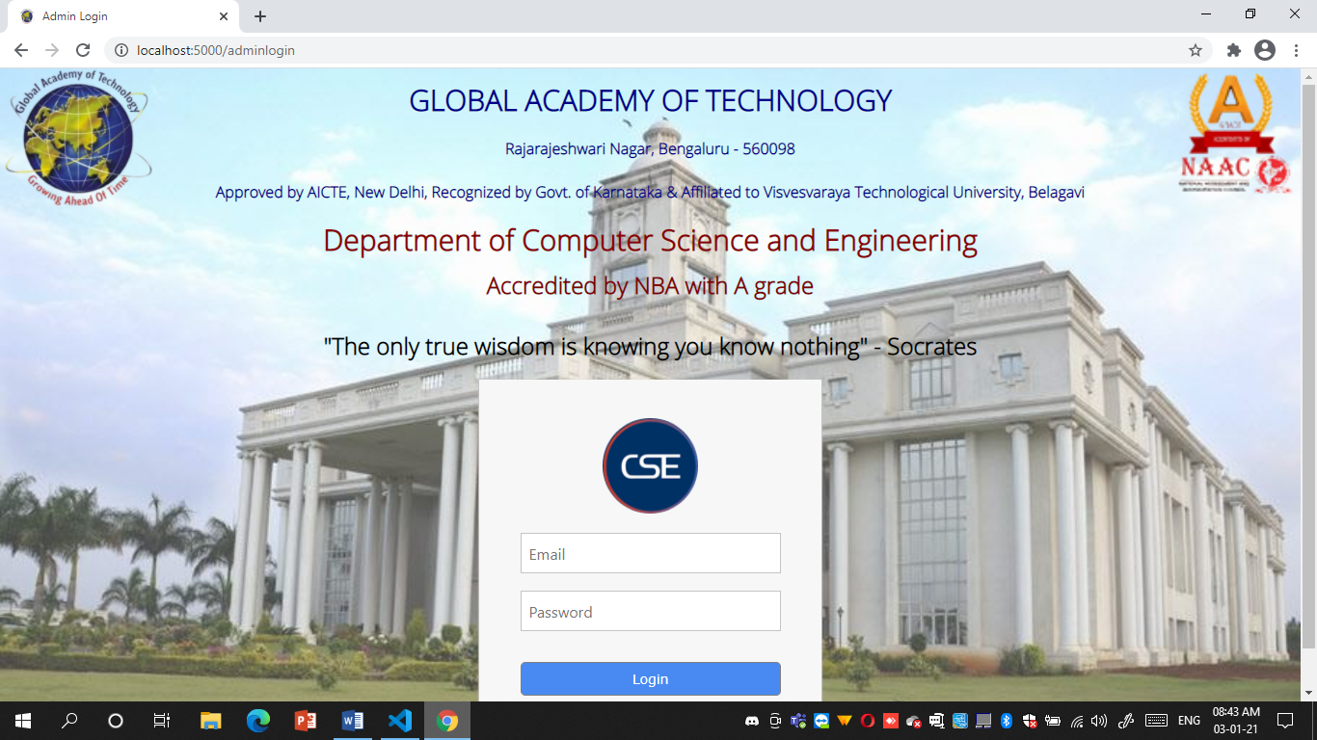

**Snapshot 3.3.2 : Admin Login (Similar for Student & Teacher Users)**

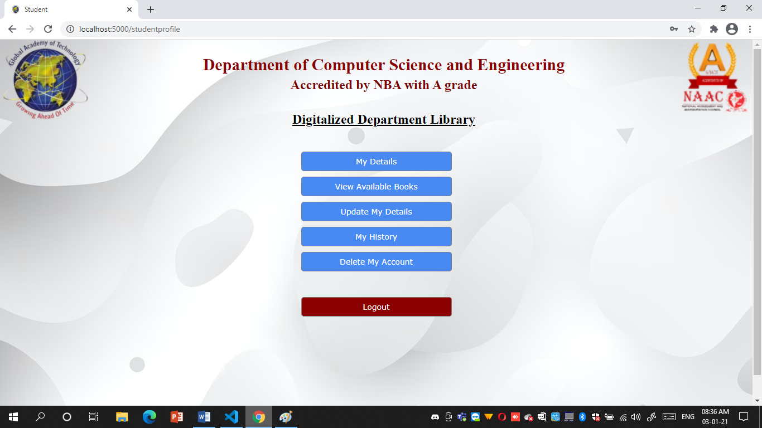

**Snapshot 3.3.3 : Student Profile (Similar to Teacher Profile)**

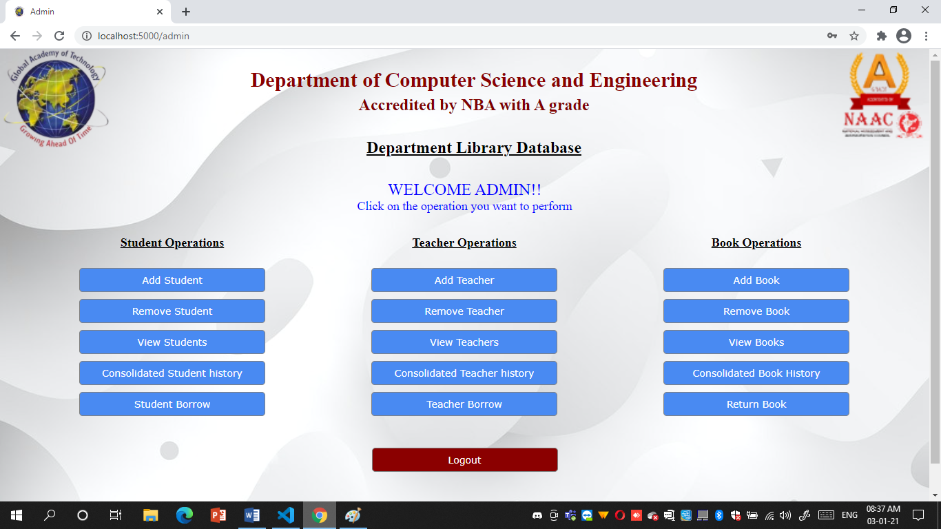

**Snapshot 3.3.4 : Admin Profile**

**CONCLUSION**

On working on this project, it helped us enhance our knowledge about python over a vast extent apart from the academics. It also helped us understand the need for the structuring of the storage format in the backend database. Immense amount of knowledge was gathered by either of us in order to understand the concept of web development in python using the micro framework “Flask”. The working on this project has also instilled a passion for Web Development. The micro framework Flask, the csv module, working with csv files, implementation of sessions, importing self-defined functions and organizing them into other folders and then importing and implementing them, and many more such new concepts were looked into and learnt to bring out a better working of the project. Organization of utility files helps in easy debugging of code in case of any bug encounters. Finally, not only as a part of academics but also a vast number of concepts were implemented thereby increasing a wide amount of knowledge. The ease in using python compared to other programming languages has instilled the urge to learn more about python for various other domains apart from Web Development.

Apart from Computer Programming Skills and Programming Knowledge, the project helped us learn a lot about the need of soft skills. We learnt major soft skills such as Time Management, Team Work and above all the Patience. While one worked on the structure of the backend the other worked on the frontend design (Time Management). After the necessary templates and backend queries were implemented, working together in order to enhance the functionality and taking into account one another’s solution taught us immensely about Team Work. During execution if there encountered and error, working together on the error or the bug taught us the need for Patience.

Overall, This Project was a very good entity that helped improve ourselves not only in academics point of view but also improved our soft skills. It is thereby been our pleasure to have worked with each other along with our guide to successfully complete the project on time with all necessary functionalities.

**REFERENCES**

**Bibliography:**

[1] “Automate the Boring Stuff with Python” by Al Sweigart

[2] “Think Python: How to Think Like a Computer Scientist” by Allen B Downey

[3] “Core Python Applications Programming” by Wesley J Chun

[4] “Database Systems Concepts” by Silberschatz korth and Sudarshan

[5] “Fundamentals od Database Systems” by Ramez Elmasri and Shamkant B Navathe

**Websites:**

[1] <https://www.w3schools.com/sql/default.asp>

[2] <https://www.w3schools.com/python/python_mysql_getstarted.asp>

[3] <https://realpython.com/>

[4] <https://pythonise.com/series/learning-flask/flask-working-with-forms>

[5] <https://pythonhow.com/building-a-website-with-python-flask/>