**GLOBAL ACADEMY OF TECHNOLOGY**

**DEPARTMENT OF COMPUTER SCIENCE & ENGINEERING (Accredited by NBA 2019-2022)**

**Rajarajeshwari Nagar, Bengaluru – 560 098**

**Academic Year: 2020 - 21**

DBMS LABORATORY WITH MINI PROJECT: 18CSL58

**PROJECT PHASE - 1**

|  |  |  |
| --- | --- | --- |
| **Title of the Project** | **Department Library Management System** | |
| **Front End** | **HTML, CSS, Bootstrap, JavaScript** | |
| **Group No: 1** | **USN** | **Name** |
|  | 1. **1GA18CS055** 2. **1GA18CS148** | 1. **Divya Bhat N** 2. **Sharan S** |
| **Guide Name** | **Prof. Reshma S** | |

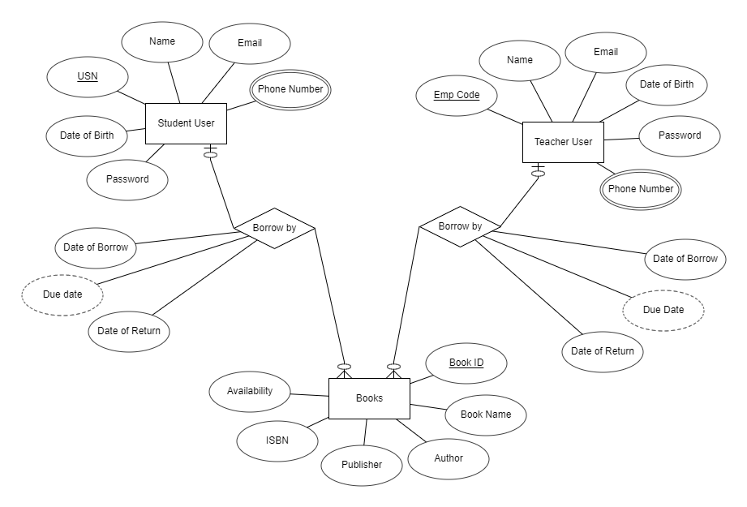

**ER TO RELATION SCHEMA MAPPING**

Book_ID, Pub_ID, Memb_ID are the primary keys for The Book, Publisher and Member Table respectively. The Borrow Table does not have any primary key, and is completely dependant on the other tables for data storage. The history of book borrowing for various members is stored in this table.

**BOOK TABLE**

* The Book Table has Author field which is linked to the Name field of the Publisher table as the Author is generally the Publisher of the Book.
* It also has other info stored in it about the book, such as the book id, book title, price and availability of book.

**BORROW TABLE**

* The Book_ID is used in the Borrow Table to track the availability for other users.
* The Pub_ID is used in the Borrow table in order to keep track of which Author’s book is largely borrowed and to provide suggestion to other users.
* The Memb_ID is used in the Borrow table in order to keep track of who borrowed which book and gain knowledge of the fields of interests of the person and suggest various other books related to the same domain.
* The Expiry_date is used to keep track of the last date by which the member has to return the book to the library. In case the person has not finished the book, he/she has full authority to issue it once again. It also helps in calculating the amount to be paid for any defaults made.
* The Brr_date is the date of borrowing the book which helps in generating the expiry date.

**PUBLISHER TABLE**

* It stores information about the Publisher such as the Publisher ID, Name/Author and Address of the Publisher.
* The Pub_ID is used in borrow table to keep track of which Author’s book is largely borrowed.

**MEMBER TABLE**

* It stores information about the Member such as the Member ID, Name and Address of the member, The expiry date of the currently borrowed book and Member type such as teacher or student.
* The Expiry_date is used to keep track of the last date by which the member has to return the book to the library.

**RELATION SCHEMA DIAGRAM**

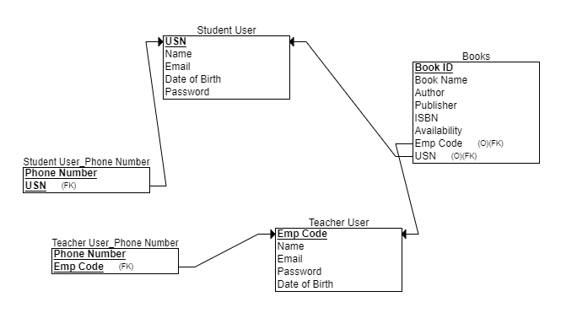

**Signature of Student Signature of Guide**