
MONTHLY PERFORMANCE
REPORT

NAUTICA SHOPPING CENTRE
FEBRUARY 2026

PREPARED FOR: MILPROPS
SITE: NAUTICA SHOPPING CENTRE
SYSTEM SIZE: 770KWP 600KVA
DATE: 05/03/2026
PREPARED BY: BRANDON FEINAUER
CHECKED BY: BETHANY LAFFORD

Table of Contents
1. INTRODUCTION 3
2. OVERVIEW 3
3. PERFORMANCE FIGURES 3
3.1 Daily Performance 3
3.2 Monthly Performance 4
4. YEARLY PERFORMANCE 5
5. Lifetime ENVIRONMENTAL IMPACT 5
6. MAJOR COMPONENT WARRANTIES 6
7. Conclusion 6

- INTRODUCTION
The following report contains a summary of the plant’s performance. The plant is monitored through a Fusion Solar monitoring device with various data acquisition capabilities. The data is captured and uploaded to a user-friendly online portal.
- OVERVIEW
The table below gives a brief overview of the monthly generated values in comparison to generation values predicted by Genergy’s engineers using PVSyst and other solar software. We will go further into detail in the sections below.
- PERFORMANCE FIGURES
The daily generation and performance figures for February 2026 are shown below. Please note that all target generation values used in this report are based on a simulation that was performed to determine the expected production and target yields that the site should be performing at, these values have been adjusted using the solar panel manufacturers warrantied degradation rates.

3.1 Daily Performance
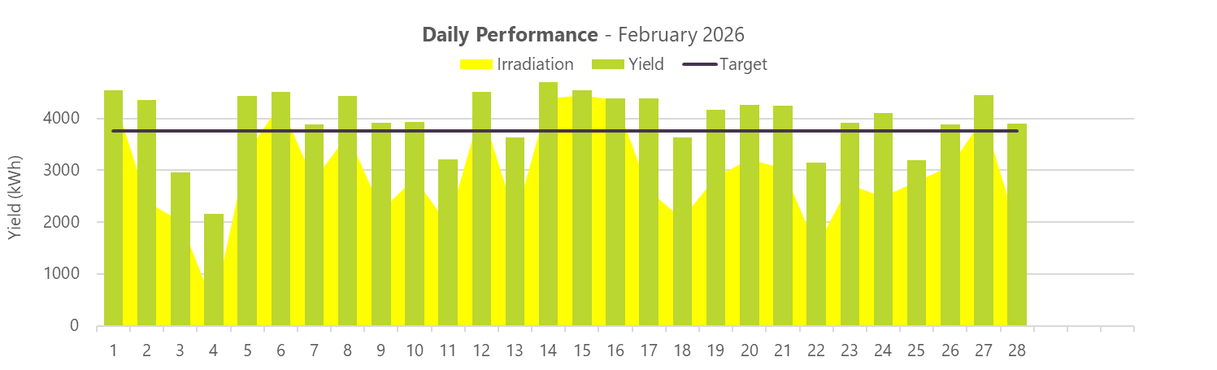

Comment on Daily Performance
The system performed consistently throughout February 2026, with daily yields generally aligning with the expected generation levels. The days that show lower production correspond with periods of adverse weather conditions, as illustrated in the graph above.

3.2 Monthly Performance
The monthly generation and performance figures for the last 12 months are shown below. Please note that all target generation values used in this report were generated using PVSyst and other solar software.

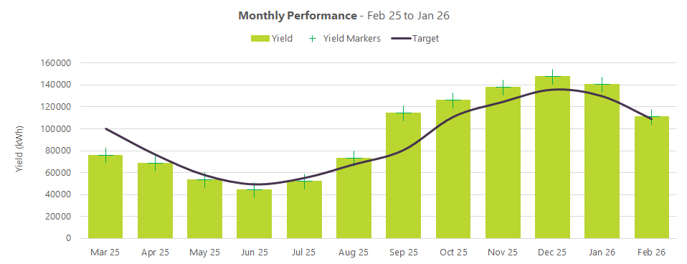

- YEARLY PERFORMANCE
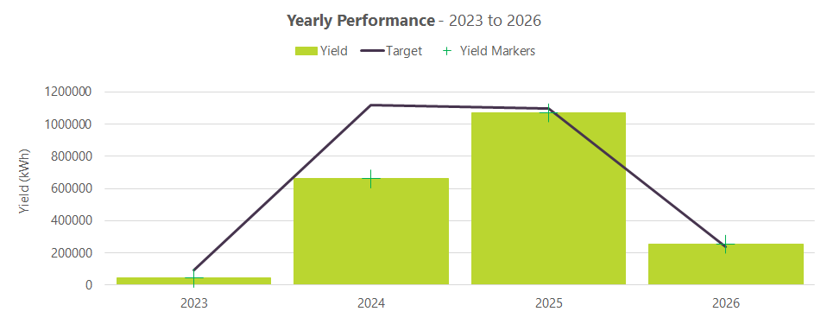

- Lifetime ENVIRONMENTAL IMPACT
To date, the system has had approximately the following effects by means of reducing the amount of electricity that would otherwise have been generated using less environmentally friendly means.
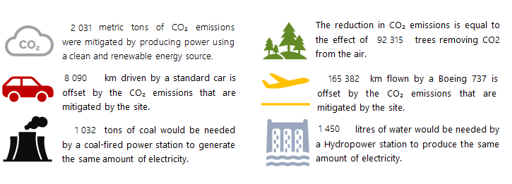

- MAJOR COMPONENT WARRANTIES
The remaining warranty periods for the systems major components are given below.
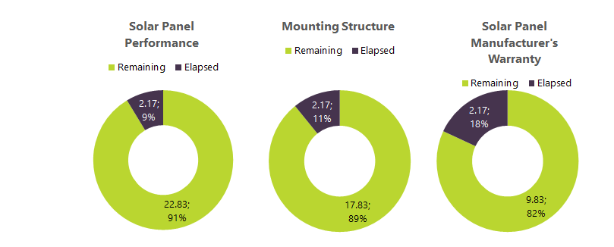

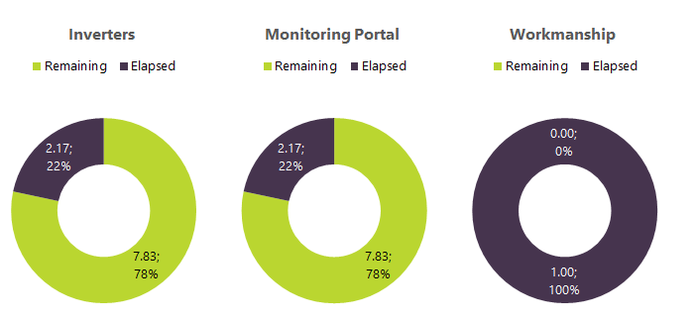

- Conclusion

The report has indicated that the system is performing as designed and is continuing to operate as expected.
The system will continue to be monitored on weekdays, with all performance data logged to the online portal. Should any error alarms occur or performance drop, a technician may conduct an unscheduled site visit. Please note that such visits will be chargeable at the call-out rates specified in the maintenance agreement.
If you have any questions regarding this report or require further assistance, please do not hesitate to contact us at maintenance@genergy.co.za.

