MACHINE LEARNING
Comprehensive Notes for Biomedical Students
Tailored for Students in:
Biomedical Engineering | Clinical Medicine | Bioinformatics
Pharmacology | Public Health | Medical Imaging

Vincent Magomere

Topics Covered: Supervised Learning • Regression • Classification • Decision Trees
Random Forests • Model Evaluation • Cross-Validation • Clinical Applications

Table of Contents
Table of Contents 1
1. Introduction to Machine Learning 1
1.1 What is Machine Learning? 1
1.2 Traditional Programming vs Machine Learning 1
1.3 Types of Machine Learning 1
1.4 ML Workflow in Biomedical Research 1
1.5 Real-World Biomedical Applications 1
2. Understanding Supervised Learning 1
2.1 What is Supervised Learning? 1
2.2 Labeled Data in Clinical Settings 1
2.3 Key Algorithms in Supervised Learning 1
2.4 Performance Metrics in Clinical Settings 1
3. Regression Models in Supervised Learning 1
3.1 What is Regression? 1
3.2 Linear Regression: Concepts and Formulas 1
3.3 Model Evaluation for Regression 1
3.4 Hands-On Project 1: Predicting Patient Recovery Time 1
4. Classification Models in Supervised Learning 1
4.1 What is Classification? 1
4.2 Logistic Regression for Clinical Diagnosis 1
4.3 K-Nearest Neighbors (KNN) in Biomedicine 1
4.4 Confusion Matrix in Medical Testing 1
4.5 Hands-On Project 2: Breast Cancer Diagnosis (Wisconsin Dataset) 1
5. Decision Trees and Random Forests 1
5.1 Decision Trees in Clinical Decision Making 1
5.2 Why Decision Trees Work Well in Medicine 1
5.3 Random Forests: Ensemble Learning 1
5.4 Hands-On Project 3: Diabetes Risk Assessment 1
6. Model Evaluation, Overfitting & Hyperparameter Tuning 1
6.1 Overfitting and Underfitting in Clinical Models 1
6.2 Cross-Validation for Clinical Validation 1
6.3 Regularization: Preventing Clinical Model Overfitting 1
6.4 Hyperparameter Tuning 1
6.5 Hands-On Project 5: Comparing Algorithms on Medical Data 1
6.6 Hands-On Project 6: Hyperparameter Tuning for Diagnostic Models 1
7. Neural Networks and Deep Learning in Biomedical Applications 1
7.1 Neural Network Architecture 1
7.2 Deep Learning Applications in Biomedicine 1
7.3 Hands-On: Simple Neural Network for Medical Classification 1
Conclusion and Next Steps 1
What You Have Learned 1
Recommended Biomedical Datasets to Practice With 1
Recommended Next Steps 1
Key Resources for Biomedical ML Students 1

CHAPTER 1: INTRODUCTION TO MACHINE LEARNING

1. Introduction to Machine Learning

1.1 What is Machine Learning?
Machine Learning (ML) is a subset of Artificial Intelligence (AI) that enables computers to learn from data and improve their performance over time without being explicitly programmed for each task. In biomedical contexts, this means ML systems can discover patterns in complex biological and clinical datasets that would be impossible for humans to identify manually.
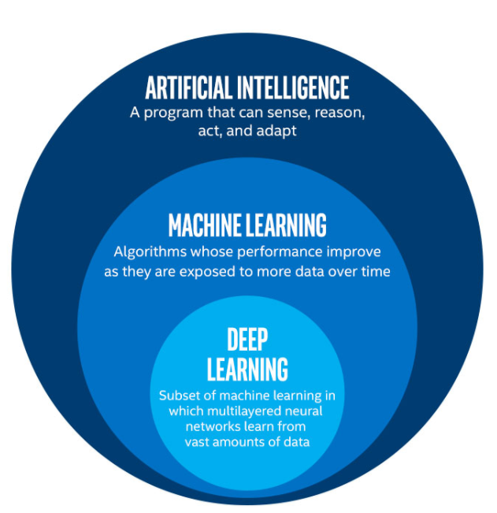

🔬 Biomedical Definition
ML algorithms identify patterns in data such as patient records, medical images, genomic sequences, and clinical trials, then use these patterns to make predictions or clinical decisions on new, unseen data.
Example: A ML model trained on 10,000 chest X-rays can learn to identify early signs of pneumonia with radiologist-level accuracy.

1.2 Traditional Programming vs Machine Learning
Aspect | Traditional Programming | Machine Learning
Approach | Rules + Data → Output | Data + Output → Rules
Logic | Programmer defines every rule | Algorithm learns patterns automatically
Adaptability | Limited to known scenarios | Adapts to new clinical data
Biomedical Example | Hardcoded diagnostic criteria | AI learning to read ECGs or pathology slides
Limitations | Cannot handle data complexity | Requires large training datasets

1.3 Types of Machine Learning
Supervised Learning
Uses labeled training data (input-output pairs) to learn a mapping function. In biomedicine, this means learning from historical patient data where outcomes are already known.
- Disease diagnosis (input: symptoms/labs → output: diagnosis)
- Drug response prediction (input: genetic profile → output: drug efficacy)
- Medical image classification (input: MRI scan → output: tumor/no tumor)

Unsupervised Learning
Works with unlabelled data to discover hidden structures. Used extensively in genomics and patient stratification.
- Patient subgroup discovery (clustering patients by disease phenotype)
- Gene expression analysis (identifying co-expressed gene modules)
- Anomaly detection (identifying unusual lab values or imaging findings)

Reinforcement Learning
Learns through interaction with an environment using rewards and penalties. Emerging in precision medicine and treatment optimization.
- Optimizing radiation therapy dosing schedules
- Personalizing drug dosage regimens for ICU patients
- Robotic-assisted surgery guidance systems

1.4 ML Workflow in Biomedical Research
A biomedical ML project typically follows these steps:
- Data Collection: Electronic Health Records (EHR), imaging databases, genomic sequencing, clinical trial data
- Data Preprocessing: Handle missing values (common in clinical data), normalize lab values, encode categorical variables.
- Feature Engineering: Select relevant biomarkers (e.g., PSA for prostate cancer, HbA1c for diabetes)
- Model Selection: Choose algorithm based on data type and clinical objective
- Training: Feed historical patient data to the algorithm
- Evaluation: Use clinical metrics like sensitivity, specificity, AUC-ROC
- Clinical Deployment: Integrate into clinical decision support systems (CDSS)
- Monitoring: Track model performance as patient populations evolve
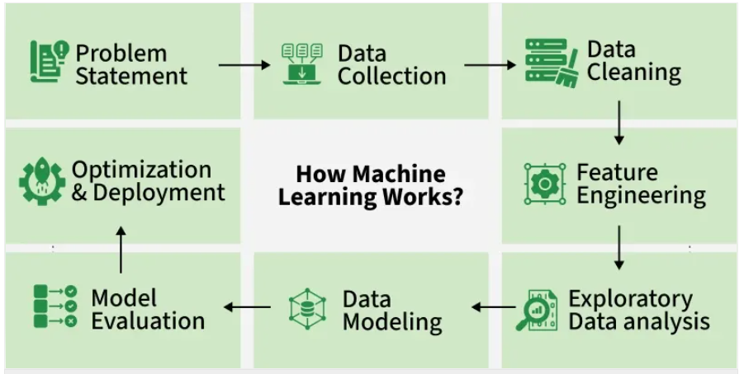
Figure: Machine learning workflow from data collection to clinical deployment

⚕️ Clinical Context
In healthcare, the stakes of model errors are high. A false negative (missing a cancer) or false positive (unnecessary biopsy) has direct patient impact. This is why model evaluation in biomedicine emphasizes sensitivity, specificity, and the AUC-ROC curve rather than simple accuracy.

1.5 Real-World Biomedical Applications
Application Area | ML Task | Example
Radiology | Image Classification | Detecting tumors in CT/MRI scans
Pathology | Object Detection | Identifying cancer cells in biopsy slides
Genomics | Regression/Clustering | Predicting gene expression, GWAS analysis
Drug Discovery | Regression | Predicting drug-target binding affinity
Clinical Records | Classification | Predicting hospital readmission risk
Epidemiology | Regression | Disease outbreak prediction and modeling
Cardiology | Time Series | ECG arrhythmia detection

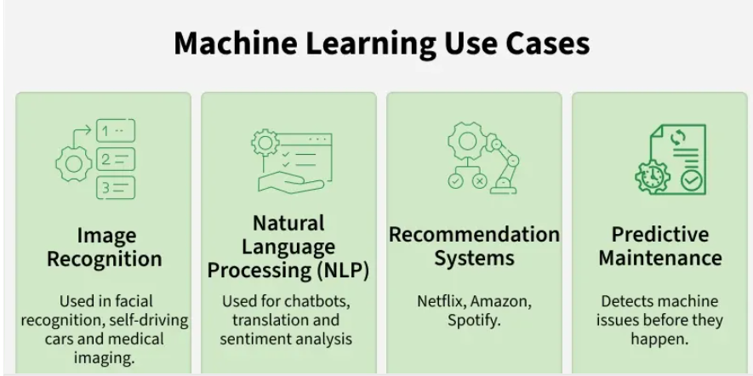

CHAPTER 2: SUPERVISED LEARNING

2. Understanding Supervised Learning

2.1 What is Supervised Learning?
Supervised learning is the most widely used type of machine learning in biomedical applications. The algorithm learns from labelled training examples — historical patient data where the outcome (diagnosis, treatment response, survival) is already known.

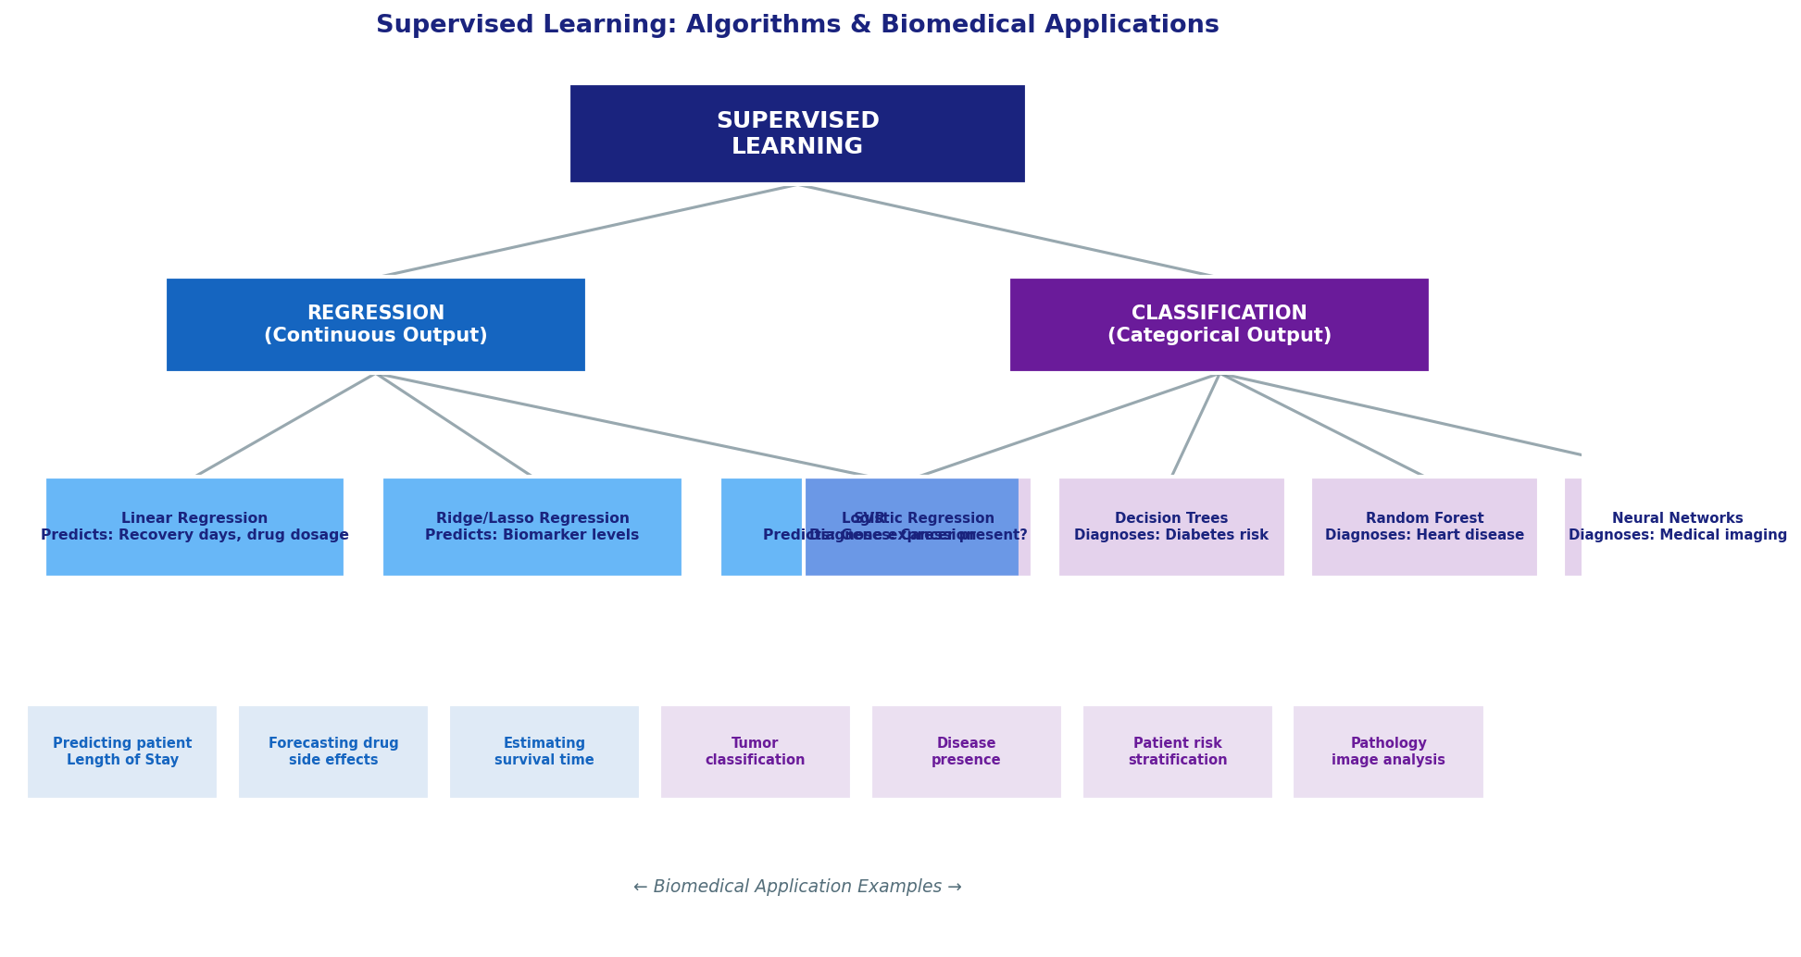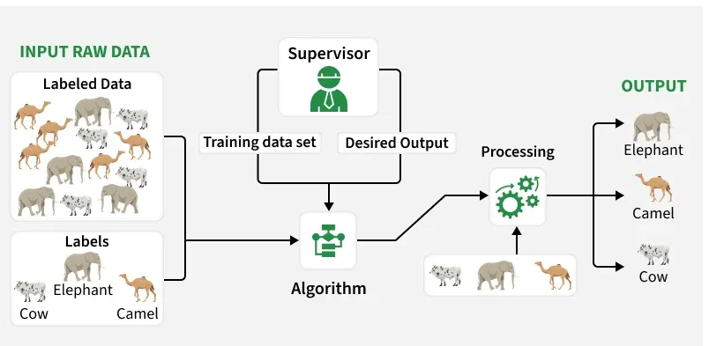
Figure: Supervised learning

2.2 Labelled Data in Clinical Settings
In biomedical supervised learning, labelled data comes from:
- Electronic Health Records (EHR) with confirmed diagnoses
- Clinical trial data with measured outcomes
- Pathologist-annotated medical images
- Genomic studies with known phenotypes

💊 Clinical Data Example
Breast Cancer Dataset (Wisconsin WDBC):
• Features (Input): Mean radius, texture, perimeter, area, smoothness, compactness...
• Label (Output): Benign (0) or Malignant (1)
• 569 samples, 30 features extracted from digitized biopsy images
• Used to train models achieving >97% diagnostic accuracy

2.3 Key Algorithms in Supervised Learning
Supervised learning algorithms are divided into Regression (continuous output) and Classification (categorical output):

Algorithm | Type | Biomedical Use Case | Strengths
Linear Regression | Regression | Predict recovery time, drug dosage | Simple, interpretable
Logistic Regression | Classification | Diagnose disease presence/absence | Probability output, interpretable
K-Nearest Neighbors | Both | Patient similarity matching | No assumptions about data
Decision Trees | Both | Clinical decision rules, diagnosis | Highly interpretable
Random Forest | Both | Heart disease, cancer prediction | High accuracy, robust
SVM | Both | Genomic classification, cancer subtyping | Effective in high dimensions
Neural Networks | Both | Medical imaging, drug discovery | Captures complex patterns

2.4 Performance Metrics in Clinical Settings
Choosing the right evaluation metric is critical in medicine. The cost of a false negative (missing a disease) is often much higher than a false positive.
Classification Metrics
Metric | Formula | Clinical Meaning | When to Prioritize
Sensitivity (Recall) | TP / (TP + FN) | How many sick patients were correctly identified? | Cancer screening, infection detection
Specificity | TN / (TN + FP) | How many healthy patients were correctly cleared? | Confirmatory tests, expensive procedures
Precision | TP / (TP + FP) | Of diagnosed patients, how many are truly sick? | When false positives cause harm/cost
F1-Score | 2 × (P × R)/(P + R) | Balance between precision and recall | Imbalanced datasets, rare diseases
AUC-ROC | Area under ROC curve | Overall diagnostic discrimination ability | Standard for clinical model reporting

Regression Metrics
Metric | Clinical Meaning | Example
MAE | Average prediction error in original units | Average error in predicted recovery days: ±2.3 days
RMSE | Penalizes large errors more | Useful when outlier predictions (very late recovery) are costly
R² | Proportion of outcome variance explained | R²=0.85 means model explains 85% of variation in drug response

Sensitivity measures the ability to detect positive instances,
Specificity measures the ability to identify negative instances
Precision measures the accuracy of positive predictions.

CHAPTER 3: REGRESSION MODELS

3. Regression Models in Supervised Learning

3.1 What is Regression?
Regression predicts continuous numerical outcomes. In biomedicine, this includes predicting drug concentrations, patient survival times, recovery durations, biomarker levels, and physiological parameters.

🔬 Biomedical Regression Examples
• Predicting post-operative hospital stay duration based on patient age, comorbidities, surgery type
• Estimating drug plasma concentration at a given time (pharmacokinetics)
• Forecasting eGFR decline rate in chronic kidney disease patients
• Predicting tumor volume reduction after chemotherapy based on initial biomarkers

3.2 Linear Regression: Concepts and Formulas
Linear regression models the relationship between variables as a straight line. It is the foundation of many advanced ML algorithms.

Simple Linear Regression
Formula
y = mx + b
Where: y = predicted value, x = input feature, m = slope (coefficient), b = y-intercept

Multiple Linear Regression (Most Common in Biomedicine)
Formula
y = b₀ + b₁x₁ + b₂x₂ + ... + bₙxₙ
Where: y = outcome (e.g., recovery days)
x₁ = age, x₂ = BMI, x₃ = blood glucose... (clinical features)
b₀ = baseline value (intercept)
b₁...bₙ = contribution of each clinical feature

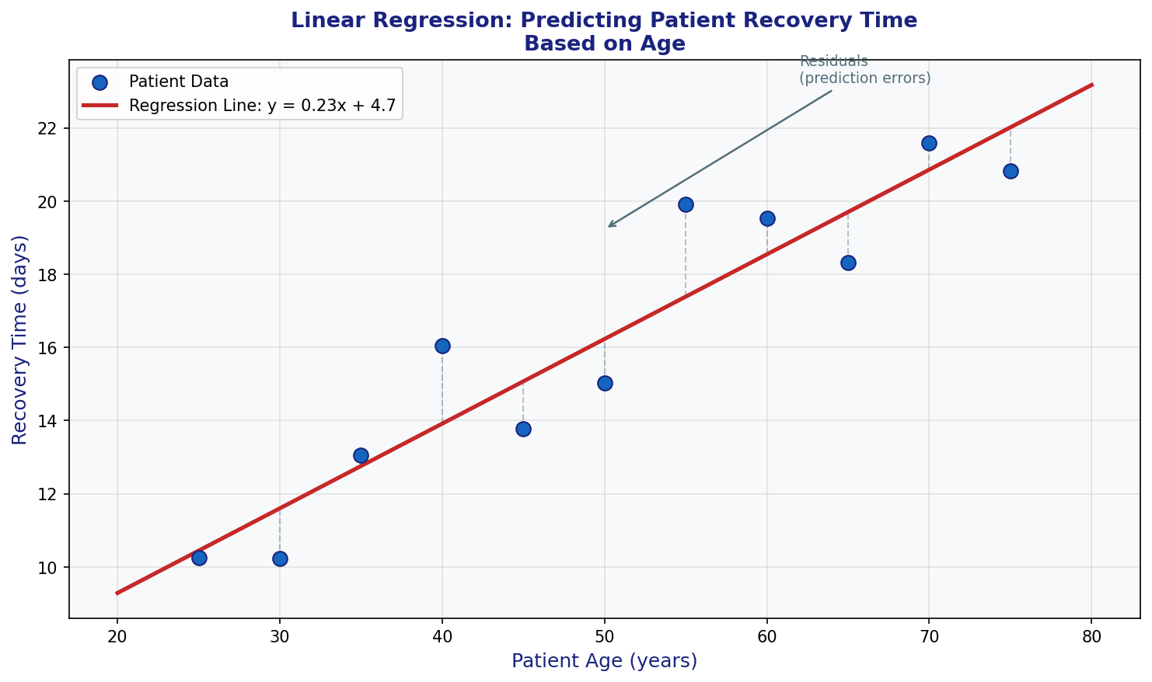
Figure: Linear regression: Predicting patient recovery time based on age

3.3 Model Evaluation for Regression
After training, we evaluate how well the model generalizes to new patients:

Metric | Formula | Interpretation
MSE | (1/n) × Σ(actual - predicted)² | Avg squared error; penalizes large deviations
RMSE | √MSE | Same units as outcome; easier to interpret clinically
MAE | (1/n) × Σ|actual - predicted| | Average absolute error; robust to outliers
R² | 1 - (SS_res / SS_tot) | Proportion of variance explained (0 to 1)

3.4 Hands-On Project 1: Predicting Patient Recovery Time
🏥 Project Goal
Build a linear regression model to predict post-surgical recovery time (days) based on patient age, BMI, pre-operative hemoglobin, and comorbidity score.
Clinical relevance: Accurate recovery predictions help optimize bed management and discharge planning.

# ─── STEP 1: Import Libraries ───────────────────────────────────
import numpy as np
import pandas as pd
from sklearn.model_selection import train_test_split
from sklearn.linear_model import LinearRegression
from sklearn.metrics import mean_squared_error, r2_score, mean_absolute_error
from sklearn.preprocessing import StandardScaler
import matplotlib.pyplot as plt

# ─── STEP 2: Create Synthetic Patient Dataset ───────────────────
np.random.seed(42)
n_patients = 200

data = pd.DataFrame({
'Age': np.random.randint(20, 80, n_patients),
'BMI': np.random.normal(27, 5, n_patients).clip(15, 45),
'Hemoglobin': np.random.normal(12.5, 2, n_patients).clip(7, 18),
'Comorbidities': np.random.randint(0, 5, n_patients),
})

# Recovery time is related to age, BMI, low hemoglobin, comorbidities
data['Recovery_Days'] = (
5
+ 0.15 * data['Age']
+ 0.20 * data['BMI']
- 0.30 * data['Hemoglobin']
+ 1.20 * data['Comorbidities']
+ np.random.normal(0, 2, n_patients) # natural variation
).clip(1, 40)

print("Dataset Overview:")
print(data.describe().round(2))
print(f"\nMean recovery time: {data['Recovery_Days'].mean():.1f} days")

# ─── STEP 3: Prepare Features and Split Data ────────────────────
features = ['Age', 'BMI', 'Hemoglobin', 'Comorbidities']
X = data[features]
y = data['Recovery_Days']

X_train, X_test, y_train, y_test = train_test_split(
X, y, test_size=0.25, random_state=42
)

# Scale features (important for regularized models)
scaler = StandardScaler()
X_train_scaled = scaler.fit_transform(X_train)
X_test_scaled = scaler.transform(X_test)

print(f"Training set: {len(X_train)} patients")
print(f"Test set: {len(X_test)} patients")

# ─── STEP 4: Train the Model ─────────────────────────────────────
model = LinearRegression()
model.fit(X_train_scaled, y_train)

# View learned coefficients (clinically interpretable)
print("\n📊 Clinical Feature Importance (coefficients):")
for feat, coef in zip(features, model.coef_):
direction = "↑ increases" if coef > 0 else "↓ decreases"
print(f" {feat:15s}: {coef:+.3f} ({direction} recovery time)")

# ─── STEP 5: Evaluate Model Performance ─────────────────────────
y_pred = model.predict(X_test_scaled)

mae = mean_absolute_error(y_test, y_pred)
mse = mean_squared_error(y_test, y_pred)
rmse = np.sqrt(mse)
r2 = r2_score(y_test, y_pred)

print("\n=== 🏥 Clinical Model Performance ===")
print(f"MAE (Mean Absolute Error): {mae:.2f} days")
print(f"RMSE (Root Mean Sq Error): {rmse:.2f} days")
print(f"R² (Variance Explained): {r2:.3f}")
print(f"\nInterpretation: On average, predictions are off by {mae:.1f} days")

# ─── STEP 6: Predict for New Patients ───────────────────────────
new_patients = pd.DataFrame({
'Age': [45, 72],
'BMI': [24.5, 31.0],
'Hemoglobin': [13.5, 10.2],
'Comorbidities': [1, 3],
})

new_scaled = scaler.transform(new_patients)
predictions = model.predict(new_scaled)

print("\n🔮 Recovery Time Predictions for New Patients:")
for i, (_, row) in enumerate(new_patients.iterrows()):
print(f" Patient {i+1}: Age={row.Age}, BMI={row.BMI:.1f}, "
f"Hgb={row.Hemoglobin}, Comorbidities={row.Comorbidities}")
print(f" → Predicted recovery: {predictions[i]:.1f} days")

📋 Expected Results & Clinical Interpretation
• R² ≈ 0.75–0.90: Model explains ~80% of variance in recovery time
• Hemoglobin coefficient will be negative (low Hgb → longer recovery, consistent with clinical knowledge)
• Comorbidity coefficient will be the strongest predictor
• Age coefficient: older patients require more recovery time
• Clinical use: Flag high-risk patients (predicted >15 days) for enhanced discharge planning

CHAPTER 4: CLASSIFICATION MODELS

4. Classification Models in Supervised Learning

4.1 What is Classification?
Classification predicts discrete categories or classes. It is arguably the most important ML task in clinical medicine — diagnosing whether a patient has a disease, classifying tumor type, or predicting treatment response.

🏥 Types of Medical Classification Problems
• Binary Classification: Disease present / absent (cancer, infection, diabetes)
• Multi-class Classification: Tumor type (adenocarcinoma, squamous cell, small cell)
• Multi-label Classification: Patient has multiple concurrent conditions
• Ordinal Classification: Disease severity (mild / moderate / severe / critical)

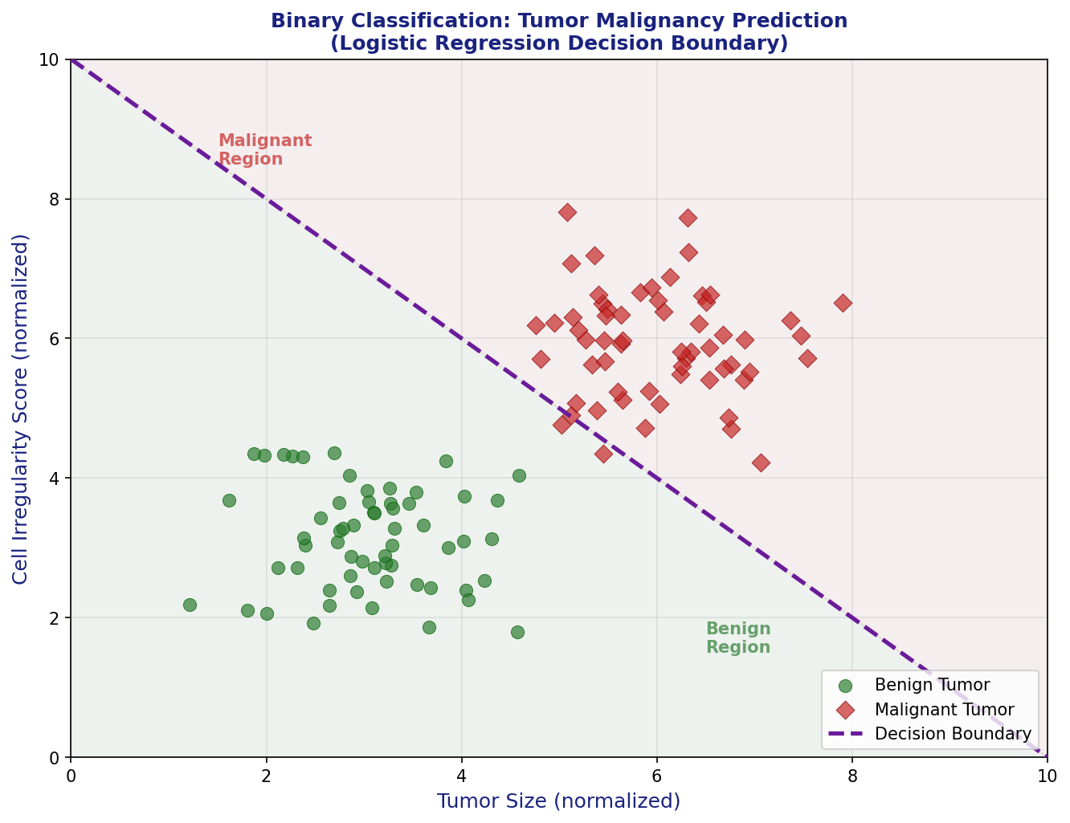
Figure: Binary classification: Separating malignant from benign tumors using clinical features

4.2 Logistic Regression for Clinical Diagnosis
Despite the name, logistic regression is a classification algorithm. It predicts the probability that a patient has a condition, making it ideal for clinical decision support.

Sigmoid Function & Clinical Threshold
P(disease) = 1 / (1 + e^-(b₀ + b₁x₁ + b₂x₂ + ... + bₙxₙ))

• If P(disease) ≥ 0.5 → Classify as DISEASE PRESENT
• If P(disease) < 0.5 → Classify as DISEASE ABSENT

Note: The threshold can be adjusted clinically:
- Lower threshold (e.g., 0.3): Increases sensitivity — catches more true cases
- Higher threshold (e.g., 0.7): Increases specificity — reduces false alarms

4.3 K-Nearest Neighbors (KNN) in Biomedicine
KNN classifies a patient by looking at their K most similar patients in the training data. It is intuitive ("this patient looks like other patients who had condition X") and requires no assumptions about data distribution.

K Value | Effect | Clinical Analogy
K = 1 | Very sensitive to individual patients (overfitting) | One expert's opinion
K = 5 | Good balance (commonly used) | 5-doctor consensus panel
K = 20 | Smooth, general patterns (may underfit) | Large committee vote

4.4 Confusion Matrix in Medical Testing
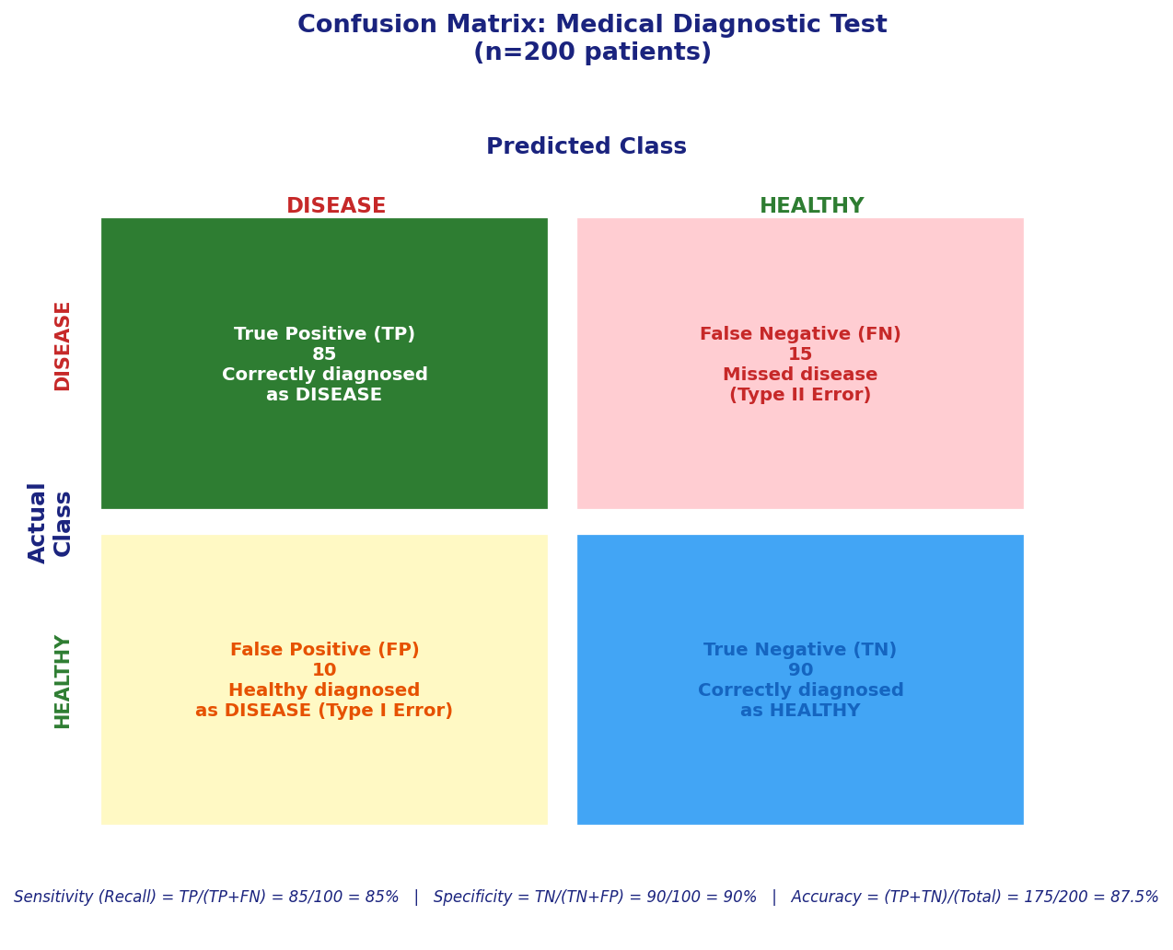
Figure: Confusion matrix: Evaluating diagnostic test performance with 200 patients

The confusion matrix shows 4 critical outcomes in medical diagnosis:
- True Positive (TP): Patient has disease AND test is positive → Correct diagnosis
- True Negative (TN): Patient is healthy AND test is negative → Correctly cleared
- False Positive (FP): Healthy patient gets positive test → Unnecessary treatment/anxiety
- False Negative (FN): Sick patient gets negative test → Missed diagnosis — most dangerous!

⚠️ Clinical Priority: Minimize False Negatives
In life-threatening conditions (cancer, sepsis, MI), missing a diagnosis (FN) is far more dangerous than a false alarm (FP). This is why cancer screening tests are designed with high sensitivity (>90%), accepting some false positives.

Key Insight: Sensitivity = TP/(TP+FN). Maximizing sensitivity minimizes missed diagnoses.

4.5 Hands-On Project 2: Breast Cancer Diagnosis (Wisconsin Dataset)
🔬 Project Goal
Use the Wisconsin Breast Cancer dataset to diagnose whether a tumor is malignant or benign.
Features: 30 measurements from digitized FNA biopsy images (radius, texture, perimeter, area, smoothness...)
Label: 0 = Malignant, 1 = Benign | 569 samples

# ─── STEP 1: Load Real Medical Dataset ──────────────────────────
import numpy as np
import pandas as pd
from sklearn.datasets import load_breast_cancer
from sklearn.model_selection import train_test_split
from sklearn.preprocessing import StandardScaler
from sklearn.linear_model import LogisticRegression
from sklearn.neighbors import KNeighborsClassifier
from sklearn.metrics import (accuracy_score, classification_report,
confusion_matrix, roc_auc_score)

# Load Wisconsin Breast Cancer Dataset (REAL biomedical data)
cancer = load_breast_cancer()
X = pd.DataFrame(cancer.data, columns=cancer.feature_names)
y = cancer.target # 0 = malignant, 1 = benign

print("Dataset Shape:", X.shape)
print(f"\nClass Distribution:")
print(f" Malignant: {sum(y==0)} patients ({sum(y==0)/len(y)*100:.1f}%)")
print(f" Benign: {sum(y==1)} patients ({sum(y==1)/len(y)*100:.1f}%)")
print("\nKey Clinical Features:")
print(X[['mean radius', 'mean texture', 'mean area', 'mean smoothness']].describe().round(3))

# ─── STEP 2: Prepare and Split Data ─────────────────────────────
X_train, X_test, y_train, y_test = train_test_split(
X, y, test_size=0.2, random_state=42, stratify=y
)

# Stratify ensures class balance in both train and test sets
print(f"Training set: {len(X_train)} samples")
print(f"Test set: {len(X_test)} samples")

# Feature scaling is critical for both Logistic Regression and KNN
scaler = StandardScaler()
X_train_sc = scaler.fit_transform(X_train)
X_test_sc = scaler.transform(X_test)

# ─── STEP 3: Train Logistic Regression ──────────────────────────
lr_model = LogisticRegression(max_iter=1000, random_state=42)
lr_model.fit(X_train_sc, y_train)
lr_pred = lr_model.predict(X_test_sc)
lr_proba = lr_model.predict_proba(X_test_sc)[:, 1] # malignancy probability

# Clinical metrics
lr_cm = confusion_matrix(y_test, lr_pred)
lr_tn, lr_fp, lr_fn, lr_tp = lr_cm.ravel()

print("=== Logistic Regression Results ===")
print(f"Sensitivity (Recall): {lr_tp/(lr_tp+lr_fn):.3f} "
f"← % malignant tumors correctly identified")
print(f"Specificity: {lr_tn/(lr_tn+lr_fp):.3f} "
f"← % benign tumors correctly cleared")
print(f"AUC-ROC Score: {roc_auc_score(y_test, lr_proba):.3f}")
print(f"Overall Accuracy: {accuracy_score(y_test, lr_pred):.3f}")

# ─── STEP 4: Train and Tune KNN Classifier ──────────────────────
# Try different K values to find optimal
k_results = []
for k in range(1, 21):
knn = KNeighborsClassifier(n_neighbors=k)
knn.fit(X_train_sc, y_train)
knn_pred = knn.predict(X_test_sc)
k_results.append({
'k': k,
'accuracy': accuracy_score(y_test, knn_pred),
'sensitivity': recall_score(y_test, knn_pred, pos_label=0) # malignant=0
})

results_df = pd.DataFrame(k_results)
best_k = results_df.loc[results_df['accuracy'].idxmax(), 'k']
print(f"\nOptimal K value: {best_k}")
print(results_df.sort_values('accuracy', ascending=False).head(5))

# ─── STEP 5: Compare Models and Make Clinical Predictions ──────
from sklearn.metrics import recall_score

best_knn = KNeighborsClassifier(n_neighbors=int(best_k))
best_knn.fit(X_train_sc, y_train)
knn_pred = best_knn.predict(X_test_sc)
knn_proba = best_knn.predict_proba(X_test_sc)[:, 1]

print("\n=== 🏥 Clinical Model Comparison ===")
print(f"{'Model':<25} {'Accuracy':>10} {'Sensitivity':>13} {'AUC-ROC':>10}")
print("-" * 60)
for name, pred, proba in [('Logistic Regression', lr_pred, lr_proba),
(f'KNN (k={int(best_k)})', knn_pred, knn_proba)]:
acc = accuracy_score(y_test, pred)
sens = recall_score(y_test, pred, pos_label=0) # malignant
auc = roc_auc_score(y_test, proba)
print(f"{name:<25} {acc:>10.3f} {sens:>13.3f} {auc:>10.3f}")

# Clinical recommendation
print("\n🔍 Full Report for Best Model:")
print(classification_report(y_test, lr_pred,
target_names=['Malignant', 'Benign']))

📋 Expected Results & Clinical Significance
• Logistic Regression: ~97% accuracy, AUC-ROC ~0.99 — excellent diagnostic performance
• Key finding: The top features are related to cell size and uniformity (mean concave points, worst radius)
• Clinical value: This automated system achieves radiologist-level accuracy, potential for triage support
• Important caveat: Always validate on external clinical data before deployment

CHAPTER 5: DECISION TREES & RANDOM FORESTS

5. Decision Trees and Random Forests

5.1 Decision Trees in Clinical Decision Making
Decision trees mirror how clinicians actually think — a series of yes/no questions leading to a diagnosis or treatment decision. They are one of the most interpretable ML models, which is critical in medicine.

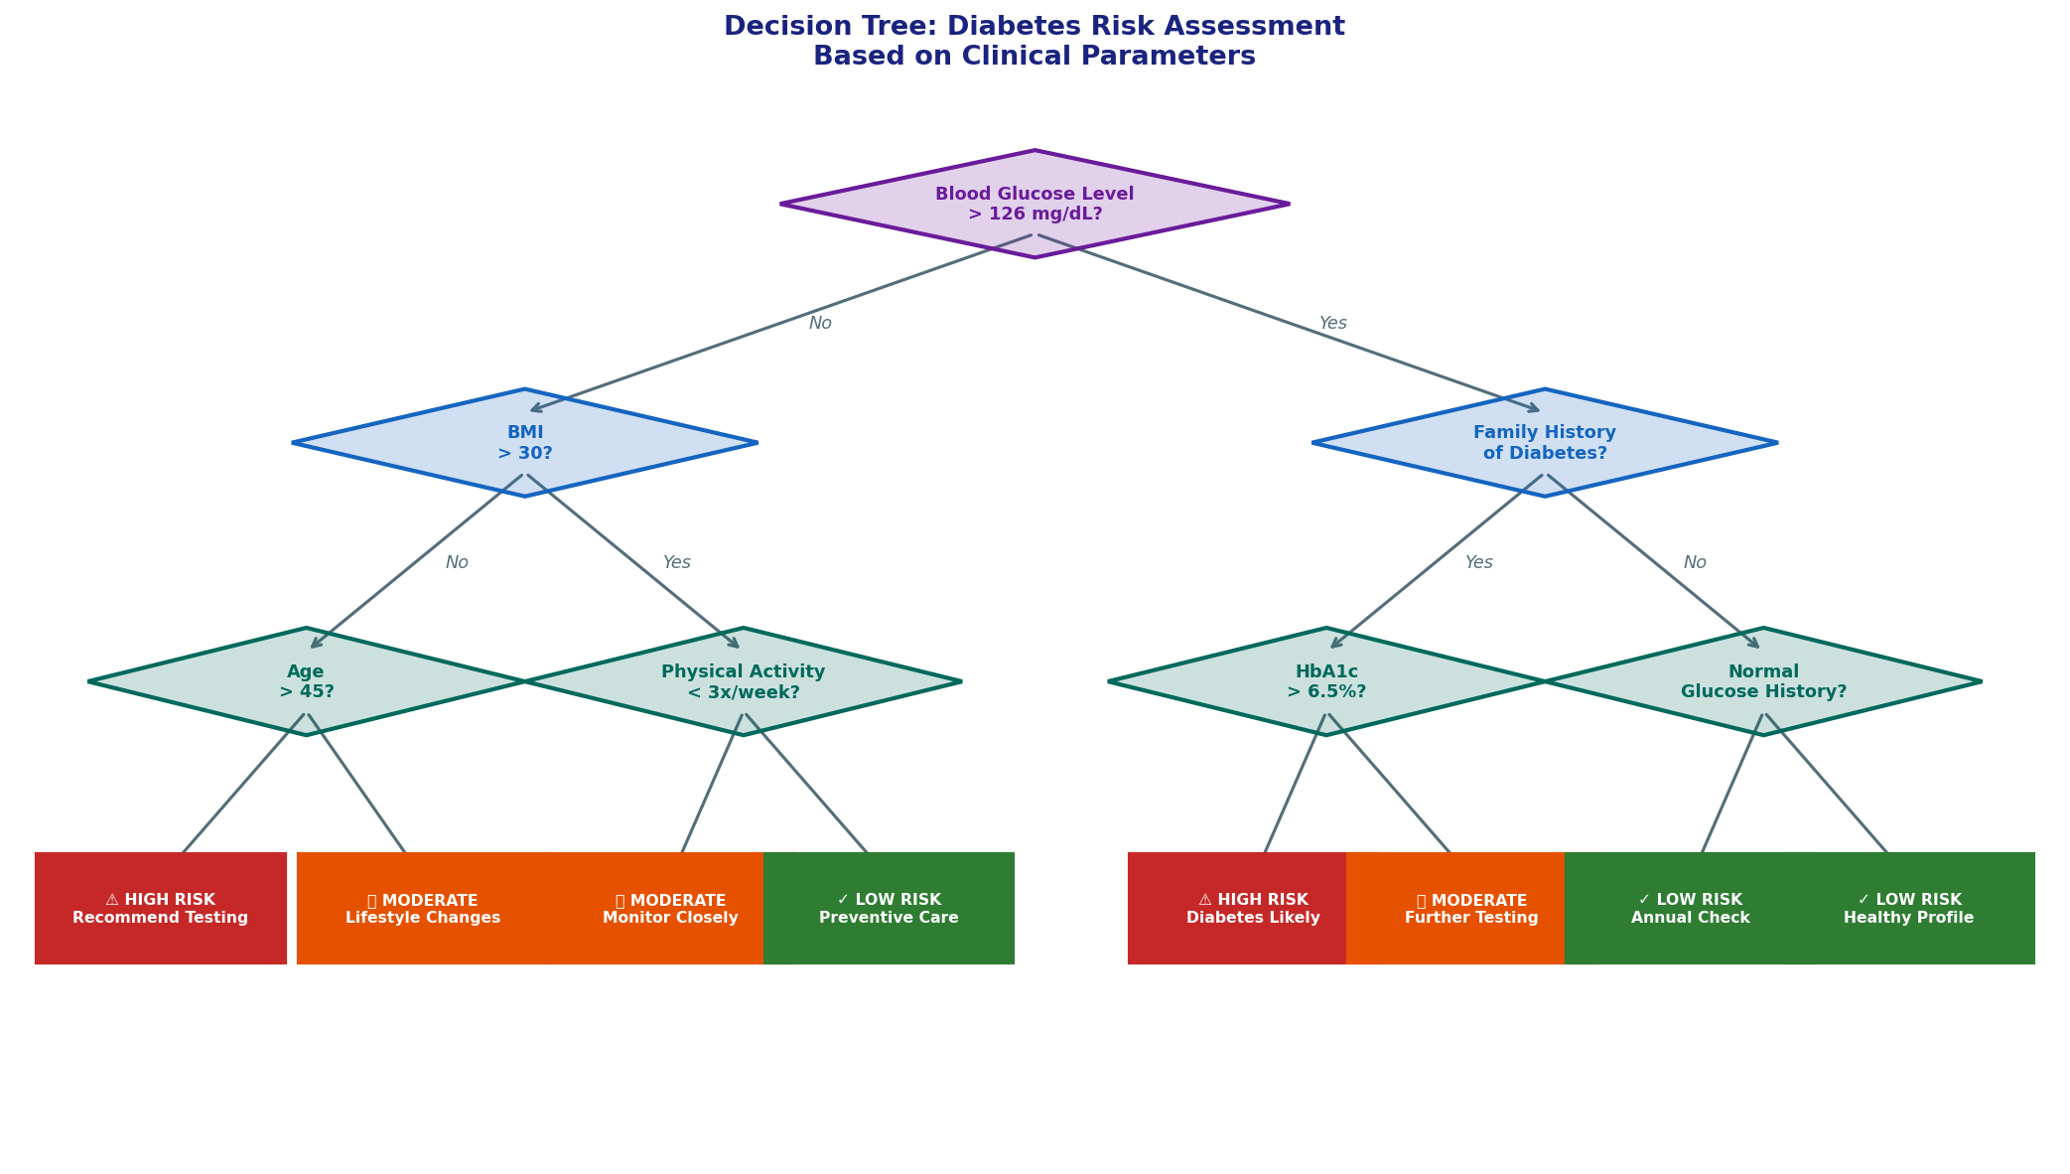
Figure: Decision tree for diabetes risk assessment using clinical parameters

Decision trees work by finding the best feature to split patients at each node to maximize separation between groups. Key concepts:
- Root Node: The most informative feature (e.g., blood glucose level for diabetes)
- Internal Nodes: Subsequent clinical questions (BMI, family history, HbA1c)
- Leaf Nodes: Final risk classification (High/Moderate/Low risk)
- Splitting Criterion: Gini impurity or information gain measures how well a feature separates classes

5.2 Why Decision Trees Work Well in Medicine
Advantage | Clinical Benefit
Interpretable | Clinicians can see exactly why a prediction was made (regulatory compliance)
No Feature Scaling | Lab values, imaging scores, and age can be used directly without normalization
Handles Missing Data | Can work with incomplete patient records
Non-linear | Captures complex diagnostic thresholds (e.g., glucose >126 mg/dL)
Feature Importance | Automatically identifies most clinically relevant variables

5.3 Random Forests: Ensemble Learning
Random Forest overcomes the main weakness of single decision trees (overfitting) by combining hundreds of trees trained on different patient subsets and features. The final prediction is a majority vote.

🌲 Why Random Forest Outperforms Single Trees
Single Decision Tree: Like asking one doctor — can be biased or miss details
Random Forest: Like a committee of 100 doctors, each with different specialties

Random Forest does two key things:
1. Bootstrap Aggregating (Bagging): Each tree trains on a random sample of patients
2. Feature Randomization: Each split considers only a random subset of clinical features

Result: High accuracy, robust to noise, less prone to overfitting on small clinical datasets

5.4 Hands-On Project 3: Diabetes Risk Assessment
💉 Project Goal
Predict whether a patient is diabetic using the Pima Indians Diabetes Dataset.
Features: Pregnancies, Glucose, BloodPressure, SkinThickness, Insulin, BMI, DiabetesPedigreeFunction, Age
Label: 1 = Diabetic, 0 = Non-diabetic | 768 female patients

# ─── STEP 1: Load Diabetes Dataset ──────────────────────────────
import numpy as np
import pandas as pd
from sklearn.model_selection import train_test_split, cross_val_score
from sklearn.preprocessing import StandardScaler
from sklearn.tree import DecisionTreeClassifier
from sklearn.ensemble import RandomForestClassifier
from sklearn.metrics import (classification_report, confusion_matrix,
roc_auc_score, accuracy_score)

# Use sklearn's diabetes dataset (or load Pima dataset from file)
url = "https://raw.githubusercontent.com/jbrownlee/Datasets/master/pima-indians-diabetes.data.csv"
cols = ['Pregnancies','Glucose','BloodPressure','SkinThickness',
'Insulin','BMI','DiabetesPedigree','Age','Diabetes']
# If no internet, create representative synthetic data:
np.random.seed(42)
n = 768
df = pd.DataFrame({
'Glucose': np.concatenate([np.random.normal(90, 15, 500), np.random.normal(140, 25, 268)]),
'BMI': np.concatenate([np.random.normal(25, 4, 500), np.random.normal(33, 6, 268)]),
'Age': np.concatenate([np.random.normal(28, 8, 500), np.random.normal(36, 10, 268)]),
'BloodPressure': np.concatenate([np.random.normal(70, 10, 500), np.random.normal(80, 12, 268)]),
'Insulin': np.concatenate([np.random.normal(80, 40, 500), np.random.normal(160, 80, 268)]),
'DiabetesPedigree': np.concatenate([np.random.normal(0.3, 0.2, 500), np.random.normal(0.6, 0.3, 268)]),
'Diabetes': [0]*500 + [1]*268
}).clip(0)

print(f"Dataset: {df.shape[0]} patients, {(df.Diabetes==1).sum()} diabetic")
print(df.groupby('Diabetes').mean().round(2))

# ─── STEP 2: Handle Missing Values & Prepare Data ───────────────
# In clinical data, 0 values for Glucose/BMI/BP are physiologically impossible
# Replace with NaN, then impute with median (common in biomedical ML)
clinical_cols = ['Glucose', 'BloodPressure', 'BMI', 'Insulin']
for col in clinical_cols:
if col in df.columns:
df[col] = df[col].replace(0, np.nan)
df[col].fillna(df[col].median(), inplace=True)

features = ['Glucose', 'BMI', 'Age', 'BloodPressure', 'Insulin', 'DiabetesPedigree']
X = df[features]
y = df['Diabetes']

X_train, X_test, y_train, y_test = train_test_split(
X, y, test_size=0.2, random_state=42, stratify=y
)

# ─── STEP 3: Train Decision Tree ────────────────────────────────
# Limit depth to prevent overfitting (clinically interpretable tree)
dt_model = DecisionTreeClassifier(max_depth=5, min_samples_split=10,
random_state=42, class_weight='balanced')
dt_model.fit(X_train, y_train)
dt_pred = dt_model.predict(X_test)

print("=== Decision Tree Results ===")
print(f"Accuracy: {accuracy_score(y_test, dt_pred):.3f}")
print(f"AUC-ROC: {roc_auc_score(y_test, dt_model.predict_proba(X_test)[:,1]):.3f}")
print("\nFeature Importances (clinical relevance):")
for feat, imp in sorted(zip(features, dt_model.feature_importances_),
key=lambda x: x[1], reverse=True):
bar = '█' * int(imp * 30)
print(f" {feat:<20}: {imp:.3f} {bar}")

# ─── STEP 4: Train Random Forest ────────────────────────────────
rf_model = RandomForestClassifier(
n_estimators=200, # 200 decision trees
max_depth=10,
min_samples_split=5,
class_weight='balanced', # Important for imbalanced medical data!
random_state=42,
n_jobs=-1 # Use all CPU cores
)
rf_model.fit(X_train, y_train)
rf_pred = rf_model.predict(X_test)
rf_proba = rf_model.predict_proba(X_test)[:,1]

print("=== Random Forest Results ===")
print(f"Accuracy: {accuracy_score(y_test, rf_pred):.3f}")
print(f"AUC-ROC: {roc_auc_score(y_test, rf_proba):.3f}")
print("\n" + classification_report(y_test, rf_pred,
target_names=['Non-Diabetic', 'Diabetic']))

# ─── STEP 5: Clinical Feature Importance Analysis ───────────────
print("=== 🔬 Random Forest Feature Importance ===")
importance_df = pd.DataFrame({
'Feature': features,
'Importance': rf_model.feature_importances_
}).sort_values('Importance', ascending=False)

for _, row in importance_df.iterrows():
bar = '█' * int(row.Importance * 40)
print(f" {row.Feature:<20}: {row.Importance:.3f} {bar}")

print("\n🔮 Risk Prediction for 3 Patient Profiles:")
profiles = pd.DataFrame({
'Glucose': [95, 155, 200],
'BMI': [22, 30, 38],
'Age': [25, 45, 55],
'BloodPressure': [70, 82, 88],
'Insulin': [85, 140, 250],
'DiabetesPedigree': [0.2, 0.5, 0.9],
})
for i, (_, row) in enumerate(profiles.iterrows()):
prob = rf_model.predict_proba(profiles.iloc[[i]])[0,1]
risk = "HIGH RISK ⚠️" if prob > 0.6 else "MODERATE ⚡" if prob > 0.3 else "LOW RISK ✓"
print(f" Patient {i+1}: Glucose={row.Glucose}, BMI={row.BMI:.0f}, Age={row.Age}"
f" → Diabetes probability: {prob:.1%} [{risk}]")

📋 Hands-On Project 4: Heart Disease Prediction (Random Forest)
Try this extension: Load the Cleveland Heart Disease dataset
from sklearn.datasets import fetch_openml
heart = fetch_openml(name="heart-disease", version=1, as_frame=True)

Features: age, sex, chest pain type, resting BP, cholesterol, ECG results, max HR...
Challenge: Achieve >85% AUC-ROC using Random Forest with class_weight="balanced"
Compare with: Logistic Regression, Decision Tree, KNN — which performs best for heart disease?

CHAPTER 6: MODEL EVALUATION, OVERFITTING & TUNING

6. Model Evaluation, Overfitting & Hyperparameter Tuning

6.1 Overfitting and Underfitting in Clinical Models
Getting the right model complexity is critical. A model that memorizes training data (overfitting) will fail on new patients, while an oversimplified model (underfitting) misses important clinical patterns.

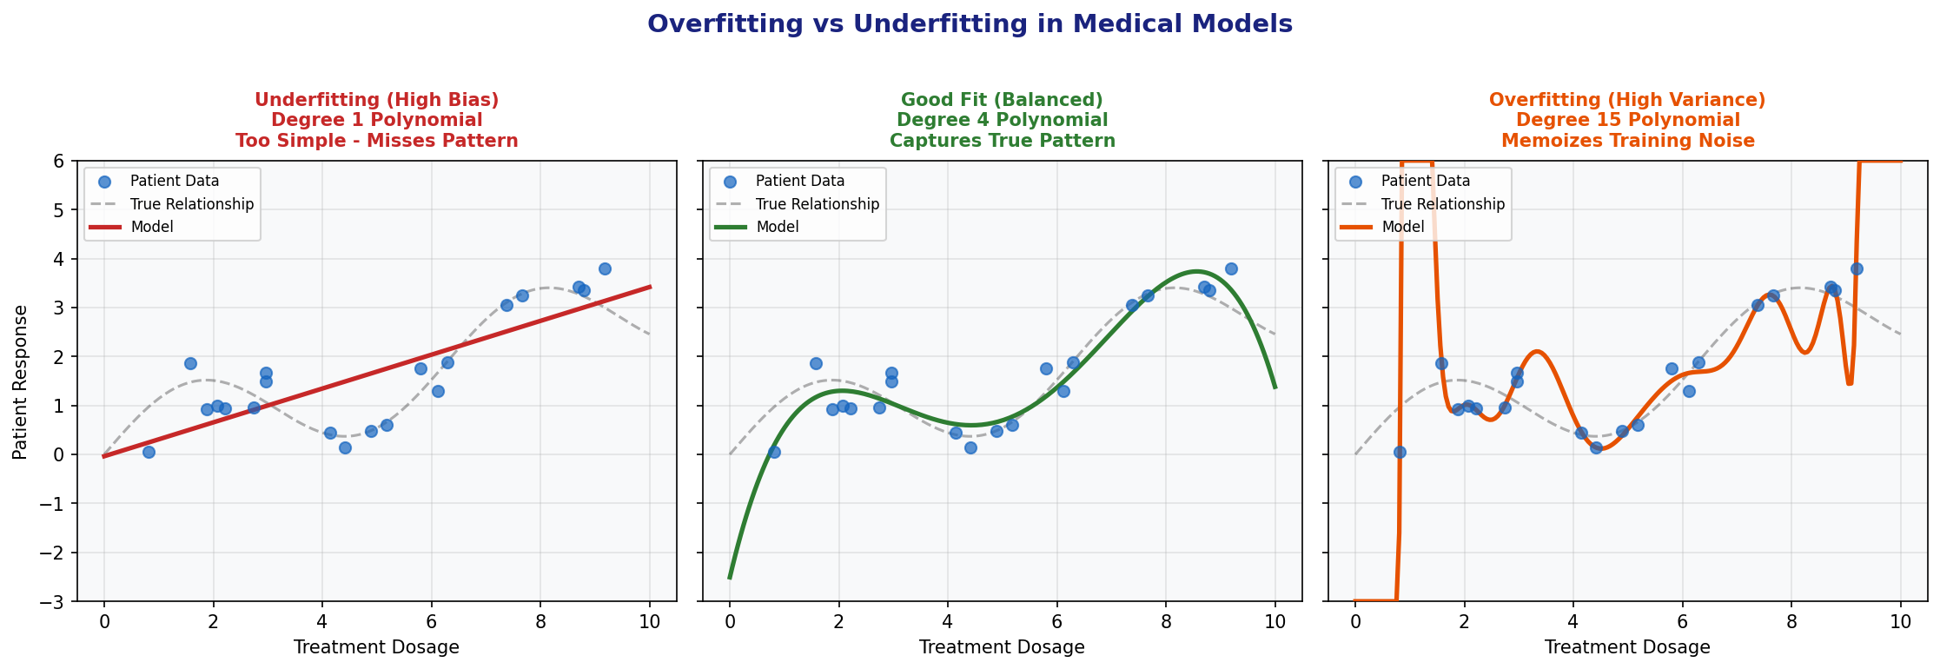
Figure: Overfitting vs Underfitting: Finding the right model complexity for clinical data

Problem | Training Performance | Test Performance | Clinical Risk | Solution
Underfitting | Poor | Poor | Misses real disease patterns | More complex model, more features
Good Fit | Good | Good | Reliable clinical predictions | This is the goal!
Overfitting | Excellent | Poor | Fails on real patients from new hospitals | Regularization, more data, cross-validation

6.2 Cross-Validation for Clinical Validation
Cross-validation provides a more reliable estimate of model performance than a single train-test split, especially important with small medical datasets.

K-Fold Cross-Validation in Medicine
Process: Divide patients into K groups (folds)
• Train on K-1 folds, validate on the remaining fold
• Repeat K times so every patient is used for testing once
• Report mean and standard deviation of performance across folds

Why it matters: A single test set may be unusually easy or hard.
Cross-validation gives a more robust estimate of real-world performance.

Stratified K-Fold: Ensures each fold has the same disease prevalence as the original dataset.
This is essential for imbalanced medical datasets (rare disease = few positive cases).

6.3 Regularization: Preventing Clinical Model Overfitting
Regularization adds a penalty for overly complex models, preventing them from memorizing noise in training data.

Regularization | Formula | Effect | Best For
L1 (Lasso) | Loss + λ × Σ|weights| | Can eliminate irrelevant features completely | High-dimensional genomic data
L2 (Ridge) | Loss + λ × Σ(weights)² | Shrinks all feature weights proportionally | Correlated biomarkers
Elastic Net | L1 + L2 combined | Balanced approach | General biomedical data

6.4 Hyperparameter Tuning
Hyperparameters are settings configured before training. Key examples in biomedical ML:

Model | Key Hyperparameters | Clinical Impact
Logistic Regression | C (inverse regularization) | Controls model complexity vs generalization
KNN | n_neighbors (K) | Balance between sensitivity and specificity
Decision Tree | max_depth, min_samples_split | Interpretability vs accuracy tradeoff
Random Forest | n_estimators, max_features | Computational cost vs performance

6.5 Hands-On Project 5: Comparing Algorithms on Medical Data
⚗️ Project Goal
Systematically compare multiple ML algorithms on the same biomedical dataset using cross-validation.
This is the standard approach for selecting the best model before clinical deployment.

# ─── MODEL COMPARISON ON BIOMEDICAL DATA ────────────────────────
import numpy as np
import pandas as pd
from sklearn.datasets import load_breast_cancer
from sklearn.model_selection import StratifiedKFold, cross_validate
from sklearn.preprocessing import StandardScaler
from sklearn.pipeline import Pipeline
from sklearn.linear_model import LogisticRegression
from sklearn.neighbors import KNeighborsClassifier
from sklearn.tree import DecisionTreeClassifier
from sklearn.ensemble import RandomForestClassifier
from sklearn.svm import SVC

# Load breast cancer dataset
cancer = load_breast_cancer()
X, y = cancer.data, cancer.target

# Define models to compare
models = {
'Logistic Regression': LogisticRegression(max_iter=1000),
'KNN (k=7)': KNeighborsClassifier(n_neighbors=7),
'Decision Tree': DecisionTreeClassifier(max_depth=5, random_state=42),
'Random Forest': RandomForestClassifier(n_estimators=100, random_state=42),
'SVM': SVC(kernel='rbf', probability=True)
}

# Use stratified 10-fold cross-validation (standard in clinical ML)
cv = StratifiedKFold(n_splits=10, shuffle=True, random_state=42)

print("=== 🏥 Model Comparison: Breast Cancer Diagnosis ===")
print(f"{'Model':<25} {'Accuracy':>10} {'±Std':>8} {'AUC-ROC':>10} {'Sensitivity':>12}")
print("-" * 70)

results = {}
for name, model in models.items():
# Pipeline ensures scaling is done inside each fold (prevents data leakage!)
pipe = Pipeline([('scaler', StandardScaler()), ('model', model)])
scores = cross_validate(pipe, X, y, cv=cv,
scoring=['accuracy', 'roc_auc', 'recall'],
return_train_score=True)
results[name] = scores
print(f"{name:<25} {scores['test_accuracy'].mean():>10.3f} "
f"{scores['test_accuracy'].std():>8.3f} "
f"{scores['test_roc_auc'].mean():>10.3f} "
f"{scores['test_recall'].mean():>12.3f}")

# ─── VISUALIZE AND INTERPRET RESULTS ────────────────────────────
# Create comparison dataframe
comparison = pd.DataFrame({
name: {
'Mean Accuracy': scores['test_accuracy'].mean(),
'Std Accuracy': scores['test_accuracy'].std(),
'AUC-ROC': scores['test_roc_auc'].mean(),
'Sensitivity': scores['test_recall'].mean(),
'Train Accuracy': scores['train_accuracy'].mean(),
}
for name, scores in results.items()
}).T.round(4)

print("\n📊 Overfitting Check (Train vs Test Accuracy):")
comparison['Overfit_Gap'] = comparison['Train Accuracy'] - comparison['Mean Accuracy']
print(comparison[['Mean Accuracy', 'Train Accuracy', 'Overfit_Gap']].round(4))

print("\n🏆 Best Model by AUC-ROC:")
best = comparison['AUC-ROC'].idxmax()
print(f" → {best}: AUC-ROC = {comparison.loc[best, 'AUC-ROC']:.3f}")
print(f" Clinical interpretation: Excellent diagnostic discrimination")

6.6 Hands-On Project 6: Hyperparameter Tuning for Diagnostic Models
# ─── GRID SEARCH FOR CLINICAL MODEL OPTIMIZATION ────────────────
from sklearn.model_selection import GridSearchCV
from sklearn.ensemble import RandomForestClassifier
from sklearn.datasets import load_breast_cancer
from sklearn.model_selection import train_test_split
from sklearn.preprocessing import StandardScaler
from sklearn.pipeline import Pipeline

cancer = load_breast_cancer()
X, y = cancer.data, cancer.target
X_train, X_test, y_train, y_test = train_test_split(
X, y, test_size=0.2, random_state=42, stratify=y
)

# Define hyperparameter search space
param_grid = {
'model__n_estimators': [50, 100, 200],
'model__max_depth': [5, 10, 15, None],
'model__min_samples_split': [2, 5, 10],
'model__class_weight': ['balanced', None]
}

pipe = Pipeline([
('scaler', StandardScaler()),
('model', RandomForestClassifier(random_state=42))
])

# Optimize for AUC-ROC (standard for clinical diagnostic models)
grid_search = GridSearchCV(
pipe, param_grid, cv=5, scoring='roc_auc',
n_jobs=-1, verbose=1
)

print("🔍 Running Grid Search (optimizing AUC-ROC for cancer diagnosis)...")
grid_search.fit(X_train, y_train)

print(f"\n✅ Best Parameters: {grid_search.best_params_}")
print(f" Best CV AUC-ROC: {grid_search.best_score_:.4f}")

# Final evaluation on held-out test set
best_model = grid_search.best_estimator_
test_auc = roc_auc_score(y_test, best_model.predict_proba(X_test)[:,1])
print(f"\n🏥 Final Test Performance:")
print(f" AUC-ROC on held-out patients: {test_auc:.4f}")
print(classification_report(y_test, best_model.predict(X_test),
target_names=['Malignant', 'Benign']))

⚠️ Critical Warning: Data Leakage in Clinical ML
Data leakage occurs when information from the test set "leaks" into the training process.
In clinical settings, this leads to overestimated performance — the model appears better than it really is.

ALWAYS use Pipeline to combine preprocessing + model:
Pipeline([("scaler", StandardScaler()), ("model", RandomForest())])

This ensures: scaling parameters are ONLY computed on training data,
never on the test set — preventing artificially inflated performance metrics.

CHAPTER 7: NEURAL NETWORKS IN BIOMEDICINE

7. Neural Networks and Deep Learning in Biomedical Applications

7.1 Neural Network Architecture
Neural networks are the foundation of deep learning — the technology behind medical image analysis, protein structure prediction (AlphaFold), and drug discovery. They are loosely inspired by biological neurons in the brain.

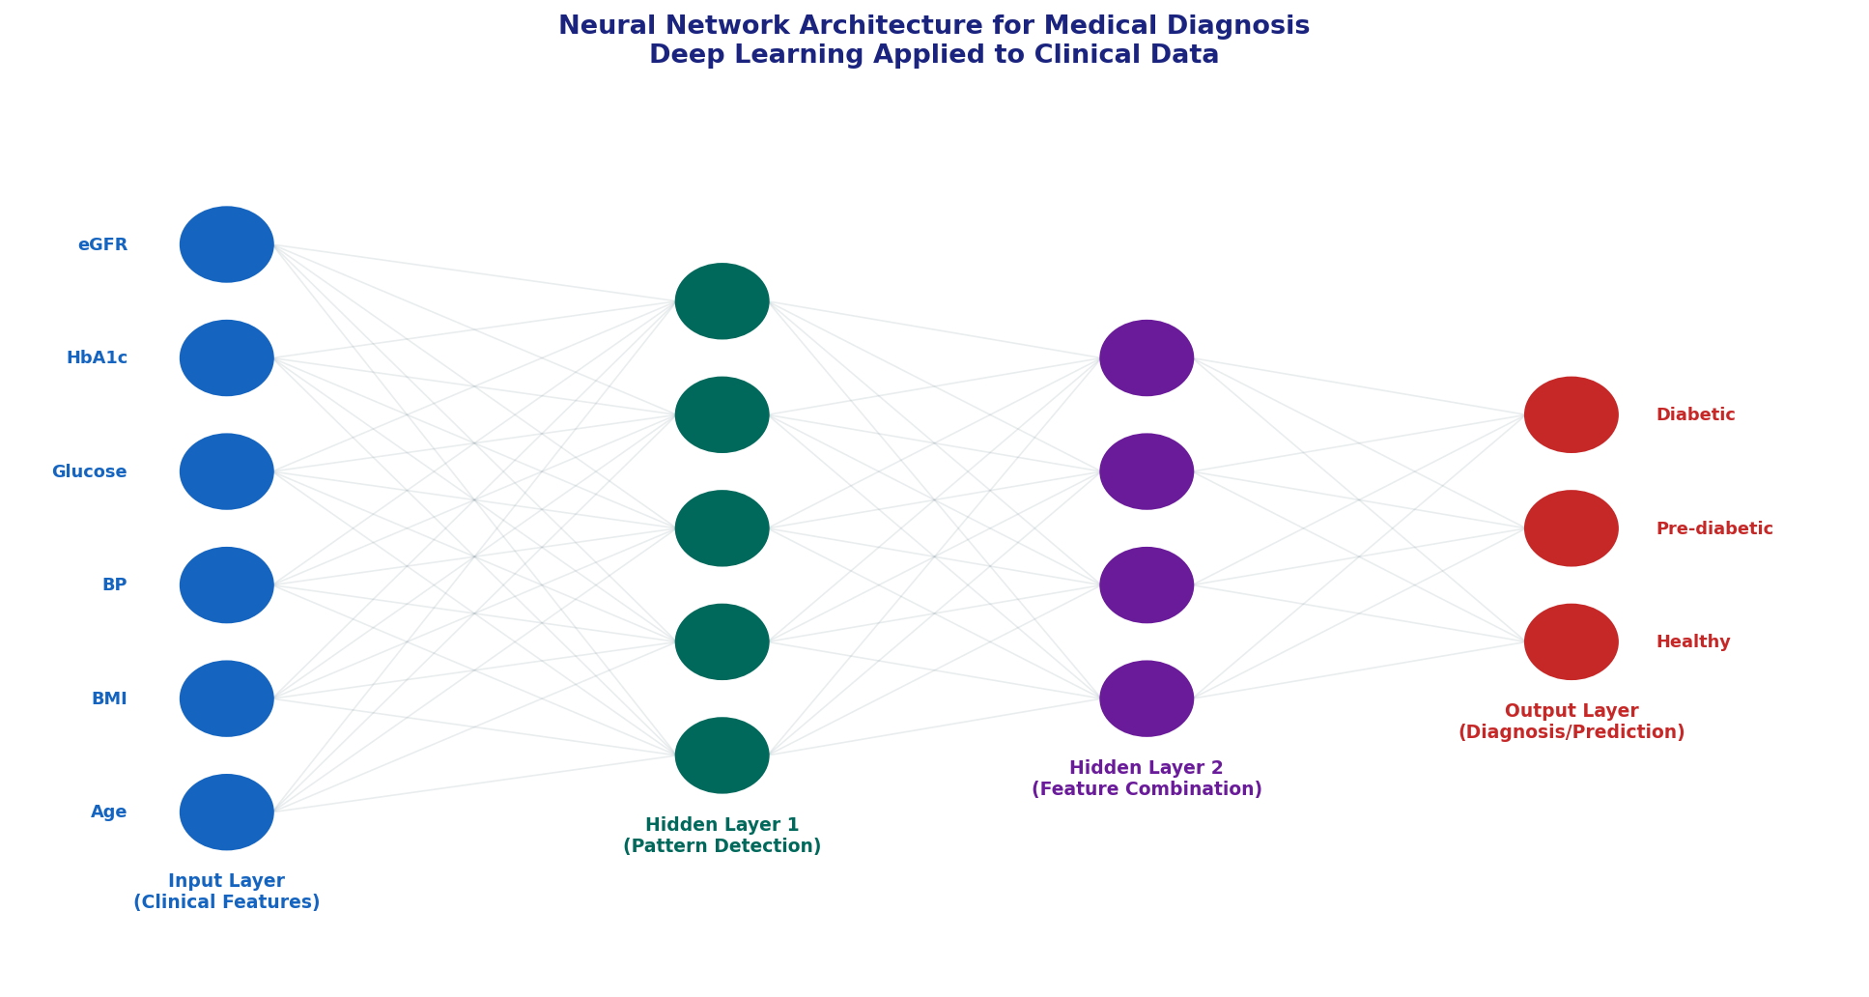
Figure: Neural network architecture for clinical diagnosis using multi-modal patient data

Layer | Function | Biomedical Analogy
Input Layer | Receives raw clinical data | Patient chart with all measurements
Hidden Layers | Learn complex feature combinations | Physician reasoning through differential diagnosis
Output Layer | Produces final prediction | Final diagnosis or risk score
Weights | Learned importance of each connection | Strength of evidence for each finding
Activation | Non-linear transformation (ReLU, Sigmoid) | Threshold effects in biological systems

7.2 Deep Learning Applications in Biomedicine
Application | Architecture | Milestone Achievement
Diabetic Retinopathy Detection | CNN | Google AI matched ophthalmologist sensitivity (94.5%)
Skin Cancer Classification | CNN | Stanford AI matched dermatologist accuracy (91%)
Protein Structure Prediction | Transformer (AlphaFold2) | Solved 50-year protein folding problem
Drug-Target Interaction | GNN / Transformer | Predicts binding affinity for novel drug candidates
ECG Arrhythmia Detection | RNN / CNN | Exceeded cardiologist accuracy on 12-lead ECG
Genomic Variant Effect | CNN / BERT | Predicts pathogenicity of DNA variants

7.3 Hands-On: Simple Neural Network for Medical Classification
# ─── NEURAL NETWORK WITH SKLEARN MLPClassifier ──────────────────
import numpy as np
from sklearn.datasets import load_breast_cancer
from sklearn.model_selection import train_test_split
from sklearn.preprocessing import StandardScaler
from sklearn.neural_network import MLPClassifier
from sklearn.metrics import classification_report, roc_auc_score

# Load breast cancer dataset
cancer = load_breast_cancer()
X, y = cancer.data, cancer.target

X_train, X_test, y_train, y_test = train_test_split(
X, y, test_size=0.2, random_state=42, stratify=y
)

scaler = StandardScaler()
X_train_sc = scaler.fit_transform(X_train)
X_test_sc = scaler.transform(X_test)

# Multi-layer perceptron: 2 hidden layers (100 and 50 neurons)
mlp = MLPClassifier(
hidden_layer_sizes=(100, 50), # Architecture: Input → 100 → 50 → Output
activation='relu', # ReLU activation function
solver='adam', # Adam optimizer
max_iter=500,
random_state=42,
early_stopping=True, # Prevent overfitting
validation_fraction=0.15 # Internal validation set
)

mlp.fit(X_train_sc, y_train)
y_pred = mlp.predict(X_test_sc)
y_proba = mlp.predict_proba(X_test_sc)[:,1]

print("=== Neural Network: Breast Cancer Classification ===")
print(f"Accuracy: {mlp.score(X_test_sc, y_test):.4f}")
print(f"AUC-ROC: {roc_auc_score(y_test, y_proba):.4f}")
print(f"\nDetailed Performance Report:")
print(classification_report(y_test, y_pred, target_names=['Malignant','Benign']))

CONCLUSION & NEXT STEPS

Conclusion and Next Steps
You have completed a comprehensive introduction to Machine Learning with a biomedical focus. You now have the foundations to apply these techniques to real clinical and research challenges.

What You Have Learned
- Core ML Concepts: Supervised, unsupervised, and reinforcement learning with biomedical applications
- Regression Models: Linear regression for predicting clinical outcomes (recovery time, biomarker levels)
- Classification Models: Logistic regression, KNN for disease diagnosis and risk stratification
- Ensemble Methods: Decision Trees and Random Forests for clinical decision support
- Model Evaluation: Sensitivity, specificity, AUC-ROC, confusion matrices in clinical context
- Best Practices: Cross-validation, regularization, hyperparameter tuning, avoiding data leakage
- Neural Networks: Deep learning architecture and biomedical applications

Recommended Biomedical Datasets to Practice With
Dataset | Task | Source | Clinical Relevance
MIMIC-III Clinical Database | Multiple tasks | PhysioNet | Real ICU patient data
TCGA Cancer Genomics | Cancer subtyping | NIH GDC | Precision oncology
ISIC Skin Lesion | Image classification | ISIC Archive | Dermatology AI
Kaggle Chest X-ray | Pneumonia detection | Kaggle | Radiology AI
UK Biobank | Disease prediction | UK Biobank | Population health
PhysioNet ECG | Arrhythmia detection | PhysioNet | Cardiology AI

Recommended Next Steps
- Advanced Algorithms: Support Vector Machines, Gradient Boosting (XGBoost), deep learning (TensorFlow/PyTorch)
- Biomedical Data Science: Medical image analysis with CNNs, NLP for clinical notes, genomics data analysis
- Explainable AI: SHAP values, LIME — essential for clinical AI interpretability and regulatory compliance
- Clinical ML Standards: Learn TRIPOD reporting guidelines and STARD standards for AI diagnostic studies
- Regulatory Considerations: FDA guidance on AI/ML-based Software as Medical Device (SaMD)
- Ethics in Medical AI: Fairness, bias detection, privacy (HIPAA compliance)

Key Resources for Biomedical ML Students
Resource | Type | Focus
scikit-learn.org | Documentation | Core ML algorithms and biomedical examples
Nature Medicine AI papers | Journal | Latest clinical AI publications
"Deep Medicine" by Eric Topol | Book | AI transformation of healthcare
"Biomedical Informatics" by Shortliffe | Textbook | Clinical informatics foundations
fast.ai Practical Deep Learning | Course | Hands-on deep learning including medical imaging
Kaggle Learn + Competitions | Practice | Real biomedical ML challenges
MIT OpenCourseWare 6.867 | Course | Rigorous ML theory foundation

Your ML Journey in Healthcare Is Just Beginning!
The intersection of machine learning and medicine is one of the most impactful fields of our era.
With these foundations, you are ready to contribute to AI-driven advances in diagnosis, treatment, and drug discovery.

