Deep Learning
Training Notes for Students
A Practical Introduction to Core Algorithms & Concepts
Vincent Magomere
Vkadenge89@gmail.com
Topics Covered
1. Introduction to Deep Learning
2. Neural Network Fundamentals
3. Convolutional Neural Networks (CNNs)
4. Recurrent Neural Networks (RNNs) & LSTMs
5. Training Deep Learning Models
6. Transfer Learning & Advanced Architectures

1. Introduction to Deep Learning

1.1 What is Deep Learning?
Deep Learning is a subset of Machine Learning that uses artificial neural networks with multiple layers to learn patterns from data. These networks are loosely inspired by how the human brain processes information.
The key idea is that instead of hand-crafting features (like in traditional ML), deep learning models learn the right features automatically from raw data — whether that's images, text, audio, or numbers.
💡 Think of it like this: Traditional ML = you tell the computer what to look for. Deep Learning = the computer figures out what to look for on its own.

1.2 Deep Learning vs Machine Learning
Feature | Traditional ML | Deep Learning
Feature Engineering | Manual | Automatic
Data Needed | Less | Large amounts
Interpretability | Easier | Harder (black box)
Performance on complex tasks | Limited | State-of-the-art
Hardware | CPU often enough | GPU recommended

1.3 Real-World Applications
- Computer Vision: Image classification, object detection, face recognition
- Natural Language Processing: Chatbots, translation, sentiment analysis
- Healthcare: Medical image diagnosis, drug discovery
- Autonomous Vehicles: Real-time scene understanding
- Speech Recognition: Voice assistants (Siri, Alexa, Google)
- Recommendation Systems: Netflix, YouTube, Spotify

2. Neural Network Fundamentals

2.1 What is a Neural Network?
A neural network is made up of layers of connected units called neurons. Each neuron receives inputs, multiplies them by weights, adds a bias, and passes the result through an activation function.
The three main types of layers are:
- Input Layer: Receives raw data (e.g., pixel values of an image)
- Hidden Layers: Extract patterns and features from data
- Output Layer: Produces the final prediction
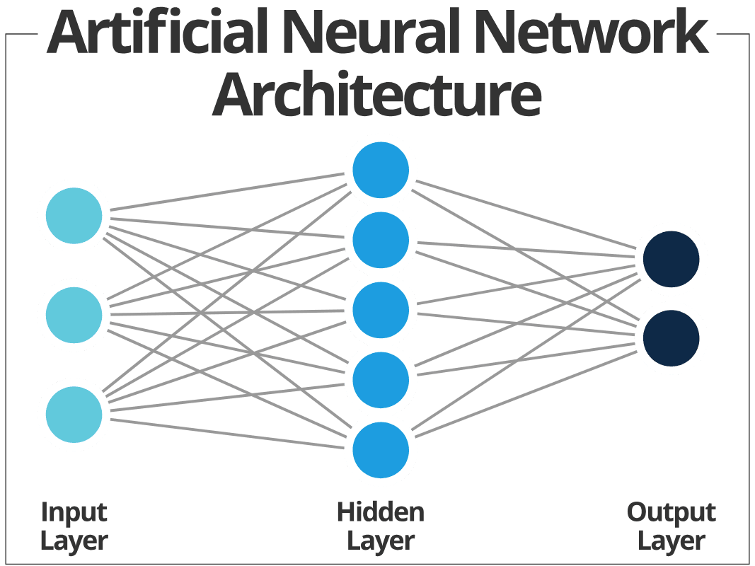

2.2 How a Single Neuron Works
A neuron computes: output = activation(w1*x1 + w2*x2 + ... + wn*xn + b)
- x1, x2, ..., xn = input values
- w1, w2, ..., wn = weights (learned during training)
- b = bias (also learned)
- activation = a function that adds non-linearity

2.3 Activation Functions
Activation functions introduce non-linearity, allowing networks to learn complex patterns.
Function | Formula | When to Use
Sigmoid | 1 / (1 + e^-x) | Binary classification output
Tanh | (e^x - e^-x) / (e^x + e^-x) | Hidden layers (centered at 0)
ReLU | max(0, x) | Most hidden layers (default choice)
Softmax | e^xi / sum(e^xj) | Multi-class classification output

2.4 Training a Neural Network
Training involves these key steps:
- Forward Propagation: Input passes through the network to produce a prediction
- Loss Calculation: Compare prediction to actual label using a loss function
- Backpropagation: Calculate gradients of the loss with respect to each weight
- Weight Update: Adjust weights using an optimizer (e.g., gradient descent)
- Repeat: Do this for many batches and epochs until loss is minimized

2.5 Example: Simple Neural Network with Keras
Python Code — Basic Neural Network (MNIST Digit Classification)
import tensorflow as tf
from tensorflow import keras
import numpy as np

# 1. Load and prepare data
(x_train, y_train), (x_test, y_test) = keras.datasets.mnist.load_data()

# Normalize pixel values from [0, 255] to [0, 1]
x_train = x_train / 255.0
x_test = x_test / 255.0

print(f"Training data shape: {x_train.shape}") # (60000, 28, 28)
print(f"Number of classes: {len(np.unique(y_train))}") # 10

# 2. Build the model
model = keras.Sequential([
keras.layers.Flatten(input_shape=(28, 28)), # Flatten 28x28 to 784
keras.layers.Dense(128, activation='relu'), # Hidden layer
keras.layers.Dense(64, activation='relu'), # Hidden layer
keras.layers.Dense(10, activation='softmax') # Output: 10 classes
])

# 3. Compile the model
model.compile(
optimizer='adam',
loss='sparse_categorical_crossentropy',
metrics=['accuracy']
)

model.summary()

# 4. Train the model
history = model.fit(
x_train, y_train,
epochs=10,
batch_size=32,
validation_split=0.1,
verbose=1
)

# 5. Evaluate on test set
test_loss, test_acc = model.evaluate(x_test, y_test)
print(f"\nTest Accuracy: {test_acc:.4f}")
💡 This simple network achieves ~98% accuracy on MNIST! The Flatten layer converts 2D images to 1D, Dense layers learn patterns, and Softmax outputs class probabilities.

3. Convolutional Neural Networks (CNNs)

3.1 Why CNNs for Images?
Regular (Dense) neural networks treat each pixel independently. CNNs exploit the spatial structure of images — nearby pixels are related. CNNs are much more efficient because they share weights across the image using filters.

3.2 Key CNN Layers

Convolutional Layer
Applies small filters (e.g., 3x3) that slide across the image, detecting features like edges, textures, and shapes. Each filter learns to detect a specific pattern.

Pooling Layer
Reduces the spatial size (down sampling) to decrease computation and make features more robust to small shifts. Max Pooling takes the maximum value in each window.

Flatten + Dense Layers
After convolutional/pooling layers extract features, the output is flattened and passed through Dense layers for the final classification.
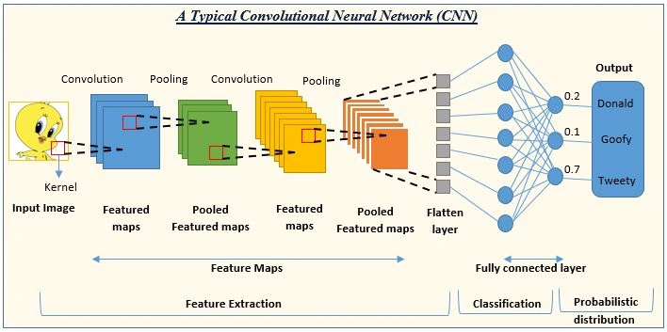

3.3 Example: CNN for Fashion MNIST
Python Code — CNN for Image Classification
import tensorflow as tf
from tensorflow import keras

# 1. Load Fashion MNIST (shirts, shoes, bags, etc.)
(x_train, y_train), (x_test, y_test) = keras.datasets.fashion_mnist.load_data()

# Normalize and reshape: CNN needs (height, width, channels)
x_train = x_train.reshape(-1, 28, 28, 1) / 255.0
x_test = x_test.reshape(-1, 28, 28, 1) / 255.0

class_names = ['T-shirt', 'Trouser', 'Pullover', 'Dress', 'Coat',
'Sandal', 'Shirt', 'Sneaker', 'Bag', 'Ankle boot']

# 2. Build the CNN
model = keras.Sequential([
# Block 1: Extract basic features
keras.layers.Conv2D(32, (3, 3), activation='relu', input_shape=(28, 28, 1)),
keras.layers.MaxPooling2D((2, 2)),

# Block 2: Extract complex features
keras.layers.Conv2D(64, (3, 3), activation='relu'),
keras.layers.MaxPooling2D((2, 2)),

# Classifier head
keras.layers.Flatten(),
keras.layers.Dense(128, activation='relu'),
keras.layers.Dropout(0.3), # Prevent overfitting
keras.layers.Dense(10, activation='softmax')
])

# 3. Compile and train
model.compile(optimizer='adam',
loss='sparse_categorical_crossentropy',
metrics=['accuracy'])

model.summary()

history = model.fit(x_train, y_train,
epochs=10,
batch_size=64,
validation_split=0.1)

# 4. Evaluate
test_loss, test_acc = model.evaluate(x_test, y_test)
print(f"\nTest Accuracy: {test_acc:.4f}")

# 5. Make a prediction
import numpy as np
predictions = model.predict(x_test[:5])
for i, pred in enumerate(predictions):
print(f"Predicted: {class_names[np.argmax(pred)]}, "
f"Actual: {class_names[y_test[i]]}")
💡 CNNs outperform regular networks on image tasks because filters learn spatial features and weights are shared — reducing parameters dramatically.

4. Recurrent Neural Networks (RNNs) & LSTMs

4.1 Why RNNs for Sequential Data?
Regular neural networks assume all inputs are independent. But for sequences — like text, time series, or speech — the order and context matter. RNNs process sequences step-by-step, maintaining a hidden state that captures past information.
- Text: 'I love deep learning' — each word depends on the previous
- Time Series: Today's stock price depends on yesterday's
- Speech: Each sound depends on the sounds before it

4.2 The Vanishing Gradient Problem
Standard RNNs struggle with long sequences because gradients shrink (vanish) as they travel back through many time steps. This means the network forgets information from early in the sequence.
Solution: Long Short-Term Memory (LSTM) networks.

4.3 LSTM Architecture
LSTMs have a special 'memory cell' and three gates that control what information is kept, updated, or forgotten:
- Forget Gate: Decides what to discard from memory
- Input Gate: Decides what new information to add to memory
- Output Gate: Decides what to output based on memory
💡 Think of LSTMs like reading a book. The forget gate removes irrelevant past context, the input gate adds new important info, and the output gate selects what's needed to answer a question.

4.4 GRU — Simplified LSTM
Gated Recurrent Units (GRUs) are a simpler version of LSTMs with only two gates (update and reset). They often perform similarly to LSTMs but train faster.

4.5 Example: Sentiment Analysis with LSTM
Python Code — LSTM for Movie Review Sentiment (IMDB)
import tensorflow as tf
from tensorflow import keras

# 1. Load IMDB movie reviews (binary: positive or negative)
max_features = 10000 # Only use top 10,000 most common words
max_len = 200 # Pad/truncate reviews to 200 words

(x_train, y_train), (x_test, y_test) = keras.datasets.imdb.load_data(
num_words=max_features
)

# 2. Pad sequences to equal length
x_train = keras.preprocessing.sequence.pad_sequences(x_train, maxlen=max_len)
x_test = keras.preprocessing.sequence.pad_sequences(x_test, maxlen=max_len)

print(f"Training samples: {len(x_train)}")
print(f"Each review padded to length: {x_train.shape[1]}")

# 3. Build the LSTM model
model = keras.Sequential([
# Embedding: convert word indices to dense vectors
keras.layers.Embedding(max_features, 64, input_length=max_len),

# LSTM layer to learn sequential patterns
keras.layers.LSTM(64, return_sequences=False),

keras.layers.Dense(32, activation='relu'),
keras.layers.Dropout(0.3),
keras.layers.Dense(1, activation='sigmoid') # Binary output
])

# 4. Compile
model.compile(optimizer='adam',
loss='binary_crossentropy',
metrics=['accuracy'])

model.summary()

# 5. Train
history = model.fit(x_train, y_train,
epochs=5,
batch_size=64,
validation_split=0.2)

# 6. Evaluate
test_loss, test_acc = model.evaluate(x_test, y_test)
print(f"\nTest Accuracy: {test_acc:.4f}")

# 7. Predict on new text (requires preprocessing in real use)
# Example output interpretation:
# sigmoid output > 0.5 = Positive review
# sigmoid output < 0.5 = Negative review

5. Training Deep Learning Models

5.1 Loss Functions
The loss function measures how wrong the model's predictions are. You want to minimize this during training.
Loss Function | Task | Example
Binary Crossentropy | Binary classification | Spam vs Not Spam
Categorical Crossentropy | Multi-class classification | Cat / Dog / Bird
Mean Squared Error | Regression | Predicting house prices
Sparse Categorical CE | Multi-class (integer labels) | MNIST digit recognition

5.2 Optimizers
Optimizers update the model's weights to minimize the loss. The main ones are:
- SGD (Stochastic Gradient Descent): Simple and effective. Slow convergence.
- Adam: Most popular choice. Adaptive learning rates. Works well out-of-the-box.
- RMSprop: Good for RNNs. Adaptive learning rates.
- AdamW: Adam with weight decay. Better regularization.

5.3 Regularization Techniques
Regularization prevents overfitting — when the model performs well on training data but poorly on new data.

Dropout
Randomly sets a fraction of neurons to zero during training, forcing the network to learn redundant representations.

Batch Normalization
Normalizes inputs to each layer, making training faster and more stable. Usually placed after Conv/Dense layers and before activation.

L2 Regularization (Weight Decay)
Adds a penalty to large weights in the loss function, encouraging simpler models.

Early Stopping
Monitor validation loss during training and stop when it stops improving — prevents training too long.

5.4 Example: Training with Callbacks & Best Practices
Python Code — Training with Callbacks and Regularization
import tensorflow as tf
from tensorflow import keras

# Load data
(x_train, y_train), (x_test, y_test) = keras.datasets.cifar10.load_data()
x_train = x_train / 255.0
x_test = x_test / 255.0

# Build model with Batch Normalization and Dropout
model = keras.Sequential([
keras.layers.Conv2D(32, (3, 3), padding='same', input_shape=(32, 32, 3)),
keras.layers.BatchNormalization(),
keras.layers.Activation('relu'),
keras.layers.MaxPooling2D((2, 2)),
keras.layers.Dropout(0.25),

keras.layers.Conv2D(64, (3, 3), padding='same'),
keras.layers.BatchNormalization(),
keras.layers.Activation('relu'),
keras.layers.MaxPooling2D((2, 2)),
keras.layers.Dropout(0.25),

keras.layers.Flatten(),
keras.layers.Dense(256, activation='relu',
kernel_regularizer=keras.regularizers.l2(0.001)),
keras.layers.Dropout(0.5),
keras.layers.Dense(10, activation='softmax')
])

model.compile(optimizer=keras.optimizers.Adam(learning_rate=0.001),
loss='sparse_categorical_crossentropy',
metrics=['accuracy'])

# Define callbacks
callbacks = [
# Stop training if val_loss doesn't improve for 5 epochs
keras.callbacks.EarlyStopping(
monitor='val_loss', patience=5, restore_best_weights=True),

# Save the best model to disk
keras.callbacks.ModelCheckpoint(
'best_model.h5', save_best_only=True, monitor='val_accuracy'),

# Reduce learning rate when stuck
keras.callbacks.ReduceLROnPlateau(
monitor='val_loss', factor=0.5, patience=3, min_lr=1e-6)
]

# Train
history = model.fit(
x_train, y_train,
epochs=50,
batch_size=64,
validation_split=0.15,
callbacks=callbacks,
verbose=1
)

# Load best model and evaluate
best_model = keras.models.load_model('best_model.h5')
test_loss, test_acc = best_model.evaluate(x_test, y_test)
print(f"\nBest Test Accuracy: {test_acc:.4f}")

6. Key Concepts & Best Practices

6.1 Important Hyperparameters
Hyperparameter | Typical Values | Effect
Learning Rate | 0.001 (Adam default) | Too high: unstable. Too low: slow.
Batch Size | 32, 64, 128 | Larger = faster but less generalization
Epochs | 10 - 100+ | Train too long = overfitting
Dropout Rate | 0.2 - 0.5 | Higher = more regularization
Number of Layers | 2 - 50+ | More layers = more capacity

6.2 Diagnosing Your Model

Overfitting
Training accuracy is much higher than validation accuracy. The model memorized training data but fails on new data.
Solutions: Add Dropout, L2 regularization, more training data, data augmentation, or reduce model size.

Underfitting
Both training and validation accuracy are low. The model is too simple.
Solutions: Add more layers, more neurons, train longer, or use a more complex architecture.

6.3 Data Augmentation
Artificially expand your training dataset by applying random transformations to images. This helps prevent overfitting and improves generalization.
Python Code — Data Augmentation with Keras
from tensorflow import keras

# Create an augmentation pipeline
data_augmentation = keras.Sequential([
keras.layers.RandomFlip("horizontal"), # Flip left-right
keras.layers.RandomRotation(0.1), # Rotate up to 10%
keras.layers.RandomZoom(0.1), # Zoom in/out up to 10%
keras.layers.RandomContrast(0.1), # Adjust contrast
])

# Add augmentation as the first layer in your model
model = keras.Sequential([
data_augmentation, # Only applied during training
keras.layers.Conv2D(32, (3,3), activation='relu', input_shape=(32,32,3)),
keras.layers.MaxPooling2D(),
keras.layers.Flatten(),
keras.layers.Dense(10, activation='softmax')
])

# The augmentation is automatically disabled during model.evaluate() and model.predict()

8. Quick Reference & Summary

8.1 Choosing the Right Architecture
Problem Type | Architecture | Example Use Case
Tabular / structured data | Dense (MLP) | Predicting customer churn
Image classification | CNN | Cat vs Dog classifier
Object detection | CNN + Detection head | Self-driving cars
Text classification | LSTM / Transformer | Sentiment analysis
Text generation | GPT (Transformer) | Chatbots, autocomplete
Time series forecasting | LSTM / GRU | Stock price prediction
Limited labeled data | Transfer Learning | Medical image diagnosis

8.2 Deep Learning Workflow Checklist
- Define the problem: Classification, regression, generation?
- Collect and prepare data: Clean, normalize, split into train/val/test
- Choose architecture: Dense / CNN / RNN / Transformer / Transfer Learning
- Build the model using Keras Sequential or Functional API
- Compile: Set loss function, optimizer, and metrics
- Train: Use callbacks (EarlyStopping, ModelCheckpoint, ReduceLROnPlateau)
- Evaluate: Check test set metrics — not just training accuracy
- Diagnose: Is it overfitting? Underfitting? Tune accordingly
- Deploy: Save model with model.save() and load with keras.models.load_model()

8.3 Saving and Loading Models
Python Code — Save and Load a Trained Model
import tensorflow as tf
from tensorflow import keras

# Save in Keras format (recommended)
model.save('my_model.keras')

# Or save in HDF5 format
model.save('my_model.h5')

# Load the model back
loaded_model = keras.models.load_model('my_model.keras')

# Verify it works
import numpy as np
test_input = np.random.rand(1, 28, 28, 1) # Example input shape
prediction = loaded_model.predict(test_input)
print("Prediction:", prediction)

# Save only weights (useful for fine-tuning)
model.save_weights('model_weights.h5')
model.load_weights('model_weights.h5') # Load into same architecture

8.4 Essential Libraries
- TensorFlow / Keras: Most popular deep learning framework. Great for beginners.
- PyTorch: Flexible, widely used in research. Dynamic computation graph.
- NumPy: Array operations and numerical computing
- Matplotlib / Seaborn: Plotting training curves and results
- scikit-learn: Classical ML, preprocessing, and evaluation tools
- Pandas: Data loading and manipulation

Happy Learning! Keep experimenting, keep building.

