General Perspective Projection Notes

The general perspective projection has been implemented in the GMT software following the algorithm laid out in Snyder, John. P., “Map Projections- A Working Manual”, US Geological Survey Professional Paper 1395, (1987) pp 169-181 – section 23 - “General Perspective Projection”.

The updates implement both the vertical and the tilted perspective projection. In addition, both the spherical and ellipsoidal earth models have been implemented.

Sample General Perspective Maps

As examples of the general perspective projections the maps in Figures 1 and 2 have been generated. The first is a full earth view from a high altitude over the Pacific.

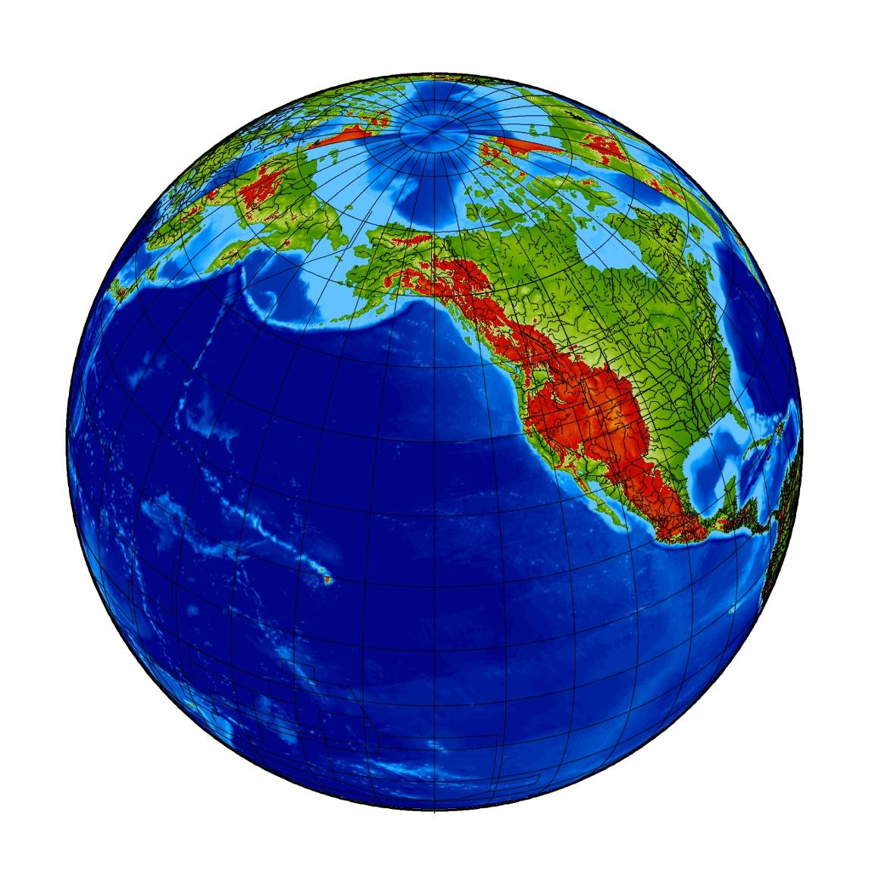
Figure 1

The second example map is a windowed view from an altitude of 160 kilometers over the North East Coast of North America looking south (Figure 2).

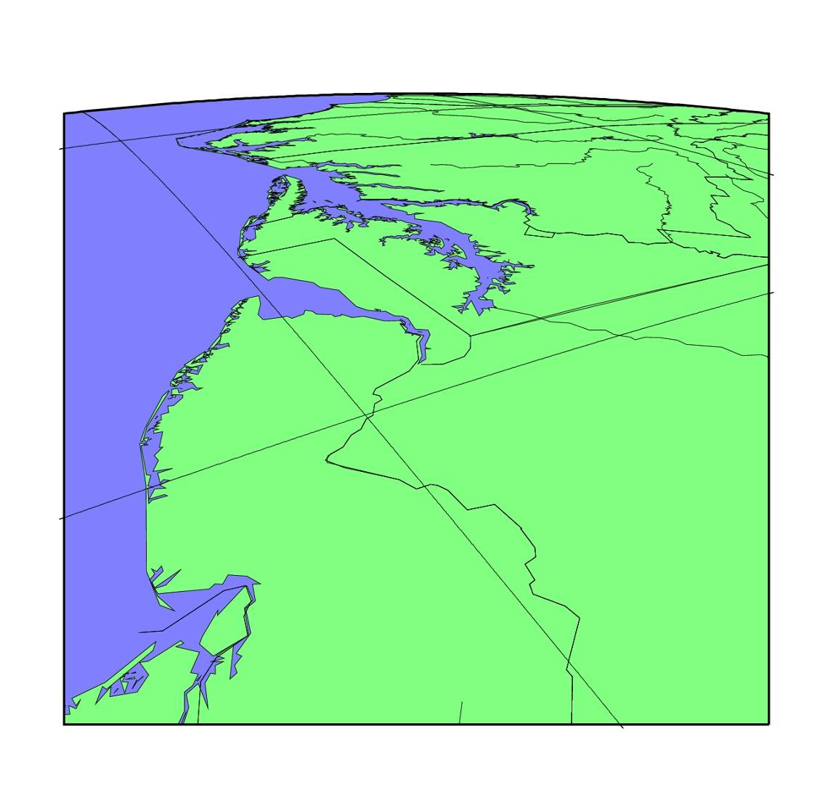

Figure 2

Twist

An additional capability has been added to the general perspective projection such that the final mapping can be “twisted” or rotated about the boresight direction. Figure 3 shows a similar plot to Figure 2 but “twisted” by 45⁰.

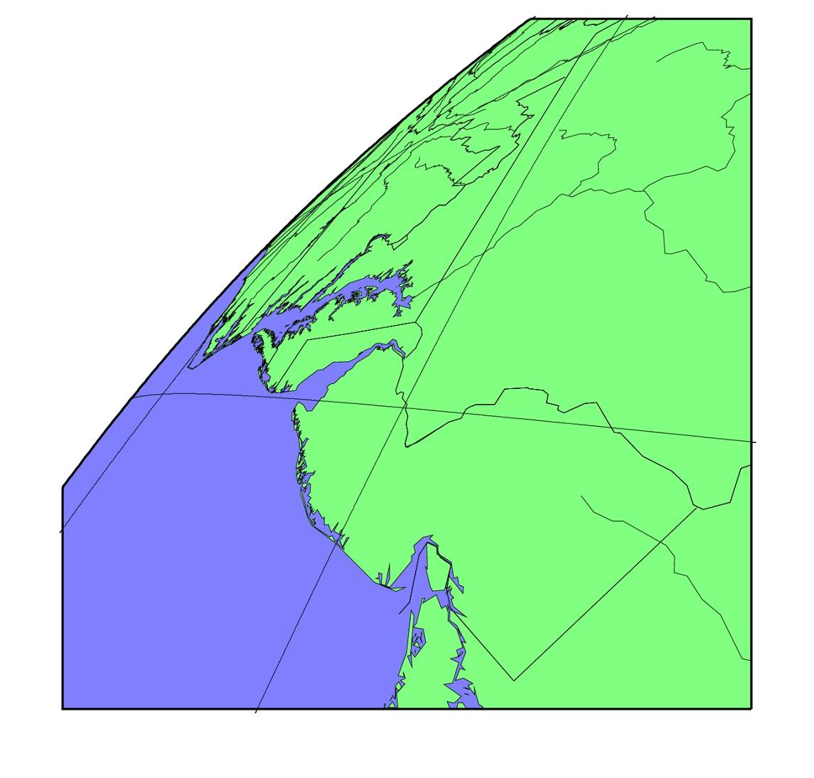
Figure 3

Tilted Perspective Projection

In general, the implementation follows the Snyder‘s algorithm except in the treatment of the conic section for the tilted perspective cases. As discussed in Snyder, p. 173, a tilted perspective projection projects the earth limb into a conic section. For a spherical earth and no tilt the outline of the projection is a circle. For a ellipsoidal earth model the outline for no tilt is approximately a circle. For a tilted projection for both the spherical and ellipsoidal earth, however, the conic section is an ellipse, parabola or a hyperbola depending on the perspective’s altitude above the earth surface and the requested tilt angle. For low altitude and even relatively small tile angles, i.e. 10-20 degrees, the outline can rapidly become an elongated ellipse or even a parabola or hyperbola.

In figure 4, the plotted curve shows the tilt angle where the conic section becomes a parabola. At tilt angle values below the curve the conic section is an ellipse while those above the curve are hyperbolas. In order to forestall similar mapping issues for elongated ellipses if the eccentricity for the projected ellipse is greater than 0.5 then the map is also truncated. The red curve is the tilt angle versus altitude where the elongated ellipse has an eccentricity of 0.5.

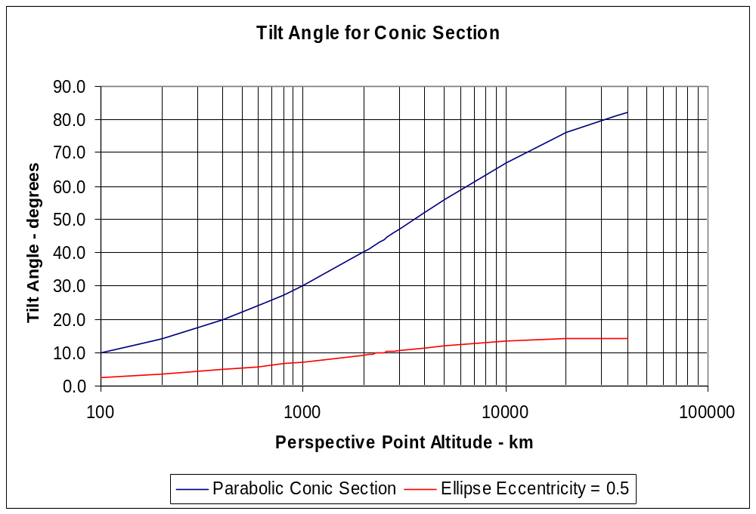

Figure 4

It should be noted that as the perspective point altitude increases the maximum tilt angle for pointing at a point on the earth rather than above the limb is also constrained. If this constraint is added than the resulting constrained tilt angles for the parabolic and ellipse with an eccentricity = 0.5 can be plotted as shown in Figure 5.

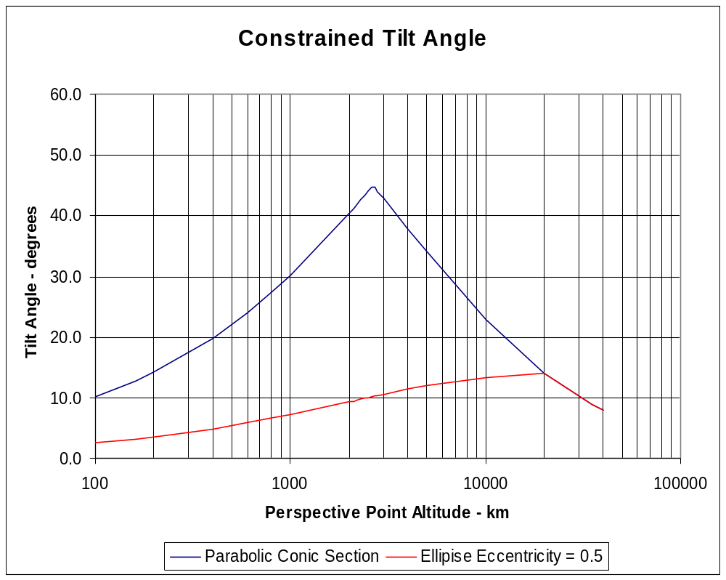

Figure 5

Truncated Full Earth Maps

If the projected limb is a parabola or hyperbola the full conic section can not be plotted in their entirety. In the current implementation the conic section is truncated by windowing. For windowed plots, there is usually no need to truncate the full view requested by the user. As an example of a truncated plot the command , for

pscoast -V -Rg -JGds-74.0/41.5/160.0/210/55/0/0.0/0.0/5.5i+ -Yc -Xc -B5g5/5g5:.hyperbolic_map.s.ps: -G128/255/128 -S128/128/255 -W -Ia -Di –Na > hyperbolic_map.s.ps

the truncated plot in Figure 6 is obtained even though the full earth is requested.

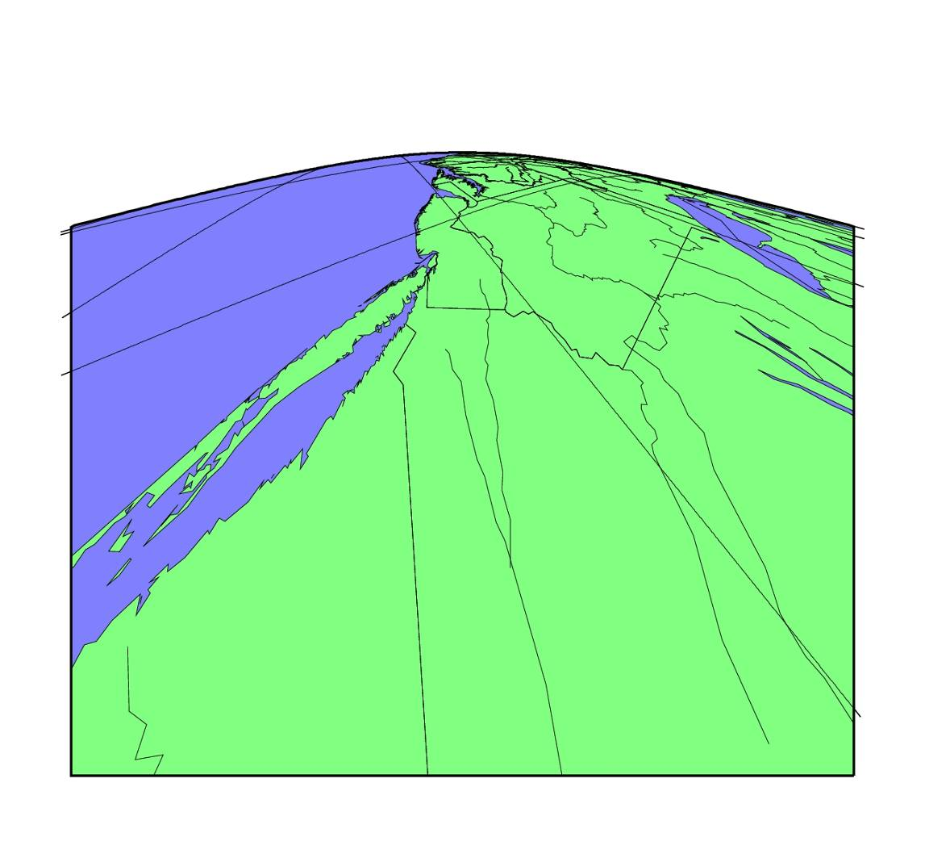
Figure 6

Earth Models

For the general perspective projection the default earth model is a spherical earth. The user can use the earth model, specified in .gmtdefaults, which may be an ellipsoid, by using the “e” flag in the coordinate transformation argument, i.e. –Jge. For pictorial and small-scale usage, the spherical equations are adequate. The ellipsoidal model is only required for high precision mapping, for example, when using some of the high resolution imagery from SPOT, Landsat and similar satellite imagers. Using a ellipsoidal model increases the rendering time.

The differences between the two earth models are illustrated in Figure 7. The map on the left is based on a spherical earth model while the one on the right is based on WGS-84. In both cases the perspective view is at the same latitude but for the ellipsoidal earth model the latitude is geodetic as opposed to the spherical earth model where the latitude is geocentric.

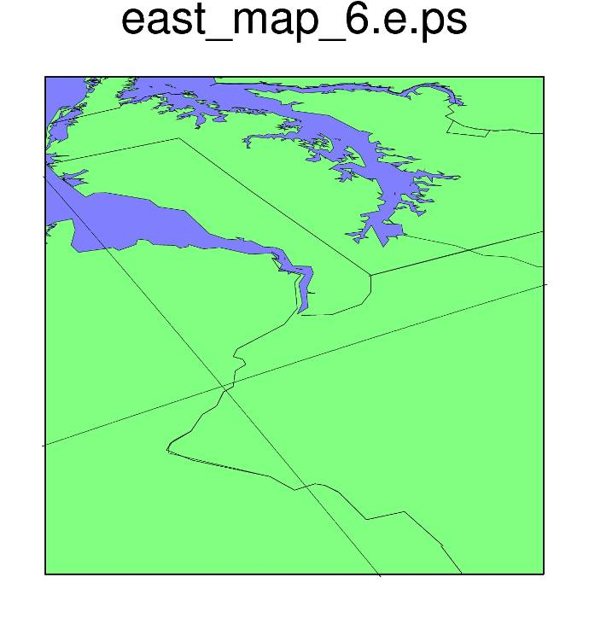
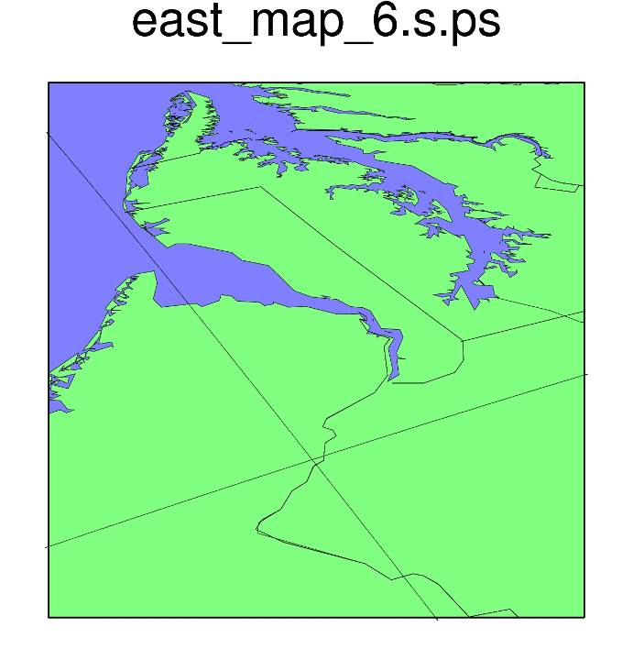

Figure 7

Grdimage

The algorithm currently implemented in grdimage (version 4.1.4) for transforming between grd formats is a forward transforming method. This basically means that the original image on a pixel to pixel basis is transformed into the requested grid format. While this method is straightforward for most projections, for the general perspective projection, where there may be significant distortion of the nominal latitude-longitudes, the forward transformation can produce results with an undersampling like those shown in Figure 8.

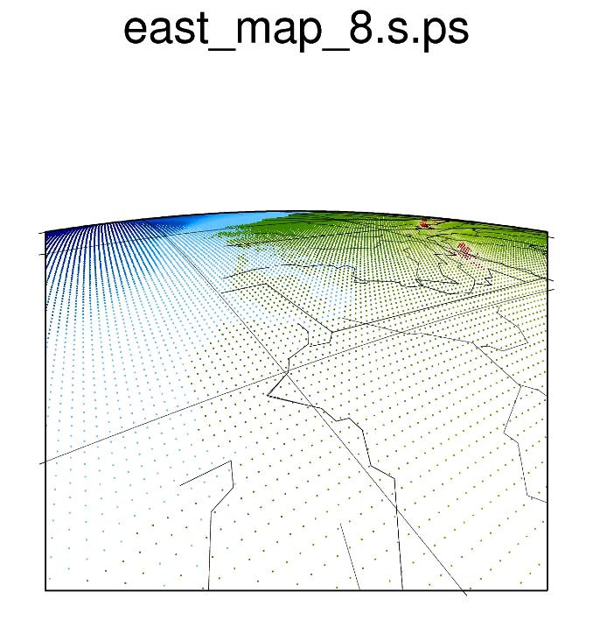
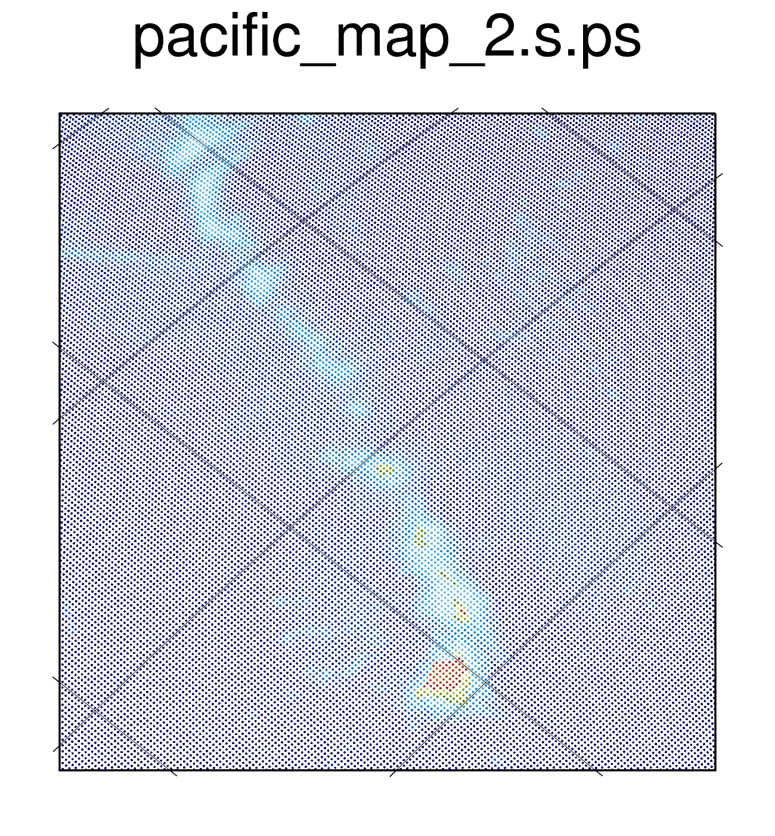

Figure 8

In order to correct for this undersampling a different algorithm for the transformation has been coded. This uses a backprojection method where the requested grid format is filled in by using back transformation, i.e. where does the requested pixel come from, rather than where is the pixel going. The results for the above mappings are shown in Figure 9.

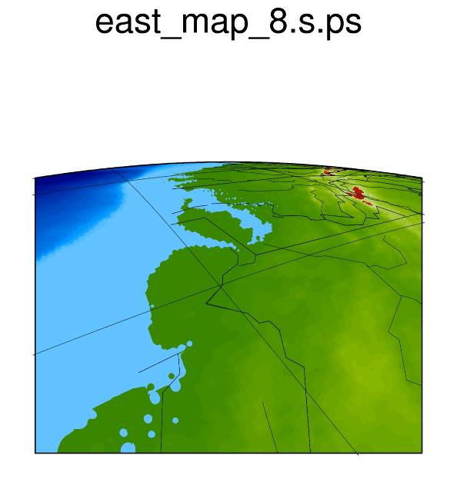
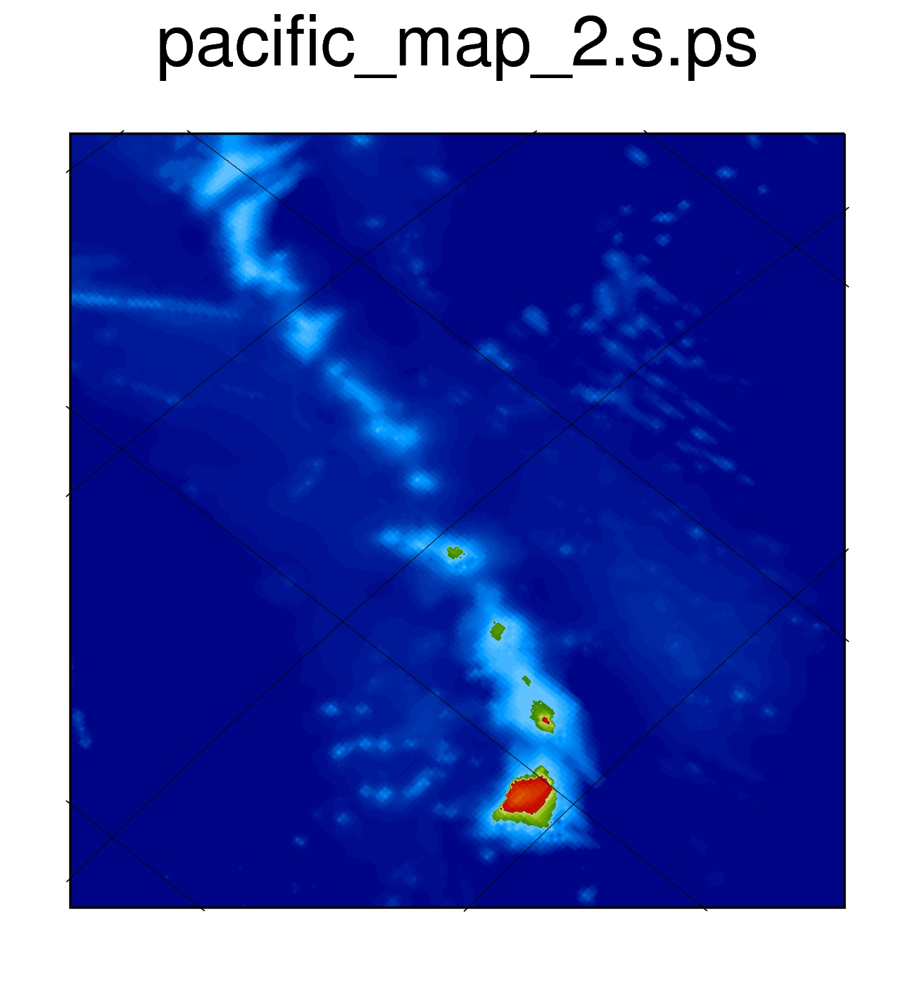

Figure 9

