./

Learning Report – Applied System Development Life Cycle and Software Testing



|  |  |  |  |  |  |
| --- | --- | --- | --- | --- | --- |
| **Ver. Rel. No.** | **Release Date** | **Prepared. By** | **Reviewed By** | **To be approved By** | **Remarks/Revision Details** |
| 1 | 25/02/2021 | 99003583 |  |  |  |
|  |  |  |  |  |  |
|  |  |  |  |  |  |
|  |  |  |  |  |  |
|  |  |  |  |  |  |

**Document History**

Table of Contents

Table of Figures 3

Table of Tables 4

ACTIVITY 1: SYSTEM/ SOFTWARE DEVELOPMENT 4

**INTRODUCTION** 4

**MY PRODUCT:** 6

**SWOT ANALYSIS** 7

**REQUIREMENTS** 7

**DESIGN** 8

HIGH LEVEL DESIGN 8

LOW LEVEL DESIGN 11

**TEST PLANS** 13

**REFERENCES** 15

# Mini Project

# Introduction:

This mini project is based on automated excel sheets where we can retrieve and extract a particular data from a large group of files into a master sheet using python automation. Our main aim is to make data entry job easy, and We are going to write a Python program that can process thousands of spreadsheets and manage all the calculations under a second for the user.

**About the project:**

The aim of the project is to extract the data present in different spreadsheets in one excel file as required by the user by different paths given by him. The excel sheet scrolls through all the spreadsheets with the following data common in all the sheets:

* Name:
* Ps Number:
* Email id:

The user defines the data that needs to be searched on the basis of the common data. The python program then reads the data corresponding to the particular data from different spreadsheets of excel. It then creates a master sheet and adds the data from all the sheets to it. In the end, the data to be provided to the user is printed to the console.

# SWOT:

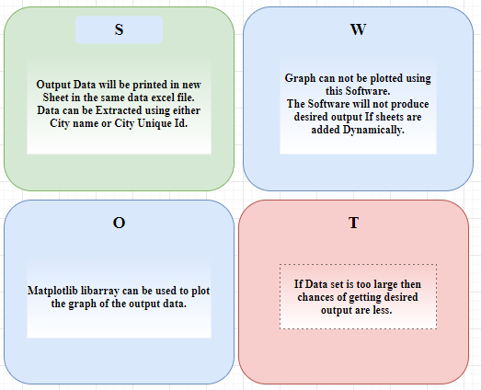

# 4 W’s & 1 H:

* **What:**
  + We are preparing the master excel sheet to search and retrieve data.
  + For easy search of a particular cell or data of a person
  + Provides information of every person details like bio, academics, health.
* **Where:**
  + To check the information and bio of a person
  + Very useful during emergency times like health issues
  + We can also use it for evaluation of marks using the mail, search the location of person.
* **When:**
  + Evaluation of exams
  + Searching for person information
  + Contact information.
  + Health check
* **How:**
* Input: - giving the PS number, name & email of person
* Output: -gives all the relevant information of person related to PS number, name or email
* source: -excel sheets give the output into the master sheet.

# Requirements:

* **High Level:**

|  |  |  |  |
| --- | --- | --- | --- |
| **S No.** | **Requirements** | **Description** | **Status** |
| HL1 | Creating | In 4 sheets Data of a person is present, one is the master sheet | Implemented |
| HL2 | Combining | All the datasheets are combined in one data sheet | Implemented |
| HL3 | Searching | By using the PS number of that person, we can get all the information of that person in Master sheet | Implemented |

* **Low Level:**

|  |  |  |  |
| --- | --- | --- | --- |
| **S No.** | **Requirements** | **Description** | **Status** |
| LL1 | Creating Rows and Columns | In each sheet we have to create 10 columns and 40 rows | Implemented |
| LL2 | Searching | Searching the data, we need in all sheets | Implemented |
| LL3 | Output | As per the requirements we have to display the output or store the output | Implemented |

# UML Diagrams:

1. **Object:**

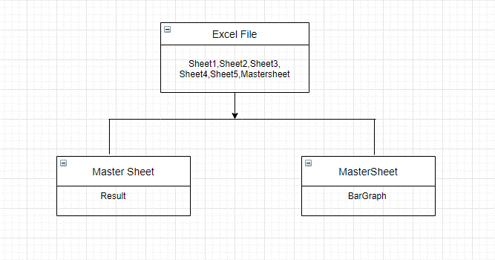

1. **Sequence:**

