**COMP7002 – Lab 1A Logbook**

**Sat 13th April 14:25**

**Part 1 and Part 4a**

***Environment Set Up***

* PCs from one department are connected to their corresponding 2960-24TT switch with a copper straight-through cable and use the Fast Ethernet ports available.
* Switches are connected with each-other with copper cross-over cables and use the available Fast Ethernet ports because our simple network does not require hyperfast (gigabit) data transmissions between our devices.

***Figure 1*** *Simple office network*

**Part 2**

***Table 1: IP Addresses for PCs***

|  |  |  |  |
| --- | --- | --- | --- |
| **Switch** | **PC** | **IP Address** | **Subnet Mask** |
| A | 1A | 107.105.114.**11** | 255.255.255.0 |
| 2A | 107.105.114.**12** |
| B | 1B | 107.105.114.**21** |
| 2B | 107.105.114.**22** |
| C | 1C | 107.105.114.**31** |
| 2C | 107.105.114.**32** |
| D | 1D | 107.105.114.**41** |
| 2D | 107.105.114.**42** |

**Figure 2** *Example: PC 2 from department A (connected to switch A) has the*

*IP address**107.105.114.12*

**Part 3**

PC ping done to test that a connection between PCs from the same department (which share the same switch) has been successfully established. Consequently, 0 packets are lost with minimal latency.

***Figure 3*** *Example: PC 1A to PC 2A ping (from same department)*

**Part 4B**

Case-sensitive passwords are set for both the User EXEC Mode and Privileged EXEC Mode to enhance security by restricting unauthorised access at the command-line interface (CLI), thereby limiting unauthorised interactions with devices directly and preventing disruptions to the network infrastructure. Logging in is now required to make changes.

***Table 2: Switch Passwords***

|  |  |
| --- | --- |
| **Console/User** | cisco |
| **Privileged EXEC Mode** | class |

**Note:** Once logged in, type ‘enable’ on CLI to request access to the Privileged EXEC Mode

**Part 5C**

* Encrypted password is set up to enable a more secure remote access to the switches via Telnet

Switch(config)#**line vty 0 4**

Switch(config-line)#password **cisco**

Switch(config-line)#login

Switch(config-line)#exit

Switch(config)#**service password-encryption**

Switch(config)#exit

***Figure 4*** *CLI logic for secure remote access to switches*

* Documenting that security and password encryption configurations are applied

***Figure 5*** *Verifying the security changes on switch A*

**Part 4C**

Configured switches’ Hostnames to A, B, C, or D to uniquely identify the networking device.

***Figure 6*** *Example: Configuring switch A’s hostname*

**Part 5A**

**Table 3: Switches IP Addresses**

|  |  |
| --- | --- |
| **Subnet Mask** | 255.255.255.0 |
| **Switch A** | 107.105.114.1 |
| **Switch B** | 107.105.114.2 |
| **Switch C** | 107.105.114.3 |
| **Switch D** | 107.105.114.4 |

* We can now uniquely identify our switches in our network

**A**(config)#**interface VLAN 1**

**A**(config-if)#ip address **107.105.114.1 255.255.255.0**

**A**(config-if)#no shutdown

**A**(config-if)#

%LINK-5-CHANGED: Interface Vlan1, changed state to up

%LINEPROTO-5-UPDOWN: Line protocol on Interface Vlan1, changed state to up

**A**(config-if)#exit

**A**(config)#exit

**A**#

%SYS-5-CONFIG_I: Configured from console by console

***Figure 7*** *Example:**Configuring**switch A’s**IP address and subnet mask*

***Figure 8*** *Details of**interfaces operating on switch B*

**Part 4D**

Confirmation that a basic network connectivity between PCs from all departments is operational

***Figure 9*** *Simple PDU simulation from PC**1B to PC 1A*

Pings confirmed that all the PCs from the organisation were reachable

***Figure 10*** *Example: Switch D ping to PC 1A*

***Figure 11*** *Example: Ping between Switches C and A*

**Part 5B and 5C**

Telnet switch B from host PC.

Password encryption enhances security.

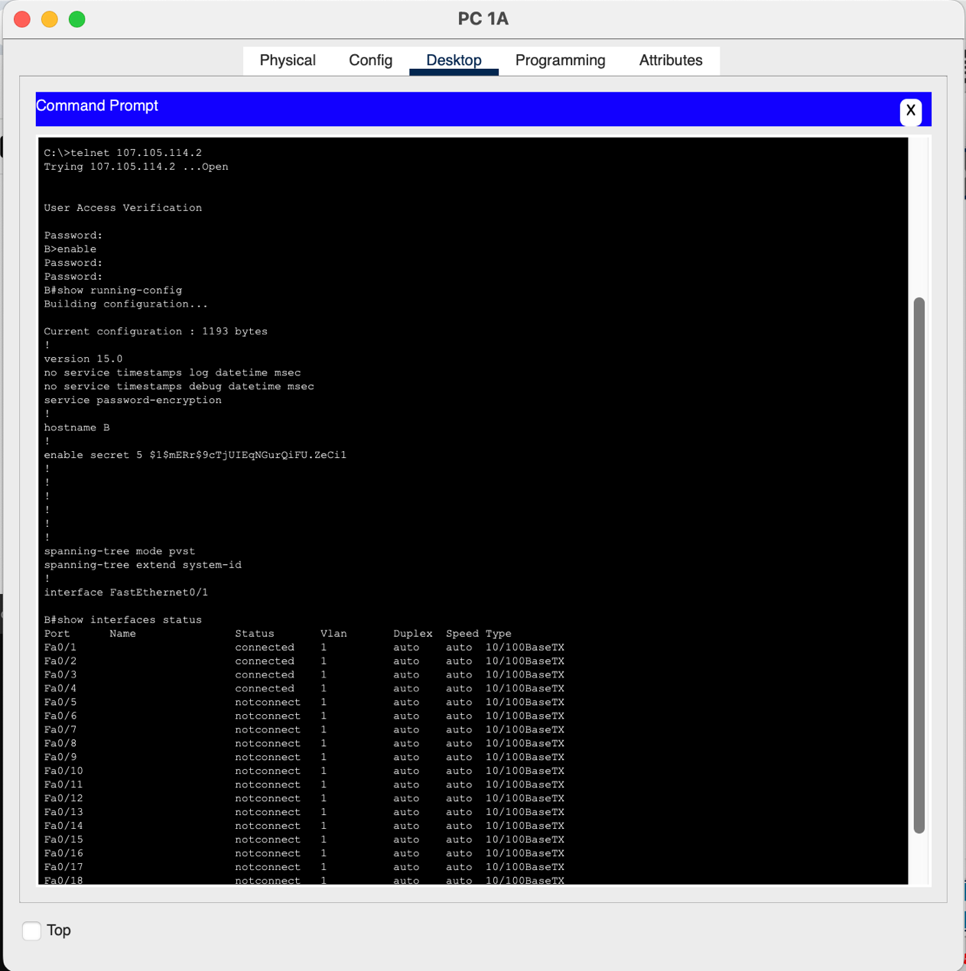

***Figure 12*** *Testing the remote connectivity of switch B*