./

Learning Report – Holographic Keyboard

Course Code: <CODE>



|  |  |  |  |  |  |
| --- | --- | --- | --- | --- | --- |
| **Ver. Rel. No.** | **Release Date** | **Prepared. By** | **Reviewed By** | **Approved By** | **Remarks/Revision Details** |
|  |  |  |  |  |  |
|  |  |  |  |  |  |
|  |  |  |  |  |  |
|  |  |  |  |  |  |
|  |  |  |  |  |  |

**Document History**

# 

Contents

Checklist 3

Activity and Tasks 4

Activity 1– System/Software Development 5

Activity 2 –Agile Aspects……………………………………………………………………16

Activity 3 – Software Development……………………………………………………17

# Checklist

* Installation of SW on Phone and Desktop
* Additional Aspects …

# Activity and Tasks

## **Activity 1**– System/Software Development

* Sub Tasks
* Complete and Evolve

## **Activity 2** – Agile Aspects

* Epics
* User stories

## **Activity 3** – Software Development

* Description
* Requirements
* Design
* Test Plan
* GitHub

**Activity: 01**

Contents

1.REQUIREMENTS

1.1 Research

1.2 SYSTEM DEFINATION

1.3 SWOT Analysis

1.3.1 STRENGTHS

1.3.2 WEAKNESSES

1.3.3 OPPURTUNITIES

1.3.4 THREATS

1.4 Requirements

2. DESIGN

2.1 Low Level Design- Behavioural

3. TEST PLAN

3.1 High Level

3.2 Low level

Introduction:

Keyboard is a set of keys that enables you to enter data into computer. It is the main input device of the computer. It has many keys which can be pressed to make characters like numbers, letters or symbols appear on the screen.

Aging :

> In 1800s : Remington’s First Sholes & Glidden Type-Writer 1867

The first manufactured typewriters resembled sewing machines more than what most people imagine when they think “typewriter.” Remington, who manufactured the first typewriters, were also manufacturing sewing machines at the time, leading to this initial design atheistic. The first Remington typewriters, created by Sholes, Glidden, and Soule even came with a foot pedal (like a sewing machine) to control carriage returns.

> In 1900s :

1961 Selectric I Typewriter by IBM

* The Selectric typewriter, no longer used type-bars that struck the page.
* The Selectrics used typeballs (resembling golf balls) that rolled, tilted, and printed the letters on the page without the typebars.
* This increased typing speed, and efficiency.
* The other new element brought to the typewriter scene with the Selectrics was that the typeballs could easily be taken out, and replaced with others to change fonts quickly on the same document.
* The Selectric Typewriter was produced up until the 1980s with three models that evolved over the course of those decades: The Selectric I, The Selectric II, and The Selectric III. They were available in a variety of colors including: vintage blue, mossy green, burnt red, beige, and black.

1986 IBM Model M Keyboard

* In 1981, IBM released their first PC. In 1986, it came equipped with the Model M keyboard.
* This computer keyboard was wildly successful because it was so easy to use, users didn’t have to convert their typewriters or provide their own build of keyboard to use as an input device for their computers.
* The Model M was a mechanical keyboard, and used the highest quality construction, giving typists the satisfaction of tactile feedback, acute accuracy and comfort.

> In 2000s :

Apple-Keyboard (membrane switches)

* In the 1990s membrane switches began to replace the mechanical key switch, as it was quieter, weighed less, and suited the needs of the new laptop generation.
* This was also an advantage for the manufactures because membrane keyboards were much cheaper to produce.

True Touch Roll-up Keyboard

Mouse and Keyboard Combo (The entire keyboard moves on the desk as a mouse)

Mini Wireless Keyboard Device

iPad and iPhone Virtual Touch-Screen Keyboards

Cost gradation :

|  |  |
| --- | --- |
| Types | Range |
| Standard Keyboard | Rs 600 - 1,500 |
| Wireless Standard Keyboard | Rs 800 - 2,500 |
| Gaming Keyboard | Rs 8,000 - 20,000 |
| Ergonomic Keyboard | Rs 4,000 - 12,000 |

Defination of my product :

Virtual Holographic keyboard

A virtual keyboard is actually a key-in device, roughly a size of a fountain pen, which uses highly advanced laser technology, to project a full sized keyboard on to a flat surface. Since miniaturization of a traditional keyboard is very difficult we go for virtual keyboard. Here, a camera tracks the finger movements of the typist to get the correct keystroke. A virtual keyboard is a keyboard that a user operates by typing on or within a wireless or optical -dectable surface or area rather than by depressing physical keys.

A virtual keyboard is a keyboard that a user operates by typing (moving fingers) on or within a wireless or optical-detectable surface or area rather than by depressing physical keys. In one technology, the keyboard is projected optically on a flat surface and, as the user touches the image of a key, the optical device detects the stroke and sends it to the computer. In another technology, the keyboard is projected on an area and selected keys are transmitted as wireless signals using the short-range Bluetooth technology. With either approach, a virtual keyboard makes it possible for the user of a very small smart phone or a wearable computer to have full keyboard capability.

Advantages Of Virtual Holographic Keyboard

* · Portability
* · Accuracy
* · Speed of text entry
* · Lack of need for flat or large typing surface
* · Ability to minimize the risk for repetitive strain injuries
* · Flexibility

SWOT Analysis :

|  |  |
| --- | --- |
| Strengths   * Portability * Accuracy * Speed of text entry * Lack of need for flat or large typing surface * Ability to minimize the risk for repetitive strain injuries * Flexibility | Weaknesses   * Battery consuming . * High cost. * Handling Isssues |
| Opportunities   * No need to carry heavy hardware. * Pocket size keyboard * Easy to handle. | Threats   * Security threat . |

Requirement :

|  |  |
| --- | --- |
| ID | Description |
| 01 | Wi-Fi : To connect the device with network. |
| 02 | Bluetooth : It can work with the bluetooth connectivity also so we need the bluetooth connection of required bandwidth. |
| 03 | Touchscreen : For using the virtual keyboard or laser keyboard we need the place to strike the laser so we can touch it and use it . |
| 04 | Laser : Important aspect for the hardware so we can see it in light form . |
| 05 | Hardware : It provides the body and system material for the device . |
| 06 | Software : Appropriate application to support the hardware and use it efficiently . |
| 07 | Guesture senser : With guesture we can make it more flexible in use , we can drag and move the keyboard just by the wave of palm . |

*Designing :*

UML diagram:

Low Level Design:

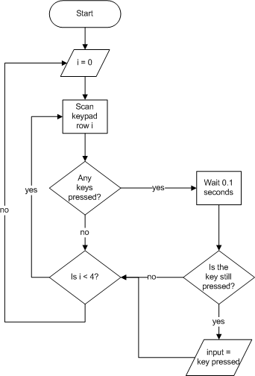

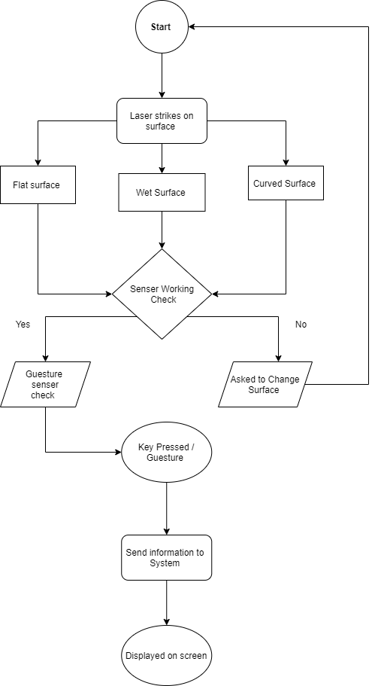

High Level Design:

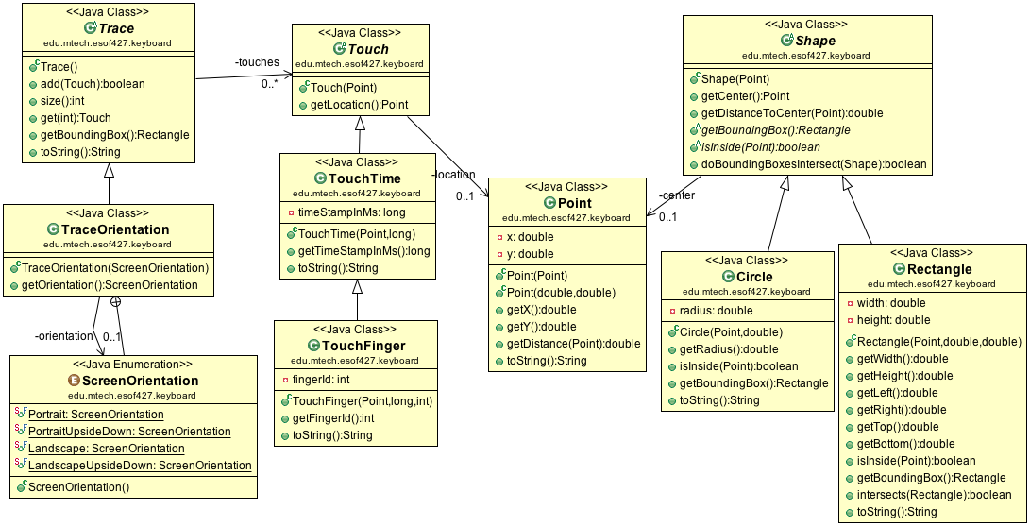

Test Plan:

* Test Plan Requirement:
* Any Surface
* Finger sensitive
* Gesture by palm
* Test Scenario
* If surface is flat or not.
* Laser working environment.
* Temperature condition for laser.

Test Plan

High Level Test Plan Requirement : Integration Testing

|  |  |  |  |  |  |
| --- | --- | --- | --- | --- | --- |
| ID | Description | Pre -Condition | Excpected Input | Excpected Output | Actual Output |
| HL_01 | Wi-Fi : To connect the device with network. | Wifi driver shoud be present in the respective system | >Wifi credentials  >Home network | WiFi connected |  |
| HL_02 | Bluetooth : It can work with the bluetooth connectivity also so we need the bluetooth connection of required bandwidth. | Drivers and same bandwith catching drivers should be installed and drivers should be updated for excpected driver . | >Access to Bluetooth  >If not USB Bluetooth can be used | Bluetooth Coonected |  |
| HL_03 | Touchscreen : For using the virtual keyboard or laser keyboard we need the place to strike the laser so we can touch it and use it . | Strinking surface should be flat or rough but not in air . | >Touchscreen should be placed in range of the laser . | Touchscreen works according to plan |  |
| HL_04 | Laser : Important aspect for the hardware so we can see it in light form . | For laser we need the striking surface . | >Current plug in to device or battery plug in | Light strikes to surface and spread uniformly . |  |
| HL_05 | Hardware : It provides the body and system material for the device . | Components of the hardware should be encapsulated . | >Current Plug in.  >Hardware tested | Hardware works and switch on |  |
| HL_06 | Software : Appropriate application to support the hardware and use it efficiently . | Respective application should be installed in the respective sytem . | >Sytem working | Activate the virtual keyboard |  |
| HL_07 | Guesture senser : With guesture we can make it more flexible in use , we can drag and move the keyboard just by the wave of palm . | Respective senser software and hardware should be installed in the system . | >Palm detection in front of the laser | Palm detection works as plan |  |

Low Level Test Plan Requirement : Unit testing

|  |  |  |  |  |  |
| --- | --- | --- | --- | --- | --- |
| ID | Description | Pre -Condition | Excpected Input | Excpected Output | Actual Output |
| HL_LL_01 | WIFI frequency and bandwidth | 2.4 **GHz** and 5 **GHz** range | >Enabling of Wifi in device | Bandwidth matched |  |
| HL_LL_02 | Bluetooth frequency and bandwidth | 2400 to 2483.5 **MHz range** | >Enabling of Bluetooth in device | Bandwidth matched |  |
| HL_LL_03 | Place to strike , any rough or flat | Flat or Rough surface available | >Flat or uneven surface should be placed | Surface works |  |
| HL_LL_04 | Specific holographic laser with sensitive support. | Laser Light and senser should be installed in the device | >Power on  >System power on | Laser strikes to surface |  |
| HL_LL_05 | Componenets of software to be installed. | Different drivers and Applications models should be installed and updated according to device software. | >Driver of application enabled. | Components works |  |
| HL_LL_06 | Specific applications and the drivers for functioning. | Different Applications models should be installed and updated according to device software | >Driver enabled  >Driver updated | Driver activated |  |
| HL_LL_07 | Guesture senser components and support drivers. | Guesture senser and surface should be available for strike and work. | >Guesture driver enabled  >System Application updated . | Palm detection work as plan |  |

**Activity : 02**

**Agile Aspects:**

**THEME**

**“**Holographic Keyboard”

**User Story**

I want a feature in which a device project light and it work as keyboard , key should be sensitive and work effectively just by touching the surface on which laser strikes .

Effort time : 2 days

**EPIC**

**A virtual keyboard system based on a true-3D optical range camera is presented. Keystroke events are accurately tracked independently on the user. No training is required by the system that automatically adapts itself to the background conditions when turned on.**

**User Story**

Device that has a guesture enabled means palm detections should be enabled , just by palm movement the numeric , captive , qwerty keypad moves side by side .

Effort time : 3 days

**User Story**

Device that has captive sensitivity and works on every surfaces like flat or curved or rough or wet , any surface that get strike by the laser .

Effort time : 3 days

**EPIC**

**I want a device which can project some light and work as keyboard. It is not the electronic device they are just the set of lights that look likes the keyboard and works like a keyboard. In this technique we use a device that produces the LASER light on the flat surface this LASER light produced is the keyboard.**

**Activity : 03**

Content :

1.REQUIREMENTS

1.1 Research

1.2 SYSTEM DEFINATION

1.4 Requirements

2. DESIGN

2.1 Low Level Design- Behavioural

3. TEST PLAN

3.1 High Level

3.2 Low level

APPENDIX A

**…………………Employee Record Management………………**

**Description :**

* Employee Record Management System is a distributed application, developed to maintain the details of employees working in any organization.
* The EMS has been developed to override the problems prevailing in the practicing manual system.
* It maintains the information about the personal and official details of the employees.

**OBJECTIVES OF THE PROJECT:**

 

* This project aims to simplify the task of maintaining records of
* the employees of Company.
*  
* To develop an well-designed database to store employee
* information.
*  
* Provides full functional reports to management of Company.
*  
* The objective of this project is to provide a comprehensive
* approach towards the management of employee information
* **Requirement :**

|  |  |
| --- | --- |
| ID | Description |
| 01 | Employee should be present. |
| 02 | Employee number should be given to employee. |
| 03 | Contact information of the employee. |
| 04 | Gender of the employee. |
| 05 | Home town / Location of the employee |
| 06 | Main branch of the employee. |
|  |  |

**Design:**

**UML Diagram**

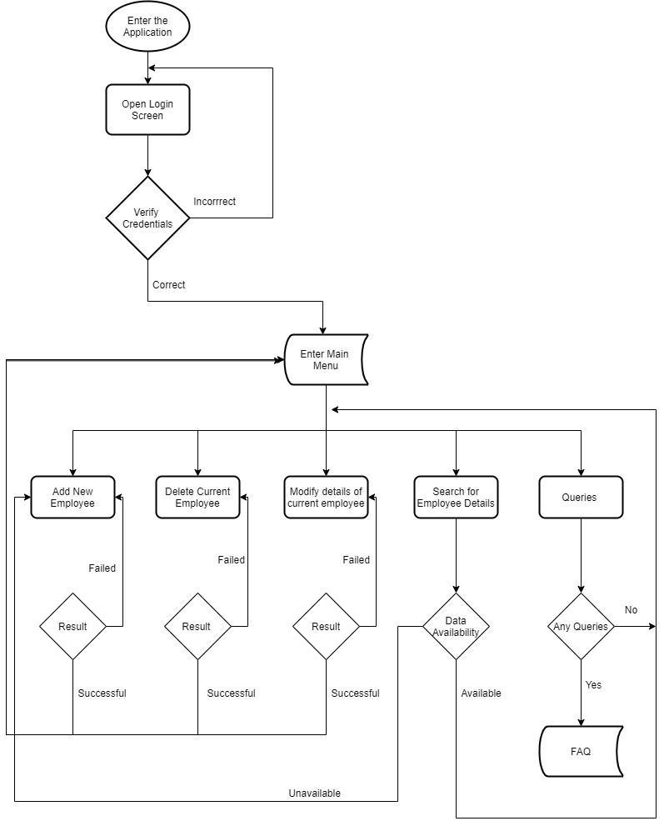

**Test Plan :**

**HIGH LEVEL TEST PLAN :**

|  |  |  |  |  |  |
| --- | --- | --- | --- | --- | --- |
| **ID** | **DESCRIPTION** | **PRE CONDITION** | **EXPECTED I/P** | **EXPECTED O/P** | **ACTUAL O/P** |
| IT_01 | NO TWO EMPLOYEES SHOULD HAVE SAME ID | UNIQUE ID MUST BE PROVIDED | ENTERING THE SAME EMPLOYEE ID | ERROR SHOULD ARISE |  |
| IT_02 | Similar Name | Unique ID is present | Name mapped and Employee ID | Correct person is matched |  |
| IT_03 | Invalid ID | THUMB IMPRESSION SHOULD BE AVAILABLE IN ATTENDANCE MACHINE | OUTSIDER PUTS HIS THUMB ON ATTENDANCE MACHINE | SORRY, NOT MATCHED |  |
| IT_04 | Name Mismatch | Correct database is present | Wrong input | Error will arise |  |

**LOW LEVEL TEST PLAN (UNIT):**

|  |  |  |  |  |  |
| --- | --- | --- | --- | --- | --- |
| **ID** | **DESCRIPTION** | **PRE COND** | **EXPECTED I/P** | **EXPECTED O/P** | **ACTUAL O/P** |
| UT_01 | EMPLOYEE NAME SHOULD CONTAIN ONLY ALPHABET | EMPLOYEE NAME | SHOULD CONTAIN ONLY ALPHABET | IN THE FORM OF ALPHABET |  |
| UT_2 | EMPLOYEE ID SHOULD CONTAIN ONLY NUMBERIC | EMPLOYEE ID | EMPLOYEE ID NUMBER | SHOULD BE IN THE FORM OF DEGITS |  |
| UT_3 | EMPLOYEES SALARY SHOULD BE ONLY NUMERIC | EMPLOYEE SALARY | IN THE FORM OF DEGITS | SHOULD BE IN THE FORM OF DEGITS |  |
| UT_4 | EMPLOYEE AGE SHOULD BE IN THE FORM OF NUMERIC | EMPLOYEE AGE | IN THE FORM OF DEGITS | AGE SHOULD BE IN THE FORM OF DEGITS |  |

**GitHub:**

1. GIT

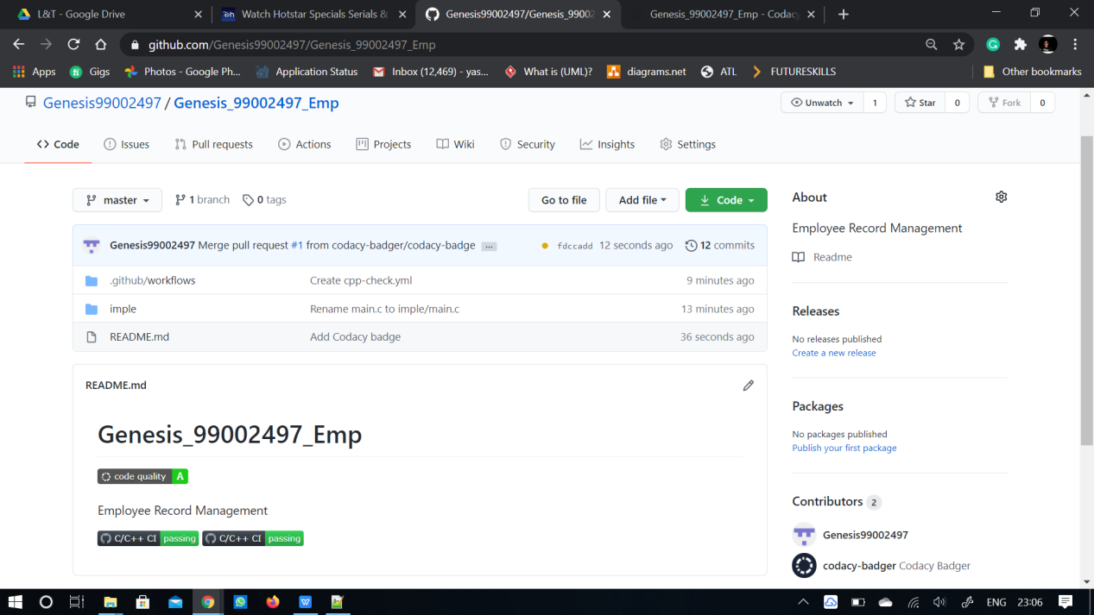

*2. MAKE*

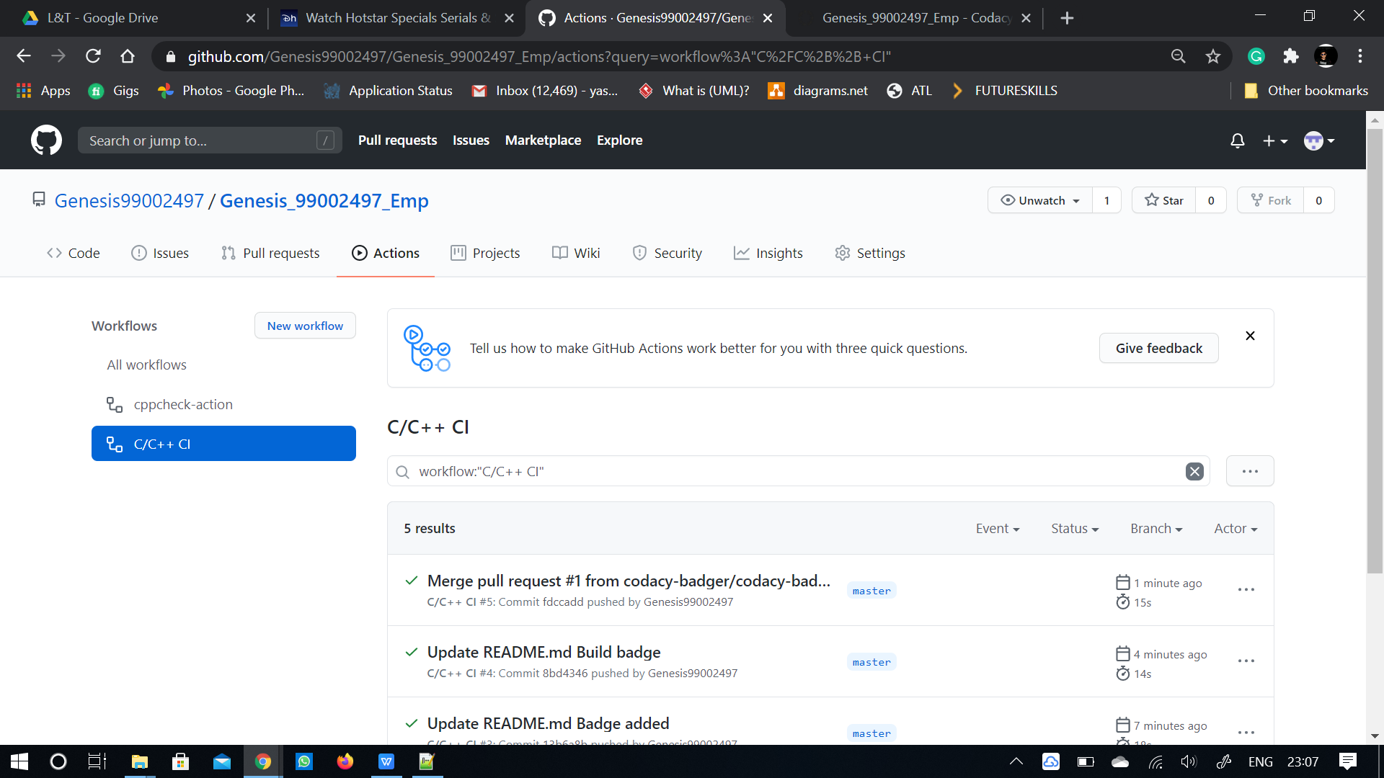

3.BUILD

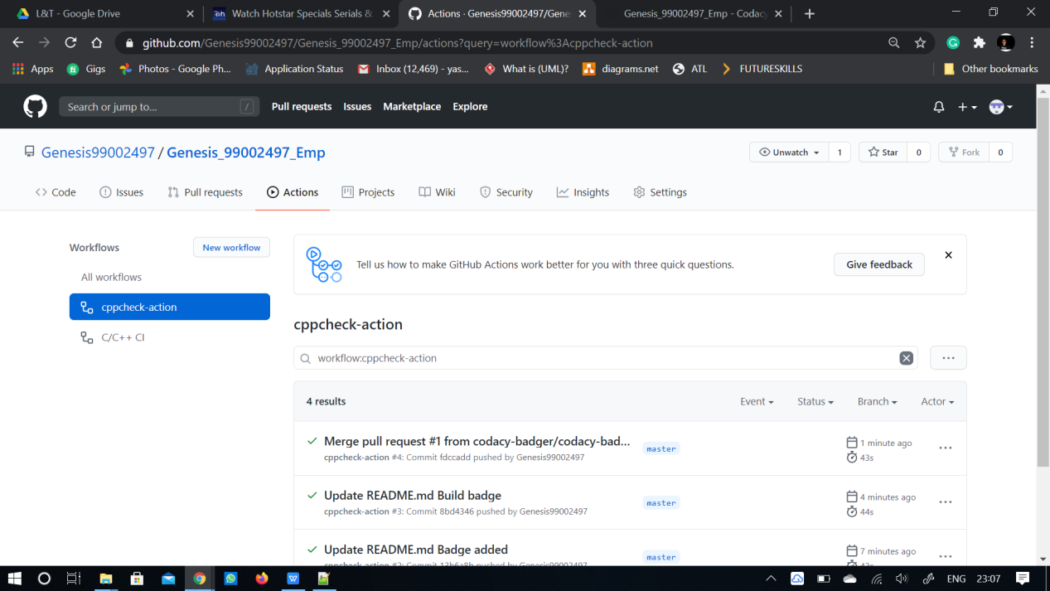



**4.CODE QUALITY**

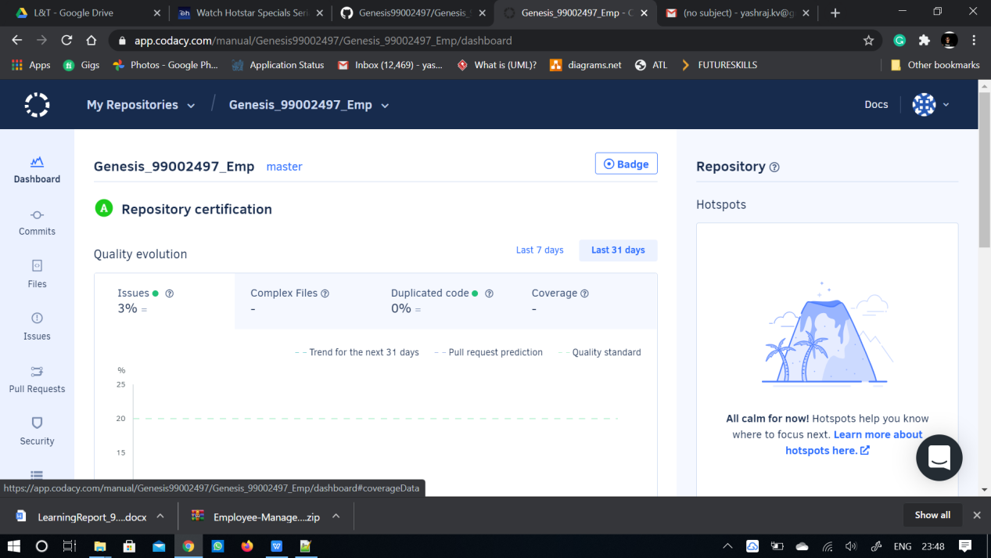

**Header file**

#include<stdio.h>

#include<string.h>

#include<stdlib.h>

#include<math.h>

**Make File**

SRC = main.c\

src/menu.c\

INC = -Iinc

PROJECT_NAME = been.out

BUILD = build

$(PROJECT_NAME): $(SRC)

gcc $(SRC) $(INC) -o $(PROJECT_NAME)

run:$(PROJECT_NAME)

./${PROJECT_NAME}

clean:

rm -rf $(PROJECT_NAME) documentation/html

$(BUILD):

mkdir build

**Repository Link:**

<https://github.com/Genesis99002497/Genesis_99002497_Emp.git>

# 

APPENDIX A

# CONTINIOUS INTEGRATION

## 1.GIT

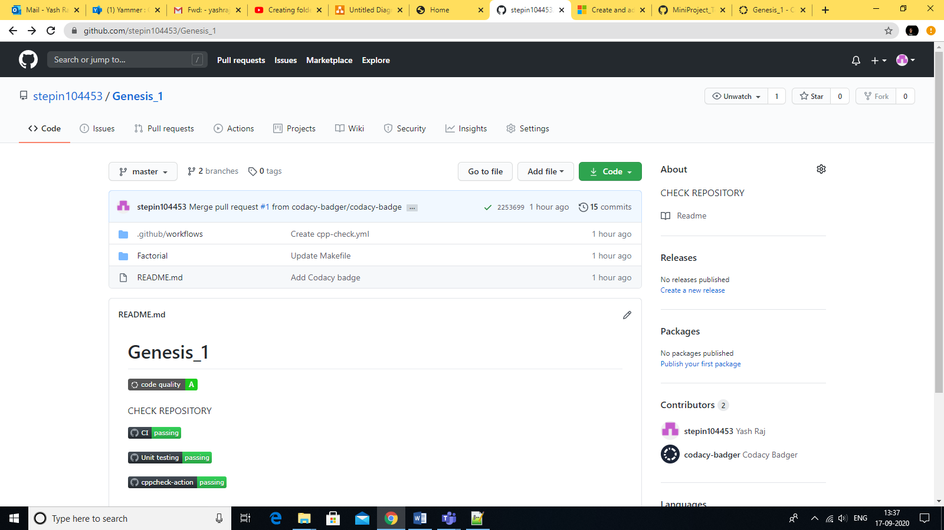

2. MAKE

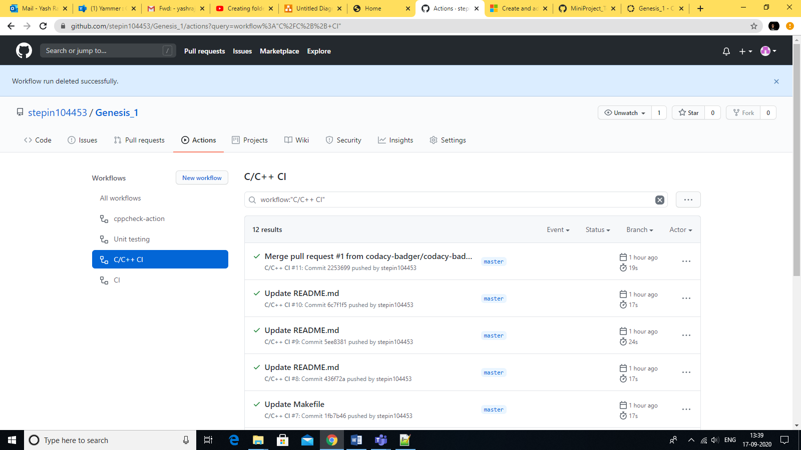

3.BUILD

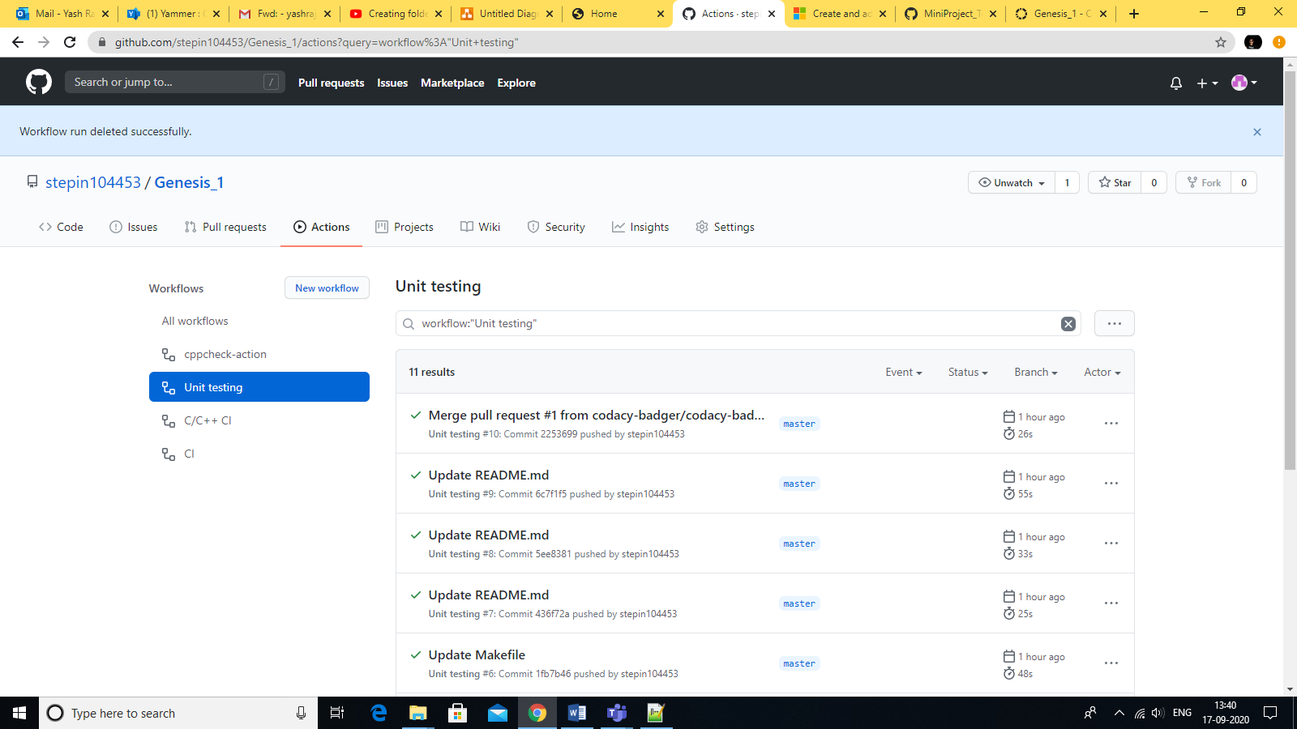

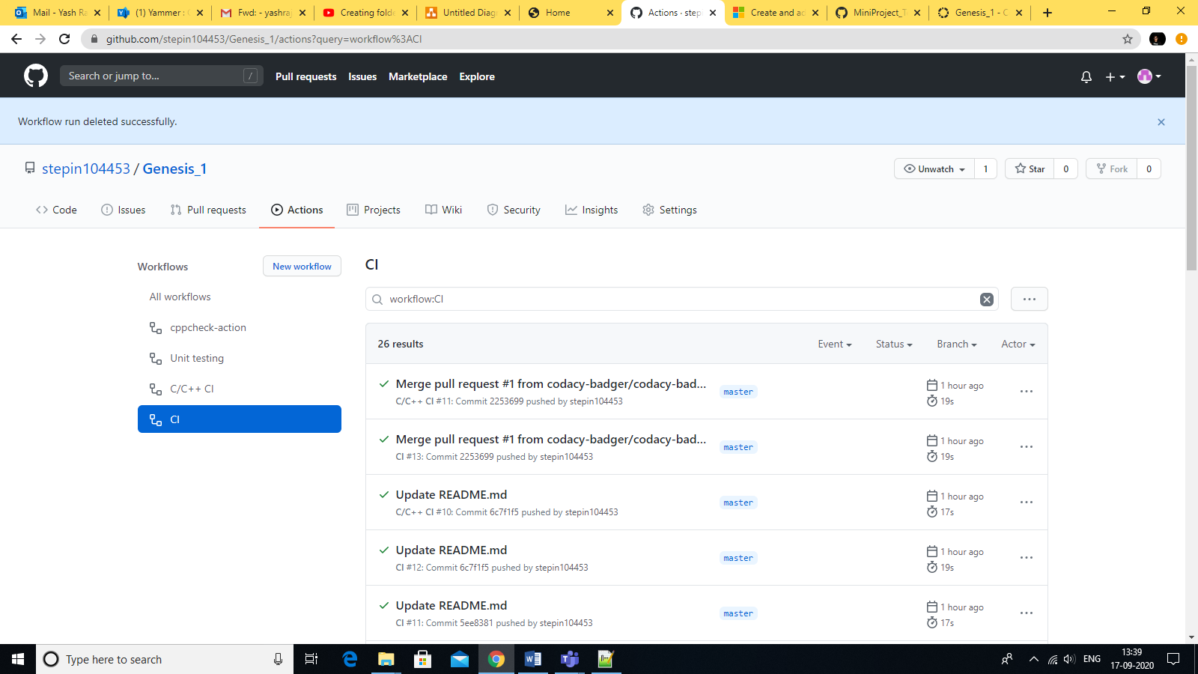

## 

## 4.CODE QUALITY

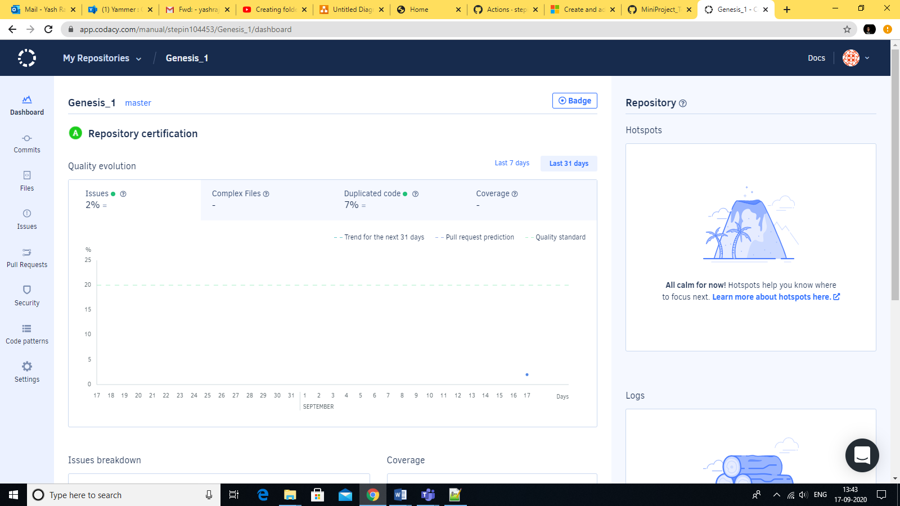

Link: https://github.com/stepin104453/Genesis_1.git

Main File

#include "factorial.h"

int factorial(int number)

{

if(number < 0)

return -1;

if(number == 0)

return 1;

return number * factorial(number-1);

}

Function Code

#include "test_factorial.h"

int main(void)

{

test_main();

return 0;

}

References:

* <http://www.academia.edu/Documents/in/Virtual_Keyboard>
* <https://www.educba.com/types-of-computer-keyboard/>
* <https://www.cdw.com/content/cdw/en/articles/computersandaccessories/2018/11/14/types-of-keyboards.html>
* <https://electronics.howstuffworks.com/gadgets/travel/virtual-laser-keyboards.html>
* <https://app.diagrams.net/#G1ygAubqOlZSeJW3LI45RQFD31rHnUT8UU>
* <https://www.includehelp.com/c-programs/c-structure-and-union-program-to-read-and-print-an-employee-details-using-structure.aspx>
* <https://codingee.com/c-program-employee-structure/>

**…………………………………THANK YOU………………………………**