./

REPORT ON

QUIZZINE – A QUIZ GAME

Course Code: <CODE>



NAME : MANISHA MISHRA

SF ID: 105183

|  |  |  |  |  |  |
| --- | --- | --- | --- | --- | --- |
| **Ver. Rel. No.** | **Release Date** | **Prepared. By** | **Reviewed By** | **Approved By** | **Remarks/Revision Details** |
|  |  |  |  |  |  |
|  |  |  |  |  |  |
|  |  |  |  |  |  |
|  |  |  |  |  |  |
|  |  |  |  |  |  |

**Document History**

# 

TABLE OF CONTENTS :

PROBLEM STATEMENT: 4

DESCRIPTION: 4

FLOWCHART: 5

DIAGRAMS: 6

DATA FLOW DIAGRAM: 6

BEHAVIOUR DIAGRAM: 6

STRUCTURE DIAGRAM: 7

7

RESEARCH: 8

TESTING: 8

TEST PLAN: 8

TEST CASES: 9

FUTURE SCOPE: 10

CONCLUSION: 10

REFERENCES: 10

# PROBLEM STATEMENT:

Design and develop a user-friendly quizzing platform to reduce the hand-operated efforts of maintaining a database, computing the scores, deciding the highest score and time needed to complete it. The main objective of this project is to motivate the users to learn and gain knowledge about certain topics asked in the questions and simultaneously making it fun-filled playing. For every wrong answer chosen by the user, the correct answer is shown which will help him/her to avoid making the same mistake in the future.

# DESCRIPTION:

QUIZZINE is a quiz contest to be played in time constraints. Here in this project, the user can access the system by giving her/his name as an input. There is a help button with rules and regulations of the game that includes the time limit of the game, the minimum number of questions to be answered correctly, and the scoring method. These instructions are to be read by the user before taking up the game. In this quiz game, there will be four categories named science, technology, verbal reasoning, and quantitative aptitude of which a category has to be selected. the game becomes a little more exciting, each of which is divided into two rounds: warm-up and challenging round. The participant has to score the threshold value in warm-up round within the time limit to go to the next round. If not, then he/she has to take the quiz again or exit from the game.

# FLOWCHART:

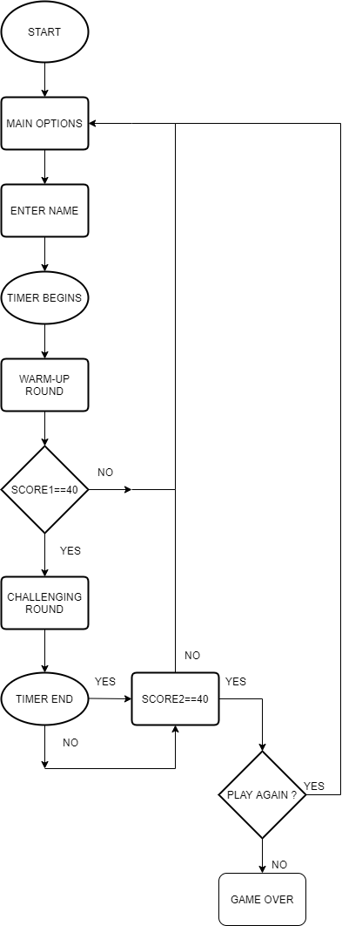

# DIAGRAMS:

## DATA FLOW DIAGRAM:

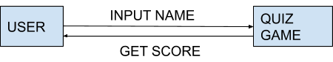

## BEHAVIOUR DIAGRAM:

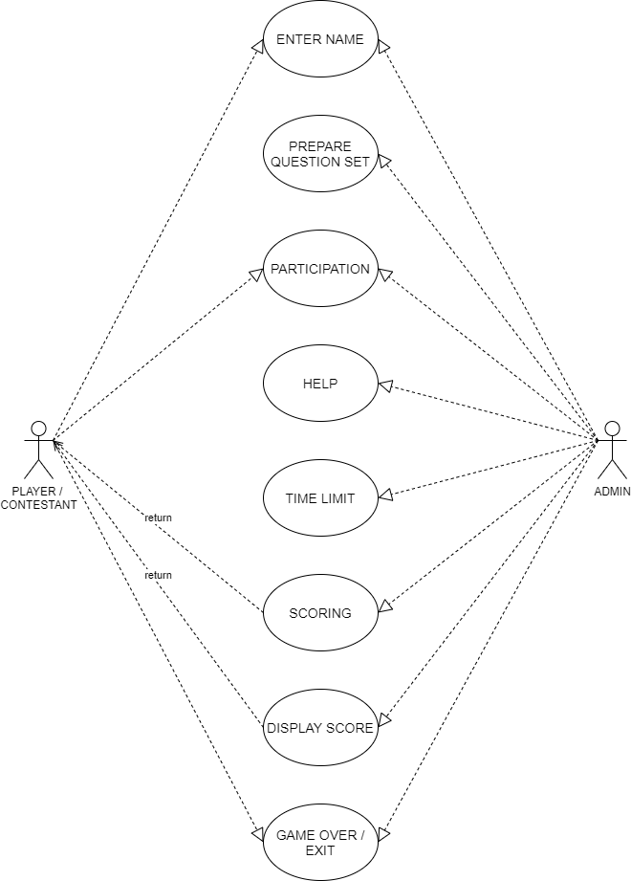

## STRUCTURE DIAGRAM:

## 

# RESEARCH:

The methodology followed for our project involves the primary means of data collection of how the manual effort of organizing quiz contests can be replaced by a software program, automatic calculation of scores and time taken can be done and the accuracy of the user can be enhanced by answering the questions within a timeframe. The users can also access themselves about their current awareness from their performance and enjoy the fun-filled quiz game. The whole project is built in the language '**C**' and various variables, strings, and file handling have been used for this project's development. The users will find it easy to play with and to understand. The interface is so basic that it will not be difficult for the user to use and navigate.

Software requirement: Microsoft visual code/code blocks

Language used: C programming

Platform: C ide

# TESTING:

Testing is an assemblage of tasks that will be designed in advance and conducted orderly. By predetermining the notations of the built program, it overcomes the emerging conflict of interest. The most objective of our project and the risk of implementation associated with it can be known from the testing. Testing could be a technical investigation procedure carried out on behalf of the stakeholder to disclose quantity-related details about the merchandise specific to the context in which it is expected to function. This is the mechanism by which a program or application is performed in order to identify miscalculations or defects. Due to the process of validating and checking a software program, testing would be specified.

## TEST PLAN:

The test plan will define the scope and tasks of our project functions. At the beginning of our project, we must plan the test plans. This project will have a unique and single identifier throughout the program. Even though exhausting testing is not possible, we can use a wide variety of tests to achieve our goal. There are at most seven to eight functions in our project. Therefore, we will conduct testing from the starting stage itself. The primary purpose of the test plan is to create an accurate code that satisfies all user requirements. This software program can be used as an effective tool, however, we would like to ensure that it can be controlled on several platforms at ease in the later stage.

## TEST CASES:

|  |  |  |  |  |
| --- | --- | --- | --- | --- |
| **TEST CASE NUMBER** | **TEST CASE NAME** | **DESCRIPTION** | **INPUT** | **EXPECTED OUTPUT/ RESULT** |
| 1 | Login | The user should enter his name | Type the user name | Successful welcome |
| 2 | Checking questions | The user should choose the right option among four options | Check the answer and pop up message for wrong answer | Messages will show whether they are correct or wrong. If wrong correct answer is shown |
| 3 | Timer for warm-up round | The user should answer the questions in specified time | Choose the option for each question | Automatically time out |
| 4 | Help option | The user can read the rules and regulations before taking up the quiz contest | Click the required option | Understanding the rules of the game |
| 5 | Highest score | The total marks scored by the user at the end of the quiz | Answer correct questions to count scores | Show the highest score |
| 6 | Reset score | The user can reset score to default after the end of game | Choose the option to reset | Score is set to default |
| 7 | Exit from game | The user can leave the game at the middle | Choose the option to exit | End quiz and show score |

# FUTURE SCOPE:

The primary objective of our project is to build a successful relationship between the user and the platform administrator. The try is to please all the users at the highest stage and have an amazing learning experience too. In the future, this project will be upgraded to a website. And give users the option to add their name and email id for further development. It is going to be more empowering.

# CONCLUSION:

This quiz system project offers the ability to administer a worldwide quiz contest. This saves time as it allows a variety of students to take the contest at a time and reveals the results as the game is finished, so there is no need to wait for the outcome. It's generated by the server automatically. The administrator has the responsibility of producing, editing, and removing the quiz documents and their basic questions. The quiz will be terminated according to the time limit kept by the administrator.

# 

# REFERENCES:

[1] Link to get the idea of source code: <https://code-projects.org/>

[2] Link to how to define tasks in a software program/project: <https://futureskillsnasscom.edcast.com/journey/system-development-life-cycle-sdlc>

[3] Theoretical understanding of C and testing: <https://futureskillsnasscom.edcast.com/journey/programming-in-c-and-unit-testing>