Normalizing Unstructured Jakarta Addresses with Small Language Models: Deterministic Verification and Confidence-State Reporting

I. Introduction
Accurate geospatial data is foundational to financial, e-commerce, and logistics systems [1]. In Indonesia, the urgency for precise addressing is underscored by the explosive growth of the e-commerce sector (nearly 500% between 2015 and 2019) [2], which has placed sustained pressure on last-mile delivery providers as the most expensive, inefficient, and polluting part of the logistics chain. This demand is especially critical in high-volume regions like Java, specifically West Java and Jakarta, where parcel delivery is heavily concentrated [2]. Indonesian addresses remain highly inconsistent due to the absence of national addressing standards [3] and the lack of centralized address governance [6]. Addresses are routinely written with idiosyncratic abbreviations (e.g., “Klp Gdng” for “Kelapa Gading”), local slang, and frequent omission of hierarchical components, leading to a reality where the majority of the addresses are incomplete. Even after the introduction of the national standard SNI 9037:2021, a survey conducted in Mantrijeron, Yogyakarta revealed that only 70 out of 2,222 buildings (3.1%) conform to standardized addressing rules [4], with pathologies including one address shared across twelve distinct structures and “nested addresses” that conflate two administrative regions in one line.
Existing approaches do not transfer cleanly. Rule-based parsers and standard probabilistic tools fail on noisy text, they struggle with Out-Of-Address (OOA) terms such as phone numbers, account codes, or unrelated metadata interspersed within the address string [5]. Furthermore, standard address locators found in common software packages are not suitable for the Indonesian situation [6] because they cannot process essential micro-administrative components like Rukun Tetangga (RT), and Rukun Warga (RW). Large Language Models offer linguistic flexibility but are costly to deploy at scale and often trail behind specialized neural architectures in parsing precision, particularly when processing specific directional components [5, 18]. Moreover, they are prone to hallucinations such as modified word index, inferred but nonexistent administrative tags, and formatting failures like nested JSON that may appear semantically valid without external verification [5].
These compounding challenges are especially familiar in DKI Jakarta, a region that combines high administrative complexity with pervasive data incompleteness in its own official records. This research concentrates on the DKI Jakarta region, a heavily populated metropolitan area characterized by a complex administrative hierarchy (Provinsi → Kota/Kabupaten → Kecamatan → Kelurahan → RT/RW). We frame the Jakarta normalization problem as a compound uncertainty problem: simultaneous structural irregularity in informal address text and structural incompleteness in the authoritative administrative reference data. We adopt the local term “data rumpang” for the latter: the Pergub-derived Jakarta street and landmark masters reveals 30.1% null kelurahan assignments, 34.2% null postal codes, and 266 landmark entries with no administrative anchor whatsoever. Any system designed for complete reference databases risks either silently failing or silently hallucinating.
This work makes four primary contributions. (i) We formalize a two-error-mode framework that decomposes address-normalization failures into syntactic extraction errors (caused by informal and noisy input text) and semantic verification errors (caused by “data rumpang” in authoritative references). We operationalize this framework by engineering a 230,000-sample hybrid synthetic training corpus. This dataset is built using a rule-based pipeline to inject realistic administrative gaps from Jakarta's master data, combined with an external LLM used strictly to generate natural-language conversational prefixes (e.g., “tolong kirim ke…”, “alamatku ada di…”) and syntactic noise (e.g., typos and abbreviations). The framework therefore functions not only as a conceptual taxonomy but as the design specification for the training corpus that supervises Stage 1. (ii) We design a two-stage hybrid inference pipeline that pairs a QLoRA-fine-tuned Llama-3.1-8B model with a deterministic post-hoc verification module (AdminVerifier), governed by an explicit null-honesty principle that resolves each failure mode at the architectural stage suited to it. (iii) We introduce a four-state per-field confidence schema (Verified, Inferred, Unverifiable, Free-form) and report its empirical distribution as a first-class finding that characterizes the epistemic completeness of Jakarta's administrative reference data independently of the language model's performance. (iv) The approach supports a Proof of Sufficiency argument: a compact 8-billion-parameter SLM, paired with structured post-hoc grounding and supervised by a corpus engineered against the two-error-mode taxonomy, can achieve competitive performance while operating at substantially lower computational and privacy cost than large-scale general-purpose language models.

II. Related Work
A. Address Parsing and Domain-Adapted Language Models
Address parsing has evolved from rule-based and statistical methods to domain-specific neural architectures. Early rule-based and statistical approaches, most notably LibPostal [5], laid the groundwork before domain-specific neural architectures became dominant. Seq2Seq-based systems have established the generative paradigm as dominant: Deepparse [7] leverages Bi-LSTM subword embeddings for multinational address parsing, and subsequent zero-shot transfer evaluations achieved 64%–72% accuracy on Indonesian addresses through attention mechanisms that improve parsing of incomplete records [12]. Building on this, GeoIndia [8] applied Seq2Seq decoding with H3 hexagonal cell prediction to unstructured Indian e-commerce addresses, demonstrating the superiority of generative models like Flan-T5 in capturing regional nuances. These Seq2Seq foundations have since been extended with spatial signals: Wu et al. (Cainiao) introduced G2PTL [13], a pre-trained model integrating Transformer-based semantic learning with Graphormer-based spatial encoding on 93 million addresses to achieve significant gains in geocoding, address parsing (AET/AEP), and arrival time estimation (PETA).

Wu et al. (Cainiao) introduced G2PTL [13], a pre-trained model that integrates Transformer-based semantic learning with Graphormer-based spatial encoding on 93 million addresses to achieve significant gains in geocoding, address parsing (AET/AEP), and arrival time estimation (PETA). In the Indian context, GeoIndia [8] applied Seq2Seq decoding with H3 hexagonal cell prediction to unstructured Indian e-commerce addresses, demonstrating the superiority of generative models like Flan-T5 in capturing regional nuances. Singh et al. [20] further enhanced spatial understanding by implementing a geo-spatially informed RoBERTa model with a distance-aware triplet loss, showing that scaling training margins based on real-world distance helps the model handle incomplete and noisy addresses more effectively. CNER-UAV study [14] on fine-grained Chinese address NER demonstrated that LLM zero-shot inference cannot substitute manual labeling for purpose-trained models on hierarchical address entities, thereby justifying the need for the domain-adapted SFT regime used in this work.
Masis and O’Connor [22] demonstrated that while LLMs struggle as standalone geographic knowledge bases, task-fine-tuned small LLMs (8B–14B parameters) can match or exceed the performance of much larger models in geocoding compositional location references. In a converging result, Hammami et al. [5] establish that fine-tuned encoders like XLM-RoBERTa-Large substantially outperform generative LLM baselines on noisy multinational financial addresses; similarly [18] reach the same conclusion on US addresses, demonstrating that BiLSTM-CRF outperforms GPT-3 on the noisy-address parsing task. Collectively, these results situate our Proof-of-Sufficiency argument within the current empirical state of SLM research.
B. Generative Normalization and the Verification Gap
Generative information extraction for address normalization has been instantiated across at least five architectural patterns. Canonical Retrieval-Augmented Generation (RAG) is pioneered by AddrLLM [1], which combines multi-instruction SFT (parsing, entity prediction, and rewriting) with address-centric vector retrieval over a nationwide Chinese address database. This paradigm is extended by AddrKG-LLM [10], which adds GraphSAGE-derived knowledge-graph embeddings and a hierarchy-aware contrastive learning objective to enforce schema-restricted decoding for sensitive medical records. GeoAgent [15], an agentic framework that leverages an LLM to dynamically invoke external map APIs as callable geospatial tools. Huang et al. [16] propose GTBERT-Pointer, a parameter-efficient framework that infuses geospatial gazetteer and hierarchical administrative knowledge into a BERT encoder through specialized adapters and an efficient global pointer mechanism. While Tarannum et al. [17] demonstrate that a 17-field schema can be parsed effectively using LLMs via structured prompting and rule-based validation without fine-tuning, Yin et al. [18] reveal that such generative approaches still underperform compared to fine-tuned BiLSTM-CRF models when handling low-quality address within a U.S. based benchmark. To address the structural unreliability inherent in these generative outputs, SLOT [23] introduces a model-agnostic framework that employs a fine-tuned Mistral-7B post-processor combined with constrained decoding to achieve 99.5% schema accuracy, providing a generalized structural layer that complements domain-specific verification strategies.
While Hu et al. [16] pair domain-adapted lightweight LLMs with external geocoder validation (GeoNames, Nominatim, ArcGIS) can outperform both rule-based parsers and general-purpose LLMs in toponym resolution, they assume comprehensive gazetteer coverage. This limitation is identified by the systematic review of Yin et al. [24] as a persistent bottleneck for next-generation systems. Wang et al. [21] take a training-time approach to the same hallucination concern, benchmarking twenty LLMs on geospatial knowledge and proposing Kahneman–Tversky Optimization for factuality alignment; our work addresses the same risk through a deterministic post-hoc grounding mechanism rather than an alignment-stage intervention. A separate line of recent work, ReaGeo [11] proposes end-to-end generative geocoding via chain-of-thought reasoning and reinforcement-learning-based geohash prediction. However, its coordinate-level outputs do not provide the structured per-field address information required for administrative record-keeping and logistics routing in the Indonesian context.
This work verification stage differs architecturally from all of these patterns: it operates entirely post-hoc on the model's structured output, performs no vector retrieval, never modifies the model's input or hidden state, and uses deterministic indexed lookup. We therefore refer to Stage 2 as Deterministic Administrative Database Grounding rather than RAG.
C. Indonesian Context and Rumpang Data
Empirical surveys of Indonesian addressing reveal extremely low compliance with national standards [4] find that only 3.1% of buildings in their Yogyakarta survey site conform to SNI 9037:2021, with pathologies including shared addresses across multiple structures and addresses that conflate multiple administrative boundaries. While Sutanta's earlier work on geocoding frameworks for urban Indonesia [6] identify institutional roots and the inadequacy of imported ArcGIS-style locators for Indonesian context. Recent attempts by Ansori et al. to resolve indigenous Bali Banjar addresses [19], which combines Levenshtein, Partial Ratio, and Token Sort Ratio fuzzy matching with domain-rule filtering to achieve 95% convergence on a Bali test set without any predefined gazetteer. Their setting differs from this work because Bali Banjar addresses do not require resolution to the national Kelurahan/Kecamatan hierarchy targeted here, and their fuzzy-only approach cannot handle the syntactic chaos (RT/RW formatting, code-switching, dense abbreviation) characteristic of Jakarta informal addresses for which the SLM stage of the present work is specifically designed. This work treats incomplete reference data (rumpang data) as a core design constraint through the null-honesty principle and the four-state per-field schema, where missing information is explicitly reported rather than hidden.

III. METHODOLOGY
A. System Architecture Overview
The proposed system normalizes informal Jakarta address strings into a structured 12-field representation conforming through a two-stage pipeline. This design is grounded in the two-error-mode framework, which decomposes address-normalization failures into two failure types: (i) syntactic extraction errors, caused by informal, noisy, or abbreviated input text, and addressed in Stage 1; and (ii) semantic verification errors, caused by incomplete administrative reference data ("data rumpang"), and addressed in Stage 2.
Stage 1 employs a fine-tuned Small Language Model (SLM) — Llama-3.1-8B with QLoRA — to extract a 12-field JSON object from a free-form address string. Stage 1 operates entirely on syntactic patterns and does not perform any database lookup. Stage 2 applies the Deterministic AdminVerifier, a post-hoc indexed lookup engine that cross-checks every extracted field against three Jakarta reference databases using exact-match hash-map retrieval. Crucially, Stage 2 performs no vector retrieval and never modifies the model's hidden state; it operates entirely on the structured output of Stage 1. Fig. 1 illustrates the complete pipeline.
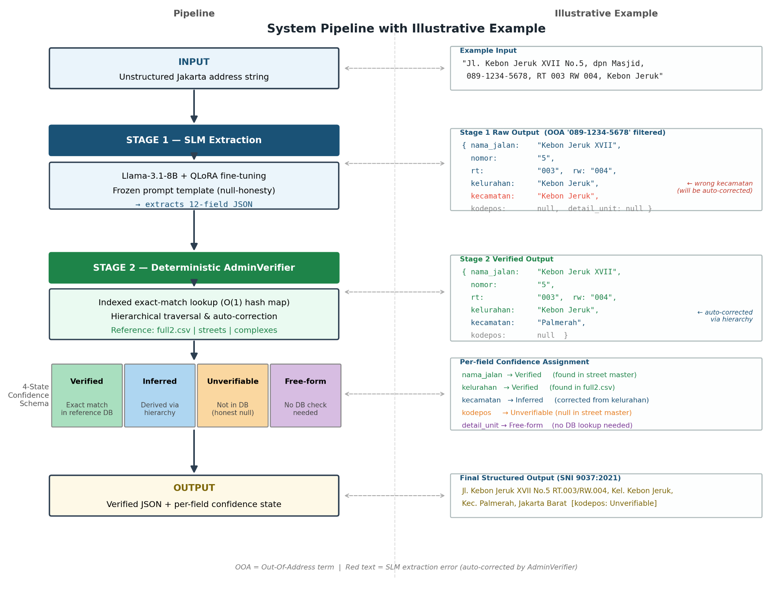
Fig. 1. Two-stage system pipeline for Jakarta address normalization.
B. Reference Data Preparation
Three Jakarta administrative reference files serve as the lookup backbone for Stage 2. All files are loaded at system startup and indexed into Python dict objects for O(1) average-case retrieval. Table I summarizes their characteristics.
TABLE I
Jakarta Administrative Reference Databases
File | Rows | Coverage | Null Rate
full2.csv | 268 | Provinsi → Kota → Kecamatan → Kelurahan hierarchy | 0%
USED_master_data_final.csv | 4,192 | Street names + admin linkage | ~30.1% kelurahan; ~34.2% kodepos
USED_master_complexes_final_v2.csv | 2,718 | Landmark & complex names | ~99% kecamatan
The non-zero null rates in the street and complex masters are not treated as data quality defects but as design constraints reflecting real-world data rumpang — the systematic incompleteness of official Jakarta administrative records. The AdminVerifier explicitly propagates this incompleteness to the output through the Unverifiable confidence state (Section III-E), operationalizing the Null-Honesty Principle: the system reports missing data rather than fabricating plausible-sounding values.
C. Training Corpus Construction
Because no large-scale labeled dataset of Jakarta addresses exists, we construct a hybrid synthetic corpus of 230,000 (input, output_JSON) pairs. The generation pipeline follows the two-error-mode taxonomy to ensure that both failure types are faithfully represented in training:
Rule-based gap injection. Administrative fields in the ground-truth JSON are nulled out at rates derived from the real reference database: kelurahan is absent in 30.1% of samples, kodepos in 34.2%, and kecamatan in ~99% of complex-type addresses. This ensures the model learns to output null for genuinely unresolvable fields rather than hallucinating.
External LLM syntactic noise generation. A large external LLM is prompted to generate only the noisy input-side text — conversational prefixes, typographical errors, RT/RW abbreviations, and out-of-address (OOA) interjections (phone numbers, order codes). Location-bearing content (street names, kelurahan, kecamatan) is always sourced from the reference databases, never from the LLM, preventing hallucinated toponyms from contaminating training labels.
The 230K samples are split 80/10/10 (train/validation/test). To prevent label leakage, grouping is performed by identical JSON output before splitting, ensuring that address variants sharing the same normalized form cannot appear in both training and evaluation partitions. The random seed is fixed at 42 for all stochastic operations.
D. Stage 1: SLM Fine-Tuning
Stage 1 fine-tunes Llama-3.1-8B using QLoRA (4-bit quantization, rank-16 adapters) to perform structured extraction from noisy address strings. The model is trained to map a free-form address string to a JSON object with 12 fields: {kelurahan, kecamatan, kota_kabupaten, provinsi, nama_jalan, nama_kompleks, blok_kavling, nomor, rt, rw, kodepos, detail_unit}.
A frozen prompt template is applied identically during both training and inference, containing an explicit instruction to output null for any field the model cannot determine from the input. This template is seen by the model in every of the ~184,000 training steps, embedding the null-honesty signal directly into the model's fine-tuned weights. The use of the same template at inference time eliminates distribution shift between training and deployment contexts.
Training uses a maximum sequence length of 512 tokens, a batch size of 8 (with 4-step gradient accumulation), and AdamW optimizer with a learning rate of 2×10⁻⁴ and cosine decay. Fine-tuning is conducted for 3 epochs on an NVIDIA A100 80 GB GPU.
E. Stage 2: Deterministic AdminVerifier
The AdminVerifier receives the 12-field JSON from Stage 1 and performs field-level verification through three sequential sub-processes:
(1) Indexed exact-match lookup. Each field is queried against the appropriate reference hash map. Kelurahan and kecamatan names are looked up in full2.csv; street names in the street master; complex/landmark names in the complex master. All string comparisons are performed after Unicode normalization and lower-casing.
(2) Hierarchical traversal and auto-correction. If a kelurahan is matched but the SLM-predicted kecamatan does not align with the verified hierarchy, the AdminVerifier silently corrects the kecamatan by ascending the full2.csv hierarchy from the confirmed kelurahan. Similarly, provinsi and kota_kabupaten are inferred from any successfully matched lower-level administrative field.
(3) Per-field confidence assignment. Each field in the output JSON is annotated with one of four confidence states, as defined in Table II.
TABLE II
4-State Per-Field Confidence Schema
State | Condition | Example
Verified | Exact match found in reference DB | Kelurahan found in full2.csv
Inferred | Derived via hierarchical traversal | Kecamatan inferred from matched kelurahan
Unverifiable | Not found in any reference DB | Kelurahan absent (data rumpang ~30.1%)
Free-form | Field type needs no DB check | Blok/kavling or unit detail
The Unverifiable state is the operational realization of the Null-Honesty Principle at inference time: when a field is absent from all reference databases — as occurs for ~30.1% of kelurahan queries due to data rumpang — the system emits Unverifiable rather than selecting the nearest-neighbor match. This prevents silent hallucination propagation into downstream geospatial pipelines.
F. Evaluation Protocol
System performance is evaluated on the held-out test split (10%, ~23,000 samples) using field-level exact-match accuracy — the proportion of individual JSON fields that exactly match the ground-truth label across all 12 fields. We report both aggregate accuracy and per-field breakdown to isolate which administrative levels remain challenging.
Three ablation conditions are evaluated: (i) Stage 1 only — raw SLM output without verification; (ii) Stage 1 + AdminVerifier (two-stage) — the full proposed pipeline; and (iii) GPT-4o zero-shot — a strong LLM baseline without fine-tuning or deterministic grounding, used to contextualize the cost-accuracy tradeoff (Proof of Sufficiency, N7). Additionally, we report the per-confidence-state distribution on the test set to empirically characterize how the AdminVerifier partitions its uncertainty.
Fig. 2 summarizes the complete research methodology procedure from data preparation through final evaluation.
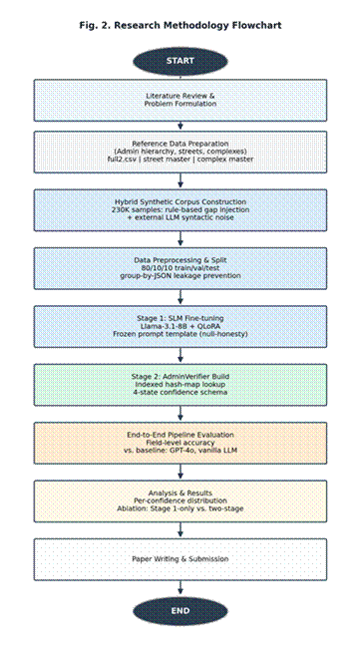
Fig. 2. Research methodology flowchart.

References
[1] Q. Yang et al., “AddrLLM: Address Rewriting via Large Language Model on Nationwide Logistics Data,” arXiv:2411.13584, Nov. 2024.
[2] I. Surjandari, R. Rindrasari, and A. Dhini, “Evaluation of Efficiency in Logistics Company: An Analysis of Last-Mile Delivery,” Evergreen, vol. 10, no. 2, pp. 649–657, 2023.
[3] H. Sutanta, N. P. P. Chintya, and Z. Syarafina, “Issues and Challenges in Developing Geocoded Address in Indonesia,” AIP Conf. Proc., vol. 1755, p. 070010, 2016.
[4] P. R. M. Aprinia and H. Sutanta, “Survei dan Pembuatan SIG Alamat Berkode Lokasi untuk Kalurahan Mantrijeron, Yogyakarta,” JGISE, vol. 7, no. 2, p. 208, 2024.
[5] H. Hammami, L. Baligand, and B. Petrovski, “Fighting Crime with Transformers: Empirical Analysis of Address Parsing Methods in Payment Data,” arXiv:2404.05632, 2024.
[6] H. Sutanta, “Developing Address Model and Geocoding Framework for Urban Area in Indonesia,” 2023.
[7] D. Beauchemin and M. Yassine, “Deepparse: An Extendable and Fine-Tunable State-of-the-Art Library for Parsing Multinational Street Addresses,” in Proc. NLP-OSS 2023, pp. 19–24.
[8] B. Singhal et al., “GeoIndia: A Seq2Seq Geocoding Approach for Indian Addresses,” in Proc. EMNLP Industry Track, 2024, pp. 395–407.
[9] Y. Hu, J. Kersten, F. Klan, and F. T. Farzana, “Toponym Resolution Leveraging Lightweight Language Models and External Geo-Knowledge,” Int. J. Geographical Information Science, 2024.
[10] J. Li, X. Pan, and Y. Jia, “Patient Address Parsing via KG-aware Contrastive Learning and Constrained On-Prem LLM Inference (AddrKG-LLM),” Scientific Reports, 2026.
[11] ReaGeo: End-to-End Geocoding via Chain-of-Thought Reasoning and Reinforcement-Learning-Based Geohash Prediction, arXiv:2604.21357, 2026.
[12] M. Yassine, D. Beauchemin, F. Laviolette, and L. Lamontagne, “Multinational Address Parsing: A Zero-Shot Evaluation,” arXiv:2112.04008, 2021.
[13] L. Wu et al., “G2PTL: A Pre-trained Model for Delivery Address and its Applications in Logistics Systems,” in Proc. ACM KDD, 2023.
[14] Y. Yao, S. Luo, H. Zhao, G. Deng, and L. Song, “Can LLM Substitute Human Labeling? A Case Study of Fine-grained Chinese Address Entity Recognition for UAV Delivery,” in Proc. ACM WWW, 2024.
[15] C. Huang, S. Chen, Z. Li, J. Qu, Y. Xiao, J. Liu, and Z. Chen, “GeoAgent: To Empower LLMs Using Geospatial Tools for Address Standardization,” in Findings of ACL, 2024, pp. 6048–6063.
[16] J. Huang, S. Liu, Y. Qiao, and Y. Wu, “Gazetteer- and Type-Enhanced Chinese Address Parsing BERT with an Efficient Global Pointer,” Int. J. Digital Earth, vol. 18, no. 2, p. 2594917, 2025.
[17] A. Tarannum, M. A. Mohammed, M. C. Cakmak, S. Al Mandalawi, and J. Talburt, “A System for Name and Address Parsing with Large Language Models,” Springer / ITNG 2024.
[18] Z. Yin, D. Li, and D. W. Goldberg, “Is ChatGPT a Game Changer for Geocoding — A Benchmark for Geocoding Address Parsing Techniques,” in Proc. ACM SIGSPATIAL, 2024.
[19] M. I. Ansori, W. Anggraeni, and R. A. Vinarti, “Integration of Fuzzy Matching and Domain Rules for Identifying Bali’s Indigenous Banjar-Based Addresses in Last-Mile Delivery Without Predefined Gazetteers,” ETASR, vol. 16, no. 1, pp. 32276–32284, 2026.
[20] U. Singh, R. S. Devanapalli, G. Bellala, and V. Goel, “Geo-Spatially Informed Models for Geocoding Unstructured Addresses,” in Proc. COLING Industry Track, 2025, pp. 236–242.
[21] S. Wang, J. Feng, T. Liu, D. Pei, and Y. Li, “Mitigating Geospatial Knowledge Hallucination in Large Language Models: Benchmarking and Dynamic Factuality Aligning,” in Findings of EMNLP, 2025, pp. 870–888.
[22] T. Masis and B. O'Connor, “Coordinates from Context: Using LLMs to Ground Complex Location References,” in Proc. EACL (Volume 1: Long Papers), 2026, pp. 1591–1606.
[23] D. Y.-B. Wang, Z. Shen, S. S. Mishra, Z. Xu, Y. Teng, and H. Ding, “SLOT: Structuring the Output of Large Language Models,” arXiv:2505.04016, 2025.
[24] Z. Yin, D. W. Goldberg, B. Lin, B. Zhou, D. Li, A. Ma, et al., “Toward Building Next-Generation Geocoding Systems: A Systematic Review,” preprint, 2025.

NOVELTY SUMMARY
- [N1] Two-error-mode framework: syntactic extraction errors + semantic verification errors
- [N2] Deterministic AdminVerifier: indexed exact lookup, post-hoc —> bukan RAG
- [N3] 4-state per-field confidence: {Verified, Inferred, Unverifiable, Free-form}
- [N4] Null-honesty principle: explicit Unverifiable output, tidak hallucinate
- [N5] Data rumpang sebagai design constraint (~30% null kelurahan Jakarta DB)
- [N6] 230K hybrid synthetic corpus: rule-based gap injection + LLM noise generation
- [N7] Proof of Sufficiency: Llama-3.1-8B QLoRA + AdminVerifier vs LLM besar
- [N8] Indonesian-specific: Jakarta RT/RW hierarchy + OOA term handling

