**Student:ParkJiWeon,**

**Student ID:2020314315,**

**Course Section Number:41,**

**WEB PROJECT**

**REPORT**

**[Online Quiz Judge]**

# For All Users – Login & Register

## [Login&Register Page]

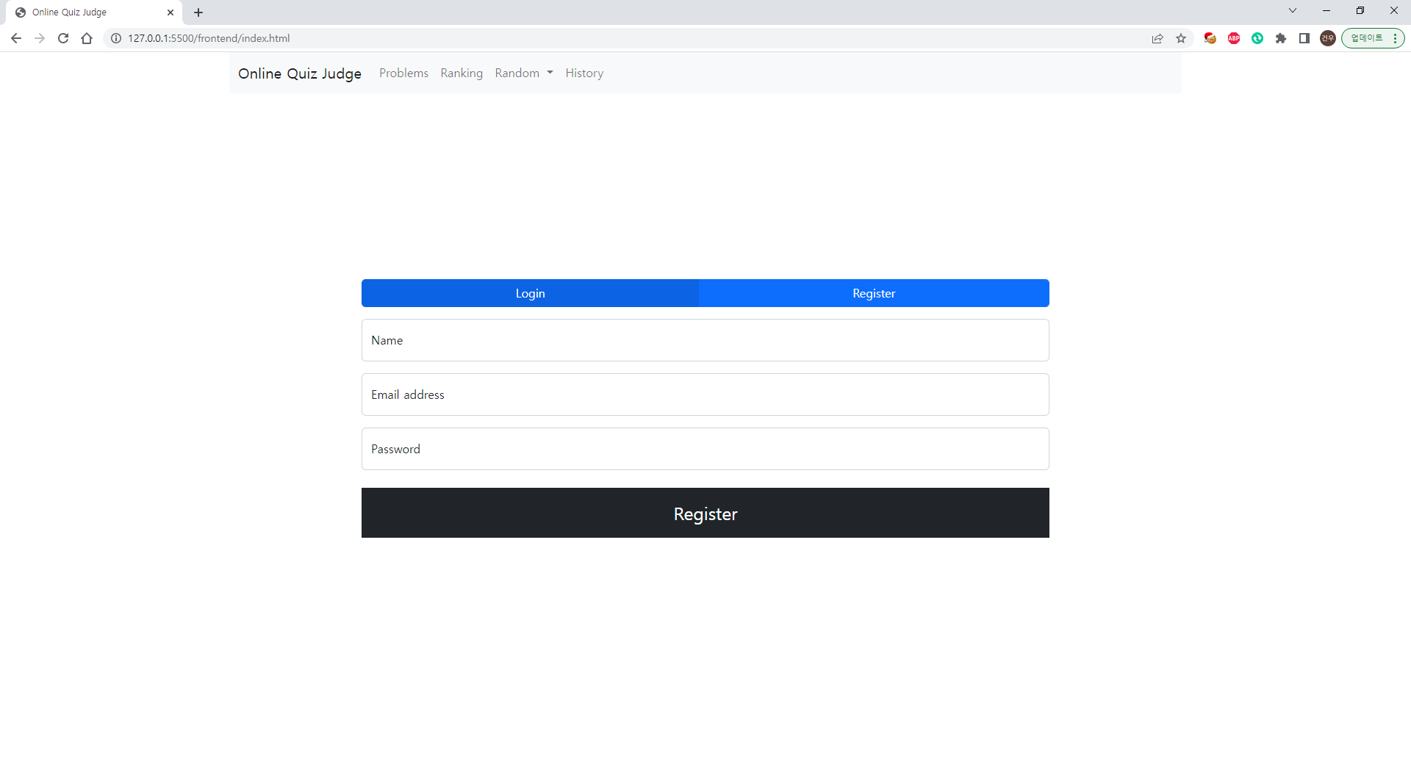

[Main Function]

* Login and Register is in same page ./index.html. By clicking Login, Register button we display login form or regiter form.
* If there is a blank in input area, alert like “invalid input”
* If register is success, move login.
* if login is success, move problem list page

# ProblemList Page

## [Member List Page]

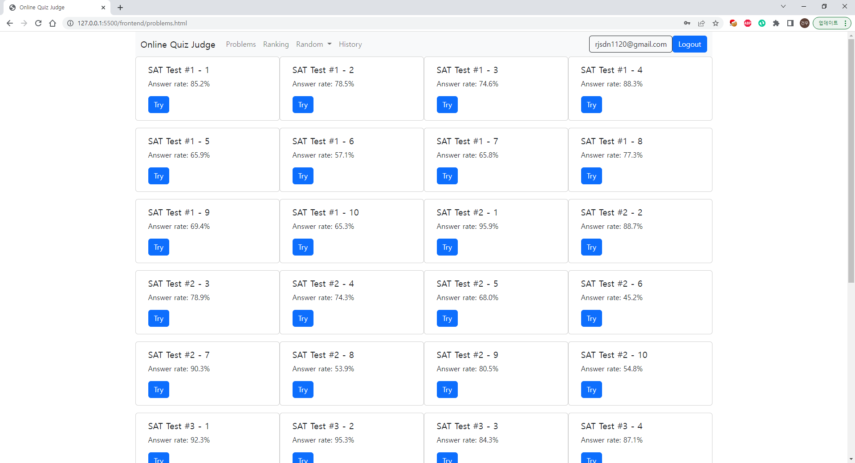

[Main Function]

* Login email is displayed on top right.
* We can logout. If click it, move login page.
* It list problems and could be scroll.
* We can move problem solving page from “try” button.
* In navigation bar, if click random, you can move random problem or unsolved random problem.

# Solving Page

## [Home Page]

[Main Function]

* we can solve the problem form the image.
* If click submit, move history page

# Ranking Page

[Main Function]

* We display ranking sorting by the number of sovled problems of each users.

# Database

Api links: <https://documenter.getpostman.com/view/20907843/2s8YzRxhjP>

# Code History

You can check the development history in our Github link.

<https://github.com/Geniemo/wpl-final-project>