FitFreak

# Introduction

At FitFreak, we understand the importance of staying fit and maintaining a healthy lifestyle. An app to track your workouts so you don’t have to remember them again. We are building this app to address a common problem faced by fitness enthusiasts - the need for an all-in-one platform that makes tracking workouts, setting goals, and monitoring progress simple and convenient.

Setting goals is an essential part of any fitness journey. With FitFreak, you can establish weight or rep-based objectives tailored to your personal preferences. By having a clear target in mind, you'll stay motivated and focused as you strive to achieve new milestones.

# Logical Features

* Keep track of workout (reps and sets and weights) (done)
* Set goals(weight/rep wise)
* Exercise Library ( A place with workout names and description ) (done)
* Progress Tracking ? (track progressthrough graphs or charts) (done)
* Nutrition Tracking (Track of calories taken per day)
* Social Sharing (Share Progress with friends)

# UI UX plan

Color theme -Black,Blue/yellow

# Conclusion

In conclusion, FitFreak is the go-to fitness app that solves the problem of disorganized workout tracking and goal setting. With its intuitive features such as exercise logging, goal setting, progress tracking, nutrition management, and social sharing capabilities, FitFreak provides a comprehensive solution for individuals striving to improve their fitness levels. By using FitFreak, users can seamlessly track their workouts, set achievable goals, monitor progress over time, manage their nutrition intake effectively and share their achievements with others. Take control of your fitness journey today with FitFreak!

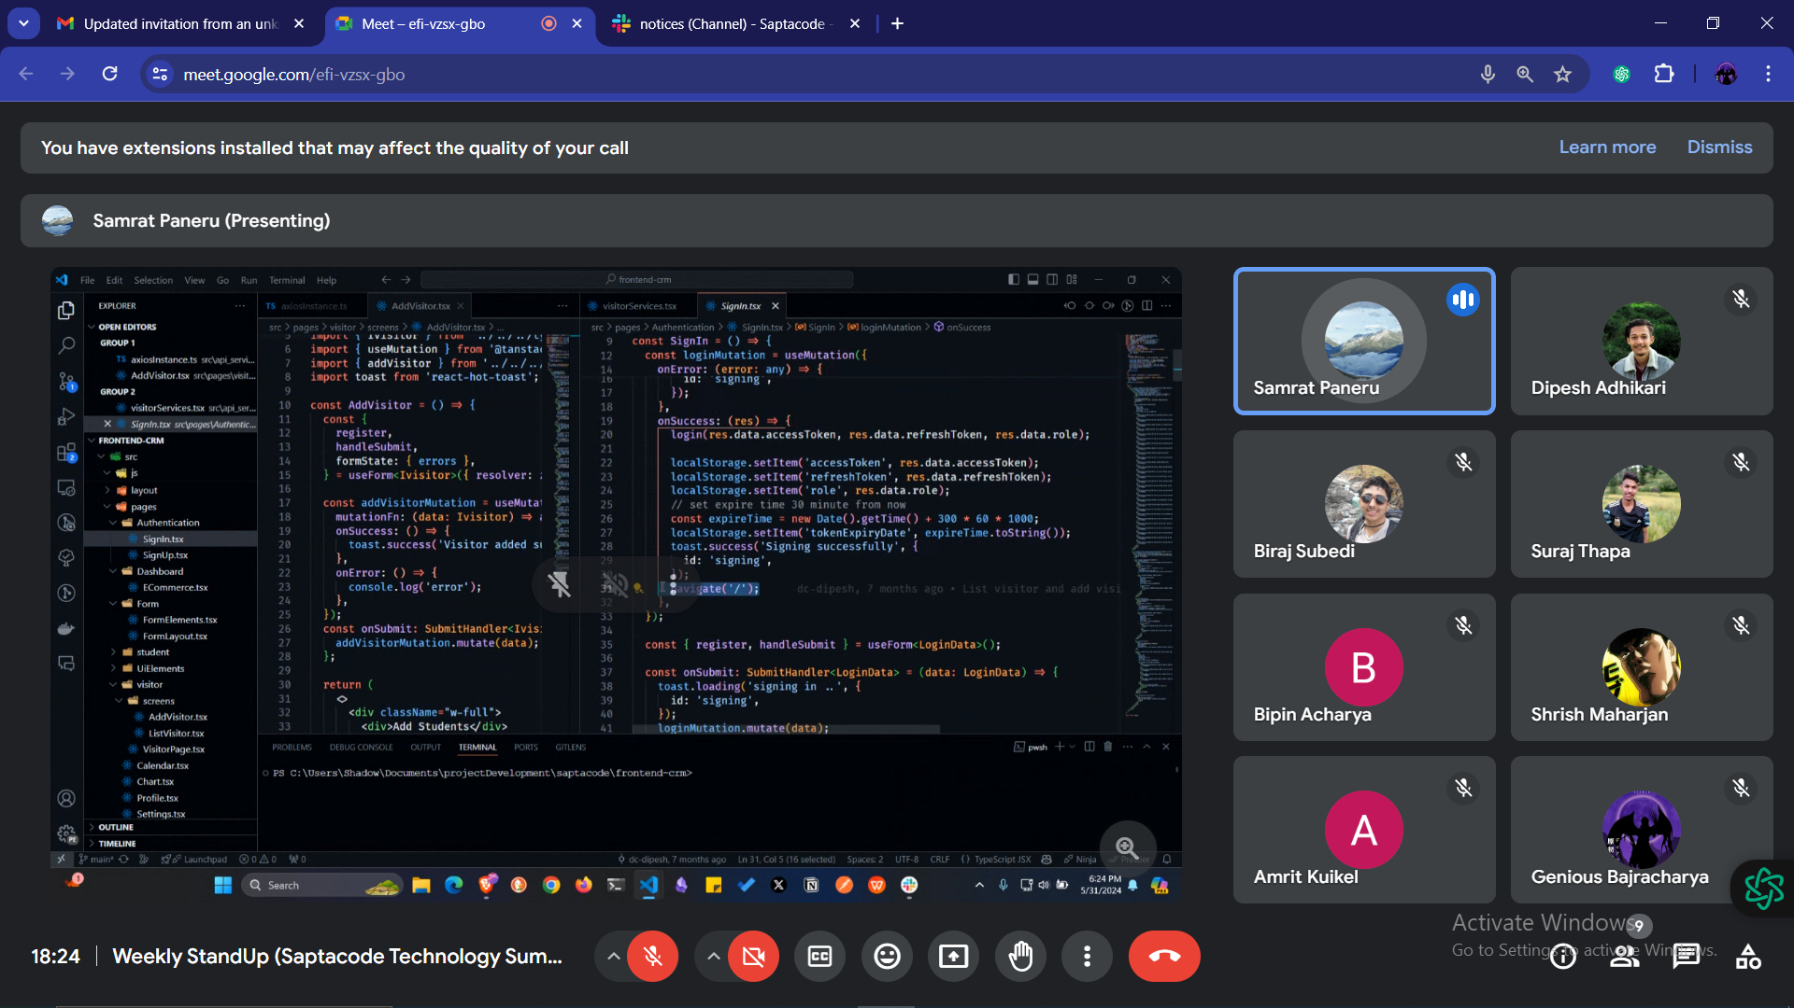

HeartBeat

