Report of HW1: Implement DQN in MountainCar-v0
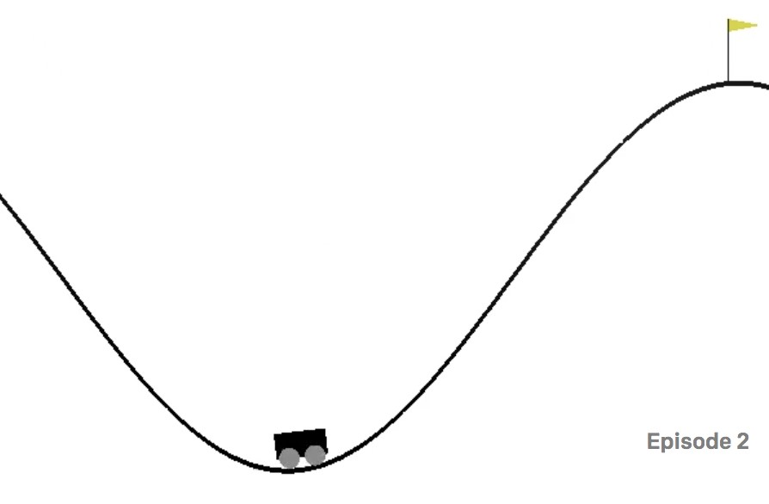

gym environment config

Observation
Num | Observation | MIN | MAX
0 | Car Position | -1.2 | 0.6
1 | Car Velocity | -0.07 | 0.07

Action
Num | 0 | 1 | 2
Action | Accelerate to the Left | Don't accelerate | Accelerate to the Right

Reward
$$f\left(x\right)=\left\{\begin{aligned}0, &agent position≥0.5 on top of the mountain \\ -1, &elsewhere\end{aligned}\right.$$

Parameters
Runtime environment | Windows 10 + Python 3.7.9 + torch 1.8.2
CPU | Intel(R) Core(TM) i5-10400F @2.90GHz
Learning rate | 0.0001
Goal | -110
Min score | -200
Eps start | 1
Eps end | 0.001
Eps decay | 0.9
Gamma | 0.99
Batch size | 64
Memory size | 100000
Max episode | 2000

Training record
Episode | Average score
100 | -179.84
200 | -179.21
300 | -147.61
400 | -147.29
500 | -133.86
600 | -127.31
700 | -124.42
800 | -119.81
900 | -111.44

Results
Success at episode | 911
Total average score | -106.32
Max reward | -84.0

Reward plot
