Machine Learning – Assignment 2

Team Members

Ajaykrishna Karthikeyan (2015A7PS0044H)
Nikhil Iyer (2015A7PS0139H)
Anirudh Srinivasan (2015A7PS0382H)

File Structure
data folder – contains training and test data
src folder – source code
src/decision_tree.cpp – Implementation of DecisionTree and RandomForest classes
src/decision_tree.h – Declaration of DecisionTree and RandomForest classes
src/main.cpp – Main program to run

Task 1:
For ID3, an object of class DecisionTree is created, and 2/3rd of training data is passed to the build function. Missing values and continous-valued attributes are handled at each node and not before the start of the algorithm. The getStats function is called to get the values of precision, recall, f-measure and accuracy.
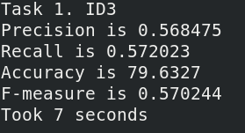

Task 2:
After building the tree, the prune function is called by passing 1/3rd of the training data. This performs reduced error pruning, in a depth-first-search manner.
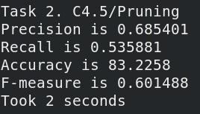

Task 3:
An object of RandomForest is created.

Hyperparameters:
1. To the constructor, the number of trees in the forest is passed as an argument.
2. The number of test data randomly sampled for each tree is the sqrt of the number of
training examples passed(sqrt(16000)~=127)
3. At each split, the attributes are randomly chosen from sqrt of the number of remaining
attributes, and the best attribute amongst these is taken.
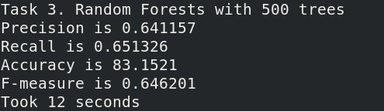

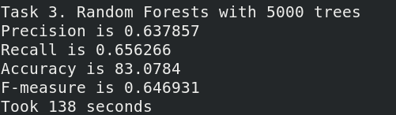

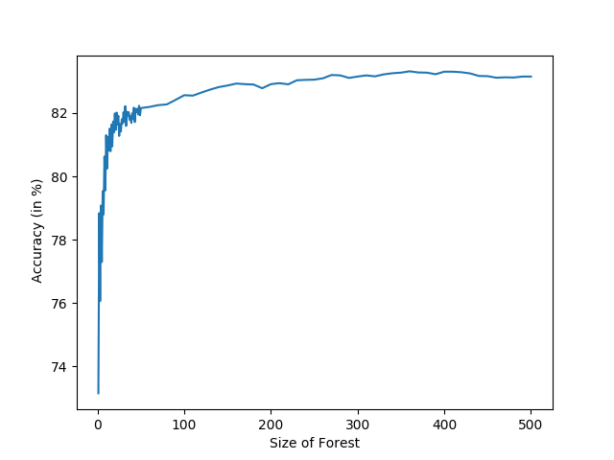

A plot of random forest accuracy vs number of trees in the forest. As the number of trees goes to around 20-30, the accuracy begins to level off at around 83%.

Conclusions:
As expected, there is an increase in accuracy when going from ID3 to C4.5. The increase in accuracy is around 4%. The same could not be said for Random Forests, though. The accuracy is very similar to that of C4.5. Increasing the number of trees from 500 to 5000 also does not affect the accuracy at all, staying at around 83%.

