Information Retrieval – Assignment 1

Team Members

Ajaykrishna Karthikeyan (2015A7PS0044H)
Nikhil Iyer (2015A7PS0139H)
Anirudh Srinivasan (2015A7PS0382H)

Task Chosen : Task 2: Building a domain-specific search engine
Search engine made for song lyrics using a data set from kaggle at https://www.kaggle.com/mousehead/songlyrics
This contains 55000 songs in the data set. Since the time to build and memory usage would be very high, only 10000 songs were taken from this

Description: The user is provided with a webpage, where he can enter his query. The homepage shows the time taken to construct the model, the number of documents in the model and the number of unique words.
Query is the lyrics of the song one wants to search for. One is presented with a list of songs, along with their accuracy to the query, sorted by accuracy. It also shows the time taken to make one query. Clicking on each song gives him a page where one can view it’s lyrics.
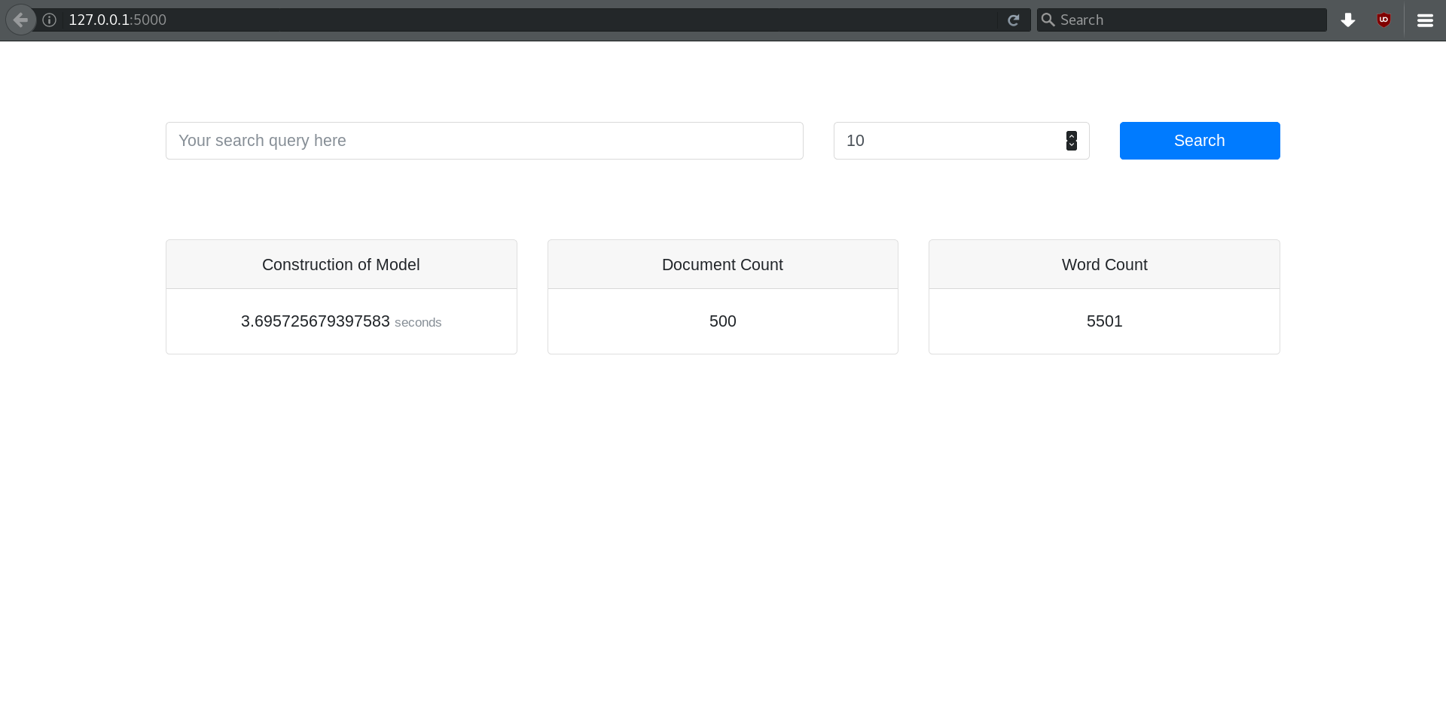
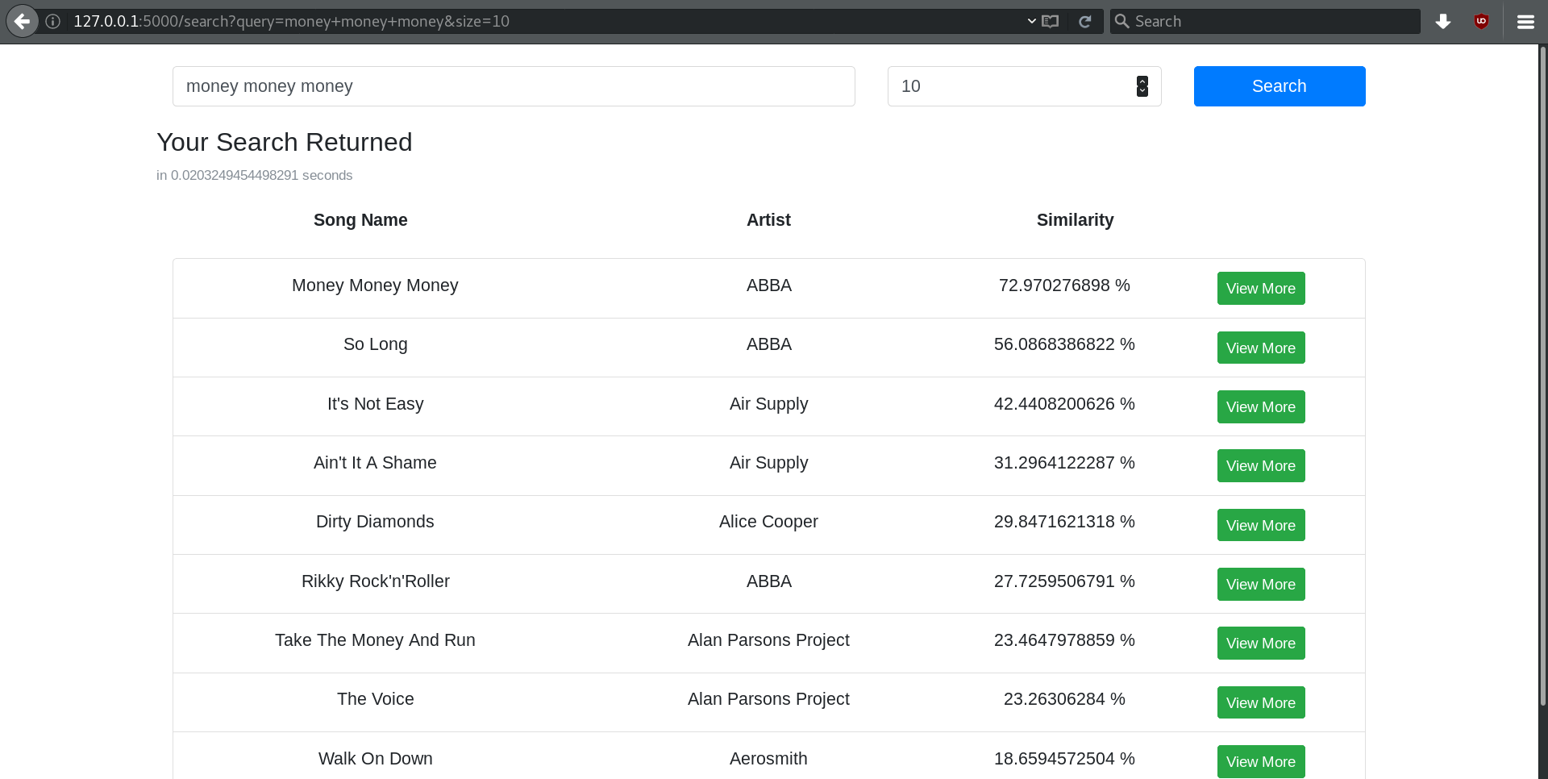
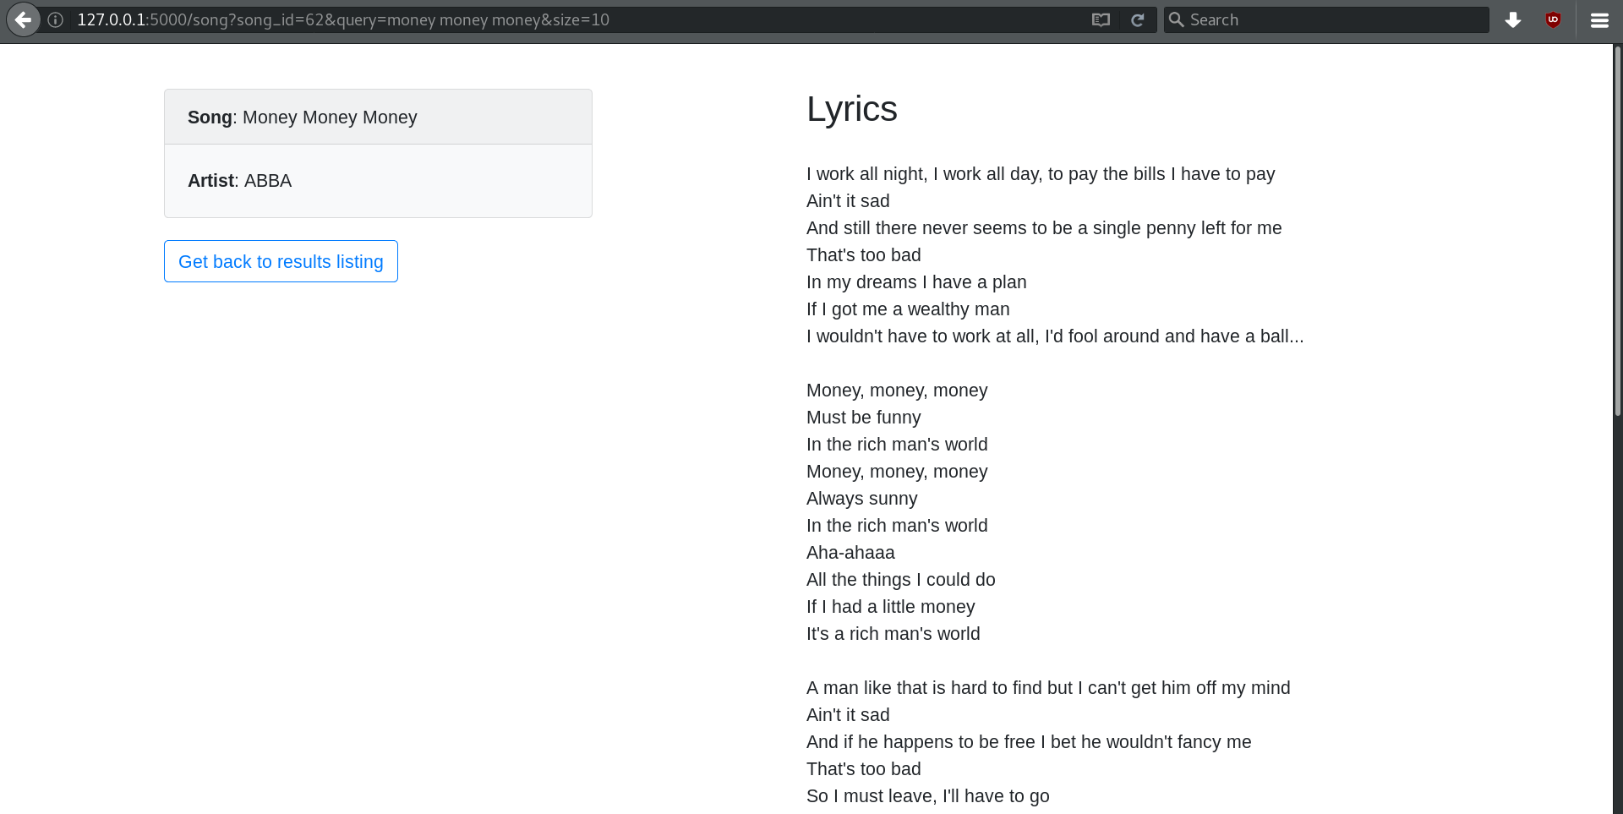
File Structure:
data folder – data that builds the model
src folder – source code
src/vectorspacemodel.py – The implementation of the vectorspace model
src/stringprocessing.py – The various pre-processing functions using NLTK
src/server.py – The file to run to start the program with the web-ui

Model: Vector Space Model with TF-IDF Weighting
A vector space model was used. The weighting used was TF-IDF
weight(term,document) = TF(term,document) * IDF(term)
TF(term,document) = {
0, occurances_of_term_in_document=0
1+log2(occurances_of_term_in_document), otherwise
}
IDF(term) = log2(no_of_documents/no_of_documents_in_which_term_occurs)

Length normalized vectors are stored in the model. The matrix’s dimensions are no_of_documents x no_of_words

The query is treated as a bag of words, and is converted into a TF matrix. To find the similarity(cosine similarity), dot product is used. The top k similar documents are retrieved using a heap.

Query and Document Pre-processing
The 3 standard processes done here are tokenization, stemming and removal of stop words. This is done using the NLTK package.NLTK has a standard list of stop words and this is used. Tokenization is done using a tokenizer that splits on spaces and punctuations. Stemming is done using porter stemmer.

However, our data set is of song lyrics, and people tend to remember song lyrics exactly as they appear. When they would want to search for a lyrics, they would give the query exactly as the lyrics appear in the song, and hence the processes of stemming and removal of stop words is probably not needed for our model. This was considered as one of the extra additions and is analysed below.

Performance:
Performance is analysed in terms of model build time and memory occupied
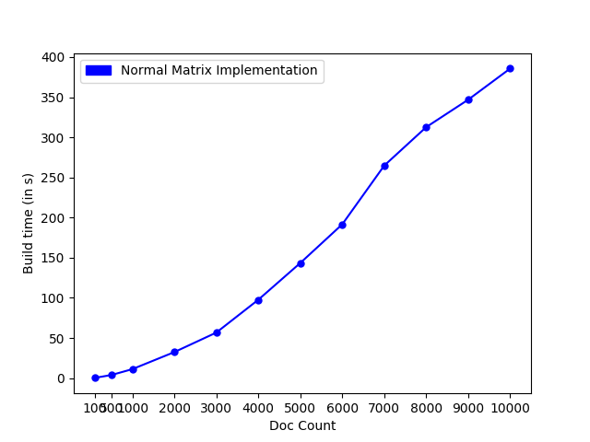
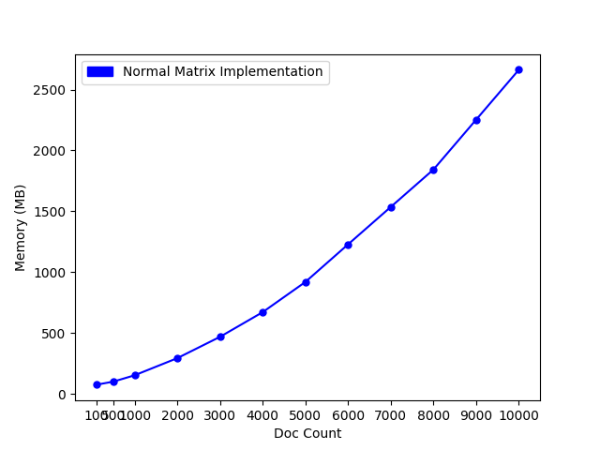

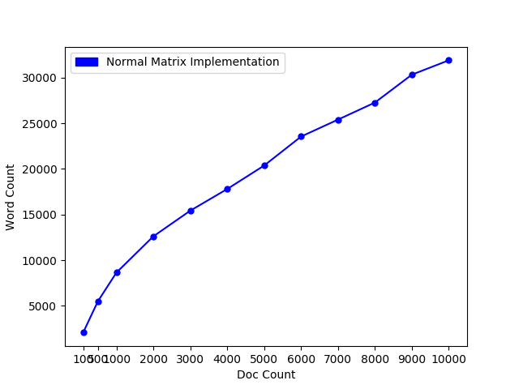
The number of words in the corpus against the document size is also plotted

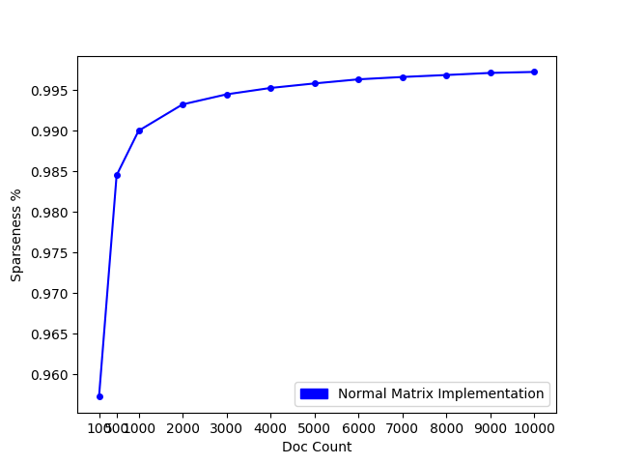

The sparseness of the matrix is plotted.

sparseness=no_of_zero_entries/no_of_entries

The sparseness of the matrix is very high(more than 99%). Hence one of the extra additions considered was using a sparse matrix implementation instead of a normal matrix implementation.

Extra Additions:
Graphical User Interface
A graphical user interface was built in the form of a web-app. This was done using the python package called flask. Nevertheless, the model is designed in such a way that it can be used with any kind of functions, with only needing to call appropriate functions to build the model and query the model

Sparse Matrix Implementation
The normal matrix implementation allocates memory for all elements in the matrix, and given that our matrix is very sparse, a lot of memory is wasted. Hence, the matrix was replaced with a sparse matrix. It’s build time and memory occupied is shown below.
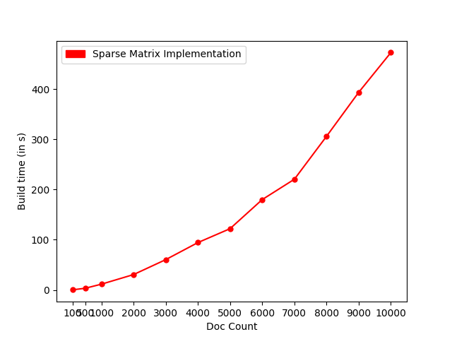
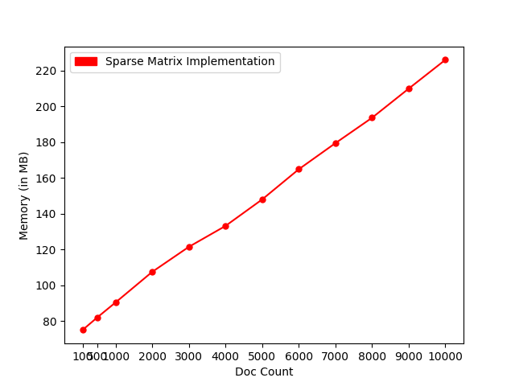

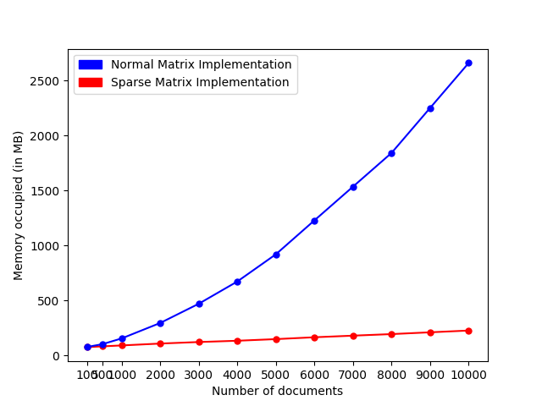

A comparison of the sparse implementation vs the non sparse implementation in terms of memory usage is shown below.

It is thus evident that the sparse matrix implementation saves heavily on the memory side.

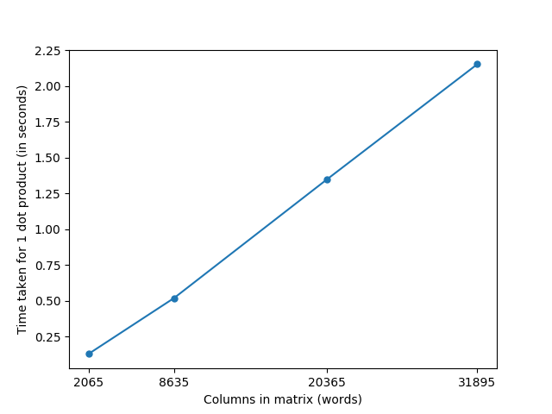
However, this came with it’s own problems. Due to the access times being higher, the time taken for a single query heavily increased
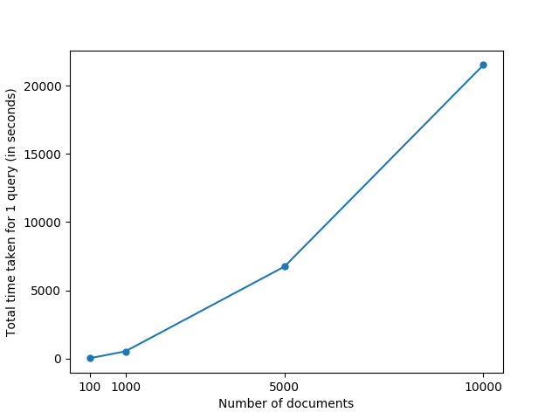
This shows the time taken for each dot product vs the the no of columns in the matrix. These kind of times are unacceptable.

This shows what the total query time would be. This is very likely due to the number of columns being very high.

10000 documents:
single dot product=2.15290s
total query time = 2152.9 s

The sparse matrix implementation was investigated, and the conclusion was that the query times were too high. Hence it was not considered.

Different Pre-processing methods
Given the nature of the queries, wherein people would prefer to enter the exact lyrics of the song, rather than any shortened version, it was considered to remove stemming and stop word removal.

4 different options are provided in the code, and any one can be chosen.
Neither stop word removal nor stemming
Only stop word removal
Only stemming
Both stop word removal and stemming

3 queries were taken from one song, and ran through the model with different options enabled. Below, are the similarity values of that song for different models.

As expected, stop word removal is not a suitable process to do. Stemming somewhat improves the accuracy, but only by a small margin. Overall, one could consider the stemming only option to be done.

Conclusions:
The performance with 10000 documents is as follows
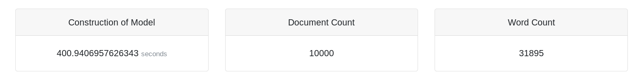
Memory usage is around 2.6GB.
Query times are around 0.35s on an average.
The sparse matrix implementation was not considered due to it’s big query times.
Stemming alone could be considered for the preprocessing part.

