Intelligent Classroom Automation with cv2 Driven IoT Solution

Dr. B Siva Nageswara Rao Asst Professor
Dept. of ECE Narasaraopeta Engineering College
Narasaraopet, INDIA bsnr2002@gmail.com
Sanampudi Pavan Kalyan Dept. of ECE
Narasaraopeta Engineering College Narasaraopet, INDIA pavankalyansanampudi@gmail.com
Pokala Naga Krishna Dept. of ECE
Narasaraopeta Engineering College Narasaraopet, INDIA nagakrishnapokala67@gmail.com

Potluri BhuLakshmi Dept. of ECE
Narasaraopeta Engineering College Narasaraopet, INDIA Potluribhumika6@gmail.com
Pilli Bhavana Dept. of ECE
Narasaraopeta Engineering College Narasaraopet, INDIA
pillibhavana3@gmail.com

Duddukuri Vachalya Dept. of ECE
Narasarsopeta Engineering College Narasaraopet, INDIA duddukurivachalya@gmail.com

Shaik Althaf Raj Dept. of ECE
Narasaraopeta Engineering College Narasaraopet, INDIA althafraj2003@gmail.com

ABSTRACT — This project introduces an innovative classroom automation system designed to enhance both the learning experience and energy efficiency through the integration of IoT (Internet of Things) technologies. Utilizing face detection and computer vision, the system tracks the number of students in real-time via a camera feed. Based on this data, the classroom is divided into distinct zones, and IoT-enabled fans are automatically controlled, turning on when students are present and off when they leave. This approach ensures optimal comfort while minimizing unnecessary energy consumption.
The system also features a web dashboard that provides real-time data on the number of students, zone occupancy, and fan status, allowing teachers and administrators to monitor the classroom environment remotely. To further engage users, real-time notifications are sent to mobile devices through a Telegram bot, providing updates on classroom activity and energy-saving efforts.

By combining IoT with face detection technology, this project offers a seamless and
interactive solution that enhances both the learning experience and sustainability in the classroom.

KEYWORDS— Classroom Automation, Face Detection, Computer Vision, Zone Identification, Fan Control, Real-Time Data, Web Dashboard, Telegram Bot, Occupancy Tracking, Energy Conservation, IoT (Internet of Things), Automation System.

INTRODUCTION
This project presents a smart classroom automation system that leverages IoT, face detection, and computer vision technologies to enhance both the learning environment and energy efficiency. The system uses real-time student tracking to control electrical devices in different classroom zones, turning them on when students are present and off when they leave, optimizing comfort while minimizing energy waste. With a web dashboard and real-time Telegram notifications, teachers and administrators can easily monitor classroom occupancy, fan status, and energy- saving efforts. This innovative solution seamlessly integrates technology and sustainability, offering a smarter, more efficient classroom experience.

RELATED WORK
In recent years, there have been several efforts to make classrooms smarter and more energy- efficient. Many schools and institutions have started using sensor networks and IoT devices to monitor things like lighting, temperature, and the number of people in the room. For example, occupancy detection systems are often used to automatically adjust lights or climate control based on how many students are present. While face detection and computer vision have been used to track student attendance, combining these technologies with electronic devices control and zone management for energy savings is a relatively new idea. Additionally, using a web interface to display real-time data and Telegram bots to send notifications directly to mobile devices is becoming a popular way to make systems more interactive and convenient. Although similar systems help improve comfort and save energy, integrating all these features in one system—like we do with face detection, zone identification, and real-time updates—brings a fresh, more efficient approach to creating smarter classrooms.

METHODOLOGY
This classroom automation system uses a combination of smart technology to improve comfort and save energy. The system works by continuously monitoring the classroom through a camera feed that detects the presence of students using face detection powered by OpenCV. When a student is detected, the system assigns them to a specific zone in the classroom, which is set up based on the room’s layout. Once a student is in a zone, the system automatically turns on the corresponding fan to keep the environment comfortable. If a student leaves the zone, the fan is turned off, helping to save energy.

To make it easy for teachers and administrators to monitor, all the data—like how many students are in each zone, the current fan status, and more—is displayed on a web dashboard. Additionally, the system connects to a Telegram bot, sending real- time notifications to mobile devices, so users can be instantly alerted when there are changes in the classroom, like when electronic components are turned on or off.
By using IoT technology, the system connects the smart fans with real-time data, making the classroom environment both more interactive and energy- efficient. It helps keep students comfortable without wasting power, all while allowing teachers to stay informed with minimal effort.
A proposed classroom environment is depicted with person surveillance done using a single camera .
Fig1. A Proposed Classroom Environment
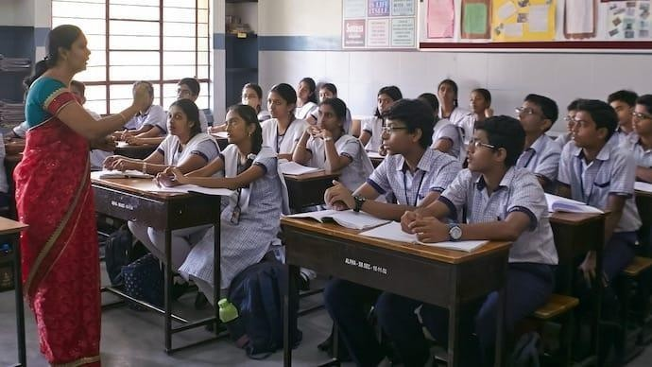
Block Diagram:
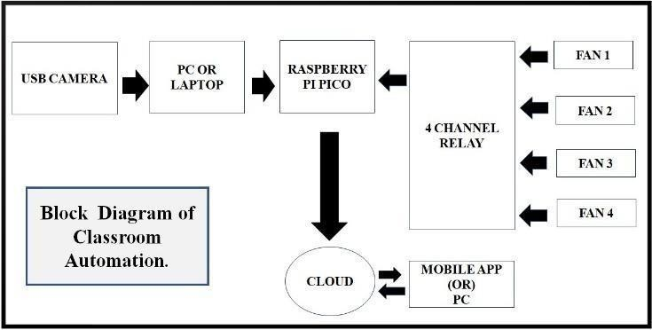
Fig 2. Architecture Diagram for Raspberry Pi Pico control.

PROPOSED SOLUTION
The intelligent classroom automation system integrates computer vision, IoT, and basics of machine learning technologies to create a smart and interactive learning environment. Utilizing OpenCV (cv2) for face detection, the tracks classroom strength, identify the seating zone of the students and occupancy, sending automated notifications via a Telegram bot.

A user-friendly web interface provides real-time updates on strength of the class, classroom occupancy, and zones occupied by the

students. The system regulates electrical equipment based on occupancy and zone detection data, promoting energy efficiency and a comfortable learning environment. By automating administrative tasks and enhancing the classroom experience, this system aims to improve the tracking students, increase teacher productivity, and promote student engagement.

PROPOSED HARDWARE SETUP
The system is designed around a Raspberry Pi Pico microcontroller and a 4-channel relay module. The Raspberry Pi Pico is interfaced with a personal computer (PC), which acts as the central processing unit. A camera module is used for demonstration purposes to take video feed. The camera senses human presence in the room, which prompts a response from the system. When detected, the Raspberry Pi Pico triggers a signal to the relay module, which subsequently turns on the assigned fans for that particular room, thereby automating the control of electrical devices based on occupancy. A telegram bot is useful to send a messages. The strength of the class, seating arrangement of students and occupancy of the class are reaches to each and every one as a message through the telegram bot. These values are also displayed on the web page.
On the contrary, when the person leaves the room, fans are automatically switched off. A relay module, which acts as an intermediary switching mechanism for controlling the electrical device, is attached to the Raspberry Pi Pico. The channel of the relay is responsible for controlling the action of these machines. In addition the relay module is used to enable the connection to high-voltage power supplies since the operating voltage range of the Raspberry Pi Pico is only up to 1.8V to 5.5V Connecting the Raspberry Pi Pico to high-voltage devices directly is not possible due to the wide voltage difference, so the relay module is a must- have device in this configuration.

Figure demonstrates the hardware structure, which involves a Raspberry Pi Pico and a 4-channel relay module.
The combination allows the Raspberry Pi Pico to control some electrical devices with the relay module acting as an on/off switching mechanism. Utilizing the relay module, the Raspberry Pi Pico can reliably switch the electrical devices on or off, achieving a smooth and automated control process.
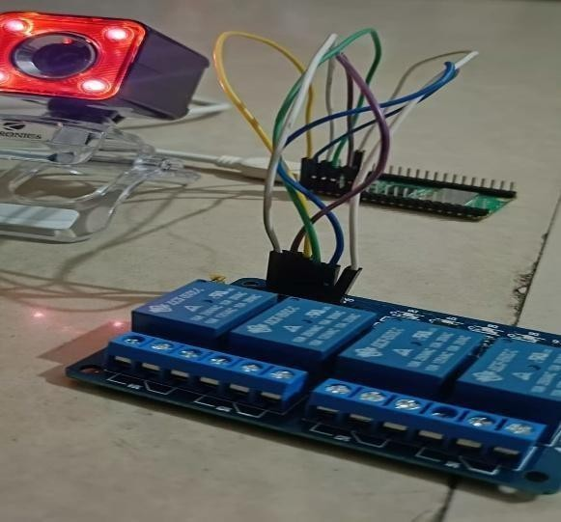
Fig 3. Proposed Hardware Setup
As shown in Figure a relay is an electrically controlled switch that enables automatic electrical equipment control with many benefits, such as increased stability, extended lifespan, and higher reliability. Therefore, relays are widely used in a wide range of applications, such as power protection, automation technology, remote control systems, and power electronics. One of the unique features of the relay is its integrated indicator light, which gives a visual indication of the operational status of the relay board. The output voltage range of the relay ranges from DC 30V/10A to AC 250V/10A. The size of the relay board is around 75mm in length, 55mm in width, and 19.3mm in height.

Also, the life of a general-purpose relay is conservatively put at more than 100,000 cycles, with some mechanical parts having life expectancies of as much as 1 million,10 million, or even 100 million cycles.

RESULTS AND ANALYSIS
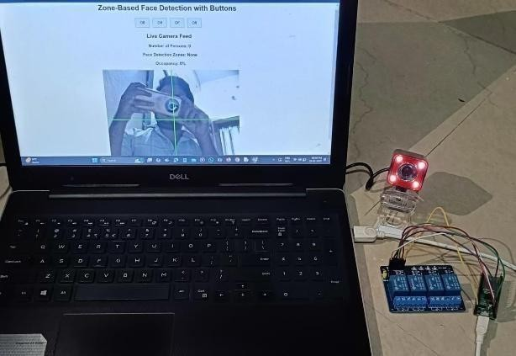
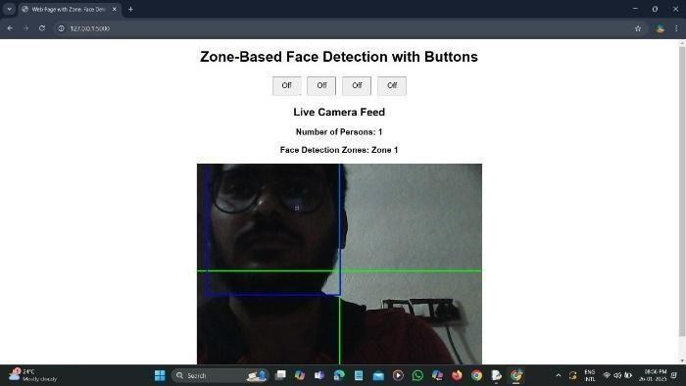

Fig 4 . Hardware setup
- Face detection and zone identification working.
- Accurate data processing and occupancy calculation.
- Telegram bot sending messages successfully.
- JavaScript code corrected for data fetching adisplay.

TELEGRAM OUTPUT
The Telegram bot integration in your code is quite simple:
Sending Messages: The /telegram_bot route uses the requests library to send a GET request to the Telegram Bot API. This request sends a message ("ask") to a specific chat ID (1698908542) using your bot's token.
Receiving Updates: The current code only sends messages. To receive updates or messages from the classroom. The teachers and administraters will monitor the classroom from remote places with this iot technology.
In essence: The Telegram bot acts as a way to send notifications or messages from you’re the classroom to a Telegram bot. You can extend this to receive messages and create interactive features.
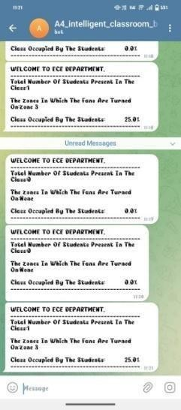
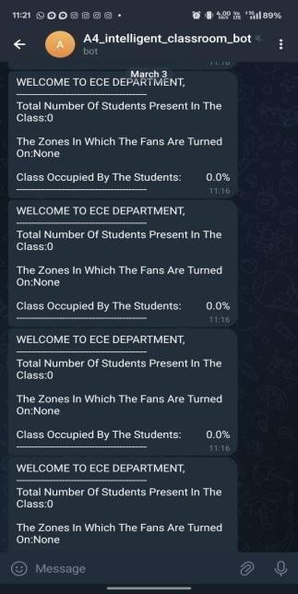
FIG 5.1: PHONE-1 FIG 5.2: PHONE-2

FIG 5.3 TELEGRAM

CONCLUSION
Finally, we conclude that this smart classroom system makes learning spaces more comfortable and energy- efficient without any manual effort. By using face detection and zone tracking, the system knows where students are sitting and automatically turns fans on and off as needed. This helps keep the room comfortable while also saving electricity. A PC dashboard shows real-time updates on the number of students, their locations, and overall classroom occupancy, making it easy to monitor everything. Plus, a Telegram bot sends quick notifications, so teachers and staff always stay informed. This system not only makes classrooms smarter but also helps create a greener, more sustainable future.

With this intelligent automation, schools can save energy, reduce costs, and improve the learning experience at the same time. Teachers and students don’t have to worry about adjusting fans anymore— the system does it for them. By bringing technology and education together, this project makes classrooms more modern and efficient. As schools look for smarter and eco-friendly solutions, this kind of automation can set a new standard for learning environments. This is just the beginning of how technology can transform education for the better.

REFERENCES
- Atu korala, K., Wijekoon, D. Tharu gasini
, M., Perera, I., & Silva, C. (2009). Smart Eye: An integrated solution for home automation, security, and monitoring via mobile phones. Proceedings of the 3rd International Conference on Next Generation Mobile Applications, Services, and Technologies (NGMAST 2009), 64-69.
- Nagendra Reddy, P. S., Kumar Reddy, K. T., Kumar Reddy, P. A., Kodanda Ramaiah, G. N., & Kishor, S. N. (2016). An IoT-based home automation system using an Android application. Proceedings of the 2016 International Conference on Signal Processing, Communication, Power and Embedded System (SCOPES), 285-290.

- Puthea, K., Hartanto, R., & Hidayat, R. (2017). A review of attendance marking systems based on face recognition. Proceedings of the 2017 2nd International Conference on Information Technology, Information Systems, and Electrical Engineering (ICITISEE), 303-308.

- Sfikas, G. (2016). Developing Intelligent Environments through IoT Technologies. Research Gate. Lohokare, J., Dani, R., Rajurkar, A., & Apte, A. (2017). Scalable Wireless Home Automation Systems for Smart Cities: An IoT Ecosystem Approach. Proceedings of the 2017 IEEE Region 10 Conference (TENCON), Penang, Malaysia, 1503-1508.
- Yuvaraj, C. B., Srikanth, M., Kumar, V.
S., Murthy, Y. V. S., & Koolagudi, S. G. (2017). Image Processing Techniques for Automated Attendance Tracking. Proceedings of the 2017 Tenth International Conference on Contemporary Computing (IC3), Noida, India, 1-3.

- Ani, R., Krishna, S., Anju, N., Aslam, M. S., & Deepa, O. S. (2017). Ensemble Classifier- Based Patient Monitoring and Diagnostic Prediction Tool Using IoT. Proceedings of the 2017 International Conference on Advances in Computing, Communications, and Informatics, 1588-1593.
- Binu, P. K., Thomas, K., & Varghese, N.
P. (2017). A Secure and Efficient Architectural Framework for IoT-Based Healthcare Systems. Proceedings of the 2017 International Conference on Advances in Computing, Communications, and Informatics (ICACCI), 487-493.

- Nahar, K. M. O., & Al-Khatib, R. M. (2017). EPSSR: A Novel Energy-Preserving System for Smart Rooms. Proceedings of the 2017 2nd International Conference on the Applications of Information Technology in Developing Renewable Energy Processes & Systems (IT- DREPS), Amman, Jordan, 1-6.

- Cuimei, L., Zhiliang, Q., Nan, J., & Jianhua, W. (2017). Enhanced Human Face Detection using Haar Cascade Classifier and Additional Classifiers. Proceedings of the 2017 13th IEEE International Conference on Electronic Measurement & Instruments, 483-487.

- Jisha, R. C., Jyothindranath, A., & Kumary, L. S. (2017). IoT- Based School Bus Tracking and Arrival Time Prediction System. Proceedings of the 2017 International Conference on Advances in Computing, Communications, and-Informatics,509-51.

