ECE 385 Final Project Proposal

Yuan Xinkai, Li Taoran

**Idea and Overview**

We propose to design and implement a music game on the FPGA. It’s a falling music game which has four pathways, notes falling from the top of the pathways and the player should press the corresponding keys on the keyboard when the notes fall right on the bottom of the pathways, the judgment line. The timing of the player’s press will be judged and scored. The scored level is divided as perfect, great, good, bad and miss according to the time difference between the note being in the position at the judgment line and the time of player press the corresponding key. The notes will be generated according to the rhythm of music. This game also supports multiple players to compete the scores with each other.

We will use System Verilog to implement all the algorithm core of the game and the controlling modules like VGA controller. We use NIOS II processor to implement the interface for keyboard, mouse and VGA. We will demonstrate the demo with the display of the whole game using monitor.

**Block Diagram**

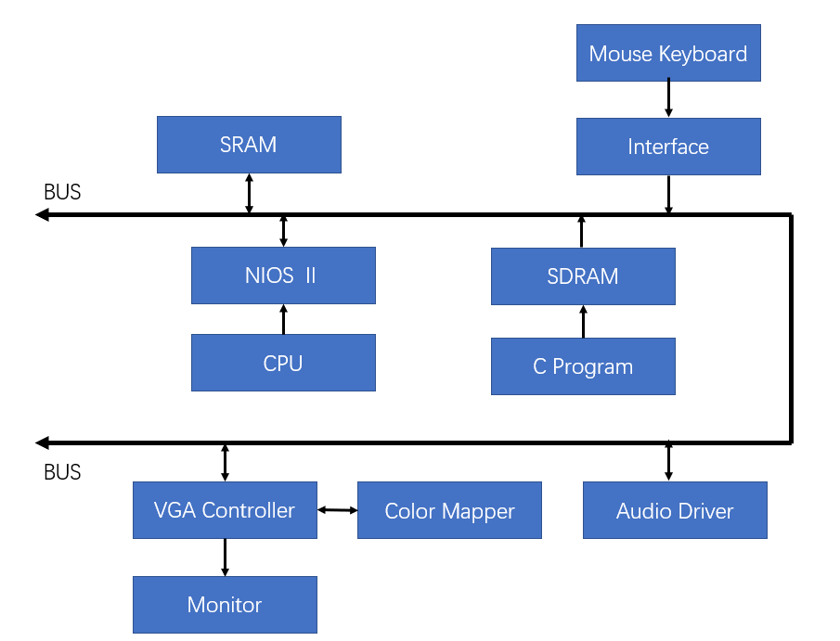

For the input module, we use keyboard and mouse for input, and NIOS II processor will run the C code for check of the input and respond to the input, then give the output to the VGA controller, which will then control the display. The background, figures and the notes will be stored in RAM.

**List of Features**

1. Baseline set of Features: the basic function is to implement the rhythm game with the pathways, notes and audio supports to work as a complete game part, use keyboard as player’s input and display them using monitor and audio module.
2. Additional features: a main menu and some other pages like setting will be included, and the mouse will be used. The game scene like the background and the pathways, the notes will be graphs with special effects added instead of pixel blocks. There will be also PvP mode which supports two players to play for the same song at the same time and compete with each other.

**Expected Difficulty**

We will implement the rhythm game with graphs displaying. The game algorithm, the display of monitor, the use of RAM, frame buffer, and all other basic functions of the software and hardware is worth **5 points**. The audio module will be added, which is worth **2 points.** We will use mouse and keyboard as the input, which is worth **2 points**. We will support multiple players for playing at the same time, which is worth **2 points**.

**Proposed Timeline**

We will have 4 weeks to finish the final project. We will finish the baseline set of Features in week 2 and 3, and the additional features will be implemented in week 4 and 5. The time for debugging is in late week 3 and late week 5.

|  |  |
| --- | --- |
| **WEEK** | **TASK** |
| **Week1: 12.7** | Finish the proposal. |
| **Week2: 12.9** | Reading all the related documents, review the previous labs, implement the display of the static game scene. |
| **Week3: 12.14** | Implement the C algorithm of the game, and finish display the game. Add the mouse and keyboard input. |
| **Week4: 12.21** | Add the audio module. Implement the above functions and debugging. Implement the main menu and setting scene of the game. |
| **Week5: 12.28** | Implement the multiple-player function. Finish all the functions in the proposal. Test the whole game for the stability. Add more functions if necessary. |
| **Demo: 1.3** | Finish all the function with no bug and survive the demo. Finish the report. |