Unix and C Programming
Assignment Report, Semester 2, 2018

By Tim Dempsey

Section 1: Function Descriptions

File: main.c

Function: int main( int argc, char* argv[] )
This function is the primary function for the Turtle Graphics program, acting as a flow of events that describes a smooth instance of a draw operation. The program takes the second command-line parameter after the executable, which represents the input file, and opens it before checking if it is NULL. If not, the flow of events begins, with calls being made to different files one by one, before any required clean-up is performed at the end. The user can view this function to get a rough idea of how the program works at a glance.

Function: void printDashes()
This small function prints “---\n” to the ‘graphics.log’ file at the start of the program instance, so that the log entries for each execution are partitioned in the logfile, which maintains a persistent state between executions.

File: file.c

Function: int readInFile( FILE* flPtr, LinkedList* list, int lineCount )
Called by main.c, this function marks the second reading of the input file, and serves to both validate the input file, and to populate the linked list with the required structs to carry out the draw operations later on. It ensures that if the file is invalid, the program will display an error message and exit; but if it is valid, it will determine the command that is displayed on each line and pass the information into a new command Struct, to be used later.

Function: int getNumLines( FILE* flPtr )
This function takes the input file and parses it once, to determine the number of lines in the file by counting the number of new line characters present, until the EOF character is reached. This value, returned as an integer, is used to control the readInFile function. The issue I was having was that using the feof() function in tandem with fscanf() was causing the program to reach the EOF and then attempt to go through the loop again; this way, this issue is avoided.

Function: void toUpperCase( char* str )
Valid input files can scramble the casing of the commands, so this function ensures that any command is handled entirely in upper case, by ensuring that the ASCII value of the characters fall within the A-Z range, and converting them otherwise. This ensures that any combination of uppercase and lowercase characters will be treated the same.

Function: int validateColour( char* val, int min, int max )
The acceptable range of foreground colours used in drawing the input file ranges between 0 and 15 for the foreground, and 0 and 7 for the background (both inclusive). This function serves the purpose of a) ensuring that the value falls within this range, b) ensuring the value is actually possible to render as an integer and c) that the character following is indeed the null terminator, denoting that the integer is valid.

Function: int validateReal( char* val )
Works in a similar fashion to validateColour, only using strtod() instead of strtol(), and is used for ensuring that the real number can a) be converted to real, and b) does not contain any invalid trailing characters by checking for the null terminator. Failure of either of these tests means the file is invalid; but there isn’t really an acceptable range as such for real numbers, so this qualification is ommitted.

Function: int validateChar( char* val )
Returns a success value as an integer if the length of the char* array is 1, which ensures that the printing functions can successfully print the pattern, and that the file is valid.

Function: void printLog( double x1, double y1, Tracker* currState, char* cmd )
This function controls the printing of any move or draw commands to a logfile, in order to chart the progresss of the cursor in a highly formatted manner. This assists with the debugging process, and if the DEBUG option is defined, can print out results to terminal as well.

File: linked_list.c

Function: LinkedList* createList()
Declares and initialises a pointer to a new LinkedList struct, whereupon all of the values are set to their default. Use of this function allows the linked list to be used as an ADT for storage when parsing an input file, which is then read sequentially later on to carry out the necessary commands.

Function: void insertLast( LinkedList* listPtr, void* contents )
Creates a new LinkedListNode struct through malloc(), and assigns the void* data field the imported contents, before having list→ tail point to this new node. In this context, it is used to populate the list with command structs as each line of the input file is read, creating a sequential in-order list of instructions.

Function: void* removeFirst( LinkedList* listPtr )
When reading through the list after its creation, each node is removed from the start of the list so that the command struct it contains can be disassembled and the data it contains executed to initiate the relevant functions. It also serves the purpose of freeing each node after the data has been extracted, cleaning up the list in the process.

File: Utility.c

Function: Tracker* createTracker()
This function declares, mallocs and sets to default a new pointer to a Tracker struct, which is used to keep track of all the fields needed to maintain position between commands – foreground and background colours, positions on the x and y axis, the current angle and the current pattern. It is only called once, and this pointer is then passed around the program as needed.

Function: void readList( LinkedList*, Tracker* currState )
The second main phase of the program, after having parsed the file to store the information in the linked list, is to read the contents of the linked list, dealing with each node in turn. This function declares a new CmdStruct, which is assigned each node in a loop as they are removed from the list. Each struct’s function pointer is triggered with the accompanying data, and the node is freed. As a result, the operations are completed and the list is processed until it is deleted.

Function: void moveCursor( char* inDistance, Tracker* currState )
One of the requirements for the program is that the cursor be able to move without drawing a line, and this function is designed to do this by importing a distance value, storing the old x/y coordinates in variables, and then calling calcMovement() to update the current state of the cursor, achieving the movement effect. This is useful when transitioning from one part of the terminal canvas to another without visually marking the screen.

Function: void drawLine( char* inDistance, Tracker* currState )
Similar to the above moveCursor function, but uses the current pattern to plot characters on the screen at the given coordinates, through use of the provided line() function in effects.c. Repeated use of this function is designed to render a printed version of the input file to screen, while updating the logfile accordingly with the coordinate changes.

Function: void plotPoint( void* currState )
Simple function, the memory address of which is passed to the line() function; takes the Tracker* pointer as a parameter so that it has access to the current pattern, which is then printed to screen each time the function is called.

Function: void changeAngle( char* angleChange, Tracker* currState )
This function updates the current angle setting based on the incoming angleChange variable, which is parsed through use of atof(). It is designed to keep the angle setting between 0 and 360 degrees, through the use of two separate while loops that add or subtract 360 from the current angle depending on whether the current angle is below or above 360 degrees for each iteration. This ensures that whenever the angle is used for calculations, it is valid and fulfils the brief.

Function: void setFG( char* inColour, Tracker* currState )/ void setBG( char* inColour, Tracker*
currState )
These two functions – put together owing to their identical purpose – take in a String representation of an integer, which is parsed with atoi(), before it is passed to the pre-written set() functions in effects.c to update the current colour.

Function: void setPattern( char* inPattern, Tracker* currState )
This function consists of a single line, accessing the current pattern that the Tracker* points to, and setting it to equal the first index of the imported char* (which will have a length of 1 regardless).

Function: roundReal( double num )
In order to pass the required parameters to the line() function in effects.c, the x/y coordinates have to be integers, so this function ensures that the integer closest to each real is the result through use of floor() and ceil() functions from the math.h library. The rounded double is returned to the drawLine() function from whence it was called, and they are cast to ints in the parameters.

Function: void calcMovement( char* inDistance, Tracker* currState )
Updates the current x and y coordinates using a combination of the imported distance value, PI and the sin/cos() functions from math.h. Determining the distance of each movement is dependent upon the angle that the cursor is moving, so this function determines this for both x and y with cos and sin respectively, as specified in the brief.

Section 2: Conversion of Input File to Coordinate System

In order to create this program, I used a two-part system – storing from file and reading from list. In order to parse the file, I defined a struct called CmdStruct, which contained a function pointer and a char pointer to store the two separate strings from each valid line. Once the first string of each line was determined, I would pass the function pointer the memory address of the relevant function – for example, if the string was “ROTATE”, I would pass &changeAngle to the function pointer. I then store the second string as a char* in the struct’s ‘value’ field, to be typecasted later.

For the second part, I initiate a while loop and remove the first node from the list with each iteration. Each node at this point contains a struct representing its line of the input file, so I call the function pointer from the struct, passing it the ‘value’ field as well as the Tracker* pointer, and this process repeats until the list is empty.

In terms of the coordinates, both the moveCursor and drawLine functions call calcMovement, which takes in the distance as a value (i.e. MOVE 10, or DRAW 5). I convert this value to a double, and use the cos() and sin() functions from the math library to determine the x and y values respectively. The default position of x/y at the start of the program is (0,0), which represents the top left hand corner. Normally, a positive y-value would send the cursor upwards, but this caused issues when printing, so I subtracted the calculated sin value from the current y value to simulate downwards movement.

ALTERNATIVE APPROACH: In terms of an alternative, I could have foregone the use of function pointers and a linked list entirely, choosing instead to directly call the functions after having parsed the command from file, but this would have been against the spirit of the brief (and not as cool).

Section 3: Sample Input and Output

Command line input: ‘./TurtleGraphics test.txt

TEST.TXT CONTENTS:
1. rotate -45 10. ROTATE 90
2. move 30 11. DRAW 10
3. FG 1
4. Pattern #
5. DRAW 10
6. Rotate 90
7. draw 10
8. ROTATE 90
9. dRAW 10
SCREEN OUTPUT:

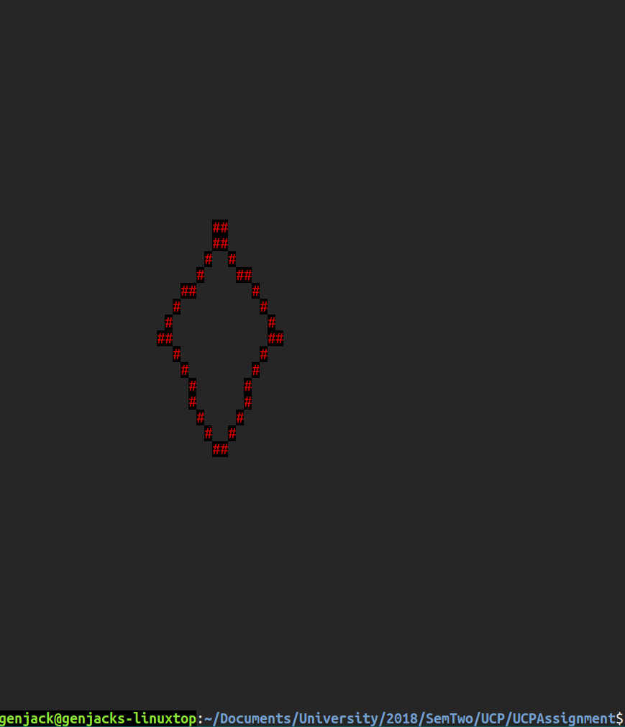
GRAPHICS.LOG:
