**Prince Louis M. Jaylo BSIT 3-C IT Elec 1 – Web Development**

**Documentation:** Robiel Prince Café Website using “Populating Pages”

**1. Overview:**The Robiel Prince Café website simulates a dynamic café application built with Laravel. It features:

* A homepage showcasing the café’s highlights and best sellers.
* A menu page listing all available items with ratings, prices, and images.
* Dynamic routing to personalize the user experience (e.g., username in URL).

**2. Rendered Web Pages:**

**A. Home Page**

**homepage.blade.php  
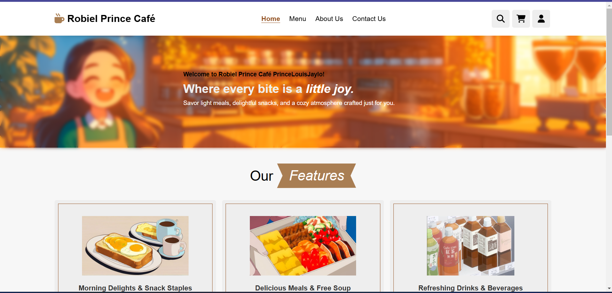  
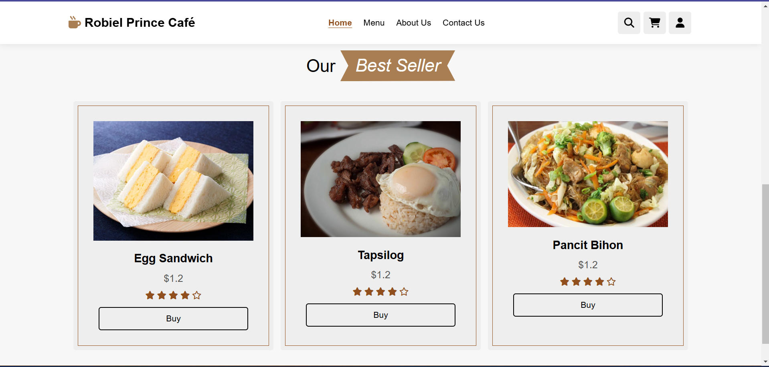**The homepage greets the user by name for example my name PrinceLouisJaylo and highlights the café’s main features, including best sellers with dynamic data passed from the controller.

**B. Menu Page**

**menupage.blade.php  
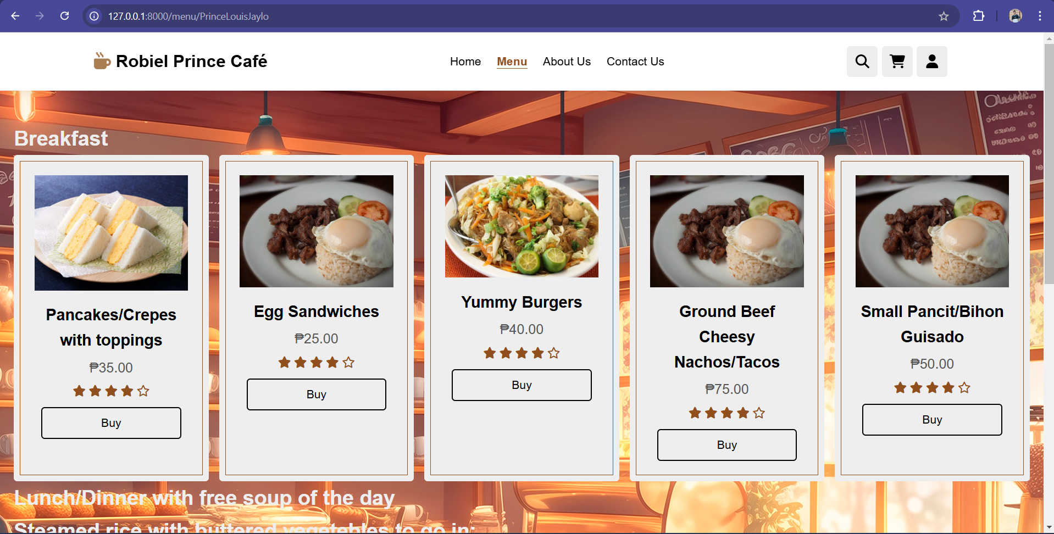**The menu page displays a dynamically loaded list of food items. Each item shows an image, name, price, and rating, fetched via the controller.

**3. Controllers:**

**A. HomePageController.php  
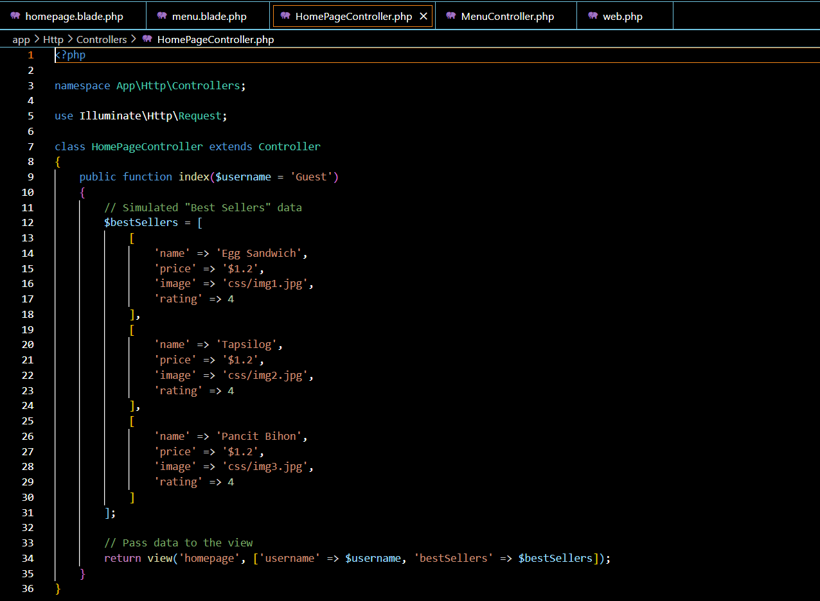  
Logic Explanation:**

* Simulates fetching "Best Seller" items from a database as an array.
* Uses $username parameter to personalize the user experience.
* Passes the bestSellers data and username to the Blade view.

**B. MenuController.php  
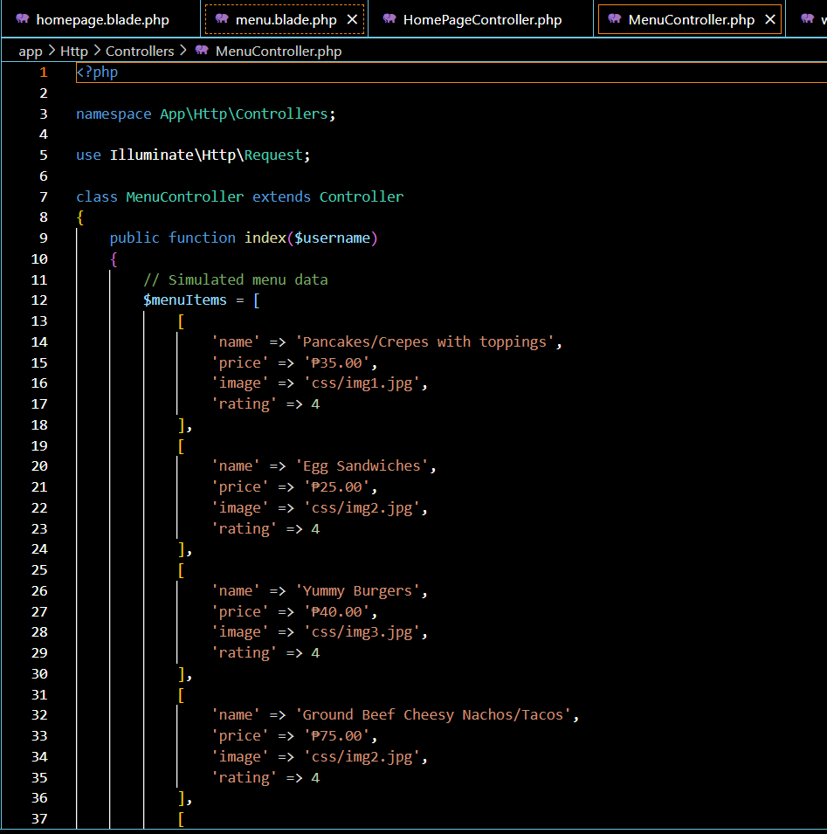  
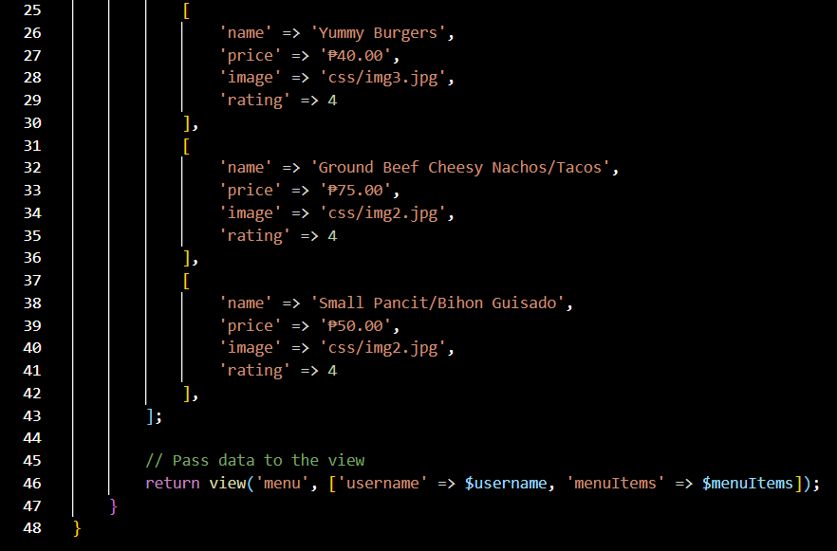  
Logic Explanation:**

* Simulates fetching menu data as an array.
* Passes the menuItems array and $username parameter to the Blade view.

**4. Routes:  
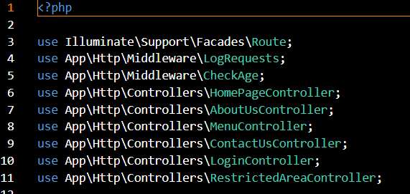  
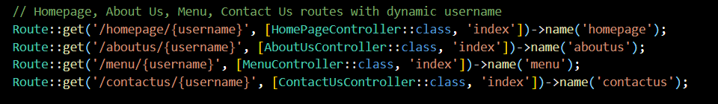  
Explanation:**

* Both routes use dynamic URL parameters ({username}) to pass the username to the controllers.
* The controllers handle these parameters and pass them to the corresponding Blade views.

**5. Blade Templates:**

**A. homepage.blade.php  
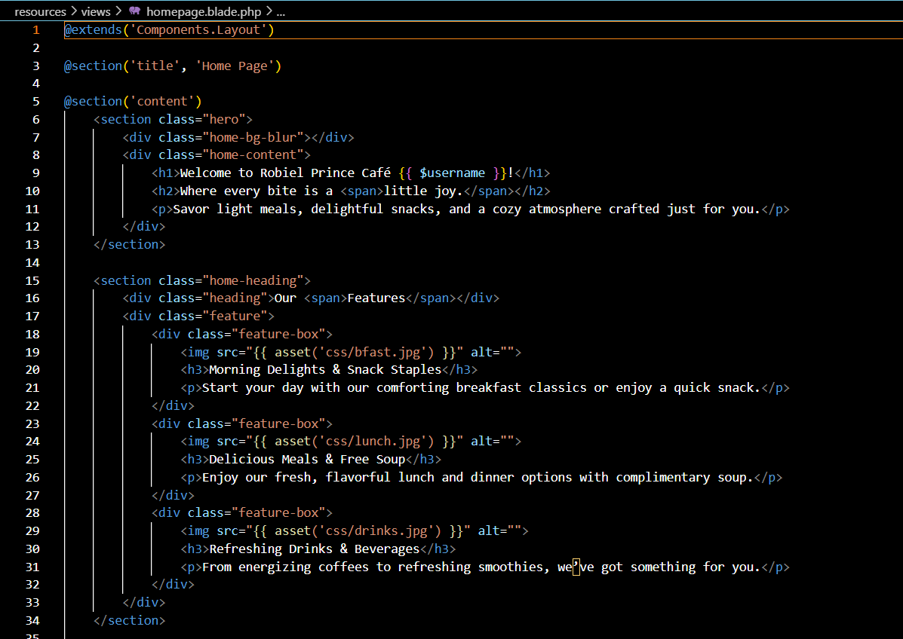  
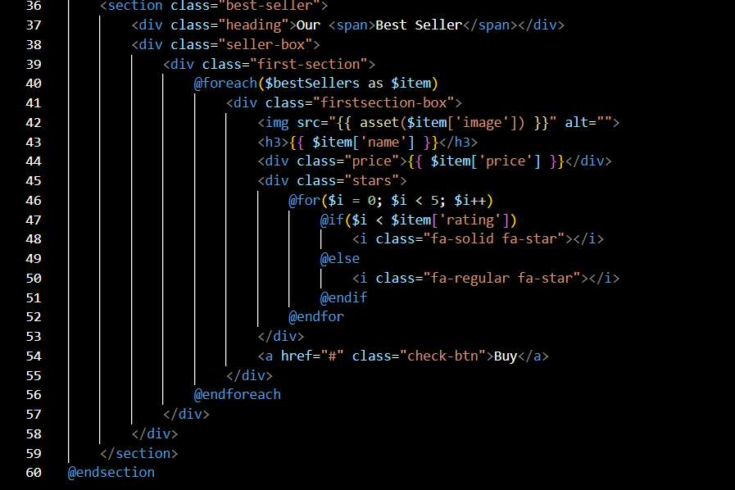**

**Description:**

* Loops through the menuItems array passed from the MenuController.
* Dynamically renders menu items with personalized content.

**B. menu.blade.php  
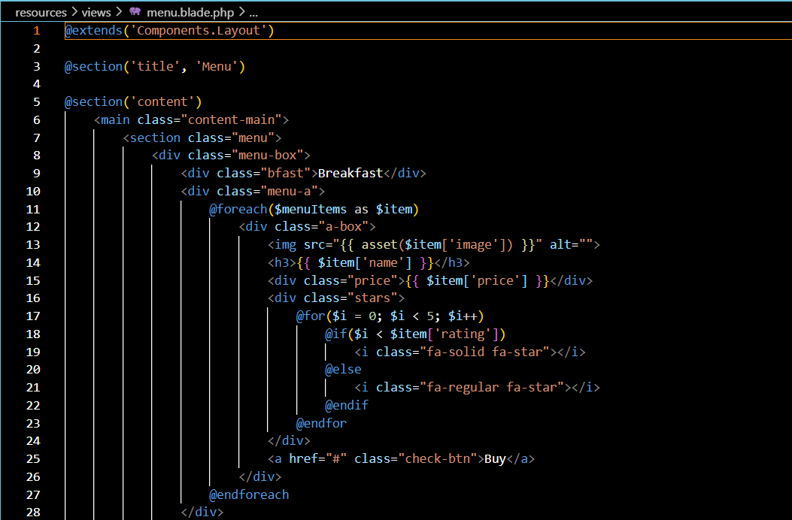  
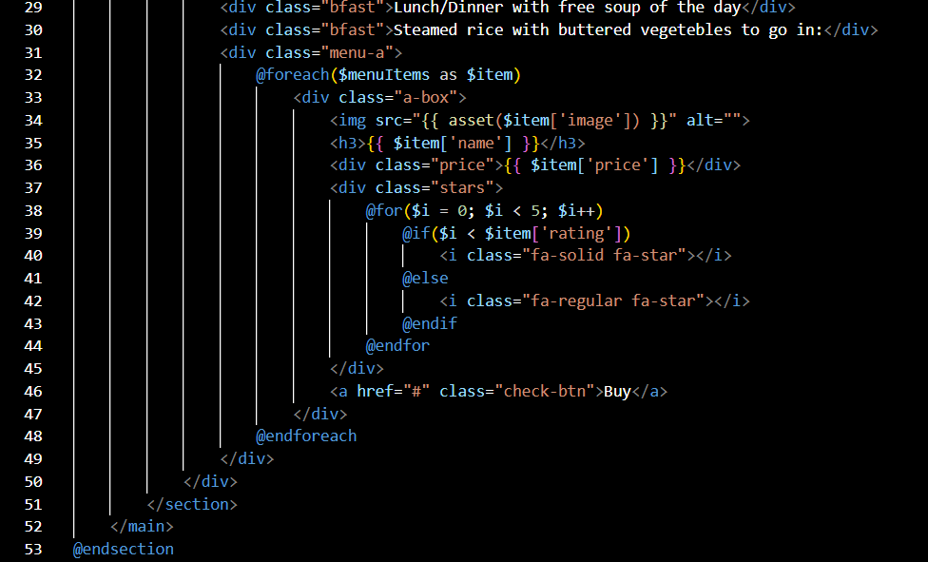  
Description:**

* Loops through the menuItems array passed from the MenuController.
* Dynamically renders menu items with personalized content.

**6. Things I have learned in this activity:**

1. **Dynamic Routing:** Using parameters in routes enables personalized content delivery.
2. **Blade Templates:** Simplifies dynamic rendering of data using loops and conditionals.
3. **Simulated Database Access:** Data arrays effectively replicate database content during development.
4. **Reusability:** Laravel controllers and views facilitate modular development, making the code reusable.