インタラクティブCG

レポート３

2017/12/26締め切り

情報化学類

201511386

関田現喜

三角形交差

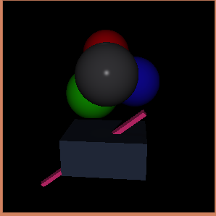

球交差

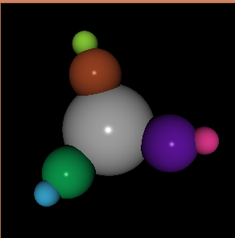

フォンのモデル

複数光源、距離減衰、方向性光源、点光源

シャドウ減衰

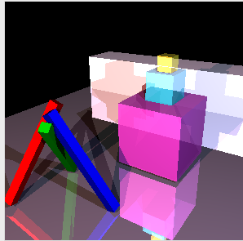

反射

屈折

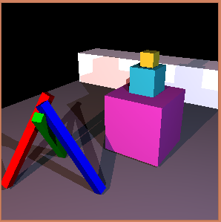

自分で作ったray

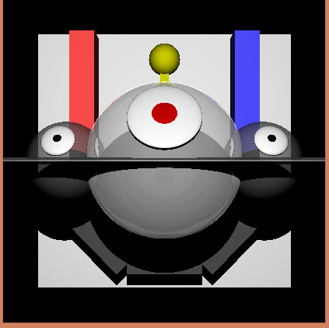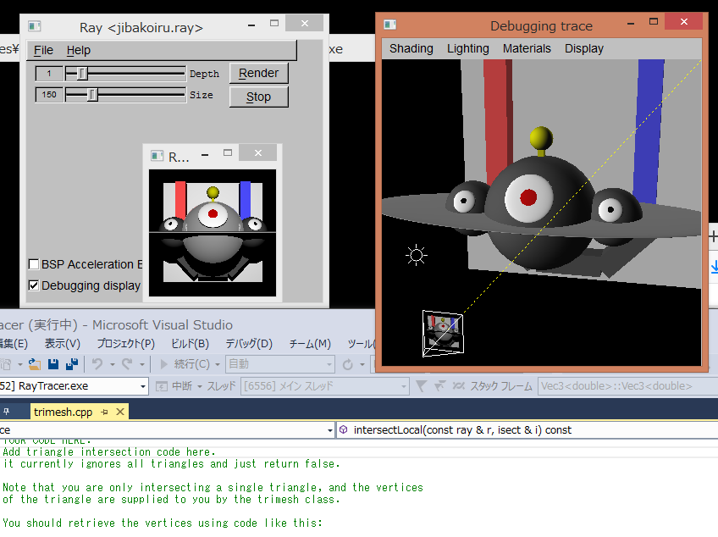

本体の部分はほとんどsphereで作成した。

背景の部分をboxで作成した。

以下にプログラムを乗せる。

SBT-raytracer 1.0

camera {

position=( 0.0,0.0,-10.0 );

viewdir=( 0.0,0.0,1.0 );

updir=( 0.0,1.0,0.0 );

fov=45;

}

point_light {

position=( 0,2.0,-10.0 );

color=( 1,1,1 );

constant_attenuation_coeff= 0.25;

linear_attenuation_coeff = 0.003;

quadratic_attenuation_coeff = 0.00004;

}

scale( 2,2,2,

sphere {

material={

diffuse=( 0.3,0.3,0.3 );

ambient=( 0.2,0.2,0.2 );

transmissive = (0.5,0.5,0.5);

specular = (0.3,0.3,0.3)

};

}

)

translate( 2.5,0,0,

sphere {

material={

diffuse=( 0.3,0.3,0.3 );

ambient=( 0.2,0.2,0.2 );

transmissive = (0.5,0.5,0.5);

};

}

)

translate( -2.5,0,0,

sphere {

material={

diffuse=( 0.3,0.3,0.3 );

ambient=( 0.2,0.2,0.2 );

transmissive = (0.5,0.5,0.5);

};

}

)

scale( 6.5,0.1,2.5,

sphere {

material={

diffuse=( 0.7,0.7,0.7 );

ambient=( 0.2,0.2,0.2 );

transmissive = (0.5,0.5,0.5);

};

}

)

rotate( 1,0,0,0.5,

translate( 0,0,-2,

scale( 0.8,0.8,0.1,

sphere {

material={

diffuse=( 1,1,1 );

ambient=( 0.2,0.2,0.2 );

};

}

)))

rotate( 1,0,0,0.5,

translate( 0,0,-2.01,

scale( 0.5,0.5,0.1,

sphere {

material={

diffuse=( 0.8,0,0 );

ambient=( 0.2,0.2,0.2 );

};

}

)))

translate( 2.5,0,0,

rotate( 1,0,0,0.5,

translate( 0,0,-1,

scale( 0.4,0.4,0.1,

sphere {

material={

diffuse=( 1,1,1 );

ambient=( 0.2,0.2,0.2 );

};

}

))))

translate( 2.5,0,0,

rotate( 1,0,0,0.5,

translate( 0,0,-1.01,

scale( 0.2,0.2,0.1,

sphere {

material={

diffuse=( 0,0,0 );

ambient=( 0.2,0.2,0.2 );

};

}

))))

translate( -2.5,0,0,

rotate( 1,0,0,0.5,

translate( 0,0,-1,

scale( 0.4,0.4,0.1,

sphere {

material={

diffuse=( 1,1,1 );

ambient=( 0.2,0.2,0.2 );

};

}

))))

translate( -2.5,0,0,

rotate( 1,0,0,0.5,

translate( 0,0,-1.01,

scale( 0.2,0.2,0.1,

sphere {

material={

diffuse=( 0,0,0 );

ambient=( 0.2,0.2,0.2 );

};

}

))))

translate(0, 2.3, 0,

scale( 0.2,0.6,0.2,

box {

material={

diffuse=( 0.8,0.8,0 );

ambient=( 0.2,0.2,0.2 );

};

}

))

translate(0, 2.6, 0,

scale( 0.4,0.4,0.4,

sphere {

material={

diffuse=( 0.8,0.8,0 );

ambient=( 0.2,0.2,0.2 );

};

}

))

translate(0, -4, 6,

scale( 3, 1, 1,

box {

material={

diffuse=( 0.3,0.3,0.3 );

ambient=( 0.2,0.2,0.2 );

};

}

))

translate(2.6, -3.1, 6,

rotate( 0,0,1,0.8,

scale( 3, 1, 1,

box {

material={

diffuse=( 0.3,0.3,0.3 );

ambient=( 0.2,0.2,0.2 );

};

}

)))

translate(-2.6, -3.1, 6,

rotate( 0,0,1,-0.8,

scale( 3, 1, 1,

box {

material={

diffuse=( 0.3,0.3,0.3 );

ambient=( 0.2,0.2,0.2 );

};

}

)))

translate(3.3, 2, 6,

scale( 1, 6.4, 1,

box {

material={

diffuse=( 1,0.3,0.3 );

ambient=( 0.2,0.2,0.2 );

};

}

))

translate(-3.3, 2, 6,

scale( 1, 6.4, 1,

box {

material={

diffuse=( 0.3,0.3,1 );

ambient=( 0.2,0.2,0.2 );

};

}

))

translate(0,0,10,

scale(13,13,0.1,

box {

material={

diffuse=( 0.9,0.9,0.9 );

ambient=( 0.2,0.2,0.2 );

};

}))