**Mr. Shota Awata—A zero-based blockchain entrepreneur without inheriting family business**

Mr. Shota Awata, a Ritsumeikan University in Japan graduate, co-founded the JCDA (Japan aging’s society of care and medical research association) with Mr. Nakamura Shuichi, who served as the Chief of Board of elderly health of Ministry of Health, Labor, and Welfare of Japan, together with Mr. Takashi Uji who served as NTT Corporation Senior. Besides, Mr. Shota is the CEO of Genkicell Chain in Japan.

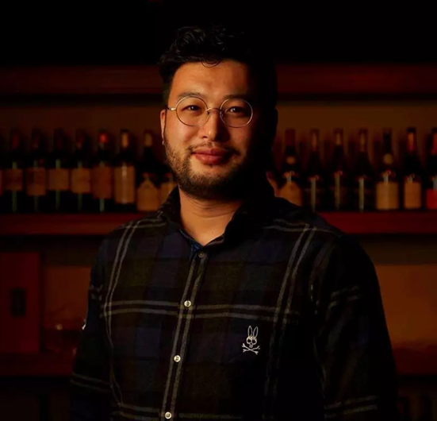

Mr. Shota is the eldest son of Toridoll consortium, renowned in Japan. Subsequent to securing his Master degree of Ritsumeikan University, rather than joining his family business, he joined Synergy Marketing, a medical consulting enterprise. Mr. Shota opted for working in the healthcare sector since he had been experiencing major diseases in the period of his high school. Together with that, he had hopes of putting forward a systematic approach, which could sustain healthful conditions, away from illness.

Right from the time of working in the medical consulting sector in the year 2013, Mr. Shota has realized the fact that Japan's advanced medical standards, combined with the Internet industry, will unquestionably break through the whole industry. Currently, both the medical and health sectors are primarily based on the treatment, nevertheless, physical examination and self-diagnosis tests are incapable of forming continuous records sporadically. How to combine the Internet industry for the accomplishment of the transition from the treatment to prevention has emerged as the key emphasis of his research work. Owing to the rapid growth of China's Internet industry, Mr. Shota learned the Internet+ conception, coinciding with his philosophy. Mr. Shota made a decision to start a curve business, originating from a foreign country.

At the beginning of the year 2017, Mr. Shota aimed at valuing the health-related data, together with attaining the value loop with the help of Internet applications based on the Internet of Things terminals as well as offline agencies. Furthermore, in the meantime, the big data collection mark was classified as a starting point. Mr. Yoshinobu Shijo promoted the project growth as the CTO of Genkicell Chian.

Mr. Shijo developed a block-based technology for the collection and marking of health data from multiple sources in a bid to develop a personal health living record (PLHR), thereby realizing the marking and classification of personal health data and making sure both the consistency and standardization of data. In the mechanism of entrepreneurship, Mr. Shota invited Mr. Keichiro Yoshida, a senior analyst at Nomura Securities, for the purpose of forming an entrepreneurial iron triangle.

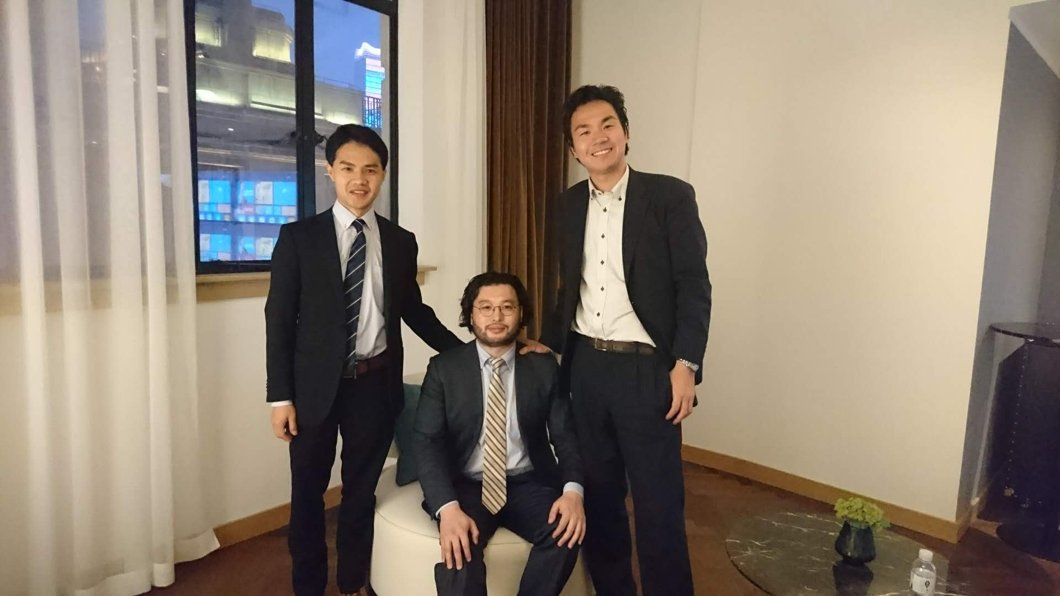

The Genkicell team started pouring heavy investment in the technological research and development right from the commencement of February 2017, aimed at strictly regulating itself through the supervision of the people and the government. Following a year-long accumulation, the team has bagged the preliminary results in terms of contacts, resources, data, technology, funds, etc. Besides, the project has appeared on the ground as a preparation for landing as well.

Conventional medical data, at a high-sensitivity level, deals with the writing habits of doctors, in addition to hospital cooperation attitudes, and government authorization procedures. There is quite a low probability of landing a corresponding project; in addition, the GCL vitality chain makes use of the non-high-sensitivity data as the source of data. The project has secured extensive amount of uninterrupted personal health medical data with the help of the cooperation with the Toyohashi City Government of Japan. In the meantime, it has acquired strategic benefits in terms of policy compliance and industry presence, being a member of the JCDA. Furthermore, Genkicell Chain makes a pivotal strategic partner of research institutes, for instance, Healtheone, Toyohashi University of Industrial Technology, and BIC, which are termed as renowned online health cloud platforms. They possess robust technical reserves, together with advanced technology research and development.

Mr. Shota Awata, the founder of Genkicell Chain, cast light on the fact that the Genkicell Chain is going to publicize project information between June and July 2018, followed by officially unveiling the public’s viewpoint.

The Genkicell Chain has garnered extensive attention of major cooperative enterprises in Japan, China, Southeast Asia, Europe and the United States. This time, through an entirely cautious appearance in the eyes of the public, it is worth looking forward to wait.