1.There will be three user-types admin/user/deck profile.

At the moment ;

We have admin and user. User can add any deck profile to his account.

To be changed;

We will have to manage list of users and list of deck profiles in admin.

And admin will “link” existing deck profiles to the users.

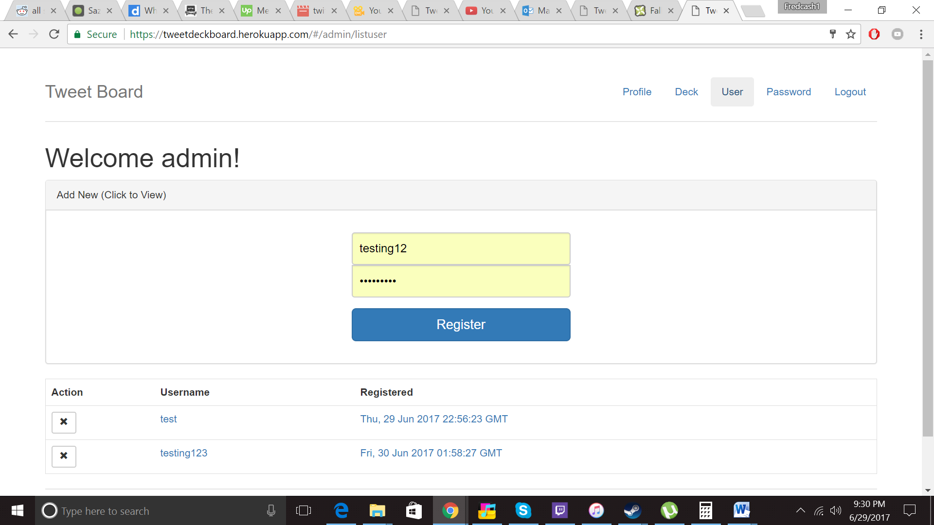

Maybe there we need a checkbox below the password field to check user or deck profile.

And if we check the box, we will need to authenticate the deck profile as we do now when we add deck profile to user.

2.User

User will be able to only see the deck profiles linked to it and the timer rows.

(So just remove the adding part in current script)

And once user click “Submit Deck row for approval”, it will send notification (email to the linked deck profiles)

3.Deck Profile

Deck profile is just for the approval of the submitted deck row.

For the notification, I think we’d better add “email” property to each deck profile.

To summarize

**Features of Admin:**

Add User/Deck profile(We need authentication&verification of deck here)

Link deck profiles to user(instead of adding deck to user; we don’t need authentication of deck profiles here as we did before)

**Features of User**

See the information(linked deck profiles,timer rows)

Submit timer rows for approval request.

**Features of Deck**

Approve/Decline the submitted timer row from user