Assignment Two

Introduction
In this assignment, you will continue to build on the project by adding new functionality. We will be adding player control and rendering only objects that need to be rendered.
At the end of this assignment, you will have an entity that will be controlled by keyboard input, and enemy object being rendered, and projectiles being spawned on button press (multiple of which will appear on screen).

Getting started
All required setups took place in Assignment 1. Check there if there seems to be something missing.

Assignment two

Part 1 (25%)

Part 1A
Not everything defined in the Blender level needs to be rendered all the time (such as the projectile). Therefore, we need to adjust our rendering to only render things that are being told to render. To do that, we are going to make use a custom property that’s already on our assets, “gameType.”

Let’s start by adding a new bool to MODEL_ENTRY and LEVEL_MODEL to represent that a model is dynamic and not part of the static level geometry. Currently, the only objects that have assigned gameType are the dynamic objects, so you can just check to make sure it’s not ‘none’. EntityData.find("gameType") lets you find entries in json data.

ReadGameLevel and ReadAndCombineH2BS are the 2 functions that handle setting the 2 different classes we’ve updated. Update these functions to set that a model is dynamic.

Part 1B
Now that we can tell the models that aren’t part of the static level geometry, let’s get them hidden from the renderer until we are ready to show them. Create a new empty component in Draw namespace to represent the DoNotRender tag.
Back in the GPU level component, for each mesh that is part of a model that is dynamic, emplace the new tag on the mesh’s entity.

Now to ignore these entities for rendering, let’s modify the renderer by updating the group we created to get all the drawable entities. Remember, we mentioned the 2nd parameter of the group creation in Assignment 1. Now we’re going to use it. Use entt::exclude<Component> to exclude entities that contain listed components from the group.

At this point, if you run the project, you should only see the 4 walls and the floor. The enemy, projectile, and player models should now be hidden.
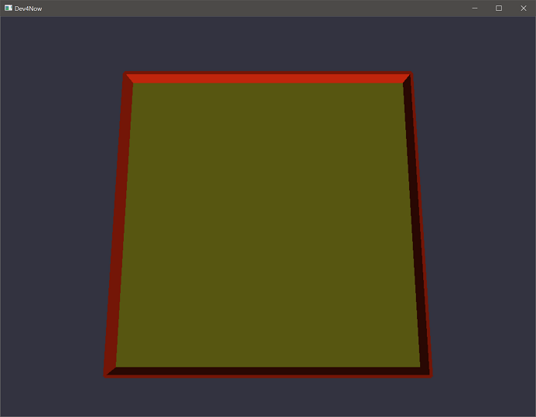

Part 1C
To be able to create new entities that use the dynamic models we just labeled, we need a way to assign these models to an entity. To do that, we’re going to create a ModelManager component that holds a list of MeshCollections. Each mesh will be represented by its own entity, so MeshCollection should contain a vector of entities. ModelManager should therefore contain a way to get these collections by name (remember the different containers we used in Assignment 1. One of those is perfect to access data off a string), since we will be using the blender name of the objects to find these models.

Note: MeshCollection is a list of all entities that represent the meshes of a given model object. Example: the Bullet has 2 meshes; the blue ball and the pink ring.

Now, before we loop through all the blender objects: emplace a ModelManager component on to the ctx entity that other data-only singletons are on (such as Input and DeltaTime). Grab the list of collections from that component so that we can add to it in the loop.

For each object, start a new MeshCollection. For each mesh in that object, if the object is dynamic, add that mesh entity to the collection. Once all the meshes are created, add that collection to the ModelManager under the object’s blender name, again if the object is dynamic.

I strongly recommend creating on_destroy somewhere to handle the destruction of the MeshCollection component and adding a helper function in the next part to get the copies of renderable entities. If you don’t handle the on_destroy of the MeshCollection now, you might run into some strange behavior in the next assignment. There won’t be anyway to test this yet, but you’ll need it next week.

At this point, you still should only see the floor and the walls, but you’ve completed the setup that will allow you to create new entities on the fly with models attached to them.

Part 2 (35%)
Now we will start adding Game components. We will add some new components to the GameComponents file. Since we will be adding the player and the starting enemy entity in this part, let us go ahead and create a Player and Enemy component to tag the new entities with. You might as well add a Bullet component too since we’ll need that eventually. These components will be empty as they are acting as tags to identify entities. We will also add a Transform component that holds a matrix to represent the transform of these game objects.

In main.cpp, it is time to start adding code to the GameplayBehavior method. Create two new entities, one for the Player and one for the Enemy. Emplace a MeshCollection and a Transform component of both entities. Emplace the correct tag (Player or Enemy) to these as well.

Both the Player and Enemy have entries in the default.ini to find model names that will need to be looked for, so grab a reference to the config file here. We will use the ‘model’ entry to get the name to look for in the ModelManager.

We need to fill out the MeshCollection of both the Player and the Enemy, and this process will also give us the initial Transform location.

Get the single instance of the ModelManager that you added to the ctx entity. Find the MeshCollection that is tied to the model’s name entry for the Player. Then, for each mesh in that collection, we are going to create a new entity that will get put into the Player’s MeshCollection. Each entity created should emplace a copy of the original’s GPUInstance and GeometryData components. Also, set the matrix in the Player’s Transform component to the transform in the first GPUInstance’s transform. This will place the player at the location defined in Blender.

Then, do the same for the Enemy entity. (Since this is oft repeated code, this is a good thing to turn into a helper method for centralized organization)

If done correctly, when you run the project, the Player and Enemy should be back on the screen in the locations they were at the end of Assignment 1. I know it feels like a lot of work to be back where we were, but now we have game entities we can do things within the future to create game play.
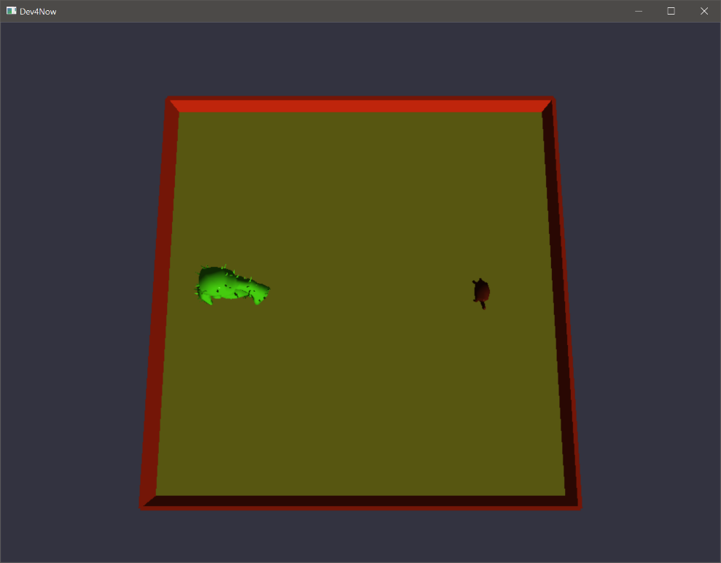

Part 3 (30%)

Part 3A
Now that we’re going to start doing some more game play stuff, let’s create a component to handle all the gameplay systems. In the Game namespace, create a GameManager component. It doesn’t need any variables currently. Create a new .cpp for this component and define an Update method. This is where we will run our all of our gameplay systems. Create a new entity in the GameplayBehavior method and attach the GameManager component to it. In MainLoopBehavior, call patch on the GameManager before we update the Window.

Part 3b
The first system we are going to make in the GameManager is a system to update all the model locations. We will achieve this by updating the transforms in all the GPUInstances to the objects Transform component. So, make a view that gets all entities that have both a Transform and a MeshCollection. Then, for each of those entities, copy the matrix that’s in Transform to each mesh GPUInstance’s transform. This means that as we update the GAME::Transform, the models will move too.

Rember that a system is a single, contained section of code that operates on one behavior at a time. In this instance, all this system does is copy from the GAME::Transform to the transforms for the meshes.

Part 3C
Create a .cpp for the Player component and provide an Update method. Grab the single Input and DeltaTime components so we can use them. Using the ‘speed’ stat from the .ini file to adjust the Player’s Transform with the WASD keys. This game exists on the X/Z plane so those are the directions you should move.

Note: Remember that a Vector is a direction and a magnitude. If moving on more than one axis, make sure to create it in such a way as to have the magnitude be the same (i.e. speed) no matter the direction moving.

Patch the player in the GameManager since that’s where we are doing all our game play updates.
With this part complete, you should be able to smoothly move the player around the level.
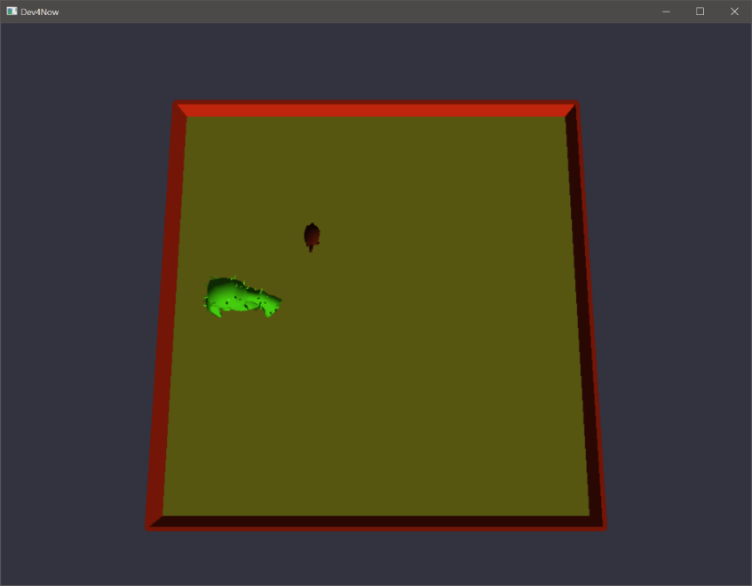

Part 4 (10%)
Create a new Game component to represent a Firing state, that contains a cooldown. We won’t let the player fire if this component is on the entity, and it will be removed once the cooldown reaches 0.
In the player’s update, if the Firing component isn’t present, we will check the fire keys and if they are pressed, we will spawn a bullet and add the Firing component.
G_KEY_LEFT, G_KEY_RIGHT, G_KEY_DOWN, and G_KEY_UP are the keys to check for firing. The specific key will determine the velocity when we get to that part next week. For now, if a button is down and we’re allowed to fire, create a Bullet entity like you did for the Player, except the transform is the Player’s location instead of the transform from blender. After creating the entity, emplace the Firing component to the Player.
Before checking for processing the fire, if the Firing component is present, reduce the cooldown and if it’s 0, remove the component.
Bullets should be left behind as you press fire buttons while moving around, and this assignment is complete.
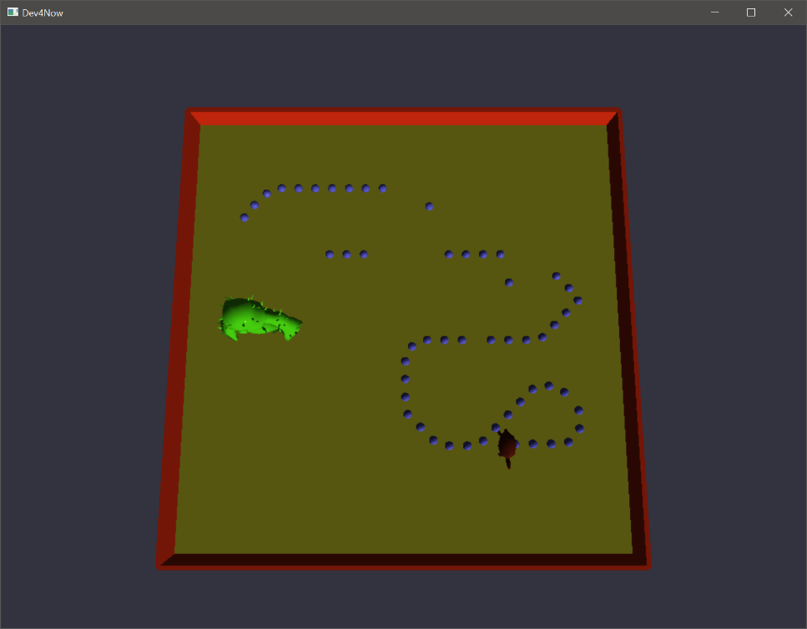

Summary
With this assignment complete, you should have your player avatar moving based on keyboard input. Pressing the fire buttons will leave a bullet behind as the player moves. The enemy is still currently standing there menacingly.
In the next assignment we will add physics systems to get non-player objects moving and colliding with other things.

Resources
Documentation for the APIs used in this course are provided here. If you run into issues with any methods in your work, start here.

ENTT
If you wish to deep dive or learn more about any given aspect of ENTT’s API, check out the ENTT wiki
https://skypjack.github.io/entt/index.html

Gateware
We will be using this API occasionally throughout these assignments for simplicity’s sake. Gateware is a powerful cross-platform API often contributed to by students here at Full Sail just like you. (Designed for 3D Engine builders)
https://gateware-development.gitlab.io/gcompiler/index.html (Official Documentation)
Tip: use the “--->” triple-dash operator on any Gateware proxy to have intellisense show you the actual arguments.

FAQ
Since this course is new, there are no questions that have appeared frequently (yet). So please, if you have questions, ask them so we can all grow.

