**Final Report Group 3**

**P-CB-S04**

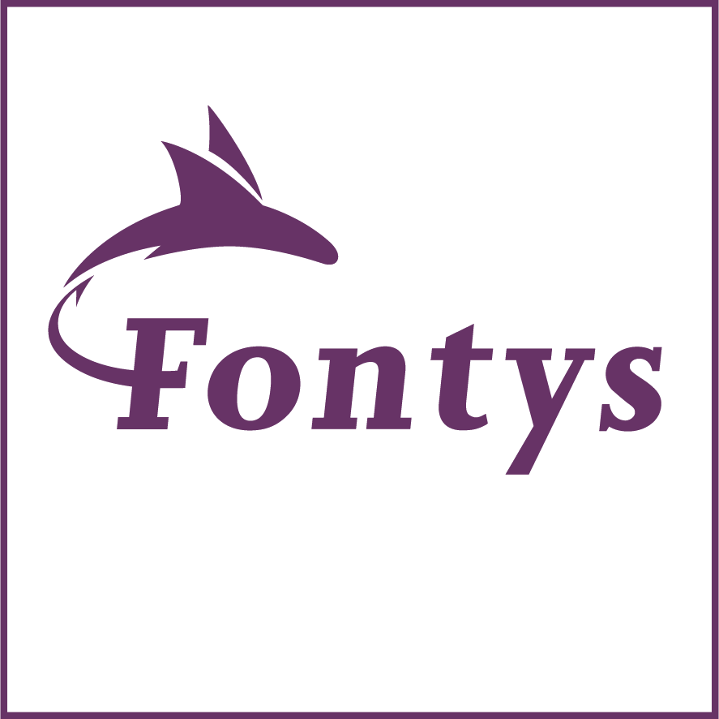

**Group 3 :**

Joran van de Moosdijk - 4220923

Matija Mandarelo – 4279425

Shanessa Kostaman – 450080

Tobias Halomoan - 4252861

**Fontys University of Applied Sciences**

**Eindhoven – Netherland**

**2020-2021**

**What’s we’ve been doing?**

For the past weeks we have been working on making a program for the Student Housing BV, which is our first big programming assignment. This means we had to work in bigger groups then we normally used to, so we had to divide the work a lot better and make sure everyone knew what to do and when to finish it.

Working together with so many people gave us a few problems, we needed to get clear what each class would do so there wouldn’t be any confusion on how to program something. Also when trying to share code n download other peoples code it didn’t always go well n it was confusing to work with git sometimes. It took us a while to get used to but with good communication it made it a lot easier to discuss everything and make sure everyone did the right stuff.

During the first week we mostly set up our plan, what did we want to get done and how would we do it. Because we just started learning new stuff so it was hard to get started on actually programming. We made mockups, discussed what classes we would need and what they would do. We discussed what everyone would start on without having to code. So we made the forms that we needed and then discussed them and added up to them.

After the first week it was mostly programming, during these weeks I feel like it would have maybe been better to call more n it would have made it easier to also do our individual tasks because it would be easier to make everyone’s code work properly n together. Towards the end we discussed more and it went a lot better. Everyone had their own tasks to work on and we helped each other were possible the last two weeks we called a little more to make sure everything would be finished on time. We still had some trouble making each individual work connect, it could have been avoided with more communication but in the end it all worked. Added some small things to make sure everything looked good.

In the end we all put our best in the project n tried doing as much as possible, our own tasks but also try to help others where possible n make sure everything worked. It wasn’t too stressful and it was a good learning opportunity, there is a big difference in making your personal small assignments after class and actually working in groups on a bigger project but it also allows u to put more time in something and in the end make something bigger then we normally do.