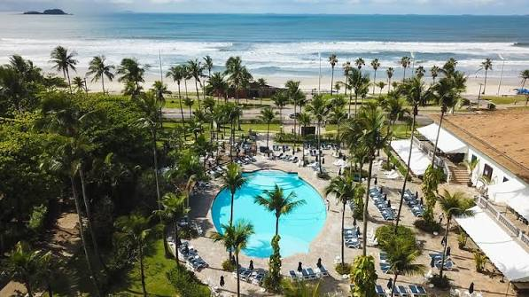

GSC27: Guarujá, Brazil, July 27-30, 2027

Themes:
Genomic Standards
in Biodiversity, Biotechnology and Genomics
of Latin America


The GSC 2027 annual meeting will be located at the 5-start beachfront resort Hotel Casa Grande, Guarujá, Brazil, located on Enseada Beach, July 27-30, 2027.

The GSC community spans the globe, including international researchers working in collaborative groups to provide a forum for developing and implementing community-driven standards in genomics, ‘omics’, and bioinformatics. Participants in the GSC include clinicians, biologists, chemists, computer scientists, groups building genomic and ‘omic databases, researchers conducting large-scale metagenomics and comparative genomic analyses, and individuals experienced in building community-based genomic standards.

Since its founding in 2005, the GSC’s Mission has focused on making genomic data discoverable, reusable, and interoperable through:
The implementation of new community-driven genomic standards
The establishment of methods of capturing and exchanging metadata
Harmonization of metadata collection and analysis efforts across the wider genomics community
Developing and making available standards-related resources and tools to help leverage the exponentially-increasing amount of genomics and metagenomics datasets
Implementing standards for reproducibility across all areas of genomics
GSC27 Daily Agenda Overview:
- July 27 GSC annual board meeting
- July 28 Day 1: Standards in Biodiversity and Biotechnology & Genomic Repositories
- July 29 Day 2: GSC MIxS & new genomic standards
    - MIxS hands-on workshop; Evening reception
- July 30 Day 3: Latin America Genomics & AI in Genomics

Attendance for the GSC27 annual meeting is expected to be between 100 and 150 participants.

Scientific vendors will have the opportunity to interact with attendees and speakers during the entire meeting including the networking events, daily coffee breaks, lunches, and between sessions. This meeting allows for ample networking time between sponsors and attendees.

Sponsorship Level Opportunities:

Platinum Sponsor ($10,000 USD/R$ 55,000) sponsors will receive the following benefits:
- Guaranteed 15-minute speaking slot in the program of the annual GSC meeting.
- Acknowledgment of sponsorship on the GSC website including links to your company’s website.
- Inclusion of the sponsor’s logo in meeting materials.
- Two free meeting registrations.
- Tabletop exhibition display (~1.6 m, 5 ft).
- Organization name and logo recognition on meeting signage.
- Logo included on inter-session slides.
- Special recognition of Platinum sponsor at symposium and in print and marketing materials.
- Full-page symposium program advertisement.
- Sponsor representative to join GSC board for board dinner.

Gold Sponsor ($7,000 USD/R$ 38,500) sponsors will receive the following benefits:
- Acknowledgment of sponsorship on the GSC website including links to your company’s website.
- Inclusion of the sponsor’s logo in meeting materials.
- One free meeting registration.
- Tabletop exhibition display (~1.6 m, 5 ft).
- Half page advertisement in meeting literature.
- Organization name and logo recognition on meeting signage.
- Logo included on inter-session slides.

Silver Sponsor ($4,000 USD/R$ 22,000) sponsors will receive the following benefits:
- Acknowledgment of sponsorship on the GSC website including links to your company’s website.
- Inclusion of the sponsor’s logo in meeting materials.
- One free meeting registration.
- Organization name and logo recognition on meeting signage.
- Logo included on inter-session slides.

Bronze Sponsor ($1,000 USD/R$ 5,500) sponsors will receive the following benefits:
- Acknowledgment of sponsorship on the GSC website including links to your company’s website.
- Inclusion of the sponsor’s logo in meeting materials.

**Custom Sponsorships are available, including add-ons, partial upgrades, and event sponsorships. Please let us know your needs. We are happy to accommodate you!

Please contact us for additional information
Lynn M. Schriml, Ph.D.
President, Genomic Standards Consortium
Professor, Institute for Genome Sciences
University of Maryland School of Medicine
Department of Epidemiology and Public Health
670 W. Baltimore St., HSF III, Baltimore, MD 21201 P: 410-706-6776

GSC27 at Casa Grande Hotel Resort and Spa:
Event Spaces

Main Hall:
The Grand Ballroom, with one of the most privileged views of the Casa Grande Hotel, can provide the ideal setting for your event.
Located facing Enseada Beach, the venue has an area of ​​460 m², distributed in two rooms of 230 m², which can be integrated or separated with acoustic partitions for your convenience.
You also have the option of having your coffee break on our 190 m² terrace, which overlooks the beach.
The venue can accommodate small to medium-sized events, with up to 450 people in an auditorium format.

Talks will be in the Salão Nobre (1+2). Right next to it there's a nice balcony with a nice view to the ocean, which we'll be able to use for coffee breaks. See an image below.

Sponsors will be able to set up either inside the room or right outside (opposite from the balcony)



