Task 1

For symmetric positive definite matrices A, the A-norm of the error decreases monotonically with increasing iteration number. (1) One can observe this behaviour in our own implementation in figure 2. In exact arithmetic, the residual should hit its minimum after approximately n iterations, where n stands for the dimension of the solution vector x which is roughly 5500 in our case. This is as well shown in our plot in figure 1. After 5500, the residual experiences no significant changes anymore. After this point, the minimum is essentially reached. The oscillations that can be observed afterwards are results of the numerical discretization and finite resolution inherent to computer precision. In general, it can be assumed that the minimum point is not exactly represented in the floating point representation of the computer.

Note that for readability reasons, we only plotted every 50th value. Please consider, that the existing data files will be overwritten once the program is executed and will therefore not deliver the same plots as below when called by the python script. However, a backup containing the data for a run with 10000 iterations is provided in the subfolder “./Abgabe_1/data_10000it/”.

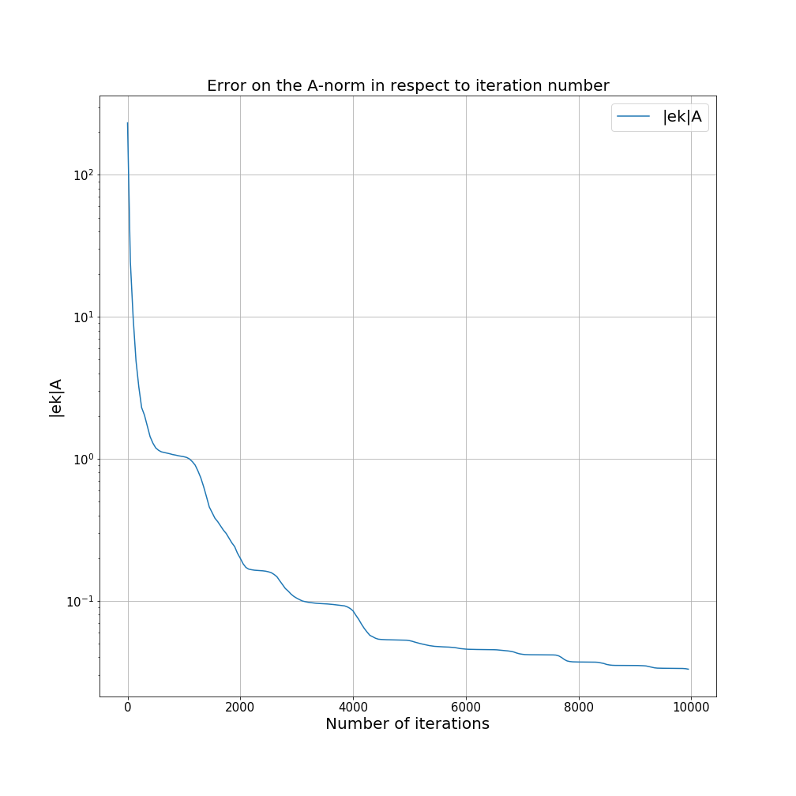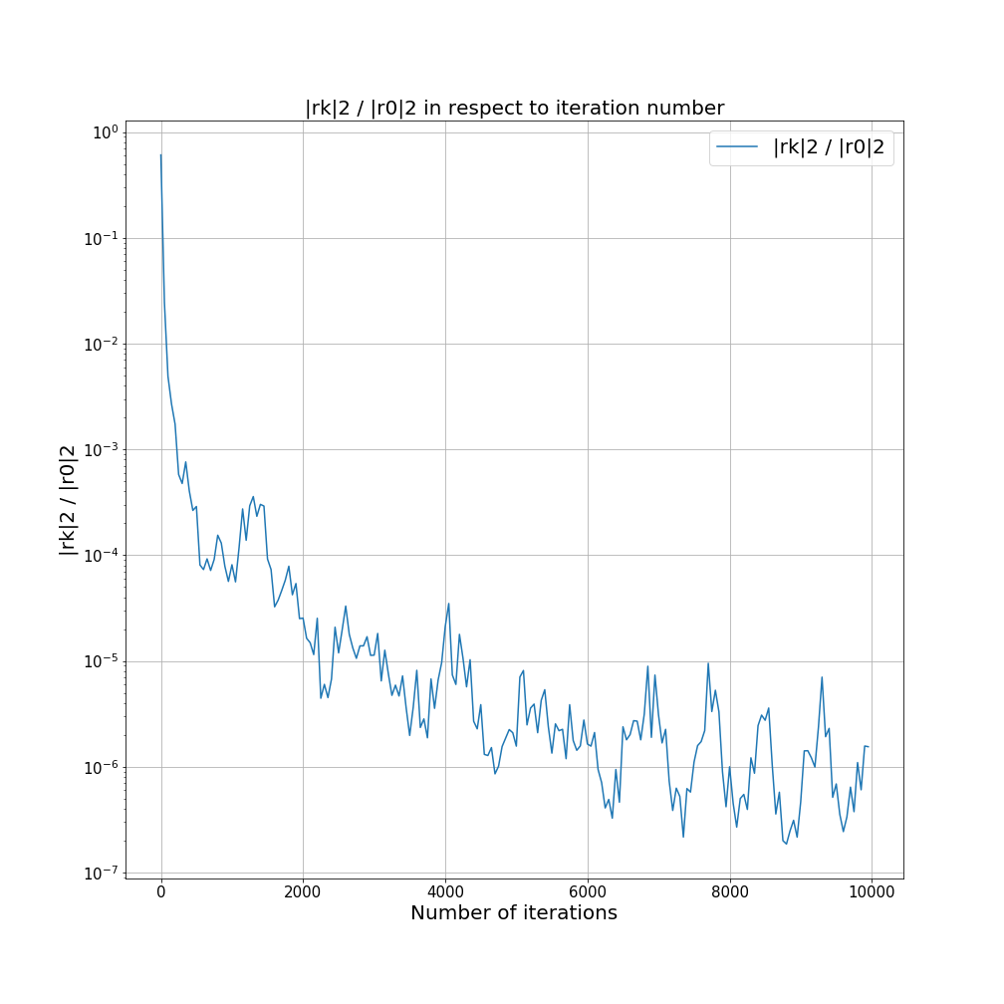

Task 2

In Task 2, we were quite surprised that the preconditioned methods worked so well since they both don’t work with the exact matrix A like we do in our own implementation. The diagonally preconditioned method only takes the diagonal entries into account and the incomplete Cholesky method is “only” an approximation to the Cholesky factorization itself. Nevertheless, both methods gave similar or better results compared to our own implementation. What is quite remarkable as well is the difference in execution time. Our implementation took 4375 seconds to execute 10000 iterations. The diagonally preconditioned Eigen method delivered a similar (slightly better) result in 5 seconds which makes it faster by a factor of 875.

Note that for readability reasons, we only plotted every 20th value. Please consider, that the existing data files will be overwritten once the program is executed and will therefore not deliver the same plots as below when called by the python script.

