
GENREC AI
ARTIFICIAL INTELLIGENCE AND MACHINE LEARNING
3 MONTHS

An INTERNSHIP REPORT

Submitted by

SANJAY RAM A

In partial fulfillment for the award of the degree
of
BACHELOR OF TECHNOLOGY
in
ARTIFICIAL INTELLIGENCE AND DATA SCIENCE
SSM INSTITUTE OF ENGINEERING AND TECHNOLOGY
DINDIGUL 624 002
ANNA UNIVERSITY::CHENNAI 600 025
OCTOBER 2026

BONAFIDE CERTIFICATE

This is to certify that SANJAY RAM A (922123243045), is a bonafide student of AI&DS Department, SSM Institute of Engineering and Technology, Dindigul - 624 002, affiliated to Anna University.

The student is studying in VII Semester during the academic year 2026-2027 and has undertaken the Industry Internship at GENREC AI from July 2026 to October 2026 as part of the academic requirements of the programme.

SIGNATURE | SIGNATURE
Dr.M.PREMKUMAR | Ms. I. JOICY
HEAD OF THE DEPARTMENT | ASSISTANT PROFESSOR
Department of Artificial Intelligence and Data Science, | Department of Artificial Intelligence and Data Science,
SSM Institute of Engineering and Technology, | SSM Institute of Engineering and Technology,
Dindigul - 624002. | Dindigul - 624002.

OFFER LETTER
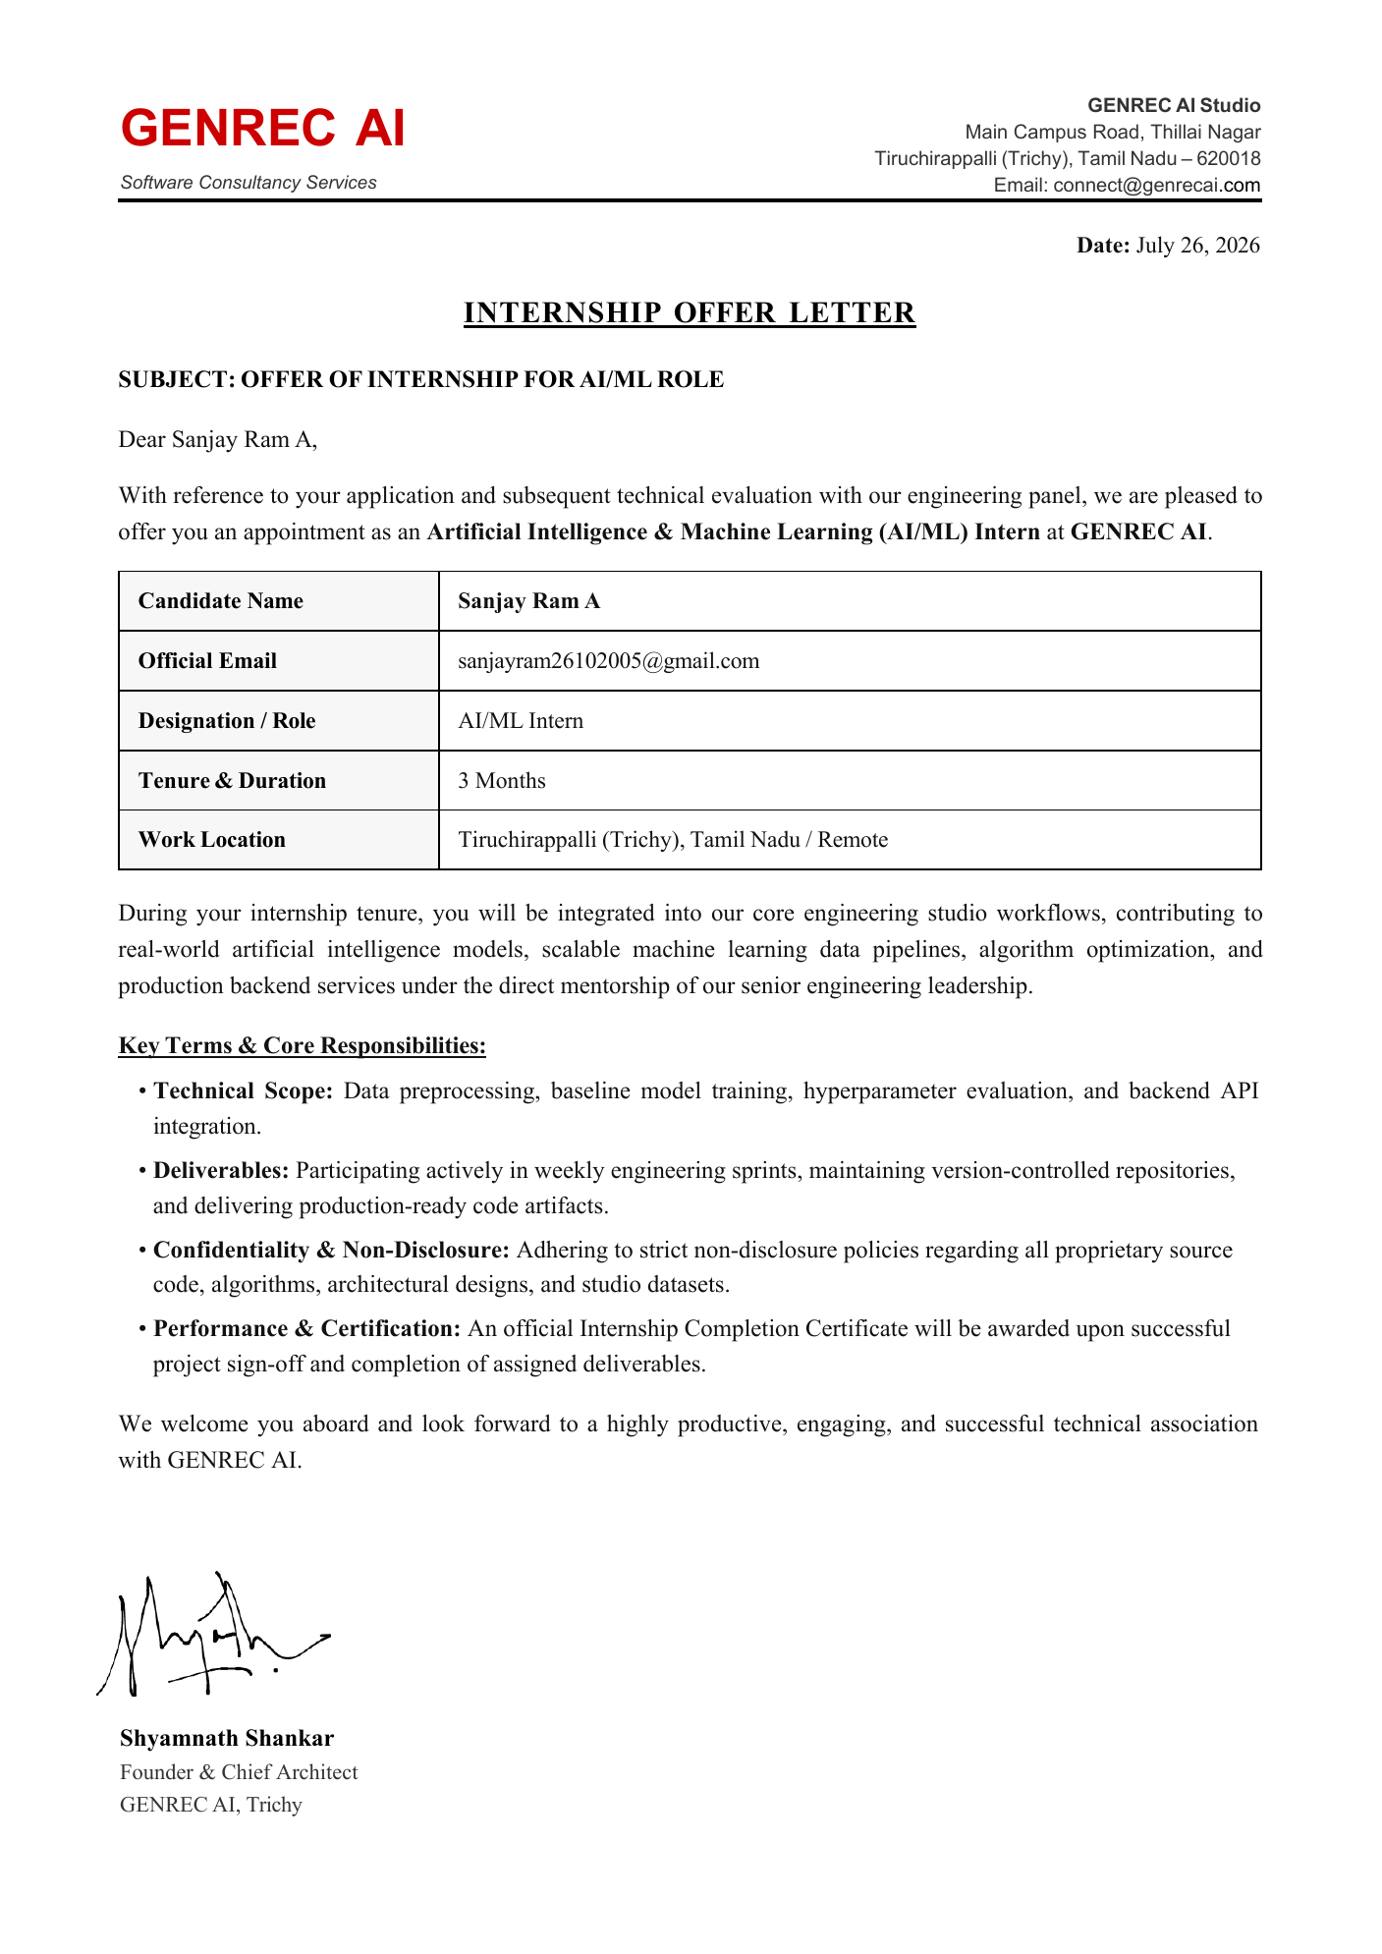
DECLARATION
I, Sanjay Ram A, declare that the work presented in this report is an authentic record of the internship carried out by me at GENREC AI between July 2026 and October 2026. The technical details, project description and learning outcomes described here reflect my own work and observations, and are consistent with the internship offer letter and the departmental review meeting record. In keeping with the confidentiality clause of the internship agreement, no proprietary source code, algorithm or studio dataset belonging to GENREC AI has been reproduced in this report; the discussion is limited to design, architecture and learning.
I further declare that this report has not been submitted, in whole or in part, to any other university or institution for the award of any degree, diploma or certificate. Wherever the ideas, figures or statements of other sources have been used, they have been acknowledged in the references. The report has been prepared in accordance with the format prescribed by the department for industry internship reports.

Place: Dindigul
Date: ____________________
ACKNOWLEDGEMENT
First and foremost, we would like to express our deep sense of gratitude to our most honorable Chairman and Management Trustees Mr. K. Shanmugavel for providing us with necessary facilities during the course of study. We feel immensely pleased to express our sincere thanks to our Principal
Dr. S. Karthigai Lakshmi for encouragement and support extended by them. We extend our solemn gratitude to Dr. M. Premkumar, Head of the Department, Artificial Intelligence and Data Science, for timely support to all our activities.
I would like to thank my Faculty Internship Coordinator, the Faculty In-Charge, for the continuous guidance, valuable suggestions, and encouragement during the internship and in the preparation of this report.
I am grateful to GENREC AI for providing me with the opportunity to gain practical exposure to an industry environment. I sincerely thank my Industry Mentor, Jaisamyukth, Software Engineer, and the entire team for their guidance, technical support, and valuable insights throughout the internship.
We express our sincere thanks to our guide Ms. I. Joicy, AP/AI&DS for her guidance throughout our Internship. Also we express our thanks to the faculty members of our department, non-teaching staff members and my dear friends for their moral support, help and encouragement towards the successful completion of the internship.
INDEX
S. No. | CONTENTS | PAGE NO.
1 | Bonafide Certificate | 2
2 | Offer Letter | 3
3 | Declaration | 4
4 | Acknowledgement | 5
5 | Executive Summary | 9
6 | List of Figures | 10
7 | List of Tables | 10
8 | Abbreviations / Acronyms | 10
9 | Chapter 1 – Introduction | 11
9.1 | Background | 11
9.2 | Internship Overview | 11
9.3 | Need and Purpose of the Internship | 12
9.4 | Objectives of the Internship | 12
9.5 | Scope of the Report | 12
10 | Chapter 2 – Company Profile | 13
10.1 | Company Introduction | 13
10.2 | Vision and Mission | 13
10.3 | Products / Services | 13
10.4 | Industry Domain | 13
10.5 | Department / Team Assigned | 13
11 | Chapter 3 – Internship Activities | 14
11.1 | Internship Plan | 14
11.2 | Training Received | 14
11.3 | Tasks and Responsibilities | 14
11.4 | Technologies and Tools Used | 15
11.5 | Weekly / Phase-wise Activities | 15
11.6 | Team Collaboration | 15
12 | Chapter 4 – Major Project / Work Undertaken | 16
12.1 | Project Title | 16
12.2 | Problem Statement | 16
12.3 | Objectives | 16
12.4 | Requirements | 16
12.5 | Existing System / Approach | 16
12.6 | Proposed Solution | 16
12.7 | Methodology | 16
12.8 | System Architecture / Workflow | 16
12.9 | Modules / Components | 18
12.10 | Implementation | 18
12.11 | Results and Outputs | 18
12.12 | Screenshots / Demonstration Evidence | 19
12.13 | Data Model Overview | 19
12.14 | Service Interface Overview | 20
12.15 | Testing and Validation Approach | 21
13 | Chapter 5 – Skills and Learning Outcomes | 22
13.1 | Technical Skills | 22
13.2 | Software / Tools / Platforms | 22
13.3 | AI / Cloud / Data Skills | 22
13.4 | Communication and Teamwork | 22
13.5 | Problem-Solving Skills | 22
13.6 | Professional Learning | 22
14 | Chapter 6 – Challenges and Solutions | 23
14.1 | Technical Challenges | 23
14.2 | Organizational / Team Challenges | 23
14.3 | Solutions Adopted | 23
14.4 | Key Lessons Learned | 23
15 | Chapter 7 – Professional Experience | 24
15.1 | Workplace Practices | 24
15.2 | Industry Standards | 24
15.3 | Professional Ethics | 24
15.4 | Safety, Security and Data Practices | 24
16 | Chapter 8 – Conclusion and Future Scope | 25
16.1 | Conclusion | 25
16.2 | Achievement of Objectives | 25
16.3 | Career Relevance | 25
16.4 | Future Scope / Recommendations | 25
17 | Completion Certificate | 26
18 | References | 27
19 | Appendices | 28
19.1 | Appendix A – Internship Certificate | 28
19.2 | Appendix B – Internship Offer / Permission Letter | 28
19.3 | Appendix C – Weekly Internship Logbook | 28
19.4 | Appendix D – Industry Mentor Evaluation | 29
19.5 | Appendix E – Final Internship Presentation / Viva Record | 29
19.6 | Appendix F – Photographs, Screenshots and Project Evidence | 29
Executive Summary
This report documents a 3 months internship in the domain of AI/ML carried out at GENREC AI, Tiruchirappalli, from July 2026 to October 2026. The internship was oriented towards production software development supported by machine learning: data preprocessing, baseline model training, hyperparameter evaluation and backend model deployment, applied to a real product rather than to isolated exercises. The practical work centred on Tabble - A Hotel OS. The project focuses on providing a QR-based hotel ordering workflow that enables guests to access the ordering system by scanning a QR code and place food orders electronically. The report describes the layered architecture designed for the platform, the lifecycle of an order from the moment a guest scans a table QR code to billing, the functional modules involved, and the individual contribution made to those modules. It closes with the engineering practices absorbed during the internship - sprint-based delivery, version control and review before merge - and the learning outcomes drawn from them.
The internship also gave exposure to the working environment of a product studio: how a requirement is discussed before it is built, how a small change is reviewed before it is merged, and how a service is kept predictable when the same request arrives twice. These habits, together with the technical outcomes, form the basis of the skills and learning outcomes recorded in Chapter 5, and the challenges met along the way and the way each was handled are summarised in Chapter 6. Supporting records, including the internship offer letter, are reproduced before the References, and the weekly logbook and mentor evaluation are included in the appendices.
LIST OF FIGURES
FIGURE NO | FIGURE | PAGE NO
Figure 1 | System architecture of Tabble - A Hotel OS | 17
Figure 2 | QR-based order lifecycle | 18
Figure 3 | Mind map of internship activities and learning | 19

LIST OF TABLES
TABLE NO | TABLE | PAGE NO
Table 1 | Main entities of Tabble - A Hotel OS (design level) | 20
Table 2 | Operations on the ordering path | 20
Table 3 | Weekly internship logbook | 28
Table 4 | Areas of guidance from the industry mentor | 29

ABBREVIATIONS / ACRONYMS
AI - Artificial Intelligence
ML - Machine Learning
API - Application Programming Interface
QR - Quick Response
CHAPTER 1
INTRODUCTION
Classroom study of artificial intelligence usually stops at the model: a dataset is cleaned, an algorithm is trained, and an accuracy figure is reported. Industry practice begins where that exercise ends. A model earns its value only once it is wrapped in a service, fed by a reliable data path, deployed behind an interface and maintained as requirements change. This internship was undertaken to work on that second half of the problem.
1.1 BACKGROUND
Classroom study of artificial intelligence usually stops at the model: a dataset is cleaned, an algorithm is trained, and an accuracy figure is reported. Industry practice begins where that exercise ends. A model earns its value only once it is wrapped in a service, fed by a reliable data path, deployed behind an interface and maintained as requirements change. This internship was undertaken to work on that second half of the problem.
The need for this second half is felt most strongly in applications that serve people directly. A hotel guest does not see a model; the guest sees a menu that opens quickly, an order that is acknowledged and a bill that matches what was ordered. Every part of the system behind that experience has to be correct for the experience to feel simple.
The internship was offered by GENREC AI as an AI/ML Intern for a period of 3 Months (July - October), as recorded in the offer letter and signed by Shyamnath Shankar, Founder & Chief Architect. The departmental review meeting collected and verified the internship details, the nature of the software development work and the project involvement.
The weeks that followed were spent inside a real engineering workflow. Requirements were discussed with the industry mentor, implemented on a branch, tested locally and reviewed before they were merged, and the same short cycle was followed for data preparation, model experiments and service integration. The resulting experience is the subject of this report.
1.2 INTERNSHIP OVERVIEW
The internship ran for 3 Months from July 2026 to October 2026 in the AI/ML domain, with work carried out from Tiruchirappalli (Trichy), Tamil Nadu / Remote. The role was designated AI/ML Intern, and the day-to-day work was that of an AI software developer contributing to a live product, Tabble - A Hotel OS.
Working remotely and from the studio at Tiruchirappalli, the intern took part in weekly sprint milestones and reported progress to the industry mentor, Jaisamyukth, Software Engineer. Tabble - A Hotel OS served as the common thread through the three months: it supplied the problem, the architecture to be understood and the codebase in which changes had to be made carefully.
1.3 NEED AND PURPOSE OF THE INTERNSHIP
The internship connected academic study with practical engineering tasks. It provided experience in preparing data, developing and evaluating models, integrating backend services and APIs, and delivering production-ready code under industry mentorship.
Three needs shaped the internship. The first was practical exposure: moving from curated coursework datasets to operational records that are incomplete and inconsistent. The second was integration: learning how a trained model, a service endpoint and a user interface are connected so that a result actually reaches the end user. The third was professional discipline: sprint delivery, version control, code review and respect for confidentiality, none of which can be learned from a textbook alone.
1.4 OBJECTIVES OF THE INTERNSHIP
Gain practical exposure to AI and machine learning development workflows in a production setting. Work through a complete data and model path: preprocessing, baseline training, hyperparameter evaluation and model evaluation. Integrate backend services and APIs so that model output and application logic reach the end user. Follow professional software engineering practice: sprint milestones, version control and production-ready code artifacts. Contribute to Tabble - A Hotel OS, a QR-based hotel ordering system, as the practical outcome of the internship.
Each objective was tied to something that could be observed at the end of the internship: a repeatable data and model path, a set of validated service operations, a history of reviewed commits, and a working ordering flow that could be followed from a table scan to a bill.
1.5 SCOPE OF THE REPORT
The report covers the internship engagement and its terms, the areas of training, the architecture and functional design of the platform worked on, the individual contribution, and the learning outcomes. Architecture and design are discussed at a level appropriate for an academic report; proprietary source code, algorithms and datasets are deliberately excluded under the confidentiality clause of the internship agreement.
The chapters that follow are arranged in the order recommended by the department. Chapter 2 introduces the company, Chapter 3 the internship activities, Chapter 4 the project undertaken, Chapter 5 the skills gained, Chapter 6 the challenges faced, Chapter 7 the professional experience, and Chapter 8 the conclusion and future scope. The internship offer letter, the references and the supporting appendices complete the report.
CHAPTER 2
COMPANY PROFILE
2.1 COMPANY INTRODUCTION
GENREC AI is an AI engineering studio located at Main Campus Road, Thillai Nagar, Tiruchirappalli (Trichy), Tamil Nadu - 620018. The studio builds artificial intelligence and machine learning systems and delivers product software, with engineering teams working on machine learning pipelines, model optimisation and predictive systems. Interns are placed with these core engineering teams and contribute to live product work rather than to separate training exercises.
The studio's working model is project based. Work arrives as product requirements, is divided into sprint-sized units, and is delivered through a shared version-controlled repository in which every change is reviewed. Interns join this model from the first week instead of being kept in a separate training track, so the learning is gained from the same discipline that the engineering team itself follows.
2.2 VISION AND MISSION
As recorded in the internship report, the studio delivers product software with engineering teams working on machine learning pipelines, model optimisation and predictive systems, placing interns with core engineering teams on live product work.
2.3 PRODUCTS / SERVICES
The project undertaken during the internship was Tabble - A Hotel OS. Its purpose is to provide a QR-based hotel ordering workflow that enables guests to access the ordering system by scanning a QR code and place food orders electronically. Its major workflow is discussed in Chapter 4.
2.4 INDUSTRY DOMAIN
The internship domain was Artificial Intelligence and Machine Learning, combined with software development and application integration: data preprocessing, baseline training, hyperparameter evaluation, and backend model deployment.
2.5 DEPARTMENT / TEAM ASSIGNED
The student worked as an AI software developer with the core engineering team under the guidance of Jaisamyukth, Software Engineer, contributing to Tabble - A Hotel OS.
CHAPTER 3
INTERNSHIP ACTIVITIES
3.1 INTERNSHIP PLAN
The internship ran for 3 Months from July 2026 to October 2026 as AI/ML Intern at GENREC AI, organised as weekly sprint milestones. Each sprint began with a short discussion of the requirement, followed by implementation, review and integration, with every change committed to a version-controlled repository and reviewed before merge.
In the first weeks the plan concentrated on orientation: reading the existing code, setting up the development environment and learning the branching and review conventions. The middle weeks moved to data and model tasks together with service integration, and the final weeks were given to feature work on the ordering path, testing and refinement in response to review comments.
3.2 TRAINING RECEIVED
Training spanned five connected areas, from data handling through model work to backend integration and engineering discipline: AI/ML Development with practical exposure to development workflows as an AI Software Developer; Data and Model Workflows including data preprocessing, baseline model training, and hyperparameter evaluation; Backend Integration of services and APIs; Software Engineering Practices of sprints, version control and production-ready artifacts; and Practical Learning through Tabble, a QR-based hotel ordering system.
Training took place on the job rather than in a classroom. The industry mentor explained the architecture of Tabble, walked through representative changes, and gave feedback on the intern's own commits, so that each area of training was practised on real tasks and then corrected through review.
3.3 TASKS AND RESPONSIBILITIES
The student worked as an AI Software Developer contributing to software-development tasks for Tabble, including the QR-based ordering workflow and related application features: resolution of a scanned code to a table session, digital menu and order placement with validation, service endpoints and data access, data preprocessing, baseline training and hyperparameter evaluation, testing and iterative improvement, and version control discipline with review before merging.
Each task was handled as a small, reviewable unit. A typical task began with a discussion of what the change should do, continued with an implementation on a separate branch and focused tests, and ended with a review in which the mentor's comments were applied before the change was merged. Keeping tasks small made it easier to find the cause of a problem and to keep unfinished work out of the product.
Where a task involved data, an additional step was added before implementation: inspecting the records that would feed the work, noting missing or inconsistent values, and agreeing with the mentor on how each case should be handled. This avoided building a feature on assumptions about data that later proved to be wrong.
3.4 TECHNOLOGIES AND TOOLS USED
AI/ML development, data preprocessing, model evaluation, backend API integration, version control, and production software practices, with weekly sprint milestones and production-ready code artifacts.
Version control was used for every change, with commits that were small, focused and described in plain language. Service endpoints were exercised through requests and responses during testing, and data preparation and model experiments were recorded so that a result could be reproduced later by rerunning the same steps.
3.5 WEEKLY / PHASE-WISE ACTIVITIES
Month 1 - Orientation and data work: understanding the product and existing codebase, development environment setup, version control workflow, and data preprocessing tasks. Month 2 - Model and backend work: baseline model training and hyperparameter evaluation; backend service and API integration for menu and order operations. Month 3 - Feature work and refinement: QR-based ordering workflow and related features, testing, review feedback, and improvement of the ordering experience.
3.6 TEAM COLLABORATION
Work was carried out with developer guidance and project feedback from Jaisamyukth, Software Engineer, who guided understanding of requirements, approaches to technical problems, and improvement of implementation quality. Code intended for the product was reviewed before being merged.
Collaboration took several forms: asking precise questions when a requirement was unclear, explaining the intent of a change when it was submitted for review, and reading the comments of the reviewer carefully before replying. This improved both the quality of the intern's contributions and the speed with which they were accepted.
CHAPTER 4
MAJOR PROJECT / WORK UNDERTAKEN
4.1 PROJECT TITLE
Tabble - A Hotel OS.
4.2 PROBLEM STATEMENT
Conventional restaurant service depends on a printed menu and a waiter acting as the channel between guest and kitchen. That channel is a bottleneck. A guest waits for a menu, waits again to place an order, and then has no visibility of the order once it is taken. Orders relayed verbally are transcribed at least once before reaching the kitchen, and each transcription is an opportunity for error. At peak hours the bottleneck widens, and the resulting delay is felt at every table.
4.3 OBJECTIVES
The project focuses on providing a QR-based hotel ordering workflow that enables guests to access the ordering system by scanning a QR code and place food orders electronically.
4.4 REQUIREMENTS
Each table carries a printed QR code encoding its identity; a guest device with a mobile browser and network access; a digital menu with categories, item detail, availability and pricing; electronic order placement with modification before confirmation; real-time order visibility; status tracking; bill generation and payment handling; and an administrative view of menu, tables and order history.
4.5 EXISTING SYSTEM / APPROACH
The existing approach is the printed menu with waiter-mediated ordering and verbal relay to the kitchen, with transcription errors and no guest visibility of order progress.
4.6 PROPOSED SOLUTION
Each table carries a printed QR code that encodes its identity. A guest scans the code, the digital menu opens in the phone browser already bound to that table, items are selected and the order is submitted electronically. The order reaches the kitchen directly, and its progress is visible to the guest. No application installation is required.
4.7 METHODOLOGY
Work was organised as weekly sprint milestones: requirement discussion, implementation, review and integration, with version-controlled commits and review before merge. The data and model path ran from preprocessing through baseline training and hyperparameter evaluation to backend deployment.
4.8 SYSTEM ARCHITECTURE / WORKFLOW
The platform is organised into four layers. Each layer depends only on the layer below it through a defined interface. The client layer holds the guest mobile browser page, the kitchen and staff dashboard, and the admin panel. The application and API layer uses an API gateway for authentication, rate limiting and traffic splitting, with domain services for menu, orders, tables and QR identity, billing and payment, and notification. The AI and ML layer holds preprocessing, recommendation and forecasting with model serving, trained separately from serving. The data and infrastructure layer holds the relational store for orders, menu, tables and users, a cache and session store, and an analytics and feature store, with version control and continuous integration as the delivery path.
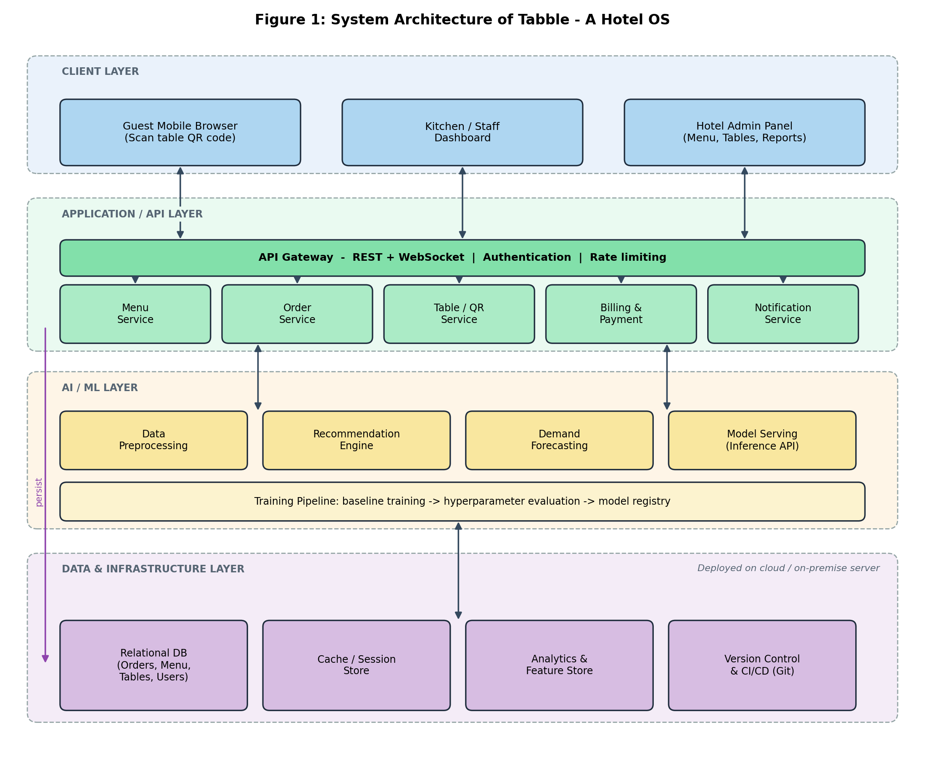
Figure 1: System architecture of Tabble - A Hotel OS
Figure 2 traces a single order from the scan at the table through to payment. Because the QR code carries the table identifier, every later stage - kitchen routing, status updates and billing - inherits it without typing a table number. The order is validated and persisted before it is announced, so the kitchen sees a committed order.
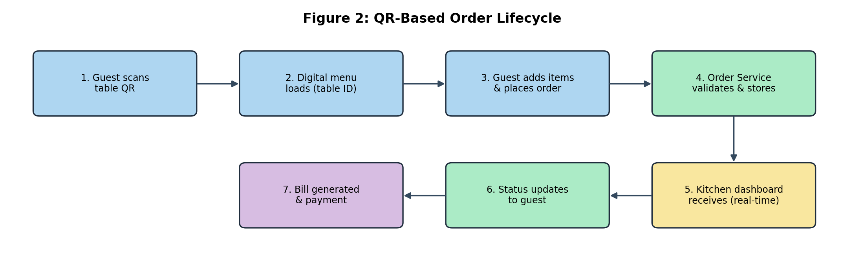
Figure 2: QR-based order lifecycle
4.9 MODULES / COMPONENTS
Table / QR maps each table to a QR code and resolves a scan to a table session. Menu serves categories, items, availability and pricing with admin updates. Order validates, persists and updates orders as the source of truth. Kitchen dashboard presents incoming orders in real time and records preparation status. Notification pushes status changes to guest and staff clients. Billing and payment generates the bill from a confirmed order and records payment. Admin manages menu, tables, staff access and order history reports. ML services provide recommendation and demand forecasting over historical order data.
4.10 IMPLEMENTATION
Implementation covered the QR-based ordering workflow including resolution of a scanned code to a table session, digital menu and order placement with validation, service endpoints with request and response handling and data access, data preprocessing into usable form, baseline training with hyperparameter evaluation on held-out data, and testing with iterative improvement from review feedback, all with focused commits reviewed before merging.
Each unit of work followed the same short cycle: discussion of the requirement with the mentor, implementation on a branch, local testing, and review before merge. For the ordering path this meant that resolving a scan, presenting the menu, validating an order and persisting it were built and reviewed as separate steps rather than as one large change, which made each step easier to check and easier to correct when review feedback arrived.
On the data side the same discipline applied. Operational records were validated and cleaned before use, missing values were handled explicitly rather than silently dropped, and numeric fields were normalised before baseline training. Hyperparameter settings were compared on held-out data, so that the choice of settings did not depend on the data used for training.
4.11 RESULTS AND OUTPUTS
The project is currently under development, with ongoing implementation, testing, and improvement of the hotel ordering experience, delivering a working QR ordering path, validated order handling, real-time kitchen visibility, and billing from confirmed orders.
The working outcome at this stage is an ordering path that can be followed from a table scan to a confirmed order, with validation at the service boundary so that incomplete or inconsistent orders are rejected early. Status changes are recorded as the kitchen works through an order, and the bill is generated from the confirmed order, so that billing never depends on information typed again by hand. The project remains under development, and further testing and refinement of the ordering experience continue.
For the machine learning part of the work, the outcome was a repeatable path from raw operational records to a baseline model with evaluated settings, which can be rerun when new data arrives and extended with better models later.
4.12 SCREENSHOTS / DEMONSTRATION EVIDENCE
Demonstration evidence is provided through the architecture, lifecycle and mind map figures of this report, tracing a single order from table scan to payment and collecting the internship activities into a single view.
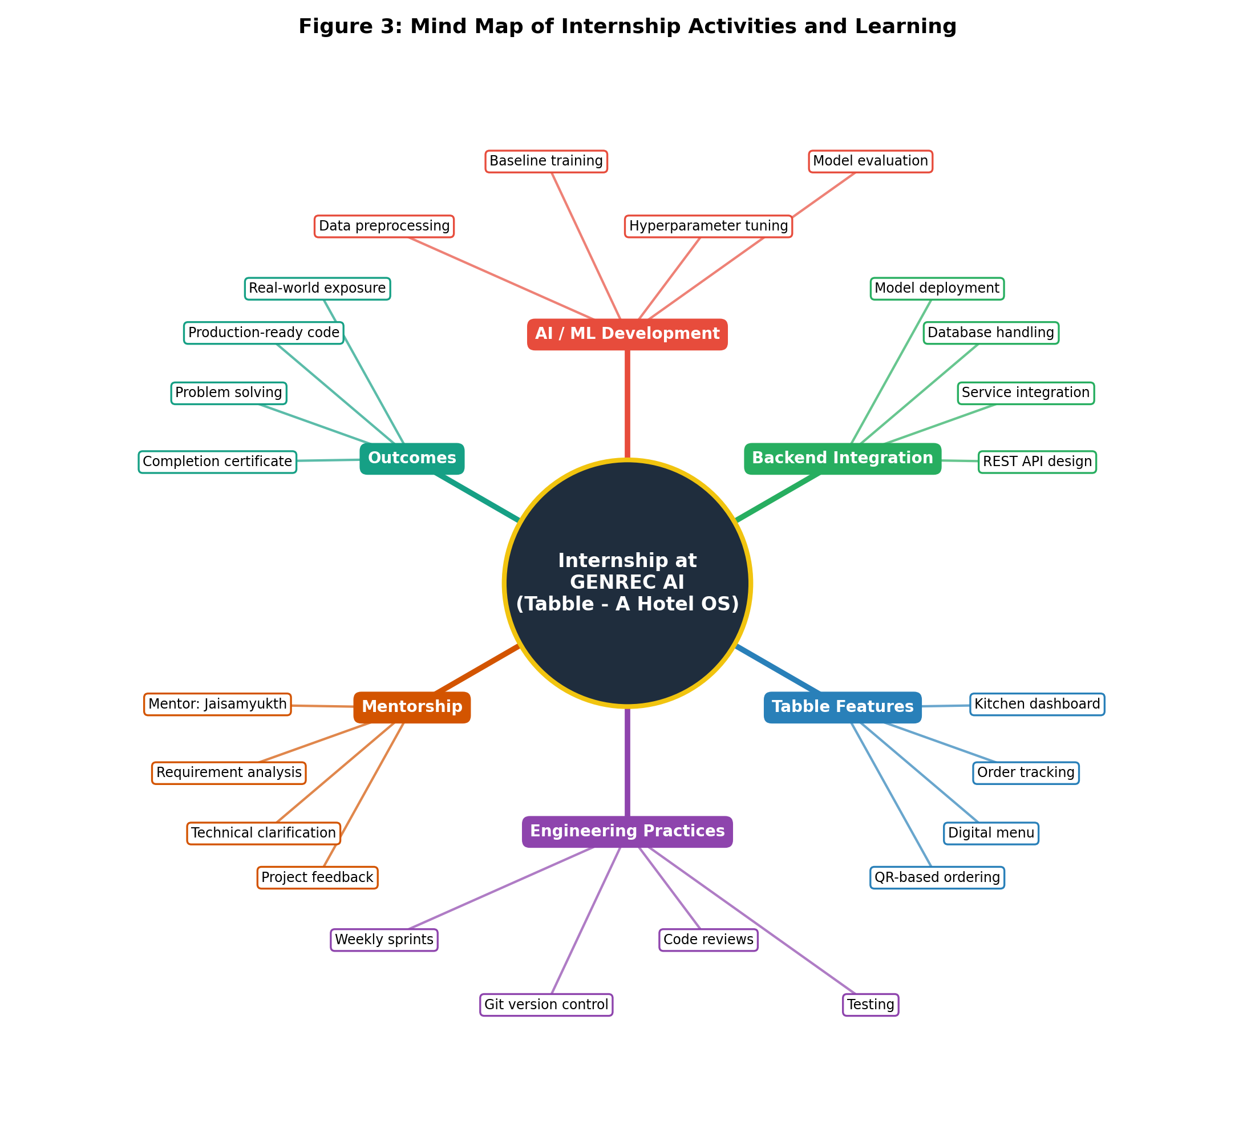
Figure 3: Mind map of internship activities and learning
4.13 DATA MODEL OVERVIEW
The data and infrastructure layer keeps orders, menu, tables and users in a relational store, with a cache for sessions and an analytics store for the machine learning work. Table 1 lists the main entities at a design level. The names and fields are indicative of how the information is organised and are not a copy of the production schema, which is proprietary to GENREC AI.
Table 1: Main entities of Tabble - A Hotel OS (design level)
Entity | Purpose | Typical information held
Table | A physical table that a guest sits at, identified by its QR code | Table identifier, label, QR code reference, current session
Menu category | Groups items for browsing | Category name, display order
Menu item | A dish or drink that can be ordered | Name, description, price, availability
Order | One submission from a table, the source of truth for the kitchen | Table, status, time of placement, time of each status change
Order item | A line within an order | Menu item, quantity, special note
Bill and payment | Charge raised from a confirmed order | Amount, payment status, payment time
User | Staff and administrators who manage the system | Name, role, access rights

Two properties of this model matter in practice. An order always carries its table identity, so every later stage inherits it without anyone typing a table number. And an order is written to the store before it is announced, so the kitchen dashboard and the guest status view read the same committed record.
4.14 SERVICE INTERFACE OVERVIEW
Each domain service exposes a small set of operations through the API gateway. Table 2 summarises the operations that make up the ordering path, again at a design level; endpoint paths and payloads are deliberately not reproduced.
Table 2: Operations on the ordering path
Operation | Service | Description
Resolve scan | Table / QR | Maps a scanned code to a table and opens a table session
View menu | Menu | Returns categories, items, availability and pricing for the session
Place order | Order | Validates the submitted items, persists the order and returns a confirmation
Update status | Order and kitchen dashboard | Records preparation status as the kitchen works through the order
Notify | Notification | Pushes status changes to the guest and staff clients
Request bill | Billing and payment | Generates the bill from the confirmed order
Record payment | Billing and payment | Marks the bill as paid and closes the table session
Manage menu and tables | Admin | Lets staff update items, availability, tables and view order history

4.15 TESTING AND VALIDATION APPROACH
Testing followed the sprint rhythm of the internship. Validation rules for incoming orders, such as unknown items, zero quantities and items that are not currently available, were exercised with focused tests so that a bad request is rejected at the service boundary instead of reaching the kitchen. The ordering path was then checked end to end, from a resolved scan through placement and status updates to billing, to confirm that each stage inherited the table identity correctly.
On the data and model side, preprocessing was checked for missing and inconsistent values before any training, baseline models were compared on held-out data rather than on the data they were trained on, and hyperparameter choices were recorded so that a result could be reproduced. Review feedback from the industry mentor was applied before each merge, and every change was kept as a small, focused commit so that a regression could be traced to a single change.
Non-functional behaviour was also considered during validation. Repeated submission of the same order was tested to confirm that it was recognised and not stored twice, interrupted requests were checked so that a half-completed order did not appear in the kitchen view, and status updates were examined over a mobile connection to confirm that they reached the guest without a manual refresh. Each of these checks was written down as a small test case so that it could be run again whenever the ordering path changed.
The outcome of the validation work was confidence in the boundaries of the system rather than a claim of completeness. Orders that were incomplete or inconsistent were rejected early, accepted orders carried a table identity from the first scan to the final bill, and the data and model steps could be rerun from raw records to an evaluated baseline. Areas that still need further testing, such as behaviour under heavy load at peak hours, were noted for the continuing development of the project and are listed with the future scope in Chapter 8.
A short checklist was used before each merge: the change does one thing, its tests pass, validation covers the new inputs, naming follows the existing code, and the commit message explains the reason for the change. Applying the same checklist every time made reviews faster and made the history of the repository easier to read for anyone joining the project later.
Reviews also looked at the wording of error messages and responses. A rejected order returns a clear reason, such as an unavailable item or an unknown table, so that the guest interface can show a helpful message and so that a developer reading the logs can tell at once which rule was applied.
CHAPTER 5
SKILLS AND LEARNING OUTCOMES
5.1 TECHNICAL SKILLS
A working understanding of the complete path from raw operational data to a deployed model reachable by an application. The ability to establish a baseline before optimising, and to evaluate a model on evidence rather than on a single accuracy figure. Practical backend integration skills: API design, validation at service boundaries, error handling and data access.
5.2 SOFTWARE / TOOLS / PLATFORMS
Backend services and APIs, version-controlled repositories with review before merge, sprint-based delivery, and production-ready code artifacts.
5.3 AI / CLOUD / DATA SKILLS
Data preprocessing with validation, cleaning, missing-value handling, normalisation, encoding and honest splitting; baseline training with structured hyperparameter evaluation on held-out data; and model evaluation by operational behaviour and error cost rather than accuracy alone.
The practice of splitting data honestly, so that a model is judged on records it has not seen, was the most valuable lesson from the data side of the internship.
5.4 COMMUNICATION AND TEAMWORK
Improved technical communication through interaction with Jaisamyukth, Software Engineer, stating problems precisely, clarifying requirements before implementation, and receiving review feedback.
5.5 PROBLEM-SOLVING SKILLS
Handling repeated submissions and interrupted requests without duplicating or losing orders, delivering kitchen updates over reconnecting mobile channels, and working within mobile-first constraints.
5.6 PROFESSIONAL LEARNING
Professional working habits: sprint-based delivery, version control, and review before merge, with an appreciation of layered architecture as a means of containing change.
The internship also built confidence in working inside an unfamiliar codebase: reading before writing, following established conventions, and asking for review early instead of late.
CHAPTER 6
CHALLENGES AND SOLUTIONS
6.1 TECHNICAL CHALLENGES
Data quality: operational records were incomplete and inconsistent far more often than curated coursework datasets, and preprocessing took a larger share of effort than expected. Correctness of order state: an order must not be duplicated or lost, and repeated submissions and interrupted requests required extra care. Real-time updates without manual refresh over mobile networks. Mobile-first constraints with no installation and little patience for load time. Working inside an existing codebase with established conventions.
Scope was a further challenge. A hotel ordering platform touches menus, tables, orders, kitchen displays, notifications and billing, and it was not always obvious which part of the system a given requirement belonged to. Understanding the layers and their interfaces was necessary before even a small change could be made with confidence.
6.2 ORGANIZATIONAL / TEAM CHALLENGES
Contributing to code written by others required reading and following existing conventions rather than introducing new ones, keeping partially finished work out of the product through sprint review and merge discipline.
There was also the discipline of time. Sprint milestones were short, and a task that was not broken down well at the start could run past its milestone. Learning to estimate small tasks realistically, and to say early when one was growing, was part of the professional growth that the internship provided.
6.3 SOLUTIONS ADOPTED
Structured preprocessing with validation and cleaning; validating and persisting an order before announcing it to the kitchen; sprint-based implementation with version control and review before merge; and mentor guidance on requirements, stalled problems and implementation quality.
6.4 KEY LESSONS LEARNED
Treat a project as an end-to-end system where requirements, data, model or application logic, interfaces and testing all affect the result, and finish a feature only when it survives review and integration.
Another lesson was that careful handling of failure cases is part of the feature and not an extra. A request that arrives twice, a connection that drops, or a value that is missing should each have a defined result, and testing for them early costs far less than finding them in use.
CHAPTER 7
PROFESSIONAL EXPERIENCE
7.1 WORKPLACE PRACTICES
Weekly sprint milestones with requirement discussion, implementation, review and integration; version-controlled changes with meaningful history; and review before merge kept partially finished work out of the product.
7.2 INDUSTRY STANDARDS
Production-ready code artifacts, validation at service boundaries, error handling, and predictable behaviour under repeated calls.
Industry practice also expects that a service describes its own limits: what it accepts, what it rejects and why. Following these standards in the ordering operations meant that clients of the service, whether a guest's browser or a kitchen display, could rely on consistent behaviour.
7.3 PROFESSIONAL ETHICS
Accurate record-keeping of internship activities as advised at the review meeting, with honest evaluation of models and work on evidence.
Professional ethics also covered respect for the work of others. Existing code was extended in the style in which it was written, review comments were treated as guidance rather than criticism, and the contributions of the mentor and the team were acknowledged in the report.
7.4 SAFETY, SECURITY AND DATA PRACTICES
Strict confidentiality regarding proprietary source code, algorithms, model weights, studio datasets and internal configuration belonging to GENREC AI. This report describes system structure, data flow and design reasoning only, with no source listings, weights, credentials, dataset samples or internal configuration reproduced.
Data practices followed the same principle. Operational records were used only for the purpose of the project, were handled within the studio's environment, and are not reproduced in this report in any identifiable form.
The internship agreement also requires that proprietary material is not shared outside the studio. For that reason, figures in this report show architecture and workflow at a conceptual level, and the tables describe entities and operations by purpose rather than by implementation detail.
CHAPTER 8
CONCLUSION AND FUTURE SCOPE
8.1 CONCLUSION
The 3 months internship at GENREC AI met its objective of moving from academic familiarity with AI and machine learning to practical participation in production software development. Working on Tabble - A Hotel OS placed the machine learning work in a context where it had to serve a real workflow: a model is useful only when the service around it is correct, and a feature is finished only when it survives review and integration.
Equally important was the change in perspective. At the start of the internship, success was measured by whether a model trained and produced a good score. By the end, success was measured by whether a feature behaved correctly for a guest at a table, survived a review, and could be maintained by someone else.
8.2 ACHIEVEMENT OF OBJECTIVES
Practical exposure to AI/ML development and software engineering was achieved through preprocessing, baseline training, hyperparameter evaluation, backend integration, sprint delivery, version control and review, all connected to the QR-based hotel ordering workflow.
8.3 CAREER RELEVANCE
The internship established production software habits and layered-architecture understanding that carry forward into the final-year project and professional AI/ML engineering work.
The experience is directly relevant to careers in AI and machine learning engineering, where models are valued through the services and products that use them. The habits of review, testing and clear communication are equally useful in any software role.
8.4 FUTURE SCOPE / RECOMMENDATIONS
The project continues under development, with ongoing implementation, testing and improvement of the ordering experience, including recommendation from ordering patterns and demand forecasting for kitchen preparation and stock decisions.
Recommendations for continuing the work include extending automated tests across the ordering path, measuring the response of the system under peak load, and evaluating the recommendation and forecasting models against fresh data as more orders accumulate. The student also intends to carry the sprint and review practices learned here into the final-year project.
COMPLETION CERTIFICATE
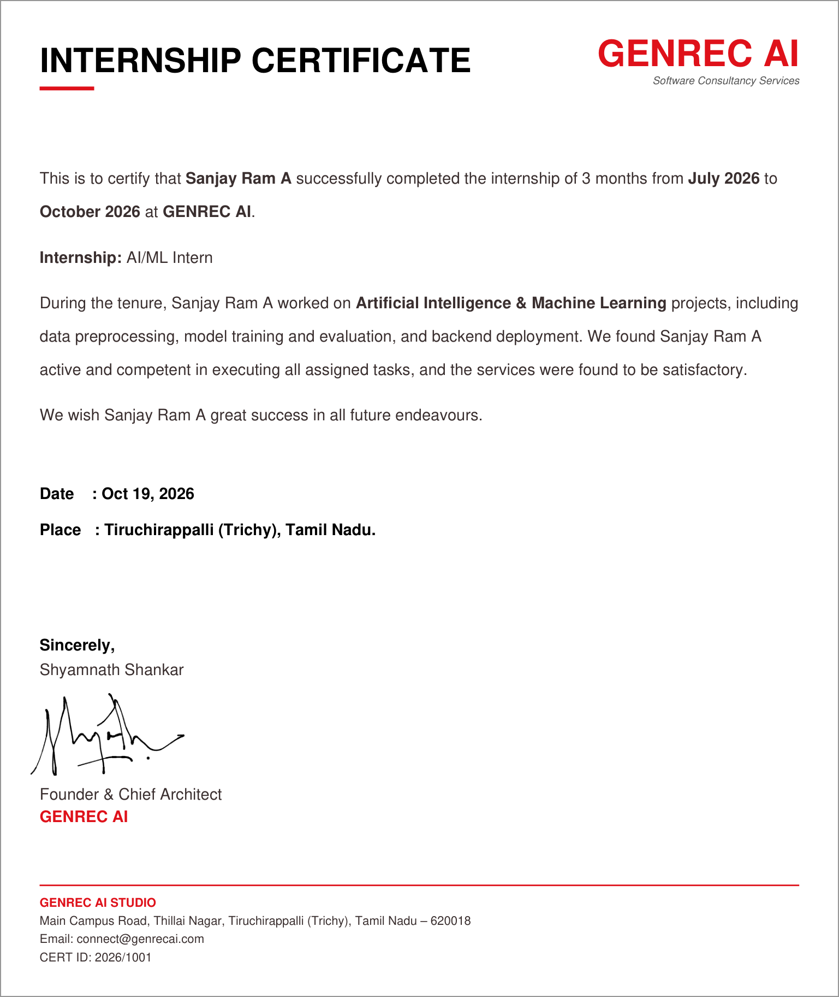
REFERENCES
Internship Offer Letter, GENREC AI, signed by Shyamnath Shankar, Founder & Chief Architect.
IV-Year Project First Review Meeting Report, Department of Artificial Intelligence and Data Science, review meeting, Academic Year 2026-2027.
Project documentation and sprint records, Tabble - A Hotel OS, GENREC AI (internal, not reproduced).
Technical guidance and code review notes from the industry mentor, Jaisamyukth, Software Engineer.
Géron, A., Hands-On Machine Learning with Scikit-Learn, Keras and TensorFlow, O'Reilly Media.
Sommerville, I., Software Engineering, Pearson Education.
Chacon, S. and Straub, B., Pro Git, Apress (available at git-scm.com).
Fielding, R. T., Architectural Styles and the Design of Network-based Software Architectures, doctoral dissertation, University of California, Irvine, 2000.
Python Software Foundation, Python Language Reference and Standard Library documentation, docs.python.org.
Pressman, R. S., Software Engineering: A Practitioner's Approach, McGraw-Hill Education.
Russell, S. and Norvig, P., Artificial Intelligence: A Modern Approach, Pearson Education.
Kleppmann, M., Designing Data-Intensive Applications, O'Reilly Media.
APPENDICES
Appendix A - Internship Certificate
This is to certify that Sanjay Ram A (Register Number 922123243045) completed an internship in AI/ML at GENREC AI from July 2026 to October 2026, working on Tabble - A Hotel OS under Jaisamyukth, Software Engineer. Company address: Main Campus Road, Thillai Nagar, Tiruchirappalli (Trichy), Tamil Nadu - 620018. The completion certificate is reproduced in full on page 26, before the References.
Appendix B - Internship Offer / Permission Letter
Offer letter, signed by Shyamnath Shankar, Founder & Chief Architect. Technical scope: data preprocessing, baseline training, hyperparameter evaluation, and backend model deployment. Deliverables: weekly sprint milestones and production-ready code artifacts. Confidentiality of proprietary source code, algorithms and datasets. Certification upon successful project sign-off. A copy of the offer letter is reproduced in full on page 3, after the Bonafide Certificate.
Appendix C - Weekly Internship Logbook
Month 1: orientation and data work - product and codebase understanding, environment setup, version control workflow, data preprocessing. Month 2: model and backend work - baseline training, hyperparameter evaluation, backend service and API integration for menu and order operations. Month 3: feature work and refinement - QR ordering workflow, testing, review feedback and improvement.
Table 3: Weekly internship logbook
Week | Month | Activity
1 | July 2026 | Orientation to the product and existing codebase; development environment and version-control workflow.
2 | July 2026 | Collection of operational records such as menu, order and table data; first quality checks.
3 | July 2026 | Data preprocessing: validation, cleaning, missing-value handling and normalisation.
4 | July 2026 | Baseline model training on the prepared data; first evaluation metrics.
5 | August 2026 | Hyperparameter evaluation on held-out data; comparison of baseline results.
6 | August 2026 | Backend service structure, request and response handling, and data access conventions.
7 | August 2026 | Menu service: categories, items, availability and pricing endpoints.
8 | August 2026 | Order service: validation and persistence of orders as the source of truth.
9 | September 2026 | Table and QR identity: resolving a scanned code to a table session.
10 | September 2026 | Kitchen dashboard and notification integration for real-time order visibility.
11 | September 2026 | Billing and payment handling from confirmed orders.
12 | October 2026 | Testing, review feedback and refinement of the ordering experience.
13 | October 2026 | Review of deliverables, documentation, and sign-off of assigned work.

Appendix D - Industry Mentor Evaluation
Industry mentor Jaisamyukth, Software Engineer, guided requirement understanding, technical problem approaches and implementation quality, with interaction for technical clarification, code-related guidance and project feedback.
Table 4: Areas of guidance from the industry mentor
Area | Guidance received
Understanding of requirements | Guided the student in understanding the requirements of the ordering workflow and splitting them into weekly sprint milestones.
Technical problem approaches | Advised on approaches to validation, data handling and service structure, and on how to evaluate baseline models.
Implementation quality | Reviewed code before merge and gave feedback on structure, readability and error handling.
Technical clarification | Available for questions and clarification throughout the internship.
Code-related guidance | Guidance on version-control practice, focused commits and review before merging.
Project feedback | Regular feedback on progress of the Tabble work and on the quality of each sprint deliverable.

Mentor: Jaisamyukth, Software Engineer, GENREC AI.
Appendix E - Final Internship Presentation / Viva Record
The review meeting collected and verified the internship details, AI/ML training, software-development responsibilities, project involvement and practical learning. The student was advised to maintain proper records and continue developing Tabble based on the technical experience gained.
Appendix F - Photographs, Screenshots and Project Evidence
Project evidence figures are included in Chapter 4 of this report (architecture, workflow/lifecycle and mind map), sourced from the internship project record.
Figure 1: System architecture of Tabble - A Hotel OS
Figure 2: QR-based order lifecycle
Figure 3: Mind map of internship activities and learning

