
PYNTREE TECHNOLOGIES
ARTIFICIAL INTELLIGENCE AND MACHINE LEARNING
2 MONTHS

An INTERNSHIP REPORT

Submitted by

RENUKA S

In partial fulfillment for the award of the degree
of
BACHELOR OF TECHNOLOGY
in
ARTIFICIAL INTELLIGENCE AND DATA SCIENCE
SSM INSTITUTE OF ENGINEERING AND TECHNOLOGY
DINDIGUL 624 002
ANNA UNIVERSITY::CHENNAI 600 025
OCTOBER 2026

BONAFIDE CERTIFICATE

This is to certify that RENUKA S (922123243043), is a bonafide student of AI&DS Department, SSM Institute of Engineering and Technology, Dindigul - 624 002, affiliated to Anna University.

The student is studying in VII Semester during the academic year 2026-2027 and has undertaken the Industry Internship at Pyntree Technologies from 01/07/2026 to 01/09/2026 as part of the academic requirements of the programme.

SIGNATURE | SIGNATURE
Dr.M.PREMKUMAR | Ms. I. JOICY
HEAD OF THE DEPARTMENT | ASSISTANT PROFESSOR
Department of Artificial Intelligence and Data Science, | Department of Artificial Intelligence and Data Science,
SSM Institute of Engineering and Technology, | SSM Institute of Engineering and Technology,
Dindigul - 624002. | Dindigul - 624002.

OFFER LETTER
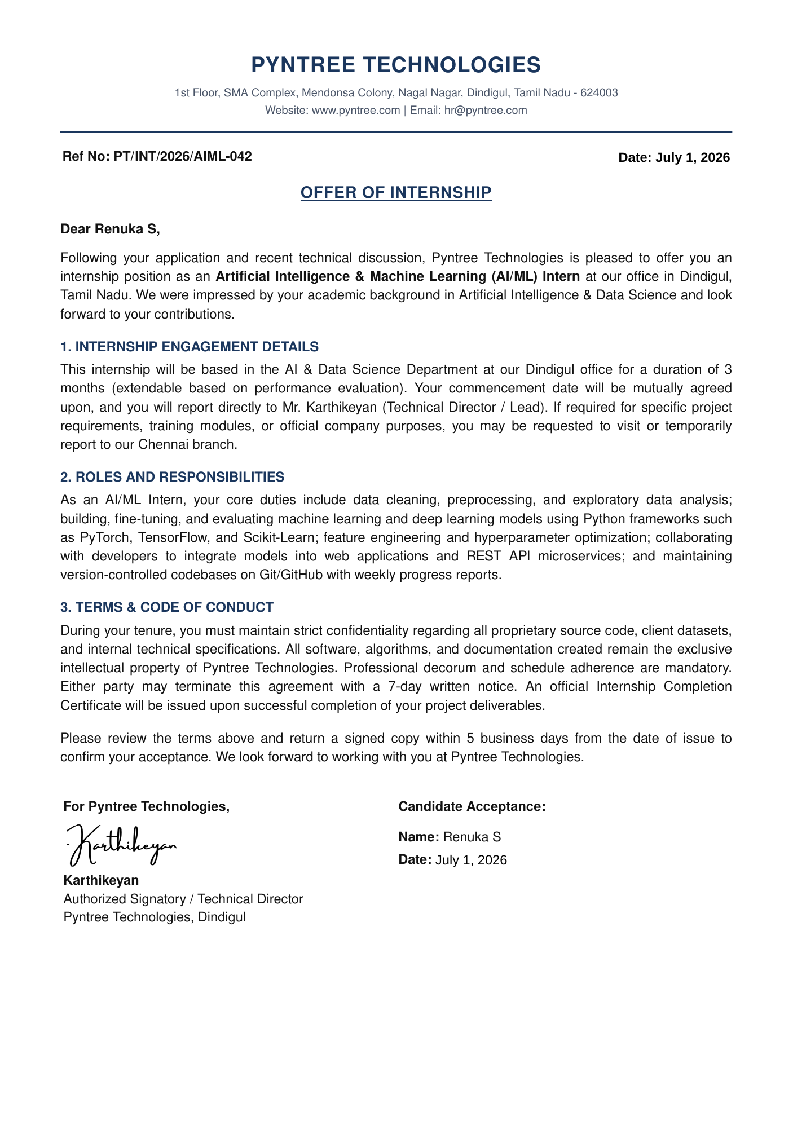
DECLARATION
I, Renuka S, declare that the work presented in this report is an authentic record of the internship carried out by me at Pyntree Technologies between 01 July 2026 and 01 September 2026. The technical details, project description and learning outcomes described here reflect my own work and observations, and are consistent with the departmental review meeting record dated 17.08.2026. In keeping with the confidentiality expected of the engagement, no proprietary source code, model weights or internal dataset belonging to Pyntree Technologies has been reproduced in this report; the discussion is limited to design, architecture and learning.
I further declare that this report has not been submitted, in whole or in part, to any other university or institution for the award of any degree, diploma or certificate. Wherever the ideas, figures or statements of other sources have been used, they have been acknowledged in the references. The report has been prepared in accordance with the format prescribed by the department for industry internship reports.

Place: Dindigul
Date: ____________________
ACKNOWLEDGEMENT
First and foremost, we would like to express our deep sense of gratitude to our most honorable Chairman and Management Trustees Mr. K. Shanmugavel for providing us with necessary facilities during the course of study. We feel immensely pleased to express our sincere thanks to our Principal
Dr. S. Karthigai Lakshmi for encouragement and support extended by them. We extend our solemn gratitude to Dr. M. Premkumar, Head of the Department, Artificial Intelligence and Data Science, for timely support to all our activities.
I would like to thank my Faculty Internship Coordinator, the Faculty In-Charge, for the continuous guidance, valuable suggestions, and encouragement during the internship and in the preparation of this report.
I am grateful to Pyntree Technologies for providing me with the opportunity to gain practical exposure to an industry environment. I sincerely thank my Industry Mentor, Karthikeyan, Software Developer, and the entire team for their guidance, technical support, and valuable insights throughout the internship.
We express our sincere thanks to our guide Ms. I. Joicy, AP/AI&DS for her guidance throughout our Internship. Also we express our thanks to the faculty members of our department, non-teaching staff members and my dear friends for their moral support, help and encouragement towards the successful completion of the internship.
INDEX
S. No. | CONTENTS | PAGE NO.
1 | Bonafide Certificate | 2
2 | Offer Letter | 3
3 | Declaration | 4
4 | Acknowledgement | 5
5 | Executive Summary | 9
6 | List of Figures | 10
7 | List of Tables | 10
8 | Abbreviations / Acronyms | 10
9 | Chapter 1 – Introduction | 11
9.1 | Background | 11
9.2 | Internship Overview | 11
9.3 | Need and Purpose of the Internship | 11
9.4 | Objectives of the Internship | 11
9.5 | Scope of the Report | 11
10 | Chapter 2 – Company Profile | 12
10.1 | Company Introduction | 12
10.2 | Vision and Mission | 12
10.3 | Products / Services | 12
10.4 | Industry Domain | 12
10.5 | Department / Team Assigned | 12
11 | Chapter 3 – Internship Activities | 13
11.1 | Internship Plan | 13
11.2 | Training Received | 13
11.3 | Tasks and Responsibilities | 13
11.4 | Technologies and Tools Used | 14
11.5 | Weekly / Phase-wise Activities | 14
11.6 | Team Collaboration | 14
12 | Chapter 4 – Major Project / Work Undertaken | 15
12.1 | Project Title | 15
12.2 | Problem Statement | 15
12.3 | Objectives | 15
12.4 | Requirements | 15
12.5 | Existing System / Approach | 15
12.6 | Proposed Solution | 15
12.7 | Methodology | 15
12.8 | System Architecture / Workflow | 16
12.9 | Modules / Components | 17
12.10 | Implementation | 17
12.11 | Results and Outputs | 17
12.12 | Screenshots / Demonstration Evidence | 18
12.13 | Additional Project for Reference: LearnLock | 18
12.14 | Testing and Validation Approach | 21
13 | Chapter 5 – Skills and Learning Outcomes | 22
13.1 | Technical Skills | 22
13.2 | Software / Tools / Platforms | 22
13.3 | AI / Cloud / Data Skills | 22
13.4 | Communication and Teamwork | 22
13.5 | Problem-Solving Skills | 22
13.6 | Professional Learning | 22
14 | Chapter 6 – Challenges and Solutions | 23
14.1 | Technical Challenges | 23
14.2 | Organizational / Team Challenges | 23
14.3 | Solutions Adopted | 23
14.4 | Key Lessons Learned | 23
15 | Chapter 7 – Professional Experience | 24
15.1 | Workplace Practices | 24
15.2 | Industry Standards | 24
15.3 | Professional Ethics | 24
15.4 | Safety, Security and Data Practices | 24
16 | Chapter 8 – Conclusion and Future Scope | 25
16.1 | Conclusion | 25
16.2 | Achievement of Objectives | 25
16.3 | Career Relevance | 25
16.4 | Future Scope / Recommendations | 25
17 | References | 26
18 | Appendices | 27
18.1 | Appendix A – Internship Certificate | 27
18.2 | Appendix B – Internship Offer / Permission Letter | 27
18.3 | Appendix C – Weekly Internship Logbook | 27
18.4 | Appendix D – Industry Mentor Evaluation | 28
18.5 | Appendix E – Final Internship Presentation / Viva Record | 28
18.6 | Appendix F – Photographs, Screenshots and Project Evidence | 28
19 | Completion Certificate | 30
Executive Summary
This report documents a 2 months internship in the domain of AI/ML carried out at Pyntree Technologies, Dindigul, from 01 July 2026 to 01 September 2026. The internship was oriented towards applied AI and machine learning: building, fine-tuning and evaluating models, data preprocessing and analysis, and integrating models into web applications and REST API microservices, with all work kept under version control. The practical work centred on a RAG Chatbot - An AI Knowledge Assistant. The project focuses on building a retrieval-augmented generation (RAG) chatbot that answers user questions grounded in an organisation's own documents, pairing semantic retrieval over a vector store with a large language model so that answers stay accurate, current and traceable to their sources. The report describes the layered architecture designed for the platform, the lifecycle of a query from the user's question through retrieval to a grounded answer, the functional modules involved, and the individual contribution made to them. It closes with the engineering practices absorbed during the internship - version control, review and testing - and the learning outcomes drawn from them. An additional project, LearnLock - an Android application that blocks selected apps until a multiple-choice question is answered correctly - is documented in Chapter 4 as a reference project, showing the same layered engineering practice in a mobile setting.
LIST OF FIGURES
FIGURE NO | FIGURE | PAGE NO
Figure 1 | System architecture of the RAG chatbot | 16
Figure 2 | Retrieval-augmented query lifecycle | 17
Figure 3 | Mind map of internship activities and learning | 18
Figure 4 | System architecture of LearnLock | 20
Figure 5 | LearnLock lock, answer and unlock lifecycle | 20

LIST OF TABLES
TABLE NO | TABLE | PAGE NO
Table 1 | Layers of the LearnLock application | 19
Table 2 | Weekly internship logbook | 27
Table 3 | Areas of guidance from the industry mentor | 28

ABBREVIATIONS / ACRONYMS
AI - Artificial Intelligence
ML - Machine Learning
RAG - Retrieval-Augmented Generation
API - Application Programming Interface
LLM - Large Language Model
APK - Android Package Kit
MCQ - Multiple-Choice Question
JSON - JavaScript Object Notation
CHAPTER 1
INTRODUCTION
1.1 BACKGROUND
Classroom study of artificial intelligence usually stops at the model: a dataset is cleaned, an algorithm is trained, and an accuracy figure is reported. Industry practice begins where that exercise ends. A model earns its value only once it is wrapped in a service, fed by a reliable data path, deployed behind an interface and maintained as requirements change. This internship was undertaken to work on that second half of the problem, applied to a language-model application.
The internship was undertaken at Pyntree Technologies as an AI/ML Intern for a period of 2 Months (July - September 2026). The departmental review meeting held on 17.08.2026 collected and verified the internship details, the nature of the AI/ML and software-development work, and the project involvement.
1.2 INTERNSHIP OVERVIEW
The internship ran for 2 Months from 01 July 2026 to 01 September 2026 in the AI/ML domain, with work carried out from Dindigul, Tamil Nadu / Remote. The role was that of an AI software developer contributing to a live product, RAG Chatbot - An AI Knowledge Assistant.
1.3 NEED AND PURPOSE OF THE INTERNSHIP
The internship connected academic study with practical engineering tasks: building, fine-tuning and evaluating models, preparing data, and integrating models into web applications and REST API microservices under version control.
1.4 OBJECTIVES OF THE INTERNSHIP
Gain hands-on experience in building, fine-tuning and evaluating machine learning and deep learning models. Work through a complete data path: cleaning, preprocessing, exploratory analysis, feature engineering and hyperparameter optimisation. Develop models with Python frameworks - PyTorch, TensorFlow and Scikit-Learn. Integrate models into web applications and REST API microservices under version control with Git and GitHub. Contribute to a retrieval-augmented generation (RAG) chatbot as the practical outcome of the internship.
1.5 SCOPE OF THE REPORT
The report covers the internship engagement and its terms, the areas of training, the architecture and functional design of the RAG chatbot, the individual contribution, and the learning outcomes. Architecture and design are discussed at a level appropriate for an academic report; proprietary source code, model weights and internal datasets are deliberately excluded.
CHAPTER 2
COMPANY PROFILE
2.1 COMPANY INTRODUCTION
Pyntree Technologies is a technology company located at 1st Floor, SMA Complex, Mendonsa Colony, Nagal Nagar, Dindigul, Tamil Nadu - 624003. The internship placed the student with the engineering team as an AI software developer, contributing to live product work in artificial intelligence and machine learning rather than to separate training exercises.
The company's working model is project based. Work arrives as product requirements, is divided into small units, and is delivered through a shared version-controlled repository in which every change is reviewed. Interns join this model from the first week instead of being kept in a separate training track, so the learning is gained from the same discipline that the engineering team itself follows.
2.2 VISION AND MISSION
As recorded in the internship report, the company engages interns in live product work in artificial intelligence and machine learning with the engineering team, rather than separate training exercises.
2.3 PRODUCTS / SERVICES
The project undertaken during the internship was RAG Chatbot - An AI Knowledge Assistant. It answers user questions grounded in an organisation's own documents, pairing semantic retrieval over a vector store with a large language model so that answers stay accurate, current and traceable to their sources. It is discussed in Chapter 4. LearnLock, an AI-assisted Android study-lock application, is documented alongside it as an additional project for reference.
2.4 INDUSTRY DOMAIN
The internship domain was Artificial Intelligence and Machine Learning: building, fine-tuning and evaluating models, data preprocessing and analysis, and integrating models into web applications and REST API microservices.
2.5 DEPARTMENT / TEAM ASSIGNED
The student worked as an AI software developer with the engineering team under the guidance of Karthikeyan, Software Developer, contributing to RAG Chatbot - An AI Knowledge Assistant.
CHAPTER 3
INTERNSHIP ACTIVITIES
3.1 INTERNSHIP PLAN
The internship ran for 2 Months from 01 July 2026 to 01 September 2026 as AI/ML Intern at Pyntree Technologies, organised incrementally with each unit beginning with requirement discussion, followed by implementation, review and integration, with every change committed on Git and GitHub and reviewed before merge.
In the first weeks the plan concentrated on orientation: reading the existing code, setting up the development environment and learning the branching and review conventions on Git and GitHub. The later weeks moved to retrieval, generation and integration, with testing and refinement of answer quality in response to review comments.
3.2 TRAINING RECEIVED
Training spanned five connected areas: AI/ML Development with hands-on experience building, fine-tuning, and evaluating machine learning and deep learning models; Data Preprocessing and Analysis including cleaning, exploratory analysis, feature engineering, and hyperparameter optimization; Python Frameworks of PyTorch, TensorFlow, and Scikit-Learn; Integration and Version Control into web applications and REST API microservices with Git/GitHub; and Practical Learning applied through the RAG chatbot.
Training took place on the job rather than in a classroom. The industry mentor explained the architecture of the chatbot, walked through representative changes, and gave feedback on the intern's own commits, so that each area of training was practised on real tasks and then corrected through review.
3.3 TASKS AND RESPONSIBILITIES
The internship work covered AI/ML development and the data and integration tasks of the RAG chatbot: document loading, cleaning and chunking; embedding and indexing into the vector store with semantic retrieval; grounded answer generation with citations; data preprocessing and analysis; model building, fine-tuning and evaluation with PyTorch, TensorFlow and Scikit-Learn; REST API integration; and version control discipline on Git and GitHub.
Each task was handled as a small, reviewable unit. A typical task began with a discussion of what the change should do, continued with an implementation on a separate branch and focused tests, and ended with a review in which the mentor's comments were applied before the change was merged. Keeping tasks small made it easier to find the cause of a problem and to keep unfinished work out of the product.
Where a task involved documents or data, an additional step was added before implementation: inspecting the material that would feed the work, noting missing or inconsistent content, and agreeing with the mentor on how each case should be handled. This avoided building a feature on assumptions about data that later proved to be wrong.
3.4 TECHNOLOGIES AND TOOLS USED
Python, PyTorch, TensorFlow, Scikit-Learn, data preprocessing, model evaluation, REST API integration, and Git/GitHub, together with a vector store for embeddings, an embedding model, a large language model, and a document store. For the additional LearnLock project: Flutter and Dart with Riverpod, go_router, sqflite and dio, Kotlin for native Android enforcement, and a FastAPI backend deployed on Cloud Run.
Version control was used for every change, with commits that were small, focused and described in plain language. Service endpoints were exercised through requests and responses during testing, and experiments with chunk size, embeddings and ranking were recorded so that a result could be reproduced later by rerunning the same steps.
3.5 WEEKLY / PHASE-WISE ACTIVITIES
Month 1 - Foundations, data and models: understanding the product and codebase, environment and Git/GitHub setup, data cleaning, preprocessing and exploratory analysis, and model building, fine-tuning and evaluation. Month 2 - Retrieval, generation and integration: document chunking, embeddings and semantic retrieval; grounded answer generation with citations, REST API integration, testing and improvement of retrieval and answer quality.
Across the two months the working rhythm stayed the same: a short planning discussion at the start of each unit of work, implementation and testing through it, and a review of what had been completed at the end. Progress against each stage of the retrieval pipeline was recorded in the logbook that appears in Appendix C.
3.6 TEAM COLLABORATION
Work was carried out with developer guidance and project feedback from Karthikeyan, Software Developer, with version control on Git and GitHub and review before merge.
Collaboration took several forms: asking precise questions when a requirement was unclear, explaining the intent of a change when it was submitted for review, and reading the comments of the reviewer carefully before replying. This improved both the quality of the intern's contributions and the speed with which they were accepted.
CHAPTER 4
MAJOR PROJECT / WORK UNDERTAKEN
4.1 PROJECT TITLE
RAG Chatbot - An AI Knowledge Assistant.
4.2 PROBLEM STATEMENT
A large language model on its own answers from what it learned during training. That creates two problems for any organisation that wants to use one over its own material. The model does not know private or recent documents, so it cannot answer questions about them; and when it does not know, it tends to produce a fluent answer anyway, with no way for the reader to check it. For factual question answering, both are disqualifying.
4.3 OBJECTIVES
The project focuses on building a retrieval-augmented generation (RAG) chatbot that answers user questions grounded in an organisation's own documents, pairing semantic retrieval over a vector store with a large language model so that answers stay accurate, current and traceable to their sources.
4.4 REQUIREMENTS
Source documents with cleaning and passage splitting; an embedding model for passages and queries; a vector store for semantic search with reranking; a large language model for grounded generation with citations; a chat interface keeping conversation context; an administrative view for the document collection; and logging with feedback capture for quality evaluation.
4.5 EXISTING SYSTEM / APPROACH
The existing approach is a language model answering from training memory alone, which cannot use private or recent documents and produces fluent but unverifiable answers when it does not know.
4.6 PROPOSED SOLUTION
Retrieval-augmented generation separates knowledge from reasoning. Documents are split into passages, converted to embeddings and stored in a vector store. When a question arrives, the most relevant passages are retrieved and placed before the language model as context, and the model answers from that context and cites it, grounding the answer in real documents.
4.7 METHODOLOGY
Work was organised incrementally: requirement discussion, implementation, review and integration, with Git and GitHub commits reviewed before merge. The pipeline ran from document preparation through embeddings and retrieval to grounded generation and REST API integration, with testing and quality improvement.
4.8 SYSTEM ARCHITECTURE / WORKFLOW
The platform is organised into four layers. The client layer holds the chat interface with citations, the admin console for the document collection, and API consumers. The application and API layer uses a gateway for authentication, rate limiting, session handling and routing, with a chat orchestrator, ingestion, retrieval, generation, and feedback and logging services. The RAG pipeline layer holds the document loader with cleaning and chunking, the embedding model, the semantic retriever with reranking, and the language model with prompt assembly joining query and context. The data and model infrastructure layer holds the vector store, the document store with metadata, and the served language and embedding models, with version control and continuous integration as the delivery path.
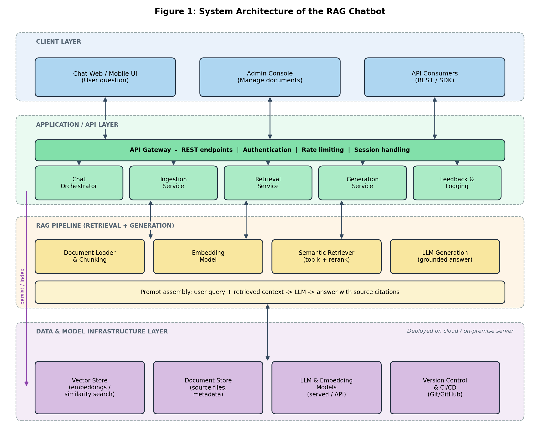
Figure 1: System architecture of the RAG chatbot
A single question is embedded and matched against the vector store, the closest passages are retrieved and reranked, and only then is the language model asked to answer from that context with citations. Without the retrieved passages the model would answer from memory and traceability would be lost.
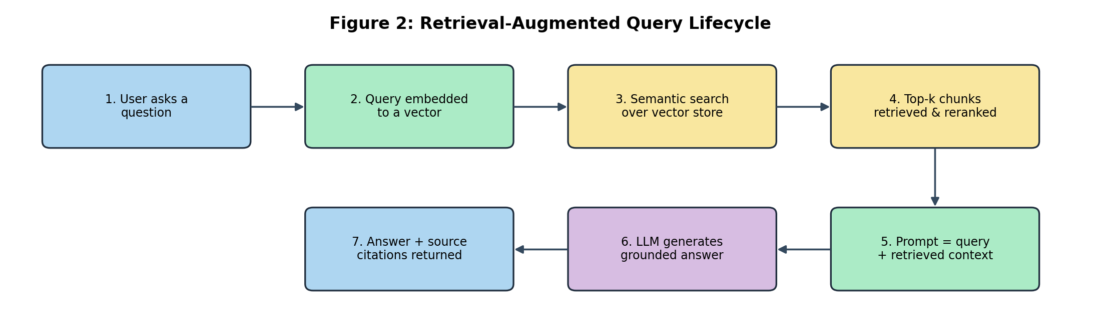
Figure 2: Retrieval-augmented query lifecycle
4.9 MODULES / COMPONENTS
Chat orchestrator coordinates a request across retrieval and generation and keeps conversation context. Ingestion service loads, cleans and chunks source documents. Embedding model converts passages and queries into vectors. Retrieval service finds and reranks the most relevant passages. Generation service prompts the language model to answer from retrieved context and cite sources. Vector store serves semantic similarity search. Document store holds source files and metadata. Feedback and logging records queries, answers and feedback for evaluation.
4.10 IMPLEMENTATION
Implementation covered document ingestion with loading, cleaning and chunking; embedding and indexing with semantic retrieval; prompt assembly for grounded generation with citations; data preprocessing and analysis; model building, fine-tuning and evaluation with PyTorch, TensorFlow and Scikit-Learn; REST API microservice integration; and Git and GitHub discipline with review before merging.
Each unit of work followed the same short cycle: discussion of the requirement, implementation on a branch, local testing, and review before merge. Ingestion, retrieval and generation were built and reviewed as separate steps, so that a problem could be traced to the stage that caused it, for example a poor answer caused by a poorly chosen passage rather than by the prompt.
4.11 RESULTS AND OUTPUTS
The project is currently under development, with ongoing implementation and testing of the document ingestion pipeline, retrieval quality and grounded answer generation, delivering retrieval over a document collection with cited, grounded answers.
At this stage the pipeline can take a document collection through cleaning, chunking, embedding and indexing, retrieve and rerank passages for a question, and return an answer that cites the passages it used. Retrieval quality was tuned by adjusting chunk size, the embedding model and the ranking step, with queries, answers and feedback logged so that quality could be reviewed and compared between changes.
4.12 SCREENSHOTS / DEMONSTRATION EVIDENCE
Demonstration evidence is provided through the architecture, query lifecycle and mind map figures of this report, tracing a single question from query to grounded answer and collecting the internship activities into a single view.
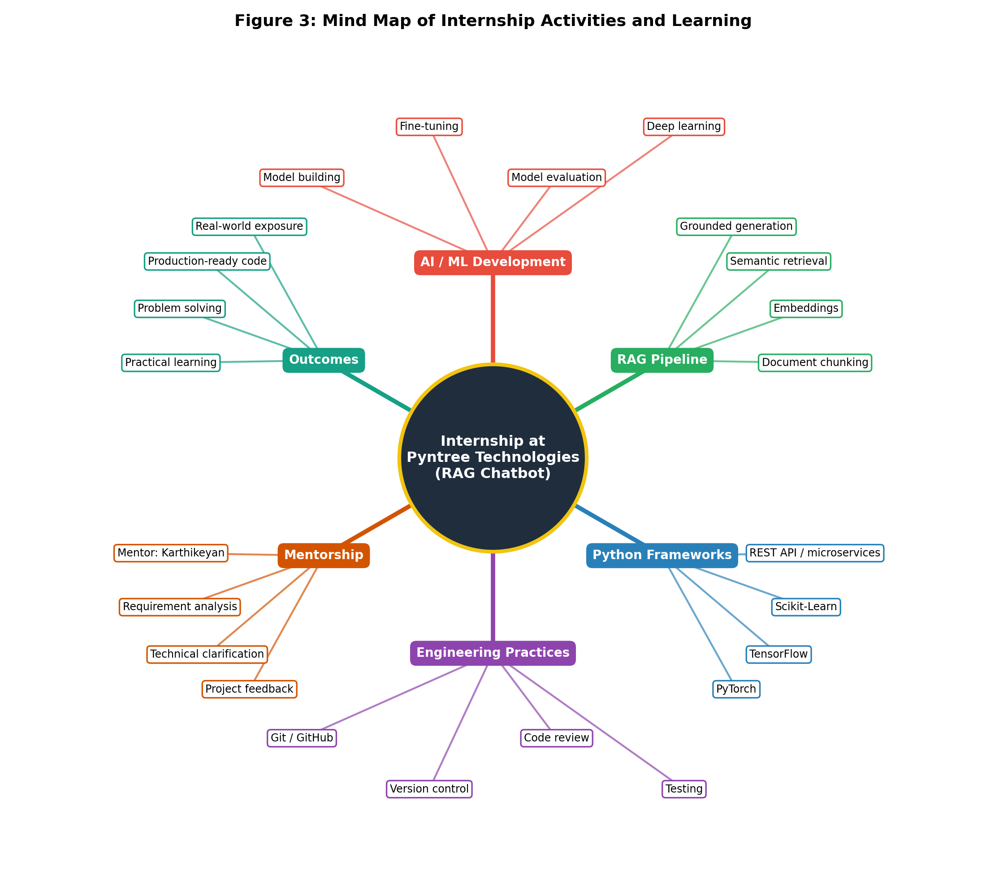
Figure 3: Mind map of internship activities and learning
4.13 ADDITIONAL PROJECT FOR REFERENCE: LEARNLOCK
4.13.1 Overview
LearnLock is an Android-only Flutter application that blocks user-selected apps and unlocks them only after the user answers a multiple-choice question correctly. The questions are generated by an AI model behind a FastAPI backend and cached locally in SQLite, so the locking behaviour keeps working even when the device is offline. The project is included in this report as an additional project for reference; it shows how a mobile client, a native enforcement layer and a backend service are separated and connected in practice.
4.13.2 Problem Statement
Screen-time tools usually rely on a plain timer or a password, which a user can dismiss without effort. Study and focus applications need friction that is useful rather than merely irritating. LearnLock turns the moment of distraction into a moment of revision: to open a blocked app the user must first demonstrate knowledge of a topic they chose, at a difficulty they chose.
4.13.3 How the Application Works
Onboarding. The user picks two to five topics, sets a difficulty for each topic (beginner, intermediate or advanced), chooses the apps to lock, sets the unlock timer, and grants the two required permissions: Usage Access and Display over other apps.
Enforcement. A Kotlin foreground service watches the active app through UsageStatsManager. When a locked app comes to the front, the service launches a native lock screen, LockActivity, which presents a quiz.
Answering. A correct answer gives a time-boxed unlock. A wrong answer allows one retry with a new question. After two failures the user may take an emergency five-minute unlock or quit. Every outcome is logged locally for on-device analytics.
Refill. When the pool of usable questions falls to between ten and fifteen, a silent batch is fetched in the background. A set of bundled fallback questions keeps locking functional when there is no internet connection.
4.13.4 System Architecture
The application is organised into three layers, summarised in Table 1 and Figure 4. The Flutter layer owns the interface, the local database and the question lifecycle. The Kotlin layer owns everything that must keep running outside the Flutter engine: foreground-app detection, the lock screen and the enforcement state. The FastAPI backend does one job only, question generation and validation, so that no AI key is ever shipped inside the APK.
Table 1: Layers of the LearnLock application
Layer | Stack | Responsibility
Flutter | Riverpod, go_router, sqflite, dio | Interface, onboarding, local database, analytics and question lifecycle
Kotlin | MethodChannel com.learnlock/native, MonitorService (foreground service), overlays, SharedPreferences | Foreground-app detection, lock screen and enforcement state
FastAPI | Python, OpenAI-compatible json_schema output, Cloud Run | Question generation and validation only; AI keys never ship in the APK

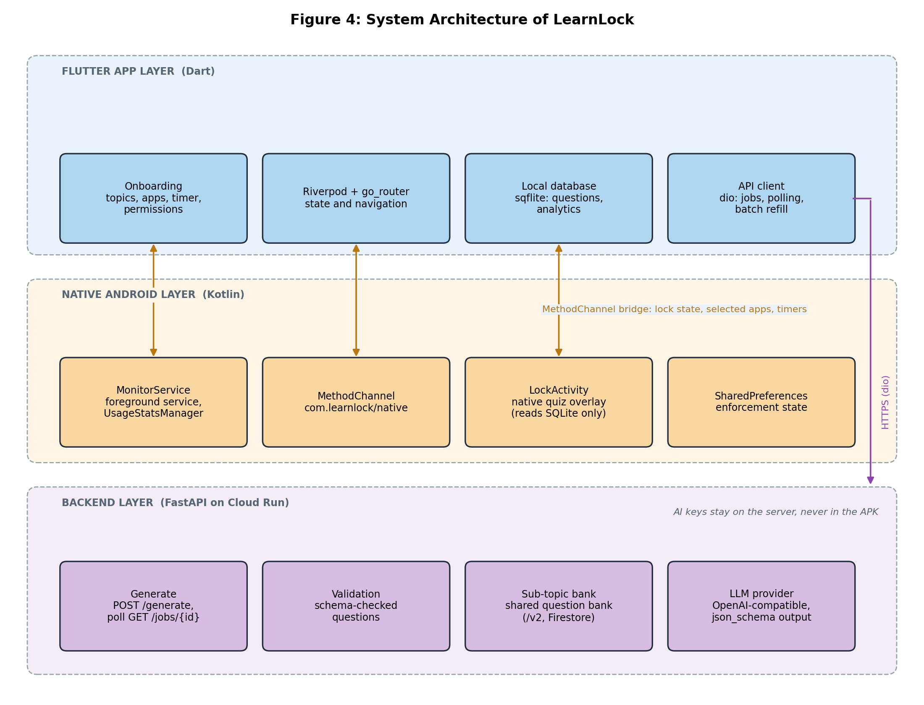
Figure 4: System architecture of LearnLock
Figure 5 follows a single lock event. The sequence is entirely local once a question pool exists: the lock screen reads questions from SQLite and records the result, and the network is touched only by the background refill.
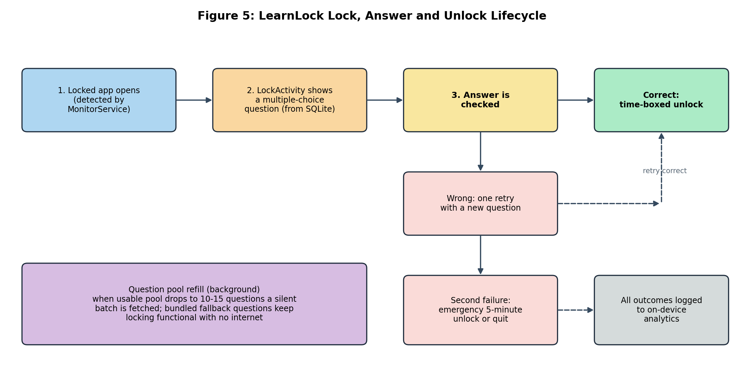
Figure 5: LearnLock lock, answer and unlock lifecycle
4.13.5 Key Design Principles
Three rules shaped the design. First, the lock screen reads SQLite only and never touches the network, so a slow or absent connection can never leave a user locked out or stuck on a blank screen. Second, analytics stay on the device. Third, because generating twenty-five to fifty questions takes minutes, the version 1 backend interface uses asynchronous jobs: the client sends a generate request and then polls a job endpoint for the result, instead of holding a connection open.
4.13.6 Question Bank Backend (Ongoing Work)
The current focus of the project is turning question generation into a reusable, scalable sub-topic bank. The planned design is a shared, Firestore-backed bank organised by a taxonomy of twelve categories, about ninety-six nodes and roughly thirty sub-topics each, with fifty questions kept per sub-topic and topped up lazily on demand. New version 2 endpoints (bank ensure, bank next, jobs and bank export) sit beside the unchanged version 1 interface. A single-filler lease prevents duplicate AI spend when several devices request the same sub-topic, and an install identifier with a server-side record of questions already seen prevents repeats for a user. On the Flutter side, the bank is warmed up quietly during onboarding so that navigation stays instant, and answer choices are shuffled on the client with a seeded shuffle.
4.13.7 Relevance to the Internship
LearnLock is not part of the RAG chatbot but exercises the same habits: work divided into layers with narrow interfaces, a backend that wraps a language model behind validation, structured model output checked against a schema, and an offline-first client. It is documented here so that the reader can compare two different ways of placing a language model inside a product.
4.14 TESTING AND VALIDATION APPROACH
Testing followed the incremental rhythm of the internship. Each stage of the retrieval pipeline was tested on its own before the stages were joined: ingestion was checked for documents that failed to load or produced empty passages, chunking was checked so that passages kept enough context to be useful, and retrieval was checked by asking questions whose answers were known to be in the collection and confirming that the right passages came back near the top.
Only after retrieval behaved sensibly was generation judged. Answers were checked to confirm that they used the retrieved passages, that the citations pointed to the passages actually used, and that a question with no support in the collection did not receive a confident invented answer. Queries, answers and user feedback were logged so that two versions of the pipeline could be compared on the same questions.
A short checklist was used before each merge: the change does one thing, its tests pass, naming follows the existing code, and the commit message explains the reason for the change.
CHAPTER 5
SKILLS AND LEARNING OUTCOMES
5.1 TECHNICAL SKILLS
A working understanding of retrieval-augmented generation end to end: ingestion, embeddings, retrieval, prompt assembly and grounded generation. Hands-on experience building, fine-tuning and evaluating models with PyTorch, TensorFlow and Scikit-Learn.
5.2 SOFTWARE / TOOLS / PLATFORMS
Python, PyTorch, TensorFlow, Scikit-Learn, REST API microservices, and Git and GitHub with review before merge and testing.
5.3 AI / CLOUD / DATA SKILLS
Data cleaning, preprocessing, exploratory analysis, feature engineering and hyperparameter optimisation applied to both tabular data and documents, including document loading, cleaning and passage splitting for embeddings and retrieval quality.
The practice of evaluating retrieval separately from generation was the most valuable lesson from the data side of the internship, since it shows which stage is responsible when an answer is poor.
5.4 COMMUNICATION AND TEAMWORK
Improved technical communication through interaction with Karthikeyan, Software Developer, for requirement understanding, technical clarification, code-related guidance and project feedback.
5.5 PROBLEM-SOLVING SKILLS
Iterating chunk size, embeddings and ranking for retrieval quality; assembling prompts so the model answers from retrieved context with citations; and preparing inconsistent real source files.
5.6 PROFESSIONAL LEARNING
Professional working habits: version control on Git and GitHub, review before merge, and testing, with an appreciation of layered architecture as a means of containing change.
The internship also built confidence in working inside an unfamiliar codebase: reading before writing, following established conventions, and asking for review early instead of late.
CHAPTER 6
CHALLENGES AND SOLUTIONS
6.1 TECHNICAL CHALLENGES
Retrieval quality: an answer is only as good as the passages retrieved, and chunk size, embeddings and ranking took more iteration than generation. Grounding and citations: keeping the model on retrieved context rather than memory required careful prompt assembly and checking. Document preparation: inconsistent real source files needed heavy cleaning and chunking. Evaluation: fluent answers can still be wrong or ungrounded. Working inside an existing codebase with established conventions.
Scope was a further challenge. A retrieval-augmented system touches document handling, embeddings, a vector store, a language model and an interface, and it was not always obvious which stage a given problem belonged to. Understanding the stages and their interfaces was necessary before even a small change could be made with confidence.
6.2 ORGANIZATIONAL / TEAM CHALLENGES
Contributing to code written by others required reading and following existing conventions, delivering in reviewable increments rather than one late submission.
There was also the discipline of time. Units of work were short, and a task that was not broken down well at the start could run past its planned time. Learning to estimate small tasks realistically, and to say early when one was growing, was part of the professional growth that the internship provided.
6.3 SOLUTIONS ADOPTED
Structured preprocessing and repeatable ingestion with an updatable index; incremental implementation with version control and review before merge; retrieval and answer quality testing; and mentor guidance on requirements and implementation quality.
6.4 KEY LESSONS LEARNED
Treat a project as an end-to-end system and deliver in reviewable increments, grounding every answer in retrieved sources so it can be traced.
A further lesson was that each stage of a retrieval pipeline needs its own checks. An answer can only be as good as the passages retrieved, so retrieval was evaluated on its own before generation was judged. Keeping changes small and reviewable made it possible to see which change had improved or worsened the results.
CHAPTER 7
PROFESSIONAL EXPERIENCE
7.1 WORKPLACE PRACTICES
Incremental work with requirement discussion, implementation, review and integration; version control on Git and GitHub; and review before merge kept partially finished work out of the product.
7.2 INDUSTRY STANDARDS
Production-ready code artifacts, validation at service boundaries, error handling, and predictable behaviour under repeated calls.
Industry practice also expects that a service describes its own limits: what it accepts, what it rejects and why. Following these standards in the chatbot's interfaces meant that clients of the service could rely on consistent behaviour, including a clear response when no supporting passage was found.
7.3 PROFESSIONAL ETHICS
Accurate record-keeping of internship activities as advised at the review meeting, with honest evaluation of models and work on evidence.
Professional ethics also covered respect for the work of others. Existing code was extended in the style in which it was written, review comments were treated as guidance rather than criticism, and the contributions of the mentor and the team are acknowledged in this report.
7.4 SAFETY, SECURITY AND DATA PRACTICES
Strict confidentiality regarding proprietary source code, algorithms, model weights, studio datasets and internal configuration belonging to Pyntree Technologies. This report describes system structure, data flow and design reasoning only, with no source listings, weights, credentials, dataset samples or internal configuration reproduced.
Data practices followed the same principle. Documents were used only for the purpose of the project, were handled within the company's environment, and are not reproduced in this report in any identifiable form.
The internship agreement also requires that proprietary material is not shared outside the company. For that reason, figures in this report show architecture and workflow at a conceptual level, and the tables describe layers and responsibilities by purpose rather than by implementation detail.
CHAPTER 8
CONCLUSION AND FUTURE SCOPE
8.1 CONCLUSION
The 2 months internship at Pyntree Technologies met its objective of moving from academic familiarity with AI and machine learning to practical participation in production software development. Working on the RAG chatbot placed the machine learning work in a context where it had to serve a real workflow: a language model is useful over an organisation's material only when retrieval feeds it the right context, and an answer is trustworthy only when it can be traced to its sources.
Equally important was the change in perspective. At the start of the internship, success was measured by whether a model trained and produced a good score. By the end, success was measured by whether an answer was correct, could be traced to its sources, survived a review, and could be maintained by someone else.
8.2 ACHIEVEMENT OF OBJECTIVES
Hands-on model building, fine-tuning and evaluation, data preprocessing and analysis, Python framework use, REST API integration and version control were achieved through the RAG chatbot.
Each objective stated in Chapter 1 was met in a form that can be pointed to: a repeatable ingestion and indexing path, a retrieval step whose quality was tuned and compared, grounded answers with citations, REST API integration, and a history of reviewed commits.
8.3 CAREER RELEVANCE
The internship established end-to-end RAG understanding and production habits that carry forward into the final-year project and professional AI engineering work.
8.4 FUTURE SCOPE / RECOMMENDATIONS
The project continues under development, with ongoing implementation and testing of the document ingestion pipeline, retrieval quality and grounded answer generation.
Recommendations for continuing the work include extending automated tests across the retrieval pipeline, measuring answer quality on a fixed set of questions after every change, and evaluating larger document collections.
REFERENCES
IV-Year Project First Review Meeting Report, Department of Artificial Intelligence and Data Science, review meeting dated 17.08.2026, Academic Year 2026-2027.
Project documentation and development records, RAG chatbot, Pyntree Technologies (internal, not reproduced).
Technical guidance and code review notes from the industry mentor, Karthikeyan, Software Developer.
Python machine learning frameworks used during the internship: PyTorch, TensorFlow and Scikit-Learn.
Lewis, P. et al., Retrieval-Augmented Generation for Knowledge-Intensive NLP Tasks, Advances in Neural Information Processing Systems (NeurIPS), 2020.
Vaswani, A. et al., Attention Is All You Need, Advances in Neural Information Processing Systems (NeurIPS), 2017.
Pedregosa, F. et al., Scikit-learn: Machine Learning in Python, Journal of Machine Learning Research, vol. 12, 2011.
Paszke, A. et al., PyTorch: An Imperative Style, High-Performance Deep Learning Library, Advances in Neural Information Processing Systems (NeurIPS), 2019.
Abadi, M. et al., TensorFlow: A System for Large-Scale Machine Learning, USENIX OSDI, 2016.
Chacon, S. and Straub, B., Pro Git, Apress (available at git-scm.com).
Sommerville, I., Software Engineering, Pearson Education.
APPENDICES
Appendix A - Internship Certificate
This is to certify that Renuka S (Register Number 922123243043) completed an internship in AI/ML at Pyntree Technologies from 01 July 2026 to 01 September 2026, working on RAG Chatbot - An AI Knowledge Assistant under Karthikeyan, Software Developer. Company address: 1st Floor, SMA Complex, Mendonsa Colony, Nagal Nagar, Dindigul, Tamil Nadu - 624003. The completion certificate is reproduced in full on page 30, at the end of the report.
Appendix B - Internship Offer / Permission Letter
Internship engagement in AI/ML at Pyntree Technologies from 01 July 2026 to 01 September 2026 as AI/ML Intern, covering AI/ML model development, data preprocessing and analysis, model evaluation, and REST API integration with Python, PyTorch, TensorFlow, Scikit-Learn and Git/GitHub, under developer mentorship with review meeting dated 17.08.2026. A copy of the offer letter is reproduced in full on page 3, after the Bonafide Certificate.
Appendix C - Weekly Internship Logbook
Month 1: foundations, data and models - product and codebase understanding, environment and Git/GitHub setup, cleaning, preprocessing and exploratory analysis, building, fine-tuning and evaluation with PyTorch, TensorFlow and Scikit-Learn. Month 2: retrieval, generation and integration - chunking, embeddings and retrieval, grounded generation with citations, REST API integration, testing and quality improvement.
Table 2: Weekly internship logbook
Week | Period | Activity
1 | 01 Jul - 07 Jul 2026 | Orientation to the product and codebase; development environment and Git/GitHub setup; data collection and cleaning.
2 | 08 Jul - 14 Jul 2026 | Data preprocessing, exploratory analysis and feature engineering; baseline models with Scikit-Learn.
3 | 15 Jul - 21 Jul 2026 | Model building and training with PyTorch and TensorFlow.
4 | 22 Jul - 28 Jul 2026 | Fine-tuning, hyperparameter optimisation and evaluation on held-out data.
5 | 29 Jul - 04 Aug 2026 | Document loading, cleaning and chunking for the RAG pipeline.
6 | 05 Aug - 11 Aug 2026 | Embedding of passages and queries; indexing into the vector store.
7 | 12 Aug - 18 Aug 2026 | Semantic retrieval with top-k search and reranking; prompt assembly.
8 | 19 Aug - 25 Aug 2026 | Grounded answer generation with citations; REST API integration with the chat orchestrator.
9 | 26 Aug - 01 Sep 2026 | Testing, retrieval-quality improvement, feedback and logging, and final handover of work.

Appendix D - Industry Mentor Evaluation
Industry mentor Karthikeyan, Software Developer, guided requirement understanding, technical problem approaches and implementation quality, with interaction for technical clarification, code-related guidance and project feedback.
Table 3: Areas of guidance from the industry mentor
Area | Guidance received
Understanding of requirements | Guided the student in reading the product requirements and breaking them into reviewable units of work.
Technical problem approaches | Advised on approaches to retrieval quality, chunking, embeddings and ranking, and on structuring model experiments.
Implementation quality | Reviewed code before merge and gave feedback on structure, readability and error handling.
Technical clarification | Available for questions and clarification throughout the internship.
Code-related guidance | Guidance on Git and GitHub practice, branching, commits and review before merging.
Project feedback | Regular feedback on progress of the RAG chatbot work and on the quality of the outputs.

Mentor: Karthikeyan, Software Developer, Pyntree Technologies.
Appendix E - Final Internship Presentation / Viva Record
The review meeting collected and verified the internship details, AI/ML training, software-development responsibilities, project involvement and practical learning. The student was advised to maintain proper records and continue developing the RAG chatbot based on the technical experience gained.
Appendix F - Photographs, Screenshots and Project Evidence
Project evidence figures are included in Chapter 4 of this report (architecture, workflow/lifecycle and mind map), sourced from the internship project record.
Figure 1: System architecture of the RAG chatbot
Figure 2: Retrieval-augmented query lifecycle
Figure 3: Mind map of internship activities and learning
COMPLETION CERTIFICATE
